**UNIVERSITY OF ILLINOIS AT URBANA-CHAMPAIGN**

**THE GRAINGER COLLEGE OF ENGINEERING**

306 Engineering Hall MC 266

1308 West Green Street

Urbana, Illinois 61801

Philippe H. Geubelle (217) 244-7648

Bliss Professor of Aerospace Engineering geubelle@illinois.edu

Executive Associate Dean http://ae.illinois.edu/directory/profile/geubelle

September 30, 2024

Frank Hoskinson ([fhoskins@illinois.edu](mailto:fhoskins@illinois.edu), Grad Programs)

April Novak ([ajnovak2@illinois.edu](mailto:ajnovak2@illinois.edu), NPRE)

Elaine Robbins ([erobbins@illinois.edu](mailto:erobbins@illinois.edu), Engineering IT) – Ex Officio

Alireza Talebpour ([ataleb@illinois.edu](mailto:ataleb@illinois.edu), CEE)

Dallas Trinkle ([dtrinkle@illinois.edu](mailto:dtrinkle@illinois.edu), MatSE)

Lucas Wagner ([lkwagner@illinois.edu](mailto:lkwagner@illinois.edu), Physics) -- Chair

Rebecca Wiltfong ([rwiltfon@illinois.edu](mailto:rwiltfon@illinois.edu), Physics)

Dear Colleagues:

Thank you for agreeing to serve on the Grainger College of Engineering IT Governance Education Working Group for the academic year 2024-2025. This working group is critical to helping ensure that IT support of the educational needs of faculty, instructors, and students in the College is of the highest quality and reliability.

Your recommendations and comments are advisory to the Executive Associate Dean, with primary responsibilities for:

* Reviewing policies concerning the sustainability and prioritization of any needed educational IT that enhances the College teaching mission, both at the Engineering College level and at the campus level.
* Considering IT support for new educational pursuits in our College, anticipating new opportunities and responding to interests and initiatives from our units.
* Monitor, assist with prioritizing, and provide feedback on the implementation of any proposals concerning educational IT.
* Assist with monitoring, providing feedback, and reporting on the progress of work to align Engineering IT services with campus-level IT services, in particular with respect to teaching.
* Coordinating and communicating with the other IT working groups with overlapping interests.

In particular, over this academic year, I would like to ask you to

* Evaluate and recommend technology investments that would enable the college and individual faculty and instructors to provide excellence in education at increasing levels of enrollment.
* Evaluate the current capabilities and recommend future directions to enable our vision of expanding online education, particularly for professional programs.
* Analyze the impacts of recent advances in Artificial Intelligence products and how IT can best support their integration into instructional practices.
* Recommend methods and pathways for improved communication and feedback between instructors and technology providers.
* Propose possible model(s) for funding and allocating technology resources and effort towards instructional innovation

You will also be asked to provide an assessment at the end of the academic year (no later than June 1, 2025) on the current state of IT support for instructional activities. Dr. Wagner has graciously agreed to chair this working group. He will be in contact with you soon to arrange for your first meeting.

I am thankful to all of you for your willingness to contribute to this important work for our College.

Sincerely,

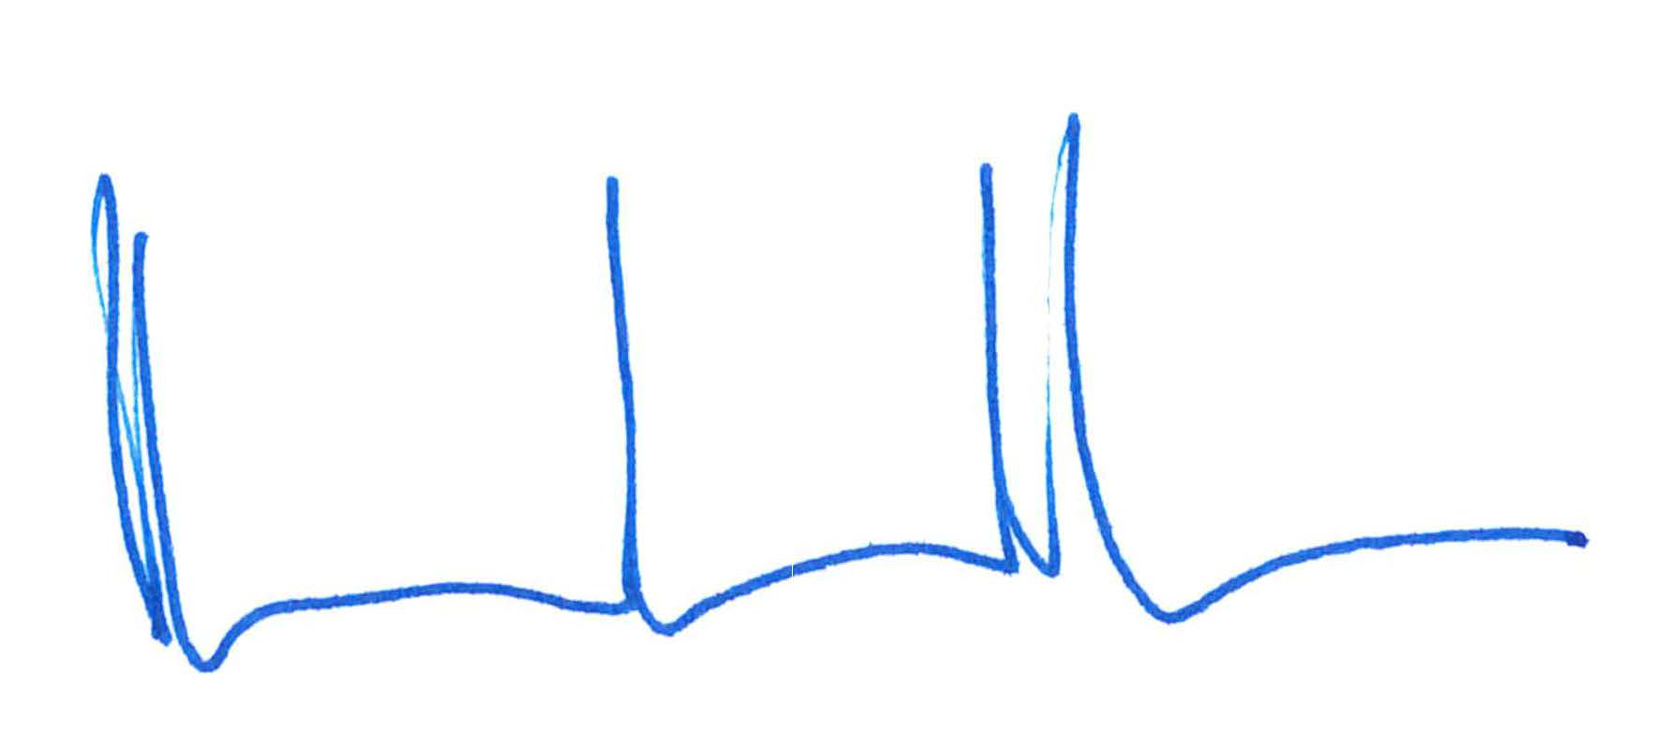

Philippe H. Geubelle