**Transportation Infrastructure Precast Innovation Center**

**(TRANS-IPIC)**

**University Transportation Center (UTC)**

*Photogrammetry and LiDAR-Based Precast Railroad Crossties Abrasion Damage Detections*

*PU-23-RP-04*

Quarterly Progress Report

For the performance period ending *06/30/2024*

**Submitted by:**

*PI: Shanyue Guan, Assistant Professor, guansy@purdue.edu*

*School of Construction Management Technology*

*Purdue University*

**Collaborators / Partners:**

*CO-PI: Chao Sun, Associate Professor, csun@lsu.edu*

*Department of Civil and Environmental Engineering*

*Louisiana State University*

*Industry Partner: MxV Rail*

**Submitted to:**

TRANS-IPIC UTC

University of Illinois Urbana-Champaign

Urbana, IL

**TRANS-IPIC Quarterly Progress Report:**

**Project Description:**

1. Research Plan - Statement of Problem

The railroad industry has been struggling with precast concrete crossties abrasion damage for a long time. Our research team has communicated with multiple class I railroads and all have responded that some of their crossties are facing the abrasion issue. To extend the precast concrete crossties service life and ensure railroad safety, there is a strong demand to mitigate the crossties abrasion damage. As it is not practical for the railroad industry to inspect thousands of miles of track to find concrete crosstie abrasion loss manually, an automated, low-cost, mobile, and accurate monitoring approach is urgently needed for the crossties' maintenance and repair.

1. Research Plan - Summary of Project Activities (Tasks)

Task 1: Visit precast concrete crossties damage site

Work closely with the railroad industry (e.g. MxV Rail) to understand abrasion damage of precast concrete damage and the typical approach the industry uses to measure the damage.

Task 2: Develop a photogrammetry and LiDAR system detecting damages

Develop a photogrammetry and LiDAR hardware system to detect the precast concrete crossties abrasion damage automatically.

Task 3: Validate the system performance in indoor and outdoor environments

Validate the system performance at Purdue University (West Lafayette, IN) Test Track Facilities.

Task 4: Reporting

Document all the completed work for paper publication and project report.

**Project Progress:**

1. Progress for each research task

Task 1 progress [80% completed]

Our team visited MxV Rail and discussed with their railroad crossties group to understand the damage pattern of precast concrete crossties and learn their technologies detecting concrete crossties conditions. Our team received three precast concrete crossties donated by MxV Rail. These precast concrete ties shown in Figure 1 will be used as test specimens for our project.

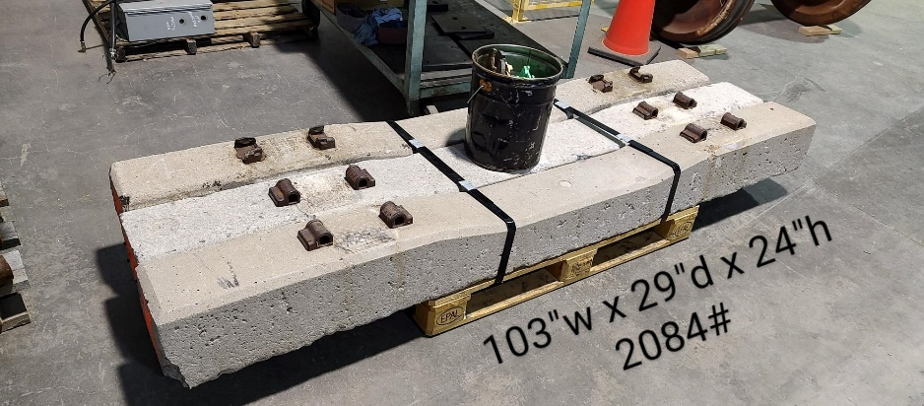

Figure 1. Precast concrete crossties donated by MxV Rail

Task 2 progress [80% completed]

Our team purchased a DJI Mavic 3 Thermal drone and used this drone to conduct 3D scanning of the concrete ties. DJI Mavic 3 Thermal is equipped with Wide-angle (Equivalent Focal Length: 24mm, 48MP) and zoom-in (Equivalent Focal Length: 162mm, 12MP, 56× Hybrid Zoom) cameras. The cameras have captured high-resolution images to assist reconstruction of a detailed 3D model with concrete crossties conditions. After the images of the drones were captured, we used Agisoft Metashape Pro software to create a 3D model using all the images. Once the 3D model is created, it will be imported to Cloudcompare software to conduct further analysis of the 3D to identify the geometry and damage information of the concrete crossties.

Task 3 progress [20% completed]

Our team has conducted a series of laboratory experiments using a drone-based photogrammetry approach to conduct 3D scanning to investigate the concrete crossties conditions. Purdue main campus is within 3 3-mile radius of Purdue Airport. To request the FAA permission to fly the drones outdoors takes extra approval. Our team decided to relocate the concrete crossties inside our Purdue Construction Management Technology Laboratory to follow the FAA policies. Three concrete ties are stationed on the ground with 2-foot intervals simulating the practical concrete crossties distribution. DJI Mavic 3 flies over the concrete crossties for about 15 to 20 minutes with different flight paths taking high-resolution video footage and images (Figure 2). Then the images and videos are imported to Agisoft Metashape to create a high-resolution 3D model (Figure 3). After the 3D model is created, the model will be analyzed using Cloudcompre software to understand the concrete crossties conditions (Figure 4). We first measured the geometry of the concrete crossties. Then calculate the volume of the concrete crossties to investigate the concrete crossties volume loss for the future. The results from the manual calculations and 3D model analysis are compared. The volume comparison results are summarized in Table 1. As we can observe the volume difference errors are reasonable but still larger than we expected. Our team reached out to MxV Rail who donated the crossties. As the crossties were manufactured a long time ago, there was no reference data for the crossties geometry. Due to the usage and transportation, there is also existing volume loss of the concrete ties, it is difficult for our group to retrieve the ground truth volumes of the ties. We are investigating the error sources and aim to mitigate the errors with better system calibrations.

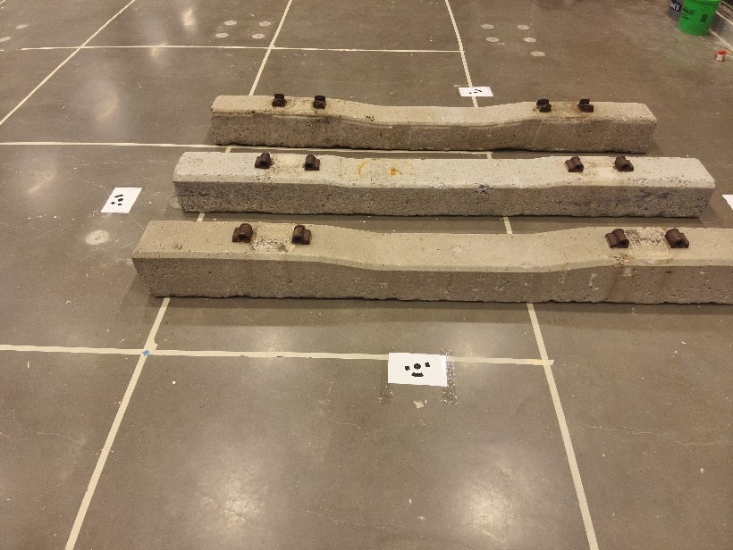

Figure 2. A drone captured concrete crossties image.

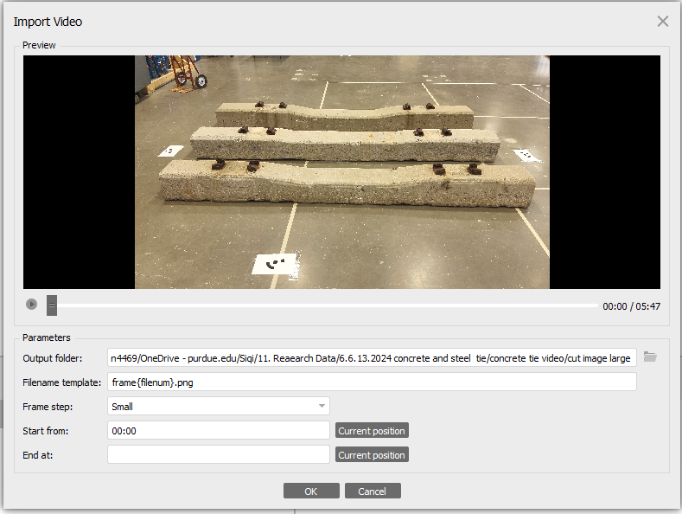

Figure 3. 3D model created by AgiSoft Metashape from the drone-based photogrammetry.

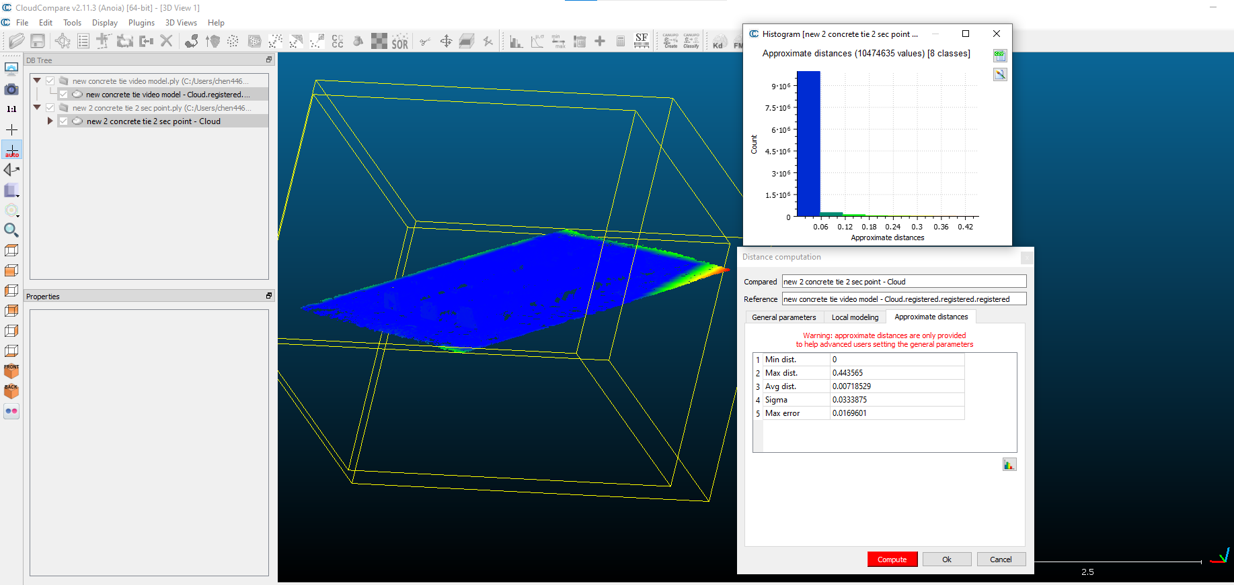

Figure 4. 3D model imported to Cloudcompare for further analysis.

Table 1. Concrete crossties volume calculations comparison.

|  |  |  |
| --- | --- | --- |
| Concrete crosstie number | Volume from 3D model (m3) | Volume from manual calculations (m3) |
| 1 | 0.1220 | 0.106 |
| 2 | 0.132 | 0.127 |
| 3 | 0.145 | 0.132 |

Task 4 progress [0% completed]

1. Percent of research project completed

As we completed most work of tasks 1 and 2, and started working on task 3, we are about 55% completion of this whole project.

1. Expected progress for next quarter

For the third quarter of this project, our team will conduct experiments using the test track facility at Purdue University to calibrate our system performance. We plan to use a target with known geometry to quantify the errors of our measurements. We will also install the rail and all other accessories to simulate the real-world railroad track cases. We also plan to move the test track facility to an outdoor environment to understand our system performance under different conditions (GPS, light).

1. Educational outreach and workforce development

In our CM370 Heavy Civil Infrastructure course at Purdue University, we developed a lecture topic about precast concrete crossties, introduced the damages of concrete crossties, and how to maintain their performance.

1. Technology Transfer

None

**Research Contribution:**

1. Papers that include TRANS-IPIC UTC in the acknowledgments section:

Our team is currently preparing a paper for the 2025 TRB convention.

1. Presentations and Posters of TRANS-IPIC funded research:

None

1. Please list any other events or activities that highlights the work of TRANS-IPIC occurring at your university (please include any pictures or figures you may have). Similarly, please list any references to TRANS-IPIC in the news or interviews from your research.

None

**References:**

[1] You, R., Wang, J., Ning, N., Wang, M., & Zhang, J. (2022). The Typical Damage Form and Mechanism of a Railway Prestressed Concrete Sleeper. Materials, 15(22), 8074.

[2] El-sayed, H. M., Fayed, M. N., Riad, H. S., & Zohny, H. N. (2022). A review of the structural performance of prestressed monoblock concrete sleepers in ballasted railway tracks. Engineering Failure Analysis, 140, 106522.

[3] Shurpali, A. A., Edwards, J. R., Kernes, R. G., Lange, D. A., & Barkan, C. P. (2014). Investigation of material improvements to mitigate the effects of the abrasion mechanism of concrete crosstie rail seat deterioration. Journal of Transportation Engineering, 140(2), 04013009.

[4] Shurpali, A. A., Van Dam, E., Edwards, J. R., Lange, D. A., & Barkan, C. P. (2012, April). Laboratory investigation of the abrasive wear mechanism of concrete crosstie rail seat deterioration (RSD). In ASME/IEEE Joint Rail Conference (Vol. 44656, pp. 99-108). American Society of Mechanical Engineers.

[5] Riding, K. A., Peterman, R. J., Guthrie, S., Brueseke, M., Mosavi, H., Daily, K., & Risovi-Hendrickson, W. (2018, April). Environmental and track factors that contribute to abrasion damage. In ASME/IEEE Joint Rail Conference (Vol. 50978, p. V001T01A009). American Society of Mechanical Engineers.