**Transportation Infrastructure Precast Innovation Center**

**(TRANS-IPIC)**

**University Transportation Center (UTC)**

Developing A Cost-Effective, Reliable, and Sustainable Precast Supply System under Price Volatility and Uncertainty of Material Supply

[LS-23-RP-04]

LSU Proposal ID: AWD-005947, GR-00014941/GR-00014942

**Quarterly Progress Report-2**

**Performance period:** *April 1- June 30, 2024*

**Submitted by:**

Bhaba R. Sarker (PI)

Professor, Department of Mechanical and Industrial Engineering

Louisiana State University, Baton Rouge, LA 70803

[**bsarker@lsu.edu**](mailto:bsarker@lsu.edu)

**Collaborators / Partners:**

Dr. Tyson Rupnow, Director

Louisiana Transportation Research Center (LTRC) [advising on project].

A private company will be contracted soon for data collection.

**Submitted to:**

TRANS-IPIC UTC

University of Illinois Urbana-Champaign

Urbana, IL

**TRANS-IPIC**

**QUARTERLY PROGRESS REPORT-2**

**I. PROJECT DESCRIPTION:**

1. **Research Plan - Statement of Problem**

The supply channel of the precast process begins with the procurement of raw materials that are processed through the PC (precast concrete) manufacturing operations and subsequently transporting the final products to the point of delivery for assembly or installation on site. This whole process involves different steps that may happen one after another or at the same time, and these processes affect the cost, time, and reliability of the final product or assignment.

*Research Goal:* Thus, this research aims at developing a cost-effective, sustainable, and reliable supply system considering the presence of price volatility and uncertainty of materials. By understanding these price changes, the study seeks to find the best way to plan the PC supply system to save money and still be reliable and sustainable.

1. **Research Plan - Summary of Proposed Project Activities (Tasks)**

The costs, sustainability, and reliability of the PC systems and components related to the transportation are the three main ingredients that need to be addressed in this research. The one-year (2024) research undertakings include:

1. **Task 1:** A *Structural Self-Interaction matrix* to be developed to extract different controlling variables and system parameters or factors that affect the stated performance outcome of the PC supply system, the reliability and manufacturing cost of precast concretes.

* A *diagrammatic* representation with variables and corresponding factors will provide the precedence and parallel relationships of general understandings of the system.
* The interrelationships and dependencies of variables, factors, and their related variants will be constructed for information of DOT and the construction community.

1. **Task 2:** *CRS Problem:* A cost-reliability-sustainability (CRS) modelwill be formulated to minimize the expected PC supply system’s cost and simultaneously improve the system's reliability and sustainability of the system.

* To accomplish this activity, dependent and independent jobs will be programmed in series and/or parallel configurations, respectively, such that different products can be completed in the shortest time and/or with maximum reliability.
* The CRS problem will provide a cost-effective optimal process/activity sequence to enhance higher reliability and sustainability; it will provide multiple alternative solutions to the management to choose the most suitable one for implementation purposes.

1. **Task 3:** UPV (*Uncertainty and Price Volatility*): Process variability and expected cost with individual material’s prices and supply uncertainty will be considered for refurbishing the warehouse in time.

* Supplying the PC components to the site(s) and sustaining the supply of the material ingredients are another part of the problem wherein repair/replacement is to be incorporated.
* The UPV problem will evaluate the cost, reliability, and sustainability when the prices are fluctuating, and uncertainty exists in the procurement of materials as they are directly dependent on the cost significantly.

**II. PROJECT PROGRESS:**

1. **Progress for each research task**

**3.1 Task 1 (QPR-1): Development of Interrelationships of hierarchical factors**, (~ 90% completed)

A hierarchical framework has been developed to represent the interdependencies among the factors of production process and supply systems of Precast Concrete (PC), which have their great impact on durability of Transportation Infrastructure. This graphical representation has also classified the factors based on their Interrelationships. In the following table, the factors are described that are related to these three main ingredients (cost, reliability, and sustainability) have been addressed in this research.

Table 1. Factors affecting the cost-effectivity and reliability of Transportation Infrastructure

|  |  |  |  |  |
| --- | --- | --- | --- | --- |
| **Factors** | **Cost** | **Reliability** | **Sustainability** | **Description** |
| Quality Control **(QC)** | √ | √ | √ | High-quality standards ensure sustainability of transportation system. |
| Price Volatility **(PV)** | √ |  |  | Price fluctuations or other unexpected incidents can include some additional project costs. |
| Transportation Infrastructure Quality **(TIQ)** | √ | √ |  | High quality infrastructure reduces transit time which affects reliability and cost. |
| Rate of RM Usage and Replenishment **(RMRUR)** | √ | √ |  | Efficient management reduces stockouts optimizing cost affecting reliability. |
| Mean Time Between Failures **(MTBF)** |  | √ | √ | Regular maintenance ensures operational durability of overall infrastructure. |
| Frequency and Duration of Delays **(FDD)** | √ | √ |  | Proactive management minimizes impact, maintaining project schedule adherence and cost control. |
| Accuracy of Real-Time Tracking System **(ARTTS)** |  | √ | √ | Enhances the ability to make informed decisions, improving operational reliability and sustainability of transportation infrastructure. |
| Cement content **(CC),** Amount of Steel **(AS),** Water-cement ratio **(W/C),** Cover on reinforcement **(COR).** | √ |  | √ | (Koskisto and Ellingwood, 2006) |
| Transporting the precast component **(TPC),** Shipping the precast component **(SPC),** Price difference for externally purchased concrete **(PDEPC)** | √ | √ |  | (Chen *et al*., 2018) |
| Hardness of Cement Paste **(HCP),** Structural Porosity **(SCP),** Aggregates and Reinforcements **(A&R),** Chloride and Carbonation Resistance **(CCR)** |  | √ | √ | (Mackechnie and Alexander, 2009) |

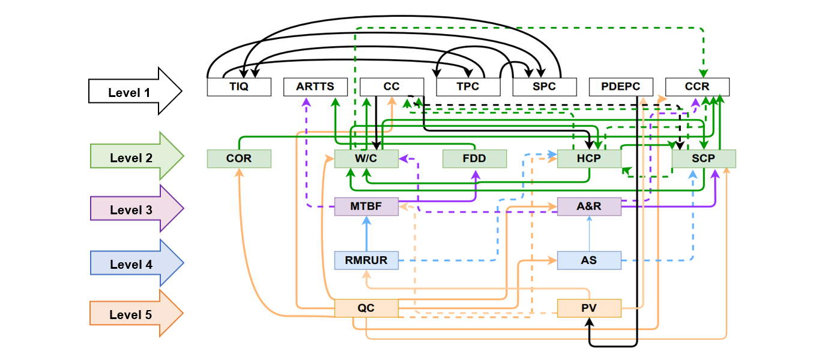

Figure 1. Diagram representing the dependence relationships of the Factors

The diagram in Figure 1 is constructed using the Interpretive Structural Modelling (ISM) approach, where the factors are organized according to their levels and illustrating their interactions. Dashed lines denote transitive relationships among the factors, while solid arrows indicate direct links. A factor positioned at an elevated level signifies its capacity to impact a greater number of other factors (Yadav and Samuel, 2022). This visual representation serves as a map, outlining the hierarchical organization and the intricate web of interconnections between various elements within the system. By clearly illustrating how different factors relate and interact with one another, the diagram becomes an invaluable tool in the system's analysis phase. The factors which are situated in level 5 are highly dependent on the other factors which can affect the cost-effectiveness, reliability, and sustainability of precast concrete production and supply chain. As per Figure 2, there are two factors in Level 5, they are: Quality Control (QC) and Price Volatility (PV). If we take QC, we can identify the factors on which QC is highly dependent. For example, there are some solid arrows which go out from QC and enter several rectangular boxes like; CC (Cement Content), W/C (Water-cement ratio), CCR (Chloride and Carbonation Resistance) etc. Because quality of precast concrete is highly related to the cement content, water-cement ratio, and the resistance properties against chlorides and carbonates.

**3.1.1 Application of ISM factors in Transportation Infrastructure:**

Using the Interpretive Structural Modeling (ISM) approach to develop a hierarchical framework in precast concrete production and supply chain is essential for enhancing the durability of transportation infrastructure. ISM helps clarify how different factors such as material quality, manufacturing processes, and logistics interact and influence each other. This understanding allows decision-makers to focus on the most critical aspects, leading to smarter resource allocation and improved strategic planning. By identifying potential risks and how they impact each other, companies can proactively address problems before they compromise the final product. Furthermore, a clear model of interdependencies fosters innovation and process improvements specifically where they will enhance the durability and performance of precast concrete in infrastructure projects.

**3.2 Task 2 Progress (QPR-2): Optimizing pallet utilization for curing cost,** (~ 75% completed)

Meeting tight deadlines is essential to avoid penalties and maintain good relationships with clients, but in most cases for PC manufactures, no priority is assigned to particular PC components with an earlier due date. Addressing these issues by optimizing how precast concrete is cured and how pallets are used can help reduce costs, avoid delays, and make manufacturing more sustainable, which is vital for keeping up with the demands of building modern transportation infrastructure (Figure 2). Improved efficiency and sustainability can enhance the reputation of construction firms, making them more competitive and better able to handle large-scale projects. Furthermore, such advancements could lead to innovations that might set new industry standards, propelling the entire sector toward more sustainable and cost-effective practices.

*Tayabji *et al.* (2010)

\**Courtesy:* HOUSING.com

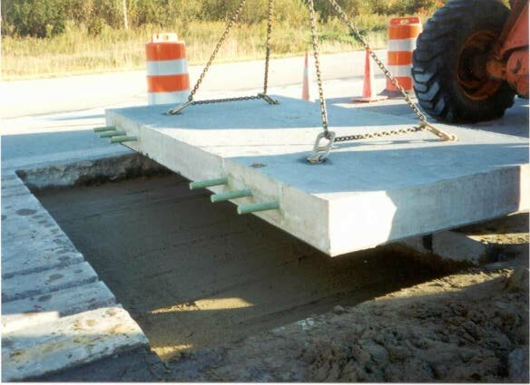

Figure 2. PC pavements installation for the construction of highways

In transportation infrastructure, manufacturing PC components efficiently is crucial for constructing roads and bridges on time and within budget. However, the curing process of PC components significantly affects the efficiency and cost of production. This curing process faces challenges like high energy consumption and labor costs during the curing stage which can increase overall expenses. In maximum PC production shops, a single component is cured on a pallet in the chamber. Thus, not using pallet space efficiently during this stage can lead to delays and waste resources (Figure 3). By fitting more components into the kiln chamber at a time, costs and resource use per component can be reduced to boost production efficiency, effectively incurring more curing costs.

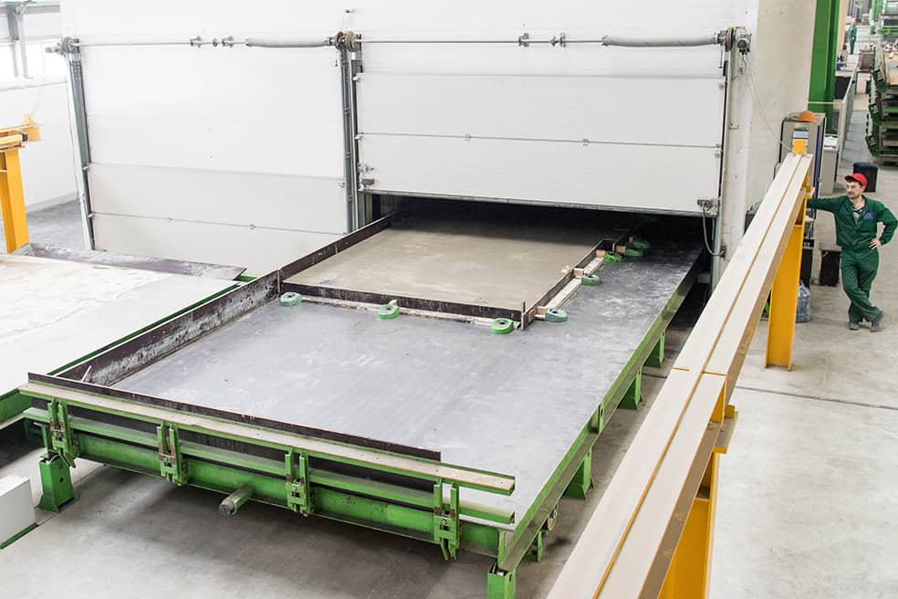

Inefficient use of pallet space

Figure 3. Mold placement on a pallet in curing process

PC products

Kiln Chamber

**3.2.1 The Curing Cost Minimization (CCM) Model**

Many factors come into play while designing an engineering system like placement strategy of PC components for curing in kiln chamber. A mathematical model for precast curing process will likewise require many technical constraints to maximize the pallet capacity utilization for ensuring the minimum cost-incurring curing process for various disparate PC components. Given the problem explained in the description above, our primary goal is now to formulate the curing cost minimization (CCM) problem for curing components and their placement in the kiln.

**3.2.2 Notation:**

The formulation of the CCM will be shown using some standard notations. Most of the factors considered by Wang *et al.* (2018) are considered here. The following notation or symbols will be used throughout the paper [see Mazumder and Sarker’s Working Paper#2 (2024b) for details].

1. *Indices*

= Component type ( = 1, 2, …, *m)*

= Precast layout on a pallet, = 1, 2, …, *n)*

1. *System Constants*

= Number of component type placed in layout , (

= Unit cost of energy (dollars/kWh)

= Demand of component type (components)

= Energy consumption rate for curing chamber (kWh/hour)

= Length of a pallet (feet)

= Labor cost (dollars/hour)

= Maximum length of component type (feet)

= = priority of component at time *t*, *t ≤*

= Current time (a point on timeline)

= Total curing time for a batch of PC components including loading and unloading the kiln (hours/batch)

= Deadline of component (a given point on timeline)

= Maximum width of component type (feet)

= Width of a pallet (feet)

= = Urgency rate of component (1/hour)

1. *Measures and Intermediate variables*

= Minimum priority value that can be assigned at the maximum allowable delay

= Maximum allowable delay (hours)

1. *System Variables:*

= Number of pallets using layout (pallets)

It may be stated that *LW* is the area per pallet (i.e., ft2/pallet) and is the area required by component (i.e., ft2/component).

**3.2.3 CCM Model Formulation:**

Curing Cost Minimization (CCM) model is obtained to find the optimal number of pallets with a particular layout with optimal number of PC components, to minimize the cost of curing operations [see Mazumder and Sarker 2024b].

CCM: = (1)

Subject to

(1a)

(1b)

(1c)

(1d)

(1e)

The constraint in CCM introduced in equation (1a) assures that the total area occupied by those precast components in layout must not be more than the area of the pallet. The constraint in equation (1b) ensures that the total number of particular required component type must meet the order agreement. Equation (1c) ensures that production scheduling comply with the delivery deadlines of PC components. Equation (1d) represents that the sum of maximum diagonals of PC components are less than the diagonal of the pallet. This ensures that the components will be limited to the size of the pallet. Lastly, equation (1e) represents the decision variables.

**3.2.4. An illustrative Example (Curing Process):**

In designing the layout of a curing kiln chamber for PC manufacturer, the objective is to determine the optimal layout configuration and the number of each layout for the curing process to minimize operational costs. The kiln accommodates a specified number of pallets, each capable of holding multiple precast components with varying dimensions and priorities. The inputs include an energy consumption rate of 36 kWh/hour, a unit cost of energy of $0.175 per kWh, a labor cost of $20 per hour, a total curing time for a batch of 8 hours, and dimensions of a pallet of 21 feet by 10 feet.

Concrete panels, paving slabs, and concrete beams are the main PC products of that manufacturing company and demands for these products are 25,20, and 35 components respectively, with dimensions of each component type of 2.5 feet, 3 feet, and 1.8 feet in length and 1.2 feet, 1.5 feet, and 1 foot in width, respectively. Assume the deadlines for concrete panels, paving slabs, and concrete beams are 270 hours, 230 hours, and 320 hours from the start, respectively, when 10 hours have passed from start. A minimum priority value of 0.1, and a maximum allowable delay of 48 hours are allowable for each component.

The optimization problem aims at minimizing the total cost of curing operations. This involves ensuring that the total area of components on a pallet does not exceed the pallet area, meeting the demand for each type of component, complying with the delivery deadlines, ensuring assigned components fit within the dimensions of the pallet, and no empty pallet to be inserted in the curing chamber (i.e., maintaining non-negative numbers of pallets for each layout configuration). The task is to determine the optimal number of pallets for each layout configuration to ensure the lowest possible curing cost and to calculate this minimum curing cost.

***Given Data:***

The data extracted from the manufacturer’s current problem can be summarized in Table 1. A component-pallet matrix where component type ( = 1, 2, 3*)* are accommodated in precast layout on a pallet, = 1, 2*)*. Here, we have three types of components are to be placed on two configurations. Number of pallets using layout it to be determined satisfying all the technological constraints of the curing system.

Table 2. Data for the PC components and the manufacturer’s kiln system.

|  |  |  |
| --- | --- | --- |
| **Variables** | **Value** | **Units** |
|  |  | Components/pallets |
|  | 0.175 | $/kWh |
|  | T | components |
|  | 36 | kWh/hour |
|  | 21 | Feet |
|  | 20 | $/hour |
|  | T | feet |
|  | T |  |
|  | 10 | hours |
|  | 8 | hours/batch |
|  | T | hours |
|  | T | feet |
|  | 10 | feet |
|  | T | 1/hour |
|  | 0.1 |  |
|  | 48 | hours |

***Computational Results:***

Using the given data in Table 1, Equation (1d) in CCM can be written as

or

which yields

Hence, using the data in Table 1, the CCM problem can be numerically formed as follows:

(2)

Subject to

(2a)

(2b)

(2c)

(2d)

(2e)

The optimal solution is produced using a linear programing technique with the help of Microsoft EXCEL solver. We got the optimal number of pallets for layout 1 and 2 as for which the minimum curing cost is

= $3,773.2

This means that, for the case mentioned in the example above, if two particular pallet layout configurations are considered for a curing process of PC components, number of pallets in the first configuration should be 2 and in the second configuration should be 4 to ensure the lowest cost for this curing operation. This calculation is performed on a computer with an *Intel(R) Core (TM) i5-10500 CPU@3.10 GHz* processor and 8 GB installed RAM.

In near future research, this mathematical model will be used to incorporate industry data to verify and compare the optimality of the solution with some real-life data from a construction company in collaboration with LTRC (Louisiana Transportation Research Center). Given that computational complexity increases with the addition of variables, the model will be revised to focus on the most critical variables that can reduce curing costs.

**3.2.5. Enhancing Infrastructure Durability through Optimized Curing Processes:**

The Curing Cost Minimization (CCM) model plays a crucial role in enhancing the durability of transportation infrastructure by optimizing the curing process of precast concrete components. This optimization ensures that each component is evenly cured, which is vital for achieving consistent material strength and structural integrity. Uniform curing reduces defects like cracks or voids, thereby increasing the lifespan and resilience of infrastructure elements such as roads and bridges. Additionally, the model promotes energy efficiency and effective labor utilization during the curing process, preventing rushed jobs and ensuring that each component meets high quality standards.

By minimizing the costs associated with the curing process, the CCM model allows for the allocation of resources towards higher-quality materials or more advanced construction techniques, further improving the durability of the infrastructure. The economic efficiency achieved through the model not only lowers the initial project costs but also reduces the lifecycle expenses associated with maintenance and repairs, supporting long-term sustainability. Moreover, the flexibility of the model to adapt to various component sizes and demands makes it an invaluable tool in the evolving field of infrastructure development, ensuring that projects not only meet current needs but are also robust enough to withstand future demands.

**3.3 Task 3 Progress (0% Completed)**

As the individual material’s price volatility and supply uncertainty play a vital role, total process variability and expected cost should be considered as well. We will need some expert’s opinions to figure out some variables related to this total process to consider the price volatility and uncertainty in our optimization problem.

1. **Percent of research project completed**

As the research project for this year has been divided into three parts, so, percentage of the research project completed approximately is (90%×33.33%) + (75%×33.33%) + (0%×33.33%) ~ 55%.

1. **Expected progress for next quarter**

A private company associated with production of PC components related to transportation infrastructure, will be contracted for data collection to check the optimality of the curing cost minimization model. Also, for next quarter, a CRS (Cost-Reliability-Sustainability) model will be formulated to determine the optimal process path that will minimize the expected precast concrete supply system’s cost and simultaneously improve the system reliability and sustainability of the system. Price volatility and material uncertainty will also be considered. Also, the two working papers under preparation currently will be modified and updated to complete the proposed research.

1. **Educational outreach and workforce development**

1. A paper entitled “Exploring Interdependencies of Factors in Precast Concrete Supply System: An Interpretive Structural Modeling Approach,” (Grant #LS-23-RP-04) was presented at the poster session at the *DOT TRANS-IPIC* Workshop, Big Ten Conference Center, 5440 Park Place, Rosemont, IL, April 22, 2024. This was the outcome of the first quarterly report QPR-1 and the audience/attendees comprised of *Trans-IPIC* researchers and collaborators.

2. A paper entitled “Factors of the Precast Concrete Supply Chain: An Interpretive Structural Modeling Approach,” was presented at the *Graduate Research Conference (GRC)*, at the Students’ Union, Louisiana State University, Baton Rouge, LA on April 30, 2024. The conference was arranged by the LSU Graduate Council for all LSU faculty and graduate students.

3. The team is in contact with LTRC (Louisiana Transportation Research Center) representative (Dr. Tyson Rupnow, Director) to assist and advise in the project.

1. **Technology Transfer**

The research team is contact with several companies through LTRC. Efforts have been given to collaborate and collect some real life data for testing purposes and feedback on the project. The final outcome is yet to achieved for technology transfer.

**III. RESEARCH CONTRIBUTION:**

1. **Papers that include TRANS-IPIC UTC in the acknowledgments section:**

1. Mazumder, A. and Sarker, B. R. (2024a), “Developing an interpretive structural model for factors affecting cost effectiveness, reliability and sustainability of precast concrete,” *Working Paper* #1 (outcome of QPR-1, January 1 - March 31, 2024).

2. Mazumder, A. and Sarker, B. R. (2024b), “Optimizing Pallet Capacity Utilization to Minimize Curing Cost in Precast Concrete Manufacturing,” *Working Pape*r #2 (Outcome of QPR-2, April 1 - June 30, 2024).

1. **Presentations and Posters of TRANS-IPIC funded research:**

1. Mazumder, A. and Sarker, B. R., “Factors of the Precast Concrete Supply Chain: An Interpretive Structural Modeling Approach,” *Graduate Research Conference (GRC)*, presented at the Students’ Union, Louisiana State University, Baton Rouge, LA on April 30, 2024.

2. Mazumder, A. and Sarker, B.R., “Exploring Interdependencies of Factors in Precast Concrete Supply System: An Interpretive Structural Modeling Approach,” presented at the *DOT TRANS-IPIC Workshop* (Grant #LS-23-RP-04), Big Ten Conference Center, 5440 Park Place, Rosemont, IL, April 22, 2024.

1. **Please list any other events or activities that highlights the work of TRANS-IPIC occurring at your university (please include any pictures or figures you may have). Similarly, please list any references to TRANS-IPIC in the news or interviews from your research.**

Mazumder, A. and Sarker, B. R., “Factors of the Precast Concrete Supply Chain: An Interpretive Structural Modeling Approach,” *Graduate Research Conference (GRC)*, presented at the Students’ Union, Louisiana State University, Baton Rouge, LA on April 30, 2024. Picture was not allowed to be taken. Attached is the cover page of the presentation.

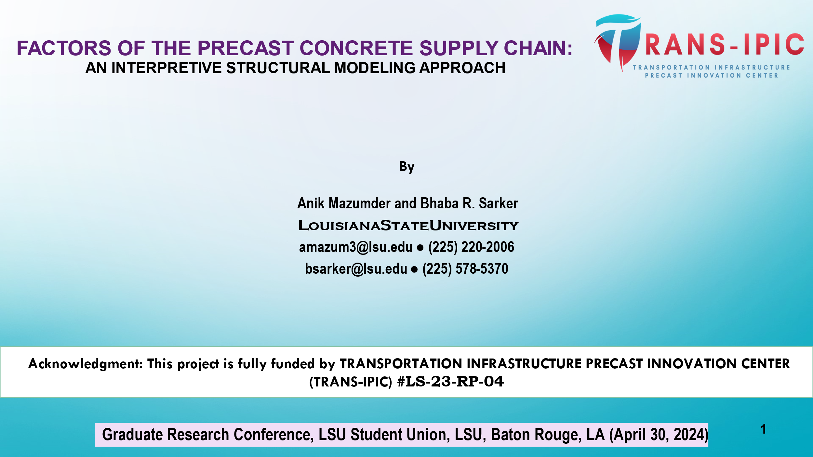

Figure 4. Cover Slide of the presentation file that was presented at GRC, LSU.

**IV. REFERENCES:**

1. Attri, R., Dev, N., and Sharma, V. (2013). Interpretive structural modelling (ISM) approach: an overview. *Research of management sciences*, *2319*(2), 1171.
2. Chen, J. H., Yan, S., Tai, H. W., and Chang, C. Y., (2017). Optimizing profits for precast concrete production and logistics. *Supply Chain Management*, 23(2), 429-448.
3. Chandra, D., and Kumar, D. (2018). A fuzzy MICMAC analysis for improving supply chain performance of basic vaccines in developing countries. *Expert Review of Vaccines*, 17(3), 263–281. https://doi.org/10.1080/14760584.2018.1403322
4. Chandramowli, S., Transue, M., and Felder, F. A. (2011). Analysis of barriers to development in landfill communities using interpretive structural modeling. *Habitat International,* 35(2), 246–253. https://doi.org/10.1016/j.habitatint.2010.09.005
5. Koskisto, O. J., and Ellingwood, B. R. (2006). Reliability-based optimization of prefabricated concrete structures. *Management, Quality and Economics in Building*, 123(3), 1118–1126. https://doi.org/10.4324/9780203973486
6. Mackechnie, J. R., and Alexander, M. G. (2009). Using durability to enhance concrete sustainability. *Journal of Green Building*, 4(3), 52–60. https://doi.org/10.3992/jgb.4.3.52
7. Mari, S. I., Lee, Y. H., and Memon, M. S. (2014). Sustainable and resilient supply chain network design under disruption risks. *Sustainability* (Switzerland), 6(10), 6666–6686. https://doi.org/10.3390/su6106666
8. Papapostolou, C., Kondili, E., and Kaldellis, J. K. (2011). Development and implementation of an optimisation model for biofuels supply chain. *Energy*, 36(10), 6019–6026. https://doi.org/10.1016/j.energy.2011.08.013
9. Sarker, B.R. (2023). Developing A Cost-Effective, Reliable, and Sustainable Precast Supply System under Price Volatility and Uncertainty of Material Supply. A proposal submitted to the DOT/Trans-IPIC, Grant#LS-23-RP-04
10. Sushil. (2012). Interpreting the interpretive structural model. *Global Journal of Flexible Systems Management*, 13(2), 87–106. https://doi.org/10.1007/S40171-012-0008-3
11. Wang, D., Liu, G., Li, K., Wang, T., Shrestha, A., Martek, I., and Tao, X. (2018). Layout optimization model for the production planning of precast concrete building components. *Sustainability*, 10(6), 1807.
12. Warfield, J. N. (1974). Developing Interconnection Matrices in Structural Modeling. *IEEE Transactions on Systems, Man and Cybernetics, SMC* 4(1), 81–87. https://doi.org/10.1109/TSMC.1974.5408524
13. Yadav, A. K., and Samuel, C. (2022). Modeling resilient factors of the supply chain. *Journal of Modelling in Management*, 17(2), 456–485. https://doi.org/10.1108/JM2-07-2020-0196.