Autonomous and Unmanned Vehicle Systems Laboratory

Hyperspectral Camera Development and Evaluation for Improved Terrain Characterization
Sidhanth Asur, Systems Engineering and Design, Class of 2023.
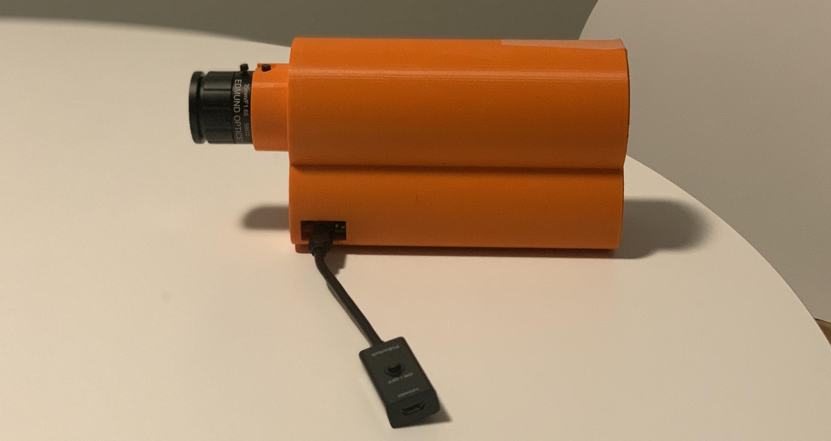

Background
Many remote sensing methods used to collect the database characteristics leverage the detailed data provided by a hyperspectral sensor (as opposed to a multispectral sensor). Unfortunately, most commercial hyperspectral sensors cost upwards of $20,000. Due to their high cost, research groups have created step-by-step guides to create low-cost hyperspectral sensors. A detailed explanation of the construction and configuration, along with a parts list and CAD files, of a low-cost hyperspectral sensor was presented in “A plug-and-play Hyperspectral Imaging Sensor using low-cost equipment” by Jairo Salazar-Vazquez and Andres Mendez-Vazquez, that will be referred to as “plug-and-play”. The paper provides all the necessary guidance for a student to create and configure a homemade hyperspectral sensor. The task was to follow the outlined document and build a low-cost hyperspectral sensor.

Procedure
In order to complete this project, the first task was to download the STL files, assess them and print them. These STL files were linked in the “plug-and-play” document and were the 3D pieces for the frame of the sensor. This process took a total of 72 hours. The assessment of the pieces, with respect to the components, was necessary in case changes needed to be made to the STL files prior to printing. After that task was completed, the printing of the pieces took less than 2 days. The components were relatively large, and a total of 12 components were sent for printing. After they were printed, these pieces were put in an Alkali solution bath to remove any excess support structures that may have remained on the printed components post removal.
The build process was rather simple considering the instructions were provided in the “plug and play” document. Some of the steps required some improvisation such as mounting the lens onto the Lens Holder piece, as well as attaching the diffractor plate onto its affiliated piece. The issues encountered most likely stemmed from the printing process, where some level of distortion took place and had to be adjusted accordingly.
The last step was the calibration process. It is worth noting that the instructions provided are for a camera, not a sensor. Accordingly, the camera was calibrated to take pictures. There were obstacles met in this process that will be mentioned in further detail in the next section. However, as a result of those obstacles, the calibration process was not completed.

Results and Discussion
As mentioned earlier, there were unfortunate obstacles encountered during this project. I was able to upload the Raspberry Imaging OS onto the RPI, but I was unable to enable the camera module, which prevented the entire calibration process. The main reason was my laptop’s operating system. As a mac user, the Raspberry OS is not accessible to me, and using it to enable the module was not possible. This was directly a result of improper prior planning. With proper planning, I would have realized that the Mac OS was not capable of running Rasbian. With this information I could have borrowed a laptop from the lab or reached out to the team for help.

Improvements
This project, while certainly time consuming, was rather straightforward and as such, there were few issues encountered. One of the main issues, and something that should be improved upon moving forward, was the “age” of this document. For clarification sake, by age I mean some of the components referenced in this document are not available for purchase. Additionally, the parts were designed around these currently unavailable components. For example, the Bill of Materials in the “plug-and-play” document called for a separate on/off switch and power supply. And to account for that in the final build, the back cover--or the Lid as it is labeled--had two openings. After extensive searching, this specific component was not available, as it was discontinued. There are more streamlined and inclusive parts such as a 2-in-1 power supply with an on/off switch. This accessory connects to the Raspberry Pi from the side. However, the outer shell of the entire camera did not account for this change in equipment and provides no access to the power input on the Raspberry Pi when installed.
A similar however, insignificant, issue was with the list of 3D parts. The “Part 4 Extension” has two parts which was unnecessary. By combining them into one part, the number of components could be reduced, and the printing time as well. Additionally, the X extension was an unnecessary part altogether. To account for the difference in depth between the case and the Raspberry Pi, and to prevent its movement, simple edits can be made to the “Case” itself.

Conclusions and Lessons Learned
The main lesson learned was prior planning. I did not properly allocate time to the project and because of that, a good amount of time was lost leaving little to no buffer time at the end for these issues. Additionally, had I planned adequately; I would have had the ability to reach out to the rest of the AUVSL team for help as there are members who are proficient in Raspberry Pi programming.
The other lesson is related to my skills, with my need to enhance my knowledge on the Raspberry Pi utility. This is not a shortcoming but more of a “looking-ahead” step. If I can enhance my own skills, in the future I would be able to come up with a method to overcome the shortcomings faced in this project.

Plan
Moving forward, my plan is to reach out to the team this Friday (December 18th, 2020) and work with a few members of the team. The focus of this task would be the Raspberry Pi Programming and calibration. Once the calibration is completed, the project will reach its conclusion. The tentative date for this is January 10th, 2021. I am proposing the date because the Sensor will be completed by the start of the Spring 2021 semester.

References
Jairo Salazar-Vazquez, Andres Mendez-Vazquez, A plug-and-play Hyperspectral Imaging Sensor using low-cost equipment, HardwareX, Volume 7, 2020, e00087, ISSN 2468-0672, https://doi.org/10.1016/j.ohx.2019.e00087.

