Transportation Infrastructure Precast Innovation Center
(TRANS-IPIC)

University Transportation Center (UTC)

Bio-Inspired Solutions for Jersey and Road Noise Barriers: Exploring 3D Printing as Alternative Precast Technology
Concrete3DP
TRANS-IPIC Project Number PU-23-RP-03

Quarterly Progress Report
For the performance period ending 12/31/2023

Submitted by:

Jan Olek¹(olek@purdue.edu),
Jeff Youngblood²(jpyoungb@purdue.edu),
Pablo Zavattieri¹(zavattie@purdue.edu )
¹Lyles School of Civil Engineering, Purdue University
²School of Materials Engineering, Purdue University

Collaborators / Partners:

Submitted to:
TRANS-IPIC UTC
University of Illinois Urbana-Champaign
Urbana, IL
TRANS-IPIC Quarterly Progress Report:

Project Description:

Research Plan - Statement of Problem
The continuous improvement of transportation infrastructure is imperative for ensuring the safety of road users and the overall efficiency of the transportation network. One of the key aspects of this enhancement involves incorporating impact-resistant structures in the construction and retrofitting of various infrastructure components[1], such as the Jersey barrier, impact attenuator, and crash cushion (Fig. 1). Crash cushion are safety devices designed to absorb and reduce the impact energy during a vehicle collision[2]. They are typically used on roads, highways, and other transportation infrastructure to enhance safety and minimize the severity of accidents. Crash cushions serve as protective barriers at the end of rigid structures, such as guardrails or concrete structures, to mitigate the consequences of a vehicle colliding with these obstacles[3].

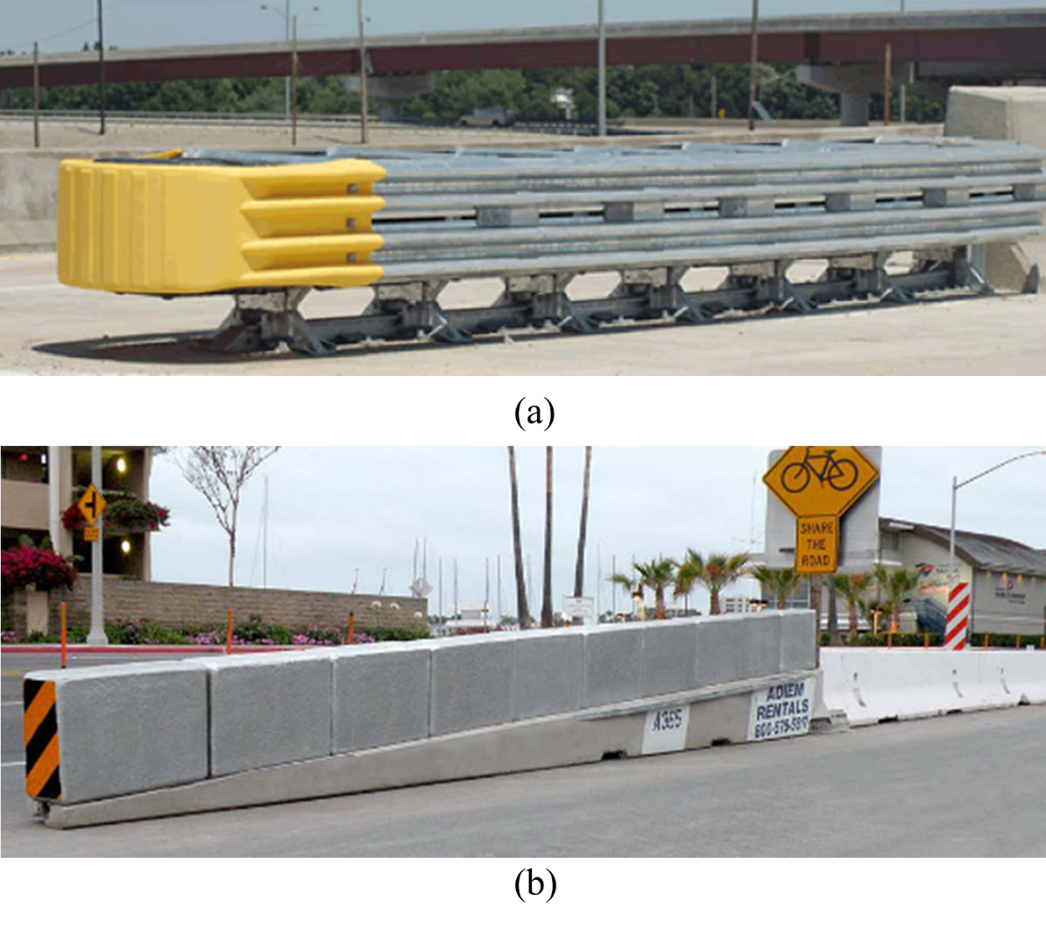
Fig.1-examples of crash cushion for energy-absorbing(a) Quadguard System(b) Advanced Dynamic Impact Extension Concrete Module [1].

Improving energy-absorption capacity of these structures plays a critical role in minimizing damage resulting from traffic accidents, reducing disruptions to traffic flow, and safeguarding the well-being of drivers, passengers, and workers[4]. Our research project seeks to introduce an innovative approach by harnessing the capabilities of 3D printing technology. Specifically, our focus is on the development of impact resistant structure through an alternative precast process using 3D printing of concrete-based materials with novel internal architectures. This approach holds the promise of not only enhancing impact energy absorption but also revolutionizing the conventional methods of barrier production.

Research Plan - Summary of Project Activities (Tasks)
Task 1 - literature review and research plan development
This task involves conducting a literature review and developing a comprehensive research plan. The literature review aims to explore existing studies, research, and knowledge relevant to the chosen research topic, specifically focusing on potential designs for concrete barriers. This step helps to select potential designs using principles of architected materials and bioinspired concepts, including architectures such as Bouligand and sinusoidal architecture[5], [6] to enhance impact resistant capacity.
Task 2 – large scale 3DP system development
This task involves develop innovative 3D printing techniques using our Large-Area Lab-Scale (LALS) printer and Large-Scale Robotic Arm (LSRA) tailored for precise and reliable production of the barriers using cement-based materials and additive manufacturing processes, ensuring structural integrity and desired functional properties.

Task 3 - Material development and testing for large-scale 3DP system
The goal of this task is to develop a sustainable and cost-efficient concrete mixture for task 4 and other future works. The mixture is amid to incorporate a high-volume replacement of limestone filler, combined with cellulose nano materials as additives, to enhance rheology and hardened mechanical properties, improve sustainability and durability, and increase cost-efficiency.

Task 4 – Sample fabrications and experimental testing
This task includes using the 3D printing system and 3DP mixture developed in tasks 2 and 3 to prepare samples with bio-inspired architectures. These samples will undergo a series of rigorous mechanical and durability tests to assess the fabricated samples' performance in real-world scenarios. Quasi-static and drop-tower impact testing will be employed to evaluate mechanical strength and impact resistance capacity. Additionally, durability testing, such as evaluating the chloride diffusion coefficient, will be conducted to gauge the long-term performance. This multifaceted testing approach ensures a thorough evaluation of the bio-inspired architectures, providing valuable insights into their mechanical, impact resistance, and durability characteristics.

Project Progress:

Progress for each research task

Task 1 - literature review and research plan development [80% completed]

Task 1.1-Desing and evaluation of roadside safety hardware
The AASHTO Manual for Assessing Safety Hardware (MASH) [7] now stands as the prevailing source for guidelines pertaining to the testing and evaluation of crashworthy performance in barriers, superseding the NCHRP Report 350[8] for assessing the safety performance of highway features[9]. Compliance with crashworthiness is affirmed if a barrier system either meets all the evaluation criteria outlined in MASH or NCHRP Report 350 for each requisite crash test or has been deemed acceptable through an in-service performance evaluation[9].
The intricate process of designing and developing a novel safety feature necessitates rigorous procedures, prominently featuring full-scale crash testing to validate the satisfactory impact performance of the feature. In the early stages of design and development, a combination of analytical and experimental tools is employed, encompassing principles of mechanics, static tests, dynamic tests, and computer simulations [9]. The initial design evolves through the application of structural loading and design procedures rooted in the principles of mechanics. Critical components undergo static tests, providing essential data such as material ultimate capacity, connection strength, and load/deflection characteristics. Dynamic tests, employing a drop weight, pendulum, or bogie vehicle, assess subsystems or prototypes, elucidating energy absorption characteristics under dynamic impact conditions. The initial design undergoes iterative modifications based on the outcomes of static and dynamic tests, as well as computer simulations, ensuring a refined and optimized safety feature[9].

Task 1.2-3DP concrete with Bio-inspired architecture for energy absorption
The advancement of impact-resistant concrete structures necessitates the integration of innovative materials and design methodologies. Recent progress has been directed towards the enhancement of high-performance concrete, reinforcement systems, and the optimization of geometric configurations. Field[10][11]. Nonetheless, persistent challenges are evident in the pursuit of a balance between mechanical robustness, cost-efficiency, durability and energy absorption capacity[10][11][12][13]. Potential solutions lie in leveraging Concrete 3D printing technology and integrating inventive design principles inspired by naturally occurring impact-resistant materials[14].

Over the recent years, there has been a notable surge in the adoption of the biomimetic approach for energy absorption, as evidenced by the trends depicted in Fig 2[14]. Although the application of bio-inspired structures for energy absorption is on the rise, it has not attained applications the same level of ubiquity as conventional structures. This is attributed to the relatively nascent nature of the bionic approach in energy absorption applications and its constraints in fabrication, as illustrated in Fig 2[14]. Some notable examples including, Bouligand and sinusoidal helicoidal architectures[6], [15], scutoid interlocking structure[16], Nacre bio-inspired composite laminate[17], etc.
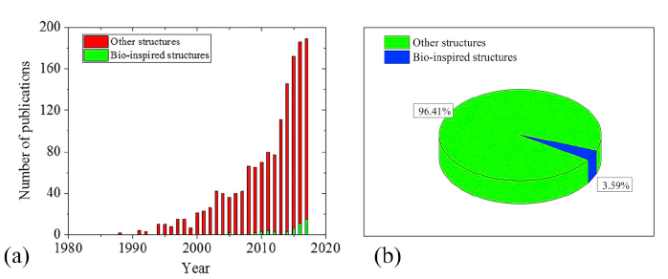

Fig. 2 - (a) Number of publications of bio-inspired structures for energy absorption based on the Scopus database (keywords shown in the Appendix); (b) the percentage of bio-inspired structures in the energy absorber[14].

The inspiration for Bouligand and sinusoidal helicoidal architectures is drawn from the dactyl club of the Mantis shrimp, a remarkable creature capable of delivering powerful strikes to its shelled prey[5][6]. These dactyl club exhibit peak striking speeds of approximately 20 meters per second and can generate forces of around 700 Newtons[18][19]. What makes the dactyl club especially impressive is its capacity to withstand the immense forces encountered during this predation interaction[19]. The Bouligand and sinusoidal helicoidal architectures within the dactyl club play a pivotal role in providing energy dissipation, load-bearing capabilities, and damage tolerance[5][6]. These characteristics are attributed to their helicoidal arrangement and the presence of interfaces[15]. Current investigations into the impact resistance of Bouligand and sinusoidal helicoidal architecture are predominantly situated within the field of fracture mechanics and polymer science[20][21][22]. Archipatbut and colleagues[23] engineered a carbon/epoxy composite plate with a helicoidal lay-up structure encompassing 40 layers. Employing a series of diverse experimental configurations, including tensile, punch, and impact testing methodologies, they validated that specimens featuring a helicoidal stacking sequence exhibited superior resistance to penetration and heightened energy absorption. Grunenfelder et al. [24]employed the helicoidal design principles observed in the stomatopod club to advance carbon fiber/epoxy composites. Experimental and computational findings revealed that the bio-inspired helicoidal architecture played a pivotal role in mitigating through-thickness damage propagation within a composite panel subjected to an impact event. This resulted in a discernible enhancement in toughness.
However, Investigations into the impact resistance capacity of 3D-printed concrete are limited. The strong anisotropy inherent in 3D-printed fiber-reinforced mortar, coupled with the presence of interfaces in the 3D-printed elements, suggests the potential for superior energy absorption capacity when incorporating helicoidal architectures. The results of this research hold promise for potential applications as energy-absorption materials, such as in the design of road side barrier systems.

Task 1.3 Materials development for large scale 3D printing using high volume replacement of limestone filler and cellulose nano materials.
The primary goal of this task is to develop a mixture for large-scale 3D printing applications, specifically for task 1.2 and potential future projects. The proposed mixture aims to integrate a large proportion of limestone filler, combined with cellulose nanomaterials as additives. The overarching objective is to enhance rheological and hardened mechanical properties, improve sustainability and durability, and optimize cost-effectiveness.
Limestone filler, rich in calcium carbonate, provides a feasible partial substitute for the clinker component in cement [25]. This substitution reduces the need for clinker production, a process known for its energy intensity and CO2 emissions. Additionally, judicious use of limestone filler contributes positively to concrete's mechanical strength and durability[26][27]. Limestone particles act as nucleation sites for the crystallization of calcium silicate hydrate (C-S-H), the primary binding phase in cementitious materials[27]. This promotes improved packing and potential enhancements in mechanical properties, such as compressive strength[27]. Furthermore, it reduces concrete permeability, making it less susceptible to water ingress, chemical aggression, and freeze-thaw damage[28]. However, using it as a high replacement in the cement mixture may lead to problems such as slowed hydration, reduced strength and increased permeability due to the dilution of clinker with excessive limestone[28].
Cellulose nanomaterials (CNMs) represent a class of biodegradable substances valued for their inherent non-toxicity and cost-effectiveness[29]. Derived from renewable sources, CNMs have gained significant attention for their potential to enhance the rheological characteristics of cementitious materials for 3D printing applications[30][31][32]. This emerging prospect positions CNMs as a promising alternative to prevalent, and often expensive, viscosity modifiers in the 3D printing industry. Recent research suggests that CNMs may accelerate the hydration process and optimize pore structures[33], thereby enhancing both the mechanical and transport properties of cementitious materials. These attributes have the potential to address challenges associated with the dilution effect in mixtures with high limestone filler replacement[27]. Along with their ability to enhance rheological properties, cellulose nanomaterials have the potential to serve as highly advantageous additives in formulating 3D printing mixtures with a high limestone filler replacement. This integration holds promise for creating a sustainable and cost-efficient concrete mixture with enhanced rheology and mechanical performance for 3D printing applications.

Task 2 – large scale 3DP system development [80% completed]
In this task, a comprehensive large-scale 3D printing (3DP) system has been developed. The system comprises an ABB robotic arm (ABB 6700), a high-pressure mortar pump (M-Tech Duo mix P20), and a high-performance extruder designed by the research group (Fig. 3). This extruder stands out with its shear mixing capabilities and a two-configuration design (open hopper and close system), strategically implemented to facilitate the printing process (Fig. 3). This unique extruder design addresses the challenges associated with aggregate size limitations by integrating with the typical pumping system, allowing for the 3D printing of concrete containing coarse aggregate instead of only sand. The shear mixing capability proves particularly advantageous when handling materials with high viscosity and a high aggregate-to-cement ratio.
An achievement in this task is the successful fabrication of a curved wall section using the 3D printing (3DP) system. The curved wall, designed with a total length of 9.4’ and a height of 3', is intended for integration into a 3D-printed earth house in Bloomington, Indiana, showcasing the practical application of advanced technology. A 1-inch nozzle was used in this print, and the layer height was configured at 10mm, yielding a total of 90 layers. Quikrete 3D printing mixture was employed to expedite the system testing phase. The current emphasis is on advancing the development of a cost-effective and sustainable concrete 3DP mixture with enhanced mechanical and durability performance for the roadside barrier application.

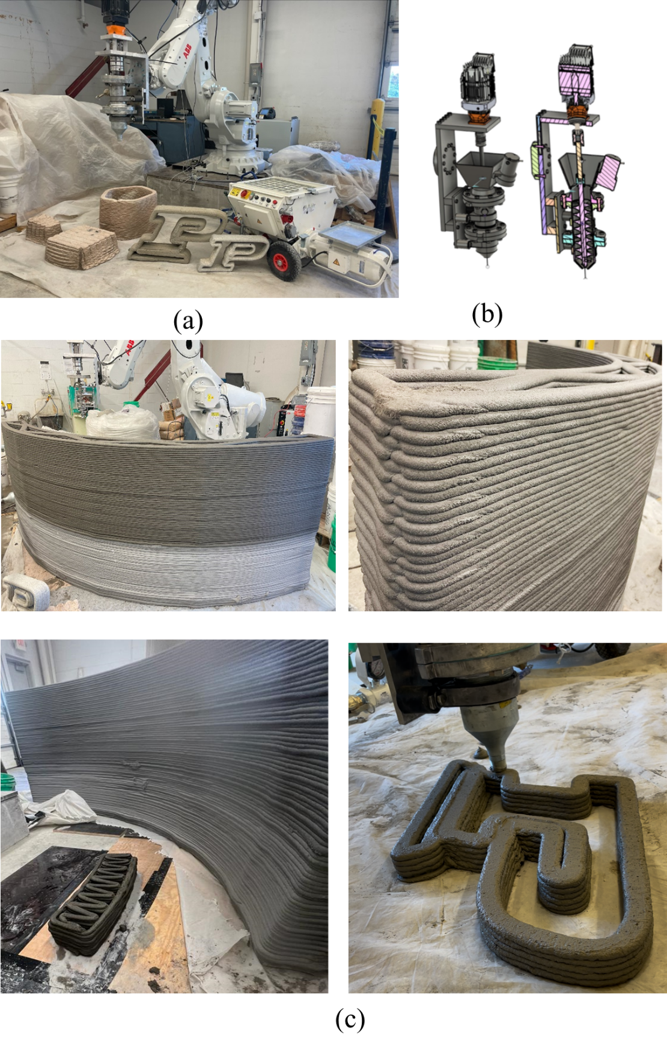
Fig. 3-(a) large-scale 3D printing system including robot arm, pump, and extruder (b) Desing of the extruder (c) specimens fabricated with the 3DP system.

Task 3 - Material development and testing for large scale 3DP system
This task includes develop a mixture for large scale 3DP applications using natural and cost effective additive and high-volume replacement of limestone filler. The main objective is to develop a mixture with enhanced rheological and hardened mechanical properties, improved sustainability and durability, and optimized cost-effectiveness.
The mixture development started from a comparison of preliminary buildability test to find suitable additives for 3DP application. During the 3DP process, challenges in constructing elements may emerge, with two common failure mechanisms being the yielding of lower layers or the buckling of the element. The primary focus of this study is to investigate the influence of different additives on the buildability of hollow cylinders, where the predominant failure mode is attributed to buckling[34]. The additives includes, viscosity modifier admixture, cellulose nano fibers, cellulose nano crystals, Polyvinyl alcohol(PVA) fiber, and nano clay. All the mixtures were designed with the same water to cement ratio and sand content, with various additives. The detailed mix designs are listed in table 1.

Table 1 – Proportions of mortar mixtures for buildability test
Mix group | Water/Cem. (W/C)* | Sand/Cem. (S/C)* | Additives
1 | 0.4 | 0.25 | 0.1% CNC*
2 | 0.4 | 0.25 | 2% VMA*
3 | 0.4 | 0.25 | 0.3% PVA†
4 | 0.4 | 0.25 | 0.1% CNF*
5 | 0.4 | 0.25 | 0.2% CNF*+25%limestone*
6 | 0.4 | 0.25 | 2%VMA*+2% nanoclay*

* dry weight of the additives with respect to the weight of total cementitious material
† percentage of the volume of the plain (no fibers) mixture

Fig. 4 displays the results of the buildability test. It is observed that the inclusion of 0.1% CNC and 0.3% PVA did not yield substantial improvements in buildability height compared to the 2% VMA baseline. Bulking failure was evident as the printing height increased in these instances. The introduction of 0.1% CNF into the system resulted in a 52% improvement in buildability height relative to the mixture with 2% VMA. However, the addition of 0.2% CNF (without limestone) led to a considerable dead zone, negatively affecting the extrudability of the mixture, as shown in Fig. 4 (b). For the mixture with 0.2% CNF, upon replacing 40% of the cement with limestone filler, both extrudability and buildability showed improvement, enabling the complete extrusion of material without encountering dead zones. In this scenario, the buildability height reached the machine's maximum limit of 180mm without failure, representing a minimum improvement of 186% compared to the 2% VMA mixture. Another notable result emerged when combining 2% VAM and 2% nano clay, achieving the maximum build height and yielding comparable outcomes to the mixture containing 0.2% CNF and 40% limestone. These findings underscore those two combinations, specifically VAM with Nano clay and CNF with limestone, exhibit the most significant improvements in buildability.

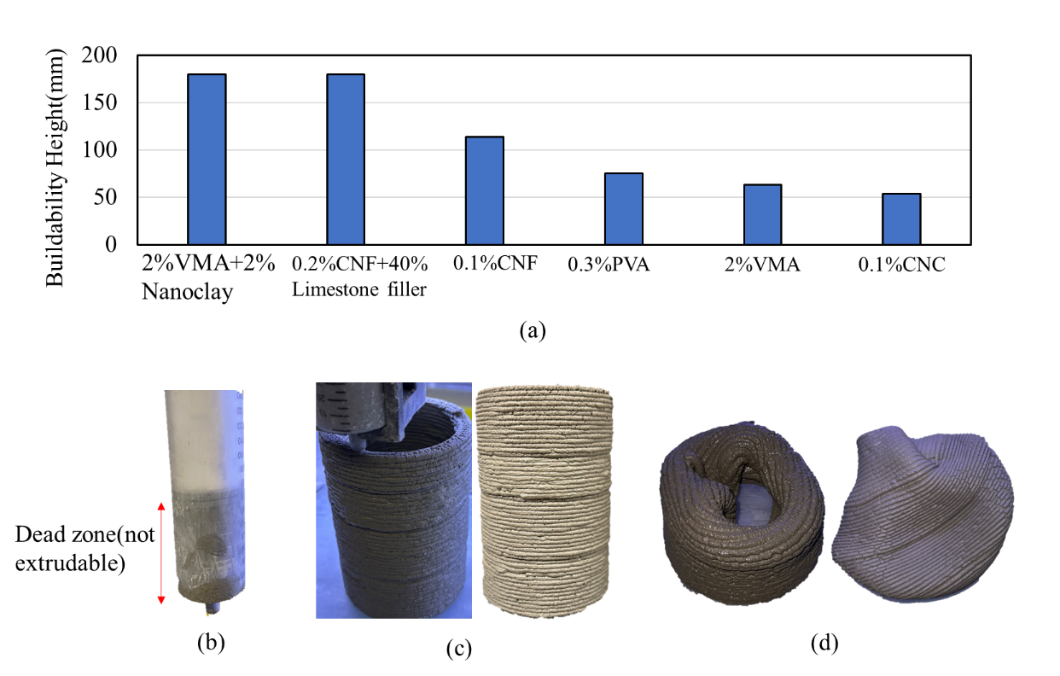

Fig. 4- (a)buildability high results for mixtures with different additives (b) example of the geometry used in buildability test (c) Example of bulking failure of buildability tests

The printed cylinder sample created using mixtures of VAM with Nano clay, and CNF and limestone was subjected to normal laboratory conditions for over 4 weeks. In the case of the sample with VMA and nano clay, a substantial crack was observed in the cylinder due to shrinkage (Fig. 5 (a)). Contrastingly, the sample incorporating CNF and limestone exhibited no evidence of shrinkage crack(Fig. 5 (b)). This absence of shrinkage crack may be attributed to the strong water retention capability of CNF, which effectively reduces the amount of free water in the system. Moreover, CNF may contribute to thickening the pore solution, thereby mitigating water evaporation and diminishing shrinkage. Additionally, the incorporation of limestone in the mixture holds the potential to decrease cement usage, consequently reducing the carbon footprint. Consequently, the combination of CNF and limestone is selected for further investigations in future studies. The next step includes studying the influence of the sand content, limestone filler content, and CNF content on the rheology and hardened properties of the 3DP mixture.

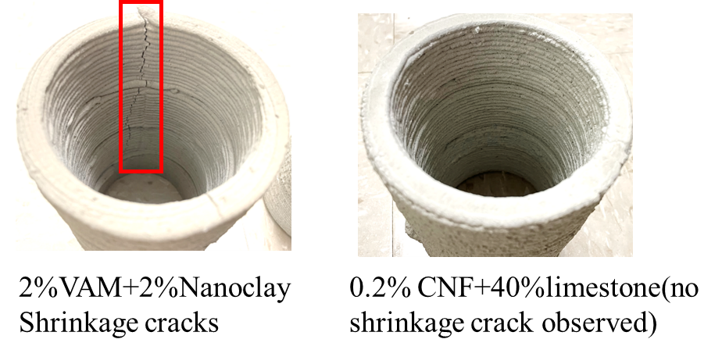

Fig. 5-3DP cylinder sample subjected to normal laboratory conditions for over 4 weeks (a) printed with 2% VMA and 2% nano clay, exhibiting a shrinkage crack; (c) printed with 2% VMA and 2% nano clay, displaying no cracking.

Task 4 – Architected Sample fabrications and mechanical testing
This task will be performed in the next quarter.

Percent of research project completed.
Approximately 25% of the entire project has been completed.

Expected progress for next quarter.
During the upcoming quarter, the completion of Task 3 is anticipated. The objective is to develop a cost-effective and sustainable mixture with improved rheological and hardened properties for large-scale 3D printing applications. The emphasis will shift towards the development of large-scale 3D-printed samples that integrate bio-inspired architectures. These samples will undergo rigorous testing, assessing their performance under both static and impact loading conditions.

Educational outreach and workforce development
Four undergraduate students, Mariana Arias Loaiza, Geiser Elizabeth Huatian, Ashwin Nomi and Andre Ponsot, actively contributed to the research activities. They assisted in conducting buildability tests and actively participated in large-scale 3D printing activities. Besides, the research team is offering a 3D printing class, CE 497 - 3D Printing for Infrastructure Applications at the civil engineering department of Purdue University. Mariana Arias Loaiza is an undergraduate visiting student from a top university in Colombia through the program Undergraduate Research Experience with Colombia (UREP-C) as part of the Colombia-Purdue Partnership (CPP), which has been successfully running for the past ten years. Geiser Elizabeth Huatian and Ashwin Nomi are Civil Engineering (CE) undergraduate students, and Andre Ponsot is in a Materials Engineering (MSE) program at Purdue University. We consider that two of these students are from underrepresented backgrounds.

Technology Transfer
No paper published in this quarter.

Research Contribution:

Number of papers
No paper published in this quarter.

Number presentations
No presentation in this quarter.

References:
[1] S. Roy, S. M. Asce, I. Unobe, S. M. Asce, A. D. Sorensen, and A. M. Asce, “Vehicle-Impact Damage of Reinforced Concrete Bridge Piers : A State-of-the Art Review,” vol. 35, no. 5, 2021, doi: 10.1061/(ASCE)CF.1943-5509.0001613.
[2] M. Budzynski, K. Jamroz, L. Jelinski, D. Bruski, and L. Pachocki, “Assessing Roadside Hybrid Energy Absorbers Using the Example of SafeEnd,” pp. 1–21, 2022.
[3] S. Jenson, M. Ali, B. Naik, and K. Alam, “International Journal of Impact Engineering Experimental , analytical , and numerical investigation of multi-chambered fluid-filled barrier for highway crash attenuators,” Int. J. Impact Eng., vol. 156, p. 103964, 2021, doi: 10.1016/j.ijimpeng.2021.103964.
[4] T. M. Pham, W. Chen, M. Elchalakani, A. Karrech, and H. Hao, “Experimental investigation on lightweight rubberized concrete beams strengthened with BFRP sheets subjected to impact loads,” Eng. Struct., vol. 205, no. December 2019, p. 110095, 2020, doi: 10.1016/j.engstruct.2019.110095.
[5] N. Suksangpanya, N. A. Yaraghi, R. B. Pipes, D. Kisailus, and P. Zavattieri, “Crack twisting and toughening strategies in Bouligand architectures,” Int. J. Solids Struct., vol. 150, pp. 83–106, 2018, doi: 10.1016/j.ijsolstr.2018.06.004.
[6] N. A. Yaraghi et al., “A Sinusoidally Architected Helicoidal Biocomposite,” Adv. Mater., vol. 28, no. 32, pp. 6835–6844, Aug. 2016, doi: 10.1002/adma.201600786.
[7] S. Edition, Manual for Assessing Safety Hardware Manual for Assessing Safety Hardware. 2016.
[8] C. W. W. Millar and P. Authority, National Cooperative Highway Research Program NCHRP Report 350 Safety Performance Evaluation.
[9] ROADSIDE DESIGN. 2011.
[10] A. Raj, P. Nagarajan, S. A. Pallikkara, and A. M. Asce, “Application of Fiber-Reinforced Rubcrete for Crash Barriers,” vol. 32, no. 2013, pp. 1–13, 2020, doi: 10.1061/(ASCE)MT.1943-5533.0003454.
[11] P. K. De Maeijer, B. Craeye, J. Blom, and L. Bervoets, “Crumb Rubber in Concrete — The Barriers for Application in the Construction Industry,” pp. 1–20, 2021.
[12] D. Yoo and N. Banthia, “Impact resistance of fiber-reinforced concrete – A review,” Cem. Concr. Compos., vol. 104, no. June, p. 103389, 2019, doi: 10.1016/j.cemconcomp.2019.103389.
[13] K. M. A. Sohel, K. Al-jabri, and A. H. S. Al Abri, “Behavior and design of reinforced concrete building columns subjected to low-velocity car impact,” Structures, vol. 26, no. March, pp. 601–616, 2020, doi: 10.1016/j.istruc.2020.04.054.
[14] N. S. Ha and G. Lu, “A review of recent research on bio-inspired structures and materials for energy absorption applications,” Composites Part B: Engineering, vol. 181. Elsevier Ltd, Jan. 15, 2020. doi: 10.1016/j.compositesb.2019.107496.
[15] N. Suksangpanya, N. A. Yaraghi, D. Kisailus, and P. Zavattieri, “Twisting cracks in Bouligand structures,” J. Mech. Behav. Biomed. Mater., vol. 76, no. June, pp. 38–57, 2017, doi: 10.1016/j.jmbbm.2017.06.010.
[16] P. Gómez-Gálvez et al., “Scutoids are a geometrical solution to three-dimensional packing of epithelia,” Nat. Commun., vol. 9, no. 1, pp. 1–14, 2018, doi: 10.1038/s41467-018-05376-1.
[17] W. Huang et al., “Multiscale Toughening Mechanisms in Biological Materials and Bioinspired Designs,” Advanced Materials, vol. 31, no. 43. Wiley-VCH Verlag, Oct. 01, 2019. doi: 10.1002/adma.201901561.
[18] J. C. Weaver et al., “The stomatopod dactyl club: A formidable damage-tolerant biological hammer,” Science (80-. )., vol. 336, no. 6086, pp. 1275–1280, 2012, doi: 10.1126/science.1218764.
[19] S. N. Patek, W. L. Korff, and R. L. Caldwell, “Deadly strike mechsanism of a mantis shrimp,” Nature, vol. 428, no. 6985, pp. 819–820, 2004, doi: 10.1038/428819a.
[20] D. Chen, R. Yang, W. Guo, Y. Huang, ; T X Yu, and S. Yin, “Defense Mechanism of Bioinspired Composites with Sinusoidally Periodic Helicoidal Fiber Architectures,” 2022, doi: 10.1061/(ASCE)AS.1943-5525.0001450.
[21] H. Quan, W. Yang, E. Schaible, R. O. Ritchie, and M. A. Meyers, “Novel Defense Mechanisms in the Armor of the Scales of the ‘Living Fossil’ Coelacanth Fish,” Adv. Funct. Mater., vol. 28, no. 46, Nov. 2018, doi: 10.1002/adfm.201804237.
[22] S. Yin et al., “Tough Nature-Inspired Helicoidal Composites with Printing-Induced Voids,” Cell Reports Phys. Sci., vol. 1, no. 7, p. 100109, 2020, doi: 10.1016/j.xcrp.2020.100109.
[23] T. Apichattrabrut, “Helicoidal Composites,” vol. 6494, 2006, doi: 10.1080/15376490500343808.
[24] L. K. Grunenfelder, N. Suksangpanya, C. Salinas, G. Milliron, N. Yaraghi, and S. Herrera, “Acta Biomaterialia Bio-inspired impact-resistant composites q,” Acta Biomater., vol. 10, no. 9, pp. 3997–4008, 2014, doi: 10.1016/j.actbio.2014.03.022.
[25] P. Tennis, M. Thomas, and W. Weiss, “State-of-the-art report on use of limestone in cements at levels of up to 15.”
[26] B. Lothenbach, G. Le Saout, E. Gallucci, and K. Scrivener, “Influence of limestone on the hydration of portland cements,” Cem. Concr. Res., vol. 38, no. 6, pp. 848–860, 2008.
[27] S. Ramanathan, K. Siva, T. Chopperla, O. B. Isgor, and W. J. Weiss, “Reducing Greenhouse Gas Emissions Using Cellulose Nanocrystals, Ordinary Portland Cement, and Limestone,” ACI Mater. J., vol. 120, no. 1, pp. 205–218, 2023, doi: 10.14359/51737293.
[28] D. Wang, C. Shi, N. Farzadnia, Z. Shi, H. Jia, and Z. Ou, “A review on use of limestone powder in cement-based materials: Mechanism, hydration and microstructures,” Constr. Build. Mater., vol. 181, pp. 659–672, 2018, doi: 10.1016/j.conbuildmat.2018.06.075.
[29] Y. Cao, P. Zavaterri, J. Youngblood, R. Moon, and J. Weiss, “The influence of cellulose nanocrystal additions on the performance of cement paste,” Cem. Concr. Compos., vol. 56, pp. 73–83, 2015, doi: 10.1016/j.cemconcomp.2014.11.008.
[30] X. Sun, Q. Wu, S. Lee, Y. Qing, and Y. Wu, “Cellulose Nanofibers as a Modifier for Rheology, Curing and Mechanical Performance of Oil Well Cement,” Sci. Rep., vol. 6, pp. 1–9, 2016, doi: 10.1038/srep31654.
[31] S. Nassiri et al., “Comparison of unique effects of two contrasting types of cellulose nanomaterials on setting time, rheology, and compressive strength of cement paste,” Cem. Concr. Compos., vol. 123, no. July, p. 104201, 2021, doi: 10.1016/j.cemconcomp.2021.104201.
[32] L. Wang et al., “Effect of surface modification on the dispersion, rheological behavior, crystallization kinetics, and foaming ability of polypropylene/cellulose nanofiber nanocomposites,” Compos. Sci. Technol., vol. 168, no. October, pp. 412–419, 2018, doi: 10.1016/j.compscitech.2018.10.023.
[33] H. H. Kolour, W. Ashraf, and E. N. Landis, “Hydration and early age properties of cement pastes modified with cellulose nanofibrils,” Transp. Res. Rec., vol. 2675, no. 9, pp. 38–46, 2021, doi: 10.1177/0361198120945993.
[34] R. Moini, J. Olek, P. D. Zavattieri, and J. P. Youngblood, “Early-age buildability-rheological properties relationship in additively manufactured cement paste hollow cylinders,” Cem. Concr. Compos., vol. 131, no. April, p. 104538, 2022, doi: 10.1016/j.cemconcomp.2022.104538.

