Reflecting and Exploring engineering.
Before meeting with an advisor, please take time to reflect on the following:
What is something you find interesting in one of your recent math, science, or engineering classes?

What is something related to technology, engineering, or science that you recently got excited about? Why is it interesting to you?

List a few of the industries/companies/laboratories you find interesting. What product or service produced do you find especially compelling?

What type of work do you want to do in your career soon after graduation? (Don’t worry about the job title, just describe the type of work/responsibilities you are looking forward to exploring)

What field (e.g., robotics, alternative energies, and prosthetics) would you like to work in, and how would different majors contribute to that field?

Which majors are you interested in/not interested in? For each major, explain why it is/is not interesting to you (see next page). Keep in mind that many areas cross over different majors. It might be useful to check the concentration of classes for certain majors. For example, robotics may be studied in any of ME, EM, EE/COMPE, CS, SED, IE, and BIOE, depending of what angle you wish to see emphasized. ME, EM, SED and IE will all put more emphasis on the mechanics behind the study of robotics (they all are heavier on PHYS 211/TAM 211 etc) for example.

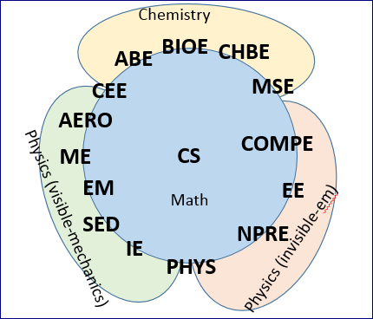
For each major, make sure to check https://grainger.illinois.edu/academics/undergraduate/majors-and-minors. Looking at the different possible concentrations/tracks/research topics might be helpful as well. Check the required technical classes for each major, as well as possible technical electives. Then fill out the table below. It is ok to be brief in your answers, but make sure you give each engineering major a chance in your exploration.
Major | Interested? (yes/no) | Why? Briefly explain
ABE
BIOE
CHBE
MSE
COMPE
CS
EE
NPRE
PHYS
IE
SED
EM
ME
AERO
CEE

Out of all the engineering majors above, which three majors do you have most interest in?

Is there any non-engineering major that might interest you as well? Perhaps a minor in a non-engineering field might be something for you to consider.

