Transportation Infrastructure Precast Innovation Center (TRANS-IPIC)

University Transportation Center (UTC)

Unveiling synergistic effects of Nano-modification and CO2 curing on the durability and carbon footprint of precast elements
PU-23-RP-02

Quarterly Progress Report
For the performance period ending 12/31/2023

Submitted by:
Mirian Velay-Lizancos (PI), Lyles School of Civil Engineering, mvelayli@purdue.edu Jan Olek (Co-PI), Lyles School of Civil Engineering, olek@purdue.edu
Raikhan Tokpatayeva(Co-PI), , Lyles School of Civil Engineering, rtokpata@purdue.edu Department: Civil Engineering
University: Purdue University

Collaborators / Partners:
N/A

Submitted to:
TRANS-IPIC UTC
University of Illinois Urbana-Champaign Urbana, IL

TRANS-IPIC Quarterly Progress Report:

Project Description:
- Research Plan - Statement of Problem
The optimization of the application of new technologies and novel materials in precast concrete elements plays a crucial role in advancing the precast industry towards a greener future. The enhancement of durability and the reduction of carbon footprint of precast concrete elements are two of the main paths towards this advancement.
Both CO2 curing (a precast treatment) and the use of nano-additives enhance the strength and reduce the porosity of cementitious composites, enhancing the durability of the concrete elements. However, CO2 curing and nano-modification may interfere with each other if used simultaneously, especially considering that the addition of nanoparticles my affect the size of calcium hydroxide crystals, which react with the CO2 during the CO2 curing process. Thus, understanding the interactions between these two approaches is vital to leverage and maximize the advantages of the application of these approaches to produce superior quality precast concrete elements in terms of durability and sustainability.

Research Plan - Summary of Project Activities (Tasks)
To achieve the objectives of Phase I of this project, a systematic research approach will be followed, consisting of the following tasks:
Task 1. Characterization of the materials. This task will involve the physical and chemical characterization of the nanoparticles, the aggregates, and the cement to be used in this study, according to the relevant standards for each type of the proposed material. Particle size, oxide and mineralogical content analyses will be performed.
Task 2. Preparation of specimens and curing process. Concrete, mortar and cement paste mixtures with 0%, 0.5%, 1%, and 2% of nanoparticles by mass of cement and two different water-to-cement ratios will be used in this study. Two different nanomaterials will be used: nano-silica and carbon black. Thus, a total of 14 different mixtures will be studied for each cementitious composite (paste, mortar and concrete). Specimens will be used to perform microstructural analysis, chemical analysis, and to determine the compressive strength development, transport properties and durability performance. Two different curing conditions and times will be examined: (i) standard curing at 21 ± 1 °C and 50% ± 5% RH (for reference), (ii) CO2 curing (20% concentration) for 12 hours (from age 24h to 36h) at a temperature of 23±1 °C and 50%±5% RH.
Task 3. Analysis of hydration process, porosity and microstructure. Microscopic Image analysis of the polished section of concrete will be used as a direct quantification of pore volume, whereas water absorption and density tests will be applied for evaluation of other parameters of the pore structure (ASTM C642¹, ASTM C1585²). Besides, the microstructure of samples will be investigated through Scanning Electron Microscopy (SEM). The hydration kinetics and hydration products of the pastes will be estimated by Isothermal Calorimeter test (IC), Thermogravimetric (TGA) and X-ray diffraction (XRD) analyses.
Tasks 4. Evaluation of transport properties. The bulk electrical resistivity and formation factor of the concrete samples will be estimated as per ASTM 1876-19. The Rapid Chloride

permeability test (ASTM C1202³) will be used to evaluate the resistance of the concretes to chloride ions ingress. The transport properties will be assessed through the analysis of the results of this section in combination with the results from water absorption test performed in task 3.
Tasks 5. Compressive strength of mortars and concretes. Compressive strength tests will be performed for each mixture design at 3, 7, and 28 days according to ASTM C39⁴.
Task 6. Analysis of the results. A comparative analysis of the test results from tasks 1 to 5 for samples with and without nanoparticles and with and without CO2 curing will be carried out. Then, the interconnection of the results of the different tests will be analyzed to acquire a deeper understanding on the combined effect of nanoparticle addition and CO2 curing; This task will help understanding the synergistic effects of CO2 curing and nanomodification on the concrete's properties, providing insights into the optimal combination.
Task 7. Draft of the report, Review and submission of Final report. This task will consist of the preparation, revision and submission of the final report of the project, summarizing the research findings, methodologies, conclusions and recommendations.

Project Progress:

- Progress for each research task

Note: It is noteworthy that the delay in funding allocation (subcontract to Purdue University) has slowed down the progress during the first quarter. It is expected that research progress will accelerate once the subcontract is in place.

Task 1. Characterization of the Materials [90% Completed]
The physical and chemical characterization of the nanoparticles, the aggregates, and the cement to be used in this study were performed.
In terms of nanoparticles, 4 types of nanoparticles were evaluated. The initially evaluated nanomaterials were:
  - PBX 55 Carbon Black powder provided by Cabot
  - BolderBlack Recovered Carbon Black Powder provided by Bolder Industries
  - Levasil CB8 Aqueous Nanosilica Solution provided by Nouryon
  - E5 Liquid Fly Ash (LFA) Type 4 Nanosilica Solution provided by Specification Products
The particle size, oxide content, and mineralogical content of each material has been determined and relevant findings are listed below. Considering the results, the selected nanoparticles to be used in the next tasks were: BolderBlack Recovered Carbon Black and Levasil CB8 Nanosilica.

Particle Size Analysis with Laser Diffraction
Procedure: The Anton Paar 1090 Particle Size Analyzer and the Small Volume Unit (SVU) with Kalliope Instruction Manual ⁵ was used to determine the particle size of PBX 55. The Mie and Fraunhofer method were used to analyze the specimen in diluted ethanol dispersion, while only the Mie method was used for dry and aqueous dispersion methods. Since this material is carbon black powder, TEM testing (part b.) was selected to determine the particle size of the PBX 55. The confined spaces of the analyzer, coupled with an aqueous solution resulted in agglomeration of the sample. This agglomeration resulted in particle size readings significantly larger than the manufacturer's specifications.

Results:
Figure 1 shows the average particle size distribution curves acquired from the four different methods of analysis. The images show that the particle size varies greatly between methods, with the Mie method providing more uniform curves. Average particle sizes for each method are shown in Table 1. Using the Mie method in dry and diluted ethanol dispersion provides the most similar mean sizes of 23.26 microns and 25.57 microns respectively.
Table 1. Mean Size by Volume of PBX 55

Average Particle Size PBX 55
(Method) | (Solvent) | Mean Size Volume (microns)
Mie | Dry | 23.26
Mie | Water | 10.73
Mie | Diluted Ethanol | 25.57
Fraunhofer | Diluted Ethanol | 105.83

4
3.5
Average Size Distribution by
Weighted Volume (%)
3
2.5
2
1.5
1
0.5
0

0 20 40 60 80 100

Particle Diameter (µm)
Mie | Dry Mie | Water
Mie | Diluted Ethanol Fraunhofer | Diluted Ethanol

Figure 1. Average Particle Size Distribution Curve of PBX 55 Carbon Black

Particle Size Analysis with Transmission Electron Microscopy (TEM)

Procedure: A Tecnai T20 Transmission Electron Microscope was used to perform TEM. Particle suspensions were deposited on copper grids for analysis.

ASTM D3849⁶ was used to determine the particle size of PBX 55, BolderBlack. Both powders were ground to a fine powder using a mortar and pestle and passed through a No. 200 sieve in preparation for the experiment. Both samples were mixed with superplasticizer, shear mixed, and sonicated to minimize agglomeration. Nanosilicas present in Levasil CB8 and E5 LFA were analyzed using a 200 times dilution with deionized water. Both samples were prepared with sonication and high shear mixing.

Results: Figures 2a and 2b show results acquired from TEM on PBX 55. The images show distinct borders between primary particles. The agglomeration of these primary particles are aggregate particles. Primary particles in Figure 2a and 2b are shown to be approximately 50nm and aggregate sizes to range from 0.15 - 0.35 microns.
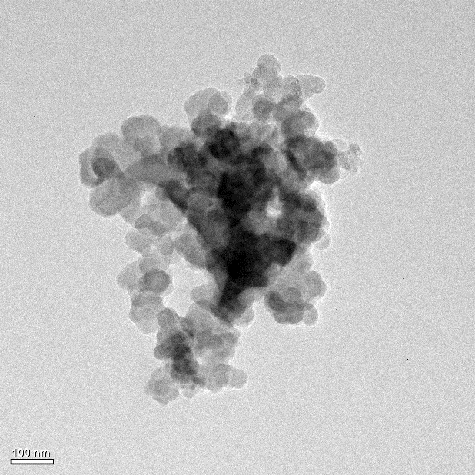
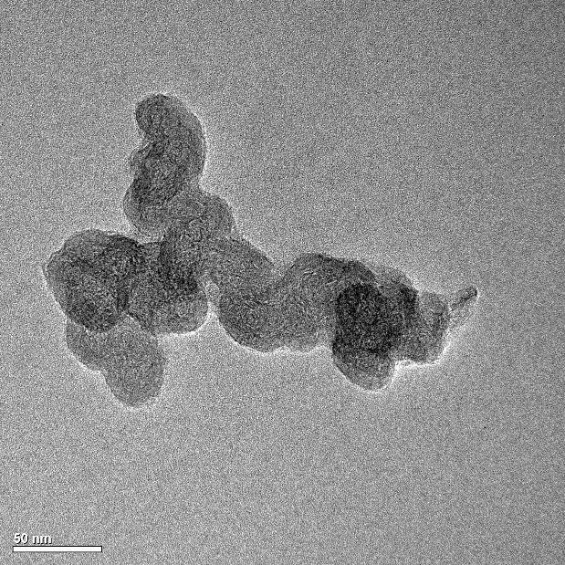
(a)`
(b)
Figure 2. TEM images of PBX 55. (a) PBX 55 Aggregate Agglomerate and
(b) PBX 55 Aggregate Particle

Figures 3a and 3b show TEM images of BolderBlack, affirming the manufacturer sample specifications of primary sizes ranging from 5-90 nm and aggregate sizes of a mean 5 microns. After sonicating, shear mixing, and adding superplasticizer to the recovered carbon black sample, aggregate size in Figure 3a is approximately 1.5 microns. Because carbon blacks are hydrophobic, aggregate sizes are likely to be larger during mixing in the presence of water and cement, especially with the lack of dispersion procedures like sonication and shear mixing.

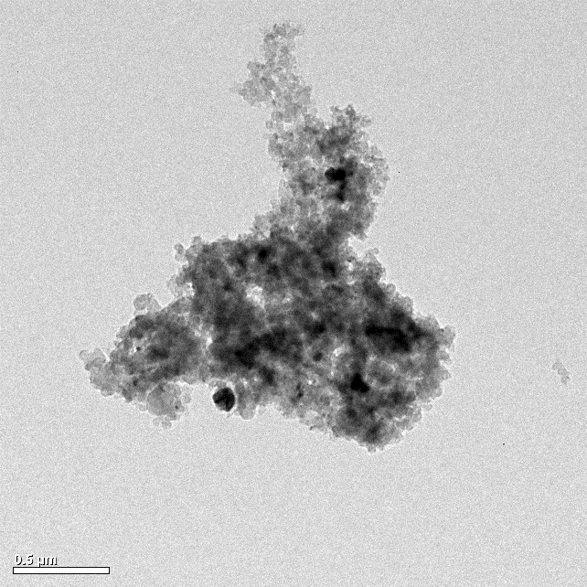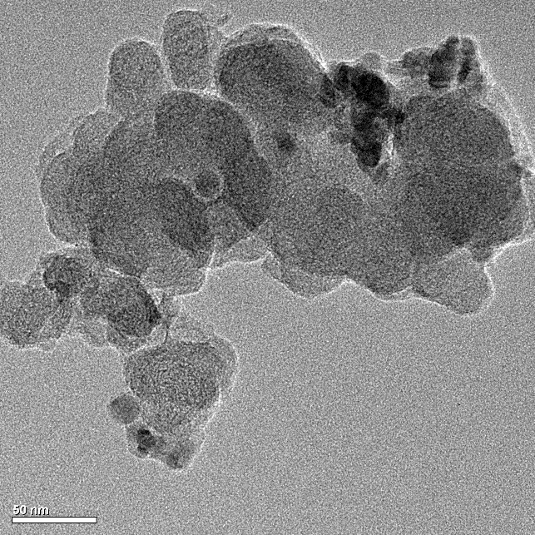
(a)
(b)
Figure 3 TEM images of BolderBlack. (a) BolderBlack Aggregate Agglomerate and
(b) BolderBlack Aggregate Particle

Figure 4 shows TEM images of the Levasil CB8 nanosilica sample. Nanosilica particles were found to range from 10-90nm in diameter.
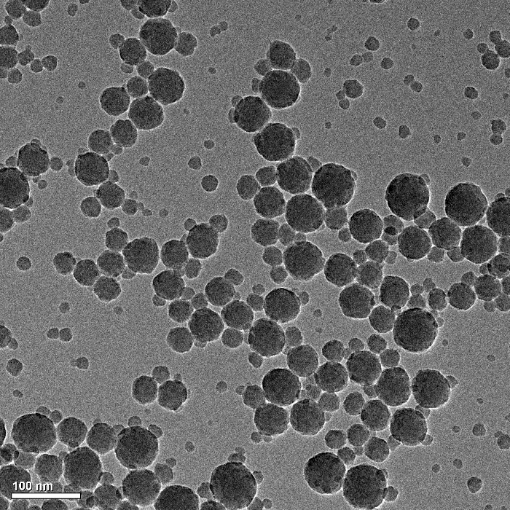
Figure 4. TEM Image of Levasil CB8 Nanosilica Particles in Aqueous Dispersion

Figure 5 shows the TEM images of the E5 LFA nanosilica sample. Nanosilica particles tend to agglomerate in this sample, but compared to the Levasil CB8 sample, the particle size range is larger. Detected particles range from as small as 5nm to 100nm in diameter.

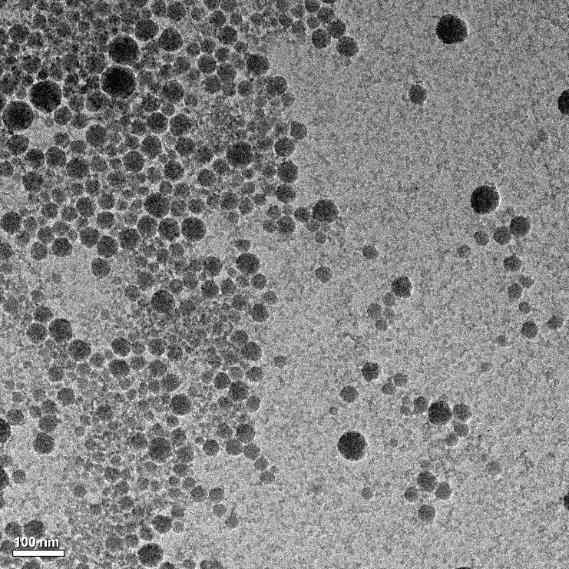
Figure 5. TEM Image of E5 LFA Nanosilica Particles in Aqueous Dispersion

Particle Size Analysis with Sieve and Fineness Testing

Procedure: ASTM C136⁷ and AASHTO T27⁸ were used to perform sieve analysis on coarse and fine aggregates. Approximately 4000g of coarse aggregates and 4000g of fine aggregates were used for sieve analysis.
Results: Type IL Cement Mill Certification Report was acquired from Buzzi Unicem Greencastle, IN plant. The cement was tested per ASTM C430⁹, and 92.5% of the cement is specified to be less than 45microns in size.
Figure 6 shows the gradation curve of coarse aggregate, with a maximum size of 1 inch and approximately 80% of the aggregate passing through a ¾ inch sieve. According to the INDOT's Standard Specifications (2024 edition)¹⁰. the gradation of the aggregate aggregate conforms to gradation of coarse aggregate #8. However, per AASHTO T27, the minimum coarse aggregate mass of 6000g for No. 8 was not met for this analysis. A sieve analysis with a satisfactory mass of a minimum 6000g will be performed early next quarter.

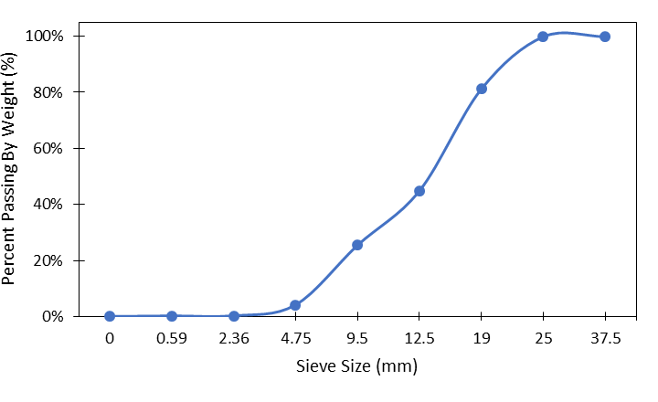
Figure 6. Gradation Curve of Coarse Aggregates

Figure 7 displays the gradation curve of fine aggregate. The results indicate that the fine aggregate is of size #23 as per Division 900 of INDOT’s Standard Specifications (2024 edition)¹¹ The maximum size of the fine aggregate is 3/8 inches, and the nominal maximum size is a No.4 sieve size (0.0187 inches).
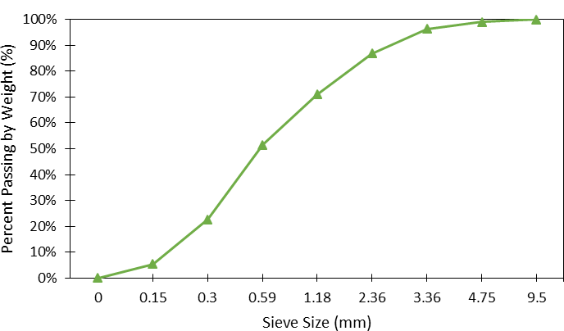
Figure 7. Gradation Curve of Fine Aggregates

Oxide Analysis with X-Ray Fluorescence (XRF) Testing

Procedure: A Hitachi Lab-X5000 XRF Spectrometer was used to determine the oxide contents of PBX 55, BolderBlack, Levasil CB8, and E5 LFA. Both carbon blacks were ground using a mortar and pestle to pass through a No. 200 sieve in preparation for the experiment. Approximately 0.5g of each powder was added to a Lab-X5000 XRF testing container for analysis. Approximately 8mL of each powder was added to a Lab-X5000 XRF testing container for analysis. The spectrometer was then used to measure oxides in the range of sodium oxide to uranium oxide.

Results: Table 2 displays the oxide content of Levasil CB8, E5 LFA, BolderBlack, and PBX
55. The silica was found to make up majority of the oxides in nanosilica solutions, making up approximately 45% of Levasil CB8 and 35% of E5 LFA. The remaining contents, not registered by the spectrometer, are assumed to be water, since both samples are in the form of aqueous solutions.
Similarly, silica makes up a majority of BolderBlack and PBX55 samples. The total percentage of oxides are the impurities present in the carbon black samples. The remaining contents are assumed to mostly be carbon oxides. From these results, it is calculated that BolderBlack is made of approximately 35% pure carbon and PBX 55 of approximately 61% pure carbon. This is significantly smaller than the values reported by the manufacturer (approximately 80% purity of BolderBlack and 95% purity of PBX55).
It should be noted that the Hitachi Lab-X5000 XRF Spectrometer was initially calibrated to detect oxides found in cement powders. It is hypothesized that this calibration setting offset the detected oxide values in nanosilicas and carbon blacks. To improve accuracy, the acquired data will be recalibrated to better evaluate carbon black powders and nanosilica solutions in the next quarter.

Table 2. Oxide Content of Nanomaterials
Oxide | Nanosilica Solution |  | Carbon Black Powder
 | Levasil CB8 | E5 LFA | BolderBlack | PBX 55
Na2O | 0.451% | 0.361% | 0.060% | 0.793%
MgO | 0.00% | 0.00% | 0.00% | 0.00%
Al2O3 | 0.00% | 0.00% | 1.570% | 1.790%
SiO2 | 45.860% | 34.950% | 17.890% | 7.280%
P2O5 | 0.00% | 0.00% | 0.043% | 0.018%
SO3 | 0.206% | 0.163% | 8.090% | 0.703%
K2O | 0.00% | 0.090% | 0.123% | 0.058%
CaO | 6.460% | 6.710% | 9.760% | 7.400%
TiO2 | 0.084% | 0.092% | 1.250% | 0.079%
Cr2O3 | 0.002% | 0.003% | 0.014% | 0.004%
Mn2O3 | 0.00% | 0.00% | 0.184% | 0.00%
Fe2O3 | 0.060% | 0.063% | 1.312% | 0.074%
ZnO | 0.042% | 0.055% | 24.679% | 0.106%
SrO | 0.404% | 0.561% | 0.130% | 0.329%
Total | 53.57% | 43.05% | 65.11% | 18.63%

Table 3. Oxide Content of Type IL
 | Buzzi Type IL Cement
Oxides | Purdue Tested | Mill Certified
CaO | 65.39 | NA
SiO2 | 20.63 | NA
Al2O3 | 4.78 | 4.47
Fe2O3 | 2.494 | NA
MgO | 3.544 | NA
Na2O | 0.077 | NA
K2O | 0.763 | NA
Eq. alk | 0.58 | 0.61
SO3 | 3.593 | 3.43

Loss of Ignition (LOI) with Carbon Black Powders
Procedure: LOI testing was used to evaluate the relative purity of the carbon black powders. The experiment was separated into three trials.
The first trial consisted of placing 0.5 g of BolderBlack and PBX 55 into separate crucibles. The samples were placed into a muffle furnace at a constant temperature of 700 ̊C for 1 hour. The weight of the samples was measured afterwards. The samples were then placed back into the muffle furnace at a constant temperature of 900 ̊C for 2 hours. The final weight of the samples was recorded.
The second trial, labeled as “Interval”, consisted of placing 0.5 g of each carbon black samples in separate crucibles and placing them into a muffle furnace at a constant temperature of 900 ̊C for 1 hour. The weights of the samples were then recorded, and the samples were placed into the furnace (kept at the same temperature of 900 ̊C) for additional 2 hours. The final weight was then recorded.
The third trial, labeled as “Continuous” consisted of placing 0.5 g of each carbon black samples in separate crucible pans and placing them into a muffle furnace set to constant temperature of 900 ̊C for 3 hrs. The final weight was then recorded.

Results: The results from LOI testing show similar trends between trials. Table 3 presents the results from the first trial, with the final weight lost after ignition being 100% for the PBX55 and 72% for the BolderBlack. Similarly, as seen in Figure 9, the final weight loss after ignition was calculated to be approximately 100% for the PBX55 and 80% for the BolderBlack. Figure 8a and 8b prove the purity of the PBX55, as the visual mass of the sample almost completely disappears after ignition. These values affirm manufacturer specifications, and further indicate calibration error in XRF testing (as previously reported in section d.).

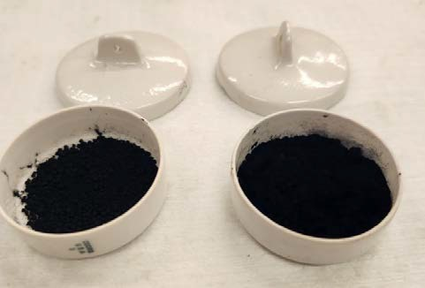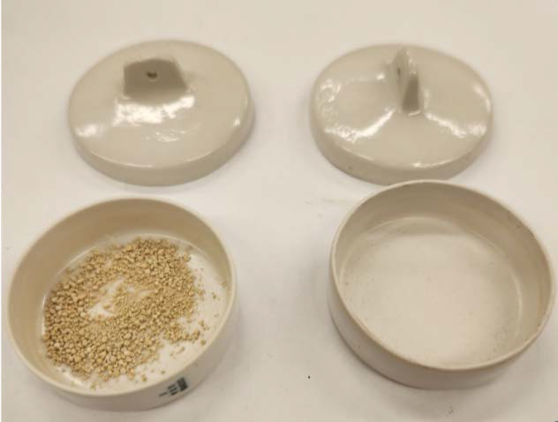
(a)
(b)
Figure 8. (a) Pre-LOI: BolderBlack (Left) and PBX 55 (Right); (b) Post- LOI BolderBlack (Left) and PBX 55 (Right)

Table 3. Loss of Weight at Varying Temperature
Temperature (°C) | Total Time (hrs) | Percent Mass Burned (%)
 |  | PBX 55 | Bolder Black
0 | 0 | 0 | 0
700 | 1 | 25.86 | 34.56
900 | 3 | 100 | 71.83

100

80
Percent Weight Lost (%)

60

40

20

0
0 0.5 1 1.5 2 2.5 3
Time (hours)
BolderBlack Interval PBX 55 Interval

BolderBlack Continuous PBX 55 Continuous

Figure 9. Loss of Weight vs Time at 900 ̊C

Mineralogical Analysis with X-Ray Diffraction (XRD)

Procedure: ASTM E3294¹² used to determine the particle size of PBX 55 and BolderBlack. Both powders were ground to a fine powder using a mortar and pestle, and passed through a No. 200 sieve in preparation for the experiment.

Results: Figure 10 shows the intensity curve for PBX 55. Comparing Figure 10 to Figure 12, the intensity curve of PBX 55 bears a close resemblance to the N774 intensity curve acquired in August 2001¹³. PBX 55 is therefore found to be an N774 carbon black.
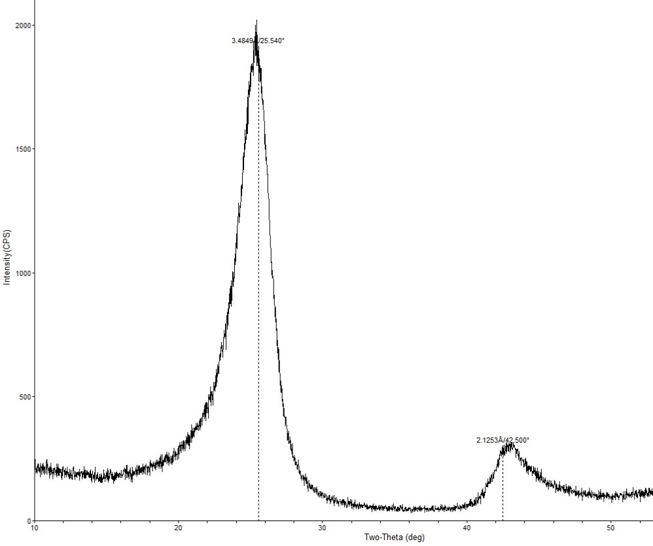
Figure 10. Intensity vs 2θ Curve of PBX55

Figure 11 plots the BolderBlack intensity curve, which shares similar 2-theta peaks to N774 seen in Figure 10, but at lower intensity. It also shares peaks with ZnS, hydrated ZnS compounds, and silicon. BolderBlack is found to be composed of N774 carbon black, zinc sulfide, and silicon.

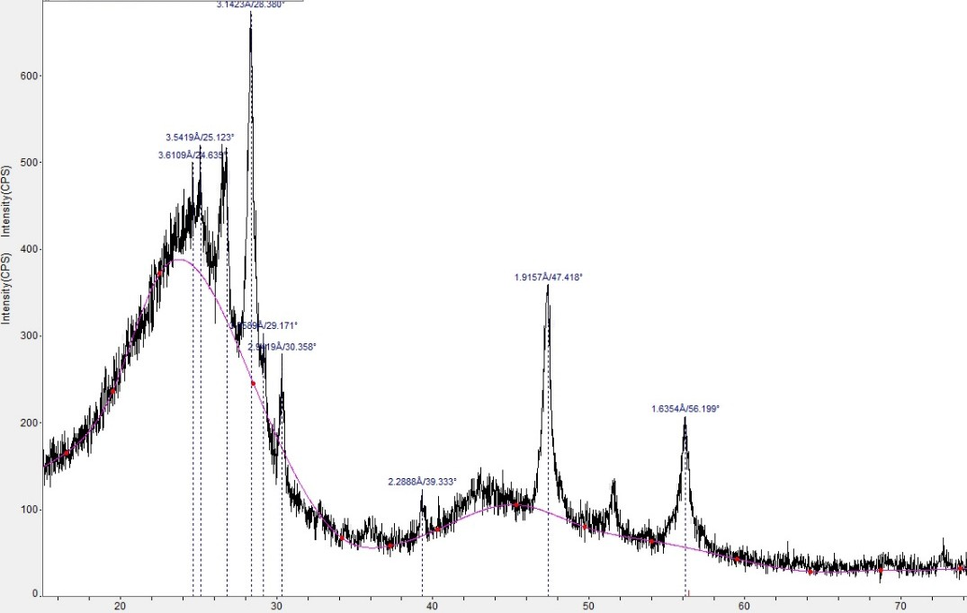

Figure 11. Intensity vs 2θ Curve of BolderBlack

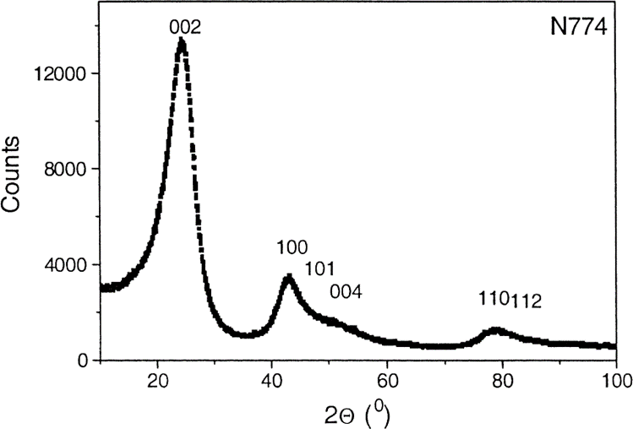
Figure 12. Intensity vs 2θ Curve of N774 Carbon Black¹³

Figure 13 and 14 display the XRD results of coarse and fine aggregate respectively. Curves labeled in the legend as “I Observed” is the pattern acquired from XRD testing, while all other curves displayed are those of other known materials. The intensity pattern of coarse aggregate matches that of dolomite almost identically. The intensity pattern of fine aggregate is found to mostly match those of dolomite, calcite, and quartz.

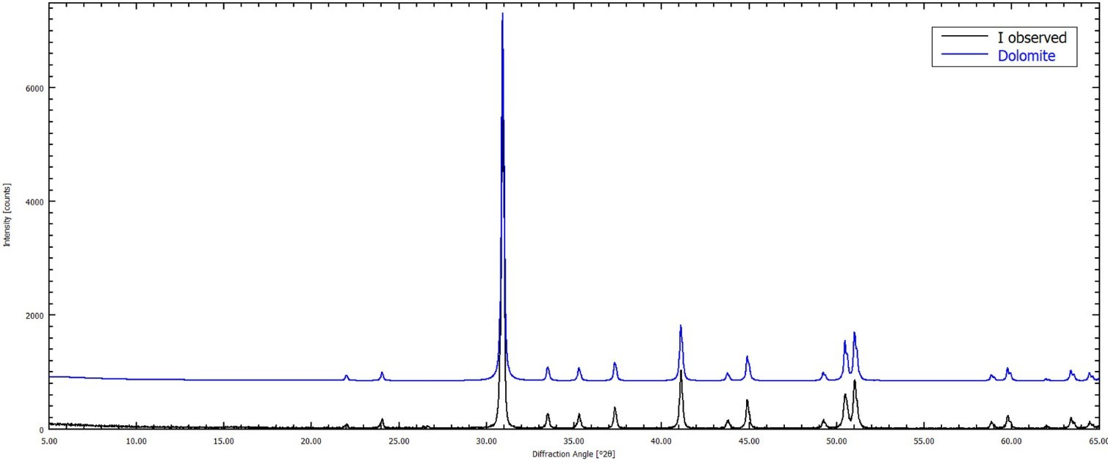
Figure 13. Intensity vs 2θ Curve of Coarse Aggregate

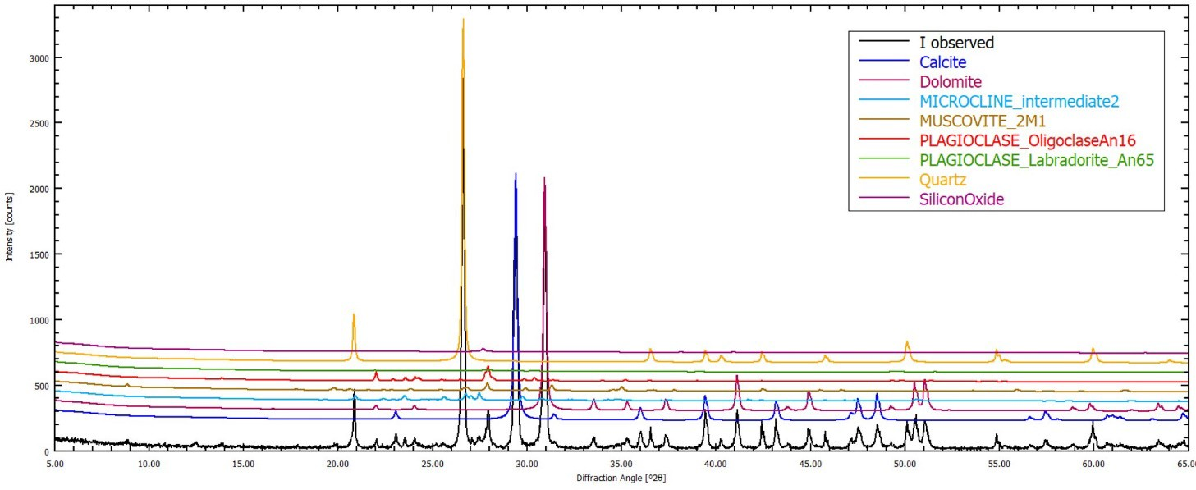
Figure 14. Intensity vs 2θ Curve of Fine Aggregate

Table 4. QXRD of Type IL Cement
Buzzi Type IL
Mineral | Purdue QXRD | Mill Certified
 | wt% | mill cert
Alite | 59.88 | NA
Belite | 13.03 | NA
Aluminate | 4.05 | 7.72
Ferrite | 5.77 | NA
Calcite | 8.09 | 10.01
Arkanite | 0.27 | NA
Gypsum | 0.29 | NA
Anhydrite | 0 | NA
Bassanite | 1.71 | NA
Periclase | 1.69 | NA
Dolomite | 2.96 | NA
Portlandite | 1.04 | NA

Relative Density of Aggregates

Procedure: ASTM C127¹⁴ was used to evaluate the relative density of the coarse aggregate. Approximately 2000g of coarse aggregate was dried for a minimum of 48hrs to achieve an oven dry state. The aggregate was then placed in a bowl of water to saturate for 24 hours.

Results: The saturated surface dry relative density for coarse aggregate was calculated to be 2.61. The absorption of the coarse aggregate was calculated to be 2.82%.

Task 2. Preparation of specimens and curing process [0% Completed]

Task 3. Analysis of hydration process, porosity and microstructure [0% Completed]

Tasks 4. Evaluation of transport properties. [0% Completed]

Tasks 5. Compressive strength of mortars and concretes. [0% Completed]

Task 6. Analysis of the results. [5% Completed]. Initial analysis of the results of Task 1 was done.

Task 7. Draft of the report, Review and submission of Final report. [0% Completed]

Percent of research project completed.
Approximately 12% of the total project has been completed this quarter. It is noteworthy that the delay in funding (transfer of the subaward) has affected the progress during the first quarter.

Expected progress for next quarter
By the end of next quarter, February 29th of 2024, 30% of this project is expected to be completed.

Task 1. Characterization of the Materials [100% completed]: XRF device will be recalibrated to more accurately represent the carbon black and nanosilica values acquired. XRD tests will be performed on evaporated nanosilica solution. Particle sizes in TEM images will be quantified using image analysis software. Sieve analysis will be performed again for coarse aggregates. Fine aggregate absorption and relative density data will be verified. All characterization data will be compiled for presentation.

Task 2. Preparation of specimens and curing process [75% completed]: All cement paste and mortar samples will be mixed and cured. Concrete specimens will be prepared in another quarter.

Task 3. Analysis of hydration process, porosity and microstructure [40% completed]: The hydration kinetics and hydration products of some of the cement paste mixture will be assessed by Isothermal Calorimeter test (IC), Thermogravimetric (TGA) and X-ray diffraction (XRD) analyses.

Task 4. Evaluation of transport properties. [0% completed].

Task 5. Compressive strength of mortars and concretes. [25% completed]: 3 and 7 compressive strength tests on mortars will be completed.
Task 6. Analysis of the results. [20% Completed]: Initial analysis of the results of the completed test will be performed.

Task 7. Draft of the report, Review and submission of Final report. [0% Completed]

Educational outreach and workforce development
One master student is involved in this project. She belongs to an underrepresented group. During the first quarter, the master student was trained by the PIs in different advanced techniques for material characterization. The Master student in collaboration with the PIs will prepare a set of short guidelines on how to perform some of these tests, and in the final part of the project, the Master student will prepare short videos explaining how to perform the tests. These videos will be used in our courses as well as in seminars for undergraduate students interested in joining future phases of this and other projects. These videos have a dual purpose in terms of workforce development: (i) to train the Master student in terms of improving communication and teaching skills, and (ii) to create material that can be used for educational outreach activities that can connect easier with underrepresented groups, since the Master student will be a role model for the next generation of researchers.

Technology Transfer
No progress on technology transfer yet.

Research Contribution:

- Number of papers
No papers were published during this quarter.

Number presentations
No presentations were done during this quarter.

References:

- ASTM. C642-21 Standard Test Method for Density, Absorption, and Voids in Hardened Concrete. ASTM Int. Published online 2021:1-3. doi:10.1520/C0642-21.2
- ASTM. C1585-20 Standard Test Method for Measurement of Rate of Absorption of Water by Hydraulic Cement Concretes. ASTM Int. Published online 2020:1-6. doi:10.1520/C1585-20.2
- ASTM. C1202-22e1 Standard Test Method for Electrical Indication of Concrete’s Ability to Resist Chloride Ion Penetration. ASTM. Published online 2022:1-8. doi:10.1520/C1202-22E01.2
- ASTM. C39/39M-21 Standard Test Method for Compressive Strength of Cylindrical Concrete Specimens. ASTM Int. Published online 2021:1-5. doi:10.1520/C0039
- Small Volume Unit (SVU) with Kalliope Instruction Manual. Anton Paar Document Finder. Accessed December 29, 2023. https://www.anton-paar.com/corp-en/services-support/document- finder/psa-series/.
- ASTM. D3849-22 Standard Test Method for Carbon Black—Morphological Characterization of Carbon Black Using Electron Microscopy. ASTM Int. Published online 2022:7-13. doi:12.3023/D3849-22.
- ASTM Int. Standard test method for sieve analysis of fine and coarse aggregates. C136. Accessed December 30, 2023. https://www.astm.org/standards/c136.
- Sieve analysis of fine and coarse aggregates AASHTO T 27 - in.gov. Accessed December 30, 2023. https://www.in.gov/indot/div/mt/aashto/testmethods/aashto_t27.pdf.
- Standard test method for fineness of hydraulic cement by the 45-μm (no. 325) sieve. ASTM C430-17. December 20, 2017. Accessed December 31, 2023. https://www.astm.org/c0430-
17.html.
- INDOT. INDOT aggregate specifications 2023 - in.gov. 2023. Accessed December 30, 2023. https://www.in.gov/indot/doing-business-with-indot/files/Aggregate_Specification_Chart.pdf.
- INDOT - Indiana Department of Transportation., 2024 Standard Specifications, Division 900 – Materials Details, Section 904.02(h)-Sizes of Fine Aggregates.
- ASTM E3294 - 23. Standard Guide for Forensic Analysis of geological materials by powder X-ray diffraction. ASTM Int. Accessed December 30, 2023. https://www.astm.org/e3294-22.html.

- Ungár, T., Gubicza, J., Ribárik, G., Pantea, C., & Zerda, T. W. (2002). Microstructure of carbon blacks determined by X-ray diffraction profile analysis. Carbon, 40(6), 929–937. https://doi.org/10.1016/s0008-6223(01)00224-x.
- ASTM C127 Standard test method for relative density (specific gravity) and absorption of coarse aggregate. ASTM Int. Accessed December 30, 2023.
https://www.astm.org/standards/c127.

