

Transportation Infrastructure Precast Innovation Center
(TRANS-IPIC)

University Transportation Center (UTC)

Holistic Quality Management of Precast Concrete Construction for Transportation Infrastructure
PU-23-RP-01

Quarterly Progress Report
For the performance period ending on December 31, 2023

Submitted by:
Hubo Cai, hubocai@purdue.edu
Lyles School of Civil Engineering
Purdue University

Collaborators / Partners:
No other collaborators/partners

Submitted to:
TRANS-IPIC UTC
University of Illinois Urbana-Champaign
Urbana, IL

TRANS-IPIC Quarterly Progress Report:

Project Description:
- Research Plan - Statement of Problem
Precast concrete systems (PCS) have been widely used by US State Department of Transportation (DOTs) as a promising alternative to cast-in-place concrete systems. High-quality PCS provide several benefits including: shorter lane closures and reduced traffic congestion attributed to accelerated construction with shorter project duration, and increased road user and worker safety when such systems are utilized correctly [1]. However, quality deficiencies during any PCS lifecycle phases (i.e., design, manufacturing, transporting, lifting and installation, and operation and maintenance (O&M)) can easily offset the expected benefits, leading to premature failures and excessive repair costs.

Current practice in quality management (QM) of PCS (PCS QM) heavily rely on manual approaches and remain isolated within each lifecycle stage. For instance, quality control (QC) during the precast-at-plant stage is done using labor-intensive performance audits and sporadic inspections with the potential to miss important problems and thus violate specifications at precast facilities [2]. Resulting quality deficiencies can impact the transportation of precast elements, their installation and connections with other components at transportation projects and their life-cycle performance and maintenance. Using checklists for pre-shipping and onsite acceptance can help capture certain quality deficiencies such as dimensions and locations of dowel bars. However, such actions are often reactive and offset benefits such as reduced project duration and shortened lane closures in transportation projects.

To address the mentioned problems, this research project aims to develop, validate, and test a holistic quality management framework/model for precast construction of transportation infrastructure. The framework collects, measures, and evaluates data of the precast process across its life cycle, from design to production, transport, installation/construction, commissioning, O&M, and decommission/reuse. By integrating BIM, laser scanning, GPR, vision sensing, extended reality (XR) along with advanced computational tools, the framework creates a digital twin as the ‘seamless’ method of information management and sharing that can be used for quality control and management of the precast systems from the life-cycle perspective. This framework is a step towards ensuring that the following key attributes of successful PCS projects can be achieved: constructability, concrete durability, load transfer at joints, panel support, performance efficiency [3].

- Research Plan - Summary of Project Activities (Tasks)
Task 1: Design a system-level framework for lifecycle data/information/knowledge acquisition and data exchange in PCS.
This task focuses on the framework design and workflow and process modeling. It consists of three steps: (a) compiling knowledge of field practice of PCS QM, (b) assessing the state-of-the-art BIM practice in PCS QM, and (c) designing a BIM-based digital twin system.

Task 2: Design an expandable BIM approach to meet the data and information needs of lifecycle PCS QM.
This task includes: (1) design of templates for expandable BIM, using IFC as the open standard, (2) identification of data needs in precast production, transporting, installation, and operation and maintenance, and (3) implementation to accommodate data needs in precast production and generate data to meet the transporting and installation needs.

Task 3: Validation and case study – the precast-at-plant stage.
This task targets quality control considering different operations in precast manufacturing at plants. The task evaluates the newly designed BIM framework by comparing with the current QM practice in terms of utilization of resources, time and labor savings, capture of deficiencies in quality, and the completeness of the BIM model.

Task 4: Presentation/panel discussion at 2024 Purdue Road School.
A presentation/panel discussion will be held at the 2024 Purdue Road School to share project findings and to engage with/learn from experienced researchers and practitioners in the field of precast concrete in transportation projects.

Project Progress:
- Progress for each research task

Task 1 progress [70% completed]
The first step in Task 1 (as described in Section 2) is the assessment of the current field practice related to quality management throughout the life cycle of PCS. Since different PCSs have many QC/QA tasks in common, Jointed Precast Concrete Pavement (JPrCP) System is studied as an example PCS for this task. For each PCS QC/QA task in different lifecycle phases (except for design stage), we determined its checklists, timing, responsible parties, methods and tools by examining existing manuals and specifications that guide the implementation of precast concrete pavement projects [4,5]. A breakdown structure of QC/QA field practice was followed to compile the knowledge, as shown in Figure 1. Driven by the idea of object-oriented modeling in BIM, specific check items are identified and organized in the format of “object-attribute”. These results will be used for the design of expandable BIM templates in Task 2 afterwards.

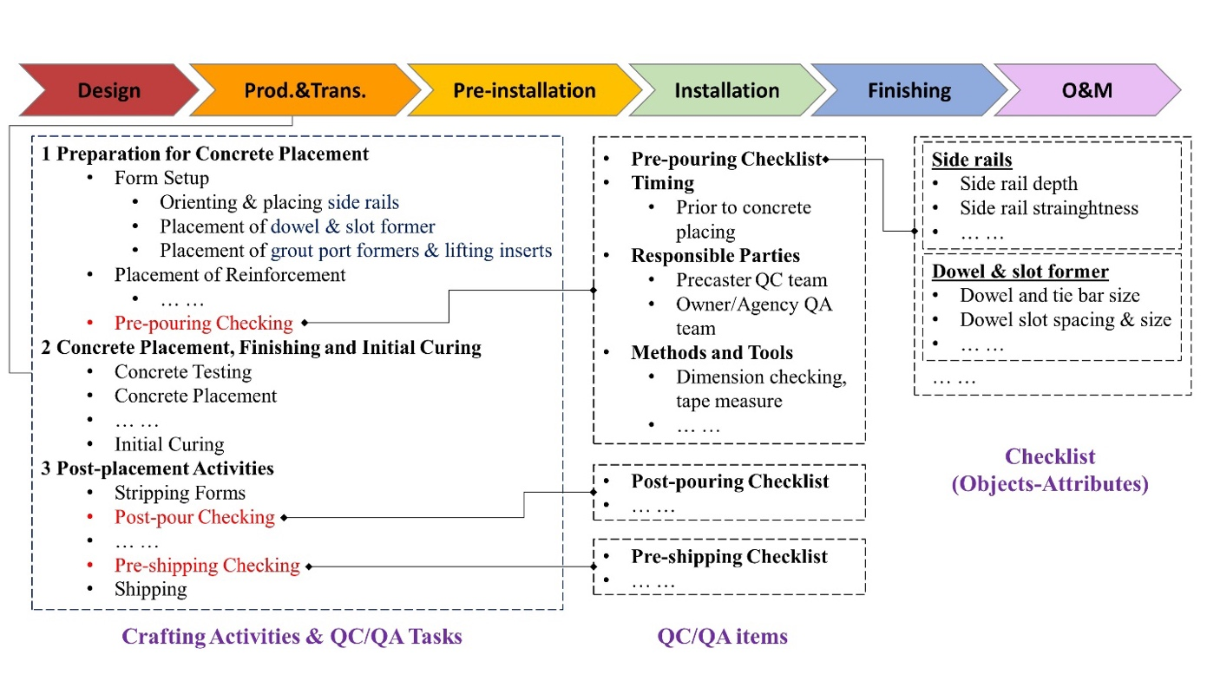

Figure 1 Breakdown structure of QC/QA field practice

The current status of BIM practice in PCS QM (the second step 2 in Task 1) is investigated by reviewing the related research literature. Three research themes regarding PCS QM were identified from existing literature: 1) advanced sensing technologies for automated inspection of PC components in fabrication and installation stages, 2) advanced sensing technologies that can automate the checking and assessment of PC components in O&M stage, and 3) BIM and IFC based data representation, storage and delivery. The sensing technologies were carefully evaluated by comparing their technical specifications, including the methods, tools, performance, working conditions, and limitations. Besides, different IFC-based data modeling approaches were reviewed by analyzing how the physical PC components can be digitally modeled by IFC entities. Preparation of a review research paper is underway to document the findings of the mentioned analysis and provide insights into how BIM practice can change the workflow and data workflow of PCS QM activities.

The framework of BIM-based digital twin system will be designed (the third step in Task 1) based on the compiled knowledge and findings from the previous two subtasks. The framework will be designed with an executable demo in Task 2; and assessed, validated, and improved in Task 3.

Task 2 progress [20% completed]
To design the expandable BIM templates, the mechanism of IFC-based data modeling was first studied. The concepts of IFC data schema include entities, attributes, relationships, and property sets. An IFC toolkit named IfcOpenShell was utilized to perform model authoring tasks, such as creating/editing/deleting objects and their attributes. A demo IFC precast concrete model was created to test multiple modeling approaches and identify suitable ones for the template design.

Task 3 progress [0% completed]
This task hasn’t started.

Task 4 progress [0% completed]
This task hasn’t started.

- Percent of research project completed
It is estimated that the total project is 25% completed in this quarter ending on December 31, 2023.

- Expected progress for next quarter
We estimate that 55% work of the total project will be completed by the end of next quarter. The specific results that will be delivered include:
- A research review paper regarding advanced sensing and data modeling technologies for intelligent PCS QM,
- A BIM-based system-level framework for PCS digital twin,
- Expandable BIM templates and their implementations in lab environment, and
- A presentation/panel discussion at 2024 Purdue Road School held in March

- Educational outreach and workforce development
NA

- Technology Transfer
NA

Research Contribution:
- Number of papers
No completed papers.

- Number presentations (when, where)
No presentations have been presented.

References:
[1] L. P. Priddy, P. G. Bly, C. J. Jackson, and G. W. Flintsch, “Full-scale field testing of precast Portland cement concrete panel airfield pavement repairs,” Int. J. Pavement Eng., vol. 15, no. 9, pp. 840–853, Oct. 2014, doi: 10.1080/10298436.2014.893320.
[2] D. Goulias and M. Scott, “Effective implementation of ground penetrating radar (GPR) for condition assessment & monitoring of critical infrastructure components of bridges and highways.,” University of Maryland (College Park, Md.). Dept. of Civil and Environmental Engineering, Tech Report MD-15-SHA-UM-3-11, Jan. 2015. Accessed: Jun. 19, 2023. [Online]. Available: https://rosap.ntl.bts.gov/view/dot/28443
[3] S. D. Tayabji, W. Brink, and United States. Federal Highway Administration, “Precast Concrete Pavement Implementation by U.S. Highway Agencies [techbrief],” FHWA-HIF-19-011, Jan. 2019. Accessed: Jun. 19, 2023. [Online]. Available: https://rosap.ntl.bts.gov/view/dot/43534
[4] P. Smith, and M.B. Snyder, “Manual for jointed precast concrete pavement (3rd Edition),” National Precast Concrete Association, 2017.
[5] S. Tayabji, “Jointed precast concrete pavement panel fabrication and installation checklists,” Federal Highway Administration (FHWA), 2019.

