Transportation Infrastructure Precast Innovation Center (TRANS-IPIC)

University Transportation Center (UTC)

Adaptive camber precast concrete girder for deflection mitigation of highway bridges
Project # UI-23-RP-04

Quarterly Progress Report
For the performance period ending Dec 31, 2023

Submitted by:
Ann C. Sychterz, Assistant Professor, Civil and Environmental Engineering, University of Illinois Urbana-Champaign, asychter@illinois.edu

Collaborators / Partners:
Jacob Henschen, Teaching Assistant Professor, Civil and Environmental Engineering, University of Illinois Urbana-Champaign, jhensche@illinois.edu

Submitted to:
TRANS-IPIC UTC
University of Illinois Urbana-Champaign Urbana, IL

TRANS-IPIC Quarterly Progress Report:

Project Description:
- Research Plan - Statement of Problem
The vision of this work is that through innovative use of mechanical anchors, precast concrete bridge girders can adaptively camber to have zero deflection when subjected to external loads. Motivation for this work is twofold: topology optimization and long-term deflection control for transforming precast concrete research. A bridge girder that contains the science of adding camber when loads are applied can reduce girder depth for stiffness requirements, optimizing material utilized as a sustainable solution in the light of climate change. Anchors inserted into slots along the top face of the girder expand longitudinally in the compression zone of the girder when vertical load is applied. The objectives of this proposed work are: 1) create a time-domain quasi static model for load-dependent adaptive camber concrete beam, and 2) compare and validate the model with experimental measurements of adaptive camber beam subjected to moving loads.

- Research Plan - Summary of Project Activities (Tasks)
Task 1.1: Model stress distribution in precast concrete adaptive girder due to exerted force from adaptive anchor system
A finite element model will be created to characterize the stress distribution in the girder as a camber is forced into the compression face. Anchors will be embedded into slots on the top face of the precast girder.

Task 1.2: Create form-finding model of time-varying camber of adaptive precast girder. A form finding method, called dynamic relaxation, is a static analysis that does not require inversion of the stiffness matrix, thus well-suited for structures undergoing large deformations. This method is better suited to large deformations compared with finite element models for the structural member.

Task 2.1: Study adaptive camber effect of one anchor for parametric analysis. To examine the experimental behavior of the expanding anchor that will form the basis of the adaptive precast girder system, stress and strain from one expanding anchor will be studied. A specimen of approximately 1-ft span and 4-in depth will be formed with one slot on the compression face for an anchor of approximately 1-in length.

Task 2.2: Build 4-ft prototype of adaptive precast concrete girder and compare measurements with analytical model.
A bench-scale precast girder will be approximately 4-ft span and a cross-section of 6- in depth and 4-in width. Minimum longitudinal tensile reinforcement will be provided. Strain gauges and high-fidelity camera measurements will be utilized for data collection during testing in the same manner as in Task 2.1.

Project Progress:
- Progress for each research task

Task 1: 20% complete
Task 2: 0% complete
Task 3: 75% complete
Task 4: 10% complete

Determination of Expansion Forces
Manufacturers of concrete anchors provide tensile pull-out strength to provide criteria for selection and application. However, using anchors to produce compressive forces within a concrete member is not intended by the manufacturer. To determine feasibility, expansion forces produced by the anchors needs to be measured through testing.
Initial ideas for test formulation utilized wood test frames along with food scales. The first test apparatus using a digital food scale, sawn lumber, and C-clamps can be seen in Figure 2. Several issues with this initial apparatus led to further development. The first issue was found in the digital scale which was zeroed after clamping and placement of the anchor. Once the sleeve anchor began to expand, readings on the scale continuously decreased until clamps were removed. Weight readings on the scale increased as the anchor deployed, but never settled as they continuously decreased. To mitigate issues with reading measurements, the food scale was changed to an analogue scale. Another issue was containment during the deployment process. The anchor had the ability to spin and move laterally without deploying in the test frame. Adding a front plate which acted as a fastened member to the face of the frame restricted lateral movement of the anchor.
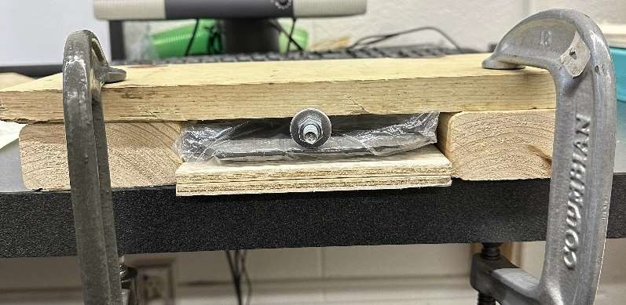
Figure 2: Initial test frame using a digital food scale, sawn lumber, and c-clamps.
A new frame was developed using plywood, sawn lumber, and wood glue. The frame along with an analogue scale can be seen in Figure 3. The test was not conducted with the scale in the orientation shown but rotated with the back of the scale against the left wall. Holes corresponding to recommended pilot hole diameters from each anchor manufacturer were drilled into the left wall. The height of the bottom of the hole aligned with the top of the scale. Each anchor has an inactive region which does not deploy to accommodate a fastened object. The back wall of the frame was thicker than the minimum specified thickness, so a spade bit was used to remove wood around the pilot hole and decrease the thickness of the back wall.

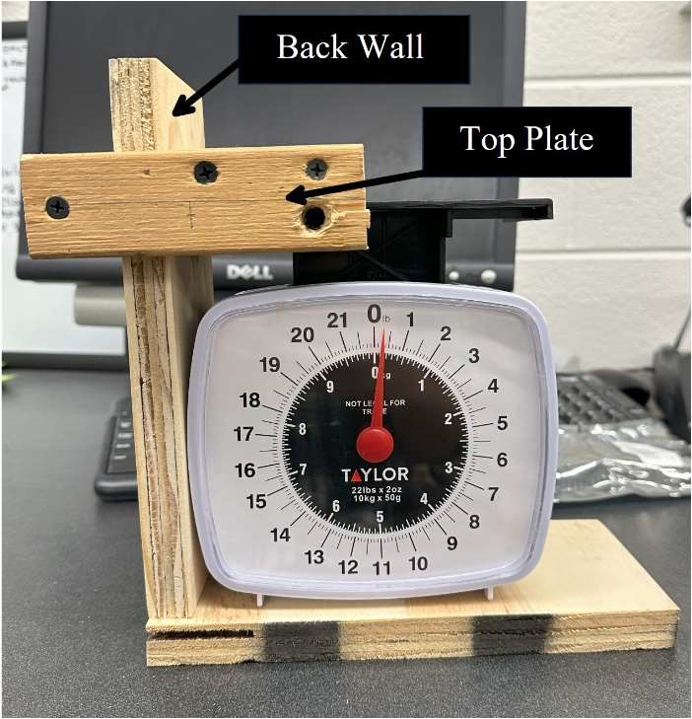

Figure 3. Test frame with the analogue scale showing the top plate and back wall. More detailed sketches along with test procedure can be found in Appendix C.
The top plate of the frame allowed for adjustment and movement vertically along the wall to match height of the scale and utilized a rectangular opening. The opening matched the width of the back wall but had a small tolerance behind the wall. Tight tolerances allow for adjustment downward to the anchor but when an upward force is applied on the top plate, a semi-fixed plane is created for the anchors to push against.

Test Procedure
To begin testing, an anchor was inserted into the pilot hole from the back of the wall. In the case of the hollow-wall anchor, a set screw was installed in the notches of the outer sleeve through the front of the frame to contain the anchor against spinning in the pilot hole (see Appendix A). Next, the scale was slid under the anchor and proper alignment was checked. The scale was oriented in a manner so that the anchor was as close to the center of the scale spring as possible to avoid eccentricity. The top plate then slid down the back wall to contain the deployed anchor against upward movement. After sliding the top plate, the scale zero may change and need to be re-zeroed for the test. Frame movement during testing was an issue encountered early in the testing process, so the frame was clamped down on the table to prevent sliding. Deployment of the anchor utilized a power drill or wrench depending on the anchor. The sleeve anchor used an adjustable wrench, and the hollow-wall anchor used the drill. The drill was set to the low speed/high torque setting to provide improved control of the deployment rate. The rate of deployment aimed to be slow and consistent throughout the process to avoid dynamic loads. Twisting occurred until the scale reached a stable reading. Maximum values displayed on the scale were recorded. A deployed hollow-wall anchor in the test scale can be seen in Figure 4.

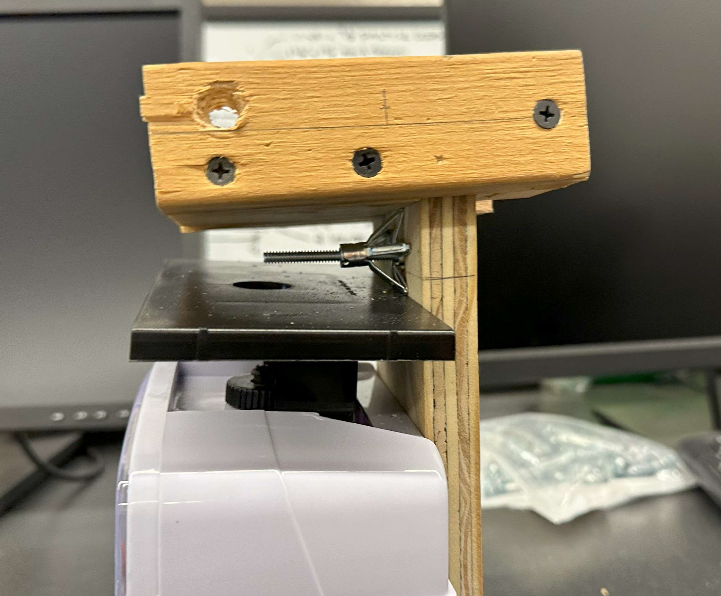
Figure 4: Hollow-wall anchor deployed in the test frame after the test has been conducted.

Results
Out of the tested anchors (hollow-wall and sleeve anchors), the hollow-wall anchors are the only anchor which produced measurable forces on the food scale. The sleeve anchors did not produce results using this test method and must be tested in another manner. The hollow-wall anchors produced 12 force readings. A scatter plot of Force vs Test Number is shown in Figure 5.
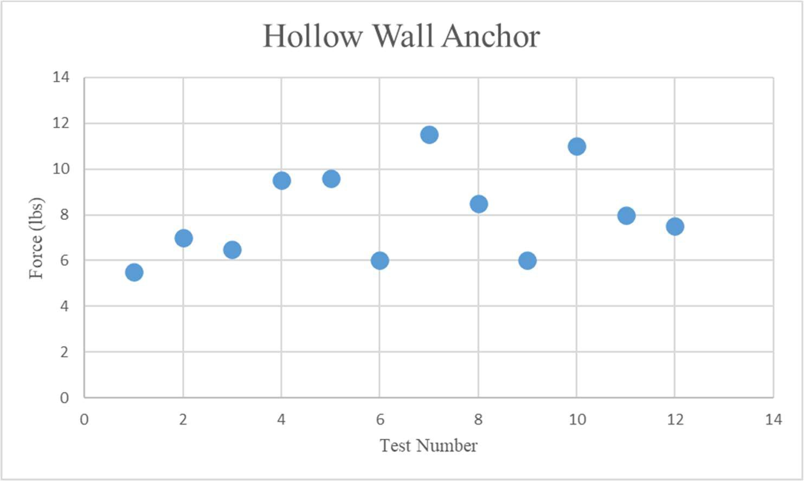
Figure 5: Force Values for the Hollow-Wall Anchors
Through twelve tests, force values ranged from 5.5-11.5 pounds producing a range of 6 pounds. The average of tests was 8.05 pounds with a standard deviation of 2 pounds. Discussion
Testing the anchors using the wood produced results for the hollow wall anchor, but not for the sleeve anchor. The sleeve anchor was expanded fully and remained flush within the test frame but did not produce force on the scale. Sleeve anchors do not deploy

in large deformations or high rates, which may have allowed the top plate to slip upward under the gradual application of force. One option may be to secure the top plate prior to deployment; however, this could require losing the adjustability and ease of movement for repeatable tests. With a secured top plate, deformations may not be large enough to engage the scale on measurable levels. Other options for measuring sleeve anchor forces will need to be explored in the future.
The hollow wall anchors produced force values with a relatively large range compared to the magnitude of the forces. The results from twelve tests do not produce a distinguishable trend other than the average at 8.05 lbs. The small magnitude of force readings produces the appearance of a very inconsistent test result. More tests should be conducted to increase data points.
Issues with the methodology and test frame limited the number of hollow-wall anchor tests to twelve. The hollow wall anchors have pointed portions around the collar which are meant for gripping the mounting surface. In wood, these points do not perform well and are susceptible to spinning. When the points spin, they dig and tear ruts into the surface of the wood (see Appendix B). To mitigate spinning a set screw was used, but the notches in the collar do not immobilize the sleeve and rutting still occurs at a slower rate. Rutting causes damage to the frame, expands the pilot hole, and creates issues for the set screw after a few tests. After a few tests, new pilot holes must be drilled to continue testing. Another issue related to the frame is slipping of the top plate and the scale under the deployed anchor. Tests were recorded on video and upon review, the top plate can be seen slipping up the back wall in several cases. Slipping can reduce the maximum value observed on the scale creating precision issues of the test. The scale can also slip from under the deployed anchor which is usually seen in a popping motion or heard. Many of the tests were treated as non-measurable due to these reasons. Slipping of the top plate can occur from pausing deployment of the anchor. Once tightening begins, a constant pace of deployment should be kept to minimize the potential for slipping. Damage to the wings of the hollow wall anchor will cause twisting of the anchor sleeve rather than deployment. If wings on the anchor are damaged on insertion, the anchor will not deploy and twist around itself (see Appendix D). Lastly, space on the test frame limited how many pilot holes could be used prior to large eccentricity in about the scale center- point/spring. Space on the back wall played a role in the number of tests which could be conducted without creating a new frame.

Conclusions
Due to the small number of tests and inability to get measurements for the sleeve anchors more testing should be conducted to understand the forces generated through the expansion of concrete anchors. For applications such as creating camber in concrete girders, the test results and method provide a starting point for further testing. The results provide a rather large range of values, but insights learned throughout the testing process will improve future testing procedures.

- Percent of research project completed
20%

- Expected progress for next quarter
  - Cast lab specimen with anchors, conduct 5-10 non-destructive tests
  - Advance modeling of concrete section using form finding with adaptive anchors
  - Begin research on parametric design Task 2.1

- Educational outreach and workforce development
Educational outreach has not yest been conducted but is in planning for third quarter. PI Sychterz will be leading the charge on developing a new collaboration with the University of Stuttgart in Germany on advancing the field of adaptive bridge girders and student advising on the subject.

- Technology Transfer
No new patents or technology have been developed in this quarter. As this is a brand new concept in the United States, patents will be the subject of future funded projects with this project being the test bed.

Research Contribution:
- Number of papers
Currently, no conference or journal papers have been published from this project. The PIs are targeting TRB 2025 and ACI 2024 Fall conferences to disseminate this work.

- Number presentations (when, where)
Currently, no presentations have been made from this project. The PIs are targeting TRB 2025 and ACI 2024 Fall conferences to disseminate this work.

References:

Akgün, Y., Gantes, C. J., Sobek, W., Korkmaz, K., & Kalochairetis, K. (2011). A novel adaptive spatial scissor-hinge structural mechanism for convertible roofs.
Engineering Structures, 33(4), 1365–1376. https://doi.org/10.1016/j.engstruct.2011.01.014

Pellegrino, S. (2001). Deployable Structures. Springer-Verlag.

Reksowardojo, A. P., Senatore, G., & Smith, I. F. C. (2020). Design of Structures That Adapt to Loads through Large Shape Changes. Journal of Structural Engineering,
146(5). https://doi.org/10.1061/(asce)st.1943-541x.0002604

Yin, L., & Ananthasuresh, G. K. (2003). Design of distributed compliant mechanisms.
Mechanics Based Design of Structures and Machines, 31(2), 151–179. https://doi.org/10.1081/SME-120020289.
Precast, Prestressed Bridge Girders.” (August).
Brown, K. M. (1998). “Camber growth prediction in precast prestressed concrete bridge

girders.” (December).
French, C. E., and O’Neill, C. R. (2012). “Validation of Prestressed Concrete I-Beam De ection and Camber Estimates.” (June), 205.
Honarvar, E., Nervig, J., and Rouse, J. M. (2015). Improving the accuracy of camber predictions for precast pretensioned concrete beams. DOT National Transportation Integrated Search - ROSA P.
Precast/Prestressed Concrete Institute. (2018). Guidelines for Camber and Profile Management in Adjacent Beams.
Stallings, J. M., Barnes, R. W., and Eskildsen, S. (2003). “Camber and Prestress Losses in Alabama HPC Bridge Girders.” PCI Journal, 48(5), 90–104.
(2017). PCI Design Handbook, 8th Edition. PCI Design Handbook, 8th Edition.
Kelleter, C., Burghardt, T., Binz, H., Blandini, L., & Sobek, W. (2020). Adaptive Concrete Beams Equipped With Integrated Fluidic Actuators. Frontiers in Built Environment, 6(July), 1–13. https://doi.org/10.3389/fbuil.2020.00091
Steffen, S., Nitzlader, M., Burghardt, T., Binz, H., Blandini, L., & Sobek, W. (2021). An actuator concept for adaptive concrete columns. Actuators, 10(10). https://doi.org/10.3390/act10100273

