- Go to the ICT website (www.ict.illinois.edu) (unless you used the link from the email)
- Under Research, Click QPR Login (shown in the image below)
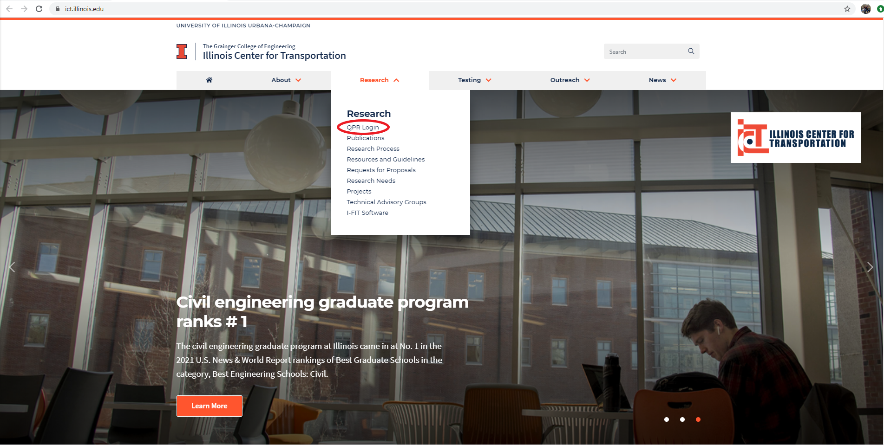

- Enter username/password. (Follow instructions on website if you do not know your password)
- If you are the TRP Chair of a project, ICT has entered your username as the TRP Chair for that project. Once your username is entered into a project’s Personnel list, that project will appear after you have logged in. Projects that require your attention for the current quarter will have a blue Review & Approve QPR button under the “Action Needed” column on the right side of the screen.
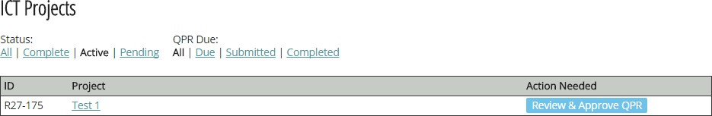
- Find the project for which you wish to approve the QPR, click Review & Approve QPR on right hand side (shown in the image below).

- Once you have clicked the Review & Approve QPR button, you will see several sections. Some fields are greyed out, some appear in white, while others appear in white with a red asterisk. A white field with a red asterisk denotes a required field. If you see errors in a greyed out section, please leave a comment in the Project Discussion Board at the bottom of the QPR or email ICT staff at ICTProjectManagement@illinois.edu with the error you have noticed.
Please review and update, as necessary, the following areas:
  - Personnel (shown in the image below) – as TRP Chair of the project, you can add:

    - TRP Members
    - TRP Co-Chairs
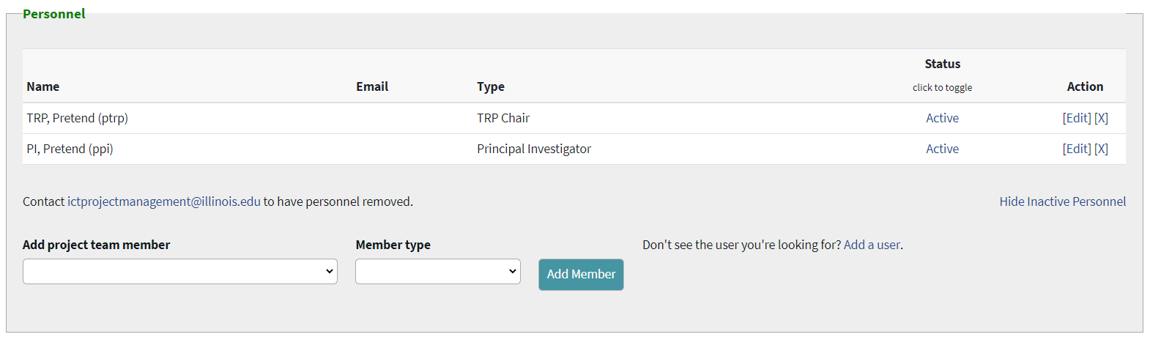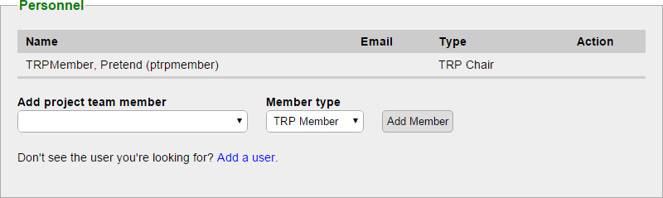

  - Technical Review Panel Updates (shown in the image below): please note this section is only available after the Principal Investigator (PI) submits the report. ICT will have already entered the Deliverable Name and Responsibility for each deliverable.
    - Deliverables: Please update Est. Due Date, Progress, Finished, and Completion Date each quarter. Add any new deliverables not listed.
    - Implementation (Required): Please enter the implementation activities performed this quarter. Please click Show history to view any available archive.

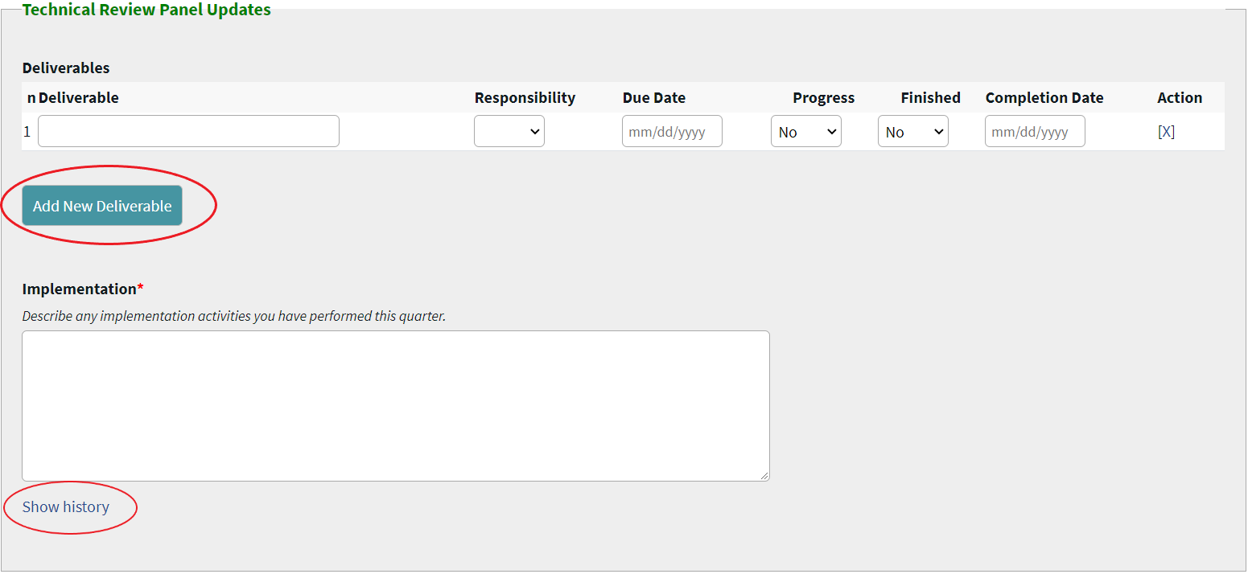

  - TRP Comments (shown in the image below):
    - Enter TRP Comments (Required): Please comment on project’s progress, results and status. These comments are included in the final QPR. Please click Show history to view any available archive.
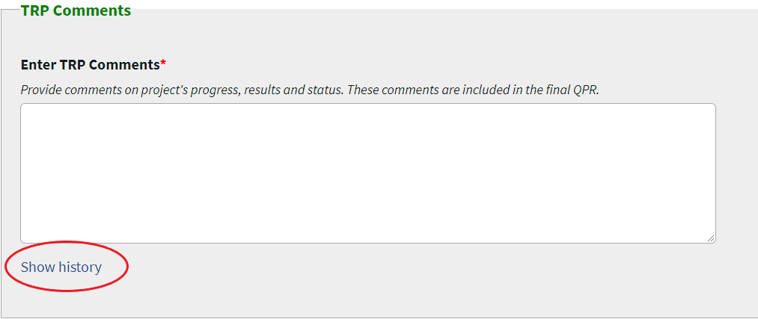

  - Project Discussion Board (shown in the image below)
    - Please use this section to send a comment to the PI of the project. The PI or a member of the ICT staff will try to address any comments that you have. Comments can include, but are not limited to:
      - Questions you have about what is listed on the quarterly report.
      - Any errors or typos you notice on the report.
    - Please note that both the Save QPR and Approve QPR buttons will submit any comments.
    - If you need the PI to revise or update the QPR, do not hit the Approve QPR button.
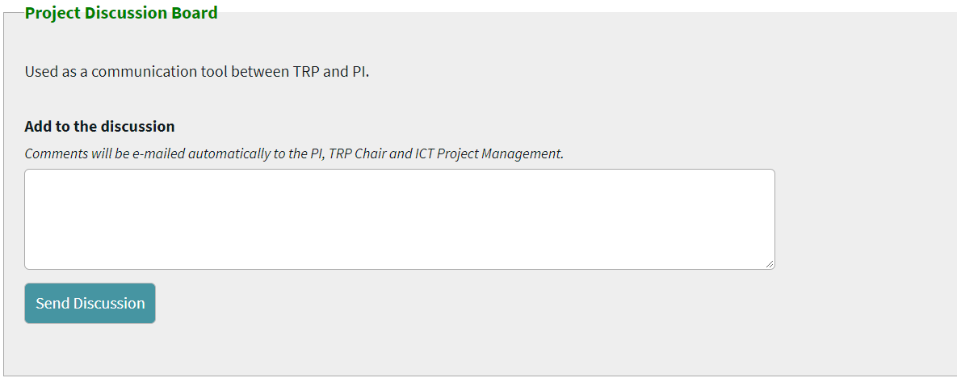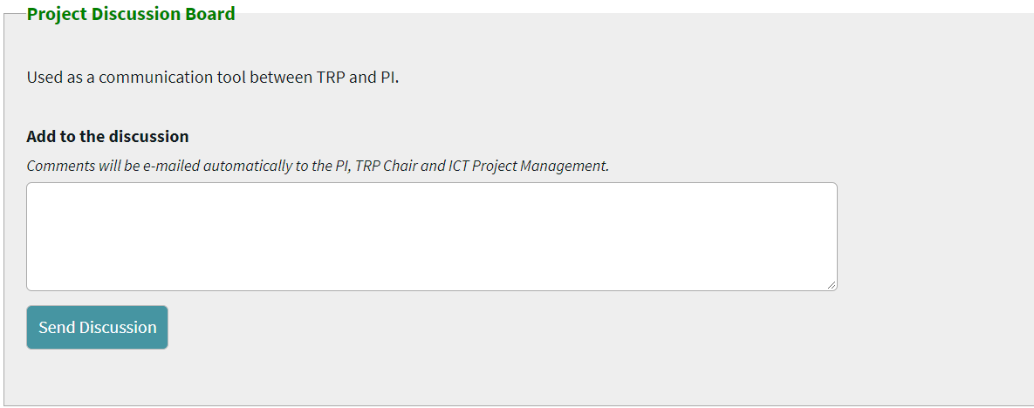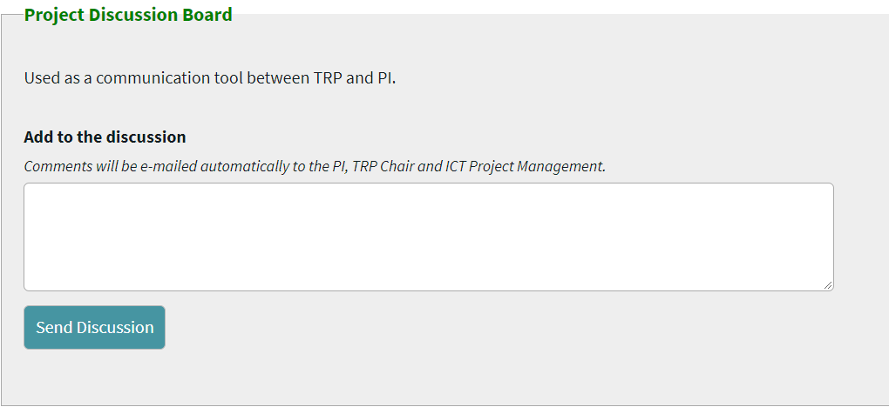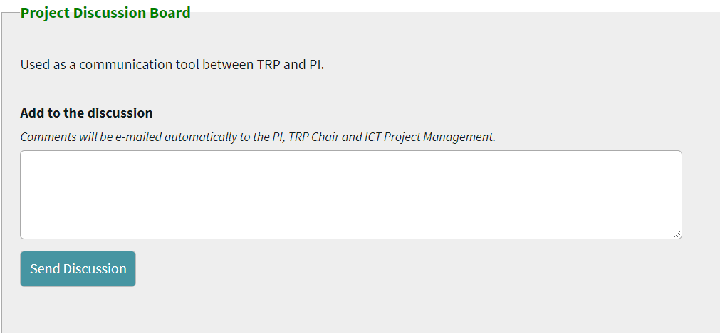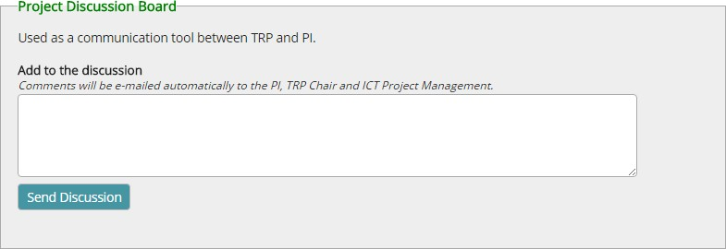

- To save your progress without approving the QPR, click Save QPR at the bottom of the page (shown in the image below).

- Once all aforementioned fields have been reviewed and updated, you can either click the:
  - “Return QPR to PI” button (shown in the image below), and wait for him/her to address your comments OR

  - “Approve the QPR” button (shown in the image below).
  - Please note that if you click the Approve QPR button, no more changes can be made to the QPR. Clicking the Approve QPR button means that you approve the QPR as is. If you want the PI to change something before you approve the QPR, then click the Return QPR to PI button. This will send an email to the PI informing them that you returned the QPR to them. You can also send them a comment with more details. Please remember that clicking the Save button DOES NOT approve the QPR.

- If you approved the QPR, but did not complete all required fields (denoted with a red asterisk), you will received a message similar to the below. You will have to complete the required fields and click Approve QPR again.
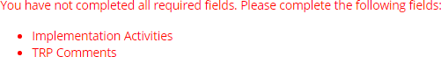

- You will receive the following message thanking you and telling you that you have successfully approved the QPR (shown in the image below):

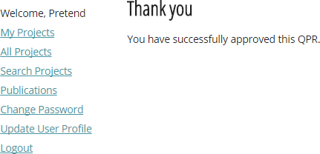

- Once you have approved the QPR, you are finished with the QPR for the quarter, and all archived sections are stored for future reference.

