

Transportation Infrastructure Precast Innovation Center
(TRANS-IPIC)

University Transportation Center (UTC)

AI-based Lift Path Planning for Robotic Installation of Precast Bridge Components
UT-25-RP-01

Quarterly Progress Report
For the performance period ending 06/30/2026

Submitted by:
PI: Dr. Jiannan Cai, jiannan.cai@utsa.edu
School of Civil & Environmental Engineering, and Construction Management (CECM)
The University of Texas at San Antonio (UTSA)
Co-PI: Dr. Ao Du, ao.du@utsa.edu,CECM, UTSA
Graduate research assistant: Mohsen Navazani, Mohsen.Navazani@utsa.edu, CECM, UTSA

Collaborators / Partners:
N/A

Submitted to:
TRANS-IPIC UTC
University of Illinois Urbana-Champaign
Urbana, IL

TRANS-IPIC Quarterly Progress Report:

Project Description:
- Research Plan - Statement of Problem

Accurate and rapid installation of precast components is crucial to ensuring the quality and productivity of precast bridge construction. Typically, large prefabricated structural components are transported by cranes to the installation location for initial positioning. Then, multiple workers are needed to collaboratively adjust the component pose so that it can precisely align with the target. The workers will need to cooperate with the crane to place the component to its final position. In current practice, the performance of crane operation is affected by multiple factors, such as the size and weight of the lifting components, experience of crane operator, complexity of jobsite, and status of outdoor environments. As a result, repetitive re-lifting and falling may be needed, which is time-consuming and reduces construction efficiency. Furthermore, it requires close coordination between skilled operators and ground workers, which is labor-intensive when the entire industry is facing a significant labor shortage crisis. Robotic technologies have great potential to improve the accuracy and efficiency of precast component installation by automating crane operation. It was found that a partially automated tower crane, or even a simple observation device, could decrease the lifting time by 10% to 50% [1]. While existing research has developed methods for automated crane path planning, these approaches frequently overlook the inherent properties and kinematic constraints of the crane itself.

In our TRANS-IPIC Year 2 Exploratory project, we conducted a pilot study and developed a robotic AI agent using deep reinforcement learning (DRL) techniques and tested the feasibility of AI-based crane lift path planning for precast bridge component installation in a high-fidelity physics-based simulation environment. However, considering the heterogeneous site configurations and task specifications in bridge construction as well as the challenges and constraints on the jobsite, there is a critical need to generalize the method to various environmental and task configurations. Furthermore, the reliability and performance of AI-generated lift path planning should be evaluated both quantitatively and qualitatively by practitioners. The successful testing and demonstration of developed methods with domain experts will largely increase the feasibility of practical implementation, thus improving bridge construction efficiency and accuracy, saving costs, and benefiting long-term quality and durability of transportation infrastructure.

In existing studies, there are increasing applications of DRL in crane path planning [2–4]. However, there remain three knowledge gaps. First, the majority of research in automated crane path planning in AEC industry has historically concentrated on vertical construction projects within the building sector, leaving robotic installation in transportation infrastructure largely unexplored. Considering the substantial scale of precast components and the complex site configurations in horizontal projects, such as bridge construction, it is imperative to investigate the feasibility of robotic approaches to generate optimal crane lifting paths. Second, the design of appropriate reward functions for complex crane operations remains a significant challenge in DRL, as poor design can lead to non-executable lifting paths. Factors such as operator competency and situational awareness are difficult to capture through manually designed rewards [5]. Third, most existing methods are evaluated via computational simulation without understanding and evaluating in terms of feasibility and reliability in practice.

To this end, objective of this project is to develop and evaluate a practical-inspired and adaptive AI-based 3D crane lift path planning method for precast bridge installation. Building upon the foundational physics-based simulation and DRL agent developed in the exploratory project, this phase focuses on overcoming the gap between computational simulation and practical feasibility. The goal is to make technology adaptive to various job conditions, physical constraints, and practical industry needs.

- Research Plan - Summary of Project Activities (Tasks)
Task 1. Understand current practice and challenges in precast bridge installation
This task employs a mixed-methods approach of industry workshops and site observations to understand current practices. We will engage with industry professionals to brainstorm the usability of robotic installation and identify challenging jobsite environments. Furthermore, the research team will conduct site visits to observe crane operators, conduct semi-structured interviews, and collect site and task configuration data to understand key factors in lift path planning.

Task 2. Practice-oriented and adaptive AI-based lift path planning:
Building upon preliminary results, this task focuses on developing a DRL agent capable of generating optimal and safe lifting paths while adapting to various site and task configurations. The simulation environment will be expanded to include diverse site configurations and varying bridge geometries. Additionally, we will refine the reward function to incorporate factors like minimizing component swing and apply transfer learning techniques to ensure the model is generalized for different scenarios.

Task 3. Evaluation:
This task involves evaluating the developed method quantitatively and qualitatively by replicating a real-world case study project in our simulation. We will compare the performance of the AI-generated lift paths against those executed by human operators using metrics such as lifting time, path length, and placement accuracy. Qualitatively, we will engage with industry professionals to assess the perceived practicality and efficiency of the AI-based method.

Project Progress:
- Progress for each research task
Task1. Understand current practice and challenges in precast bridge installation [90% Completed]

- Industry Engagement & Data Collection:
  - Building on the collaboration established last quarter with Zachry Construction, a major construction company specializing in highway and infrastructure construction, we obtained additional real-world project information that directly informs the physical parameters and operational constraints of our simulation. At this stage the project is exploratory: rather than replicating the full Zachry jobsite, we use its lift-plan parameters (crane model, boom length, counterweight, payload mass, rigging mass, and bridge span dimensions) to scale a simplified environment in which we can test the feasibility of the method before scaling up to the complete site.

- Site Visits and Field Data Collection:
  - We conducted two site visits to active precast concrete highway bridge construction projects in San Antonio, operated by two different contractors (Lone Star Constructors and AlamoNex Construction), where we observed live crane operations during precast bridge installation and collected detailed planning and execution data (Figure 1). Observing the lifts directly helped us understand the operational considerations that shape a lift plan, and we learned how crews sequence picks across a multi-span bridge, position cranes and define working radius and clearance zones, classify a lift as standard or complex, and verify safety conditions before and during the lift. These practices directly inform the site and task configurations, boundary conditions, and safety constraints we build into our simulation environment and reinforcement learning model design.
  - We collected four lift-planning document sets from two different contractors, plus a recorded crane-planning session. The first two sets, from Lone Star Constructors, cover dual-crane precast girder erection on a multi-span bridge using Liebherr crawler cranes. They include a Crane Lift Planning and Execution Permit classifying each lift as complex, an overview spreadsheet of per-span lift parameters, plan-view photographs showing crane positions and working radii, erection-plan sheets, and supporting rigging calculations. The third and fourth sets, from AlamoNex Construction, are two Critical Lift Plans for dual-crane (multi-agent) girder erection using all-terrain cranes. They document the load and rigging arrangement, crane placement, and capacity utilization, along with placement and rigging sketches and the relevant load charts. Together these materials provide a field-grounded reference for how real lifts are planned, sequenced, and verified.
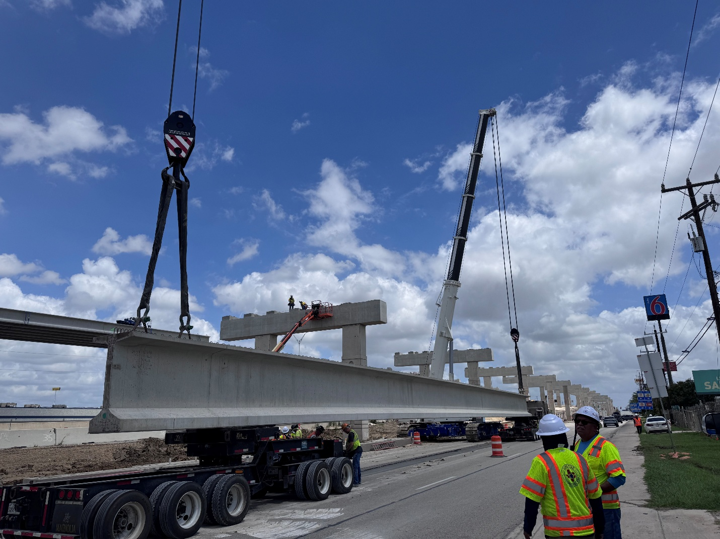
Figure 1: Site visit observing a live precast girder lift during bridge installation

Task 2: Practice-oriented and adaptive AI-based lift path planning [55% Completed]

- Crane Planner 2.0 Integration for Ground-Truth Validation:
  - We evaluated and adopted Liebherr Crane Planner 2.0 (CP 2.0) as a source of real-world ground-truth data for validating our RL policy. The software's engine is connected to Liebherr's LICCON control system, providing accurate joint limits, boom stiffness thresholds, and Load Moment Limiting (LML) data, and it automatically computes the dynamic center of gravity and ground-pressure distribution as the boom moves. After securing a Pro license, we created a project and configured a Liebherr LTM 1400-6.1 to match the simulation environment (telescopic boom, no luffing jib, 40 t rear counterweight, fully extended VarioBase, 2× reeving), modeled the concrete payload and a 2-rope sling, and defined and animated a complete five-step lifting trajectory (Pick, Lift Off, Transit Mid, Above Target, Set) (Figure 2). It is important to note that, at this feasibility stage, we did not reproduce the actual jobsite; we applied the project's lift parameters within a simplified scene in which the object positions are arranged more simply than on the real site. Playback verification confirmed the operation stayed within utilization limits with no collision warnings, and the project geometry and per-step report were extracted for use as the validated baseline trajectory.

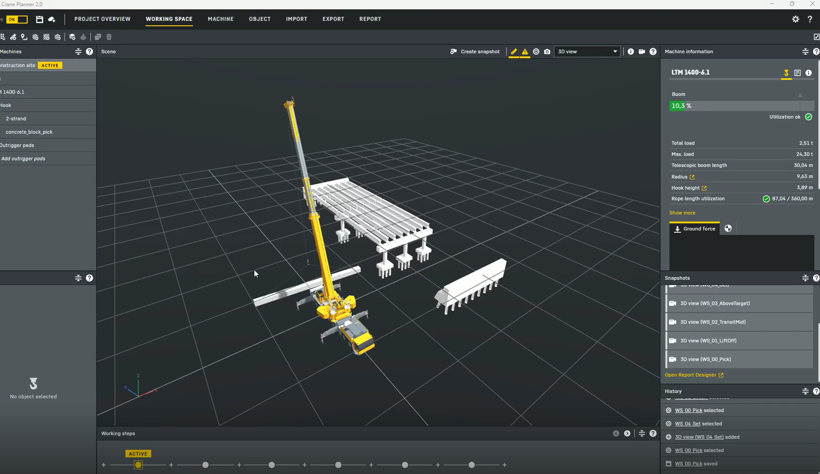
Figure 2: The Liebherr LTM 1400-6.1 modeled in Crane Planner 2.0, showing the five-step lifting trajectory in a simplified scene layout

- Migration to a Connected-Joint Crane Model:
  - The crane model was migrated to a 1:1 scaled simulation environment based on the Liebherr LTM 1400-6.1 specifications. All crane components and the concrete payload were rebuilt in Blender with correct coordinate origins to ensure precise real-world scaling and eliminate the need for error-prone runtime scaling adjustments in code. The crane and payload were sized to match the lift-plan parameters; consistent with the feasibility scope of this stage, the surrounding environment is a simplified layout in which the object positions are arranged more simply than on the actual project site.

- Rope and Rigging Simulation:
  - The rope and rigging connect the crane hook to the precast girder and govern how the suspended load hangs and sways during a lift, so they must be represented in the simulation for the agent to learn realistic, safe motions. In our earlier setup the slings and payload were modeled as separate hanging bodies, which was prone to instability and slowed reinforcement learning. Following further testing, the rigging was simplified for stability and RL efficiency. The payload is now connected directly to the crane hook through clean joint configurations. A dynamic visual cable was added at the top of the hook so that the hoist actuator visually and physically mimics winch operation by changing the cable length.

- Payload Standardization and Collision Robustness:
  - The payload cross-section was calibrated to the project-standard TX70 girder specification. Concrete tunneling through the floor under the heavy load was resolved. The resulting crane model and payload in the simulation environment are shown in Figure 3.

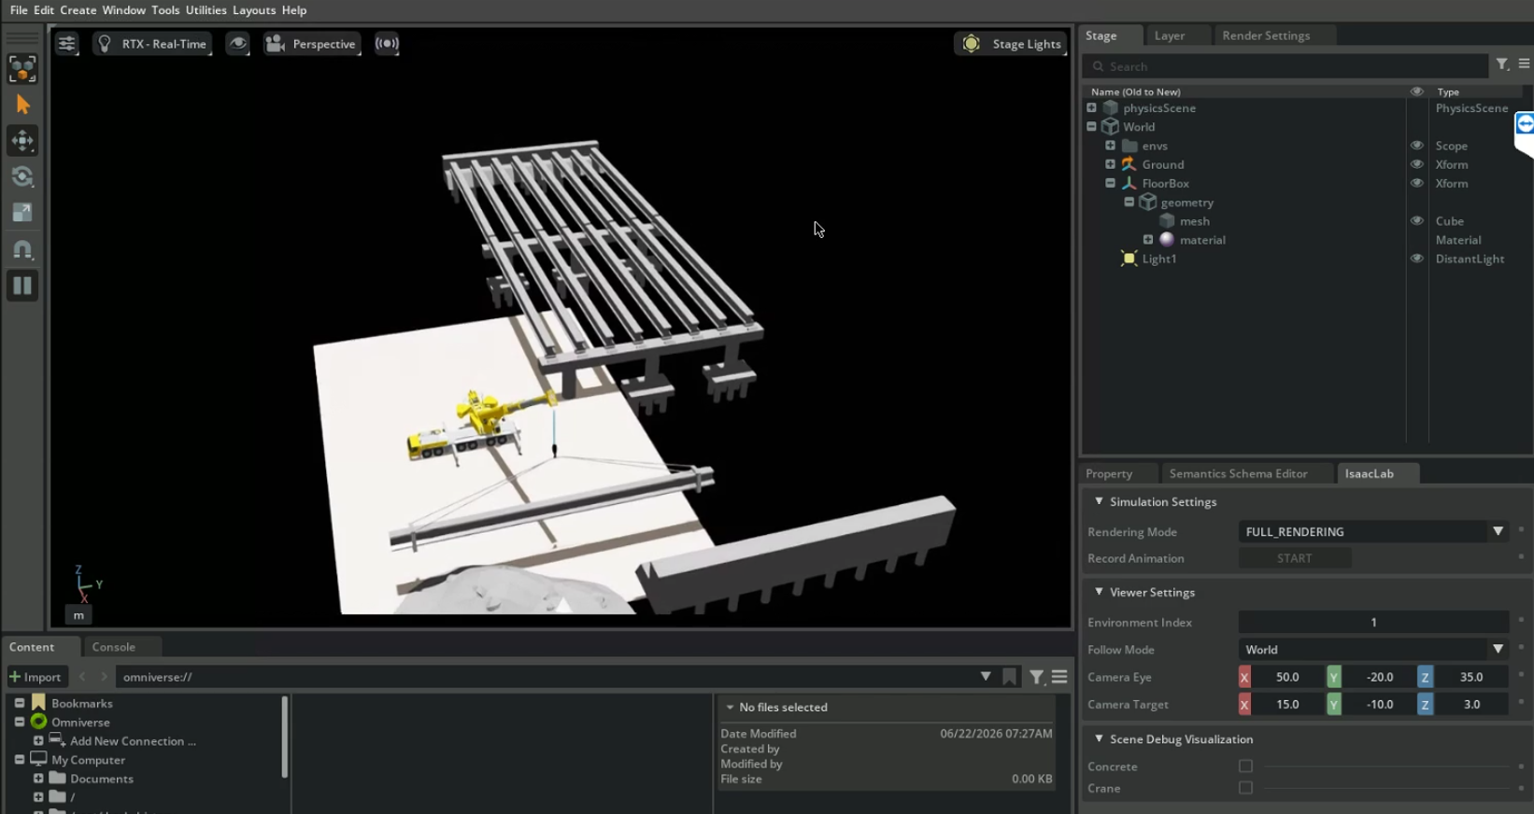
Figure 3: The scaled LTM 1400-6.1 crane model lifting a girder payload in the simplified Isaac Sim environment

Task 3: Evaluation [0% Completed]
- Status:
  - This task has not yet commenced, as it relies on the maturation of the AI training currently underway in Task 2. Testing and validation will begin once the RL algorithms are adequately trained on the newly implemented physics.

- Percent of research project completed
By the end of the second quarter, approximately 50% of the overall project is complete, keeping the project on schedule. Task 1 is roughly 90% done. During this quarter we visited two contractor jobsites (Lone Star Constructors and AlamoNex Construction), recorded a live crane-planning session, and gathered four lift-planning document sets. Together, these give us a solid base of field data and a clear approach to evaluate our simulation. Task 2 is about 55% done. We rebuilt the crane model at full scale, added Crane Planner 2.0 as a ground-truth reference, and got a stable physics environment running for the LTM 1400-6.1. Task 3 remains at 0% as it is scheduled for the final phase of the project timeline.

- Expected progress for next quarter
Task 1: Finalize the analysis of the field data collected during the two site visits and the recorded crane-planning operation, and consolidate the three crane path-planning documents into a unified set of site and task configurations and safety constraints for the simulation. Follow up with site personnel (crane operators, safety supervisors, spotters) where availability allows.

Task 2: Complete the RL environment setup, finalizing model development, and execute full PPO training runs. Improve the model to learn to keep the crane stable and avoid tipping, and refine the reward to discourage excessive payload sway and jerky motion.

Task 3: Begin the case study by building the Zachry project scenario in simulation and training the reinforcement learning agent on it, including exploring transfer learning to generalize the policy across multiple beams.

- Educational outreach and workforce development
- Graduate student mentoring: One Ph.D. student was funded by this project and was trained in conducting multidisciplinary research across robotics, AI, civil engineering, and construction.
- K-12 outreach activities:
  - Co-PI Du participated in the UTSA Engineering Summer Camps for local high school students by offering lectures for the bridge building competition
  - PI Cai is mentoring 1 high school student as summer intern, and graduate research assistant, Mohsen Navazani assists in the mentorship by designing mini projects on robotics tailored for high school students and providing timely advice and guidance.

- Technology Transfer
No technology transfer activities took place this quarter. Future plans may involve sharing the simulation environment and/or RL model with industry stakeholders for feedback and improvement.

Research Contribution:
- Papers that include TRANS-IPIC UTC in the acknowledgments section:
N/A

- Presentations and Posters of TRANS-IPIC funded research:

The graduate research assistant, Mohsen Navazani, received the Best Student Poster Award (1st Place) at the 2026 Transportation Infrastructure Precast Workshop (TIP2026), held in Rosemont, IL, in April 2026, recognizing the top research presentation among student participants at the TRANS-IPIC Workshop.

We have just presented the exploratory project from Year 2 at a major international conference in construction engineering and management. Details are as follows:
- Date: March 20, 2026
- Conference: CI & CRC Joint Conference 2026
- Location: San Antonio, TX
- Presentation:
  - Mohsen Navazani, Ao Du, Shuai Li, and Jiannan Cai. “Reinforcement Learning-Based Motion Planning for Mobile Crane Operation in Precast Concrete Bridge Installation”
- The corresponding paper is accepted for proceedings and is in press.

- Please list any other events or activities that highlights the work of TRANS-IPIC occurring at your university (please include any pictures or figures you may have). Similarly, please list any references to TRANS-IPIC in the news or interviews from your research.

N/A

Appendix 1: Research Activities, leadership, and awards (cumulative, since the start of the project)

- Number of presentations at academic and industry conferences and workshops of UTC findings
- No. = 2

- Number of peer-reviewed publications submitted based on outcomes of UTC funded projects
- No. = 0

- Number of peer-reviewed journal articles published by faculty.
- No. = 6 (this is the total number of journal papers PI and Co-PI published in 2026, not necessarily related to this project)

- Number of peer-reviewed conference papers published by faculty.
- No. = 0

- Number of TRANS-IPIC sponsored thesis or dissertations at the MS and PhD levels.
- No. MS thesis = 0
- No. PhD dissertations = 0
- No. citations of each of the above = 0

- Number of research tools (lab equipment, models, software, test processes, etc.) developed as part of TRANS-IPIC sponsored research
- Research Tool #1 (Name, description, and link to tool) = 1 (Isaac simulation environment, still under development)
- Research Tool #2 (Name, description, and link to tool) = 0
- Research Tool #3 (Name, description, and link to tool) = 0

- Number of transportation-related professional and service organization committees that TRANS-IPIC faculty researchers participate in or lead.
- Professional societies
  - No. participated in = 2
  - No. lead = 0
- Advisory committees (No. participated in & No. led)
  - No. participated in = 0
  - No. lead = 0
- Conference Organizing Committees (No. participated in & No. led)
  - No. participated in = 0
  - No. lead = 1
- Editorial board of journals (No. participated in & No. led)
  - No. participated in = 0
  - No. lead = 0
- TRB committees (No. participated in & No. led)
  - No. participated in = 0
  - No. lead = 0

- Number of relevant awards received during the grant year
- No. awards received = 1

- Number of transportation related classes developed or modified as a result of TRANS-IPIC funding.
- No. Undergraduate = 0
- No. Graduate = 0

- Number of internships and full-time positions secured in the industry and government during the grant year.
- No. of internships = 0
- No. of full-time positions = 0

References:
[1] S.H. Cho, S.U. Han, Reinforcement learning-based simulation and automation for tower crane 3D lift planning, Automation in Construction 144 (2022). https://doi.org/10.1016/j.autcon.2022.104620.
[2] O. Makarov, T. Harada, Reinforcement Learning for AI-Positioning of Suspended Load by a Crane Vessel, in: 2024 10th International Conference on Electrical Engineering, Control and Robotics, EECR 2024, 2024. https://doi.org/10.1109/EECR60807.2024.10607270.
[3] D.H. Chun, M. Il Roh, H.W. Lee, Automation of crane control for block lifting based on deep reinforcement learning, J. Comput. Des. Eng. 9 (2022). https://doi.org/10.1093/jcde/qwac063.
[4] A. Zhu, T. Dai, G. Xu, P. Pauwels, B. De Vries, M. Fang, Deep Reinforcement Learning for Real-Time Assembly Planning in Robot-Based Prefabricated Construction, IEEE Transactions on Automation Science and Engineering 20 (2023). https://doi.org/10.1109/TASE.2023.3236805.
[5] Z. Wang, C. Huang, B. Yao, X. Li, Integrated reinforcement and imitation learning for tower crane lift path planning, Automation in Construction 165 (2024). https://doi.org/10.1016/j.autcon.2024.105568.

