

Transportation Infrastructure Precast Innovation Center
(TRANS-IPIC)

University Transportation Center (UTC)

Improving Temporary Traffic Control Systems in Highway Construction Zones with Precast Concrete Installation Strategies using Traffic Flow Simulation of Lane Closures
[LS-25-RP-01]

Quarterly Progress Report: Y3-2
Performance period: April 1- June 30, 2026

Submitted by:
Bhaba R. Sarker (PI)
Professor, Department of Mechanical and Industrial Engineering
Louisiana State University, Baton Rouge, LA 70803
bsarker@lsu.edu

Collaborators / Partners:
Graduate Assistant: Anik Mazumder (amazum3@lsu.edu)
Participating Co.: Rinker, Gainey’s, Premier Concrete Products, and WASKEY for collaboration and validation of research works.

Submitted to:
TRANS-IPIC UTC
University of Illinois Urbana-Champaign
Urbana, IL

TRANS-IPIC Quarterly Progress Report (Y3-2)
- PROJECT DESCRIPTION
Highway construction zones often cause traffic congestion, safety risks, and delays, especially when work is rushed or poorly timed. In this section, we highlight the problem statement and the project’s tasks to be completed.
- Research Plan - Statement of Problem
Highway construction zones are major disruption points that often cause congestion, safety risks, project delays, and potential durability issues for transportation infrastructures built with precast concrete (PC) components, especially when installation occurs under high-traffic conditions. In Baton Rouge and much of Louisiana, maintaining two open lanes near work zones improves traffic flow but limits workspace and complicates site operations. Night construction is often used to reduce daytime congestion, yet it introduces risks such as poor visibility, worker fatigue, and reduced installation accuracy. Although agencies like the Federal Highway Administration (FHWA) and state Departments of Transportation (DOTs) promote work-zone management strategies, many current practices still rely on static assumptions and lack integration with real-time traffic data and optimized construction planning.
Research Goal: The goal of this project is to develop a smart planning approach for scheduling precast-related road construction activities (e.g., crane setup, placement, grouting, and anchoring) while minimizing reliance on night work. So, the research objective was to improve the traffic flow, and maintain mobility and safety during precast installation, to reduce total costs including agency costs (construction and maintenance) and road user costs (delays, crashes, and vehicle operating costs).
Research Plan - Summary of Project Activities (Tasks)
As outlined in the proposed research plan for Year 3, the research for developing a Traffic Congestion Modeling (TCM) in the PC supply network is in progress. However, to achieve the current objective of Year 3 (2026), following three phases are being conducted:
- Task 1 (Y3-1): TCM (Traffic Congestion Modeling): In this phase, probabilistic models of traffic buildup at typical one-lane or two-lane closure points during construction projects of roads, highways and interstates are being developed using construction activity timelines.
- Task 2 (Y3-2): PCS (Phased Construction Scheduling): This phase will develop strategies for coordinating construction activities to ensure that precast elements arrive exactly when needed and can be installed without interruption.
- Task 3 (Y3-3): WPS (Work-Zone Performance Simulation): In the final phase, common construction scenarios will be simulated to evaluate the effectiveness of the proposed strategies in improving traffic flow and handling of precast components.
- PROJECT PROGRESS
In this section, the progress in completing the research tasks is highlighted followed by future work, educational outreach, workforce development, and technology transfer.
- Progress for each research task
The progress of each research task is described below:
I. Task 1 (Y3-1): (Traffic Congestion Modeling, TCM): Precast concrete (PC) components are widely used in transportation infrastructure because of their rapid installation, quality control, and durability. However, construction-related lane closures and uncontrolled ramp inflows can increase congestion, disrupt operations, delay PC delivery and installation, and generate vibrations that may affect component performance (Gasser et al. 2025; Gu et al. 2024; Zhasmukhambetova et al. 2025). As illustrated in Figure 1 and described in QPR Y3-1, dynamic ramp metering can regulate highway inflow, maintain safe traffic densities, and limit ramp queues near work zones. Accordingly, the proposed Density-Based Network Ramp Metering (DNRM) model uses multi-objective optimization to minimize highway congestion and ramp queues while maintaining smooth metering operations. A real-world dataset was used to represent congestion in the DNRM model. It contains 15-minute traffic volumes from 36 sensors on two major highways in the Northern Virginia–Washington, DC region, along with 47 temporal and roadway features (Zhao et al., 2019).
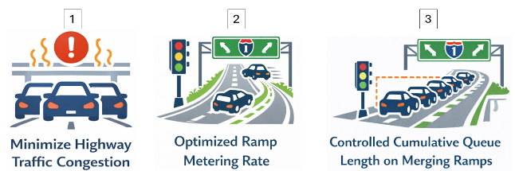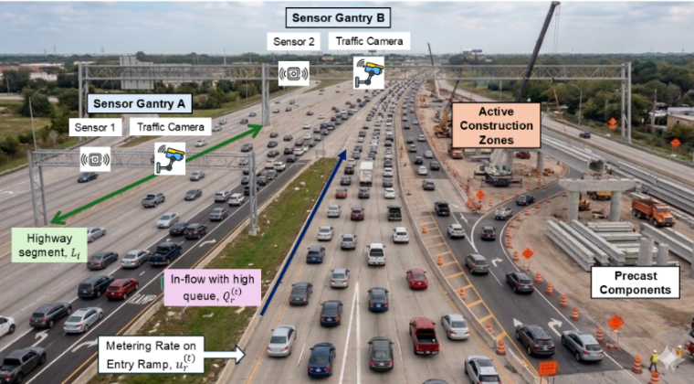
Objectives
Current issue
Figure 1. Traffic flow conditions and monitoring framework near a highway work zone during precast concrete transportation infrastructure construction.
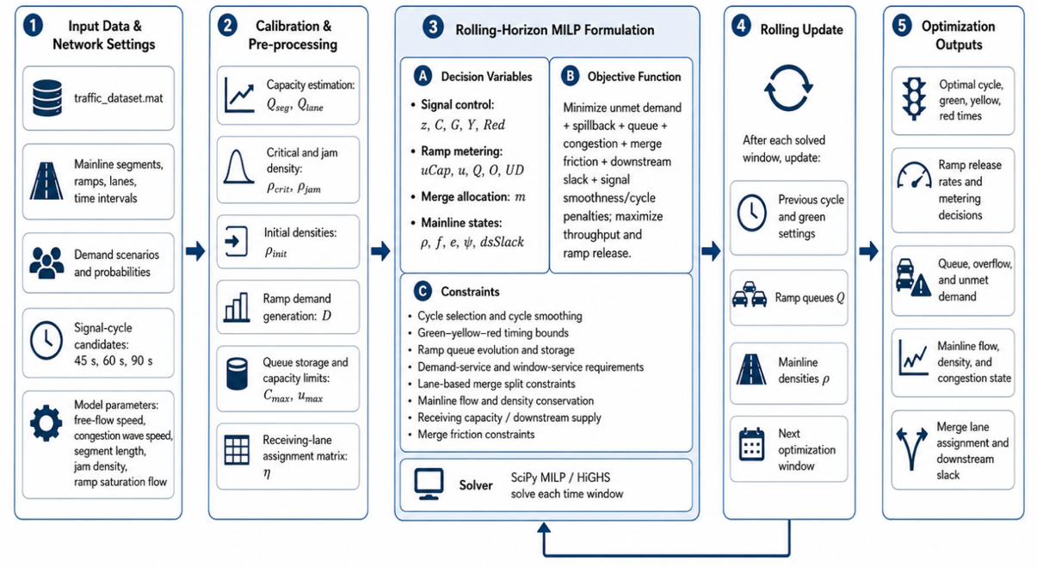
Figure 2. Proposed DNRM architecture.
During this reporting period (April 1–June 30, 2026), a rolling-horizon Signal-Lane-Based Density Network Ramp Metering (DNRM) MILP framework (Figure 2) was implemented to coordinate traffic control with phased precast concrete construction activities. The model jointly optimizes ramp releases, signal timing, queues, and lane assignments as lane availability and downstream capacity change across delivery, equipment mobilization, erection, and reopening phases. It served approximately 91% of total ramp demand, allowing higher releases under favorable conditions and more restrictive metering during capacity-constrained construction phases. This phased control supports safer and more efficient traffic operations around precast work zones.
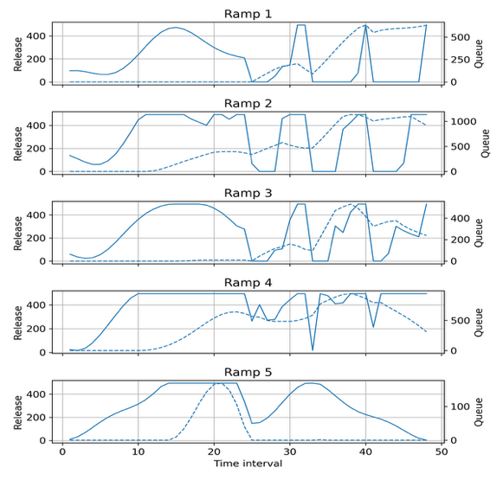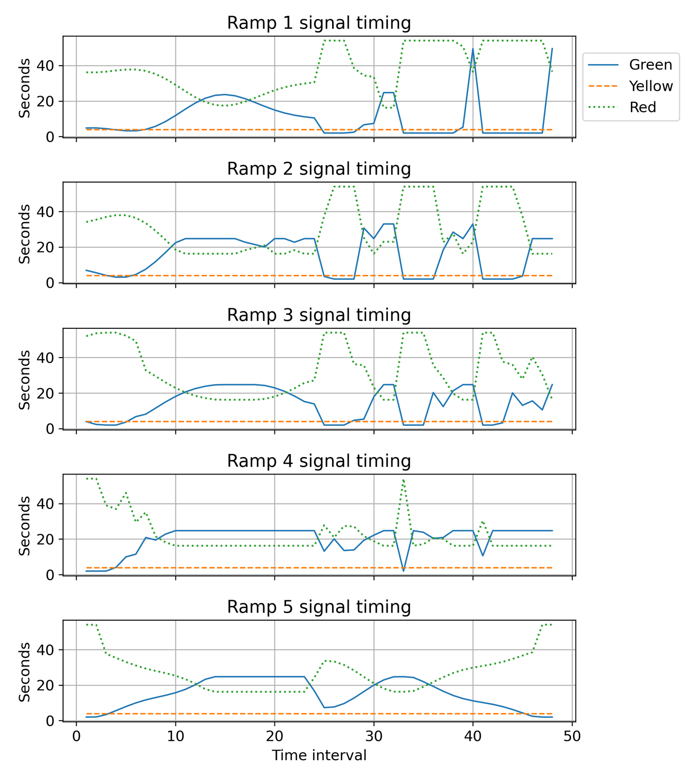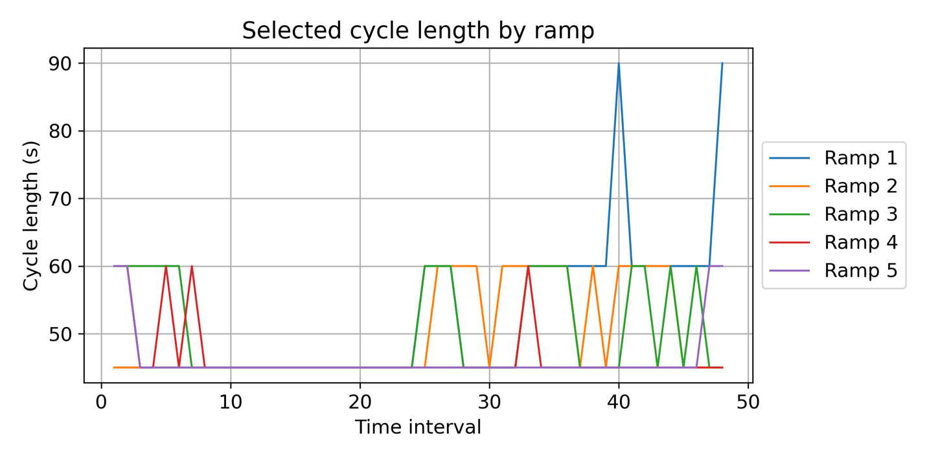
Figure 3. Dynamic ramp-metering performance of DNRM model over 48-time intervals.
II. Task 2 (Y3-2): (Phased Construction Scheduling, PCS): Successive phases of precast construction alter lane availability, lateral clearance, work intensity, and merging conditions, producing time-varying work-zone capacity. Consequently, ramp-metering rates should adapt to prevailing downstream traffic and capacity conditions to prevent traffic breakdown and excessive queue formation and therefore phased precast construction requires adaptive ramp-metering rates (Benekohal et al., 2004). More restrictive releases can be applied during deliveries, crane operations, and lane closures, while higher releases can reduce queues during lower-impact phases. The model also distributes merging vehicles across available lanes, supporting coordinated construction scheduling, ramp control, and lane-level traffic management. The results also show that the optimization model dynamically adjusted ramp-release rates, queue levels, and signal timings over the 48-time intervals. When queues increased, the model generally modified green and red durations to regulate vehicle entry, with some ramps receiving more restrictive control than others. The 45-second cycle was selected most frequently, while 60- and 90-second cycles were used only during specific traffic conditions, demonstrating the framework’s ability to adapt ramp-metering decisions over time (Figure 3). The proposed framework converts the optimized ramp-metering outputs from each rolling-horizon interval into a real-time animation of corridor operations. The visualization (Figure 4) continuously updates ramp-release rates, queues, signal timings, cycle lengths, lane-specific merging flows, and mainline density conditions, enabling the effects of optimized ramp-metering decisions near precast concrete work zones to be observed over time.
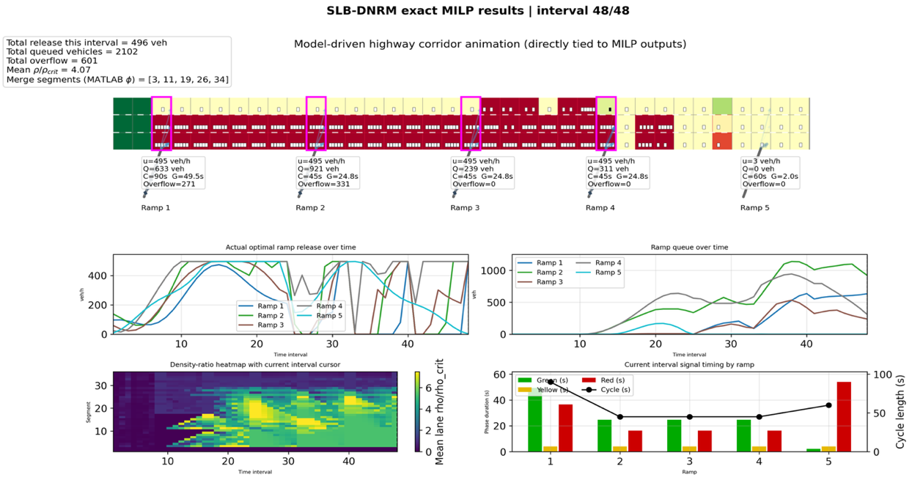
Figure 4. Final-frame visualization of the DNRM rolling-horizon MILP, showing optimized ramp releases.
The final animation frame summarizes the optimized ramp-metering and corridor conditions at interval 48 of 48. At this stage, the model released 496 vehicles while managing 2,102 queued vehicles and 601 vehicles of queue-storage exceedance, with a mean density-to-critical-density ratio of 4.07. Ramps 1– 4 maintained high release rates, whereas Ramp 5 was restricted to a minimal release because its signal provided only 2 seconds of green time. The corridor visualization and density-ratio heatmap indicate that congestion was concentrated around several merge segments, while the lower plots show how ramp releases, queues, signal phases, and cycle lengths evolved throughout the study horizon. These results demonstrate the framework’s ability to coordinate lane-specific merging, ramp queues, and adaptive signal timing near precast concrete work zones; the identified high-demand intervals and merge locations will guide further bottleneck-mitigation and work-zone scheduling analyses in the next quarter.
- Percent of research project completed
As the research project for this year has been divided into three parts, the percentage of the research project completed is approximately (95%×33.33%) + (60%×33.33%) + (0%×33.33%) ~ 52%. The computational parts of Stages 1 and 2, are in progress, and it will be included in the working paper to be submitted to a refereed journal.
- Expected progress for next quarter
Over the next quarter, we plan to integrate real project data into the model and run pilot tests to assess its performance under practical conditions.
- Educational outreach and workforce development
Not yet.
- Technology Transfer
The research team is in contact with several companies (Precast Concrete Products, Waskey, Gainey’s and Rinker) through LTRC.
- RESEARCH CONTRIBUTION
- Papers that include TRANS-IPIC UTC in the acknowledgments section:
      - Mazumder, A. and Sarker, B.R. (2025b), “Determining Optimal Variable Order Quantities of Raw Materials for Precast Concrete Production Considering Demand Variability and Uncertain Material Prices," Submitted to Asia Pacific Journal of Operational Research. 1st submission: September 8, 2025; 1st Revision: February 12, 2026. (APJOR: M250908R1)
      - Mazumder, A., and Sarker, B. (2026a). Optimal Assignment of Precast Components to Minimize Curing Cost. 2026 Transportation Infrastructure Precast Workshop (TIP2026), Rosemont, IL, USA. https://doi.org/10.5281/zenodo.19858353
      - Mazumder, A. and Sarker, B. R. (2026b). A Column-Generation Approach for Two-Dimensional Layout Optimization with Capacity Constraints to Minimize Curing Cost in Precast Manufacturing. Available at SSRN: http://dx.doi.org/10.2139/ssrn.6568961
      - Mazumder, A., Bappy, M. M. and Sarker, B. R. (2026c), “Monotonicity-Constrained Physics-Informed Neural Networks for Concrete Compressive Strength Prediction,” Submitted to Innovative Infrastructure Solutions. 1st submission: January 28, 2026 (under review). (IIS-D-26-00174)
      - Mazumder, A. and Sarker, B. R. (2026e), “Optimal vendor-manufacturer cooperative policy for perishable precast materials under stochastic demand and lead-time uncertainty,” Submitted to Applied Mathematical Modelling. 1st submission: May 09, 2026 (under review). (AMMOD-D-26-02118).
- Presentations and Posters of TRANS-IPIC funded research:
      - Mazumder, A. and Sarker, B. R. (2024), “Factors of the Precast Concrete Supply Chain: An Interpretive Structural Modeling Approach,” Graduate Research Conference (GRC), Louisiana State University (Union Building), Baton Rouge, LA on April 30, 2024.
      - Mazumder, A. and Sarker, B. R. (2025a), “Optimizing Raw Material Ordering Policies for Efficient Precast Concrete Production under Fluctuating Demand and Price,” Presentation ID: 6670, IISE Annual Conference & Expo 2025, Renaissance Atlanta Waverly Hotel & Convention Center (Room: Tyndall), Atlanta, Georgia, May 31- June 3, 2025.
      - Mazumder, A. and Sarker, B. R. (2025b), “Optimal Component Allocation on Pallet to Minimize Curing Costs in Precast Manufacturing,” Presentation ID: 8864, IISE Annual Conference & Expo 2025, Renaissance Atlanta Waverly Hotel & Convention Center (Room: Andover), Atlanta, Georgia, May 31- June 3, 2025.
      - Mazumder, A. and Sarker, B. R. (2025c), “Optimizing Pallet Utilization to Reduce Curing Costs in Precast Concrete Manufacturing,” Poster ID: 7037, 2025 INFORMS Annual Meeting, Georgia World Congress Center and Omni Atlanta Hotel at Centennial Park, Atlanta, Georgia, October 26- 29, 2025.
      - Mazumder, A. and Sarker, B. R. (2026a), “A Two-Dimensional Bin Packing Model with Knapsack Constraints for Production and Curing Optimization in Precast Concrete Systems,” presented at 23rd MIE Graduate Student Conference, 1206 Patrick F. Taylor Hall, Louisiana State University, Baton Rouge, LA, April 18, 2026.
      - Mazumder, A. and Sarker, B.R. (2026b), “Traffic Flow Optimization in Highway Work Zones During Construction Activities,” Poster presented at 23rd MIE Graduate Student Conference, 1206 Patrick F. Taylor Hall, Louisiana State University, Baton Rouge, LA, April 18, 2026.
      - Mazumder, A. and Sarker, B.R. (2026c), “A Rolling-Horizon Mixed-Integer Optimization Model for Signal-Cycle-Aware Dynamic Ramp-Metering Control,” Scheduled at 2026 INFORMS Annual Meeting (Abstract ID: 1520), San Francisco, CA, November 1-4, 2026.

- Please list any other events or activities that highlights the work of TRANS-IPIC occurring at your university (please include any pictures or figures you may have). Similarly, please list any references to TRANS-IPIC in the news or interviews from your research.

Not yet
Appendix 1
Research Activities, leadership, and awards (cumulative, since the start of the project)

- Number of presentations at academic and industry conferences and workshops of UTC findings
- No. = 4, 1 (Scheduled on November 1, 2026)
- Number of peer-reviewed publications submitted based on outcomes of UTC funded projects.
- No. = 4
- Number of peer-reviewed journal articles published by faculty.
- No. = 1
- Number of peer-reviewed conference papers published by faculty.
- No. = 1
- Number of TRANS-IPIC sponsored thesis or dissertations at the MS and PhD levels.
- No. MS thesis = 1 (October 29, 2025)
- No. PhD dissertations = 1 (on-going)
- No. citations of each of the above = 0
- Number of research tools (lab equipment, models, software, test processes, etc.) developed as part of TRANS-IPIC sponsored research.
- Research Tool #1 (Name, description, and link to tool) = (CCM Model, Curing Cost Minimization tool, https://github.com/17anik23/Curing-Cost-Minimization-Model.git)
- Research Tool #2 (Name, description, and link to tool) = (PINN Model, Physics Informed Neural Network for Concrete Compressive Strength prediction, https://github.com/17anik23/PINN_Concrete-Strength.git)
- Research Tool #3 (Name, description, and link to tool) = (Dynamic ramp metering control model, https://drive.google.com/file/d/1TZEDkG77nyaM9U8y1Y8rHdLDGyOB2Y_p/view?usp=sharing)
- Number of transportation-related professional and service organization committees that TRANS-IPIC faculty researchers participate in or lead.
- Professional societies
  - No. participated in = 4 (DSI, IISE, INFORMS, POMS)
  - No. lead = 0
- Advisory committees (No. participated in and No. led)
  - No. participated in = 1 (IISE Fellow)
  - No. lead = 0
- Conference Organizing Committees (No. participated in and No. led)
  - No. participated in = 0
  - No. lead = 0
- Editorial board of journals (No. participated in and No. led)
  - No. participated in = 2
  - No. lead = 0
- TRB committees (No. participated in and No. led)
  - No. participated in = 0
  - No. lead = 0
- Number of relevant awards received during the grant year.
- No. awards received = 0
- Number of transportation related classes developed or modified as a result of TRANS-IPIC funding.
- No. Undergraduate = 0
- No. Graduate = 0
- Number of internships and full-time positions secured in the industry and government during the grant year.
- No. of internships = 0
- No. of full-time positions = 0

References:

- Benekohal, R. F., Kaja-Mohideen, A. Z., & Chitturi, M. V. (2004). Methodology for estimating operating speed and capacity in work zones. Transportation Research Record, 1883(1), 103-111.
- Chu, M., Zhang, Z., Liu, J., Wu, S., and Dong, C. (2025). Experimental Research on Mechanical Behaviour of Precast Concrete Shear Walls with Horizontal Joint Quality Defects. Buildings, 15(21), 3951.
- De la Fuente, A., Bairán, J. M., and Cavalaro, S. H. P. (2019). Case study of failure of long prestressed precast concrete girder during lifting. Engineering Failure Analysis, 100, 512-519.
- Gasser, C., Manninger, T., Vorwagner, A., Klackl, S., Krispel, S., Stadler, C., and Kleiser, M. (2025). Experimental study on the impact of traffic‐induced vibrations on early‐age concrete. Structural Concrete. 19 May 2025. https://doi.org/10.1002/suco.70143Digital Object Identifier (DOI).
- Gu, P., Wu, H., Li, L., Li, Z., Hong, J., and Zhuang, M. L. (2024). Effect of traffic vibration on compressive strength of high-strength concrete and tensile strength of new-to-old concrete interfaces. Buildings, 14(12), 3765.
- Lighthill, M. J., and Whitham, G. B. (1955). On kinematic waves II. A theory of traffic flow on long crowded roads. Proceedings of the royal society of London. Series A. Mathematical and Physical Sciences, 229(1178), 317-345.
- Raimund Bürger, Christophe Chalons, Rafael Ordoñez, Luis Miguel Villada (2021). A multiclass Lighthill-Whitham-Richards traffic model with a discontinuous velocity function. Networks and Heterogeneous Media, 2021, 16(2): 187-219.
- Sarker, B. R. and Mazumder, A. (2024), “Improving Temporary Traffic Control Systems in Highway Construction Zones with Precast Concrete Installation Strategies using Traffic Flow Simulation of Lane Closures.” A report submitted to the DOT/Trans-IPIC, Grant #LS-25-RP-01 (for first quarter, January 1-March 31, 2026).
- Villalobos-Vega, E., Yadak, O. M., Dawson, C. E., Floyd, R. W., and Harvey, P. S. (2026). Precast Concrete End Diaphragm System for Accelerated Bridge Construction in Seismic-Prone Regions: Constructability and Lateral Testing. Journal of Bridge Engineering, 31(3), 04026004.
- Zhang, F. (2017). Lateral stability of long precast prestressed concrete girders during transient load situations. Master’s Thesis, Universitat Politècnica De Catalunya –Barcelona Tech, June 2017.
- Zhao, L., Gkountouna, O., and Pfoser, D. (2019). Spatial auto-regressive dependency interpretable learning based on spatial topological constraints. ACM Transactions on Spatial Algorithms and Systems (TSAS), 5(3), 1-28.
- Zhasmukhambetova, A., Evdorides, H., and Davies, R. J. (2025). Critical Risk Factors Affecting Time and Cost in Highway Construction: A Global Systematic Literature Review. Future Transportation, 5(4), 192. https://doi.org/10.3390/futuretransp 5040192

