

Transportation Infrastructure Precast Innovation Center
(TRANS-IPIC)

University Transportation Center (UTC)

3D Printed Smart Permanent Concrete Formwork for Precast
Structural Component-Structural Performance – Phase 2:
Large Scale Testing
LS-24-RP-02

Quarterly Progress Report
For the performance period ending July 1st 2026

Submitted by:
Yen-Fang Su, ysu@lsu.edu
Civil & Environmental Engineering
Louisiana State University and A&M College

Collaborators / Partners:
Ayman Okeil, aokeil@lsu.edu
Department of Civil & Environmental Engineering
Louisiana State University and A&M College

Submitted to:
TRANS-IPIC UTC
University of Illinois Urbana-Champaign
Urbana, IL

TRANS-IPIC Quarterly Progress Report:

Project Description:
- Research Plan - Statement of Problem
Tens of thousands of bridges and more than 40% of all the roads and highways in the US are in urgent need of rehabilitation [1]. Structural health monitoring (SHM) has gained importance in detecting, measuring severity, and locating the early damage in the concrete infrastructure. However, issues such durability, material compatibility, and cost challenge the wider adoption of this technology. Tackling these challenges by infusing additional functionalities to precast concrete (PC) will yield enhanced resilience and extended life-span. In our previous research, self-sensing cementitious composites (SSCC) demonstrated the capability for producing smart formwork, the fabrication of which depended on the additive manufacturing technology [2]. In this phase of our research, our aim is to evaluate the structural performance of large-scale 3D printed smart formwork and validate its feasibility in real-world applications.

- Research Plan - Summary of Project Activities (Tasks)
Task 1: Literature Review and Test Matrix Design
Task 2: Specimen Fabrication
Task 3: Load Testing
Task 4: Data Analysis and Multiphysics Modeling

Project Progress:
- Progress for each research task
Task 2: Specimen Fabrication [70% completed to date]
Task 2-1: Review Structural Design for 3D Printed Concrete Members
During the iterative structural experiment design and specimen fabrication, we further extend the literature review on the current state of structural analysis on large-scale 3D printed concrete members. The criteria in the selection of the paper for reviewing were presence of reinforcement and 1:1 scale of the tested specimens. To this end, specimens subjected to axial and flexural loading such as column, beams, slabs, walls, and joints were analyzed. The novel reinforcement techniques employed were examined. Finally, the pre-crack and post-crack behavior of the 3D printed concrete (3DPC) structural members were evaluated.
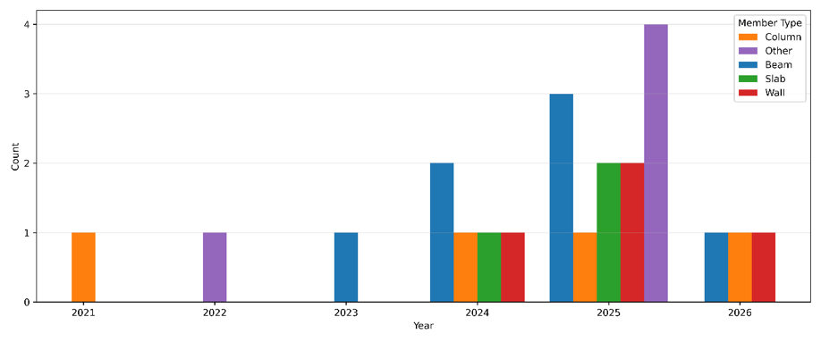
Figure 1. Distribution of the reviewed 3DPC studies by year and structural member type.
In total, 21 studies investigating the structural response of 3DPC large scale elements were uncovered. The publication year and the member type is shown in Figure 1. Of these 21 studies, only 4 concentrate on the 3DPC columns. Zhu et al. [3] investigated large-scale circular composite columns measuring Ø250 × 500 mm, in which a 3D-printed concrete shell served as permanent formwork for a cast-in-place concrete core. The results showed that the printed shell made a clear structural contribution by carrying load and providing confinement, with good shell–core bonding and no debonding at the interface. Numerically, the printed shell had a compressive strength of about 40 MPa compared with about 30 MPa for the cast core, and both axial stiffness and peak load increased with increasing reinforcement ratio. Failure was characterized by longitudinal and inclined cracking followed by crushing, while reinforced specimens also showed longitudinal bar buckling, but without spalling or interfacial separation. Bates and Aslani [4] studied 250 mm square GFRP-reinforced concrete columns in both short (0.82 m) and long (1.8 m) configurations, comparing 3D-printed permanent formwork columns with equivalent mold-cast GFRP-RC columns under axial compression. The main finding was that the printed columns achieved only about half the capacity of the mold-cast counterparts. In terms of failure, the cast columns exhibited sudden brittle crushing and explosive spalling, while the printed columns showed progressive spalling and peeling of the printed shell with continued load transfer through the core and GFRP cage. Nguyen-Van et al. [5] examined 270 mm diameter and 700 mm high reinforced concrete columns incorporating sinusoidal printed infill patterns and cast mortar, representing a lightweight and geometrically optimized 3DCP column concept. The results demonstrated that infill architecture strongly affects load capacity, ductility, stress distribution, and sustainability, with intermediate infill complexity proving most efficient. Compared with solid columns, topologically optimized design achieved superior normalized capacity using less material. The study concluded that sinusoidal infill acts as internal confinement, smooths stress trajectories, reduces stress concentrations up to an optimal level, and improves capacity-to-mass ratio as well as environmental efficiency. Licciardello [6] addressed large-scale load-bearing 3DPC columns for a 30 m tower system. The study confirmed that 3DPC columns can satisfy the structural demands of a tall tower, but their realized member capacities remain significantly below the nominal material strength and are highly sensitive to confinement, grouting quality, and joint detailing. Capacity comparisons showed that well-confined columns behaved stably but still underutilized the available material strength.

Task 2.2: Test Specimen Design
Figure 2 shows the schematic of the 3DPC column shell as well as the eccentric axial loading setup. In this study, the longitudinal and transversal strains measured locally though strain gauges will be compared with that of 3DPC sensor. To ensure the repeatability of the 3DPC sensor, six layers of self-sensing concrete will be printed at three different heights. Top and bottom segments will be b (column width) distance away from the supports, while the third segment will be placed in the midsection of the column. 3DPC sensors and the concrete strain gauges will be installed on both the tension and compression sides of the column. Furthermore, the global response of the column under eccentric loading will be measured using LVDTs. 4 longitudinal LVDTs will be installed; 2 on the tension side and 2 on the compression side. Additionally, the neutral axis will be determined at each stage of loading via the strain gauges installed on the longitudinal rebars. The eccentric loading will be achieved through a pinned-pinned boundary condition. These boundary conditions will be achieved by preparing a custom steel collar that will house the specimen during loading. The free rotation of the column at the supports will be achieved by applying the axial compressive force via the round knife hinges. In the next quarter, the parts necessary for the testing will be manufactured.
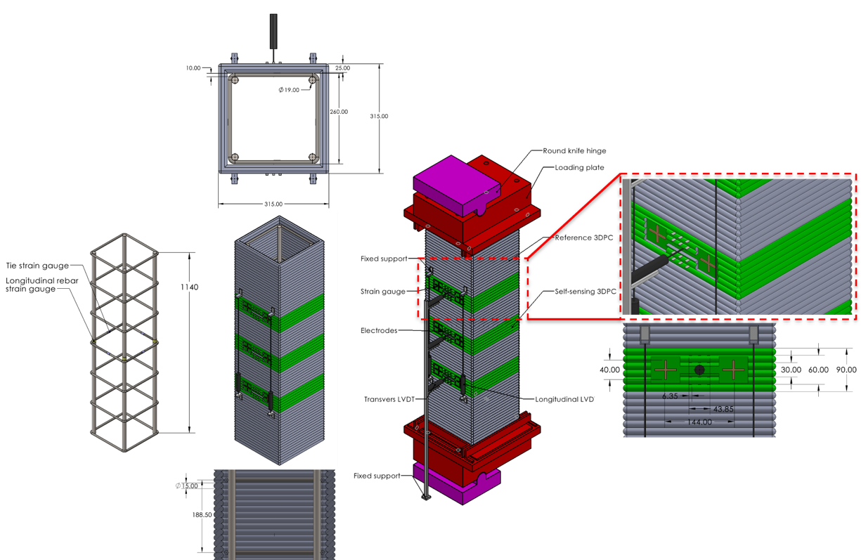
Figure 2. Reinforcement, 3DPC shell, strain gauges, LVDTs, and eccentric axial loading schematic
Task 3: Load Testing [10% completed to date]

A servo hydraulic Instron actuator and an MTS load cell with a capacity of 110 kips were recently calibrated and made operational, as shown in Figure 3. A self-aligning loading platen, measuring 18 in. by 18 in., was installed to ensure uniform compressive loading of specimens with larger cross-sections. In addition, a 2 in.-thick ultra-high-performance concrete (UHPC) baseplate, with a compressive strength exceeding 20 ksi, was cast on top of the floor steel beam. The vertical spacing between the baseplate and the self-aligning platen provides sufficient clearance for the 3DPC column, loading plate, and round knife hinge assembly. For strength testing and self-sensing measurements of laboratory-scale specimens, a loading stage was also fabricated using steel plates and beams.

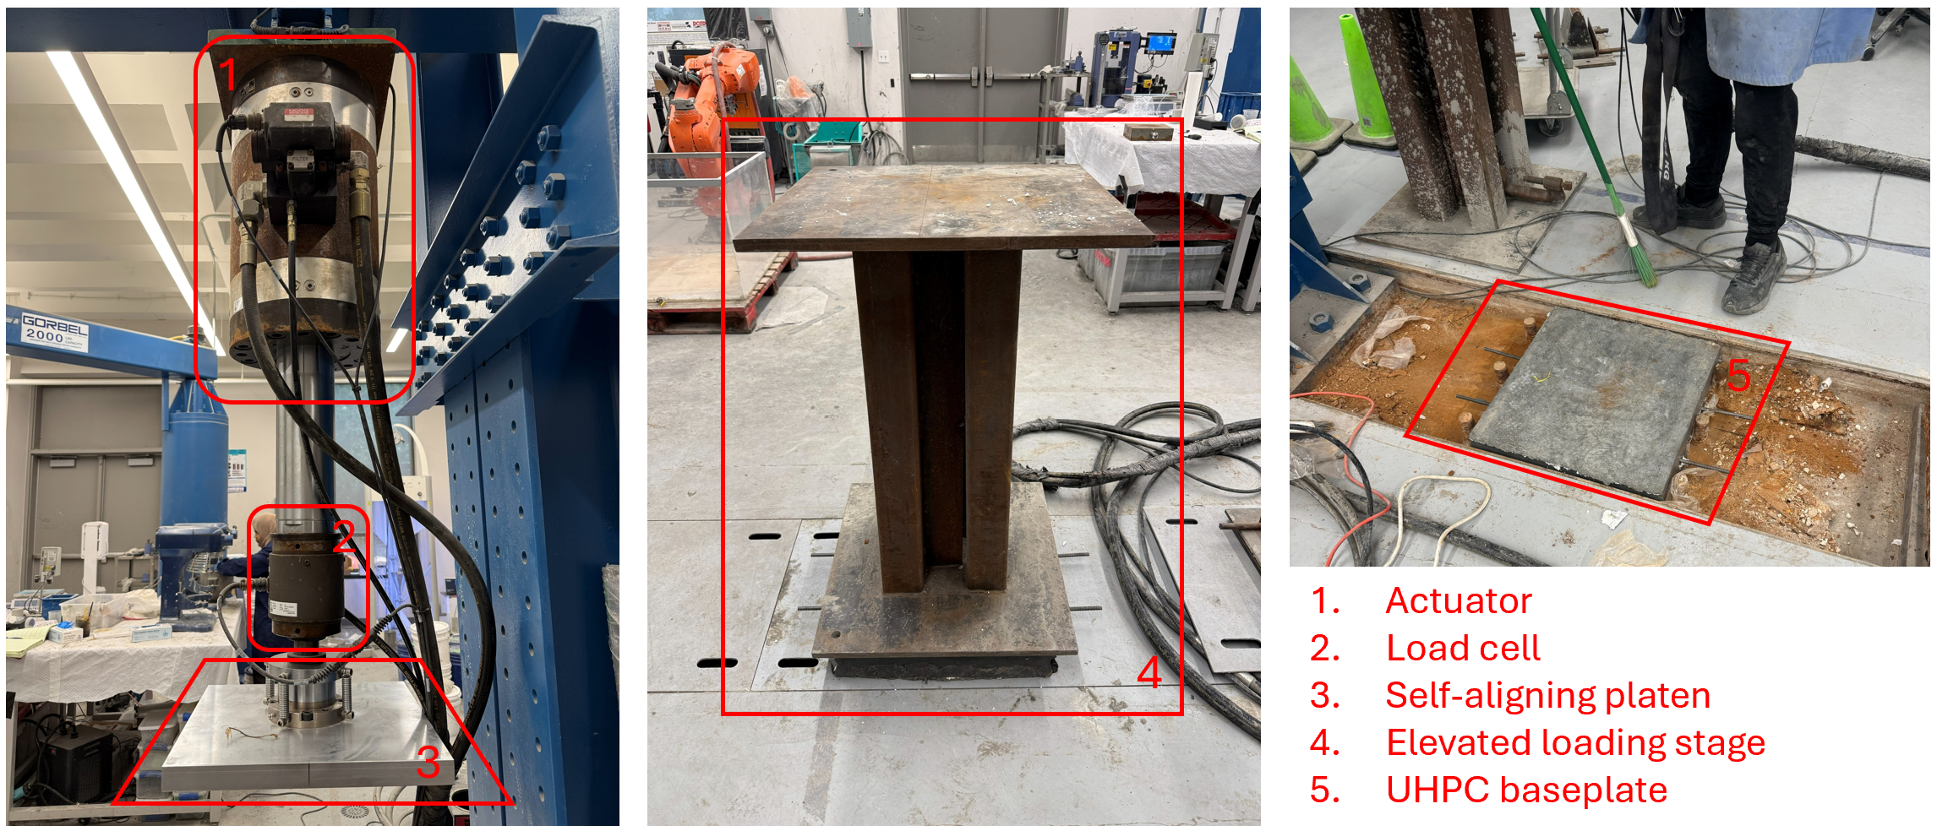
Figure 3. Different components of the loading instrument and their setup

Task 4: Data Analysis and Multiphysics Modeling [10% completed to date]

For the modeling component, a coupled Multiphysics model is developed in COMSOL Multiphysics to simulate the self-sensing behavior of 3D printed smart concrete. The model integrates Solid Mechanics and Electrical Currents interfaces. The Solid Mechanics module is used to compute the strain distribution under applied loading, which is then linked to electrical conductivity through a strain-dependent relation (Eq. 1):
σ = σ₀ exp(kε) | (1)
where σ is the instantaneous conductivity, σ₀ is the initial conductivity, k is the strain-sensitivity coefficient, and ε is the mechanical strain. This formulation enables the electrical response to evolve with deformation. The resulting electrical potential and current fields are used to calculate resistance and the corresponding fractional change in resistivity for comparison with experimental results. Experimentally measured resistance includes both piezoresistive effects and time-dependent drift caused by polarization. To correct this, a calibrated relationship is applied:
R_{cal} = R_{m} − κ ln(t) | (2)
In Eq. 2, R_{cal} is the corrected resistance, R_{m} is the measured resistance, κ is the polarization-drift coefficient, and t is time. This logarithmic correction removes polarization-induced drift from the data. The corrected fractional resistance change is then compared with model predictions to evaluate the effectiveness of the strain-based conductivity formulation. The overall modeling framework and representative simulation outputs are illustrated in Figure 4.
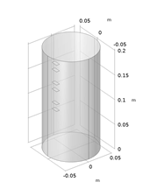
(a)
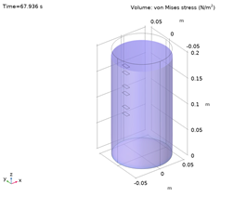 | 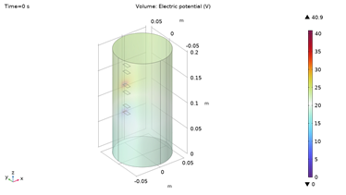
(b) | (c)
Figure 4: COMSOL model showing: (a) specimen geometry, (b) simulated strain distribution, and (c) electric potential distribution from the coupled solid mechanics-electrical currents analysis.

- Percent of research project completed
Task 1: Literature Review and Test Matrix Design [100%]
Task 2: Specimen Fabrication [70%]
Task 3: Load Testing [10%]
Task 4: Data Analysis and Multiphysics Modeling [10%]

- Expected progress for next quarter
In the next quarter, the completion of the fabrication of all the specimens are aimed. Additionally, the loading both symmetrically and asymmetrically at upper thresholds of 10%, 20%, and 40% will be performed.

- Educational outreach and workforce development
- Graduate student - Khalilullah Taj secured third place in LSU 14th Graduate Student Research Conference. His presentation title is “Humidity and Temperature Effect on the 3D Printed Smart Concrete Columns” that supported by this project.
- Mentoring one high school student – Kaylee Meng on the LSU High School Summer Research Internship, focus on 3D printing of concrete columns.

- Technology Transfer
None

Research Contribution:
- Papers that include TRANS-IPIC UTC in the acknowledgments section:
(G: Graduate Student, UG: Undergraduate Student)
- Khalilullah Taj^{G}, Yen-Fang Su*, Vijaya Gopu, and Tyson Rupnow. 2026. “Impedance-Based Characterization and Equivalent Circuit Modeling of Recycled Carbon Fiber-Enabled Self-Sensing Cementitious Composites.” Construction and Building Materials 524 (146337): 146337.
- Khalilullah Taj^{G}, Laraimie A. Reid^{UG}, and Yen-Fang Su*. 2026. “Environmental Influence on the Smart Self-Sensing 3D-Printed Concrete Column.” In Sensors and Smart Structures Technologies for Civil, Mechanical, and Aerospace Systems 2026, edited by Ching Tai Ng, Didem Ozevin, and Filippo Ubertini, 13949:18. SPIE.
- Masoud Pasbani^{G} , Khalilullah Taj^{G}, Ayman Okeil, Xueying Wang, and Yen-Fang Su*. 2026 “Sustainable Self-Sensing Ultra-High Performance Concrete with Portland Limestone Cement and Steel Carbon Hybrid Fibers: Multi-Objective Optimization of Mechanical, Durability, and Piezoresistive Performance” Construction and Building Materials (Under review)
- Khalilullah Taj^{G}, Shezan Mahmud^{G}, Mohammed Alnaggar, and Yen-Fang Su*. 2026. “Calibration and Standardization of Self-Sensing Cementitious Sensors through Polarization–Piezoresistivity Decoupling: Effects of Testing Configuration.” Structural Health Monitoring, (In preparation)
- Khalilullah Taj^{G}, Masoud Pasbani^{G}, Ayman Okeil, and Yen-Fang Su*. 2026. “Review of Structural Performance in 3D Printed Reinforced Concrete Members” Engineering Structures, (In preparation)

- Presentations and Posters of TRANS-IPIC funded research:
- Khalilullah Taj^{G}, Mohammed Alnaggar, Yen-Fang Su*, “The Influence of Environmental Factors on the Stress-Sensitivity of Self-Sensing Cementitious Composites” ASCE EMI 2026 Boulder, CO, USA, 2026
- Khalilullah Taj^{G}, Shezan Mahmud^{G}, Mohammed Alnaggar, Ayman Okeil, Yen-Fang Su*, “Temperature Compensation for Piezoresistivity in Smart Concrete Structures”, TRB Annual Meeting 2027, DC, (In preparation)

- Please list any other events or activities that highlights the work of TRANS-IPIC occurring at your university
None

References:

[1] A. S. Azhar, S. A. Kudus, A. Jamadin, N. K. Mustaffa, and K. Sugiura, “Recent vibration-based structural health monitoring on steel bridges: Systematic literature review,” Ain Shams Eng. J., vol. 15, no. 3, p. 102501, Mar. 2024.
[2] K. Taj and Y.-F. Su, “Development of Durable Self-Sensing Cementitious Composites (SSC) for Transportation Infrastructures Rehabilitation and Monitoring,” FHWA/LA.24/24-4TIRE, July 2024.
[3] B. Zhu, B. Nematollahi, J. Pan, Y. Zhang, Z. Zhou, and Y. Zhang, “3D concrete printing of permanent formwork for concrete column construction,” Cem. Concr. Compos., vol. 121, no. 104039, p. 104039, Aug. 2021.
[4] R. Bates and F. Aslani, “Performance of 3D-printed concrete columns with GFRP rebars under axial compression,” Sci. Rep., vol. 15, no. 1, p. 39419, Nov. 2025.
[5] V. Nguyen-Van, C. C. Jie, Y. X. Zhang, and H. S. Wong, “Effect of infill architecture on structural performance and sustainability of 3D-printed reinforced concrete columns,” Eng. Struct., vol. 351, no. 122057, p. 122057, Mar. 2026.
[6] L. Licciardello, “Experimental and Analytical Investigation of the Load-Bearing Capacity of 3D Printed Concrete,” Concrete E-Learning Platform | IBK, ETH Zurich, 18-Nov-2025. [Online]. Available: https://concrete.ethz.ch/blog/experimental-and-analytical-investigation-of-the-load-bearing-capacity-of-3d-printed-concrete/. [Accessed: 15-June-2026].

