- Report No.  UB-23-RP-01 |  | - Government Accession No  N/A | - Recipient’s Catalog No.  N/A
- Title and Subtitle  Evaluating Prestressed Concrete Beams with Cracks using Machine Learning |  |  | - Report Date  May, 2026
- Performing Organization Code

N/A
- Author(s)  Pinar Okumus, Ph.D., http://orcid.org/0000-0002-2197-3261  Negar Elhami Khorasani, Ph.D., https://orcid.org/0000-0003-3228-0097  Mohamed Hassan Lasheen, https://orcid.org/0009-0000-4309-2070 |  |  | - Performing Organization Report No.  UB-23-RP-01
- Performing Organization Name and Address  University at Buffalo, The State University of New York, 212 Ketter Hall,  Buffalo, NY14260 |  |  | - Work Unit No.  N/A
- Contract or Grant No.

69A3552348333
- Sponsoring Organization Name and Address  Transportation Infrastructure Precast US Department of Transportation  Innovation Center (TRANS-IPIC) Office of Research, Development and University of Illinois Urbana-Champaign. Technology (RD&T)  Civil & Environmental Engineering. 1200 New Jersey Avenue, SE  205 N Mathews Ave, Urbana, IL 61801 Washington, DC 201590 |  |  | - Type of Report and Period Covered  Final Report  September 2023 - September 2024,  January 2025 - May 2026
14. Sponsoring Agency Code

N/A
15. Supplementary Notes

For additional reports and information visit the TRANS-IPIC website https://trans-ipic.illinois.edu
16. Abstract
Bridge owners face challenging decisions on whether a bridge should be posted, repaired or replaced when prestressed concrete members have shear-related cracks due to overloading. The decisions are currently made based on engineering judgment, costly load-testing or time consuming and complex modeling. This project developed a reliable and efficient tool through machine learning to relate cracking to applied shear and stiffness of bridge members. The project also extended existing datasets by creating new high quality test data that can be used to validate the developed tool and to improve its predictions.
Two Gaussian Process Regression (GPR) algorithms were trained to correlate shear crack widths, beam geometric, material, and design properties with applied shear and stiffness of the beams. Two databases comprising 79 and 37 beams were compiled for applied shear and stiffness predictions, respectively. The beams in the applied shear and stiffness databases have 409 and 254 data points related to crack widths, respectively. A third database of 804 beams was compiled to train an algorithm for shear strength prediction to be used as a reference point for applied shear predictions. The GPR models achieved mean absolute percentage errors of 7%, 18%, and 15% for the applied shear, stiffness, and shear strength predictions, respectively. A Pennsylvania PA18/30 beam was tested under quasi-static cyclic loading. Pre-test predictions of shear strength were obtained from design codes and finite element analysis. The beam exhibited shear cracks and resisted loads higher than calculated by design codes and finite element analysis. Residual and transient shear crack widths, along with concrete and steel strains and midspan displacements, were recorded at each loading cycle.

17. Key Words  Prestressed concrete beams; Shear evaluation; Shear cracks; Stiffness; Shear strength; Machine learning; Gaussian process regression; Full-scale testing; Web tool |  |  |  | 18. Distribution Statement  No restrictions.
19. Security Classification (of this report)  Unclassified. | 20. Security Classification (of this page)  Unclassified. |  |  | 21. No. of Pages  37 | 22. Price  N/A
Disclaimer:
The contents of this report reflect the views of the authors, who are responsible for the facts and
the accuracy of the information presented herein. This document is disseminated in the interest of information exchange. The report is funded, partially or entirely, under 69A3552348333 from the U.S. Department of Transportation’s University Transportation Centers Program. The U.S.
Government assumes no liability for the contents or use thereof.



Transportation Infrastructure Precast Innovation Center
(TRANS-IPIC)

University Transportation Center (UTC)

Evaluating Prestressed Concrete Beams with Cracks using Machine Learning
UB-23-RP-01

FINAL REPORT

Submitted by:
Pinar Okumus, Associate Professor, pinaroku@buffalo.edu
Department of Civil, Structural and Environmental Engineering
University at Buffalo, the State University of New York

Collaborators / Partners:
Negar Elhami Khorasani, Associate Professor, University at Buffalo (Co-PI)
Varun Chandola, Associate Professor, University at Buffalo (collaborator)
Mohamed Hassan Lasheen, Graduate Research Assistant, University at Buffalo

Submitted to:
TRANS-IPIC UTC
University of Illinois Urbana-Champaign
Urbana, IL

Executive Summary
Bridge owners face difficult decisions on whether a bridge should be posted, repaired or replaced when prestressed concrete (PC) members have shear cracks due to overloading. The decisions are currently made based on engineering judgment, costly load-testing or time-consuming modeling. Guidance is needed to interpret cracks and their impact on shear capacity to avoid overly conservative load ratings and to keep bridges operational, without compromising safety and economy.
This project developed a tool through machine learning (ML) to relate crack widths to applied shear and stiffness of PC bridge members. Additionally, this project generated test data required to validate the data-driven tool and to improve its predictions by expanding the existing limited dataset with additional higher-quality data. Integrating higher-quality data into the existing datasets improves the reliability of the tool’s predictions for real-world applications.
A database of 804 shear test results for PC beams is compiled from the literature and filtered to predict shear strength. Two smaller databases with 79 and 37 beams, which are subsets of the larger database, are compiled for applied shear and stiffness predictions, respectively. The beams in the applied shear database have 409 data points with shear crack width measurements and corresponding shear. The beams in the stiffness database have 254 data points with shear crack width measurements and corresponding stiffness. The predictive features for shear strength were the product of prestressing steel area and its effective prestress (A_{ps} f_{se}), product of longitudinal tensile reinforcement area and its yield strength (A_{sl} f_{yl}), bottom flange width (b_{bf}), prestressing depth (d_{p}), ratio of the product of the shear reinforcement area and its yield strength to shear reinforcement spacing (A_{sv} f_{yv} /s), shear span to prestressing depth ratio (a/d_{p}), web width (b_{w}), square root of the compressive strength of concrete ($\sqrt{{f'}_{c}}$), product of draped area of prestressing steel and sine of draping angle (A_{draped} sinα). Applied shear and stiffness predictions had crack width (W_{cr}) as an additional predictive feature. Target features were shear strength, applied shear normalized by shear strength, and stiffness normalized by maximum stiffness.
Three algorithms have been trained using the shear strength dataset: Ordinary Linear Regression (OLR), Support Vector Regression (SVR), and Gaussian Process Regression (GPR). The GRP algorithm is selected after a k-fold cross-validation showed that the error in shear strength predictions was consistently smaller (15% with nine predictive features) with GPR compared to the errors with SVR (18% with nine predictive features) and OLR (33% with eight predictive features).
Shear strength was also predicted using ACI 318-19’s simplified and detailed methods and the 10th edition of the AASHTO LRFD Bridge Design Specifications (BDS) as a comparison. The mean absolute percentage error of the ACI 318-19’s simplified and detailed methods and AASHTO LRFD BDS was 40%, 27%, and 38%, respectively, as compared to the 15% error for GPR. The higher errors in ACI 318-19 and AASHTO LRFD BDS predictions are partially explained by the intentional conservatism of design specifications. The error in the applied shear and stiffness predictions of GPR was 7% and 18%, respectively.
Finite element modeling was used to demonstrate how analyses can supplement ML predictions by providing information such as reinforcement strains that correspond to a given load. A web application was created for evaluating beams for given geometric properties, material properties, reinforcement details and crack width. This web-based tool can inform repair decisions for bridge owners.
To validate the ML-based tool and improve its reliability, a Pennsylvania PA 18/30 beam was tested under quasi-static cyclic loading. The tested beam resisted loads (>450 kips) higher than those predicted by finite element analysis (425 kips) and design codes (210 kips-346 kips). ML was the only method that did not underestimate the measured shear strength: 603 kips when trained using the existing database from the literature, and 458 kips when trained using the database expanded by adding data from the tested beam. The peak transient shear crack width in the loaded state of the tested beam was 2.5 to 5.0 times the residual shear crack width in the unloaded state. After adding the tested beam to the existing databases, the GPR algorithms were re-trained. While the prediction errors virtually remained the same, this re-training substantially reduced the scatter in shear strength predictions, decreasing the coefficient of variation from 0.92 to 0.58.

Table of Contents
1. Problem description 8
2. Background 8
3. Research scope and objectives 8
Research scope 8
Research objectives 8
4. Research description 9
Task 1. Compile and filter test data 9
Task 2. Select ML algorithms 15
Task 3. Predict shear strength, applied shear, and stiffness 16
Task 4. Supplement ML predictions with finite element analysis 16
Task 5. Develop software for implementation 16
Task 6. Test a prestressed concrete beam 17
Task 7. Database update and refined predictions 19
5. Project results 20
ML algorithm selection 20
Features influential in predicting shear strength 21
Predictions for unseen beams 21
Supplemental data from finite element analysis 22
Predictions of ML trained using existing databases 23
Shear strength 23
Applied shear 24
Stiffness by direct method 24
Stiffness by indirect method 25
Pre-test predictions for the tested beam 26
Test results 27
Material test results 27
Load-displacement response 28
Crack width measurements 29
Predictions of ML trained using the expanded database 30
Shear strength 30
Applied shear 30
Stiffness 31
Post-test prediction for the tested beam 32
Shear strength 32
Applied shear 32
Stiffness 32
Web application for implementation 33
6. Conclusions and recommendations 34
Conclusions 34
Recommendations 35
7. Practical application on transportation infrastructure 35
8. References 35
9. Acknowledgements 37

Problem description
Bridge owners face difficult decisions on whether a bridge should be posted, repaired or replaced when prestressed concrete (PC) members have shear cracks due to overloading. The decisions are currently made based on engineering judgment, costly load testing or time-consuming modeling. Guidance is needed to interpret cracks to avoid overly conservative load ratings and to keep bridges operational, without compromising safety and economy.

Background
Bridge owners currently rely on existing guidelines, such as the AASHTO Manual for Bridge Inspection (AASHTO 2018), to evaluate PC members with shear cracking. However, the recommended actions in these guidelines are based on durability concerns rather than strength assessment. Several mechanics-based methods have been proposed to relate cracking to member capacity (Lantsoght et al. 2016, Paolo M. Calvi and Michael 2018, Zaborac et al. 2020). However, they are not widely used in practice because they require assumptions that may not apply to all bridges, and some methods do not align with the approaches of the current design standards.
The growing use of machine learning (ML) has enabled researchers to relate cracks or crack patterns to the condition of reinforced concrete structures (Farhidzadeh et al. 2013, Ebrahimkhanlou et al. 2016, Davoudi et al. 2018, Fathalla et al. 2018, Athanasiou et al. 2020, Castillo et al. 2024, Castillo et al. 2025). However, these studies do not address prestressed concrete members. In addition, many of them (Farhidzadeh et al. 2013, Ebrahimkhanlou et al. 2016, Davoudi et al. 2018, Athanasiou et al. 2020) depend on crack images, which require complex image processing and often do not explicitly account for crack width or key design parameters that influence capacity. The fractal analysis approach proposed by Ebrahimkhanlou et al. (2019) can be applied to prestressed concrete members, but it does not provide estimates of stiffness. Finally, recent ML-based studies on prestressed concrete beams focused only on predicting shear capacity (Bedriñana et al. 2023, Jang et al. 2025, Sung et al. 2025), limiting their usefulness for evaluation of existing structures with signs of distress. The study presented in this report addresses these research gaps by focusing on prestressed concrete members, by predicting applied shear and stiffness corresponding to crack widths, and by providing test data that can be used to validate and improve predictions.

Research scope and objectives

Research scope
The scope of this project is to develop a reliable and efficient ML-based method to relate cracking to applied shear and stiffness in bridge members and to create high-quality test data to validate and improve the predictions of the developed method. The implementation of the method is facilitated by creating an online tool with a user interface.

Research objectives
Objective 1: Compile and filter test data for training ML algorithms
Existing data in the literature on the shear behavior of PC beams is compiled and curated to create a comprehensive dataset. Existing databases are reviewed to obtain crack information and design details. Any gaps in data are documented. The compiled data is organized into subsets to be used for training ML algorithms to predict applied shear and stiffness of crack PC beams.
Objective 2: Create a tool through ML to predict shear strength, applied shear, and stiffness
The datasets are used to train a supervised learning model. The model determines relationships between structural design parameters and target features (shear strength, applied shear, stiffness) from historical data presented in a training dataset. Linear and non-linear ML models are explored. Using a suitable ML algorithm, shear capacity, applied shear, and stiffness that corresponds to given crack widths are predicted. The input is geometric properties, material properties, reinforcement details, and crack widths under increasing loading for PC beams for which test data is available. Prediction accuracy is evaluated using a cross-validation analysis.
Objective 3: Supplement ML predictions with strains from finite element analysis
A PC beam is modeled using finite element analysis to further examine the condition of beams at a given load. Information obtained from finite element analysis such as reinforcing bar, concrete, or strand stresses supplement ML predictions.
Objective 4: Generate high-quality data to validate and improve ML predictions
A PC beam is designed, fabricated, and tested to collect the data needed to refine and validate the developed tool. The test results are used to re-train and refine the predictions of shear strength, applied shear, and stiffness of the ML algorithms. The improvement in predictions due to higher-quality data is documented. In addition, the relationship between transient and residual shear crack width at different load levels is investigated.

Research description

Task 1. Compile and filter test data

Shear strength data
A database of 804 PC beam shear test results is compiled as summarized in Table 1. The majority of the data comes from the shear dataset collected by Nakamura et al. (2013). Additional filtering is applied to Nakamura et al. (2013) such that the filtered dataset only includes slender, normal-weight concrete, simply supported beams prestressed with bonded strands and failing in shear. Slender PC beams are defined as those with an a/d_{p} ≥ 2, where a is the shear span, and d_{p} is the distance from the extreme compression fiber to the centroid of the strands at midspan. This filtered dataset is further expanded by incorporating recent experimental studies published since the compilation of the Nakamura et al. (2013) dataset as listed in Table 1.

Table 1. Experimental dataset of PC beams collected to train ML algorithms.
Reference | Number of tests
Shear dataset by Nakamura et al. (2013) with additional filtering | 794
De Wilder et al. (2015) | 7
Joshi et al. (2018) | 1
Perumalla et al. (2022) | 2
Total | 804

Each experimental sample consists of 9 predictive features that relate to geometry, material properties, reinforcement details and one target feature (experimental shear strength). These predictive features are: product of prestressing steel area and its effective prestress (A_{ps} f_{se}), product of longitudinal tensile reinforcement area and its yield strength (A_{sl} f_{yl}), bottom flange width (b_{bf}), prestressing depth (d_{p}), ratio of the product of the shear reinforcement area and its yield strength to shear reinforcement spacing (A_{sv} f_{yv} /s), shear span to prestressing depth ratio (a/d_{p}), web width (b_{w}), square root of the compressive strength of concrete ($\sqrt{{f'}_{c}}$), product of draped area of prestressing steel and sine of draping angle (A_{draped} sinα).
Figure 1 presents the relative frequency distributions of predictive features, and indicates the minimum, mean, maximum, and standard deviation for each feature. Relative frequency distribution provides a visual representation of the data’s spread and statistics and is also an indicator of the applicability range of the ML algorithms. For example, most beams in the dataset have d_{p} and b_{w} less than 20 inches and 6 inches, respectively. These values are small compared to bridge beams. Although this may hinder the accuracy of the ML algorithms to make predictions for larger members, the accuracy can be improved by retraining ML algorithms when new test data becomes available. The notation G3-1, C80P2S10, B105 refer to beams that were used to demonstrate the ML framework as will be described later in the report.

Figure 1. Relative frequency distribution of predictive features for shear strength database.

Applied shear data
A second database with 79 beams, which is a subset of the main database of 804 beams, is compiled for applied shear predictions. The beams in this second database have 409 crack width measurements and corresponding applied shear. Each experimental sample consists of 10 predictive features and one target feature (measured applied shear corresponding to a crack width normalized by the measured shear strength). The predictive features are A_{ps} f_{se}, A_{sl} f_{yl}, b_{bf}, d_{p}, A_{sv} f_{yv} /s, a/d_{p}, b_{w}, $\sqrt{{f'}_{c}}$, A_{draped} sinα, and crack width (W_{cr}). Figure 2 presents the relative frequency distributions for different predictive features of this database. The notation PS1-0, G3-1, C80P2S10, B105 refer to beams that were used to demonstrate the ML framework as will be described later in the report. Beam PS1-0 exhibited shear behavior but failed prematurely due to bond. Therefore, this beam is not shown in Figure 1.

Figure 2. Relative frequency distribution of predictive features for applied shear database.

The crack width measurements with their corresponding applied shear normalized by the measured shear capacity (V_{applied}/V_{max}) are visualized in Figure 3. Although several trends are visible for this data, the results exhibit significant scatter, indicating that crack width alone is insufficient as an indicator of the normalized shear. Therefore, beam material and geometric properties are considered as predictive features in addition to crack width to improve the prediction of normalized shear.

Figure 3. Experimental crack width versus normalized shear in the collected database.

Stiffness data
Decreasing stiffness of a beam under loading is an indicator of beam health as concrete cracking, reinforcement yielding or fracture, and changes in prestress can cause stiffness changes. Two approaches are applied to correlate crack width with stiffness, as shown in Figure 4.

Figure 4. Predicting stiffness from crack width using two different approaches

Direct approach
This approach directly correlates crack width with stiffness using a database with 37 beams. This database includes beams that have both crack width records and load-midspan displacement relationships. This leads to 254 shear versus stiffness data points with corresponding crack width measurements. The dataset is compiled from experimental studies by Bruce (1962), Hanson and Hulsbos (1971), Maruyama and Rizkalla (1988), Xiaoyi XuanI and Kyuichi (1988), Teoh et al. (2002), De Silva et al. (2008), Heckmann and Bayrak (2008), and Villamizar et al. (2017).
The load-displacement curves are first digitized and smoothened to remove jaggedness caused by pauses in testing. The post-peak parts of the load-displacement curves are excluded as the beams at this stage would fail, rendering any evaluation inconsequential. Stiffness values are extracted from the load-displacement curves at eleven displacement intervals. The first interval extends from zero displacement to the end of the linear elastic part of the load-displacement curve. The remaining ten intervals extend from the end of the linear elastic region to the displacement corresponding to the measured shear strength and are equally spaced. Within each interval, stiffness is calculated as the constant slope of the linear segment connecting the sampling points.
A monotonic decreasing constraint is applied to ensure that stiffness values do not increase with load. Stiffness (K_{applied}) corresponding to crack width measurements is normalized by the maximum (initial) stiffness (K_{max}) to bound the stiffness values between 0 and 100%. The stiffness data points with their corresponding crack width measurements are visualized in Figure 5. Although a decreasing stiffness trend is visible in this figure with increasing crack widths, the large scatter indicates that crack width is not the only predictive feature for stiffness.

Figure 5. Shear crack width and normalized stiffness values of the beams in the dataset.

Ten predictive features are selected to predict the target feature (stiffness corresponding to a crack width normalized by the initial stiffness). These features are A_{ps} f_{se}, A_{sl} f_{yl}, b_{bf}, d_{p}, A_{sv} f_{yv} /s, a/d_{p}, b_{w}, $\sqrt{{f'}_{c}}$, A_{draped} sinα, and W_{cr}. Figure 6 presents the relative frequency distributions for different predictive features of this database.

Figure 6. Relative frequency distribution of predictive features for stiffness database.

Two conditions are enforced in post-processing of the stiffness predictions: 1) when the shear crack width is zero (an uncracked beam), the predicted stiffness is the same as the initial stiffness (100% of K_{max}), and 2) the predicted stiffness of a cracked beam cannot exceed the initial stiffness of the beam (100% of K_{max}).
Indirect approach
An alternative GPR algorithm was trained to indirectly correlate crack width with stiffness so that a larger database can be utilized. In this approach, first, the applied shear corresponding to a given crack width is predicted using the algorithm developed to predict applied shear as described in the report. Then, the predicted applied shear is used as an input to a new algorithm that predicts the corresponding stiffness.
A database with 182 tests is compiled for indirect stiffness predictions. This database includes only beams that have load-midspan displacement relationships. This leads to 1202 applied shear versus stiffness data points. Stiffness values are extracted from the load-displacement curves at locations where noticeable changes in the load-midspan displacement curve are observed. Within each interval, stiffness is calculated as the constant slope of the linear segment connecting the sampling points. A monotonic decreasing constraint was applied during this process to ensure that stiffness values do not increase with load.
The stiffness data points with their corresponding shear are visualized in Figure 7. Although a decreasing stiffness trend is visible in this figure with increasing shear, the large scatter indicates that the applied shear is not the only predictive feature for stiffness.
Figure 7. Normalized shear and stiffness values of the beams in the dataset.

Ten predictive features are selected to predict stiffness: A_{ps} f_{se}, A_{sl} f_{yl}, b_{bf}, d_{p}, A_{sv} f_{yv} /s, a/d_{p}, b_{w}, $\sqrt{{f'}_{c}}$, A_{draped} sinα, and V_{applied}/V_{max}. Two conditions are enforced in post-processing of the predictions: 1) when the beam has no load, i.e., V_{applied} = 0, the predicted stiffness is the same as the initial stiffness, and 2) the predicted stiffness of a cracked beam cannot exceed the initial stiffness of the beam.

Task 2. Select ML algorithms
The literature is reviewed for ML algorithms suitable for the objectives of this project. Ordinary linear regression (OLR), support vector regression (SVR), and Gaussian process regression (GPR) algorithms are selected to be investigated because they can be applied to relatively small datasets such as the ones available for PC beams and do not require high computational power to be trained.
A k-fold cross-validation is performed, which shuffles the samples randomly and divides the dataset into k subgroups with one subgroup selected for validation and the remaining subgroups for training. This process is repeated k times so that each subgroup is selected for validation. The mean absolute percentage error (MAPE), defined in Equation (1), is selected as the performance metric to evaluate the prediction accuracy. MAPEs obtained from the three algorithms predicting the shear strength are compared to determine the most suitable algorithm. The algorithms are trained to predict the shear strength of PC beams considering all possible combinations of the following features: A_{ps} f_{se}, A_{sl} f_{yl}, b_{bf}, d_{p}, A_{sv} f_{yv} /s, a/d_{p}, b_{w}, $\sqrt{{f'}_{c}}$, and A_{draped} sinα. The type of algorithm with the least MAPE in shear strength predictions were used for applied shear and stiffness predictions.

$MAPE=\frac{\sum{\left|\frac{Predicted value - true value}{true value}\right|}}{number of samples}$ | (1)

Task 3. Predict shear strength, applied shear, and stiffness
The GPR algorithm is used to predict the shear strength given beam properties, and then to predict the applied shear and stiffness corresponding to crack widths. The algorithms take into account beam geometric properties, material properties, and reinforcement details. MAPE is calculated to identify the most influential features on shear strength, applied shear, and stiffness.
The shear strength of the beams in the dataset is also calculated per ACI 318-19’s (ACI Committee 318 2019), and AASHTO LRFD Bridge Design Specifications (BDS) 2024 (AASHTO 2024) to compare the prediction error of the specifications to the ones obtained from the GPR algorithm. For ACI 318-19, the shear strength is calculated at a distance equal to (a – d) and (h/2) from the nearest support for beams under concentrated and distributed loads, respectively, where a is the shear span, d is the distance of tension reinforcement from the compression face, and h is the beam height. For AASHTO LRFD BDS 2024, the shear strength is calculated at a distance equal to (a – d_{v}) and (d_{v}) from the nearest support for beams under concentrated and distributed loads, respectively, where d_{v} is the effective shear depth as defined by AASHTO LRFD BDS.

Task 4. Supplement ML predictions with finite element analysis
Four beams are excluded from the training dataset for additional validation of the GPR algorithm. ML algorithms are used to predict the shear strength and applied shear for these beams to demonstrate error for beams that were not seen by the algorithms and the use of the ML algorithms. The four beams are selected from the studies of Hanson and Hulsbos (1971), Maruyama and Rizkalla (1988), Lee et al. (2010), and De Wilder et al. (2015) denoted as G3-1, PS1-0, C80P2S10, and B105, respectively. Of these four beams, two have shear reinforcement less than the minimum required by ACI 318-19. These types of beams compose a very small part of the training dataset. The other two beams have more than the minimum required shear reinforcement. These types of beams compose a larger portion of the training dataset.
Once ML algorithms predict the applied shear for a given crack width, finite element analysis (FEA) can be used to evaluate the condition of a beam (e.g., stresses and strains in steel and concrete) under the corresponding load. To illustrate the concept, beam “B105” was modeled using VecTor2 (Vecchio 2021). VecTor2 utilizes modified compression field theory for nonlinear FEA of concrete membrane structures.

Task 5. Develop software for implementation
A web application has been created using Python, an open-source programming software, to facilitate the use of the ML algorithm. This web application provides free access to the tool without the need for a software license and enables users to predict shear strength, applied shear, and stiffness for PC beams.

Task 6. Test a prestressed concrete beam
Test data is needed to validate the developed data-driven tool and improve its predictions by supplementing the existing limited datasets with higher-quality data. A 20 ft long 20 in. deep beam is cast on November 12, 2025 and tested on March 12–13, 2026. Six concrete cylinders are tested under axial compression and splitting tensile on the day of beam testing.

Specimen design
A 20 ft. long 30 in. deep Pennsylvania PA 18/30 beam is designed to be tested. The design is performed such that the failure mode is shear. The design of the test specimen is shown in Figure 8. The two sides of the beam along the length had different shear reinforcement amounts to constrain shear failure to one side and to collect crack width-load data from both sides of the beam. The beam did not have draped or debonded strands. Instead, prestress was designed so that the tensile stress on the top fiber is equal to the tensile strength predicted by AASHTO 2024. The design 28-day compressive strength was 10 ksi. The strands were prestressed to 189 ksi before losses.

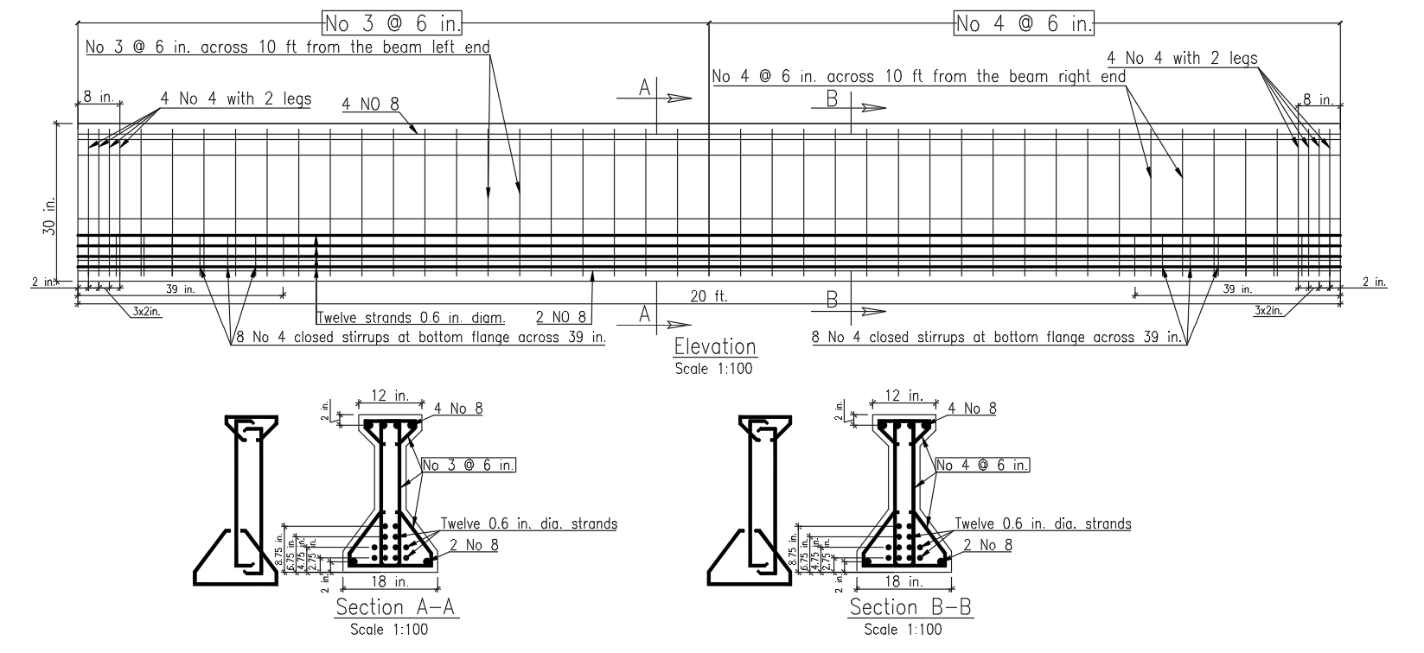
Figure 8. Beam specimen design.

Test setup
The beam is tested under three-point bending at the SEESL at University at Buffalo, as shown in Figure 9. The beam is tested in a load frame using an actuator with a 600 kip capacity. Loading is applied cyclically in downward deflection direction. This allows transient and residual shear crack widths corresponding to increasing loading to be documented. The 20 ft long beam is loaded at midspan with supports located 4 ft away from each end to avoid prestress transfer length to be within the testing regions.
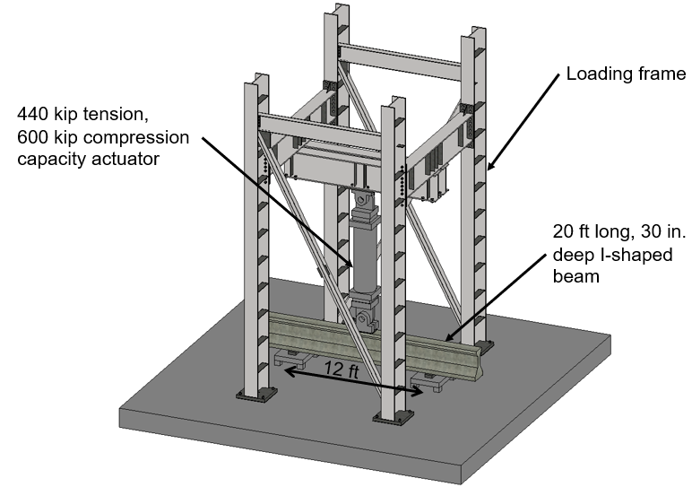
Figure 9. Test setup.

Loading
The beam is subjected to eight compression load cycles. The actuator loading rate is 0.031 in./min for the first two cycles and 0.075 in./min for the remaining six cycles. The loading protocol is shown in Figure 10.

Figure 10. Loading protocol.

Instrumentation
Figure 11 shows the instrumentation. Load, midspan displacement, support displacement, and residual and peak transient shear crack widths were recorded. Additional instrumentation included strain gages on stirrups, strands, and concrete.

Figure 11. Instrumentation.

Task 7. Database update and refined predictions
The test data are added to the existing databases. The applied shear and stiffness data points with their corresponding crack widths are shown in Figure 12 and Figure 13, respectively. In these figures, the data obtained from the tested beam are marked with red markers.

Figure 12. Shear crack width and applied shear values of the updated applied shear database.

Figure 13. Shear crack width and stiffness values of the updated stiffness database.

The web-based evaluation tool is also updated using the expanded database. Shear strength, applied shear, and stiffness of the tested prestressed beam are predicted to demonstrate the use of the tool, and set expectations for error.

Project results

ML algorithm selection
Figure 14 compares the shear strength prediction errors of the three algorithms investigated in Task 2 for a given number of features included in a prediction. The reported errors are from the specific feature(s) that led to the lowest prediction errors. This error is computed as the average of the errors from k-fold cross-validations for these specific features. The smallest MAPE obtained using OLR, SVR, and GPR are 33%, 18%, and 15%, respectively. Except for the prediction with only 1 predictive feature (which is not realistic), GPR consistently has smaller MAPEs compared to the other algorithms. Therefore, GPR is selected as the most suitable algorithm for subsequent predictions of shear strength, applied shear, and stiffness.

Figure 14. Comparison of shear strength prediction errors for the three algorithms: OLR, SVR, and GPR.

The shear strength is also calculated using the approaches of ACI 318-19’s simplified approach, ACI 318-19’s detailed approach, and AASHTO LRFD BDS 2024 for comparison to ML predictions. The MAPE for the shear strength predictions by ACI 318-19’s simplified approach, ACI 318-19’s detailed approach, and AASHTO LRFD BDS 2024 are 40%, 27%, and 38%, respectively. As shown in Figure 14, MAPE for the GRP algorithm is 15%. Although the GPR algorithm has a smaller error compared to the design codes, the higher error of the design specifications is partially due to their intentional conservatism to serve design purposes.

Features influential in predicting shear strength
Figure 15 identifies the feature(s) that lead to the lowest shear strength error considering a specific number of features. The smallest MAPE of the shear strength prediction is also shown in the figure. For example, when the prediction is based on a single feature, d_{p} yields the lowest error, 42%, compared to other combinations with a single feature, indicating that d_{p} is the most influential feature. Figure 15 shows that MAPE does not decrease considerably (≤1%) when five or more features are included in the predictions. This indicates that adding features beyond d_{p}, b_{w}, A_{ps} f_{se}, A_{sv} f_{yv}/s, a/d_{p}, and √f'_{c} provides no significant benefit to the predictions and the remaining features (b_{fb}, A_{sl} f_{yl}, and A_{draped} sinα) have minimal influence on reducing the error. The low predictive contribution of A_{sl} f_{yl} and A_{draped} sinα may be because over 50% of the beams in the training dataset did not have longitudinal reinforcement or draped strands.

* For no. of features between 2-6, there were other combinations of features that led to virtually identical error to the ones presented here.
Figure 15. Features with the least shear strength error using the GPR algorithm for a specific number of features.

Even though the results presented in this section show that some features may have insignificant predictive power, training the GPR algorithm using all features does not require high computational power. Therefore, all nine features are considered for training the GPR algorithms for shear strength. The algorithms that predict applied shear and stiffness had crack width as the additional feature.

Predictions for unseen beams
Shear strength and applied shear are predicted for four beams that were excluded from the training datasets. The beams are noted as G3-1, PS1-0, C80P2S10, and B105 and are tested by Hanson and Hulsbos (1971), Maruyama and Rizkalla (1988), Lee et al. (2010), and De Wilder et al. (2015), respectively. The beams are selected so that they have shear reinforcement smaller (A_{v} < A_{vmin}) and larger (A_{v} ≥ A_{vmin}) than required by ACI 318-19. The predictions for these four beams are summarized in Figure 16. It should be noted that Beam PS1-0 failed due to loss of bond between strands and concrete. Therefore, the measured shear strength of this beam is considered unavailable, and the shear strength is not predicted by ML. Overall, the ML had 2% to 34% error in shear strength predictions.
ML predicted applied shear corresponding to crack widths with an average error between 2% and 15%. The predictions of the four beams are within 15% of and follow the trends measured via testing. The error was higher for beams with less than the minimum required shear reinforcement by ACI 318-19, possibly due to the much smaller number of beams with smaller amounts of reinforcement in the training dataset.

A_{v} < A_{vmin}
Beam “G3-1”
Error in shear strength = 34%
Error in applied shear = 15%

Beam “PS1-0”
Shear strength not predicted due to bond failure in testing.
Error in applied shear = 12%

A_{v} ≥ A_{vmin}
Beam “C80P2S10”
Error in shear strength = 2%
Error in applied shear = 9%

Beam “B105”
Error in shear strength = 4%
Error in applied shear = 2%

Figure 16. Shear strength and applied shear error for four sample beams excluded from the training dataset.

Supplemental data from finite element analysis
Figure 17 shows the results of the FEA model for load-displacement response compared with the experimental results for beam B105 tested by De Wilder et al. (2015). Beam B105 is a 24.8 in. deep I-shaped beam tested under four-point bending, with eight 0.5 in. diameter bottom strands and two 0.4 in. diameter top strands, an initial prestressing of 109 ksi, and a single-leg 0.25 in. diameter shear reinforcement spaced at 5.9 in. The FEA model is considered validated as the shear strength, the load at the onset of flexural cracking, and the load at the onset of web shear cracking are predicted within 8%, 2%, and 0% of the test results, respectively. In addition, similar crack patterns at the ultimate load from FEA and testing provided additional qualitative validation as also shown in Figure 17.
The validated model is used to demonstrate how FEA can be used to obtain additional information on beam condition that ML cannot provide. Figure 17 shows the load at which the onset of stirrup yielding occurs and the extent of stirrup yielding at the ultimate load. This information is invaluable for evaluation of beam health and cannot be obtained from ML.
For example, for the beam shown in Figure 17, at a crack width of 0.7 mm, the applied shear predicted using the ML algorithm for beam “B105” is 81%. The FEA predicts the shear strength as 232 kN. Combining ML and FEA results, the 0.7 mm crack width corresponds to a shear of 81%*232 kN = 188 kN. At this shear level, the FEA results indicate that the stirrups have not yielded, as the onset of stirrup yielding occurs at a shear of 200 kN. Therefore, the beam is considered repairable.

Figure 17. Comparison of shear-displacement relationship and crack patterns from testing and FEA for beam B105 tested by De Wilder et al. (2015).

Predictions of ML trained using existing databases

Shear strength
Figure 18 compares the shear strength predicted using GPR and obtained from the test data. Points lying on the 45-degree line indicate zero-error predictions. Approximately 95% of the predictions had variances below 1.07 kip², while the remaining points were labeled as high-variance predictions, showing lower confidence. The ten-fold error of the predictions is 15% and the coefficient of variation of the ratio of shear strength obtained from testing and predicted using GPR is 0.92.

Figure 18. Shear strength predicted using GPR and obtained from testing.

Applied shear
Figure 19 compares the applied shear predicted using GPR and obtained from the test data. The applied shear corresponding to a given crack width (V_{applied}) is normalized by the shear strength (V_{max}). Approximately 95% of the predictions had variances below 1.08, while the remaining points were labeled as high-variance predictions, showing lower confidence. The ten-fold error of the predictions is 7% and the coefficient of variation of the ratio of applied shear obtained from testing and predicted using GPR is 0.09.

Figure 19. Applied shear predicted using GPR and obtained from testing.

Stiffness by direct method
Figure 20 compares the stiffness predicted using GPR and obtained from the test data. The stiffness corresponding to a given crack width (K_{applied}) is normalized by the initial stiffness (K_{max}). Approximately 95% of the predictions had variances below 1.4, while the remaining points were labeled as high-variance predictions, showing lower confidence. The ten-fold error of the predictions is 18%, which is considered acceptable. However, the predictions have a large scatter. The scatter can be improved when additional data becomes available through testing.

Figure 20. Stiffness obtained from testing and GPR using the direct approach.

Stiffness by indirect method
While the result shown in Figure 20 is encouraging, incorporating additional training data may be able to reduce the scatter and improve the accuracy of the predictions. The indirect method was pursued for this reason as it utilizes a larger training dataset. Figure 21 compares the stiffness predicted using GPR with the values obtained from the test data for a given applied shear. The ten-fold error of the predictions is 41%, indicating relatively large error and scatter. This scattering may be attributed to the indirect modeling approach, in which W_{cr} is not included as a predictive feature. Because W_{cr} is an important damage indicator that captures stiffness degradation associated with beam cracking, excluding it may limit the model’s ability to accurately predict stiffness changes. It is concluded that increasing the database size by including beams that have an indirect link between stiffness and crack widths did not improve the error. Therefore, the direct approach is selected for further analysis.

Figure 21. Stiffness obtained from testing and GPR using the indirect approach.

Pre-test predictions for the tested beam
Prior to testing, a combination of ML, FEA, and design codes are used to predict the behavior of the beam tested within this study to guide the testing and to benchmark predictions before testing. The shear strength of the beam obtained by ML, FEA, AASHTO LRFD BDS, ACI 318-19, and ACI 318-25 prior to testing is summarized in Table 2. ML was the only method that did not underpredict the measured capacity (> 450 kips). All design codes significantly underestimated the measured capacity. The variations in predictions were consistent with the uncertainties associated with shear behavior of concrete structures.

Table 2. Strength predictions of various methods for the test specimen
Prediction Method | Load at failure
Machine learning | 603 kips
FEA | 425 kips
AASHTO LRFD Bridge Design Specifications | 268 kips
ACI 318-25 Detailed method | 346 kips
ACI 318-19 Simplified method | 210 kips

In addition, the FEA was used to predict the loads at which flexure cracking, shear cracking, onset of stirrup yielding occur, as shown in Figure 22. The FEA also provided expected crack patterns and stirrup strains at failure load, as shown in Figure 23.

Figure 22. Shear-displacement relationship from FEA.

Figure 23. Crack patterns and stirrup strains at ultimate load from FEA.

Finally, ML was also used to predict the applied shear corresponding to a set of crack widths for the designed test specimen, as shown in Figure 24. Figure 24 shows that ML predicts the first crack to occur when the applied shear reaches approximately 75% of the shear capacity.

Figure 24. Pre-test GPR predictions of shear history corresponding to crack widths for the test beam.

Test results

Material test results
Three cylinders were tested under axial compression, resulting in an average compressive strength of 10.6 ksi, which is higher than the design compressive strength of 10 ksi. Three additional cylinders were tested in splitting tension, resulting in an average splitting tensile strength of 0.47 ksi, which is lower than the design tensile strength of 0.66 ksi predicted using AASHTO LRFD 2024. As a result of the relatively low tensile strength, flexural cracks due to prestressing were observed at the beam top flange, as shown in Figure 25. These cracks did not affect the beam structural behavior because they were closed during testing and the beam failed in shear.

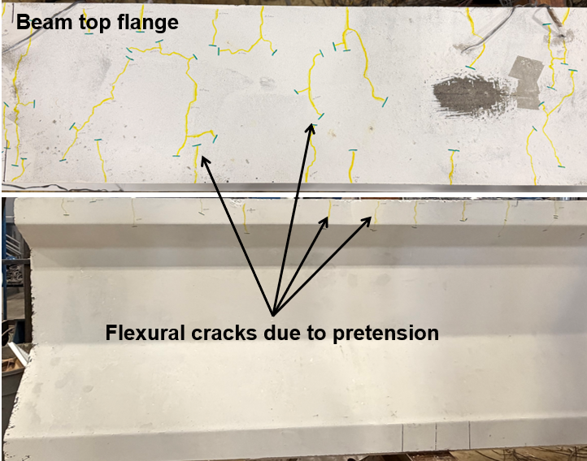
Figure 25. Top flange flexural cracking due to prestressing.

Load-displacement response
Figure 26 shows load-displacement response obtained from testing. The ultimate load, the load at the onset of flexural cracking, the load at the onset of web shear cracking, and the load at the onset of stirrup yielding are marked as observed or measured during testing. The beam was loaded up to 450 kips of applied load when significant cracking and flattening of the load-displacement curve are observed. The testing is stopped at this point to prevent test equipment from being overloaded. The beam is expected to fail at a load between 450 kip and 500 kip. However, in this study, 450 kip is taken as the failure load. The FEA predictions are also shown on Figure 26 as a comparison.

Figure 26. Load versus beam midspan displacement from testing and FEA.

Crack width measurements
Figure 27 shows the residual crack pattern after unloading from the last cycle. The available shear crack width measurements obtained from the existing databases are transient shear crack widths, that is, they were measured when the beam was still under loading during testing. In contrast, field-measured crack widths are typically residual, since the loading that cause the cracks rarely remain on the bridge during inspection. Table 3 shows the ratio of transient shear crack width (W_{cr,t}) to residual shear crack width (W_{cr,r}) at various loading levels. This ratio ranges from 2.5 to 5.0, which indicates that the W_{cr,r} should be converted to W_{cr,t} to be used as an input to the machine learning when field crack-width measurements are taken in the unloaded state.

Figure 27. Beam damage after unloading from the last loading cycle.
Table 3. Ratio of transient to residual shear crack width for the tested beam under various loading levels.
V_{applied}/V_{max} (%) | W_{cr,t} (in.) | W_{cr,r} (in.) | W_{cr,t}/W_{cr,r}
54 | 0.00591 | 0.00197 | 3.0
58 | 0.00787 | 0.00197 | 4.0
64 | 0.00984 | 0.00197 | 5.0
69 | 0.00984 | 0.00394 | 2.5
72 | 0.01181 | 0.00394 | 3.0

Predictions of ML trained using the expanded database
The GPR algorithms were re-trained using the database expanded by the testing performed within this study. When adding new data from the tested beam, transient crack widths are used to be consistent with the existing databases. The updated algorithms are used to predict shear strength, applied shear, and stiffness. The results are compared to the predictions made before the updating of the databases.

Shear strength
Figure 28 compares the shear strength predicted using the GPR algorithm re-trained by the dataset that includes the test specimen. The data points belonging to the tested specimen are marked in red. Before the new specimen is added to the dataset, the ten-fold error is 15% and the coefficient of variation is 0.92, as shown previously in Figure 18. After the tested beam is added to the database, the error becomes 14% and the coefficient of variation becomes 0.58. Adding a single beam to the shear strength database did not decrease the prediction error considerably (~1%). However, it led to a significant reduction in the coefficient of variation of the ratio between experimental and predicted shear strength. This reduction indicates that adding a larger scale beam to the database may help reduce the high-variance samples.
The failure load predicted by the GPR algorithm for the tested beam is 603 kips before the training database is updated. When the algorithm is re-trained, the new prediction for failure load is 458 kip. This is very close to the measured failure load. Although the test is stopped at 450 kip, observations during testing indicated that the beam is expected to fail between 450 and 500 kip.

Figure 28. Shear strength predicted by GPR algorithm trained with the expanded database.

Applied shear
Figure 29 compares the applied shear predicted using the updated GPR. Prior to updating the database, the ten-fold error and the coefficient of variation are 7% and 0.09, respectively (Figure 19). Adding a few crack width vs applied shear data points to the database did not decrease the prediction error and coefficient of variation considerably. This may be due to the beam being already well-represented by the training data or the tendency of ML to overfit.

Figure 29. Applied shear predicted by GPR algorithm trained with the expanded database.

Stiffness
Figure 30 compares the stiffness predicted using GPR trained by the expanded database. When using the existing database to train the stiffness prediction algorithm, the ten-fold error and the coefficient of variation are 18% and 0.47, respectively, as presented in Figure 20 previously. Adding the tested beam to the stiffness database did not decrease the stiffness prediction error and the coefficient of variation.

Figure 30. Stiffness predicted by GPR algorithm trained with the expanded database.

Post-test prediction for the tested beam
The ML algorithms re-trained using the database expanded by the addition of the tested beam are used to predict the shear strength, applied shear, and stiffness of the beam. While pre-test predictions presented earlier provide predictions for a beam unseen by the algorithm, the post-test predictions ensure the beam is represented by the training data.

Shear strength
The updated GPR algorithm predicted a failure load of 458 kips, which closely agrees with the ultimate load of 450 kips obtained from the final testing cycle. The measured failure is expected within 450 kip to 500 kip load range.

Applied shear
Figure 31 compares the applied shear predicted using the updated GPR algorithm with the values obtained from the test data for the tested beam. The values are provided for transient crack widths measured during testing. The applied shear predictions for given crack widths closely match the measured applied shear values.

Figure 31. Applied shear predicted by the updated GPR algorithm and measured by testing.

Stiffness
Figure 32 compares the stiffness predicted using the updated GPR algorithm with the values obtained from the testing. The stiffness values are predicted for measured transient crack widths shown in Table 3. The stiffness predicted by GPR acceptably matches the ones measured by testing with a small MAPE of 3%.

Figure 32. Stiffness predicted by the updated GPR algorithm and measured by testing.

Web application for implementation
A web application is developed and is available at the following link: https:/ /hassan-lasheen.onrender.com/. The application uses GPR algorithms trained using the databases updated with the tested beam. The user interface of the web application is shown in Figure 33.

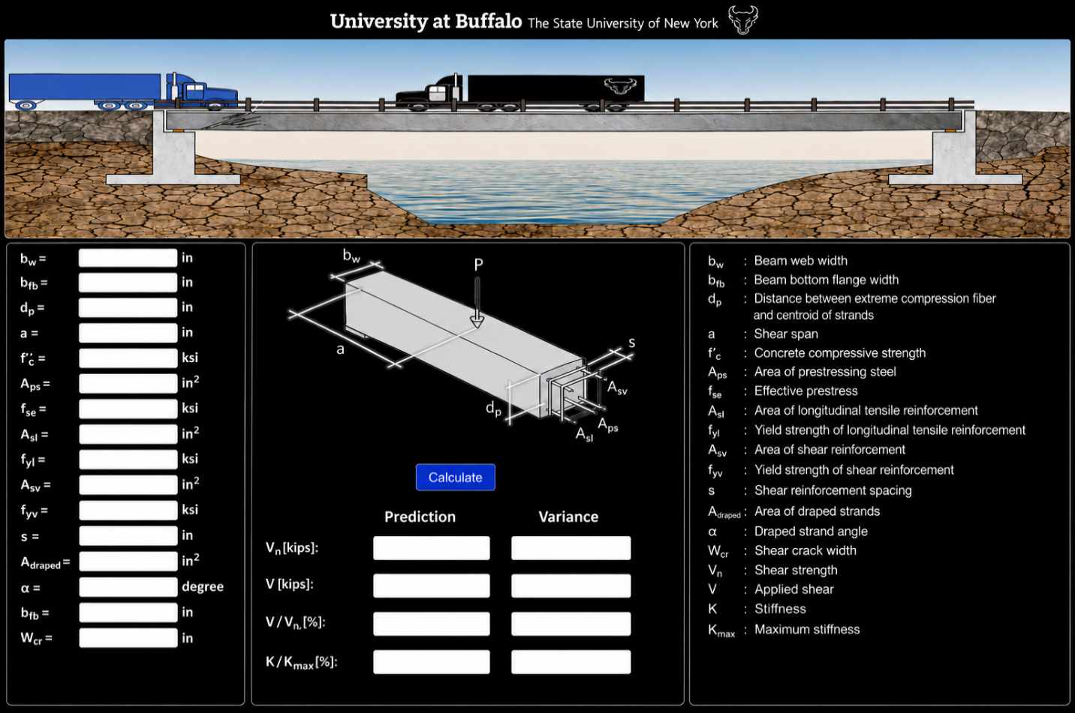
Figure 33. User interface of the developed web application.

Conclusions and recommendations

Conclusions
This study developed a machine learning (ML) tool implemented through a web-interface to evaluate prestressed concrete (PC) girders that have shear cracks. Three Gaussian process regression (GPR) algorithms were trained to predict shear strength, applied shear, and stiffness. The applied shear was defined as the shear at a given crack width normalized by the shear strength, while stiffness was defined as the stiffness corresponding to a crack width normalized by the initial stiffness. The GPR algorithms were trained considering all input features related to beam geometry, material properties, reinforcement details and, for applied shear and stiffness predictions, shear crack widths. Influential features for shear strength predictions are documented. To understand the prediction accuracy of the developed ML tool, to improve its predictions, and to investigate the relationship between the peak transient shear crack widths in the loaded state and the residual shear crack widths in the unloaded state, a 30-inch deep pretensioned beam was designed and tested under quasi-static cyclic loading.
The main conclusions are the following:
- The GPR algorithm has less mean absolute prediction error (15%) than support vector regression (18%) and ordinary linear regression (33%) algorithms in predicting shear strength and is used in all predictions in this study.
- The GPR algorithms provided reasonable predictions of the shear strength, applied shear, and stiffness for PC girders with ten-fold errors of 15%, 7%, and 18%, respectively. The error did not change significantly when an additional beam tested through this study is added to the training database. However, the scatter in shear strength predictions reduces significantly as evident by the coefficient of variation changing from 0.92 to 0.58. The reduction may be attributed to the fact that most beams in the shear strength database are relatively small in size. Therefore, adding a new larger sized beam can improve the predictions.
- Shear strength predictions of ML had smaller errors compared to the predictions of ACI 318-19’s simplified and detailed approaches, and AASHTO LRFD 2024. However, the larger errors in shear strength predictions of design codes are attributed to their intended conservativeness.
- Stiffness predictions had a large scatter indicated by a large coefficient of variation (0.47). This is attributed to the limited size of the stiffness dataset (37 beams with 254 stiffness datapoints). The error and scatter in the stiffness predictions can be reduced by additional and higher quality data when data become available in the future.
- Training the GPR algorithm using all possible feature combinations indicated that d_{p}, b_{w}, A_{ps} f_{se}, A_{sv} f_{yv}/s, a/d_{p}, and √f'_{c} have significant influence on shear strength predictions, while the remaining features (b_{fb}, A_{sl} fyl, and A_{draped} sinα) have minimal influence on the shear strength prediction. The insignificant predictive power of A_{sl} f_{yl} and A_{draped} sinα may be due to the majority of the beams in the training dataset not having longitudinal reinforcement or draped strands. Because additional input features do not increase the computational cost of running the algorithms, all features are considered in predictions.
- Supplementation of the ML predictions using finite element analysis (FEA) is demonstrated for an example beam. The process involves obtaining the applied shear to shear capacity ratio corresponding to a crack width from ML, calculating the applied shear using the shear capacity predicted by FEA or ML, and documenting the stress state of stirrups, prestressing strands, and concrete at this applied shear. The additional information on stirrups, prestressing strands, and concrete can be compared to yield, fracture, and crushing limits of the materials and help the bridge owners prioritize intervention actions.
- The tested beam resists much larger loads (>450 kips) than those predicted by design codes. The capacity is predicted as 268 kips by AASHTO LRFD BDS 2024, 346 kips by ACI 318-25 detailed method, and 210 kips by ACI 318-19 simplified method. In comparison, FEA predicts the capacity much better as 425 kips. ML predicts the capacity as 603 kips using the training set that exclude the tested beam and as 458 kips using the training set that include the tested beam. Out of all methods, ML is the only one that did not underestimate the capacity. When the training set included the tested beam, the capacity prediction is very close to the measured capacity.
- The transient and residual shear crack width measurements obtained from the tested beam show that the transient crack width was approximately 2.5 to 5.0 times greater than the residual crack widths. This finding is significant because the crack widths in the existing databases are transient. On the other hand, crack widths measured in the field are residual. This indicates that the residual crack widths measured in the field may need to be converted into transient crack widths to be used as input for the GPR algorithms. Additional data is needed to develop a conversion method.

Recommendations
Based on the findings of this study, the following recommendations are made:
- A new data-driven tool is developed to evaluate prestressed concrete beams with shear cracks. The tool can be used by bridge owners and engineers for prioritizing intervening actions.
- ML and FEA can be used as tools to better estimate the capacity as design code estimations of shear capacity tend to be very conservative. This level of conservativeness may not be needed for evaluation of existing infrastructure.
- While the developed ML tool has acceptable accuracy in an average sense, the performance of the ML depends on the size and quality of training data. Users should pay attention to how well the beam they are evaluating is represented by the training data. The ML predictions are expected to lead to larger errors when the evaluated beam features are much different than the ones used to train the algorithms. Nevertheless, the ML tool can be updated for better accuracy as new data becomes available.

Practical application on transportation infrastructure
This study developed a new data-driven tool for evaluating prestressed concrete bridge beams that have shear related distress. The tool supports bridge engineers in making inspection, repair, maintenance, and retrofit decisions for an individual bridge or to prioritize these actions for multiple bridge in an inventory. Therefore, this research improves asset management and safety by enabling timely and informed intervening actions.

References

AASHTO. 2018. "Manual for Bridge Element Inspection." American Association of State Highway and Transportation Officials, 3rd edition.
AASHTO. 2024. "AASHTO LRFD Bridge Design Specifications." Washington, DC: American Association of State Highway and Transportation Officials, 10th edition.
ACI Committee 318. 2019. Building Code Requirements for Structural Concrete (ACI 318-19) and Commentary on Building Code Requirements for Structural Concrete (ACI 318R-19). Farmington Hills, MI: American Concrete Institute.
Athanasiou, A., A. Ebrahimkhanlou, J. Zaborac, T. Hrynyk and S. Salamone. 2020. "A machine learning approach based on multifractal features for crack assessment of reinforced concrete shells." Computer‐Aided Civil and Infrastructure Engineering 35(6): 565-578. doi: 10.1111/mice.12509
Bedriñana, L. A., J. Sucasaca, J. Tovar and H. Burton. 2023. "Design-oriented machine-learning models for predicting the shear strength of prestressed concrete beams." Journal of Bridge Engineering 28(4): 04023009. doi: 10.1061/JBENF2.BEENG-6013
Bruce, R. N. 1962. "An experimental study of the action of web reinforcement in prestressed concrete beams." Ph.D. Dissertation, University of Illinois at Urbana-Champaign, 248 pp.
Castillo, R., N. Elhami-Khorasani, P. Okumus and V. Chandola. 2024. "Using crack width for shear, stiffness, and stirrup strain history predictions for reinforced concrete beams." Structure and Infrastructure Engineering: 1-13. doi: 10.1080/15732479.2024.2359488
Castillo, R., P. Okumus, N. E. Khorasani and V. Chandola. 2025. "Shear Condition Classification of Cracked Reinforced Concrete Beams Using Machine Learning." Journal of Bridge Engineering 30(7): 04025040. doi: 10.1061/JBENF2.BEENG-7290
Davoudi, R., G. R. Miller and J. N. Kutz. 2018. "Structural load estimation using machine vision and surface crack patterns for shear-critical RC beams and slabs." Journal of Computing in Civil Engineering 32(4): 04018024. doi: 10.1061/(ASCE)CP.1943-5487.0000766
De Silva, S., H. Mutsuyoshi and E. Witchukreangkrai. 2008. "Evaluation of shear crack width in I-shaped prestressed reinforced concrete beams." Journal of Advanced Concrete Technology 6(3): 443-458. doi: 10.3151/jact.6.443
De Wilder, K., P. Lava, D. Debruyne, Y. Wang, G. De Roeck and L. Vandewalle. 2015. "Experimental investigation on the shear capacity of prestressed concrete beams using digital image correlation." Engineering Structures 82: 82-92. doi: 10.1016/j.engstruct.2014.10.034
Ebrahimkhanlou, A., A. Athanasiou, T. D. Hrynyk, O. Bayrak and S. Salamone. 2019. "Fractal and Multifractal Analysis of Crack Patterns in Prestressed Concrete Girders." Journal of Bridge Engineering 24(7): 04019059. doi:10.1061/(ASCE)BE.1943-5592.0001427
Ebrahimkhanlou, A., A. Farhidzadeh and S. Salamone. 2016. "Multifractal analysis of crack patterns in reinforced concrete shear walls." Structural Health Monitoring 15(1): 81-92. doi: 10.1177/1475921715624502
Farhidzadeh, A., E. Dehghan-Niri, A. Moustafa, S. Salamone and A. Whittaker. 2013. "Damage Assessment of Reinforced Concrete Structures Using Fractal Analysis of Residual Crack Patterns." Experimental Mechanics 53(9): 1607-1619. doi: 10.1007/s11340-013-9769-7
Fathalla, E., Y. Tanaka and K. Maekawa. 2018. "Remaining fatigue life assessment of in-service road bridge decks based upon artificial neural networks." Engineering Structures 171: 602-616. doi: 10.1016/j.engstruct.2018.05.122
Hanson, J. M. and C. Hulsbos. 1971. "Ultimate Shear Tests of Large Prestressed Concrete Bridge Beams." ACI Symposium Publication 26: 523-551. doi: 10.14359/17990
Heckmann, C. and O. Bayrak. 2008. "Effects of increasing the allowable compressive stress at release on the shear strength of prestressed concrete girders." Master’s thesis, University of Texas at Austin, 175 pp.
Jang, H., S. Han and O. Bayrak. 2025. "Data-Driven Machine Learning for Predicting the Strength of Pretensioned Concrete Girders Considering Shear Failure Mode." Journal of Structural Engineering 151(8): 04025116. doi: 10.1061/JSENDH.STENG-14496
Joshi, S. S., N. Thammishetti and S. S. Prakash. 2018. "Efficiency of steel and macro-synthetic structural fibers on the flexure-shear behaviour of prestressed concrete beams." Engineering Structures 171: 47-55. doi: 10.1016/j.engstruct.2018.05.067
Lantsoght, E. O. L., C. v. d. Veen, J. C. Walraven and A. d. Boer. 2016. "Case Study on Aggregate Interlock Capacity for the Shear Assessment of Cracked Reinforced-Concrete Bridge Cross Sections." Journal of Bridge Engineering 21(5): 04016004. doi: 10.1061/(ASCE)BE.1943-5592.0000847
Lee, S.-C., J.-Y. Cho and B.-H. Oh. 2010. "Shear Behavior of Large-Scale Post-Tensioned Girders with Small Shear Span-Depth Ratio." ACI Structural Journal 107(2): 137-145. doi: 10.14359/51663529
Maruyama, K. and S. H. Rizkalla. 1988. "Shear design consideration for pretensioned prestressed beams." ACI Structural Journal 85(5): 492-498. doi: 10.14359/2782
Nakamura, E., A. R. Avendaño and O. Bayrak. 2013. "Shear Database for Prestressed Concrete Members." ACI Structural Journal 110(6): 909-918. doi: 10.14359/51686147
Paolo M. Calvi, E. C. B. and P. C. Michael. 2018. "Model for Assessment of Cracked Reinforced Concrete Membrane Elements Subjected to Shear and Axial Loads." ACI Structural Journal 115(2): 501-509. doi: 10.14359/51701093
Perumalla, M., R. Yogeendra and A. Laskar. 2022. "Shear Tests on Post-Tensioned High-Strength Self-Consolidating Concrete I-Beams under Distributed Loads." ACI Structural Journal 119(1): 3-14. doi: 10.14359/51734215
Sung, W., N. Potnuru, S. Alfaris, P. Sideris, S. Paal, M. Koliou, A. Birely, M. B. Hueste and S. Hurlebaus. 2025. "Shear capacity prediction model for prestressed concrete beams via data-driven methods." Structures 71: 108122. doi: 10.1016/j.istruc.2024.108122
Teoh, B., M. Mansur and T. Wee. 2002. "Behavior of high-strength concrete I-beams with low shear reinforcement." ACI Structural Journal 99(3): 299-307. doi: 10.14359/11913
Vecchio, F. Formworks, VecTor2 & Augustus Bundle. (Ver. 4.4 Basic)
Villamizar, S., J. A. Ramirez and G. Aguilar. 2017. "Shear Strength and Behavior of High-Strength Concrete Prestressed Beams." ACI Structural Journal 114(1): 277-289. doi: 10.14359/51689458
Xiaoyi XuanI, S. R. and M. Kyuichi. 1988. "Effectiveness of Welded Wire Fabric as Shear Reinforcement in Pretensioned Prestressed Concrete T-Beams." ACI Structural Journal 85(4): 429-436. doi: 10.14359/2711
Zaborac, J., A. Athanasiou, S. Salamone, O. Bayrak and T. D. Hrynyk. 2020. "Crack-based shear strength assessment of reinforced concrete members using a fixed-crack continuum modeling approach." Journal of Structural Engineering 146(4): 04020024. doi: 10.1061/(ASCE)ST.1943-541X.0002564

Acknowledgements
This work is supported by the US Department of Transportation, Tier 1 University Transportation Center (Transportation Infrastructure Precast Innovation Center) and Institute of Bridge Engineering, University at Buffalo, The State University of New York. Any opinions, findings, conclusions, or recommendations expressed in this material are those of the authors and do not necessarily reflect the views of the supporting agencies.

