Report No.  UI-24-RP-05 |  | - Government Accession No  N/A | - Recipient’s Catalog No.  N/A
- Title and Subtitle  Leveraging artificial intelligence and mechanics to model concrete creep |  |  | - Report Date  March 2026
- Performing Organization Code

N/A
- Author(s)  Ramez Hajj, Assistant Professor, https://orcid.org/0000-0003-0579-5618  Babak Asadi, Graduate Research Assistant, https://orcid.org/0000-0002-4946-8793 |  |  | - Performing Organization Report No.  UI-24-RP-05
- Performing Organization Name and Address  University of Illinois Urbana-Champaign  Civil & Environmental Engineering  205 N Mathews Ave, Urbana, IL 61801 |  |  | - Work Unit No.  N/A
- Contract or Grant No.

69A3552348333
- Sponsoring Organization Name and Address  Transportation Infrastructure Precast US Department of Transportation  Innovation Center (TRANS-IPIC) Office of Research, Development and University of Illinois Urbana-Champaign. Technology (RD&T)  Civil & Environmental Engineering. 1200 New Jersey Avenue, SE  205 N Mathews Ave, Urbana, IL 61801 Washington, DC 201590 |  |  | - Type of Report and Period Covered  Final Report  January 2025 – December 2025
14. Sponsoring Agency Code

N/A
15. Supplementary Notes

For additional reports and information visit the TRANS-IPIC website https://trans-ipic.illinois.edu
16. Abstract

This project investigated data-driven prediction of concrete creep compliance $J$to support transportation infrastructure design, with emphasis on prestressed and precast systems where creep contributes to prestress loss and long-term deflections. Using the Northwestern concrete creep database, we replicated state-of-the-art deterministic tree ensembles (Random Forest, XGBoost, LightGBM) as baselines and developed two complementary models: a probabilistic artificial neural network with Monte Carlo dropout (ANN-MC) for uncertainty quantification and a Kolmogorov–Arnold Network (KAN) for interpretable functional modeling. ANN-MC achieved the best test performance (R²=0.963, RMSE=11.359, MAE=3.813), while KAN remained competitive (R²=0.958, RMSE=12.166, MAE=4.560) and enabled interpretation via PD/ICE analyses and feature ranking. The best-performing model was deployed as a public web tool to enable rapid screening and scenario exploration for engineering practice.
17. Key Words  [Enter words, terms, or phrases that identify important topics in the report. When possible, terms should be selected from the Transportation Research Thesaurus (TRT) (http://trt.trb.org) in addition to terms not found in the TRT. |  |  |  | 18. Distribution Statement  No restrictions.
19. Security Classification (of this report)  Unclassified. | 20. Security Classification (of this page)  Unclassified. |  |  | 21. No. of Pages  [Enter No. pages] | 22. Price  N/A
Disclaimer:
The contents of this report reflect the views of the authors, who are responsible for the facts and the accuracy of the information presented herein. This document is disseminated in the interest of information exchange. The report is funded, partially or entirely, under 69A3552348333 from the U.S. Department of Transportation’s University Transportation Centers Program. The U.S. Government assumes no liability for the contents or use thereof.



Transportation Infrastructure Precast Innovation Center
(TRANS-IPIC)

University Transportation Center (UTC)

Leveraging artificial intelligence and mechanics to model concrete creep
UI-24-RP-05

FINAL REPORT

Submitted by:
Ramez Hajj, Assistant Professor, rhajj@illinois.edu
Department of Civil & Environmental Engineering
University of Illinois Urbana-Champaign

Submitted to:
TRANS-IPIC UTC
University of Illinois Urbana-Champaign
Urbana, IL

Executive Summary:

Time-dependent deformation (creep) in concrete is a major driver of long-term serviceability problems in transportation structures, especially in precast and prestressed systems where creep contributes to prestress loss, increased deflections, and cracking. Predicting creep compliance $J$across a wide range of mixture designs, environmental conditions, specimen geometries, and loading histories remains challenging because the governing behavior is nonlinear, multivariate, and affected by unavoidable variability in materials and testing.

This project developed an artificial intelligence–enabled framework, informed by viscoelastic mechanics concepts, to predict concrete creep compliance using the Northwestern concrete creep database. The modeling dataset comprised 26,813 processed creep-compliance records described by 14 input variables spanning mixture proportions and constituents, strength, humidity and temperature conditions, geometry descriptors, and time/loading descriptors. The study established a rigorous benchmark by reproducing widely used, state-of-the-art tree-based regressors as deterministic baselines and then advancing two complementary models that address key gaps for mechanics-driven use: uncertainty quantification and interpretability.

Three tree-ensemble baselines (Random Forest, XGBoost, LightGBM) reproduced strong point-prediction accuracy (test $R^{2}$in the 0.946–0.953 range; RMSE in the 13.9–14.8 range), but they remain limited for reliability-oriented engineering decisions because they do not directly provide predictive uncertainty. To address this, a probabilistic ANN with Monte Carlo dropout (ANN-MC) was developed, achieving the best overall predictive performance (test $R^{2}=0.963$, RMSE $=11.359$, MAE $=3.813$) while also producing an uncertainty band through repeated stochastic inference. Relative to the best replicated tree baseline (LightGBM), ANN-MC reduced RMSE from 13.901 to 11.359 (18.3%) and reduced MAE from 4.830 to 3.813 (21.1%).

In parallel, an interpretable Kolmogorov–Arnold Network (KAN) was trained as a functional surrogate with competitive accuracy (test $R^{2}=0.958$, RMSE $=12.166$, MAE $=4.560$) and a structure that supports direct interpretation via learnable one-dimensional spline edge functions. Interpretation was demonstrated using partial dependence (PD) curves (global marginal trends) and individual conditional expectation (ICE) curves (sample-specific trajectories that reveal heterogeneity and interactions), together with a PD-based feature ranking that identified temperature $T$as the dominant driver, followed by cement content $c$and age at loading $t_{0}$, with $a/c$, $RH_{\text{test}}$, and $w/c$ forming the next influence tier.

To facilitate adoption, the best-performing model (ANN-MC) was deployed for public use as a web application. This tool enables rapid screening and scenario exploration by returning immediate estimates of $J$with uncertainty information, supporting early-stage mixture evaluation, sensitivity studies, and decision support for prestressed and precast applications.

Table of Contents

Executive Summary [i]
1. Problem description [1]
2. Fundamentals of concrete creep [2]
2.1. Overview of creep in viscoelastic aging materials [2]
2.2. Types of viscoelastic material models [2]
2.3. Causes of creep in concrete [4]
2.4. Effect of mix design variables [5]
2.5. Applications of viscoelasticity theory [6]
2.5.1. Viscoelasticity in the microprestress theory and other creep theories [6]
2.5.2. Micromechanical modeling [7]
2.6. Consideration of thermal effects [8]
2.7. Connections to numerical and computational modeling [8]
2.8. Relationship to creep Poisson’s ratio in concrete [8]
2.9. Connection to prestress loss in concrete structures [9]
3. Physics-informed machine learning for creep [10]
3.1. Physics-regularized life prediction and inverse identification [10]
3.2. Physics-informed surrogates and structural analogues [11]
3.3. History-aware operators and variational formulations [12]
3.4. Synthesis, limitations, and directions [12]
4. Research scope and objectives [15]
5. Research description [17]
5.1. Creep dataset [17]
5.2. Machine learning models [17]
5.2.1. Probabilistic ANN model [17]
5.2.2. Kolmogorov–Arnold Networks (KANs) [18]
5.3. Evaluation metrics [21]
6. Project results [22]
6.1. Dataset statistics [22]
6.2. Tree-based baseline models [23]
6.3. Probabilistic ANN (MC dropout) model [24]
6.4. KAN model [26]
6.4.1. KAN architecture and performance [26]
6.4.2. Interpretations based on KAN model [28]
6.5. Web tool for creep compliance prediction [32]
7. Conclusions and recommendations [33]
8. Practical application/impact on transportation infrastructure [34]
9. References [35]

- Problem description

Creep is defined as the deformation of a material under a constant load. In cementitious concrete structures, creep is most often observed due to the self-weight of the structure or other dead loads. Over the last several decades, researchers have sought to understand the fundamental mechanics underlying creep in concrete. Concrete typically displays linear elastic behavior when it is mechanically loaded. However, creep has been represented as a viscoelastic phenomenon, meaning that the material can be modeled as a time-dependent material, for which its response depends on loading time.

Creep is particularly critical for prestressed concrete structures, as excessive creep can result in prestress loss. Therefore, it is critical and timely to consider the overall effects of creep on concrete, including the mechanical models which can predict and represent this behavior. Furthermore, it is important to understand the mix design factors which govern creep in concrete. This study seeks to utilize existing datasets to explore this problem.

One of the major goals of TRANS-IPIC is to extend the life of existing transportation infrastructure through the development of novel materials and technologies in precast concrete (PC). Extending the durability of PC requires a thorough understanding of the mechanisms which cause it to fail prematurely. In many cases, creep can cause substantial issues affecting the performance of PC, and concrete in general, which reduces its service life due to substantial cracking. Considering the interest of TRANS-IPIC specifically in prestressed concrete as well, this project is of substantial interest, because creep can result in prestress loss in concrete. Because the creep response in concrete depends on so many factors, this study will explore the response of concrete and PC to creep loading and develop a predictive algorithm based on the latest methods in machine learning, which will allow for newfound insights into creep of PC to better design and formulate concrete which is more durable against this issue. This study will also present a framework for integrating mechanics into these machine learning-driven creep predictions and a method for obtaining closed-form solutions which can be used in solving problems from a mechanics perspective.

- Fundamentals of concrete creep

2.1. Overview of creep in viscoelastic aging materials

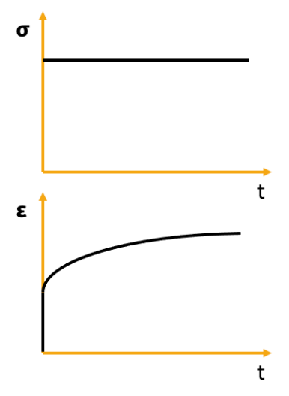
The creep response of a viscoelastic material occurs when a constant load is applied. The material's response has two parts, an elastic part of the response which results in instantaneous deformation, and a viscous part which results in time-dependent deformation. Figure 1 shows the loading input and resultant creep response of a viscoelastic material. Similarly, when the load is removed, some of the deformation is restored to its original position instantaneously, while the other part is restored over time, as long as the material stays within its linear viscoelastic deformation range.

Figure 1. Input loading and resultant response for creep of a viscoelastic material.
When creep is applied, the resulting material property measured is creep compliance, represented as D(t) (in flexure, tension, or compression) or J(t) (in shear). However, it should be noted that creep in concrete is often represented as J(t) generically. For a linear elastic material, compliance is the direct inverse of modulus, either in flexure/tension/compression or shear. However, this relationship does not hold true for linear viscoelastic materials in the time domain. Therefore, the modulus of a viscoelastic material cannot be directly obtained under creep loading.

Because of the long time scale at which creep occurs in concrete, the aging of concrete must be simultaneously considered. This is because concrete is a reactive material, in which hydration occurs over long times due to chemical reactions between cement and water, which results in concrete's hydration products (Bazant, 1977). Furthermore, the history of the material is critical. The history is represented mechanically by the superposition principle, which states that the sum of responses to two different stress histories in a material is the sum of the two deformation responses. Assuming the superposition principle holds true, the constitutive law governing concrete creep can be represented by Equation 1 (Bazant, 1975).

$$ε\left(t\right)-ε^{θ}\left(t\right)=\int_{0}^{t}{J\left(t,t^{'}\right)dσ(t^{'})}$$ | (1)

Where:
$ϵ\left(t\right)$ = strain,
$ϵ^{θ}\left(t\right)$ = stress-independent inelastic strain due to shrinkage and thermal expansion,
$J(t,t')$ = creep compliance function of the material, which is defined as the stress at time t due to a constant unit stress applied at time t', and
$σ\left(t\right)$ = stress.

2.2. Types of viscoelastic material models

There are several models which can capture the viscoelastic nature of a material which exhibits creep. Mechanical models capture the behavior of the material by piecing together “elements” of different types and arrangements to form a mechanical response to loading or deformation. The two most commonly used elements are elastic springs, and viscous dashpots. Elastic spring elements act in accordance with Hooke's law (Equation 2). Viscous dashpot elements follow the principles of a Newtonian fluid, in which viscosity is proportional to stress divided by strain rate (Equation 3).

$$σ= Eϵ$$ | (2)
$$σ=η\frac{dϵ}{dt}$$ | (3)
Where:
$σ$ = stress
E = Young’s modulus
$η$ = viscosity, and
$ϵ$ = strain.

The simplest two models which are commonly used are the Maxwell model and Kelvin-Voigt model (Shitkova & Krusser, 2022). The Maxwell model consists of a spring and dashpot element in series, so that the sum of their strains is equal to the total strain of the system and the total stress is equal to the stress in each element. The Kelvin-Voigt model places the spring and dashpot elements in parallel and, therefore, the total strain is equal to the strain in each element, and the total stress is equal to the sum of the spring and dashpot stress. In general, Kelvin-Voigt models are considered the more appropriate models for creep, but both can be used. A summary of both models is shown in Figure 2.

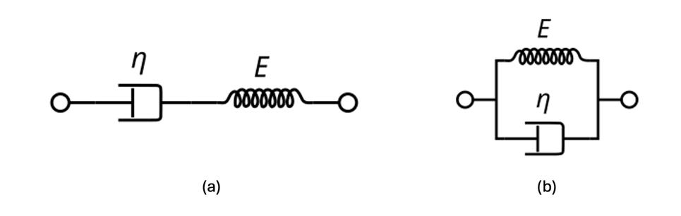
Figure 2. Schematic of (a) Maxwell model and (b) Kelvin-Voigt model.
As these two models alone cannot adequately describe most viscoelastic behavior, several models build on these. The Generalized Maxwell model utilizes a series of Maxwell elements in parallel with each other, with a single spring also in parallel representing the fully elastic part of the material response. One common form of this model is a Standard Linear Solid (SLS) model, also called the Zener model, which consists of a Maxwell element in parallel with a single elastic spring element. When it comes to four-element models, Burgers model is one of the most common models used as it can capture the elastic and viscous behavior of a material well. The Burgers model consists of a combination of a Maxwell and Kelvin-Voigt element to create a four element model. This model can consist of two Maxwell elements in parallel, or a Kelvin-Voigt element in series with a Maxwell element. When more parameters are needed, the Generalized Kelvin-Voigt model can be used, which consists of several Kelvin-Voigt elements in series. A more complete description of each of these models and the underlying constitutive equations can be found in Shitkova & Krusser (2022).

Another approach is to use fractional calculus in the formulation of such models. In these formulations, a fractional derivative is used to represent some or all of the dashpot elements in the model. The fractional derivative element can be represented by the model proposed by Koeller (1984) (Equation 4). A full discussion of the derivation of this formulation and history behind it can be found in Shitkova & Krusser (2022).

$$σ=Eτ_{σ}^{γ}D^{γ}ε$$ | (4)
Where:
$τ_{σ}^{γ}=η/E$ or retardation time,
$γ$ is the memory parameter ranging from 0 (elastic solid) to 1 (viscous fluid), and
$D^{γ}ε$ is the fractional derivative of deformation versus time.

Finally, other phenomenological models exist for fitting data from experiments on viscoelastic materials. One of the most common models generally used is the Prony series; however, this model is designed specifically for relaxation experiments (where deformation is controlled and load is measured). Therefore, its coefficients cannot be easily obtained for creep experiments or measurements. For this reason, more simplistic models such as variations of the power law functions have been used to fit creep data (Bazant & Chem, 1985a; Bazant & Chem, 1985b; Wittmann & Beltzung, 2016).

Although many are covered in more detail later in this paper, a brief summary of some studies which have used each model type for studying concrete creep are described in Table 1. This table is not comprehensive, but can serve as a reference for readers looking to learn more about applying the specific models to concrete creep.

Table 1. Example uses of classic rheological phenomenological models to capture creep behavior of concrete.

Model Type | Description | Uses in Concrete Creep
Maxwell model and modifications | Generalized Maxwell Model | Bazant & Wu (1974)
Maxwell model and modifications | Use of structural derivatives | Liang & Guan (2022)
Kelvin-Voigt Model and modifications | Generalized Kelvin-Voigt Model | Bazant & Asghari (1974)
Kelvin-Voigt Model and modifications | Other modifications to model | De Schutter (2004)  Benboudjema & Torrenti (2008)  Briffaut et al. (2012)
Fractional Calculus | Single fractional element  Fractional Kelvin-Voigt Model  Fractional Maxwell Model | Ribeiro et al. (2021)  Bourns & Vrcelj (2023)  Mei et al. (2023)  Chen et al. (2024)

2.3. Causes of creep in concrete

The first step toward describing the causes of creep in concrete is separating the creep response from the shrinkage response. Both creep and shrinkage cause time-dependent strain in concrete. However, the creep response is caused by mechanical loading while the shrinkage response is caused by the change in volume of the concrete due to its moisture volumetric changes. Figure 3 shows the parts of the creep response and shrinkage response and how they occur over time. As with all viscoelastic materials, the creep response occurs most rapidly during the early loading of the structure. Some studies have shown that up to 50% of creep occurs in the first three months and that 90% occurs in the first three years (Gilbert & Ranzi, 2010; Huang et al., 2023). In this figure, two types of creep are observed, basic creep and drying creep.
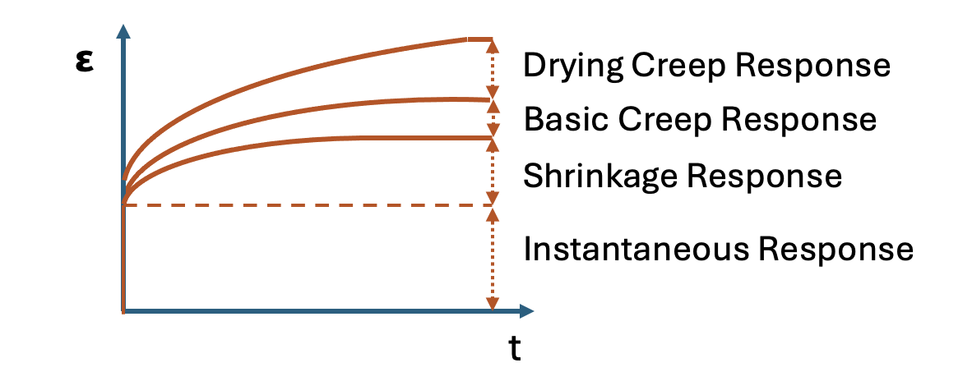
Figure 3. Deformation of loaded concrete specimens due to shrinkage and creep (adopted from Huang et al. (2023))
Basic creep has been described through many mechanisms, with several theories including seepage theory, viscous shear theory, microcrack theory, and microprestress-solidification theory. A full review detailing all of these can be found elsewhere (Hong et al., 2023). Meanwhile, drying creep, which should not be confused with drying shrinkage, is often described by the so-called “Pickett effect.” This effect involves increased local stresses in empty pores as the specimen dries and therefore additional deformation in the solidified cement (Brooks, 2001) while microcracking due to the drying also plays a role in this effect (Altoubat & Lange, 2002; Bazant & Yunping, 1994).

2.4. Effect of mix design variables

Several mix design factors therefore have an impact on concrete creep. In a typical concrete mix, the design factors include cement type and amount, water/cement ratio, aggregate type, sand type, and coarse/fine aggregate ratios. Nowadays, several admixtures are also commonly used which have an impact on concrete durability, including the creep response. The largest database of creep and shrinkage data for concrete comes from the Northwestern University database, collected as part of RILEM TC107 (Bazant & Panula, 1978; Bazant et al., 1991; Hubler et al., 2015; Wendner et al., 2015), which is publicly available (Bazant & Li, 2008). This database resulted in the presentation of the B4 model. Since then, however, several researchers have also applied machine learning techniques to study this database and develop predictive models for concrete creep (Han et al., 2016; Li et al., 2021; Hilloulin & Tran, 2022; Liang et al., 2022). Other machine learning models based on several literature datasets and experimental data have also been developed in the last several years (Bouras & Li, 2023). Other researchers have also developed modifications to the B4 model for specific types of concrete, such as fly ash concrete (Cao et al., 2024).

A range of other studies have been conducted to better understand the importance of mix design variables on concrete creep. Another publicly available dataset from IFSTARR provided insights into creep of high performance concrete (HPC) and indicated that a quasi-linear function of water to cement ratio and aggregate content could model HPC creep well (Le Roy et al., 2017). Reddy & Ramaswamy (2018) examined several different mixes and assessed factors affecting their creep. One of their findings was a mix with hematite aggregate showed the most creep due to the limited water absorption of that aggregate type. Fly ash, which resulted in more hydration and therefore stiffer concrete, resulted in less creep strain, as expected. A higher aggregate to cement ratio was also shown to result in lower creep, while one self-consolidating mix showed the least creep, which was observed to be due to the low permeability and therefore slower drying. Considering all of these mixtures, they developed a new model based on the micro-prestress theory. The model was later built upon by the same research group and was found to consider the effect of aggregate stiffness on creep in a way that typical concrete design codes cannot (Pal & Ramaswamy, 2024). Other studies have demonstrated the impacts of supplementary cementitious materials (SCMs) such as ground granulated blast furnace slag (GGBFS) on creep deformations, although some studies have shown increases in creep (Shariq et al., 2016) while others showed reductions in creep deformations (Li & Yao, 2001; Zhang et al., 2024). A more thorough summary, although far from exhaustive, of recent studies and the effect of different mix design variables is provided in Table 2.

Table 2: Recent studies on effect of mix design variables on creep.

Study | Concrete Type | Mix Design Variable | Effect on Creep
Well-known | Various | Water/cement ratio | Higher w/c ratio leads to higher creep.
Xu et al. (2019) | Ultra high strength (UHS) concrete | Coarse aggregates, steel fiber content, age of concrete | Coarse aggregates, longer aging times, and fibers reduced creep (2% fiber had more creep than 1%)
Li et al. (2022) | Concrete with SCMs and superplasticizer | Coarse aggregate content, shape, gradation | Higher coarse aggregate  content reduced creep, size & gradation had no effect
Shen et al. (2020) | High strength concrete | Silica fume content | Higher content increased  tensile creep strain
Zhao et al. (2016) | Fiber reinforced concrete | Fiber type | Creep response depends on fiber type
Bouras & Li (2023) | Various from  literature | Several variables | Temperature/time were most critical variables, followed by fine aggregate mass/ compressive strength
Liang et al. (2022) | Northwestern database | Several variables | Most influential parameters were time since loading, compressive strength, and concrete age at loading
Cao et al.  (2024) | Fly ash concrete | Fly ash content | More fly ash results in  increased creep recovery

2.5. Applications of viscoelasticity theory

Given the many experimental and machine learning studies thus far, it is necessary to have mechanistic models for creep in addition to those based solely on fitting empirical equations. As shown in Equation 1, creep response is a function of both loading time and age at the time of loading. Because of this, it is very difficult to identify the creep function J(t, t′) empirically (Bazant, 1977). The work of Bazant (1977) introduced several hypotheses which could define the basic creep function of concrete, based on the idea that the hydrating cement paste is a composite of changing properties, with each component having a defined time-independent behavior. Assuming no moisture or temperature change, the creep function as shown in Equation 5 was introduced.

$$J\left(t,t^{'}\right)= \frac{1}{E_{g}υ(t)}+\frac{1}{l^{2}(t^{'})}\int_{t}^{t'}{\frac{1}{v(t)}\frac{F_{g}(τ-t^{'})}{∂τ}dτ}$$ | (5)
where:
E_{g} = constant instantaneous modulus,
v = volume of solidified material,
l = the mean length of the passage of the particles who migrate and cause creep to occur, and
F(t-t’) = a theoretical creep function assuming a constant l.

In the same work, Bažant (1977) suggested that at an older age, cement paste volume would no longer change substantially. Therefore, a double power law function could be used to fit creep data after the early age period, based on the associated creep function (Equation 6).

$$J\left(t,t'\right) = \frac{1}{E_{0}} + \frac{ϕ_{1}}{E_{0}}{\left(t'\right)}^{-m}{\left(t-t'\right)}^{n}$$ | (6)

where E₀ = E_{g}v for constant v, and φ₁, m, and n are constant material parameters. Finally, Bažant and Chern (1985a) showed that a triple power law (Bazant, 1977) function could describe the creep function (Equation 7) including the early age period.

$$J\left(t,t^{'}\right)=\frac{A}{E_{0}}{\left(t^{'}\right)}^{p}+\frac{ϕ_{1}}{E_{0}}{\left(t^{'}\right)}^{-m+p}B\left(t,t^{'}\right)$$ | (7)

where A, p, φ₁, and m are constant material parameters and B(t, t′) is the binomial integral defined in Equation 8.

$$B\left(t,t^{'}\right)=\int_{t^{'}}^{t}{τ^{-p}{\left(τ-t^{'}\right)}^{n+p-1}}d$$ | (8)

The triple power law model was shown to fit well to experimental data, and thus served as one of, if not the first, fundamental equations used to describe creep including the aging component mechanistically. It should also be noted that the power law fitting function is an empirical model rather than a micromechanical one. Later, Bazant and Prasannan (1989) introduced a micromechanics-based model for creep which summarized the creep strain as the viscoelastic strains (both aging and non-aging) and the viscous flow (aging). In addition, they captured the creep rate as stress-dependent to introduce non-linearity into the model.

Nielsen (1982) utilized a different assumption from Bazant (1977), that volume of cement paste components were constant with time and that mechanical properties of the paste were changing with age, to formulate a micromechanical model. The basic creep of cement paste was represented by a Pseudo Maxwell model. The formulation of the Maxwell model is essentially the Kelvin representation of the Burgers model. Because of the simplicity of this model, just a Kelvin element in series with a Maxwell element, the developed formulation only required three material properties. These are the Young's modulus representing the elastic response, the flow modulus, and the delayed elastic constant, which are functions of the concrete mix composition and curing conditions.

2.5.1. Viscoelasticity in the microprestress theory and other creep theories

Later, Bazant et al. (1997) posed a physical theory and corresponding creep functions based on the microprestress-solidification concept. In this formulation, the authors considered the viscosity part of the compliance function to be dictated by tensile microprestress caused by multi-axial bonds and bridges of hardened cement paste in the gel. This could better describe long-term aging since volume change is negligible in the long term, by explaining viscoelastic behavior originating from the relaxation of tensile microprestress. The Pickett effect was also described well by the microprestress theory. The developed compliance function from their study is shown in Equation 9, where the microprestress relaxation (S) is defined by the differential equation shown in Equation 10. The microprestress theory has also been applied to shotcrete (Sercombe et al., 2000), which is a sprayed concrete applied at very high velocity.

$$J\left(t,t^{'}\right)=\frac{n\left(q_{2}λ_{0}^{m}t^{-m}+q_{3}\right)}{\left(t-t^{'}\right)+λ_{0}^{n}{\left(t-t^{'}\right)}^{1-n}}+q_{4}^{'}\left(p-1\right)S^{p-2}\dot{S}$$ | (9)

$$\dot{S}+c_{0}S^{p}=-c_{1}\frac{\dot{h}}{h}$$ | (10)

where h = relative humidity in a capillary pore,
c₀ =C_{s}cp,
Cs = stiffness of a spring element in the mechanical representation of the microprestress phenomenon, q′₄ = cp,
and c, p, c₁, q₂, q₃, m, n, and λ₀ are constants.

2.5.2. Micromechanical modeling

Scheiner and Hellmich (2009) developed a micromechanical model based on the elastic-viscoelastic correspondence principle. Since only one component of the mix was considered viscoelastic (hydrates), they transformed the viscoelastic boundary value problem to homogenize the elastic and viscoelastic properties of the different components including cement, water, hydrates, and air, using Laplace-Carson transform. One critical finding of their study was that the Burgers model could serve as a good approximation of viscoelastic properties of hydrates, and that simpler models could not capture them. The homogenization approach was later used by Honorio et al. (2016) in a combined numerical and analytical approach, which agreed well with experimental data. One interesting finding of their study was that in the numerical scheme used, they did not observe a difference between spherical and polyhedral aggregate types in terms of effect on creep.

Chen et al. (2020) conducted a microindentation test on cured cement paste and formulated a viscoelastic creep model to match the experimental results. The convolution integral representing the results of an indentation test on a viscoelastic material is represented by Equation 11 (Vandamme & Ulm, 2009).

$$P\left(t\right)=φ\int_{0}^{t}{M\left(t-τ\right)\frac{d}{dt}h^{1+1/d}\left(τ\right)dτ}$$ | (11)

where:
P(t) = penetration load,
h(t) = penetration depth,
M(t) = contact relaxation modulus,
$φ$= $4\sqrt{R}/3$,
and d = 2 for a spherical tip of radius R.

By transforming this equation and other viscoelastic functions into the Laplace domain, solving the problem in an elastic space using the correspondence principle, and transforming back to the time domain, Equation 12 was formed for the relaxation force under constant deformation (penetration depth).

$$P\left(t\right)=\frac{2\sqrt{R}}{\left(1-ν^{2}\right)}{\left(\frac{h_{max}}{τ_{L}}\right)}^{3/2}\int_{0}^{τ_{L}}{\sqrt{τ}E\left(t-τ\right)d}τ$$ | (12)

where $τ_{L}$ is the loading time. It should be noted that a constant Poisson’s ratio of 0.25 was assumed. Three micromechanical models were employed, the M2C model (Sellier et al., 2016), the Generalized Kelvin-Voigt (GKV) model, and the microprestress-solidification model of Bazant et al. (1997). The M2C model was composed of a Kelvin-Voigt element in series with a Maxwell element which has a specific formulation for the viscosity of the dashpot. In this model, the short-term creep was represented by the Kelvin-Voigt element and the long-term creep was represented by the dashpot of the Maxwell element (with its spring representing instantaneous response). However, both this model and the microprestress-solidification model fit the experimental data well, indicating both the C-S-H sliding mechanism and the microprestress mechanism could play a role in creep in this test.

2.6 Consideration of thermal effects

Hauggard et al. (1999) presented a creep model which considered two opposing temperature effects on creep, that hydration rate increases with temperature which reduces creep rate, but that water is more mobile at high temperatures, increasing creep rate. The first was included implicitly in the aging term of the model. Meanwhile, the effect of temperature on mobility of water was included in the model by the microprestress terms, and by changing the viscosity of the cement paste with temperature according to the Arrhenius concept (Equation 13). Later studies found that the activation energy in the Arrhenius equation could be considered uniform across different scales and aging conditions (Binder et al., 2023).

$$f=Ae^{-U/RT}$$ | (13)

where:
f = the rate constant, which depends on temperature,
A = constant,
U = activation energy (assumed as 33.5 kJ/mol),
R = ideal gas constant (8.314 J/mol$°$K),
T = temperature in $°$K.

Some models have also been developed for specific temperature conditions. For example, Bouras et al. (2018) introduced a fractional viscoelastic model for high temperature nonlinear creep, which was found to be sensitive to aggregate types. It was suggested that this model could be used in high temperature scenarios including fire, at which creep rate is very high.

2.7. Connections to numerical and computational modeling

Later researchers continued to build on the microprestress theory by performing simulation studies at both larger and smaller scales. Wei et al. (2016) extended existing microprestress-solidification theory to account for early tensile creep based on different temperature and relative humidity conditions, and verified their results experimentally. Di Luzio & Cusatis (2013) implemented finite element modeling to verify an updated Solidification-Microprestress-Microplane (SMM) theory of creep at early ages, which considered not only creep but also shrinkage, thermal deformation, and fracture to capture the cracking observed in a concrete structure. Liang et al. (2024) studied four models for capturing early age stress relaxation in concrete and used a finite element implementation to examine their validity in one dimention (1D) and three dimensions (3D). The best model involved use of a Maxwell chain to model the creep compliance and then numerical conversion to relaxation. Luo et al. (2024) recently used a single fractional element to represent the viscoelasticity in creep and implemented this model into a finite element framework.

Geng et al. (2024) demonstrated the effects of water content on the behavior of calcium silicate hydrate (C-S-H) using molecular dynamics simulation, suggesting that increasing water contents resulted in weakened bonds and increase slip, which resulted in the relaxation phenomenon. Their findings were consistent with experimental results, which found the idea of slip of C-S-H layers to be the most plausible explanation of the creep mechanism (Suwanmaneechot et al., 2020). Meanwhile, Gan et al. (2021) suggested that the ratio of low density to high density C-S-H has substantial effect on the creep compliance, based on a numerical lattice creep model they developed.

2.8. Relationship to creep Poisson’s ratio in concrete

The viscoelastic Poisson's ratio is one of the most complex issues in linear viscoelasticity. Hilton & Yi (1998) suggested completely avoiding the use of viscoelastic Poisson's ratio functions, as they have shown them to be non-unique. Nonetheless, the Poisson's ratio, although frequently assumed to be constant, is a critical input for most numerical and analytical models of concrete creep. The creep Poisson's ratio is particularly challenging because, unlike the Poisson's ratio under relaxation, the correspondence principle does not apply (Charpin & Sanahuja, 2017).

2.9. Connection to prestress loss in concrete structures

Prestressing of concrete involves applying a compressive stress to reduce overall deflections caused by live and dead loads during a structure's lifetime. However, creep can cause major issues in terms of loss of this prestressing, which may result in excessive deflections and premature cracking of the structure.
Therefore, definition of accurate models for concrete creep is critical in performing structural design and analysis where prestressed concrete is used. Research on prestress loss and its impacts on reinforced concrete structures has been ongoing over the last 60 years or more. Initial studies on the subject suggested that the losses due to creep could be mitigated by temporary or permanent application of greater prestress (Podolny, 1969). However, applying this method is complex, as highly accurate creep predictions must be made, especially in light of the use of both prestressed and non-prestressed reinforcing steel in structures to precisely apply the amount of desired prestressing. For this reason, empirical design equations are difficult to trust (Ghali, 1989), especially as novel and new technologies are deployed in prestressed concrete structures (Bertola & Brühwiler, 2025; Park & Andrawes, 2025; Zhao et al., 2025).

Because of these challenges, having a concrete creep model which is reliable, trustworthy, and dynamic is critical for the future of prestressed concrete construction. Some work has been done to indicate this importance, for example, Chateauneuf et al. (2014) compared the creep predicted by the Eurocode for building to a probabilistic viscoelastic model and found that epistemic uncertainties in creep prediction could be sufficient to cause a safety issue in prestressed concrete bridge decks. Later, a probabilistic numerical model was developed based on the boundary element method (Oliviera et al., 2019), which investigated sensitivity to several inputs, finding load estimation to be most critical. Other studies have explored the development of new models for the time-dependent loss of prestress based on relationships between creep, shrinkage, and the change in stress in steel reinforcement (Yang et al., 2020; Han et al., 2023). These models and other numerical efforts (Park et al., 2024) have often shown substantial disagreement with European and American Association of State Highway and Transportation Officials (AASHTO) design code equations. Finally, machine learning has also been recently implemented as a tool to develop better predictions of the prestress loss (Zhang et al., 2023).

In summary, creep in concrete has been one of the most critical issues facing engineers, designers, and researchers engaged with cement and concrete materials over the last century. Creep models have been both empirical in nature, recently aided by machine learning, and also based on fundamental concepts of viscoelasticity, which is the time-dependent behavior innate to concrete due to both its molecular composition and the aging behavior of concrete over long time scales. These complexities have resulted in the application of a large number of analytical, numerical, and empirical models relating concrete creep to its constituents and conditions. However, challenges still remain, and there is a gap in terms of integrating machine learning approaches with mechanics.

- Physics-informed machine learning for creep

This section concerns physics-informed machine learning (PIML) for creep rather than generic machine learning for materials. This distinction is important because creep is not a static input-output problem. The target may be rupture life, remaining life, strain history, damage evolution, or a full constitutive operator, and each target is governed by path dependence, temperature sensitivity, stress redistribution, damage accumulation, and, in many systems, evolving internal structure. A model can fit a dataset and still fail under altered loading paths, sparse sensing, long-time extrapolation, or transfer across geometries and materials. The most useful recent literature can therefore be synthesized by understanding where physics enters the learning loop: (i) physics-regularized predictors for life and inverse damage identification, (ii) physics-informed surrogates that accelerate constitutive or structural simulation while preserving key mechanics, and (iii) history-aware operator or variational models that try to learn path-dependent evolution itself. Because this type of published creep literature is still sparse in some civil-structural settings, a few concrete and structural analogues are retained below, but they are treated as transferable PIML designs rather than as direct creep benchmarks. Representative studies discussed in this section are summarized in Table 3, which compares the material or system, data source, model class, physics-integration strategy, and primary target of each work.

3.1. Physics-regularized life prediction and inverse identification

The first and most directly creep-relevant group uses physics to stabilize prediction when data are scarce or noisy. Muránsky et al. (2026) study long-term creep-rupture prediction for 2.25Cr-1Mo (Grade 22) steel from short-term creep tests using a PINN-style, physics-regularized neural-network framework rather than a classical residual-based PINN. Their comparison is valuable because it places three regimes side by side: a mechanistic Stress-Modified Ductility Exhaustion (SMDE) model, a purely data-driven neural network, and physics-regularized hybrids in which the neural-network predictor is trained with a dual objective that remains anchored to the mechanistic model. From a machine-learning standpoint, the contribution is not a novel deep architecture but a careful loss design for extrapolation. The target is rupture life, and the central idea is to learn only the correction that the data justify while preserving the physically interpretable scaffold that governs the long-time trend. That strategy is particularly relevant for creep because rupture databases are often small, stress-temperature coverage is incomplete, and naive black-box regressors can become unreliable exactly in the extrapolative regime where creep engineering needs them most.

Yan et al. (2025) embedded physics into their model architecture. Their Physics-Informed Kolmogorov-Arnold Network (PIKAN) predicted the remaining creep life of 7050 aluminum alloy using a dataset of uniaxial tensile creep specimens with creep measured over multiple temperatures and stress levels. The model was built around a recurrent processing cell in which physics-informed layers provide a baseline life update through a revised Larson-Miller formulation together with Robinson's linear damage rule, while data-driven Kolmogorov-Arnold Network (KAN) layers learned the residual bias caused by creep behavior that is difficult to capture in closed form. The target was remaining life rather than the full constitutive field, so the architecture was purpose-built for prognosis. The paper is notable because physics is not just an external penalty term; it is part of the state update itself. That makes the learned correction easier to interpret and keeps the dominant creep-life trend explicit. Their findings report improved accuracy, robustness, and interpretability over physics-only, data-driven, and other hybrid models, although they did not utilize a standardized scalar error metric that can be compared directly across studies.

Zhang et al. (2025) focused on inverse identification of creep damage and reconstruction of full-field structural response from limited and noisy measurements. In their self-adaptive Physics-Informed Parallel Neural Network (PIPNN), separate subnetworks were assigned to different structural segments or subdomains, and the subnetworks were coupled through a physics-informed loss that enforces equilibrium together with creep-strain and damage-evolution relations. Neural Tangent Kernel (NTK)-based adaptive weighting was used to balance competing loss terms and reduce training stiffness, and the reported workflow combined Adam with limited-memory Broyden-Fletcher-Goldfarb-Shanno with box constraints (L-BFGS-B). The target was not only hidden parameters such as initial damage but also spatio-temporal state fields, which is why the study was especially relevant for structural health monitoring of creep-sensitive members. Validation was reported for a two-bar system with rupture, a planar truss with localized damage, and a two-span Euler-Bernoulli beam with distributed degradation. The main outcome was that, for creep identification problems, physics-informed learning is most powerful when the architecture mirrors domain decomposition and when the loss is explicitly engineered to manage heterogeneous equations and noisy observations.

3.2. Physics-informed surrogates and structural analogues

Among the concrete and civil-structural analogues, Park and Hwang (2023) are the most directly transferable to service-time creep in prestressed members. They formulated early-age behavior of a prestressed concrete beam through a closed-form integro-differential equation written in terms of the effective prestress force. The mechanics embedded in their equation include concrete creep, concrete shrinkage, tendon relaxation, and the time evolution of concrete elastic modulus. The target is the time history of prestress loss and section stresses, not a generic regression output. The model used the exponential linear unit (ELU) activation, was trained with Adam followed by L-BFGS, evaluates the integral term with 40 Gauss quadrature points, and studied 144 hyperparameter combinations to balance accuracy and computation. The network is therefore best viewed as a continuous-time solver for the governing structural equation rather than as a black-box predictor. That framing is useful for creep researchers because it shows how time-dependent structural effects can be embedded directly in the training objective without dense labeled data. The paper reports close agreement with finite-difference reference solutions; for the rectangular prestressed beam example, the absolute difference at 365 days in prestress loss was 0.027%, and the corresponding stress differences at the top, bottom, and tendon level were below 0.2%.

Li et al. (2026) is highly relevant future concrete creep prediction frameworks. Their target was constitutive closure under triaxial compression, specifically the portion of the Karagozian and Case (KCC) concrete model that is most uncertain under extrapolation. Instead of replacing the entire constitutive law with a network, the authors inserted a constrained Gaussian process regression (GPR) surrogate into the KCC model by learning the failure surface while keeping the broader elastoplastic scaffold intact. The target was therefore not creep strain directly, but the paper showed a method to to learn only the part of a constitutive model that is empirically weak. For creep modeling in concrete, this emphasizes the need to preserve the trusted mechanics, learn the uncertain closure, and let the surrogate expose its own uncertainty where data are sparse.

Hamza et al. (2025) explored the time-dependent strain response of ceramic matrix composites under creep-relevant, non-monotonic loading histories. The training data were generated by a high-fidelity generalized method of cells (HFGMC) micromechanics model, so the learning problem was tied to a physics-based simulator. The surrogate architecture was a hybrid recurrent-convolutional-feedforward network, sequential history information was handled by recurrent layers, non-sequential descriptors were embedded by convolutional processing, and the final mapping to strain history was performed by dense layers. The loss was also physics-enriched rather than purely statistical. Their work demonstrates how a surrogate can inherit physics twice, first through the simulator that generates the data and second through training penalties that filter out mechanically inadmissible trajectories.

Liu et al. (2025) used an autoregressive physics-informed neural network (ARPINN) to predict the creep response, creep life, and orientation-evolution behavior of polycrystalline Inconel 617 under complex loading. The ARPINN was trained on crystal plasticity finite element (CPFE) simulations that resolve mechanisms such as dislocation-mediated deformation, grain-level interaction, and texture evolution. The paper also treats microstructure representation as part of the learning problem where principal component analysis (PCA) and a homogenized fabric-tensor description are both considered for encoding orientation information. For creep mechanics, this is one of the clearest examples of PIML functioning as an accelerator for multiscale constitutive simulation rather than as an empirical regressor.

A few other examples exist in recent papers. Zhang et al. (2023) targeted rupture-life prediction and design guidance for oxide/oxide ceramic matrix composites using a compact small-dataset workflow. Their pipeline combined missing-value imputation, standardization, global sensitivity analysis, and comparison across support vector regression (SVR), random forest (RF), and light gradient boosting machine (LGBM) models. The physics-informed ingredient is the explicit inclusion of minimum creep rate and microstructure descriptors as prior information. Pal et al. (2025) shifted the target to local creep prediction in a turbine blade. They utilized a finite element-generated dataset spanning multiple temperature distribution cases and a physics-informed creep prediction workflow for turbine blades.

3.3. History-aware operators and variational formulations

The third group of studies addresses a difficult element of creep modeling, learning constitutive evolution under path dependence in a way that is not fragile to time discretization, loading history, or changing material state. Bhattacharya et al. (2025) formulated the problem at the homogenization level. Using a Kelvin-Voigt viscoelastic setting as the main analytical vehicle, they develop a neural-operator framework for learning the map from microstructure and loading history to effective constitutive response, and they provided a universal approximation result for that setting. Guo et al. (2025) provided an operator architecture for observable path dependence. Their History-Aware Neural Operator (HANO) targeted next-step constitutive updates for path-dependent materials without relying on hidden internal states that must be reconstructed or consistently initialized. Instead, the input was a short observable window of recent strain-stress history together with the upcoming strain increment. The backbone is a Fourier neural operator (FNO), and the model includes hierarchical self-attention to capture both global loading patterns and local path events. This design is feasible for creep because it aims to be discretization-invariant and less sensitive to unknown initial states than recurrent neural-network surrogates. This work demonstrates the concept on elastoplastic and progressive-damage benchmarks rather than classical creep curves, but the operator logic is highly relevant to creep because long-time history dependence represents a similar underlying mechanics framework.

Shen and Mao (2025) and Lin et al. (2026) add two complementary ways of making history-aware learning more mechanically disciplined. Shen and Mao (2025) aimed to understand the macroscopic response and internal-variable evolution of viscoelastic composites from representative volume element (RVE) simulations. Their recurrent neural operator (RNO) was constructed so that objectivity and thermodynamic consistency are preserved, and the formulation separates equilibrium and non-equilibrium strain-energy contributions. Lin et al. (2026) targeted creep, stress relaxation, buckling, and post-buckling in growing viscoelastic biological tissues. Their PINN was not residual-only; it was incremental and energy-based, minimizing the total potential energy at each increment. In that variational formulation, physics was implemented through admissible energetics and equilibrium rather than through pointwise residual matching alone. This methodology is valuable because creep instabilities and localization problems often benefit from variational structure.

3.4. Synthesis, limitations, and directions

Current physics-informed machine-learning research relevant to creep remains promising but incomplete. The main limitation is the lack of broad experimental datasets suitable for rigorous benchmarking. Many recent studies rely on finite element, micromechanics, crystal-plasticity, or homogenization data rather than large experimental campaigns. These studies are valuable for method development, but they do not fully resolve how well the learned models transfer to real materials, long durations, and practical engineering conditions. A second limitation is the heterogeneity of the literature. Existing studies differ substantially in material systems, scale, prediction target, loading conditions, and evaluation metrics, which makes direct comparison difficult. For concrete and civil-structural applications, the literature shows that physics-informed machine learning can address time-dependent service problems with sparse labels, but these studies should be viewed as methodological rather than direct replacements for benchmark creep dataset analyses.

The most important next step is the development of benchmark-quality, multi-fidelity experimental datasets with consistent metadata, broader loading-path coverage, and clear train-test protocols. Future research should also place greater emphasis on uncertainty-aware calibration, reproducible reporting of architecture and training strategy, and tighter integration between mechanics-based constitutive structure and history-aware learning. In particular, operator-based and incremental physics-informed formulations appear promising for creep because they offer a natural way to represent path dependence, long-time evolution, and state history within a mechanics-consistent framework.

Table 3. Representative recent physics-informed machine-learning studies relevant to creep.

Reference | Material / system | Data source | Model class | Physics integration | Target
Muránsky et al. (2026) | 2.25Cr-1Mo Grade 22 steel | Short-term creep-rupture tests | Neural network + mechanistic prior | Dual-loss training anchored to SMDE | Long-term rupture life
Yan et al. (2025) | 7050 aluminum alloy | Uniaxial tensile creep tests across temperatures and stresses | PIKAN hybrid recurrent model | Revised Larson-Miller + Robinson rule in physics layers; KAN residual correction | Remaining creep life
Zhang et al. (2025) | Two-bar system, planar truss, two-span beam | Synthetic noisy structural-response data from governing equations | Self-adaptive PIPNN | Creep-strain and damage laws in loss; NTK-based adaptive weighting | Initial damage and full-field response
Park and Hwang (2023) | Prestressed concrete beam | Finite-difference reference solutions | PINN | Integro-differential beam equation with creep, shrinkage, relaxation, modulus evolution | Prestress loss and stress history
Li et al. (2026) | Concrete under triaxial compression | Experimental observations across confinement levels | Constrained GPR within KCC model | Derivative-based physical constraints + probabilistic uncertainty | Failure-surface constitutive closure
Hamza et al. (2025) | Ceramic matrix composites | HFGMC micromechanics simulations | Recurrent-convolutional surrogate | Loss regularizes isochoric flow, thermodynamic consistency, creep-rate behavior | Strain-history response
Liu et al. (2025) | Polycrystalline Inconel 617 | CPFE simulations with microstructure evolution | ARPINN | Autoregressive rollout plus physics-based microstructure encoding | Creep response, life, orientation evolution
Zhang et al. (2023) | Oxide/oxide ceramic matrix composites | Experimental rupture-life dataset | SVR / RF / LGBM workflow | Minimum creep rate and microstructure descriptors used as prior information | Rupture life and design screening
Pal et al. (2025) | Gas-turbine blade | Finite-element-generated local creep data | Physics-informed local-creep workflow | Physics-informed candidates included in comparison | Local creep prediction
Bhattacharya et al. (2025) | Viscoelastic and elastoviscoplastic constitutive settings | Offline cell-problem or homogenization data | Neural-operator framework | Homogenization structure motivates operator design and theory | History- and microstructure-dependent constitutive operator
Guo et al. (2025) | Path-dependent constitutive benchmarks | Synthetic constitutive path data | HANO with FNO backbone | Observable historical window and hierarchical attention replace hidden-state reconstruction | Next-step constitutive update
Shen and Mao (2025) | Viscoelastic composites | RVE simulations | RNO | Objectivity and thermodynamic consistency built into formulation | Macroscopic stress and internal variables
Lin et al. (2026) | Growing viscoelastic biological tissues | Mechanics-based benchmark problems | Incremental energy-based PINN | Total potential energy minimized at each increment | Creep, relaxation, buckling, post-buckling
Abbreviations: PIML, physics-informed machine learning; PINN, physics-informed neural network; PIKAN, Physics-Informed Kolmogorov-Arnold Network; KAN, Kolmogorov-Arnold Network; PIPNN, Physics-Informed Parallel Neural Network; NTK, Neural Tangent Kernel; SMDE, Stress-Modified Ductility Exhaustion; GPR, Gaussian process regression; KCC, Karagozian and Case concrete model; HFGMC, high-fidelity generalized method of cells; CPFE, crystal plasticity finite element; ARPINN, autoregressive physics-informed neural network; PCA, principal component analysis; SVR, support vector regression; RF, random forest; LGBM, light gradient boosting machine; GLM, generalized linear model; HANO, History-Aware Neural Operator; FNO, Fourier neural operator; RNO, recurrent neural operator; RVE, representative volume element
- Research scope and objectives

The scope of this research was to develop and validate machine-learning (ML) models for predicting concrete creep compliance $J$ with two practical requirements that are not simultaneously addressed by most existing data-driven approaches: (i) uncertainty-aware prediction suitable for reliability-oriented engineering decisions, and (ii) mechanics-friendly interpretability that supports understanding nonlinear trends and interactions in a form that can be used alongside viscoelastic constitutive concepts. Despite over a century of research, the time-dependent deformation of concrete remains only partially understood and is commonly represented through empirically calibrated constitutive models and simplified approximations. While these approaches (including aging theories, solidification-based models, and microprestress formulations) have advanced predictive capability, they still require substantial tuning and do not directly resolve the two requirements above.

A first gap is that uncertainty is intrinsic to creep testing and to downstream structural use of compliance functions. At the material scale, creep compliance is measured over long durations where uncontrolled variability is unavoidable: specimen-to-specimen differences in hydration and microstructure, deviations in moisture and temperature history, and experimental noise (e.g., load control and deformation sensing) all influence the observed response. At the structural scale, creep enters mechanics through hereditary operators (for example, superposition-based constitutive representations), so uncertainty in $J$propagates into uncertainty in predicted time-dependent strains, curvatures, deflections, and prestress losses. Therefore, beyond point predictions, engineering practice benefits from models that produce uncertainty-aware outputs that can be propagated through mechanics calculations and used in sensitivity studies and reliability-oriented assessment. Similar uncertainty-aware ML has been shown to be practical in transportation materials modeling through Bayesian neural network formulations that quantify aleatoric and epistemic uncertainty for engineering use (Asadi et al., 2023), motivating the uncertainty-aware ANN formulation adopted here for concrete creep compliance.

A second gap is interpretability and functional usability in mechanics. State-of-the-art predictive performance on tabular creep databases is often achieved using boosted tree ensembles. These models can be highly accurate, but they are typically deterministic, offer limited transparency for inspecting nonlinear relationships and interactions, and do not naturally yield functional representations that can be embedded into analytical derivations or mechanics-driven workflows. This motivates the development of an interpretable surrogate that retains competitive accuracy while enabling direct trend and interaction analysis.

To address these two gaps, this project pursued two complementary modeling directions. First, a probabilistic artificial neural network (ANN) model was developed using Monte Carlo (MC) dropout to approximate a predictive distribution rather than returning a single deterministic value. By retaining dropout during inference and performing multiple stochastic forward passes, the model produces a predictive mean and an uncertainty band, enabling uncertainty-aware creep-compliance prediction under realistic data variability and limited coverage of rare regimes. Second, a Kolmogorov–Arnold Network (KAN) (Liu et al., 2024) was developed as an interpretable functional surrogate, in which the mapping to $J$is expressed through learnable one-dimensional edge functions (B-splines). This structure supports mechanics-relevant interpretability, including inspection of nonlinear marginal trends, heterogeneity, and interactions, and it offers a pathway toward extracting explicit functional forms that are useful in mechanics-oriented analysis

Therefore, the scope of the research is as follows:
- A comprehensive review of the incorporation of viscoelasticity theory in concrete creep and selection of the best creep datasets for use in modeling (as presented above)
- Developing machine learning models which accurately predict concrete creep using these datasets
- Developing probabilistic ANN models (e.g., via MC dropout) to quantify predictive uncertainty in creep and shrinkage predictions
- Implementing KAN as a framework to obtain closed-form solutions for concrete creep problems, which presents substantial novelty as KAN has not yet been used for civil engineering materials problems
- Deploying the most accurate machine learning model in a web application for public use

- Research description

5.1. Creep dataset

The research team began an extensive review of the literature to obtain data related to precast concrete creep from experimental studies. The research team investigated literature which dealt with creep in prestressed concrete. Among the early studies of this is the work of colleagues at the University of Alberta (Ghali & Dilger, 1974; Tadros et al., 1975), who investigated analytical solutions for prestress loss due to creep in prestressed concrete, and presented a design method which considered them. One of the subsequent works in this area was the study of Dilger (1982), who developed equations describing creep in uncracked, reinforced concrete. Later, several experimental studies were also conducted to better understand creep in precast and prestressed concrete. A recent review paper provides a thorough overview of studies of the prestress loss due to creep (Bonopera et al., 2020). This paper identified the use of both destructive and nondestructive techniques. Creep may also be a very important issue when self-consolidating concrete is used to make precast concrete structures (Aslani & Nejadi, 2011).

However, it was discovered that there were not very comprehensive datasets for prestressed concrete specifically. Instead, the research team identified a few working models within existing literature for concrete creep which leverage fundamental mechanics of viscoelastic materials. The research team chose to start with these to work toward an initial model covering concrete as a material, before developing the framework for using this model in precast/prestressed concrete. An initial research direction identified by the team involves the development of an interpretable and accurate data-driven machine learning (ML) framework for predicting the creep behavior of concrete. As with all ML-based methodologies, the success of this approach is contingent upon the availability of a comprehensive and high-quality dataset to ensure reliable model training and robust generalization across diverse conditions. The extensive database (Bažant & Li, 2008) compiled at Northwestern University includes 621 creep tests and 490 shrinkage tests, enabling robust validation of creep prediction models for design applications. The database contains 29,196 creep compliance measurements across various time intervals. Fourteen variables are available as potential model inputs: cement type, cement content (kg/m³), amount of superplasticizer (kg/m³), water-cement ratio, aggregate-cement ratio, compressive strength at 28 days (MPa), environmental humidity of specimen preconditioning (%), humidity during test (%), temperature during loading ($°$C), volume-surface ratio, concrete age at loading (day), time since loading (day), loading stress (MPa), and creep test type. The dataset was randomly split into 80% for training and 20% for testing to evaluate model generalization on held-out data.

5.2. Machine learning models

5.2.1 Probabilistic ANN model

Concrete creep measurements and their use in structural analysis are inherently uncertain. Creep compliance is recorded over long durations, and the measured response can vary due to specimen-to-specimen differences in hydration and microstructure, deviations in curing and environmental histories (humidity and temperature), and experimental noise (e.g., load control, deformation sensing, and operator-dependent procedures). These sources of variability are commonly referred to as aleatoric uncertainty. In addition, data-driven models are affected by epistemic uncertainty, which arises from limited training data, sparse coverage of the mix-design space, and limited observations of rare regimes (e.g., very long-term time horizons). For mechanics-driven applications, point predictions alone are often insufficient; uncertainty-aware predictions are needed so uncertainty can be propagated through hereditary operators (e.g., superposition-based compliance integrals) into quantities such as time-dependent strain, curvature, and prestress loss.
To quantify uncertainty while retaining a practical training workflow, this study adopts a Bayesian neural network formulation using Monte Carlo (MC) dropout (Gal & Ghahramani, 2016). Let the dataset be D = (X, Y), where X contains the input variables (e.g., mix design parameters, environmental conditions, age at loading, and time since loading) and Y contains measured creep compliance values. Bayesian inference seeks the posterior distribution of network weights w given the observed data:

$$P(w|D) = P\left(D | w\right)P(w)/P\left(D\right)$$ | (14)

Here, $P(w)$ is a prior over weights, $P\left(D | w\right)$ is the likelihood induced by the network and an observation noise model, and $P\left(D\right)$is the evidence (a normalizing constant). Exact evaluation of the posterior is intractable for modern neural networks. Variational inference approximates the posterior with a simpler distribution $q_{θ}\left(w\right)$, selected by minimizing the Kullback-Leibler divergence between $q_{θ}\left(w\right)$and $P(w|D)$:

$$q_{θ}^{*}\left(w\right)=\arg{\min_{q_{θ}} KL(q_{θ}\left(w\right) ||{P(w|D)}}$$ | (15)

MC dropout provides an efficient approximation to this variational objective by introducing stochasticity through Bernoulli masks applied to network units (and therefore to effective weights) during both training and inference. For layer$l$ with parameter matrix $M_{l}$, dropout induces a random binary mask $Z_{l, j}\sim Bernoulli(p_{l})$ for each retained unit $j$. The effective weight matrix can be written as:

$$W_{l}=M_{l}∙diag\left({\left[Z_{l,j}\right]}_{j=1}^{K_{l}}\right), Z_{l, j}\sim Bernoulli\left(p_{l}\right).$$ | (16)

Training proceeds by minimizing a standard regression loss (here, mean squared error) with $L_{2}$ regularization, which corresponds to the variational objective under the dropout approximation:

$$L_{dropout}=\frac{1}{N}\sum_{i=1}{L\left(y_{i},\hat{y_{i}}\right)+λ\sum_{l=1}^{L}{({\left|\left|W_{l}\right|\right|}_{2}^{2}+{|\left|b_{l}\right||}_{2}^{2}}})$$ | (17)

At inference, dropout remains active and the network is evaluated $T$ times with different dropout masks, producing stochastic predictions ${{\{\hat{y}}^{\left(t\right)}(x)\}}_{t=1}^{T}$ for the same input $x$. The predictive mean and variance are approximated by:
$$μ\left(x\right)=\frac{1}{T}\sum_{t=1}^{T}{{\hat{y}}^{\left(t\right)}\left(x\right), σ^{2}\left(x\right)=}\frac{1}{T}\sum_{t=1}^{T}{{\left({\hat{y}}^{\left(t\right)}(x)\right)}^{2}-μ{\left(x\right)}^{2}}$$ | (18)

These quantities yield an uncertainty-aware prediction for creep compliance that can be summarized using confidence intervals (e.g.,$μ\left(x\right)±1.96σ\left(x\right)$ for an approximate 95% interval) and propagated through mechanics calculations that depend on creep compliance. In this project, the probabilistic ANN serves as a baseline uncertainty-aware model against which deterministic models and interpretable KAN-based formulations can be compared, and it helps identify regimes where additional data or improved model structure is needed. Monte Carlo dropout has also been used to quantify prediction confidence in deep learning models for transportation-material fracture properties inferred from post-test imagery (Asadi et al., 2025)

5.2.2 Kolmogorov–Arnold Networks (KANs)

Recent advancements in artificial intelligence (AI) have resulted in the development of sophisticated systems capable of making decisions based on complex reasoning processes that remain opaque to human understanding. The drive to demystify the black-box nature of neural networks has gained considerable interest in recent years (LeCun, 2015; Vaswani et al., 2017; Dhariwal & Nichol, 2021). Enhancing the interpretability of these networks is essential, as it plays a key role in building trust in their use. Multilayer perceptrons (MLPs) (Rosenblatt, 1962), grounded in the universal approximation theorem, serve as the fundamental basis for deep learning models across numerous applications. Despite their widespread use, Liu et al. (2024) recently questioned if MLPs are the optimal nonlinear regressors and proposed an alternative: Kolmogorov–Arnold Networks (KANs).

KANs are motivated by the Kolmogorov–Arnold representation theorem (Kolmogorov, 1957), which has previously been studied in the context of depth-2 representations (Sprecher & Draghici, 2002; Lai et al., 2021). The original theorem is an existence result (i.e., it guarantees that such a decomposition exists, but it is not unique and does not prescribe a single constructive parameterization). Liu et al. (2024) advanced this perspective into a practical neural architecture that supports arbitrary widths and depths and can be trained efficiently using gradient-based optimization. Unlike MLPs, which apply fixed nonlinear activation functions at nodes after a linear transformation, KANs place learnable nonlinear functions on edges (connections). In other words, each connection is not a scalar weight but a learnable one-dimensional function. Nodes then combine incoming signals primarily through summation, without applying additional fixed nonlinearities at the nodes. Since the publication of the recent KAN paper, it has attracted significant attention in the research community.

As a start to this task, the research team explored the mathematical formulation of KAN to ensure it can be used herein. The universal theorem underlying the development of MLPs posits that a feed-forward network with a single hidden layer, comprising a finite set of neurons, has the capability to approximate continuous functions within compact subsets of $R^{n}$. KAN, on the other hand, is based on the Kolmogorov-Arnold representation theorem (Kolmogorov, 1957), which states that any multivariate continuous function can be decomposed into univariate functions and additions. The theorem states that any continuous multivariate function $f:{\left[0, 1\right]}^{n}$ → $R$ can be articulated as:

$$f\left(x\right)= \sum_{q=1}^{2n+1}{Φ_{q}\left(\sum_{p=1}^{n}{φ_{q,p}\left(x_{p}\right)}\right)}$$ | (19)
where $ϕ_{q,p}:[0,1]→R$and $Φ_{q}:R→R$ are univariate functions. KAN is composed of multiple hierarchical layers, as illustrated in Figure 4, which depicts a KAN architecture with two such layers. To avoid confusion with the $Φ_{q}(⋅)$ functions in Eq. (19), the transformation at layer $l$is denoted by $Φ_{l}$, structured as a matrix of learnable 1D edge functions:

$$Φ_{l}=\left\{φ_{l,j,i}\right\}, i=1,2,…,n_{l}, j=1,2,…,n_{l+1}$$ | (20)

Figure 4. KAN Architecture.

Each edge function $φ_{l,j,i}$ can be expressed as a B-spline, a piecewise-defined polynomial function consisting of a linear combination of basis functions, improving the capacity of the network to learn complex data representations. In this context, $n_{l}$ signifies the number of input features for a given layer $l$, whereas $n_{l+1}$indicates the number of output features generated by that layer, illustrating the dimensionality changes throughout the network layers. These parameterizable spline functions are represented as:

$$spline\left(x\right)= \sum_{r}{C_{r}B_{r,k}\left(x\right)}$$ | (21)

where $C_{r}$ represents the control points and $B_{r,k}(x)$ denotes the basis splines. denotes the B-spline basis functions. Here, $B_{r,k}(x)$, with $r$as the index of the basis spline and $k$ as the order (degree), is recursively defined over a non-decreasing sequence of knots $t_{0},t_{1},…,t_{m}$ as:
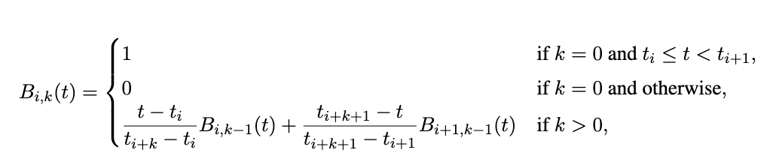 | (22)

This formulation enables each $φ_{l,j,i}$ to adjust its shape according to the data, providing exceptional flexibility in modeling the interactions between inputs within the network. By combining the above three equations to define each layer of the network, the overall architecture of a KAN resembles stacking layers in MLPs, but it improves upon this by employing complex functional mappings instead of simple linear transformations and nonlinear activations:

$$\text{KAN}\left(x\right)=\left(Φ_{L-1}∘Φ_{L-2}∘⋯∘Φ_{1}∘Φ_{0}\right)x$$ | (23)

Where $Φ_{L}$ is the function-matrix transformation for the $l$th layer. If neuron $i$in the $l$th layer is referred to as the $i$th, and neuron $j$in the $\left(l + 1\right)$th layer is referred to as the $j$th, then the activation function $ϕ_{l,j,i}$connects neuron $\left(l,i\right)$to neuron $\left(l+1,j\right)$:

$$φ_{l,j,i}, l=0,…,L-1, i=1,…,n_{l}, j =1,…,n_{l+1}$$ | (24)

The transformation $Φ_{l}$ of each layer processes input $x_{l}$to generate the input $x_{l+1}$for the subsequent layer. As illustrated in Figure 4, the activation functions are located on the edges rather than the nodes, differing from MLPs. Hence, the pre-activation of $ϕ_{l,j,i}$is $x_{l,i}$, and the post-activation is ${\tilde{x}}_{l,i,j}$. Subsequently, the values ${\tilde{x}}_{l,i,j}$are summed to compute $x_{l+1,j}$, representing the activation value at the $\left(l+1,j\right)$-node:

$$x_{l+1,j}=\sum_{i=1}^{n_{l}}{{\tilde{x}}_{l,i,j}=\sum_{i=1}^{n_{l}}{ϕ_{l,i,j}(x_{l,i})}}$$ | (25)

Thus, the function-matrix $Φ_{l}$can be expressed as an $n_{l+1}×n_{l}$ matrix of edge activations:

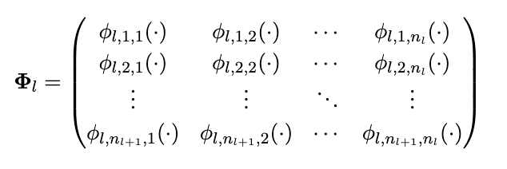 | (26)

5.3. Evaluation metrics

To evaluate model performance, this study reports three standard regression metrics computed between measured creep compliance values and the corresponding model predictions: the coefficient of determination (R²), root mean squared error (RMSE), and mean absolute error (MAE). Let $y_{i}$denote the measured creep compliance for observation $i$, let ${\hat{y}}_{i}$denote the model prediction, and let $N$denote the total number of evaluated observations. The coefficient of determination quantifies the fraction of variance in the measured data that is captured by the model:

$$R^{2}=1-\frac{\sum_{i=1}^{N}{{\left(y_{i}-{\hat{y}}_{i}\right)}^{2}}}{\sum_{i=1}^{N}{{\left(y_{i}-\overline{y}\right)}^{2}}}$$ | (27)

where $\overset{ˉ}{y}$ is the mean of the measured values.

RMSE and MAE quantify prediction error in the units of the response, with RMSE emphasizing larger errors due to the squared term:

$$RMSE=\sqrt{\frac{1}{N}\sum_{i=1}^{N}{{\left(y_{i}-{\hat{y}}_{i}\right)}^{2}}}$$ | (28)

$$MAE=\frac{1}{N}\sum_{i=1}^{N}{|y_{i}-{\hat{y}}_{i}|}$$ | (29)

- Project results

6.1 Dataset statistics

Table 4 summarizes descriptive statistics of the processed creep dataset, including the count, mean, standard deviation, and quartiles for each variable. All variables contain 26,813 observations, reflecting the final set of creep compliance records used in modeling after data cleaning and preprocessing. The input space spans mixture-proportioning variables (e.g., $w/c$, $a/c$, cement content $c$), material/state descriptors (e.g., $f_{c28}$, humidity and temperature), geometric and boundary-condition descriptors (e.g., $V/S$), and loading/time descriptors (e.g., age at loading $t_{0}$, applied stress $σ$, and time since loading $t$). Several features exhibit wide ranges and strong skewness—particularly the time-related variables ($t_{0}$, $t$) and geometric descriptors—motivating normalization prior to training to improve numerical conditioning and optimization stability. The target creep compliance $J$spans a broad range (exceeding 1000 $μ$m/m/MPa), emphasizing the need for models that remain accurate in both low-compliance regimes (where most observations concentrate) and the high-compliance tail (where fewer observations are available and extrapolation is more challenging).

Table 4. Summary statistics of the dataset.

Feature | mean | std | min | 25% | 50% | 75% | max
w/c | 0.46 | 0.13 | 0.2 | 0.35 | 0.45 | 0.55 | 0.9
a/c | 4.83 | 4.03 | 0.5 | 3.93 | 4.73 | 5.42 | 131.43
c | 390.08 | 97.44 | 0 | 333 | 383 | 445 | 1314
a | 2.78 | 0.81 | 1 | 3 | 3 | 3 | 10
SP | 0.52 | 1.12 | 0 | 0 | 0 | 0.5 | 7.73
fc28 | 52.92 | 26.76 | 11 | 34 | 45 | 67.2 | 160
V/S | 28.2 | 12.77 | 3.91 | 20 | 30 | 33.33 | 200
H0 | 93.9 | 13.7 | 35 | 98 | 99 | 100 | 105
t0 | 78.36 | 321.08 | 0.5 | 7 | 28 | 29 | 4560
T | 27.12 | 18.78 | -20 | 20 | 20 | 23 | 150
RH_test | 79.65 | 22.54 | 0 | 60 | 99 | 99 | 101
type | 2.48 | 0.9 | 1 | 2 | 3 | 3 | 4
sigma | 13.24 | 11.19 | -8.2 | 7 | 10 | 15.79 | 136
t | 283.08 | 877.02 | 0 | 5.1 | 36 | 169.1 | 11202.7
J | 68.54 | 64.11 | 0 | 31.7 | 52.3 | 87.14 | 1063.99

Figure 5 presents the Pearson correlation heatmap across all input variables and the target $J$. Several physically plausible trends are evident. Most notably, $J$increases with higher $w/c$, consistent with mixtures that are generally less stiff and more prone to time-dependent deformation. Conversely, $J$decreases with higher compressive strength $f_{c28}$, reflecting the expected inverse relationship between stiffness/strength development and compliance. Time since loading $t$exhibits the expected positive association with $J$, since creep compliance grows with increasing duration under sustained load. Correlations among inputs also highlight meaningful multicollinearity: mixture-design variables (e.g., $w/c$, cement content, and strength) are interrelated, and environmental/loading descriptors show additional dependencies. This correlation structure is important for two reasons. First, it motivates strong nonlinear regressors (e.g., boosted trees and neural networks) that can learn coupled effects without requiring manual feature engineering. Second, it underscores the value of complementary modeling approaches: tree ensembles can deliver strong predictive accuracy under multicollinearity, while interpretable functional models (e.g., KAN) can help disentangle and inspect learned relationships in a mechanics-relevant form.

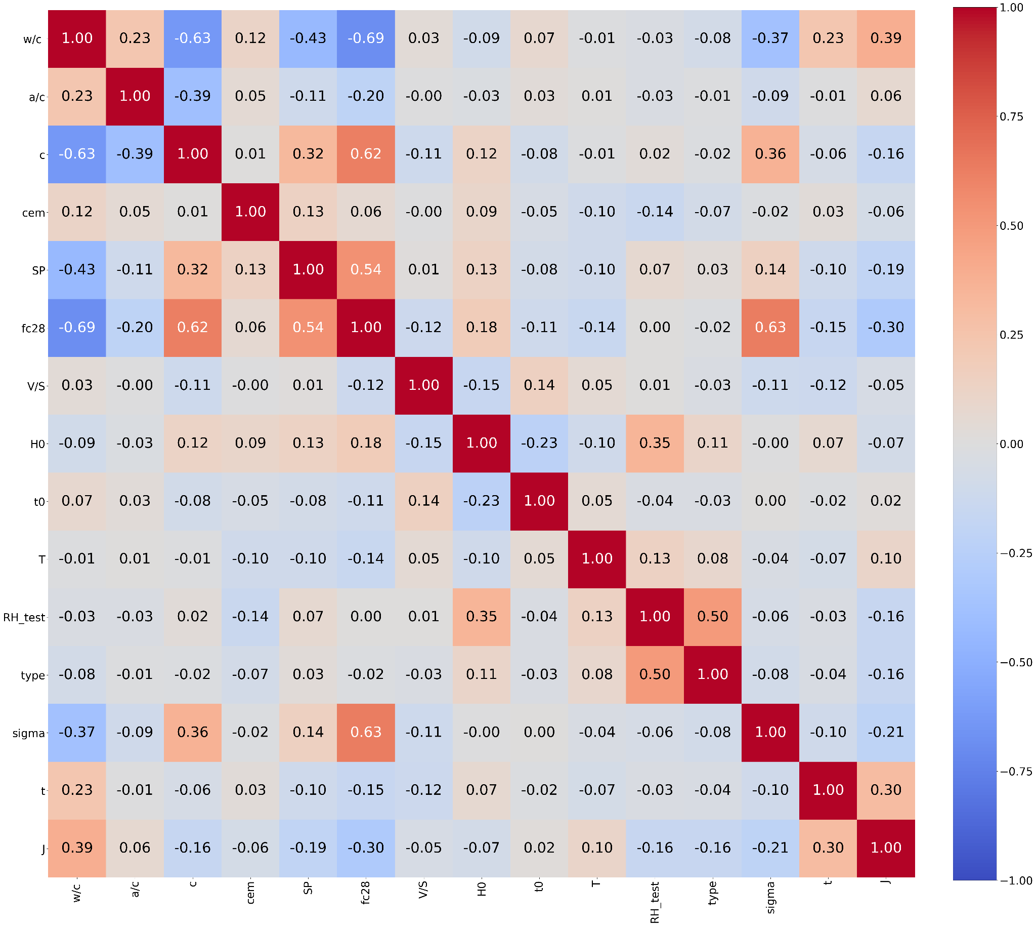
Figure 5. Feature correlation map.

6.2. Tree-based baseline models

Following prior work (Liang et al, 2022), three widely used tree-based regression models were implemented as deterministic baselines: Random Forest (RF), XGBoost, and LightGBM (LGBM). Figure 6 compares predicted versus measured creep compliance for these models on both training and testing splits (80/20 split, as described previously). Across all three methods, predictions align closely with the $y=x$reference line for the dominant low-to-moderate compliance region, indicating that the models capture the main trends in the dataset. Deviations become more noticeable at larger $J$values, where the data are sparser and the problem becomes more sensitive to long-term extrapolation and rare combinations of mixture, environment, and loading variables. This behavior is consistent with the statistical structure of the dataset (Table 4), where the upper tail of $J$is represented by fewer samples. RF and XGBoost achieved comparable accuracy (RMSE $≈14.8$, $R^{2}≈0.946\text{–}0.947$), while LGBM performed best among the tree models (RMSE $=13.901$, MAE $=4.830$, $R^{2}=0.953$). Collectively, these results establish a strong deterministic baseline for creep compliance prediction on this dataset. However, these models are not designed to provide calibrated predictive uncertainty, which is needed when compliance predictions are propagated through mechanics operators (e.g., hereditary integrals) and when decisions depend on reliability-oriented assessments rather than point estimates alone.

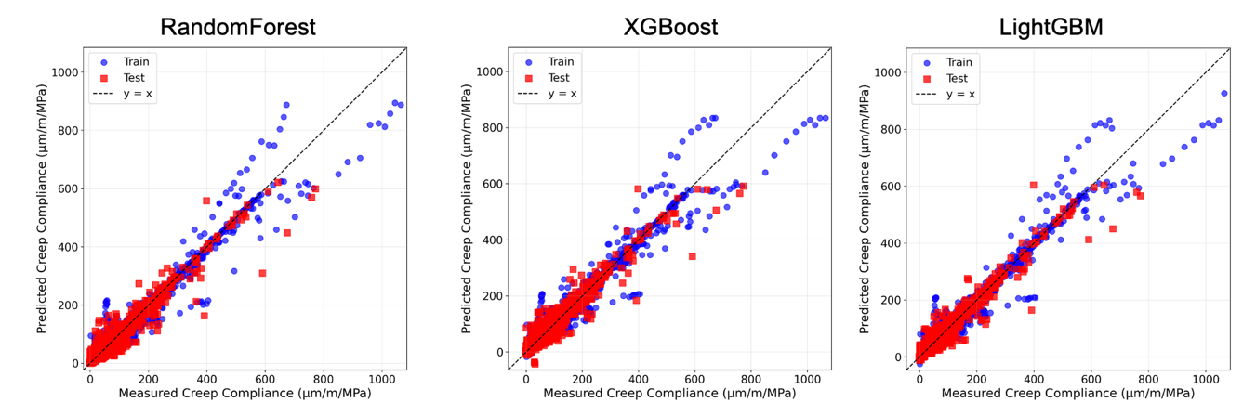
Figure 6. Performance of tree-based models.

6.3. Probabilistic ANN (MC dropout) model

To explicitly quantify predictive uncertainty while improving predictive accuracy, a probabilistic neural network was developed using Monte Carlo (MC) dropout. The ANN was trained as a regression model and evaluated using the MC predictive mean (averaging multiple stochastic forward passes with dropout active at inference). The best hyperparameters identified for this model were:

- Architecture: 14–672–336–168–1
- Loss: MSELoss
- Optimizer: AdamW (learning rate $5×{10}^{-3}$, weight decay $5×{10}^{-6}$)
- Dropout probability: 0.1
- Batch size: 512
- Early stopping: patience = 100 epochs (stop if no RMSE improvement)
- Stochastic forward passes: $T=200$

Figure 7 shows predicted versus measured creep compliance using the MC predictive mean on both training and testing data. Compared with the tree-based baselines, the ANN-MC model exhibits tighter adherence to the $y=x$ line across a broader range of compliance values, with visibly improved behavior in the higher-compliance region where the tree models show more scatter and occasional under/over-estimation. Quantitatively, Table 5 confirms this improvement: ANN-MC achieved RMSE = 11.359, MAE = 3.813, and $R^{2}=0.963$on the test set, representing the strongest overall performance among the evaluated models. Relative to the best tree baseline (LGBM), this corresponds to an RMSE reduction of approximately 18% and an MAE reduction of approximately 21%, indicating a substantial accuracy gain while also enabling uncertainty estimation through the predictive distribution.

Finally, the probabilistic nature of the ANN is illustrated through representative predictive distributions (Figure 8). For each selected test sample, repeated stochastic forward passes yield a distribution of predicted $J$values whose spread reflects predictive uncertainty. In data-dense regimes (typical combinations of mixture, environment, and time), these distributions are relatively narrow and centered close to the measured value, indicating higher confidence. Wider distributions appear for samples associated with rarer regions of the feature space and/or larger compliance values, consistent with increased epistemic uncertainty driven by limited training coverage in those regimes. These uncertainty estimates can be summarized as confidence intervals and propagated through downstream mechanics calculations that depend on the compliance function, supporting sensitivity studies and reliability-oriented assessments.

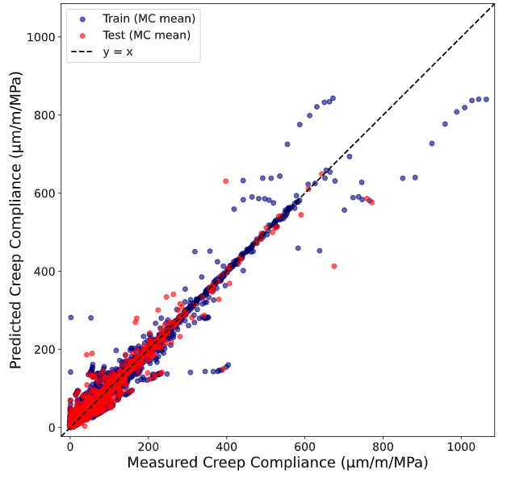
Figure 7. Performance of probabilistic ANN model.

Figure 8. Example probability distribution functions for 9 data points from the creep dataset.
6.4 KAN model

To complement the deterministic tree ensembles and the probabilistic ANN baseline, a Kolmogorov–Arnold Network (KAN) was developed as an interpretable nonlinear regressor for predicting creep compliance $J$(µm/m/MPa) from the 14 input variables. The main motivation for KAN in this study is that it can reach modern nonlinear regression accuracy while keeping the learned mapping decomposable through learnable one-dimensional functions, which enables direct interpretation of nonlinear trends and interactions rather than treating the model as a purely black-box predictor.

6.4.1. KAN architecture and performance

The tuned KAN used for the results in this section follows the width configuration $\left[14 , 160 , 80 , 40 , 1\right]$, meaning that three hidden KAN layers with widths 160, 80, and 40 map the 14 standardized inputs to a single scalar prediction of creep compliance $J$. Each edge function is parameterized by cubic B-splines (degree 3; spline order $k=4$) defined over a uniform grid across the normalized input domain. We use a grid resolution of 33 points (i.e., 32 uniform intervals) spanning the scaled input range, which provides sufficient flexibility to capture strong nonlinear trends while preserving smoothness. In the implementation, a fixed random seed of 33 is used for reproducibility, and the spline initialization noise scale is set to 0.2; the remaining optional model flags are disabled. The model is trained as a regression learner for $J$using the Adam optimizer with learning rate $5×{10}^{-4}$and weight decay set to zero. Training uses a batch size of 512.

Figure 9 shows the loss history for train and test sets over 1200 epochs. The loss drops sharply in the first tens of epochs, indicating rapid acquisition of the dominant nonlinear structure, and then decreases gradually toward a stable plateau. Importantly, the separation between the training and test curves remains small throughout training and does not grow in later epochs. This stable gap suggests that the tuned KAN capacity is well matched to the data complexity and that optimization improves performance mainly by refining the fit in more complex regimes rather than by memorizing the training set.

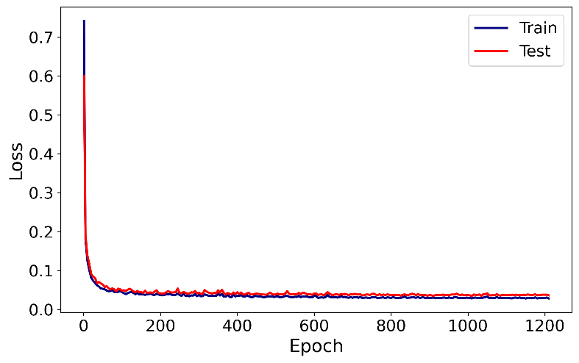
Figure 9. Training and test loss vs. epoch for the tuned KAN (1200 epochs).

Figure 10 depicts predicted versus measured creep compliance. Across the bulk of the data distribution, both training and test points concentrate tightly around the 1:1 line, indicating accurate regression in the low-to-moderate compliance regime where most samples lie. At higher compliance values, the spread increases and a small number of points depart from the diagonal, consistent with rare regimes being intrinsically harder to predict (e.g., extreme temperature–mixture combinations). Nevertheless, the overall alignment remains strong, and the model does not exhibit an obvious systematic failure mode such as global underprediction or overprediction across the response range. Quantitatively, the KAN achieves $R^{2}=0.972$, RMSE = 10.98, MAE = 3.11 on the training set, and $R^{2}=0.958$, RMSE = 12.17, MAE = 4.57 on the test set. The modest degradation from training to test is consistent with Fig. 5.4a and indicates stable generalization.

The residual histogram in Figure 11 shows the distribution of prediction errors. Both train and test residuals are sharply centered at zero, implying negligible global bias. The training residuals are slightly narrower than test residuals, but the test distribution remains strongly peaked at zero with comparatively light tails. This indicates that most predictions fall close to the measured values, and that larger errors are relatively rare.

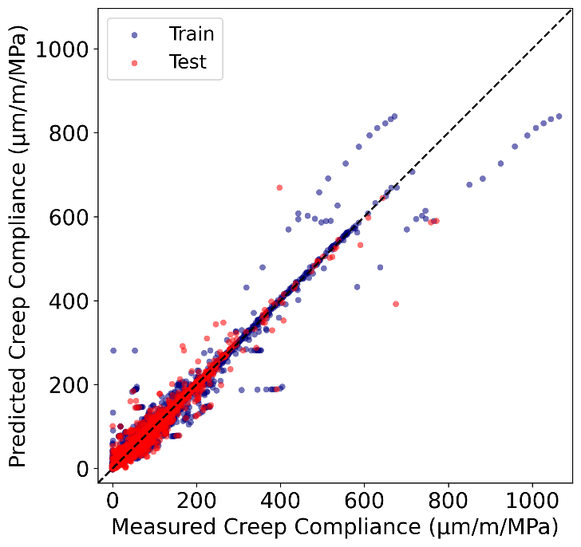
Figure 10. Predicted vs. measured creep compliance $J$for the tuned KAN on train and test sets.
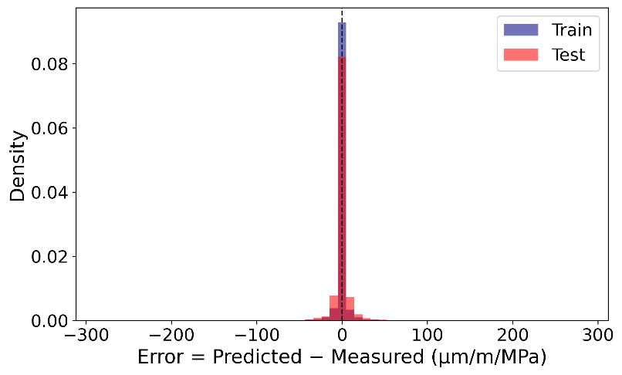
Figure 11. Residual histograms for the tuned KAN on train and test sets.
Table 5 summarizes test-set performance for all five models. The three tree ensembles form a consistent tier ($R^{2}≈0.946$–0.953, RMSE $≈13.9$–14.8). ANN-MC is the strongest overall predictor ($R^{2}=0.963$, RMSE = 11.36, MAE = 3.81). KAN improves substantially over the tree ensembles and remains competitive with ANN-MC while offering an explicitly interpretable surrogate structure. Overall, KAN reduces RMSE by about 1.7–2.7 (µm/m/MPa) relative to the tree ensembles and improves $R^{2}$ relative to RF/XGBoost while remaining close to LGBM. Although ANN-MC remains the top performer, KAN narrows the gap while providing more transparent trend and interaction analysis, which is essential for extracting mechanistic insight from the learned surrogate.

Table 5. Test-set performance ($R^{2}$, RMSE, MAE) of the developed ANN–MC and KAN models compared with the state-of-the-art tree-based baselines (RF, XGBoost, LGBM) reported by Liang et al. (2022). Best results are shown in bold, and second-best results are underlined.

Model | R² | RMSE | MAE
RF | 0.946 | 14.836 | 5.207
XGBoost | 0.947 | 14.816 | 5.409
LGBM | 0.953 | 13.901 | 4.83
ANN-MC | 0.963 | 11.359 | 3.813
KAN | 0.958 | 12.166 | 4.56

6.4.2. Interpretations based on KAN model

The partial dependence (PD) curves in Figure 12 summarize how the KAN prediction changes as each variable is swept across its scaled range while averaging over the empirical distribution of the remaining inputs. Several dominant and physically meaningful marginal patterns emerge. Temperature $T$is the strongest global driver in the PD curves. The response increases substantially across the domain, with a noticeably steeper rise toward the upper end, indicating that higher temperature regimes produce markedly higher predicted compliance. Cement content $c$ also exhibits a strong marginal effect. The curve remains relatively moderate through most of the range but rises sharply near the high end, implying that extreme $c$regimes correspond to a pronounced increase in predicted compliance in the learned mapping. The time-related input $t_{0}$ shows an opposing trend: the PD curve decreases strongly across the range, approaching very low predicted compliance at the high end. This is consistent with $t_{0}$ acting as a dominant “stiffening” driver in the model, where larger $t_{0}$ corresponds to reduced compliance under the conditions present in the dataset.

Mixture proportion ratios show structured nonlinearities. The a/c ratio exhibits a clear valley-shaped PD curve: predicted compliance decreases from low a/c to a mid-range minimum and increases again toward higher a/c. This indicates that both very low and very high a/c regimes are associated with higher compliance, while an intermediate a/c band is associated with lower compliance. In contrast, w/c shows a largely monotonic increasing profile, with compliance rising steadily and reaching its highest values at the upper end of the scaled range. This is consistent with w/c acting as a workability-related control in the early stages of concrete life.

Other variables display weaker marginal effects but are still nontrivial. RH_test shows a moderate, non-flat dependence with a dominant peak near the central region and additional smaller oscillations, with lower predictions toward the extremes, suggesting that humidity effects are present but are not purely additive. The PD curves for fc28 and SP are predominantly decreasing, indicating that increases in these inputs reduce predicted compliance on average in the learned mapping. The “type” variable shows a strongly nonmonotonic pattern, which is expected when discrete categories are represented numerically. The surrogate assigns distinct response levels to different categories, which appear as rises and drops when the encoded variable is swept continuously.

Figure 13 quantifies global influence by ranking variables according to the standard deviation of their PD curves. Temperature dominates with a PD sensitivity of 57.59 $μ$m/m/MPa, which is roughly twice the next most influential inputs. Cement content and $t_{0}$form the second tier, with nearly identical sensitivities (30.24 and 30.23 $μ$m/m/MPa, respectively). A third tier includes a/c (21.10), RH_test (20.89), and w/c (20.51 $μ$m/m/MPa), confirming that mixture proportions and testing humidity remain influential but less dominant than temperature and the two leading mixture/time drivers. The remaining variables contribute progressively smaller PD sensitivities: type (17.93), V/S (17.35), cem (17.22), $σ$(16.59), fc28 (12.70), $t$(11.70), SP (11.60), and H0 (8.40 $μ$m/m/MPa).

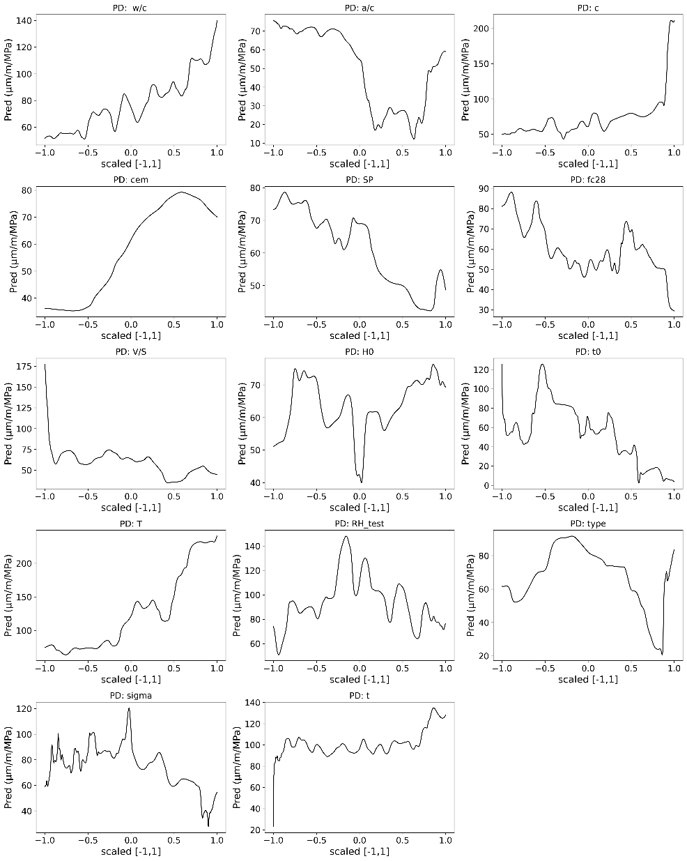
Figure 12. Partial dependence (PD) curves for all 14 inputs from the tuned KAN.
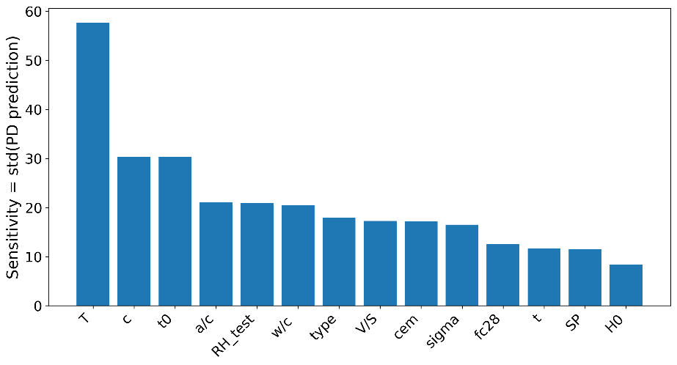
Figure 13. PD-based global sensitivity ranking (standard deviation of PD curves) for the 14 inputs.

PD curves provide a global average effect, but they can hide heterogeneity when a feature’s effect depends strongly on other inputs. The ICE plots in Figure 14 expose this by showing the conditional response trajectory for many individual samples (gray), along with the mean trajectory (blue).

For temperature $T$, the mean ICE curve increases, but the gray trajectories show step-like increases at different points along the scaled axis. This indicates that the effective “temperature threshold” for a rapid increase in compliance varies across samples, which is consistent with strong interaction structure (for example, temperature effects being amplified under certain mixture proportion regimes). For cement content $c$, the mean effect is increasing, but many individual curves remain relatively flat until the upper end where they rise sharply, matching the PD observation of a high-end escalation and indicating that the sharp rise is driven by specific covariate combinations rather than uniformly across the dataset.

For w/c, the mean ICE monotonically increases, but the spread widens toward the high end, implying that high w/c increases compliance more strongly for some samples than others. The a/c ICE curves show substantial variation in curvature and in the location of the minimum, indicating that the valley-shaped PD curve is an average of multiple regime-specific responses. RH_test shows clustered trajectories rather than a single smooth trend, again suggesting that humidity effects are conditional and interact with dominant mixture or temperature variables. The ICE behavior for encoded categorical variables (such as type) shows distinct bands, consistent with discrete categories inducing different response levels.

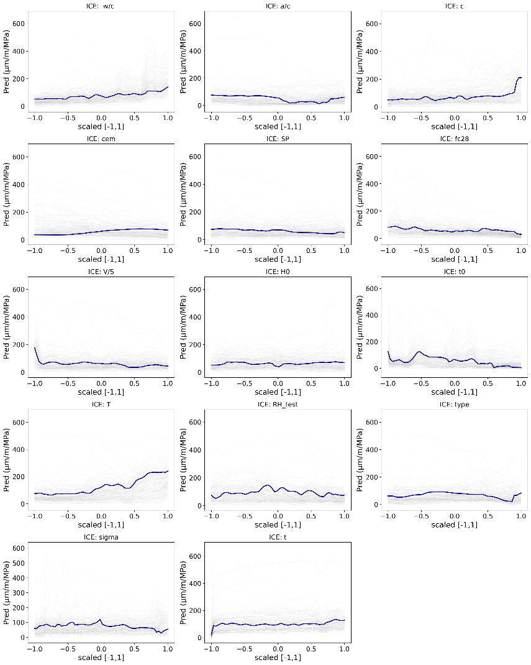
Figure 14. ICE plots for key inputs (individual trajectories and mean trend) from the tuned KAN.
Figure 15 visualizes the pairwise response surfaces among the dominant variables (T, c, $t_{0}$, a/c, RH_test, and w/c), where color represents predicted compliance. These surfaces clarify why certain variables show large ICE dispersion and why some PD curves have strong nonmonotonic structure.

The $T×$ w/c surface shows a pronounced synergy: compliance is relatively low when either $T$or w/c is low, but it increases sharply in the joint high-$T$/high-w/c corner. This interaction explains the widening ICE spread for w/c at the upper end and indicates that w/c amplifies thermal compliance. The $T×c$surface exhibits a similar coupling, with the highest compliance concentrated in the region where both $T$and $c$are high. In contrast, at low $T$, the surface remains comparatively dark across a wide range of $c$, indicating a muted cement effect under cooler regimes.

Interactions involving a/c explain the nonmonotonic marginal dependence. In $T×$a/c, compliance increases with temperature at all a/c levels, but the slope and plateau levels vary with a/c, meaning the a/c regime that minimizes compliance is not fixed and can shift with $T$. In $c×$a/c, elevated compliance appears at extreme a/c values when combined with higher cement content, which is consistent with the valley-shaped PD curve for a/c being an average over regimes. The $T×t_{0 }$and $c×t_{0}$surfaces exhibit banded structure, indicating that the marginal effect of $t_{0}$depends on temperature and cement content, rather than acting as a purely additive shift.

Overall, these interaction patterns support two major conclusions. First, the KAN surrogate captures non-additive couplings among the dominant mixture and environmental drivers, which is consistent with the heterogeneity observed in the ICE curves. Second, the interaction plots provide an interpretable explanation for why PD sensitivity alone does not fully describe the model: some variables exert their influence primarily through conditional effects that only become strong within specific regions of the input space.

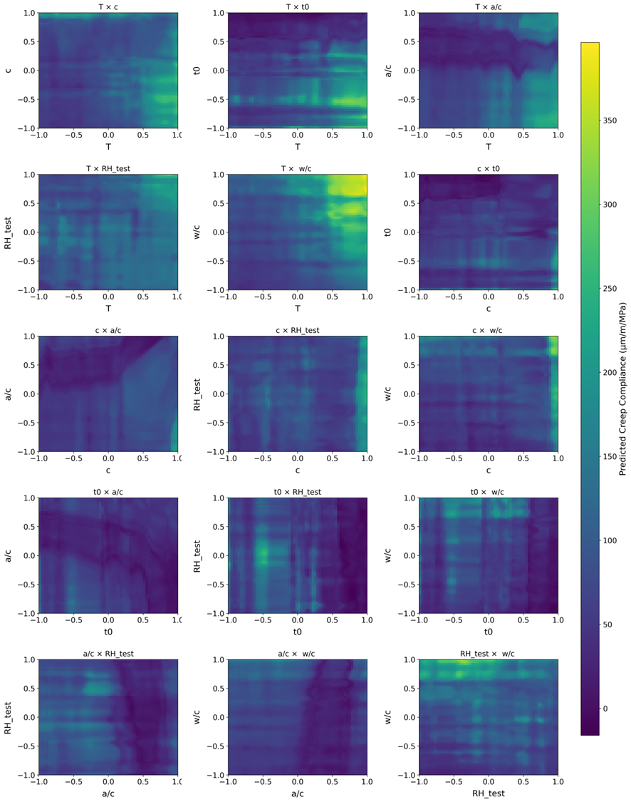
Figure 15. Pairwise interaction surfaces among dominant variables, with color indicating predicted $J$.

Finally, a compact KAN was evaluated to test whether a smaller interpretable surrogate can retain useful fidelity for screening or deployment. This compact configuration preserves the same 14-input interface and cubic-spline parametrization but reduces the overall capacity (reduced layer width and a coarser spline grid), resulting in approximately 10,800 trainable parameters and a test $R^{2}$of about 0.93. Although this compact model sacrifices accuracy relative to the tuned KAN, it retains the dominant qualitative trends observed in PD/ICE analyses and preserves the key interaction patterns among the top drivers, making it a practical option when a lightweight, interpretable surrogate is preferred.

Overall, KAN also has the advantage of providing a closed-form solution, which can provide a useful creep function for solving mechanics problems as described above. However, it should be noted that the current functions are extremely complex and cannot be practically used due to the number of input parameters. Therefore, future work should focus on developing simpler KAN models which can provide useful functions for solving physical problems in concrete creep.

6.5. Web tool for creep compliance prediction

To facilitate practical use, we deployed a public Concrete Creep Predictor web application at https://creep-compliance-webapp.onrender.com/. The interface (see Figure 16) lets users specify mix design, environmental conditions, time and loading variables, and mechanical descriptors, and then click Predict to estimate creep compliance J. As shown in Table 4, the most accurate model on the test set is ANN-MC, which achieved the highest R2 and the lowest errors among the five learners. ANN-MC also supports uncertainty quantification via Monte Carlo inference, returning both a mean prediction and an uncertainty band. This deployment enables rapid screening and scenario exploration for practitioners, in seconds, without installation.

Figure 16. Concrete Creep Predictor web application interface.

- Conclusions and recommendations:

Concrete creep is a time-dependent deformation under sustained load that can strongly affect serviceability and durability, particularly in prestressed and precast systems where creep contributes to prestress loss, increased deflections, and cracking. A practical gap in current data-driven creep prediction is that state-of-the-art machine-learning models are often tree-based ensembles that provide strong point-prediction accuracy but are limited in two ways: they do not naturally quantify predictive uncertainty and they offer limited mechanics-friendly interpretability of nonlinear trends and interactions. To close this gap, this study developed two complementary models using the Northwestern concrete creep database (26,813 processed creep-compliance records with 14 input variables spanning mixture composition, environmental and curing conditions, geometry and test descriptors, and time/loading variables): a probabilistic ANN with uncertainty quantification (ANN-MC) and an interpretable Kolmogorov-Arnold Network (KAN). For fair benchmarking, the state-of-the-art tree-based models were also replicated as baselines. The following are the findings of this study:

- The replicated tree ensembles (Random Forest, XGBoost, and LightGBM) formed a consistent accuracy tier on the test set ($R^{2}=0.946$–0.953, RMSE $=13.901$–14.836, MAE $=4.830$–5.409), establishing a strong deterministic reference but without uncertainty-aware outputs.
- ANN-MC achieved the highest test accuracy among all evaluated models ($R^{2}=0.963$, RMSE $=11.359$, MAE $=3.813$) and provides uncertainty quantification through Monte Carlo dropout by returning a predictive mean and uncertainty band, which is essential for reliability-oriented use and for propagating uncertainty into time-dependent structural quantities.
- KAN remained strongly competitive ($R^{2}=0.958$, RMSE $=12.166$, MAE $=4.560$) while enabling direct interpretation because the mapping to creep compliance $J$ is expressed through learnable one-dimensional edge functions (B-splines). Interpretation was demonstrated using partial dependence (PD) curves, which summarize the marginal effect of an input on predicted $J$ averaged over the empirical distribution of other inputs, and individual conditional expectation (ICE) curves, which show sample-specific response trajectories and expose heterogeneity and interactions that PD averages can hide. In addition, a PD-based global ranking (using the standard deviation of each PD curve as a sensitivity score) identified the most influential drivers as temperature $T$(largest sensitivity), followed by cement content $c$and age at loading $t_{0}$; a third tier consisted of the key proportion and conditioning variables $a/c$, $RH_{\text{test}}$, and $w/c$, while the remaining inputs exhibited progressively smaller influence under this global measure.

Physics-informed machine learning will be investigated next to move beyond input–output regression toward mechanics-consistent discovery. This will include (i) Physics-informed ML for governing equations, involving implementation of physics-informed neural networks (PINNs) and related operator-learning approaches to infer components of the governing differential or integro-differential equations behind concrete creep (for example, learning parameters/functional forms consistent with hereditary integrals and aging viscoelasticity), rather than only fitting input–output mappings, and (ii) PINN variants tailored to concrete creep: extending beyond standard PINNs by embedding rheological structure directly (e.g., fractional viscoelastic elements, Burgers/Maxwell/Kelvin chains, or microprestress-solidification ODE constraints) so the learned model respects known causal structure and produces physically consistent time evolution.

- Practical application/impact on transportation infrastructure

To translate the developed creep-compliance predictors into a usable engineering tool, the most accurate model in this study (ANN-MC; Table 4) has been deployed as a publicly accessible web application at https://creep-compliance-webapp.onrender.com/. The interface enables rapid screening and scenario exploration by allowing users to enter mixture design variables, environmental conditions, geometry descriptors, and loading/time inputs and then obtain an immediate estimate of creep compliance $J$. Unlike deterministic models, ANN-MC also provides uncertainty quantification through Monte Carlo inference, returning a predictive mean and an uncertainty band; this is particularly valuable for transportation applications where creep directly affects prestress loss, long-term deflections, and serviceability checks in precast and prestressed elements. From an implementation standpoint, the tool is feasible because it requires no specialized software installation, runs in seconds, and can be used during early-stage mixture selection, sensitivity studies, and comparative evaluation of design or curing scenarios. This tool can therefore be directly used for risk assessment of different concrete mix design parameters by agencies and concrete structural designers.

- References

Altoubat, S. A., & Lange, D. A. (2002). The Pickett effect at early age and experiment separating its mechanisms in tension. Materials and Structures, 35(4), 211-218.
Asadi, B., Hajj, R., & Al-Qadi, I. L. (2023). Asphalt concrete dynamic modulus prediction: Bayesian neural network approach. International Journal of Pavement Engineering, 24(2), 2270569.‏
Asadi, B., Shah, V., Vyas, A., Golparvar‐Fard, M., & Hajj, R. (2025). Hybrid deep learning model for predicting failure properties of asphalt binder from fracture surface images. Computer‐Aided Civil and Infrastructure Engineering.‏
Aslani, F., & Nejadi, S. (2011). Comparison of creep prediction models for self-compacting and conventional concrete. In International Symposium on High Performance Concrete. New Zealand Concrete Society.
Bazant, Z. P. (1975). Theory of creep and shrinkage in concrete structures: A precis of recent developments. Mechanics today, 2(1).
Bažant, Z. P. (1977). Viscoelasticity of solidifying porous material—concrete. Journal of the Engineering Mechanics Division, 103(6), 1049-1067.
Bažant, Z. P., & Asghari, A. (1974). Computation of Kelvin chain retardation spectra of aging concrete. Cement and Concrete Research, 4(5), 797-806.
Bažant, Z. P., & Chern, J. C. (1985a). Triple power law for concrete creep. Journal of Engineering Mechanics, 111(1), 63-83.
Bazant, Z. P., & Chern, J. C. (1985b, September). Log double power law for concrete creep. In ACI journal, Proceedings (Vol. 82, No. 5, pp. 665-675).
Bažant, Z. P., Hauggaard, A. B., Baweja, S., & Ulm, F. J. (1997). Microprestress-solidification theory for concrete creep. I: Aging and drying effects. Journal of engineering Mechanics, 123(11), 1188-1194.
Bažant, Z. P., Kim, J. K., & Panula, L. (1991). Improved prediction model for time-dependent deformations of concrete: Part 1-Shrinkage. Materials and structures, 24(5), 327-345.
Bažant, Z. P., & Li, G. H. (2008). Comprehensive database on concrete creep and shrinkage. Evanston, IL, USA: Infrastructure Technology Institute, McCormick School of Engineering and Applied Science, Northwestern University.
Bažant, Z. P., & Panula, L. (1978). Practical prediction of time-dependent deformations of concrete: Part II: Basic creep. Matériaux et Construction, 11(5), 317-328.
Bazant, Z. P., & Prasannan, S. (1989). Solidification theory for concrete creep. I: Formulation. Journal of engineering mechanics, 115(8), 1691-1703.
Bažant, Z. P., & Wu, S. T. (1974). Rate-type creep law of aging concrete based on Maxwell chain. Matériaux et Construction, 7(1), 45-60.
Bažant, Z. P., & Yunping, X. I. (1994). Drying creep of concrete: constitutive model and new experiments separating its mechanisms. Materials and structures, 27(1), 3-14.
Benboudjema, F., & Torrenti, J. M. (2008). Early-age behaviour of concrete nuclear containments. Nuclear engineering and design, 238(10), 2495-2506.
Bertola, N., & Brühwiler, E. (2025). Transforming the static system of prestressed concrete bridges using UHPFRC. Journal of Bridge Engineering, 30(7), 05025005.
Bhattacharya, K., Cao, L., Stepaniants, G., Stuart, A., & Trautner, M. (2025). Learning memory and material dependent constitutive laws. arXiv preprint arXiv:2502.05463.
Binder, E., Koenigsberger, M., Flores, R. D., Mang, H. A., Hellmich, C., & Pichler, B. L. (2023). Thermally activated viscoelasticity of cement paste: Minute-long creep tests and micromechanical link to molecular properties. Cement and Concrete Research, 163, 107014.
Bonopera, M., Chang, K. C., & Lee, Z. K. (2020). State-of-the-art review on determining prestress losses in prestressed concrete girders. Applied Sciences, 10(20), 7257.
Bouras, Y., Zorica, D., Atanacković, T. M., & Vrcelj, Z. (2018). A non-linear thermo-viscoelastic rheological model based on fractional derivatives for high temperature creep in concrete. Applied Mathematical Modelling, 55, 551-568.
Bouras, Y., & Li, L. (2023). Prediction of high-temperature creep in concrete using supervised machine learning algorithms. Construction and Building Materials, 400, 132828.
Bouras, Y., & Vrcelj, Z. (2023). Fractional and fractal derivative-based creep models for concrete under constant and time-varying loading. Construction and Building Materials, 367, 130324.
Briffaut, M., Benboudjema, F., Torrenti, J. M., & Nahas, G. (2012). Concrete early age basic creep: Experiments and test of rheological modelling approaches. Construction and Building Materials, 36, 373-380.
Brooks, J. J. (2001). A theory for drying creep of concrete. Magazine of Concrete Research, 53(1), 51-61.
Cao, J., Tu, N., Liu, T., Han, Z., Tu, B., & Zhou, Y. (2024). Prediction models for creep and creep recovery of fly ash concrete. Construction and Building Materials, 428, 136398.
Charpin, L., & Sanahuja, J. (2017). Creep and relaxation Poisson’s ratio: Back to the foundations of linear viscoelasticity. Application to concrete. International Journal of Solids and Structures, 110, 2-14.
Chateauneuf, A. M., Raphael, W. E., & Moutou Pitti, R. J. (2014). Reliability of prestressed concrete structures considering creep models. Structure and Infrastructure Engineering, 10(12), 1595-1605.
Chen, J., Gong, L., & Meng, R. (2024). Application of fractional calculus in predicting the temperature-dependent creep behavior of concrete. Fractal and Fractional, 8(8), 482.
Chen, Z., Frech-Baronet, J., & Sorelli, L. (2020). A microindentation two-fold creep model for characterizing short-and long-term creep behavior of a cement paste. Mechanics of Materials, 150, 103559.
De Schutter, G. (2004). Applicability of degree of hydration concept and maturity method for thermo-visco-elastic behaviour of early age concrete. Cement and Concrete Composites, 26(5), 437-443.
Dhariwal, P., & Nichol, A. (2021). Diffusion models beat gans on image synthesis. Advances in neural information processing systems, 34, 8780-8794.‏
Di Luzio, G., & Cusatis, G. (2013). Solidification–microprestress–microplane (SMM) theory for concrete at early age: Theory, validation and application. International Journal of Solids and Structures, 50(6), 957-975.
Dilger, W. H. (1982). Creep analysis of prestressed concrete structures using creep-transformed section properties. Pci Journal, 27(1), 98-118.
Gal, Y., & Ghahramani, Z. (2016, June). Dropout as a bayesian approximation: Representing model uncertainty in deep learning. In international conference on machine learning (pp. 1050-1059). PMLR.‏
Gan, Y., Romero Rodriguez, C., Zhang, H., Schlangen, E., van Breugel, K., & Šavija, B. (2021). Modeling of microstructural effects on the creep of hardened cement paste using an experimentally informed lattice model. Computer‐Aided Civil and Infrastructure Engineering, 36(5), 560-576.
Geng, Z., Tang, S., Wang, Y., A, H., He, Z., Wu, K., & Wang, L. (2024). Stress relaxation properties of calcium silicate hydrate: A molecular dynamics study. Journal of Zhejiang University-SCIENCE A, 25(2), 97-115.
Ghali, A. (1989). Stress and strain analysis in prestressed concrete: a critical review. PCI JOURNAL, 34(6), 80-97.
Ghali, A., Tadros, M. K., & Dilger, W. H. (1974). Accurate Evaluation of Time-Dependent Deflections of Prestressed Concrete Frames. Special Publication, 43, 357-376.
Gilbert, R. I., & Ranzi, G. (2010). Time-dependent behaviour of concrete structures. CRC Press.
Guo, B., Lin, Z., & He, Q. Z. (2025). History-aware neural operator: Robust data-driven constitutive modeling of path-dependent materials. Computer Methods in Applied Mechanics and Engineering, 447, 118358.
Hamza, M. H., Borkowski, L., & Chattopadhyay, A. (2025). Physics-informed machine learning model for ceramic matrix composite creep. In AIAA SCITECH 2025 Forum (AIAA 2025-2516).
Han, B., Xie, H. B., Zhang, D. J., & Ma, X. (2016). Sensitivity analysis of creep models considering correlation. Materials and Structures, 49(10), 4217-4227.
Han, W., Tian, P., Lv, Y., Zou, C., & Liu, T. (2023). Long-term prestress loss calculation considering the interaction of concrete shrinkage, concrete creep, and stress relaxation. Materials, 16(6), 2452.
Hilloulin, B., & Tran, V. Q. (2022). Using machine learning techniques for predicting autogenous shrinkage of concrete incorporating superabsorbent polymers and supplementary cementitious materials. Journal of Building Engineering, 49, 104086.
Hilton, H. H., & Yi, S. (1998). The significance of (an) isotropic viscoelastic Poisson ratio stress and time dependencies. International Journal of Solids and Structures, 35(23), 3081-3095.
Hong, S. H., Choi, J. S., Yuan, T. F., & Yoon, Y. S. (2023). A review on concrete creep characteristics and its evaluation on high-strength lightweight concrete. Journal of Materials Research and Technology, 22, 230-251.
Honorio, T., Bary, B., & Benboudjema, F. (2016). Multiscale estimation of ageing viscoelastic properties of cement-based materials: A combined analytical and numerical approach to estimate the behaviour at early age. Cement and Concrete Research, 85, 137-155.
Huang, Y., Wang, J., Wei, Q. A., Shang, H., & Liu, X. (2023). Creep behaviour of ultra-high-performance concrete (UHPC): A review. Journal of Building Engineering, 69, 106187.
Hubler, M. H., Wendner, R., & Bažant, Z. P. (2015). Statistical justification of Model B4 for drying and autogenous shrinkage of concrete and comparisons to other models. Materials and Structures, 48(4), 797-814.
Koeller, R. (1984). Applications of fractional calculus to the theory of viscoelasticity. Journal of Applied Mechanics, 51, 299-307.
Kolmogorov, A. N. (1957). On the representations of continuous functions of many variables by superposition of continuous functions of one variable and addition. In Dokl. Akad. Nauk USSR (Vol. 114, pp. 953-956).‏
Lai, M. J., & Shen, Z. (2021). The kolmogorov superposition theorem can break the curse of dimensionality when approximating high dimensional functions. arXiv preprint arXiv:2112.09963.‏
LeCun, Y., Bengio, Y., & Hinton, G. (2015). Deep learning. nature, 521(7553), 436-444.‏
Le Roy, R., Le Maou, F., & Torrenti, J. M. (2017). Long term basic creep behavior of high performance concrete: data and modelling. Materials and structures, 50(1), 85.
Li, C., Sharma, H., Wu, Y., Magallanes, J., Ramesh, K. T., & Shields, M. D. (2026). Physics-informed Gaussian process regression for the constitutive modeling of concrete: A data-driven improvement to phenomenological models. arXiv preprint arXiv:2601.03367.
Li, J., & Yao, Y. (2001). A study on creep and drying shrinkage of high performance concrete. Cement and Concrete Research, 31(8), 1203-1206.
Li, K., Long, Y., Wang, H., & Wang, Y. F. (2021). Modeling and sensitivity analysis of concrete creep with machine learning methods. Journal of Materials in Civil Engineering, 33(8), 04021206.
Liang, M., Chang, Z., Wan, Z., Gan, Y., Schlangen, E., & Šavija, B. (2022). Interpretable Ensemble-Machine-Learning models for predicting creep behavior of concrete. Cement and Concrete Composites, 125, 104295.
Liang, M., Luzio, G. D., Schlangen, E., & Šavija, B. (2024). Experimentally informed modeling of the early‐age stress evolution in cementitious materials using exponential conversion from creep to relaxation. Computer‐Aided Civil and Infrastructure Engineering, 39(23), 3507-3530.
Liang, Y., & Guan, P. (2022). Improved Maxwell model with structural dashpot for characterization of ultraslow creep in concrete. Construction and Building Materials, 329, 127181.
Liu, W., Weng, H., Zhang, X., Liao, W., Dai, Y., & Liu, Y. (2025). A physics-informed intelligent constitutive approach for predicting creep deformation considering polycrystalline microstructure evolution. International Journal of Plasticity, 194, 104500.
Lin, Z., Bai, J., Li, S., Chen, X., Li, B., & Feng, X.-Q. (2026). A physics-informed neural network framework for simulating creep buckling in growing viscoelastic biological tissues. Computer Methods in Applied Mechanics and Engineering, 452, 118715.
Liu, Z., Wang, Y., Vaidya, S., Ruehle, F., Halverson, J., Soljačić, M., … Tegmark, M. (2024). KAN: Kolmogorov-Arnold Networks. 1–50. Retrieved from http://arxiv.org/abs/2404.19756
Luo, X., Zhou, Y., Yi, F., & Yi, W. (2024). Modeling time-dependent deformation in concrete: A fractional calculus method with finite element implementation. Journal of Building Engineering, 95, 110171.
Mei, S., Li, X., Wang, X., & Liu, X. (2023). Calculation of short-term creep of concrete using fractional viscoelastic model. Materials, 16(12), 4274.
Muránsky, O., Tran, M. N., & Payten, W. (2026). On the application of PINN-style physics-regularised neural networks to high-temperature creep rupture life prediction. International Journal of Pressure Vessels and Piping, 219, 105691.
Nielsen, L. F. (1982). On the prediction of creep functions for concrete. In Fundamental Research on Creep and Shrinkage of Concrete (pp. 279-289). Dordrecht: Springer Netherlands.
Oliveira, H. L., Chateauneuf, A., & Leonel, E. D. (2019). Probabilistic mechanical modelling of concrete creep based on the boundary element method. Advances in Structural Engineering, 22(2), 337-348.
Pal, B., & Ramaswamy, A. (2024). A multi-scale approach to predict shrinkage and creep of cementitious composite in a hygro-thermo-chemo-mechanical framework-theoretical formulation and numerical validation. Mechanics of materials, 188, 104866.
Pal, V., Singh, A. K., Chakraborty, S., Abdallah, J., & Shrivastava, R. (2025). Physics informed machine learning model for local creep prediction in turbine blade. In Proceedings of ASME Turbo Expo 2025: Turbomachinery Technical Conference and Exposition (Paper GT2025-153825).
Park, H.-W., & Hwang, J.-H. (2023). Predicting the early-age time-dependent behaviors of a prestressed concrete beam by using physics-informed neural network. Sensors, 23(14), 6649.
Park, H. W., Mukharromah, N. I., Hwang, J. H., & Lee, S. C. (2024, November). Finite difference equation of Volterra integral equation for estimating the time-dependent prestress loss of a prestressed concrete beam. In Structures (Vol. 69, p. 107437). Elsevier.
Park, S., & Andrawes, B. (2025). Application of NiTiNb shape memory alloys in the end region of prestressed concrete bridge girders. Advances in Structural Engineering, 13694332251340717.
Podolny, W. J. (1969). Understanding the Losses in Prestressing. PCI JOURNAL, 14(5), 43-53.
Reddy, D. H., & Ramaswamy, A. (2018). Experimental and numerical modeling of creep in different types of concrete. Heliyon, 4(7).
Ribeiro, J. G. T., de Castro, J. T. P., & Meggiolaro, M. A. (2021). Modeling concrete and polymer creep using fractional calculus. Journal of materials research and technology, 12, 1184-1193.
Rosenblatt, F. (1962). Principles of neurodynamics: Perceptrons and the theory of brain mechanisms (Vol. 55). Washington, DC: Spartan books.‏
Scheiner, S., & Hellmich, C. (2009). Continuum microviscoelasticity model for aging basic creep of early-age concrete. Journal of engineering mechanics, 135(4), 307-323.
Sellier, A., Multon, S., Buffo-Lacarrière, L., Vidal, T., Bourbon, X., & Camps, G. (2016). Concrete creep modelling for structural applications: non-linearity, multi-axiality, hydration, temperature and drying effects. Cement and Concrete Research, 79, 301-315.
Sercombe, J., Hellmich, C., Ulm, F. J., & Mang, H. (2000). Modeling of early-age creep of shotcrete. I: model and model parameters. Journal of engineering mechanics, 126(3), 284-291.
Shariq, M., Prasad, J., & Abbas, H. (2016). Creep and drying shrinkage of concrete containing GGBFS. Cement and Concrete Composites, 68, 35-45.
Shen, M., & Mao, S. (2025). Learning the history-dependent material behavior of viscoelastic composites using recurrent neural operator. Composite Structures, 374, 119718.
Shitikova, M. V., & Krusser, A. I. (2022). Models of viscoelastic materials: a review on historical development and formulation. Theoretical Analyses, Computations, and Experiments of Multiscale Materials: A Tribute to Francesco dell’Isola, 285-326.
Sprecher, D. A., & Draghici, S. (2002). Space-filling curves and Kolmogorov superposition-based neural networks. Neural Networks, 15(1), 57-67.‏
Suwanmaneechot, P., Aili, A., & Maruyama, I. (2020). Creep behavior of CSH under different drying relative humidities: Interpretation of microindentation tests and sorption measurements by multi-scale analysis. Cement and Concrete Research, 132, 106036.
Tadros, M. K., Ghali, A., & Dilger, W. H. (1975). Time-dependent prestress loss and deflection in prestressed concrete members. PCI Journal, 20(3), 86-98.
Vandamme, M., & Ulm, F. J. (2009). Nanogranular origin of concrete creep. Proceedings of the National Academy of Sciences, 106(26), 10552-10557.
Vaswani, A., Shazeer, N., Parmar, N., Uszkoreit, J., Jones, L., Gomez, A. N., ... & Polosukhin, I. (2017). Attention is all you need. Advances in neural information processing systems, 30.‏
Wei, Y., Guo, W., & Liang, S. (2016). Microprestress-solidification theory-based tensile creep modeling of early-age concrete: Considering temperature and relative humidity effects. Construction and Building Materials, 127, 618-626.
Wendner, R., Hubler, M. H., & Bažant, Z. P. (2015). Statistical justification of model B4 for multi-decade concrete creep using laboratory and bridge databases and comparisons to other models. Materials and Structures, 48(4), 815-833.
Wittmann, F. H., & Beltzung, F. (2016). Fundamental aspects of the interaction between hardened cement paste and water applied to improve prediction of shrinkage and creep of concrete: a critical review. Journal of Sustainable Cement-Based Materials, 5(1-2), 106-116.
Yan, J., Zhou, J., Zhang, J., Zhao, P., Zhang, Z., Wang, W., & Xuan, F. (2025). Physics-informed Kolmogorov-Arnold network for remaining creep life prediction in 7050 aluminum alloy. Engineering Fracture Mechanics, 327, 111433.
Yang, M., Gong, J., & Yang, X. (2020). Refined calculation of time-dependent prestress losses in prestressed concrete girders. Structure and Infrastructure Engineering, 16(10), 1430-1446.
Zhang, B., Shi, D., Liu, C., Hao, W., & Yang, X. (2023). Physics-informed machine learning with high-throughput design module for evaluating rupture life and guiding design of oxide/oxide ceramic matrix composites. Ceramics International, 49(22), 34945-34957.
Zhang, H., Guo, Q. Q., & Xu, L. Y. (2023). Prediction of long-term prestress loss for prestressed concrete cylinder structures using machine learning. Engineering Structures, 279, 115577.
Zhang, R., Warn, G. P., Radlińska, A., & Chatzi, E. (2025). Self-adaptive physics-informed parallel neural networks for creep damage identification. Engineering Structures, 344, 121314.
Zhang, Y., Liu, X., Xu, Z., Yuan, W., Xu, Y., Yao, Z., ... & Si, R. (2024). Early-age cracking of fly ash and GGBFS concrete due to shrinkage, creep, and thermal effects: a review. Materials, 17(10), 2288.
Zhao, Y., Zhao, X. L., Dong, Z., Cui, C., Zhao, Z., & Shi, C. (2025). Performance of a novel ultra-durable hollow UHPC slab reinforced with prestressed Fe-SMA bars. Advances in Structural Engineering, 13694332251340735.

- Acknowledgements

The authors gratefully acknowledge researchers from TU-Delft for sharing their processed version of the Northwestern University creep dataset to enable us to check our work directly. The authors also appreciate help of Praneeth Rangamudri in developing and deploying the web tool created in this study.

