

Transportation Infrastructure Precast Innovation Center
(TRANS-IPIC)

University Transportation Center (UTC)

Instrumented Precast Concrete Curbs for Urban Infrastructure Readiness in Autonomous Vehicle Deployment
[UT-25-RP-02]

Quarterly Progress Report
For the performance period ending March 31, 2026

Submitted by:
Samer Dessouky, PhD, PE, F. ASCE
School of Civil & Environmental Engineering and Construction Management
University of Texas at San Antonio
samer.dessouky@utsa.edu

Collaborators / Partners:
University of Texas at San Antonio (UTSA)

Submitted to:
TRANS-IPIC UTC
University of Illinois Urbana-Champaign
Urbana, IL

TRANS-IPIC Quarterly Progress Report (Section 1 – 7, 5 pages max.):

Project Description:
- Research Plan - Statement of Problem
Autonomous vehicles (AVs) require reliable environmental perception and curbside awareness to operate safely in urban environments. However, curb detection and lateral localization may be affected by poor lighting, weather, visual occlusion, degraded GPS, and indistinct or worn curb geometry. Conventional curb infrastructure is not designed to support AV perception systems under these challenging conditions.

This research addresses that gap by investigating instrumented precast concrete curbs embedded with passive identification markers and retroreflective visual elements. The goal is to enhance curb detectability and improve AV curbside navigation and alignment in complex urban settings. By integrating smart features into modular precast curbs, the project aims to provide a durable, scalable, and cost-effective infrastructure solution that supports AV readiness while minimizing disruption to existing roadway systems.

- Research Plan - Summary of Project Activities (Tasks)
Task 1 – Technology Survey and System Requirements Definition
Identify and assess suitable passive identification and retroreflective technologies for curb integration and AV sensor compatibility.

Task 2 – Integration Design and Prototype Fabrication
Design and fabricate precast curb prototypes embedded with selected passive identification markers and retroreflective elements.

Task 3 – Structural and Durability Testing
Evaluate the mechanical performance and environmental durability of smart curb prototypes.

Task 4 – Precast Sensor-embedded Functionality Testing with AV-detection Equipment
Assess the detectability and performance of embedded curb technologies using representative AV sensing equipment.

Task 5 – Pilot Installation and Environmental Exposure Assessment
Demonstrate in-situ functionality and resilience of smart curbs in a real-world environment.

Task 6 – Dissemination and Outreach
Develop implementation guidance and disseminate project findings to stakeholders.

Project Progress:
- Progress for each research task

Task 1 – A technical survey of candidate passive identification technologies and retroreflective materials has been initiated. The review focuses on passive UHF RFID systems and high-intensity prismatic retroreflective materials suitable for integration into precast curb units. Detection capabilities, environmental durability, and compatibility with vehicle-mounted RFID detection systems are being evaluated. Initial system requirements related to detection range, visibility, installation constraints, and constructability have been identified to support the development of smart curb prototypes. [70% completed to date]

Task 2 – Integration Design and Prototype Fabrication
Preliminary design concepts for instrumented curb systems have been developed based on standard curb configurations. The design effort has focused on evaluating locations and installation concepts for passive RFID markers and retroreflective elements, including potential integration with existing curb infrastructure, as well as initial constructability considerations for prototype implementation (Figure 1). [30% completed to date]
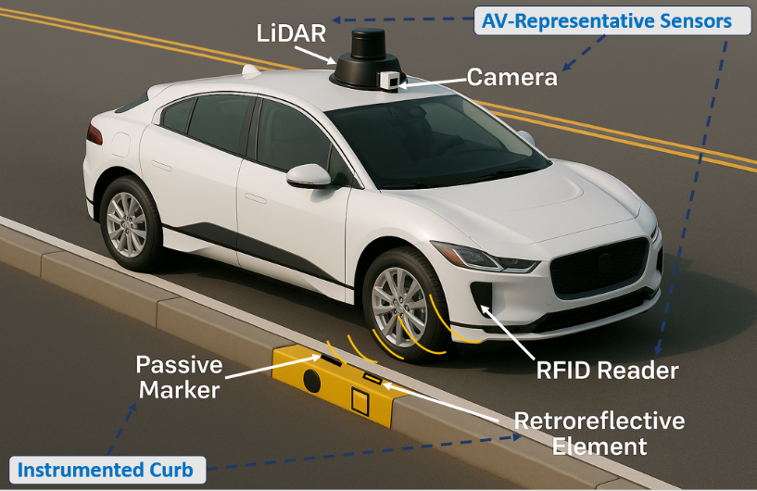
Figure 1. Instrumented precast curb with embedded RFID tags and retroreflective elements.

Task 3 – Structural and Durability Testing
Preliminary planning for structural and durability evaluation has begun. The research team is reviewing potential testing approaches for assessing curb performance and identifying relevant standards and procedures that will support future experimental activities. Structural and durability testing will be conducted following the fabrication of smart curb prototypes and preparation of the required testing setup. [5% completed to date]

Task 4 – Precast Sensor-embedded Functionality Testing with AV-detection Equipment
Initial planning for functional testing has begun, including consideration of sensing platforms and experimental scenarios for evaluating embedded curb detectability under representative AV operating conditions. A vehicle-mounted sensing platform equipped with an RFID reader is being considered to simulate AV infrastructure detection during field testing. [0% completed to date]

Task 5 – Pilot Installation and Environmental Exposure Assessment
This task has not yet begun and will proceed after prototype fabrication and initial testing are completed. [0% completed to date]

Task 6 – Dissemination and Outreach
Initial dissemination efforts have begun through preparation of research materials related to the smart curb concept and project scope. Additional outreach and stakeholder engagement activities will occur in later phases of the project. [0% completed to date]

- Percent of research project completed
The project is estimated to be approximately 20% complete. Progress during this quarter focused primarily on technology surveys, system requirements definition, and preliminary design and testing planning activities.

- Expected progress for next quarter
During the next quarter, the research team expects to advance the integration design of smart curb prototypes and finalize the selection and procurement of passive identification and retroreflective technologies. Additional effort will focus on preparing structural and functional testing procedures and refining experimental plans for evaluating curb detectability using passive RFID tags and a vehicle-mounted RFID reader.

- Educational outreach and workforce development
This project is supporting a graduate research assistant and workforce development in smart transportation infrastructure at the University of Texas at San Antonio. A PhD student is actively involved in the project through literature review, technology evaluation, and experimental planning activities related to AV-ready infrastructure. Additional educational outreach, demonstrations, and presentations are anticipated in later project phases.

- Technology Transfer
At this stage, the project is in the early research and development phase. No patents, specifications, or formal implementation guidelines have been produced during this reporting period. However, the project is expected to generate deployment guidance related to smart curb integration, sensor compatibility, and practical implementation for transportation agencies in later phases.

Research Contribution:
- Papers that include TRANS-IPIC UTC in the acknowledgments section:
None during this reporting period.

- Presentations and Posters of TRANS-IPIC funded research:
Shiha, M., and Dessouky, S. (2026). Instrumented Precast Concrete Curbs for Urban Infrastructure Readiness in Autonomous Vehicle Deployment. Research poster prepared for presentation at an upcoming annual Trans-IPIC workshop in April 2026.

- Please list any other events or activities that highlights the work of TRANS-IPIC occurring at your university (please include any pictures or figures you may have). Similarly, please list any references to TRANS-IPIC in the news or interviews from your research.
The UTSA Mini E-Week Lab Exhibit event on Friday, March 6 2026 provided tour to local school districts to our lab where we presented our research work including Trans-IPIC.

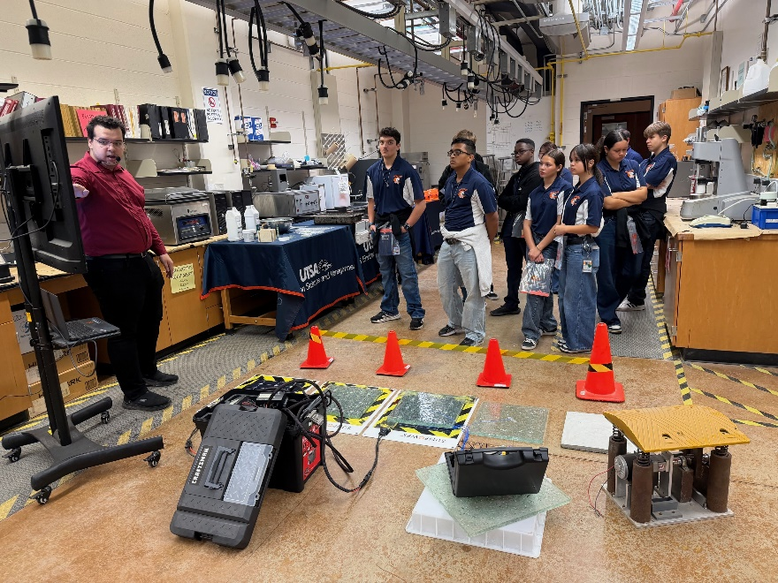
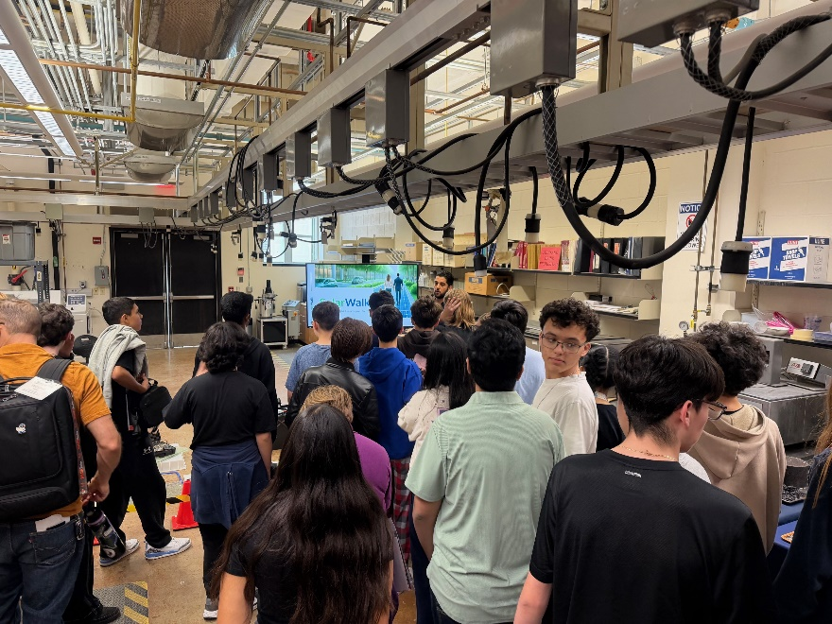

Appendix 1: Research Activities, leadership, and awards (cumulative, since the start of the project)

- Number of presentations at academic and industry conferences and workshops of UTC findings
- No. = 0

- Number of peer-reviewed publications submitted based on outcomes of UTC funded projects
- No. = 1

- Number of peer-reviewed journal articles published by faculty.
- No. =2

- Number of peer-reviewed conference papers published by faculty.
- No. =0

- Number of TRANS-IPIC sponsored thesis or dissertations at the MS and PhD levels.
- No. MS thesis = 0
- No. PhD dissertations =1
- No. citations of each of the above =0

- Number of research tools (lab equipment, models, software, test processes, etc.) developed as part of TRANS-IPIC sponsored research
- None to date

- Number of transportation-related professional and service organization committees that TRANS-IPIC faculty researchers participate in or lead.
- Professional societies
  - No. participated in =1
  - No. lead =0
- Advisory committees (No. participated in & No. led)
  - No. participated in =0
  - No. lead =0
- Conference Organizing Committees (No. participated in & No. led)
  - No. participated in =0
  - No. lead =0
- Editorial board of journals (No. participated in & No. led)
  - No. participated in =2
  - No. lead =0
- TRB committees (No. participated in & No. led)
  - No. participated in =0
  - No. lead =0

- Number of relevant awards received during the grant year
- No. awards received = 1

- Number of transportation related classes developed or modified as a result of TRANS-IPIC funding.
- No. Undergraduate =0
- No. Graduate = 0

- Number of internships and full-time positions secured in the industry and government during the grant year.
- No. of internships =1
- No. of full-time positions = 0

References:
None during this reporting period.

