

Transportation Infrastructure Precast Innovation Center
(TRANS-IPIC)

University Transportation Center (UTC)

Advanced concretes for girders with unbonded post-tensioning strands
UB-25-RP-02

Quarterly Progress Report
For the performance period ending March 31, 2026

Submitted by:
Ravi Ranade, Associate Professor, ranade@buffalo.edu
Department of Civil, Structural and Environmental Engineering
University at Buffalo

Co-PIs: Pinar Okumus (pinaroku@buffalo.edu), University at Buffalo

Collaborators / Partners:
None

Submitted to:
TRANS-IPIC UTC
University of Illinois Urbana-Champaign
Urbana, IL

TRANS-IPIC Quarterly Progress:

Project Description:
- Research Plan - Statement of Problem

Unbonded post-tensioning (PT) is widely used in segmental construction and spliced girders, particularly for long-span bridges [1-3]. As the strands are external or placed in ducts without grouting, they remain accessible during a bridge’s service life, enabling inspection, evaluation, and replacement if needed. However, the lack of bond between the strands and the concrete reduces structural efficiency. The capacity of an unbonded PT girder is typically controlled by concrete crushing or by fracture of the bonded reinforcement rather than by yielding of the PT strands, resulting in a lower capacity than that of bonded systems. Thus, unbonded PT sacrifices some structural capacity in exchange for improved serviceability, durability, and constructability. In this project, we propose replacing conventional concrete (CC) with ductile fiber-reinforced concrete, known as an Engineered Cementitious Composite (ECC), to enhance the strength and displacement capacity of unbonded PT girders while retaining their durability advantages [4-9]. The distributed microcracking behavior of ECC is more compatible with strand deformation, and numerical analyses indicate that it can improve the structural performance of unbonded PT girders, bringing them closer to the behavior of bonded systems. This work aims to expand the use of unbonded PT in durable, long-lasting bridges.

The specific objectives of this project are as follows:
- To develop a suitable ECC for use in a prestressed concrete girder
- To experimentally evaluate the effect of replacing CC with ECC on the flexural behavior of a beam with unbonded PT strands
- To develop a numerical model for accurately modeling the behavior of a girder with unbonded PT strands and investigating the girder behavior through parametric analysis
- To provide recommendations for designing girders with ECC, accounting for its tensile strength and ductility

- Research Plan - Summary of Project Activities (Tasks)

The following tasks will be performed to achieve the research objective stated above.

Task 1 - ECC Mix Development: An ECC mix with compressive strength similar to that of CC, commonly used in prestressed girders, will be developed. A typical ECC has a compressive strength of about 5-7 ksi. Increasing the compressive strength to our target range, suitable for precast concrete bridge members (8-12 ksi), while achieving a tensile strain capacity of at least 1%, will require modifications to the matrix and the fiber-matrix bond.

Task 2 - Proof-of-concept testing: For experimentally testing the idea of replacing CC with ECC to achieve higher flexural capacity, beam specimens with ECC and CC will be fabricated with unbonded strands. Bending tests will be conducted. Our preliminary numerical analysis showed that having some bonded strands, rather than none, is optimal for leveraging the tensile ductility of ECC. Therefore, some bonded strands will be considered for specimen design. Displacements, strand stresses, reinforcement, and concrete strains will be measured. The outcomes of this task are the load-displacement relationship, crack patterns, and strand stress at failure.

Task 3 - Numerical model development and validation: A numerical model in a finite-element software will be developed and validated. The model will build on the principles of strain and displacement compatibility (with concrete) for bonded and unbonded reinforcement, respectively. The numerical model will provide load-displacement behavior, as well as stresses and strains in concrete, reinforcing bars, and strands at any section along the girder length to develop a deeper understanding of the structural behavior of girders with unbonded PT strands. The numerical model created in Task 3 will be validated using the data collected in Task 2.

Task 4 - Parametric studies: The validated models from Task 3 will be used to understand the impact of design parameters on the effectiveness of ECC. The specimens tested in Task 2 will be modeled with varying total reinforcement areas, two concrete types, and bonded strands to total reinforcement ratios.

Task 5 - Design method development: The nominal moment capacity (M_{n}) and stress in unbonded strands at M_{n} (f_{ps}) will be calculated following a conventional mechanics-based force-equilibrium approach commonly used for CC design. However, unlike the CC design, which assumes zero tensile strength of CC, ECC’s tensile strength will be considered in the design.

Project Progress:
- Progress for each research task

Task 1 – ECC Mix Development (60% complete)

Task 1 focused on developing an ECC mix with compressive strength comparable to that of conventional concrete (CC) typically used in prestressed concrete girders. To develop such a mixture, the first step was to prepare trial mixtures to increase the matrix compressive strength. Four trial mixtures with weight proportions shown in Table 1 were developed:

- Baseline mixture (Mix 1): A widely investigated ECC mixture developed previously in the PI’s laboratory served as the baseline mixture. This ECC mixture consisted of cement, fly ash, silica sand, and a high-range water-reducing admixture (HRWRA).

- Mixtures with undensified microsilica (Mix 2 and 3): To further enhance the compressive strength relative to Mix 1, 5% and 15% of the cement weight used in Mix 1 were replaced with undensified microsilica (955U) in Mix 2 and 3, respectively. Microsilica was expected to improve both compressive strength and the viscosity required for effective fiber dispersion, thereby reducing the need for viscosity modifiers.

- Mixture with a lower water-to-binder ratio (Mix 4): This mixture was developed to increase compressive strength by reducing the water-to-binder ratio without adding microsilica.

For mixture preparation, the dry ingredients were first mixed for 3 minutes, then water was added, and mixed for an additional 2 minutes. The HRWRA was then added sequentially in increments of 0.33% by weight of cement. After each addition of HRWRA, the mixture was mixed for 2 minutes to evaluate its consistency. Once a slurry-like consistency was achieved, as shown in Figure 1, the HRWRA dosage was fixed, and fibers (Poly-vinyl-alcohol fibers, 8mm length) were introduced into the mix. The mixture was then mixed for an additional 3 minutes to ensure uniform fiber dispersion. Water segregation and fiber dispersion were manually assessed by visually examining and pinching small quantities of the mixture.

Table 1. Mixture composition and strength qualification test results
Mixture ID | Cem-ent | Fly ash | Silica-sand | Water/  binder* ratio | HRWRA | Micro-silica  (955U) | 4-day comp. strength (Projected 28-day strength), ksi | COV (%)
Mix 1 | 1 | 1.20 | 0.82 | 0.31 | 1.00% | - | 3.7  (6.1-9.2) | 4.70
Mix 2 | 0.95 | 1.30 | 0.86 | 0.31 | 1.33% | 0.05 | 3.2  (5.4-8.0) | 6.9
Mix 3 | 0.85 | 1.41 | 0.97 | 0.31 | 1.00% | 0.15 | 3.5  (5.9-8.9) | 5.4
Mix 4 | 1 | 1.20 | 0.82 | 0.24 | 1.66% | - | 5.5  (9.1-13.7) | 4.3
* Binder includes cement and supplementary cementitious materials – fly ash and microsilica

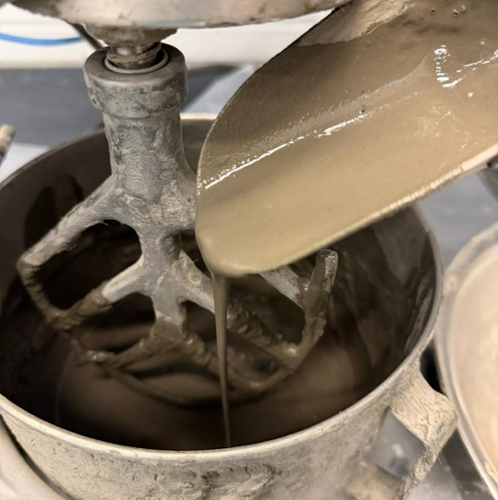

Figure 1. HRWRA dosage calibration based on mixture consistency

For each trial mixture, six 2-inch cube specimens were prepared to evaluate early-age compressive strength (4-day compressive strength). Assuming the 4-day strength is 40-60% of the 28-day strength, Mix 4 has the greatest likelihood of exceeding our 28-day target compressive strength of 8 ksi.

Task 2- Proof of concept testing (10% complete):

Task 2 focuses on experimentally evaluating the replacement of CC with ECC to achieve higher flexural capacity in prestressed members.

Conventional concrete mix design:
For a meaningful comparative evaluation, a CC specimen will be tested as a benchmark. Two trials of CC mixtures, with a compressive strength comparable to that of the ECC developed in Task 1, were developed. The CC mixtures consisted of crushed limestone aggregates with a maximum nominal aggregate size of 0.5 inch, river sand with a fineness modulus of 2.7, tap water, and a high-range water-reducing admixture (HRWRA). Both mixtures contained fine and coarse aggregates at a volumetric ratio of 45%–55% of the total aggregate content. The water-to-cement ratios were 0.35 and 0.28 for the two mixtures. The HRWRA dosage was calibrated to achieve self-compacting behavior without observable segregation or bleeding. Six cylindrical specimens (4 inch diameter × 8 inch height) were prepared to assess the compressive strength of the mixtures. The mixture compositions and ingredient properties are shown in Table 2, Table 3, and Table 4.

Table 2. Conventional concrete mixture proportions
Material | lbs/cyd
Coarse aggregate (surface saturated dry (SSD)) | 1615
Fine Aggregate (SSD) | 1264
Cement (Type IL) | 800
Water | 245(w/c=0.35)/ 196(w/c=0.28)
High Range Water Reducing Admixture (HRWRA) | (11 oz/Cwt)/ (21 oz/Cwt)

Table 3. Conventional concrete ingredients’ properties
Fine aggregates:
Fineness modulus | 2.7
Bulk specific gravity in SSD state | 2.66
Coarse aggregates:
Nominal maximum aggregate size | 0.5”
Bulk specific gravity in SSD state | 2.58
Cement: | Type IL

Table 4. Moisture content of aggregates used in conventional concrete
 | Moisture content (%)
 | Natural | SSD
Coarse aggregates | 1.18 | 0.40
Fine aggregates | 3.93 | 1.94

Cross-section design:
In addition to ECC and CC mixture development, the trial beam cross-section, reinforcement detailing, and prestressing configuration for the planned proof-of-concept testing are being evaluated. These designs considered the available testing facilities in the PI’s laboratory and the measurement requirements necessary to capture the structural response and outcomes relevant to the project objectives.

Remaining tasks have not yet started.

- Percent of research project completed
15%

- Expected progress for next quarter
In the next quarter, Task 1 will be completed. Proof-of-concept testing (Task 2) will be continued, and numerical model development and validation (Task 3) will begin.

- Educational outreach and workforce development
We participated in Science Exploration Day in March 2026, as detailed below:
Location- Department of Civil, Structural, and Environmental Engineering (CSEE), University at Buffalo, Buffalo, New York.
Date- March 18, 2026
Details- A group of local high school students visited the Department of Civil, Structural and Environmental Engineering (CSEE) at the University at Buffalo. They interacted with TRANS-IPIC-associated faculty and students.
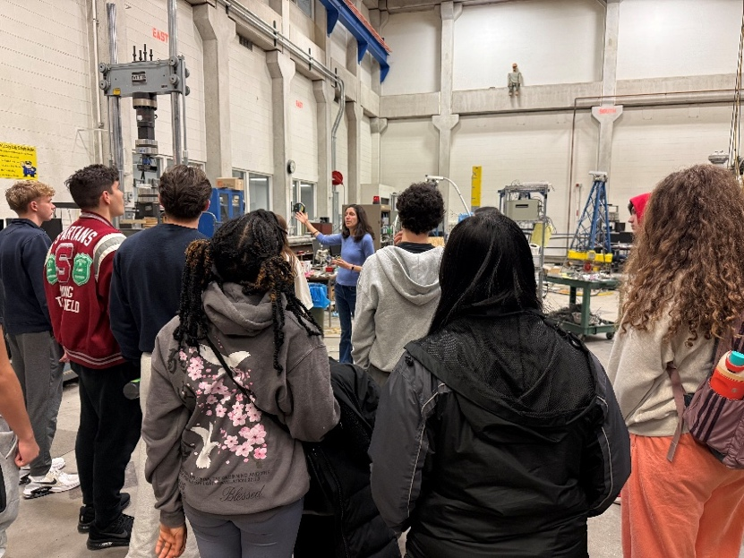
TRANS-IPIC-associated PhD student and faculty demonstrating their research to high school students

- Technology Transfer
None

Research Contribution:
- Papers that include TRANS-IPIC UTC in the acknowledgments section:
None

- Presentations and Posters of TRANS-IPIC funded research:
None

- Please list any other events or activities that highlights the work of TRANS-IPIC occurring at your university (please include any pictures or figures you may have). Similarly, please list any references to TRANS-IPIC in the news or interviews from your research.
None

Appendix 1: Research Activities, leadership, and awards (cumulative, since the start of the project)

- Number of presentations at academic and industry conferences and workshops of UTC findings
- No. = 0

- Number of peer-reviewed publications submitted based on outcomes of UTC funded projects
- No. = 0

- Number of peer-reviewed journal articles published by faculty.
- No. = 2

- Number of peer-reviewed conference papers published by faculty.
- No. = 1

- Number of TRANS-IPIC sponsored thesis or dissertations at the MS and PhD levels.
- No. MS thesis = 0
- No. PhD dissertations = 0
- No. citations of each of the above = 0

- Number of research tools (lab equipment, models, software, test processes, etc.) developed as part of TRANS-IPIC sponsored research
- Research Tool #1 (Name, description, and link to tool) = 0
- Research Tool #2 (Name, description, and link to tool) = 0
- Research Tool #3 (Name, description, and link to tool) = 0

- Number of transportation-related professional and service organization committees that TRANS-IPIC faculty researchers participate in or lead.
- Professional societies
  - No. participated in = 4
  - No. lead = 0
- Advisory committees (No. participated in & No. led)
  - No. participated in = 2
  - No. lead = 0
- Conference Organizing Committees (No. participated in & No. led)
  - No. participated in = 2
  - No. lead = 0
- Editorial board of journals (No. participated in & No. led)
  - No. participated in = 2
  - No. lead = 0
- TRB committees (No. participated in & No. led)
  - No. participated in = 1
  - No. lead = 0

- Number of relevant awards received during the grant year
- No. awards received = 0

- Number of transportation-related classes developed or modified as a result of TRANS-IPIC funding.
- No. Undergraduate = 0
- No. Graduate = 2

- Number of internships and full-time positions secured in the industry and government during the grant year.
- No. of internships = 0
- No. of full-time positions = 0

References:

[1] National Academies of Science Engineering and Medicine, “Considerations for the Design and Construction of Bonded and Unbonded Post-Tensioned Concrete Bridge Elements,” Washington, DC, 2025.
[2] N. Brenkus, H. R. Hamilton, and W. A. Potter, “Flexural Strength and Hinge Behavior of Internally Post‐Tensioned Members with Mixed Bonded and Unbonded Tendons,” PTI Journal, vol. 13, no. 2, p. 18, 2017.
[3] N. R. Brenkus, J. Tatar, H. R. Hamilton, and G. R. Consolazio, “Simplified finite element modeling of post-tensioned concrete members with mixed bonded and unbonded tendons,” Engineering Structures, vol. 179, pp. 387-397, 2019/01/15/ 2019, doi: 10.1016/j.engstruct.2018.10.051.
[4] G. Fischer and V. C. Li, “Effect of matrix ductility on deformation behavior of steel-reinforced ECC flexural members under reversed cyclic loading conditions,” ACI Structural Journal, vol. 99, no. 6, pp. 781-790, 2002.
[5] W.-J. Ge et al., “Flexural Behavior of ECC–Concrete Hybrid Composite Beams Reinforced with FRP and Steel Bars,” Journal of Composites for Construction, vol. 23, no. 1, p. 04018069, 2019, doi: 10.1061/(ASCE)CC.1943-5614.0000910.
[6] M. J. Jung and P. Okumus, “Engineered Cementitious Composites for Unbonded Post-Tensioned Beams,” presented at the fib Congress, Oslo, Norway, June 12-16, 2022.
[7] K. Kesner and S. Billington, “Investigation of Ductile Cement-Based Composites for Seismic Strengthening and Retrofit,” presented at the 4th International Conference on Fracture Mechanics of Concrete and Concrete Structures, Cachan, France, May 28-June 1, 2001.
[8] V. C. Li, “From micromechanics to structural engineering - The design of cementitious composites for civil engineering applications,” J. Struct. Mech. Earthquake Engrg., vol. 10, no. 2, pp. 37-48, 1993.
[9] V. C. Li, “On Engineered Cementitious Composites: A Review of the Material and its Applications,” Journal of Advanced Concrete Technology, vol. 1, no. 3, pp. 215-230, 2003.

