

Transportation Infrastructure Precast Innovation Center
(TRANS-IPIC)

University Transportation Center (UTC)

Continuous & Low-cost Inspection of Precast Concrete Bridges using Connected Automated Vehicles (CAVs) – Phase II
UB-24-RP-01

Quarterly Progress Report
For the performance period ending 03/31/2026

Submitted by:
PI: Chaozhe He, chaozhe@buffalo.edu
Department of Mechanical and Aerospace Engineering
University at Buffalo

Collaborators / Partners:
Co-PI: Dr. Mingchen Gao,
Department of Computer Science and Engineering,
University at Buffalo (UB); mgao8@buffalo.edu
Senior Personnel: Prof. Darrell Kaminski,
Department of Civil, Structural & Environmental Engineering,
University at Buffalo (UB); darrellk@buffalo.edu

Submitted to:
TRANS-IPIC UTC
University of Illinois Urbana-Champaign
Urbana, IL

TRANS-IPIC Quarterly Progress Report (Section 1 – 7, 5 pages max.):

Project Description:
- Research Plan - Statement of Problem
In this year’s project, we are developing an end-to-end automatic framework to assign SNBI CS to bridge damage. As a target use case, we focus on a precast-concrete bridge deck element, and use connected automated vehicles as the sensor (“inspector”), leveraging computer vision techniques and connectivity to assess SNBI CS to cracking damage.

- Research Plan - Summary of Project Activities (Tasks)

Task 1: Develop an Infrastructure-guided deck condition states assessment.
Task 1.1 Build on the vehicle-forward-facing camera-based road-cracking inspection algorithm developed in Phase I and continue to improve its performance.
Task 1.2 Establish infrastructure at the center role to coordinate vehicle detection tasks and aggregate detection results, aligning with detections from other means (e.g., manual detection reports) to deliver a continuous deck condition state assessment workflow.
Task 1.3 Seek to work with industry partners, including C-V2X providers and commercial fleets, to explore the feasibility of having such running on commercial fleets along these routes to inspect precast concrete bridges.

Task 2: Evaluate real-world performance in NYS
Task 2.1 Work with NYS DOT to identify candidate pilot bridges and acquire relevant inspection reports and data.
Task 2.2 Build a database and evaluate the established assessment performance both in terms of spatial and temporal accuracy.

Project Progress:
- Progress for each research task
Task 1 [40%]:
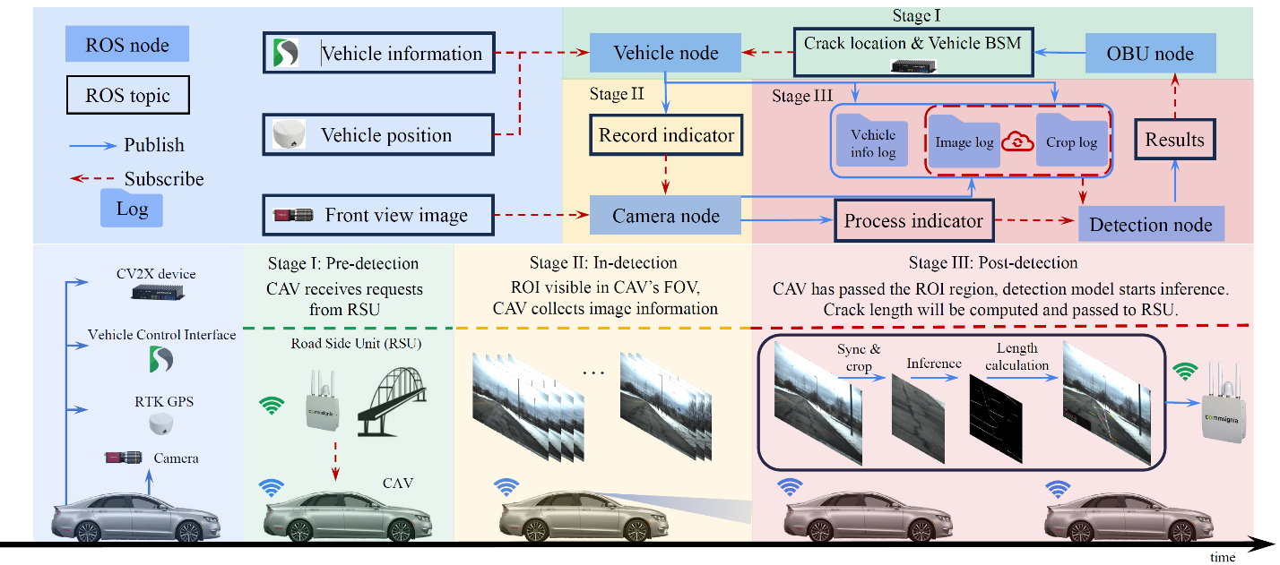
Task 1.1 [70%] This quarter, the team has spent significant effort in fulfilling this task.
Figure 1 Implemented Crack Detection Pipeline

On one hand, the team has successfully implemented a first function detection pipeline detailed in Figure 1. The pipeline is working in a serial thread and subjected to further optimization to improve real-time performance. It is fully functional on the vehicle allowing real-time data collection, testing and validation.
More specifically, the team are improving the detection model performance from multiple fronts
- Data preparation: the team carefully prepared and annotated a concrete deck surface cracks dataset that consists of a vehicle's forward-facing view. The team implemented a hybrid annotation mechanism that leverages both automated edge-detection algorithms and human refinement to streamline the annotation process. The dataset consists of 443 images, with 100 reserved for testing (RT100) and 343 for training (RT343).
- The team refined augmentation algorithms to enhance the training process. Specifically, three distinct augmentation approaches: Advanced Balanced Augmentation (V1), our novel crack-density-aware method that categorizes samples as none, minimal, moderate, or dense and applies adaptive multipliers (2× for rare categories) alongside 4 rotations, 3 flips, brightness/contrast jitter, elastic deformation (30\% probability), and density-aware cropping; Augmentation by DeepCrack [1] (V2), a deterministic replication of the literature approach using 9 rotations, 3 flips, and 5 fixed crops per image; and Enhanced DeepCrack Augmentation (V3), which extends V2 with modular Gaussian noise, blur, and brightness perturbations to study incremental effects.
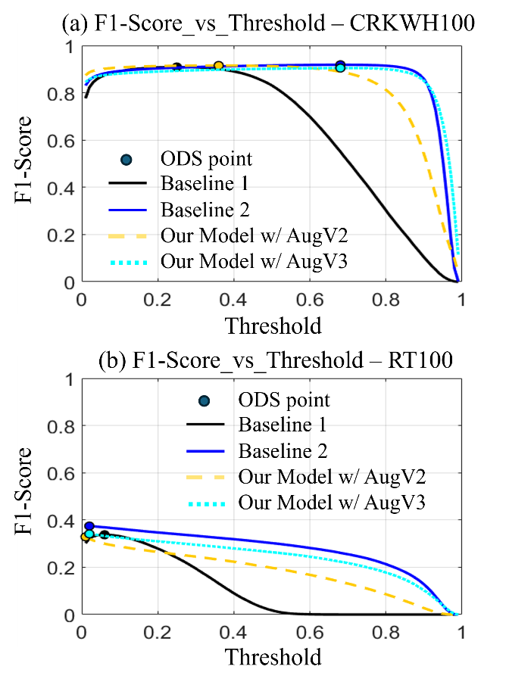
Figure 2 Model Performance comparison
With these two attempts, we were able to significantly improve the model’s performance. In Figure 2 where we compare with two baseline DeekCrack (baseline 1) [1] and LECSFormer (baseline 2) [2] using the F1 score. We are able to improve on the RT100 dataset, while maintaining the same level on the baseline concrete crack dataset CRKWH100 [3]. However, we still need to improve further to achieve better performance with more domain specific data. We are working on documenting our report the preliminary design in our upcoming conference paper [4].

Task 1.2 [30%] We have started the effort on designing a protocol that puts infrastructure at the center role to coordinate vehicle detection tasks and aggregate detection results, aligning with detections from other means (e.g., manual detection reports) to deliver a continuous deck condition state assessment workflow. We have just kicked off this effort and are expected to report more in next quarter.

Task 1.3 [0%] We have not started this effort in this quarter.

Task 2 [10%]:
Task 2.1 [20%] With our colleagues Prof. Darrell Kaminski and Prof. Pinar Okumus, we have established a connection with the local NYS DOT office and are acquiring necessary information about the bridges while launching workforce development activities through joint workshops and discussions, etc. We are expected to report more updates next quarter.

Task 2.2 [0%] We have not started this effort in this quarter.

- Percent of research project completed
We estimate that 25% of the total project will be completed by the end of this quarter.

- Expected progress for next quarter
We are expected to wrap up Task 1 in the next quarter by collecting additional data and baselining several models. We are expected to make major progress on Tasks 1.2 and 2.1, targeting project progress towards 60% by the end of the next quarter.

- Educational outreach and workforce development
The research team has been actively participating in educational outreach in events, engaging in workforce development on connectivity, automation, and transportation systems. One of the spotlight events is the Engineers’ Week at the Buffalo Museum of Science in Buffalo, New York, on February 21st, 2026.

The whole team of UB Safe and Autonomous Systems (SEAS) Lab, directed by PI Chaozhe He, provided hands-on demonstrations for the public, showcasing how connectivity and automation could give safer transportation systems and workforce environments.

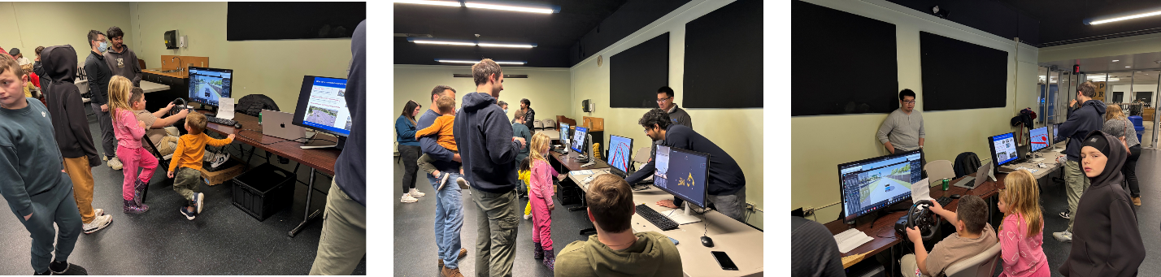

The research team actively participated in all TRANS-IPIC Monthly Webinars. The team is scheduled to present research findings at the TRANS-IPIC workshop on April 14, 2026.

- Technology Transfer
N/A

Research Contribution:
- Papers that include TRANS-IPIC UTC in the acknowledgments section:

H. Xiao, Y. Ramesh, R. Shukla, S. Sarkar, C. R. He. Infrastructure-Guided Connectivity-Enhanced Road Crack Detection and Estimation. The Fourth IEEE International Conference on Mobility: Operations, Services, and Technologies (MOST), Detroit, MI, May 2026 (to appear).

- Presentations and Posters of TRANS-IPIC funded research:
PI Chaozhe He and PhD Student Haosong Xiao gave presentations at the 5th Modeling, Estimation and Control Conference (MECC 2025) on October 8th 2025, reporting results from research funded in this project
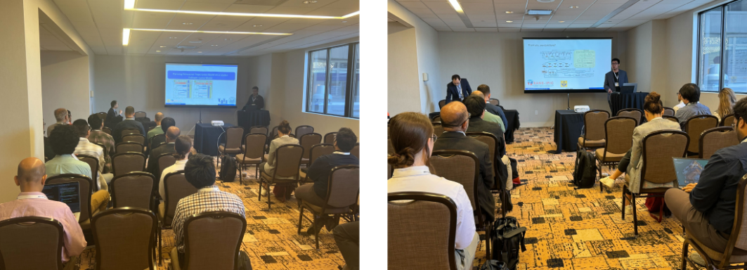

PhD Student Haosong Xiao entered poster competition at UB Mechanical and Aerospace Engineering (MAE) and at School of Engineering and Applied Sciences (SEAS), won 2nd place
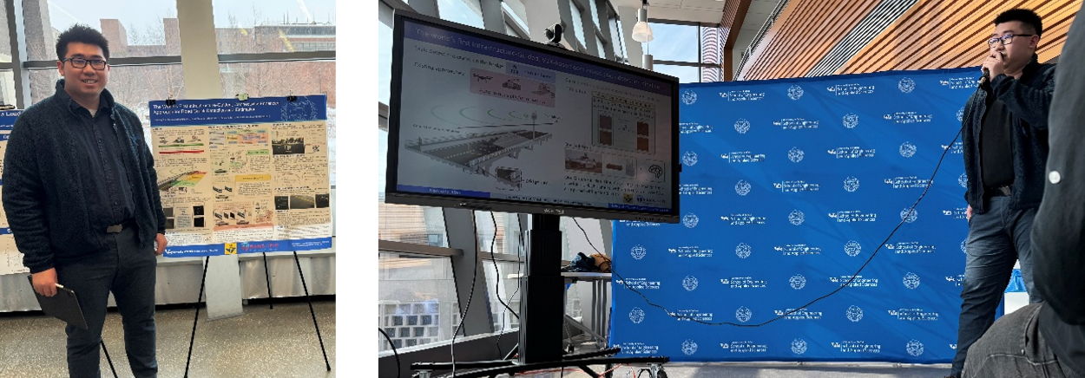

The World’s First Infrastructure-Guided, Connectivity-Enhanced Approach for Road Crack Detection and Estimation, H. Xiao, Y. Ramesh, R. Shukla, S. Sarkar, C. R. He.

- Please list any other events or activities that highlights the work of TRANS-IPIC occurring at your university (please include any pictures or figures you may have). Similarly, please list any references to TRANS-IPIC in the news or interviews from your research.

N/A

Appendix 1: Research Activities, leadership, and awards (cumulative, since the start of the project)

- Number of presentations at academic and industry conferences and workshops of UTC findings
- No. = 3

- Number of peer-reviewed publications submitted based on outcomes of UTC funded projects
- No. = 1

- Number of peer-reviewed journal articles published by faculty.
- No. = 0 (1 in preparation)

- Number of peer-reviewed conference papers published by faculty.
- No. = 2

- Number of TRANS-IPIC sponsored thesis or dissertations at the MS and PhD levels.
- No. MS thesis = 1 (expecting)
- No. PhD dissertations = 1 (expecting)
- No. citations of each of the above = 0

- Number of research tools (lab equipment, models, software, test processes, etc.) developed as part of TRANS-IPIC sponsored research
- Research Tool = 1, CAV based road crack detection, implementation ready code that allows connected automated vehicle based on Autoware platform to detect road crack using front facing camera, links: https://github.com/CHELabUB/cav_road_crack_detection

- Number of transportation-related professional and service organization committees that TRANS-IPIC faculty researchers participate in or lead.
- Professional societies
  - No. participated in = 1 (IEEE ITSC, IV Associate Editor)
  - No. lead = 0
- Advisory committees (No. participated in & No. led)
  - No. participated in = 0
  - No. lead = 0
- Conference Organizing Committees (No. participated in & No. led)
  - No. participated in = 2, 3rd and 4th IEEE International Conference on Mobility: Operations, Services, and Technologies (MOST)
  - No. lead = 0
- Editorial board of journals (No. participated in & No. led)
  - No. participated in = 0
  - No. lead = 0
- TRB committees (No. participated in & No. led)
  - No. participated in = 0
  - No. lead = 0

- Number of relevant awards received during the grant year
- No. awards received = 1 (UB MAE student poster challenge 2nd Place Winner)

- Number of transportation related classes developed or modified as a result of TRANS-IPIC funding.
- No. Undergraduate = 0
- No. Graduate = 1 MAE 502 Vehicle Control Systems (offering for twice now)

- Number of internships and full-time positions secured in the industry and government during the grant year.
- No. of internships = 0
- No. of full-time positions = 0

References:

[1] Q. Zou, Z. Zhang, Q. Li, X. Qi, Q. Wang, and S. Wang, "DeepCrack: Learning Hierarchical Convolutional Features for Crack Detection," IEEE Trans Image Process, Oct 31 2018, doi: 10.1109/TIP.2018.2878966.
[2] J. Chen, N. Zhao, R. Zhang, L. Chen, K. Huang, and Z. Qiu, "Refined Crack Detection via LECSFormer for Autonomous Road Inspection Vehicles," IEEE Transactions on Intelligent Vehicles, vol. 8, no. 3, pp. 2049-2061, 2023, doi: 10.1109/tiv.2022.3204583.
[3] N. Ma et al., "Vehicular Road Crack Detection with Deep Learning: A New Online Benchmark for Comprehensive Evaluation of Existing Algorithms," arXiv preprint arXiv:2503.18082, 2025.
[4] H. Xiao, R. Shukla, Y. S. Ramesh, Swarat;, and C. R. He, "Infrastructure-guided continuous inspection of the bridge deck surface crack using connected automated vehicles," in International Conference on Mobility: Operations, Services, and Technologies (MOST), Detroit, MI, 2026, to appear.

