

Transportation Infrastructure Precast Innovation Center
(TRANS-IPIC)

University Transportation Center (UTC)

Integrating Sensing Technologies, AI, and BIM to Automate the Lifecycle Quality Control of Precast MSE Wall Systems
PU-25-RP-01

Quarterly Progress Report
For the performance period ending on March 31, 2026

Submitted by:
Hubo Cai, hubocai@purdue.edu
Lyles School of Civil and Construction Engineering
Purdue University

Collaborators / Partners:
No other collaborators/partners

Submitted to:
TRANS-IPIC UTC
University of Illinois Urbana-Champaign
Urbana, IL

TRANS-IPIC Quarterly Progress Report (Section 1 – 7, 5 pages max.):

Project Description:
- Research Plan - Statement of Problem
Precast mechanically stabilized earth (MSE) wall systems are widely used in transportation infrastructure across the United States due to their advantages in quality, durability, and construction efficiency. However, despite being manufactured in controlled environments, these systems remain highly vulnerable to quality deficiencies throughout their lifecycle stages, including manufacturing, transportation, installation, and operation. Deficiencies at any stage can compromise structural performance, lead to premature failures, and result in significant repair costs. Given the large scale deployment of MSE wall systems, ensuring consistent and reliable quality control (QC) across their lifecycle is a critical yet unresolved challenge.

The current QC practice for precast MSE wall systems relies heavily on manual inspections that are labor-intensive, time-consuming, and prone to human error. Techniques such as tape measurements and visual inspections are commonly used in precast construction, but they are often incompetant to detect critical issues such as dimensional deviations from the design, reinforcement defects, and transportation-induced damages (Hong et al., 2025). Moreover, these practices are fragmented across lifecycle stages, with each stage operating in isolation. As a result, quality issues are often detected late, data are poorly shared, and root causes are difficult to trace. The reliance on static, checklist-based documentation further limits the ability to achieve proactive and integrated quality management.

Although emerging technologies such as building information modeling (BIM), digital twins, low-cost sensing tools (e.g., pocket LiDAR and smartphone cameras), and AI offer promising opportunities, they have not been effectively integrated into the current QC workflows. There remains a significant gap in developing a unified, automated, and lifecycle-oriented QC framework that leverages these technologies. Without such integration, the construction industry continues to face inefficiencies, inconsistent quality assurance, and limited data-driven decision-making. Therefore, there is a pressing need for a scalable, cost-effective solution that enables automated inspection, continuous data integration, and holistic quality management of precast MSE wall systems across all lifecycle stages.

- Research Plan - Summary of Project Activities (Tasks)
Task 1: Assess the low-cost pocket LiDAR and develop AI algorithms for near real-time dimensional measures during manufacturing and construction stages. This task is decomposed into two subtasks. Subtask a) focuses on assessing the feasibility of pocket LiDAR in capturing dimensional features of PC MSE walls, and Subtask b) focuses on developing near real-time AI algorithms that can process the LiDAR scan data to derive the dimensional measures.

Task 2: Develop an AI algorithm to determine damage that occurs during transportation based on before- and after- images captured by smart phones. This task focuses on two subtasks: (a) assessing state-of-the-art image-based AI algorithms in monitoring precast damage, including classification, detection, and quantification, and (b) developing a VLM (Visual Language Model)-based algorithm for classifying precast damages during transportation and exploring damage quantification.

Task 3: Integrate BIM with sensing technologies for generating accurate 3D as-builts and automating QC throughout PCS lifecycle stages. This task designs (1) a data-fusion approach for generating accurate 3D as-builts and (2) a digital twin-based method for automated compliance checking and documentation, covering the stages of precast plant production, transportation, lifting, and field installation.

Task 4: Validation and case studies. This task aims to verify and validate the methods, algorithms, and tools developed in Tasks 1, 2, and 3, which will be conducted using small-scale testbeds in the laboratory.

Task 5: Presentation/panel discussions at 2027 Purdue Road School and the Precast Show. Project design and findings will be shared through presentation/panel discussions at 2027 Purdue Road School and workshops at 2027 Precast Show. This will be also an opportunity to hear from experienced researchers and practitioners in the field of precast concrete in transportation projects.

Project Progress:
- Progress for each research task

Task 1 progress [50% completed]
The feasibility of pocket LiDAR as a low-cost solution for dimensional quality control of precast concrete elements has been evaluated. Pocket LiDAR feasibility was assessed through comparisons with a Terrestrial Laser Scanner (TLS) and tape measurements for rebar positions and dimensions of a concrete slab specimen.

Point cloud data of the concrete slab specimen were collected in both pre-casting and post-casting stages using TLS and iPhone LiDAR system. Three measurement approaches were employed: (1) TLS using a FARO Focus 3D X 330 scanner (FARO Technologies, n.d.), (2) pocket LiDAR using an iPhone 16 Pro equipped with an integrated LiDAR sensor and camera (Apple Inc., n.d.), and (3) manual tape measurements representing current industry practice. For pocket LiDAR data acquisition and processing, Pix4Dcatch was used for scanning and registration, and Pix4Dmatic was used for point cloud reconstruction. Figure 1 shows the data collection environment and the drawings of the target slab.

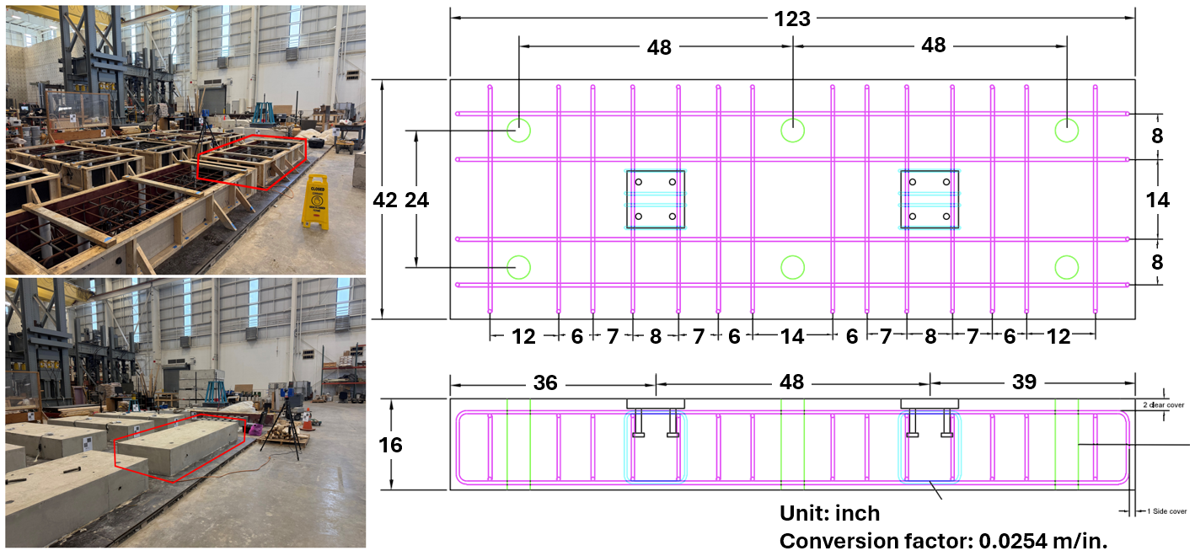
Figure 1. Data collection at Bowen Lab: pre- and post-casting (left); drawings (right).

TLS scans were conducted at high resolution (1/1 resolution, 4× quality), requiring approximately 4 hours of acquisition time and resulting in dense point clouds (~85 million and ~81 million points for pre- and post-casting stages, respectively) with a mean registration error of 2.0 mm. In contrast, pocket LiDAR data were collected within approximately 3 minutes, producing significantly lighter point clouds (~1.6 million and ~0.8 million points after cropping).

The datasets were evaluated in terms of point cloud fidelity, dimensional accuracy, and compliance with industry tolerances. For point cloud fidelity assessment, the comparison focuses on the pre-casting state due to its higher geometric complexity. The point clouds generated from TLS and pocket LiDAR are shown in Figure 2. The TLS and pocket LiDAR datasets were downsampled to a voxel size of 1 mm and aligned using the Iterative Closest Point (ICP) algorithm. The registration resulted in a fitness score of 0.547 and a Root Mean Square Error (RMSE) of 2.8 mm, indicating a reasonable geometric alignment between the two datasets. Correspondence analysis using a 5 mm threshold further showed that a substantial portion of points from pocket LiDAR aligned well with TLS data. The spatial distribution of corresponding and non-corresponding points is illustrated in Figure 3, and quantitative results are summarized in Table 1.

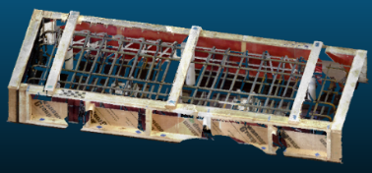 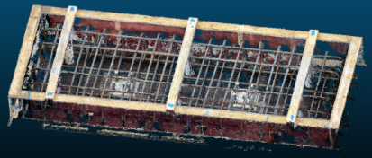Figure 2. Point clouds generated from TLS (left) and Pocket LiDAR (right) in the pre-casting state.

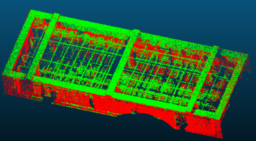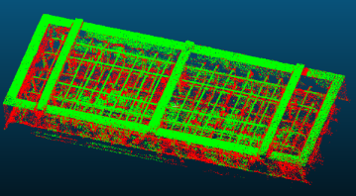
Figure 3. Correspondence visualization between TLS (left) and pocket LiDAR (right) point clouds. Corresponding points are shown in green, and non-corresponding points are shown in red.
Table 1. Number of inliers and outliers after point cloud registration.
Technology | Inliers | Outliers | Total
TLS | 441,683 | 378,469 | 820,152
Pocket LiDAR | 465,210 | 313,644 | 778,854

Dimensional accuracy was evaluated by extracting rebar intersection coordinates and concrete dimensions from TLS, pocket LiDAR, and tape measurements. The results showed that pocket LiDAR significantly outperformed tape measurements in rebar position estimation, achieving an RMSE of 5.5 mm relative to TLS, compared to 45.8 mm for tape measurements. This demonstrates that pocket LiDAR can provide substantially more reliable and consistent measurements for reinforcement placement. For concrete dimensions (length, width, and depth), pocket LiDAR and tape measurements showed comparable accuracy, with RMSE values of 7.3 mm and 5.9 mm, respectively. This similarity is attributed to the relatively simple geometry of the concrete slab, where manual measurements remain effective.

A compliance checking analysis was conducted by comparing measured values against design specifications and industry tolerances (±12.7 mm for rebar placement, ±12.7 mm for length, and ±6.3 mm for width and depth) (ACI, 2010; PCI, 2024). The results of the compliance checking indicate that pocket LiDAR can reliably identify most tolerance violations for both rebar positions and concrete dimensions. For rebar positions, discrepancies between TLS and pocket LiDAR were observed in the compliance assessment of two rebars, S3 and S4, as shown in Figure 4. They were classified as compliant by TLS (with deviations of 9.9 mm and 10.2 mm) but non-compliant by pocket LiDAR (16.8 mm). Tape measurements, on the other hand, incorrectly classified all rebar positions as non-compliant, likely due to cumulative measurement errors inherent in manual spacing measurements. For concrete dimensions, all three methods consistently identified compliance with tolerance limits.
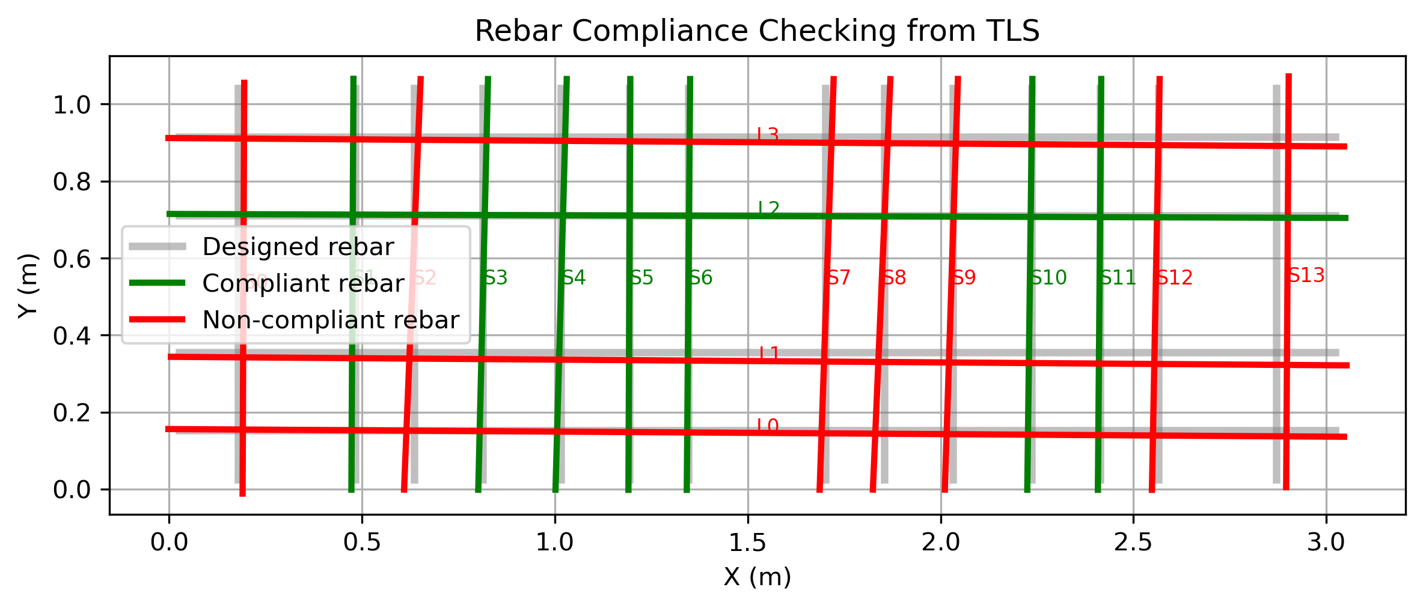
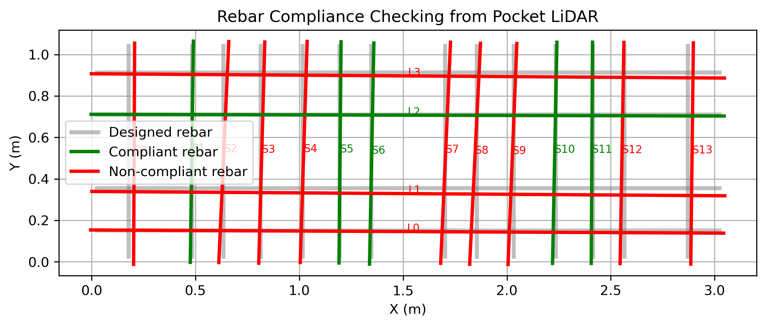
Figure 4. Results of rebar compliance checking based on TLS point cloud (top) and pocket LiDAR point cloud (bottom).

Overall, the results demonstrate that pocket LiDAR provides a strong balance between accuracy, efficiency, and cost. While TLS remains the most accurate method, pocket LiDAR achieves sufficient accuracy for many QC applications while drastically reducing data acquisition time and operational complexity. The findings highlight the potential of pocket LiDAR to support rapid and automated QC workflows in precast construction.

Task 2 progress [0% completed]
This task hasn’t started.

Task 3 progress [0% completed]
This task hasn’t started.

Task 4 progress [0% completed]
This task hasn’t started.

Task 5 progress [0% completed]
This task hasn’t started.

- Percent of research project completed
It is estimated that the total project is 15% completed in this quarter ending on March 31, 2026.

- Expected progress for next quarter
We estimate that 40% work of the total project will be completed by the end of next quarter. The specific results that will be delivered include:
- Near real-time AI algorithms that measure dimensions of Precast Concrete system MSE walls and their components based on scan point clouds,
- A comprehensive literature review to assess state-of-the-art image-based AI algorithms in precast damage monitoring,
- A VLM-based algorithm that can identify damage during transportation, and
- A poster presentation at TRANS-IPIC UTC Workshop held in April.

- Educational outreach and workforce development
NA

- Technology Transfer
NA

Research Contribution:
- Papers that include TRANS-IPIC UTC in the acknowledgments section:
A manuscript for TRANS-IPIC UTC Workshop has been submitted.

- Presentations and Posters of TRANS-IPIC funded research:
No events or activities have been presented.
A poster presentation is planned for the 2026 TRANS-IPIC UTC Workshop.

- Please list any other events or activities that highlights the work of TRANS-IPIC occurring at your university (please include any pictures or figures you may have). Similarly, please list any references to TRANS-IPIC in the news or interviews from your research.
No events or activities have been presented.
NA.

Appendix 1: Research Activities, leadership, and awards (cumulative, since the start of the project)

- Number of presentations at academic and industry conferences and workshops of UTC findings
- No. = 0

- Number of peer-reviewed publications submitted based on outcomes of UTC funded projects
- No. = 0

- Number of peer-reviewed journal articles published by faculty.
- No. = 0

- Number of peer-reviewed conference papers published by faculty.
- No. = 0

- Number of TRANS-IPIC sponsored thesis or dissertations at the MS and PhD levels.
- No. MS thesis = 0
- No. PhD dissertations = 0
- No. citations of each of the above = 0

- Number of research tools (lab equipment, models, software, test processes, etc.) developed as part of TRANS-IPIC sponsored research
NA.

- Number of transportation-related professional and service organization committees that TRANS-IPIC faculty researchers participate in or lead.
- Professional societies
  - No. participated in = 1
  - No. lead = 1
- Advisory committees (No. participated in & No. led)
  - No. participated in = 0
  - No. lead = 0
- Conference Organizing Committees (No. participated in & No. led)
  - No. participated in = 1
  - No. lead = 0
- Editorial board of journals (No. participated in & No. led)
  - No. participated in = 1
  - No. lead = 0
- TRB committees (No. participated in & No. led)
  - No. participated in = 0
  - No. lead = 00

- Number of relevant awards received during the grant year
- No. awards received =

- Number of transportation related classes developed or modified as a result of TRANS-IPIC funding.
- No. Undergraduate = 0
- No. Graduate = 0

- Number of internships and full-time positions secured in the industry and government during the grant year.
- No. of internships = 0
- No. of full-time positions = 0

References:
American Concrete Institute (ACI) (2010). Specification for tolerances for concrete construction and materials (ACI 117-10) and commentary (ACI 117R-10). Farmington Hills, MI: American Concrete Institute.
Apple Inc. (n.d.) iPhone User Guide. Available at: https://support.apple.com/en-is/guide/iphone/iph689bcd137/ios (Accessed: 31 March 2026).
FARO Technologies (n.d.). Technical specification sheet for the Focus laser scanner. Available at: https://knowledge.faro.com/Hardware/Focus/Focus/Technical_Specification_Sheet_for_the_Focus_Laser_Scanner (Accessed: 25 March 2026).
Hong, Z., Hong, Y., Cai, H., Abraham, D.M., Zhang, J. and Dunston, P.S. (2025). ‘BIM-Based Framework for In-Plant Quality Control of Precast Concrete Manufacturing’, Journal of Construction Engineering and Management, 151(12), p.05025017. https://doi.org/10.1061/JCEMD4.COENG-16659.
Precast/Prestressed Concrete Institute (PCI) (2024). PCI 135-24: Specification for tolerances of precast concrete (draft). Available at: https://www.pci.org/PCI_Docs/About/Standards/PCI-135_TolerancesStd_Public%20Comment_20240306-test.pdf (Accessed: 25 March 2026).

