- Report No.  PU-24-EP-01 |  | - Government Accession No  N/A | - Recipient’s Catalog No.  N/A
- Title and Subtitle  IFC-based BIM for Robotic Installation of Precast Bridge Components |  |  | - Report Date  December 2025
- Performing Organization Code

N/A
- Author(s)  Jiansong Zhang, PhD, https://orcid.org/0000-0001-5225-5943  Hubo Cai, PhD, https://orcid.org/0000-0003-4527-1974 |  |  | - Performing Organization Report No.  PU-24-EP-01
- Performing Organization Name and Address  School of Construction Management Technology,  Purdue University  550 W Stadium Ave, West Lafayette, IN 47907 |  |  | - Work Unit No.  N/A
- Contract or Grant No.

69A3552348333
- Sponsoring Organization Name and Address  Transportation Infrastructure Precast US Department of Transportation  Innovation Center (TRANS-IPIC) Office of Research, Development and University of Illinois Urbana-Champaign. Technology (RD&T)  Civil & Environmental Engineering. 1200 New Jersey Avenue, SE  205 N Mathews Ave, Urbana, IL 61801 Washington, DC 201590 |  |  | - Type of Report and Period Covered  Final Report  [Enter Month Year – Month Year]
14. Sponsoring Agency Code

N/A
15. Supplementary Notes

For additional reports and information visit the TRANS-IPIC website https://trans-ipic.illinois.edu
16. Abstract

Precast bridge projects have been widely adopted by US DOT agencies to accelerate construction, minimize traffic disruptions, and enhance structural quality and durability. However, onsite assembly of precast components remains a time-consuming, repetitive, and hazardous task in precast projects. Robotic installation of precast bridge components presents a promising solution to improve both efficiency and safety in precast bridge construction. AASHTO has adopted the Industry Foundation Classes (IFC) standard for building information modeling (BIM)-based bridge modeling in 2019. Although the IFC bridge standard is well developed to facilitate the communication and coordination of BIM-based bridge construction, there is a lack of interoperable BIM to support robotic installation and its constructability analysis. This limitation restricts the achievement of BIM benefits throughout the lifecycle of a bridge project, which involves a large number of precast products such as beams, girders, and deck panels.

In this project, technologies were developed that enhance IFC-based BIM interoperability and facilitate robotic installation of large and complex precast bridge components such as deck panels. Specifically, our project developed an invariant signature-based approach for automated extraction of critical bridge component information from IFC data. Furthermore, heuristic and simulation-based planning were integrated to generate crane operational plans and provide a systematic assessment of the plans’ constructability. Our developed algorithm successfully extracted the correct information from six different bridge model files, originating from different software exports into IFC with different versions (IFC4, IFC2X3 and IFC4X3). This testing shows that our invariant signature-based method can successfully complete the bridge components extraction from IFC models correctly. It is a robust and automated approach to IFC information extraction. The interoperability and automation levels in bridge automation construction are expected to be enhanced with this approach. Experimental results also showed that the integration of heuristic and simulation-based planning effectively: 1) assessed the feasibility of lifting operation using selected crane size and crane lifting location, 2) generated feasible plans given the chosen crane size and location with low computational cost, and 3) afforded plan validation via realistic physical simulations for constructability analysis.

The resulting technology from this project takes different formats of bridge BIM, converts them into IFC-Bridge and then into operation plans and construction process simulations can help harness the opportunity that comes with the transformative precast materials and construction methods developed at the TRANS-IPIC center, to help address data efficiency/interoperability problems in the context of precast bridge construction, aligned with TRANS-IPIC’s strategic goal #3 “Advance the field of building information modeling (BIM) using new technologies” and Topic (5): Robotic Production and Installation of Precast Components. This provides a solid foundation for the development of a smart crane that is intelligent and automated.
17. Key Words  Building Information Modeling (BIM), Industry Foundation Classes (IFC), Precast Bridge Construction, Crane Operation, Automation, Planning, Simulation. |  |  |  | 18. Distribution Statement  No restrictions.
19. Security Classification (of this report)  Unclassified. | 20. Security Classification (of this page)  Unclassified. |  |  | 21. No. of Pages  25 | 22. Price  N/A
Disclaimer:
The contents of this report reflect the views of the authors, who are responsible for the facts and
the accuracy of the information presented herein. This document is disseminated in the interest of information exchange. The report is funded, partially or entirely, under 69A3552348333 from the U.S. Department of Transportation’s University Transportation Centers Program. The U.S.
Government assumes no liability for the contents or use thereof.



Transportation Infrastructure Precast Innovation Center
(TRANS-IPIC)

University Transportation Center (UTC)

IFC-based BIM for Robotic Installation of Precast Bridge Components
[PU-24-EP-01]

FINAL REPORT

Submitted by:
Jiansong Zhang, zhan3062@purdue.edu
School of Construction Management Technology
Purdue University

Hubo Cai, hubocai@purdue.edu
Lyles School of Civil and Construction Engineering
Purdue University

Collaborators / Partners:
Atlas Excavating; Milestone Contractors; Force Construction; Kelley Construction; Walsh Group; Aldridge Electric; Superior Construction; FH Paschen; Indiana Constructors

Submitted to:
TRANS-IPIC UTC
University of Illinois Urbana-Champaign
Urbana, IL

Executive Summary:

Precast bridge projects have been widely adopted by US DOT agencies to accelerate construction, minimize traffic disruptions, and enhance structural quality and durability. However, onsite assembly of precast components remains a time-consuming, repetitive, and hazardous task in precast projects. Robotic installation of precast bridge components presents a promising solution to improve both efficiency and safety in precast bridge construction. AASHTO has adopted the Industry Foundation Classes (IFC) standard for building information modeling (BIM)-based bridge modeling in 2019. Although the IFC bridge standard is well developed to facilitate the communication and coordination of BIM-based bridge construction, there is a lack of interoperable BIM to support robotic installation and its constructability analysis. This limitation restricts the achievement of BIM benefits throughout the lifecycle of a bridge project, which involves a large number of precast products such as beams, girders, and deck panels.

The invariant signatures of architecture, engineering, and construction (AEC) objects successfully demonstrated in the vertical construction sector in supporting BIM interoperability, although initial efforts have been made in adopting them in the horizontal construction (civil infrastructure) domain by supporting automated drainage and pavement components classifications, there is great potential to adopt them in the civil infrastructure domain especially for bridge projects which requires better BIM support for the more delicate geometries compared with road projects. With the adoption of BIM powered by invariant signatures of AEC objects, it is expected the transportation and installation of precast bridge components can be performed with improved efficiency, safety, and sustainability. In addition, to automate crane operational analysis, there is a gap in including crane dynamics in assessing the lifting plans.

In this project, technologies were developed that enhance IFC-based BIM interoperability and facilitate robotic installation of large and complex precast bridge components such as deck panels. Specifically, our project developed an invariant signature-based approach for automated extraction of critical bridge component information from IFC data. Furthermore, heuristic and simulation-based planning were integrated to generate crane operational plans and provide a systematic assessment of the plans’ constructability.

Our developed algorithm successfully extracted the correct information from six different bridge model files, originating from different software exports into IFC with different versions (IFC4, IFC2X3 and IFC4X3). This testing shows that our invariant signature-based method can successfully complete the bridge components extraction from IFC models correctly. It is a robust and automated approach to IFC information extraction. The interoperability and automation levels in bridge automation construction are expected to be enhanced with this approach. Experimental results also showed that the integration of heuristic and simulation-based planning effectively: 1) assessed the feasibility of lifting operation using selected crane size and crane lifting location, 2) generated feasible plans given the chosen crane size and location with low computational cost, and 3) afforded plan validation via realistic physical simulations for constructability analysis.

One main challenge is implementing our method in the physical world with industry equipment and hardware, as real-world construction operations are conducted in a dynamic environment with affluent of factors. In view of that, digital twin provides a feasible approach ahead to vividly capture all relevant factors through real-time data. An effective and accurate digital twin is recommended as the next step to help eventually bring our method to real world implementation.

The resulting technology from this project takes different formats of bridge BIM, converts them into IFC-Bridge and then into operation plans and construction process simulations can help harness the opportunity that comes with the transformative precast materials and construction methods developed at the TRANS-IPIC center, to help address data efficiency/interoperability problems in the context of precast bridge construction, aligned with TRANS-IPIC’s strategic goal #3 “Advance the field of building information modeling (BIM) using new technologies” and Topic (5): Robotic Production and Installation of Precast Components. This provides a solid foundation for the development of a smart crane that is intelligent and automated.

Table of Contents

Table of Contents
1. Problem description: 7
2. Background (including literature review): 7
3. Research scope and objectives: 7
4. Research description: 7
5. Project results: 8
5.1 Bridge Components Classification 9
5.2 Information Extraction 10
5.3 Simulation for Bridge Panel Installation Planning 13
5.3.1. Heuristic planning algorithm 13
5.3.2. Unity3D-based Simulation for Constructability Analysis 16
5.4 Educational outreach and workforce development 19
5.5 Technology Transfer 23
5.6 Presentations and Posters of TRANS-IPIC funded research: 23
6. Conclusions and recommendations: 24
7. Practical application/impact on transportation infrastructure: 24
8. References: 25

Problem description:
Precast bridge projects have been widely adopted by US DOT agencies to accelerate construction, minimize traffic disruptions, and enhance structural quality and durability [1,2]. However, onsite assembly of precast components remains a time-consuming, repetitive, and hazardous task in precast projects [3]. Robotic installation of precast bridge components presents a promising solution to improve both efficiency and safety in precast bridge construction.

Background (including literature review):
Building information modeling (BIM) plays an important role in gathering design and construction information for the planning and execution of robotic installation. AASHTO has adopted the Industry Foundation Classes (IFC) standard for BIM-based bridge modeling in 2019. Although the IFC bridge standard is well developed to facilitate the communication and coordination of building information modeling (BIM)-based bridge construction, there is a lack of interoperable BIM to support robotic installation and its constructability analysis. This limitation restricts the achievement of BIM benefits throughout the lifecycle of a bridge project, which involves a large number of precast products such as beams, girders, and deck panels.

The invariant signature of an AEC object is defined as “a set of intrinsic properties of the object that distinguish it from others and that do not change with data schema, software implementation, modeling decisions, and/or language/cultural contexts” [4]. It has been successfully demonstrated in the vertical construction sector in supporting BIM interoperability: (1) between architectural design and construction cost analysis [5]; (2) between architectural design and code compliance checking [6]; (3) between architectural design and structural analysis [4]; and (4) between architectural design and energy modeling/simulation [7]. It also has been initially tested in the horizontal construction (i.e., civil infrastructure) sector for BIM interoperability between drainage/pavement design and quality assurance analysis [8]. Invariant signatures of AEC objects have been successfully tested and demonstrated in multiple BIM interoperability scenarios as forementioned [9]. However, the existing research and development in adopting invariant signatures of AEC objects heavily focused on vertical construction (for buildings). Although initial efforts have been made in adopting them in the horizontal construction (civil infrastructure) domain by supporting automated drainage and pavement components classifications [6], there is great potential to adopt them in the civil infrastructure domain especially for bridge projects which requires better BIM support for the more delicate geometries compared with road projects. With the adoption of BIM powered by invariant signatures of AEC objects, it is expected the transportation and installation of precast bridge components can be performed with improved efficiency, safety, and sustainability.
In addition, to automate crane operational analysis, recent studies developed computational algorithms for lifting trajectory planning by focusing on 1) optimizing multiple performance objectives (e.g., minimum energy and time consumption, shortest path, smooth trajectories), and 2) improving computational efficiency of the algorithms [10,11]. However, there is a gap in including crane dynamics in assessing the lifting plans [12].

Research scope and objectives:
This project aims at developing technologies that enhance IFC-based BIM interoperability and facilitate robotic installation of large and complex precast bridge components such as deck panels. Specifically, our project develops an invariant signature-based approach for automated extraction of critical bridge component information from IFC data. Furthermore, heuristic and simulation-based planning are integrated to generate crane operational plans and provide a systematic assessment of the plans’ constructability. The proposed approaches are investigated in applications that support BIM interoperability among precast bridge design, robotic installation, and constructability analysis through four tasks detailed in the next section.

Research description:
The research conducted follows an empirical and data-driven approach, including four tasks as follows.
Task 1 – Model bridge in different BIM software. This task selects representative large and complex pre-cast bridge deck components and models them using OpenBridge and Autodesk Revit, with the aim to generate non-proprietary bridge deck data for supporting later algorithm development.

Task 2 – Export IFC from BIM models. This task exports the components from different BIM software (OpenBridge and Revit) into IFC, directly and/or indirectly (thru third-party or open-source paths), with a focus on IFC4 and contingency use of IFC2X3 and IFC4X3.

Task 3 – Develop planning algorithms and associated simulation. This task develops invariant signature-based algorithms that take IFC-based precast bridge designs and automatically produce operational plans for robotic installation and corresponding construction simulations for constructability analysis and process optimization.

Task 4 – Roundtable. A roundtable with industry professionals held at Purdue Construction Advisory Council Meetings to gauge industry needs/interest and broadly disseminate the research findings.

Project results:
With the purpose of running a simulation of the installation process in the Unity3D environment, IFC model of the bridge with pre-cast panel for the deck is required as input. Two different software programs (OpenBridge Designer and Autodesk Revit) were utilized in these model development process. Each software was used to create models of a sample bridge with precast decks based on assumed initial dimensions and primary information about the bridge. The models developed using OpenBridge Designer and Autodesk Revit are shown in Figure 1.

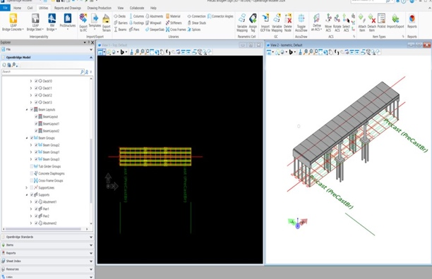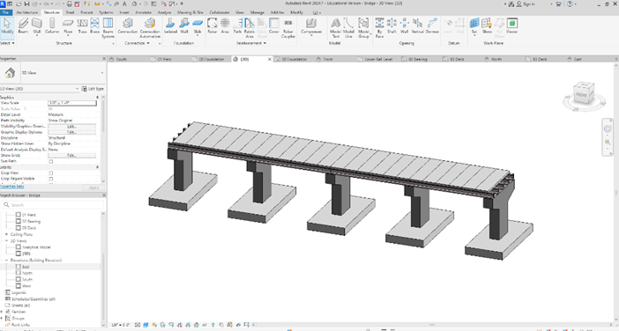
Figure 1. Bridge modelling with Openbridge Designer (left) and with Autodesk Revit (right).

The sample bridge models were converted to IFC as shown in Figure 2.

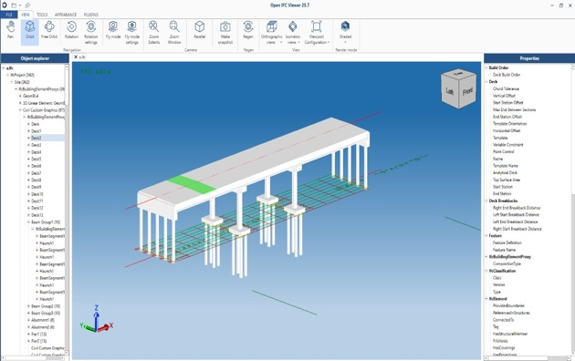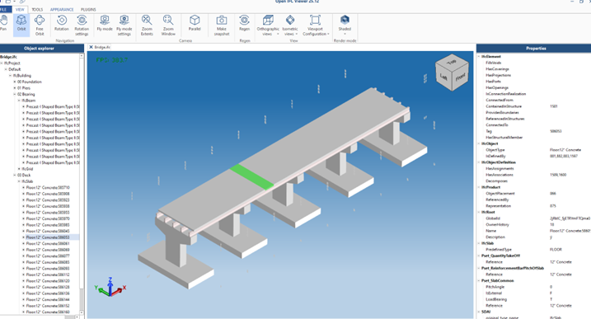
Figure 2. IFC file of the bridge modeled from OpenBridge Designer (left) and modeled from Autodesk Revit (right).

Invariant signature-based method was developed for automatically extracting bridge component information from IFC, and automatically planning bridge installation and conducting constructability analysis, based on input IFC files. The method integrated heuristic and simulation-based planning.

Bridge Components Classification
Focusing on installation of deck panels, we first developed a classification algorithm that can automatically identify/classify the decks among various bridge components using invariant geometric signatures (see Figures 3 & 4). Next, we developed information extraction algorithms that can extract necessary information (e.g., ID, location, bounding box) of the decks for installation planning. The developed algorithms can adapt to different software platforms (e.g., OpenBridge and Revit) and IFC versions (IFC4, IFC4X3, IFC2X3).

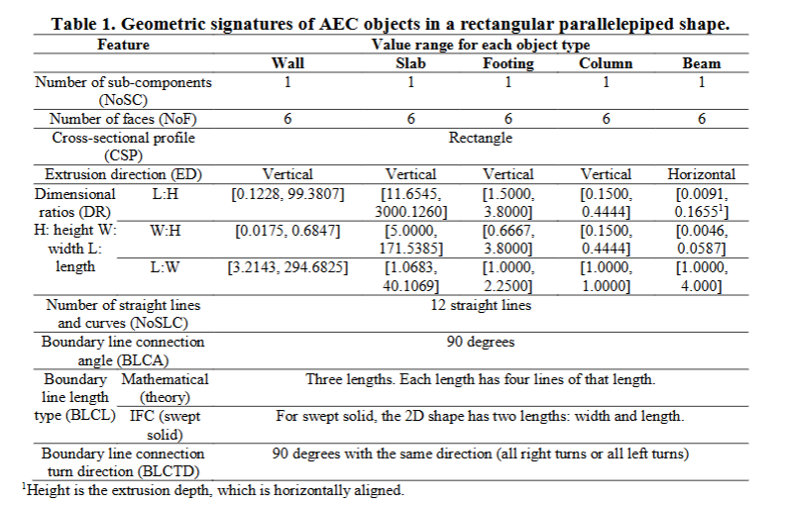
Figure 3. Invariant geometric signatures adapted [13].
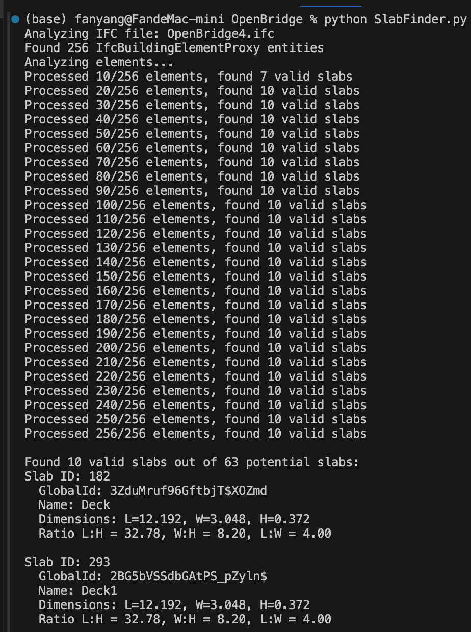
Figure 4. Partial results from the invariant signature-based classification algorithm.

Information Extraction
To establish interoperable BIM for robotic bridge installation, it is important to extract critical information from IFC models to serve as inputs to installation planning. Figure 5 illustrates our pipeline for the automated information extraction. Key information includes the size, location, and mass of bridge panels, as well as obstacle information such as the geometry of the bridge body. One major challenge of the extraction is the absence of explicit component-type attributes in the exported IFC data. For example, in early IFC versions, bridge components exported from OpenBridge were often labeled generically as IfcBuildingElementProxy rather than as specific IFC entities such as IfcSlab and IfcBeam. Additionally, the geometry of these components was typically represented as undifferentiated meshes, which makes it difficult for the computer to distinguish between critical components such as slabs, piers, and girders.

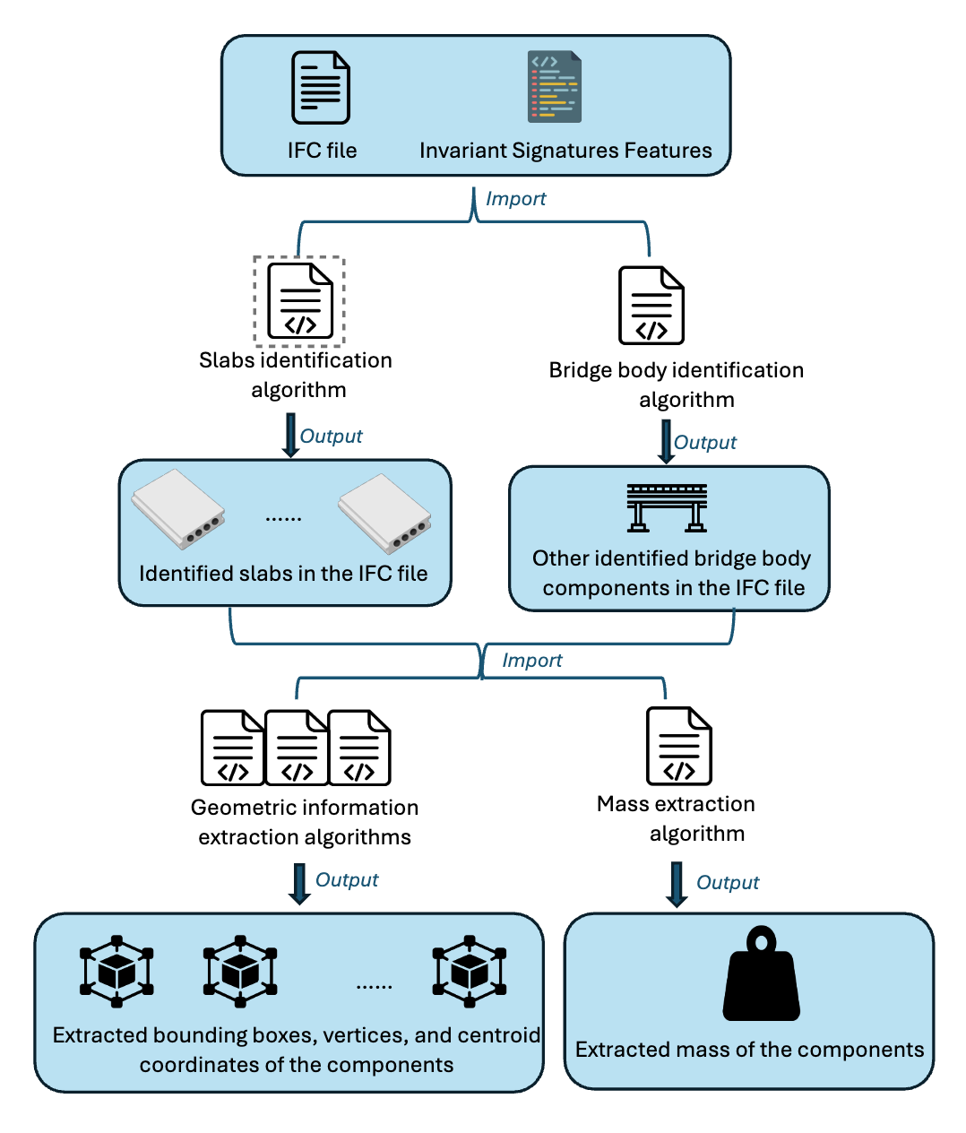
Figure 5. IFC-based information extraction pipeline.
To address these challenges, we utilized invariant signatures to identify the target components. As demonstrated in previous research [13] and also illustrated in Figure 3, different types of components have distinct ranges of geometric invariant signature values. Focusing on installation of deck panels (slabs), we developed a classification algorithm that can automatically differentiate the decks from other bridge components using geometric invariant signatures (see Figure 6). Similarly, we applied the same approach to identify bridge body components (primarily Beams), to provide contextual information to assist downstream planning tasks.

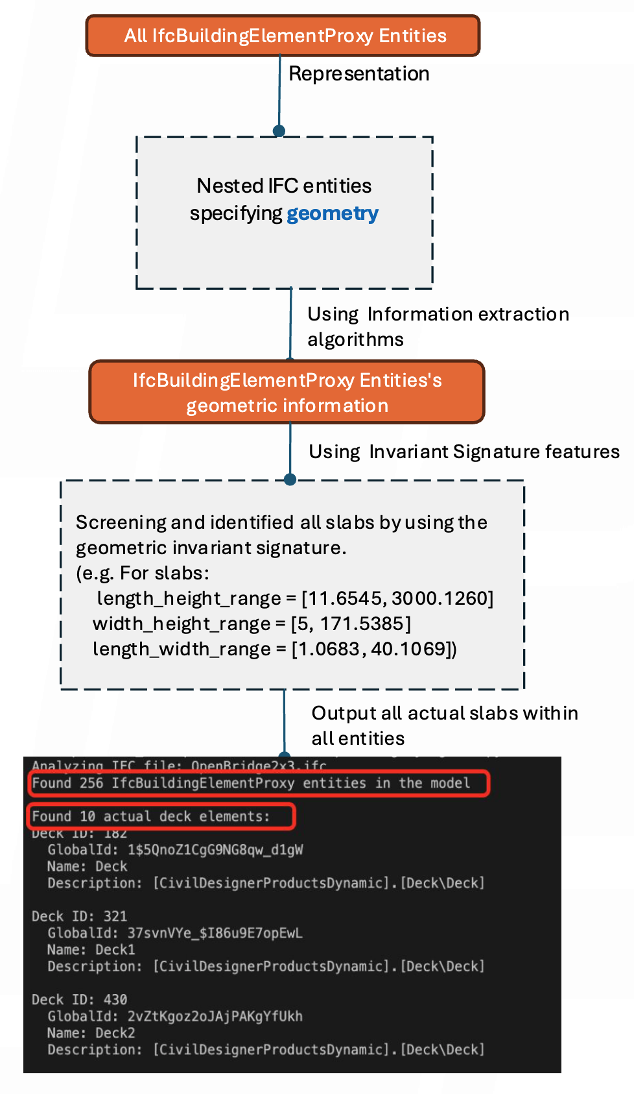
Figure 6. An example of applying invariant signatures to extract target components.
The second step involves extracting relevant information from identified components. Essential information includes ID, location, bounding box, mass of the slabs and other bridge body components. An extracted information sample is shown in Figure 7, where ten slabs in an IFC model were identified, and the coordinates of their bounding boxes vertex and center points were extracted. The developed algorithms can adapt to different software platforms (e.g., OpenBridge and Revit) and IFC versions (IFC4, IFC4X3, IFC2X3).

Our developed algorithm successfully extracted the correct information from six different bridge model files, originating from two software (Revit and Openbridge) and their exports into three IFC versions (IFC4, IFC2X3 and IFC4X3). This testing shows that the pipeline can successfully complete all the above extraction correctly. The invariant signature-based pipeline is a robust and automated approach to IFC information extraction. The interoperability and automation levels in bridge automation construction are expected to be enhanced with this approach.

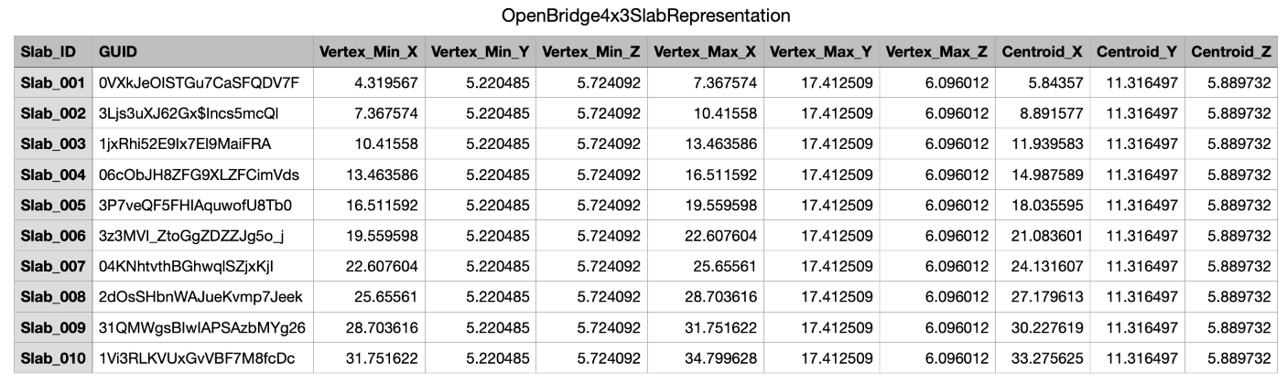Figure 7. Extracted IFC information sample of the algorithms.

Simulation for Bridge Panel Installation Planning

We developed a heuristic planning algorithm that automatically generates control parameters for crane operations. In addition, a behavior tree-based control architecture was developed for executing the generated plans and was simulated in Unity3D for constructability analysis. The results showed that the integration of heuristic and simulation-based planning effectively: 1) assessed the feasibility of lifting operation using selected crane size and crane lifting location, 2) generated feasible plans given the chosen crane size and location with low computational cost, and 3) afforded plan validation via realistic physical simulations for constructability analysis.

5.3.1. Heuristic planning algorithm

The presented algorithm is for analyzing the crane lifting conditions in a precast bridge construction project. The algorithm is based on the heuristic planning approach which evaluates crane operation feasibility, calculates optional boom configuration, ensures safe lifting operation by avoiding physical collision.

The heuristic planning approach is designed for locating the feasible crane location for lifting precast panels based on the crane lifting capacity configuration (in reference to the load chart). Engineering heuristics are applied to determine and identify the boom length and working radius based on preferred crane location by users. With the feasible pairs of crane locations and boom length, under the physical movement constraint of the crane, the output of the heuristic planning algorithm serves as input to crane simulation detailed in section 5.3.2.

We adopted a multi-stage planning strategy that mimics crane operators’ engineering decisions under real-world crane operational constraints and three operation assumptions: (1) one action of the crane at a time. For example, while rotating, boom length cannot be extended or retracted. (2) the location of the crane and panel pick-up location can be provided by user and adjusted in the simulation environment (detailed in section 5.3.2). (3) the distance from the pick-up location to the crane is closer than the distance from the crane to the placement location.

The heuristic planning algorithm (see pseudo code in Table 1) contains two main filtering stages:
- Stage 1: Capacity-based filtering: based on the load chart of a crane (see Figure 8 for example), pairs of feasible radius and boom length, the pairs valid for operation are obtained. For example, assuming the load is heavier than 10 tons, all the possible capacity in the box is satisfied, and the system will obtain corresponding pairs (radius and boom length).

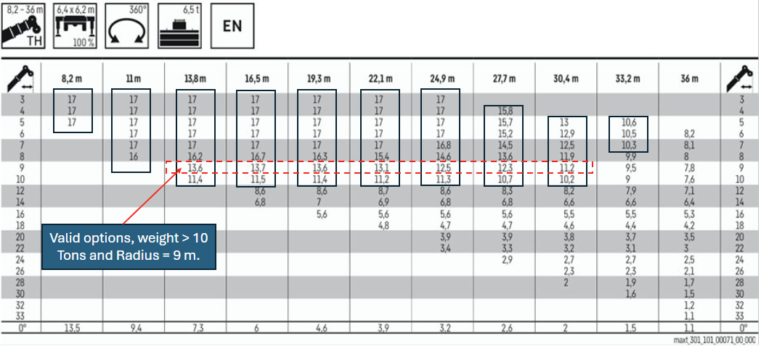
Figure 8. Load chart and example for valid pairs for load heavier than 10 tons [14].

The pairs are further filtered with the provided coordination of the crane which was obtained from the simulation environment (see section 5.3.2). By using the coordination of the placement location and crane location, distance is calculated in horizontal plane (XZ), based on which the number of valid pairs are further reduced. For example, assuming that the crane was parked at a distance 9 m from the placement location, the valid capacity reduces to those in the dashed line box shown in Figure 8.

- Stage 2: Geometric constraint filtering:
Three geometric constraints are used for further filtering. Details based on the planning layout and lifting action diagram are as follows (Figure 9).

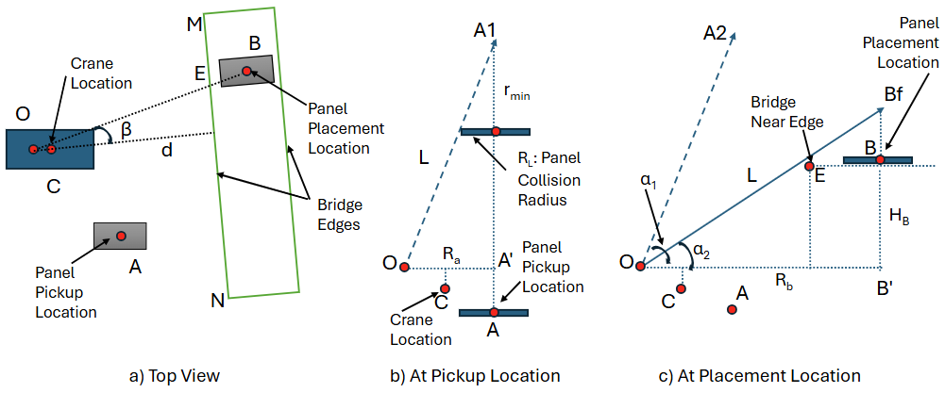
Figure 9. Crane, panel, and bridge layout and diagrams.
Constraint 1: Boom-Load Collision Prevention at Pickup location (see Figure 9b)
With the selected pairs, the length of the Boom (L) is known. Considering the radius of the panel, R_{L}, (assuming the panel can be rotated around its center) and the height of bridge (H_{B}), the constraint 1 is obtained using Equations (1) to (3) below:

$$\frac{r_{min}}{R_{L}}=\frac{\sqrt{L^{2}-R_{a}^{2}}}{R_{a}}$$
(Equation 1)
$$\sqrt{L^{2}-R_{b}^{2}}-r_{min}>H_{B}$$
(Equation 2)
$\sqrt{L^{2}-R_{b}^{2}}-\frac{\sqrt{L^{2}-R_{a}^{2}}}{R_{a}} R_{L}>H_{B}$ (Equation 3)

Constraint 2: Load-Bridge Collision Prevention/Rope length constraints
By taking into account the length of the rope during the operation, from both pickup location and placement location, we got the constraints of Equation (4) and Equation (5):

$\frac{\sqrt{L^{2}-R_{a}^{2}}}{R_{a}} R_{L}<r<\sqrt{L^{2}-R_{b}^{2}}-H_{B}$ (Equation 4)
$\frac{\sqrt{L^{2}-R_{a}^{2}}}{R_{a}} R_{L}<\sqrt{L^{2}-R_{b}^{2}}-H_{B}$ (Equation 5)
Also, the sling height (H_{s}) is user provided and a part of the lifting cable length, presenting the constraints of Equations (6) to (8).

$r_{min}>H_{s}$ (Equation 6)
$r_{min}=\frac{\sqrt{L^{2}-R_{a}^{2}}}{R_{a}}R_{L}$ (Equation 7)
$\frac{\sqrt{L^{2}-R_{a}^{2}}}{R_{a}}R_{L}>H_{s}$ (Equation 8)

Constraint 3: Boom-bridge collisions
While rotating the boom from pickup location to the placement plane, the angle of pickup boom must be larger than the angle formed between the horizontal plane and the closest edge of the bridge boundary to the crane. Therefore, it ensures that there is no collision while rotating. This is reflected in Equation (9), where d is the shortest distance from point O to the bridge’s edge.

$\frac{\sqrt{L^{2}-R_{a}^{2}}}{R_{a}} >\frac{H_{B}}{d}$ (Equation 9)

During the placement of the panel onto the bridge, considering the placement plane in Figure 9c, the final angle of the boom (∠α₂) during placement must be larger than the angle between the edge of the bridge in the place and the horizontal plane (∠B’OE). This ensures that when placed, the boom does not collide with the edge of the bridge. It is important to note that the bridge edge is governed by two points (i.e., point M and point N in Figure 9).

$\frac{\sqrt{L^{2}-R_{b}^{2}}}{R_{b}} >\frac{H_{B}}{d/{\cos{β}}}$ (Equation 10)

After applying the constraints [Equations (1)-(10)], only final feasible pairs of boom length remain and are used in setting up the simulation (detailed in section 5.3.2)

Table 1. Pseudo code of heuristic planning algorithm (based on illustration of Figure 9).

Algorithm 1 Heuristic planning
- Input: $loadChart,$ $panelInfo$, and parameters from simulator
- Output:1) IDs of installable panels $slabIDList$ given current site layout, and 2) control parameters for installing these panels $paramList$ (including ${boomAngle}_{pickUp}$,$boomAngle_{placement}$, $boomLength$, ${cableLength}_{_pickUp}$, ${cableLength}_{_liftUp}$, ${cableLength}_{_placement}$)
- Get coordinates of point $A$ and $C$ from simulator
- Get coordinates of point $B$, $N$ and $M, loadRadius, loadWeight$ from $panelInfo$
- Define parameters such as $slingHeight, outriggerHeight, installHeight$, and $safetyFactor$
- Main()
- {
- pairList1 = CapacityBasedFiltering($loadWeight$, $safetyFactor$, $loadChart$)
- foreach panel in $panelInfo$ do
- pairList2 = GeometricConstraintFiltering($C,A,B,N,M, pairList1$, $loadRadius$, $slingHeight$, $outriggerHeight$)
- if pairList2 != null then
- controlParam = GetControlParameters($C,A,B, pairList2$, $loadRadius$, $slingHeight$, $outriggerHeight$, $installHeight$)
- $slabIDList$.Add(panel.ID)
- $paramList$.Add(controlParam)
- end
- end for
- }
- CapacityBasedFiltering($loadWeight$, $safetyFactor$, $loadChart$)
- {
- for i = 1, 2, …, $loadChart.rowLength$ do
- for j = 1, 2, …, $loadChart.colLength$ do
- if $loadChart\left[i,j\right]> loadWeight/safetyFactor$ then
- pairList1.Add([i, j])
- end
- end for
- end for
- Convert pairLst1 from indices to associated values of boom length and working radius
- return converted pairList1
- }
- GeometricConstraintFiltering($C$, $A$, $B$, $N$, $M$,$pairList1$, $loadRadius$, $slingHeight$, $outriggerHeight$)
- {
- Derive point $O_{pickUp} and O_{placement}$ based on $C$, $A$, and $B$
- Derive $d$ and $β$ based on $C$, $N$, and $M$
- if |$O_{placement}B^{'}|$ is within radius range from pairList1 then
- foreach pair=1,2, … in $pairList1$ do
- if Constaint#1, Constaint#2, and Constaint#3 are satisfied then
- pairList2.Add(pair)
- end
- end for
- end
- return pairList2
- }
- GetControlParameters($C, A, B, pairList2$, $loadRadius$, $slingHeight$, $outriggerHeight$, $installHeight$)
- {
- Randomly select one feasible pair from $pairList2$
- Calculate the control parameters based on relative spatial layout among bridge, load, and crane given the selected pair.
- return control parameters
- }

5.3.2. Unity3D-based Simulation for Constructability Analysis

A simulation application was developed using Unity3D to support constructability analysis and plan refinement for robotic bridge panel installation. The development process comprises three primary components: virtual environment configuration, algorithm development, and simulation-based constructability analysis.

Virtual environment configuration aims at preparing 3D models (bridge and crane) and virtual scenes (terrain and layout of models) for simulation. To ensure model compatibility with Unity3D, IFC bridge models were preprocessed and converted into OBJ models using Blender. The preprocessing included merging components (e.g., columns, foundations, piles, and beams) into a single bridge body model while retaining individual deck panels as separate components. To facilitate accurate physical simulation, the pivot point of bridge component, which defines the component’s local coordinate system and controls its transformations (i.e., location, rotation, and scale), needs to be properly set up. In our case, the pivot of bridge body was set to the global origin, while deck panel pivots remained at their respective centroids. These models, along with a programmable crane, were then imported into Unity3D and augmented with colliders to enable realistic physical interactions. Figure 9 illustrates the workflow of model preprocessing and importing.

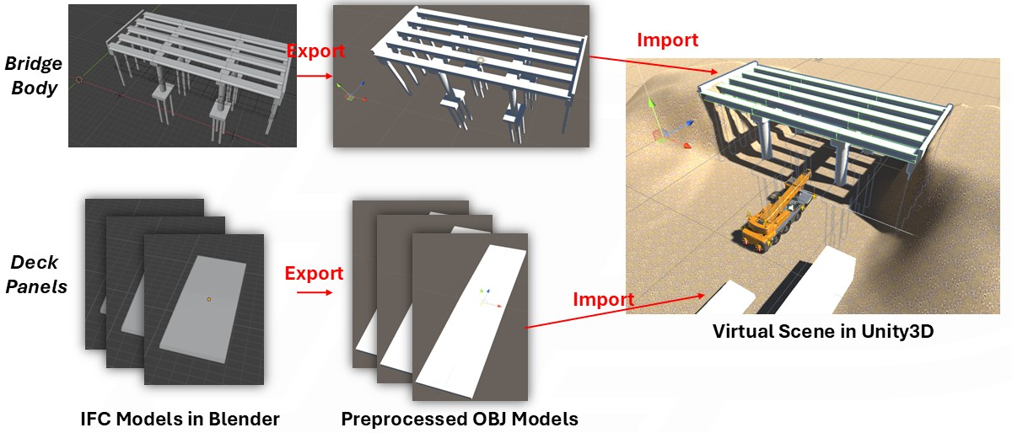
Figure 10. Preprocessing and importing IFC bridge models into Unity3D.
Algorithm development involves developing algorithms for heuristic planning and crane control. The heuristic planning algorithm was developed by following the pseudo code in Table 1, which calculates necessary parameters for crane installation actions. The crane control algorithm was developed based on behavior tree (BT) - a tree-like control architecture that sequences crane actions (Figure 11). The BT decomposes a high-level installation goal into a set of primitive actions. Each action is responsible for a specific subtask/subgoal (see Table 2) and consumes the generated parameters to execute the installation. As illustrated in Figure 11, the BT features a sequence node at the bottom for single-panel installation actions, and a repeater node at the top to loop the process until all panels are installed. Figure 12 presents a screenshot of the BT execution interface, which enables intuitive monitoring of the whole installation process and status of individual nodes.

Table 2. Primitive actions of bridge panel installation
Action ID | Action Name | Function
A1 | SetUpSupport | Deploy crane outriggers to stabilize lifting operations
A2 | SetUpCrane | Prepare crane components (cabin, hook, boom) at a ready pose for lifting operations
A3 | SetUpLoop | Set up loop number for the installation process
A4 | GeneratePlan | Read and share action parameters with subsequent actions
A5 | RotateToDirection | Rotate crane body towards target panel location
A6 | LuffToAngle | Adjust boom to desired elevation angle
A7 | BoomReaching | Extend/retract boom to specified length
A8 | HookDown&Up | Lower/lift hook to manipulate panel
A9 | Loading | Attach panel to hook
A10 | Unloading&Installation | Detach and install panel at the specified location

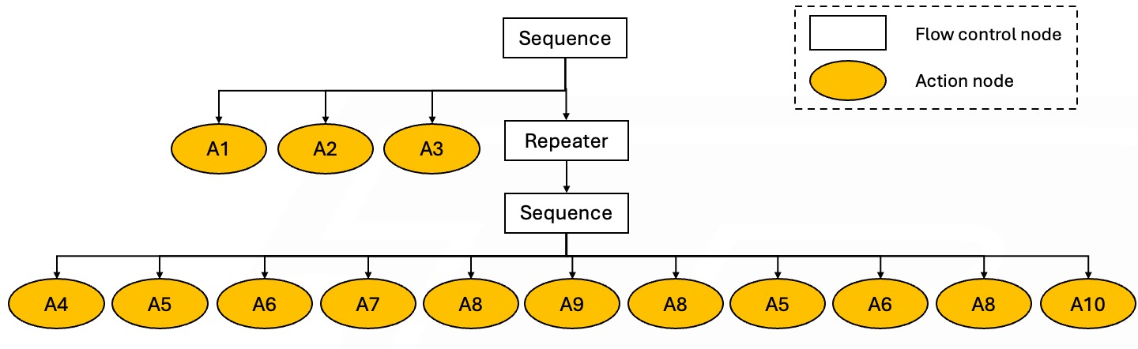
Figure 11. Behavior tree that describes and controls the panel installation.

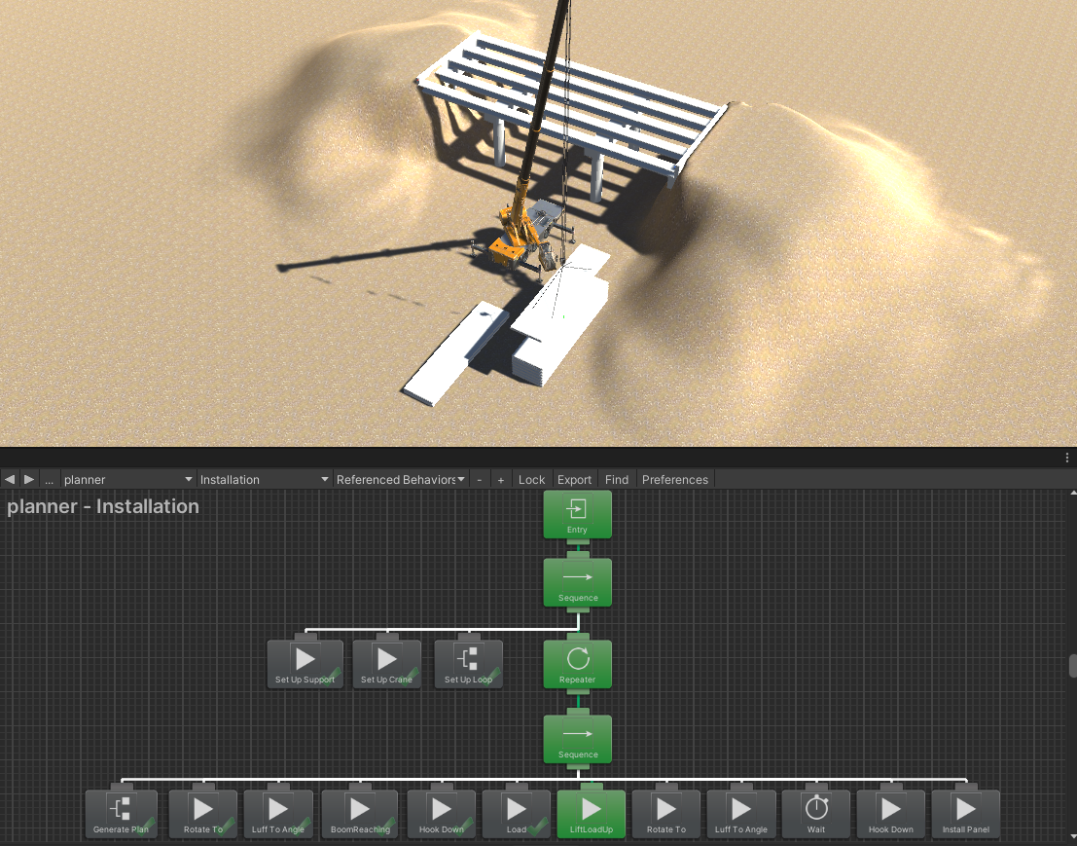
Figure 12. A screenshot of the execution of developed behavior tree.
Simulation-based constructability analysis evaluates and refines generated plans through iterative simulation. As illustrated in Figure 13, the process begins with crane selection and site layout setup, followed by heuristic planning. If the generated plan is valid, it is executed via physical simulation and visually evaluated by the human user. When planning or execution issues are identified, the user can adjust the layout or reselect a capable crane and repeat the process until a satisfactory plan is found. This iterative process enables 1) feasibility assessment of the chosen crane size and site layout at the pre-execution planning phase, and 2) detailed validation of the generated plan by examining dynamics of the execution using Unity3D’s physical engine.

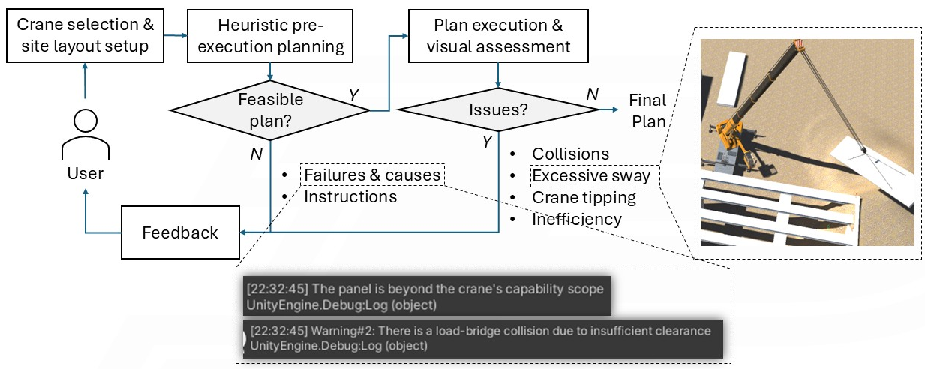
Figure 12. Workflow of simulation-based constructability analysis and feedback illustrations.
We organized a roundtable discussion during school of construction management technology’s construction advisory council meeting to solicit industry inputs in challenges and pain points in bridge construction in general, and in precast bridge construction in particular. Main points of challenging construction operations received include: ground improvements, deep foundation, drilled shafts, cement stabilization, crane sizing, and jobsite layout. These were taken into consideration in our crane planning algorithms. We also plan to give a presentation of this project at TRB 2026 to disseminate our research findings.

Educational outreach and workforce development

We developed the digital replica of the D. Dorsey Moss Construction Lab in Unity 3D software. Figure 13 below shows some preliminary virtual scenes for safety protocol training, crane operation, and steel structure assembly, respectively.

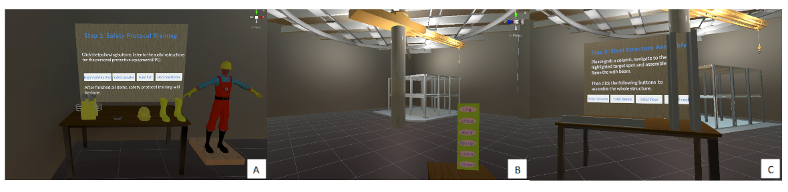
Figure 13. The scenes of preliminary virtual simulation: (a) Safety protocol training; (b) Crane operation;(c) Steel structure assembly.
A two-way data synchronization framework is necessary to ensure real-time communication between the physical and virtual worlds. A sensing system is deployed using inertial measurement units (IMU), depth cameras, and LiDAR to capture environmental and operational data, which will be streamed to the digital simulation platform. Conversely, data generated in the digital simulation will be used to remotely control crane operations [15].

Our AutoIC lab has created a modular, real-time localization pipeline that uses depth sensors such as LiDAR and depth cameras to identify the position and orientation of the crane in the lab environment. We implemented our work using the Robot Operating System 2 (ROS2) framework, a popular middleware for implementing robotics applications and thus enables ease of use.

The pipeline is organized into two major stages: segmentation and tracking, each deployed as an independent ROS2 node. The segmentation node, written in Python, receives raw point clouds and preprocesses them using voxelization to reduce spatial density and computational cost. Clustering is then performed by using the DBSCAN algorithm, which is robust to non-uniform shapes typical in construction equipment. The cluster representing the crane can be identified algorithmically by its distinctive features, such as size (Figure 14).

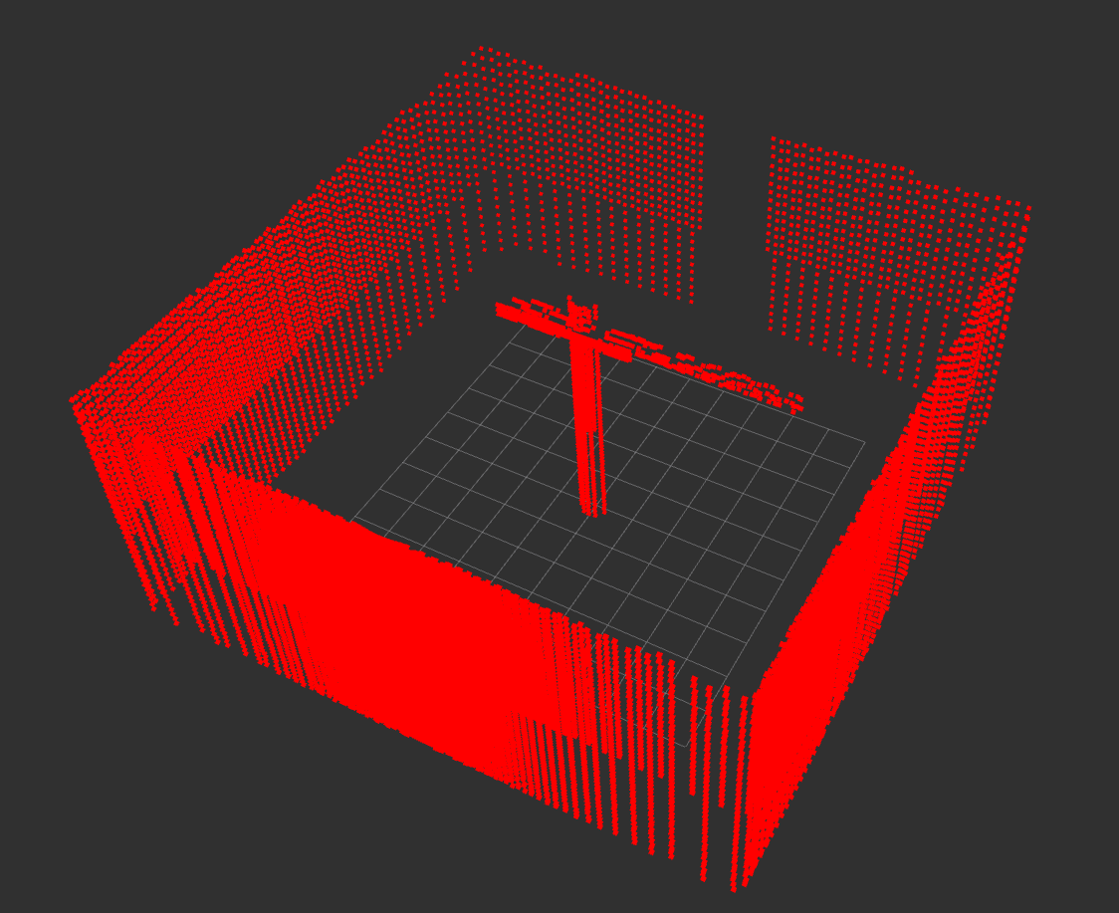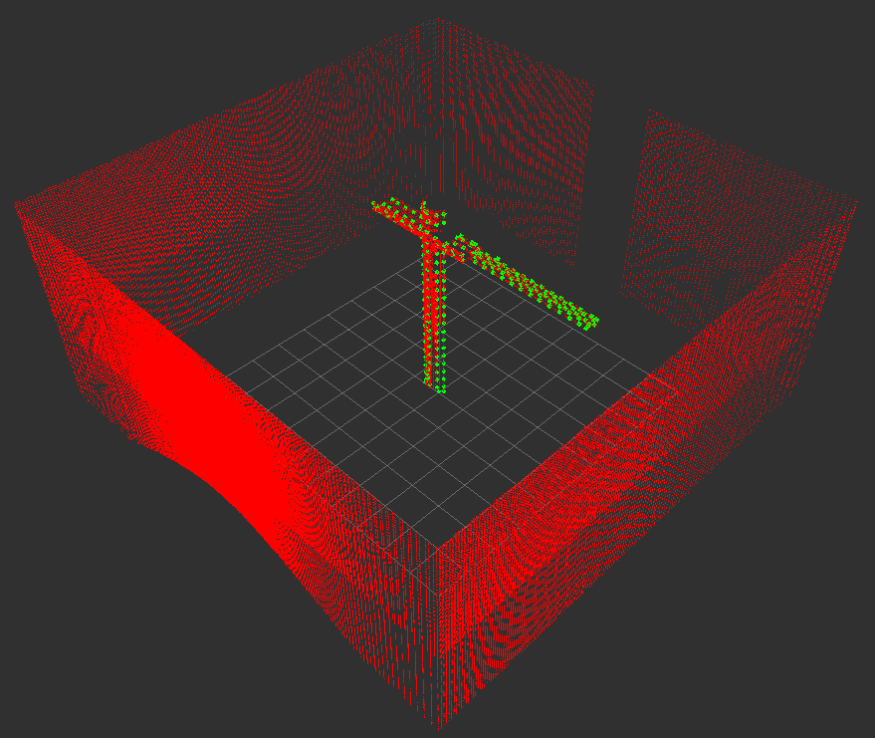
Figure 14. Segmentation node input point cloud (left) and segmented output (right).
The segmented points are then transmitted to the tracking node via ROS2 topic on a local network to calculate the crane’s orientation. A core challenge addressed in our implementation is that LiDAR does not fully observe the crane at all times due to its limited field of view. Depending on the crane orientation, the sensor may only capture points from the side of the structure facing the sensor. To address this, the tracking node collapses the segmented crane points into a 2-dimensional horizontal plane and runs a voxelization step to reduce the points’ positional skew (Figure 15).

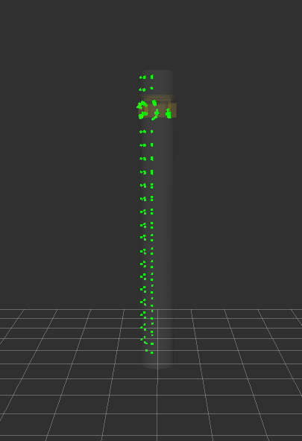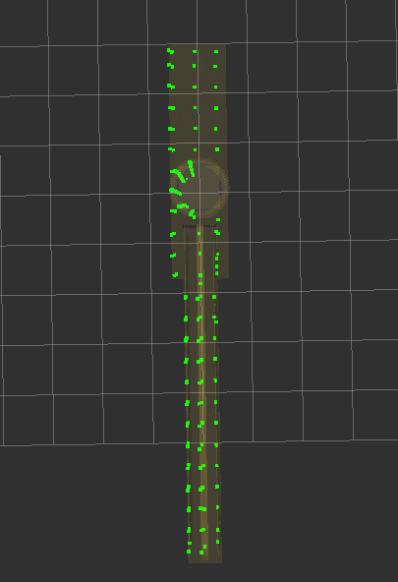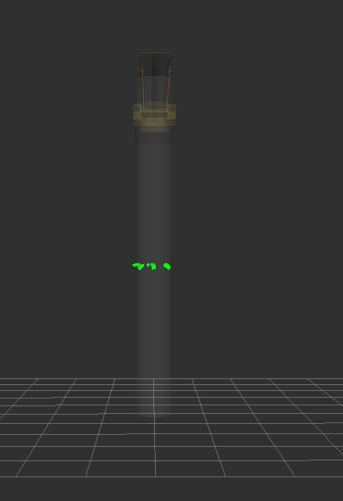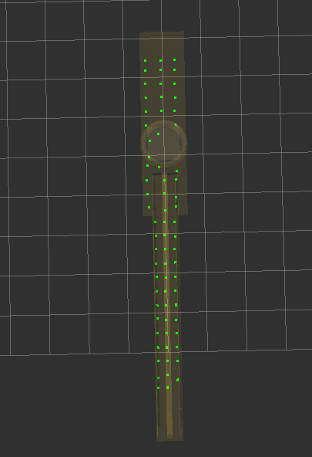
Figure 15. Before (left) and after (right) flattening and voxelizing the segmented points. A notable observation is that the flattened point cloud has significantly fewer points and is more evenly distributed across the width of the crane arm.
From the flattened points, the node averages the point locations for a measure of center of the crane’s arm and draws a vector from the base of the crane to the center of the crane boom, providing an orientation vector indicating the rotational positioning of the crane (Figure 16). It then publishes the crane position and rotation continuously over the network. These values can then be read directly by the digital-twin environment, which updates the virtual crane in real time. The real-time loop makes it possible to watch the crane move live in simulation and creates a foundation for future features.

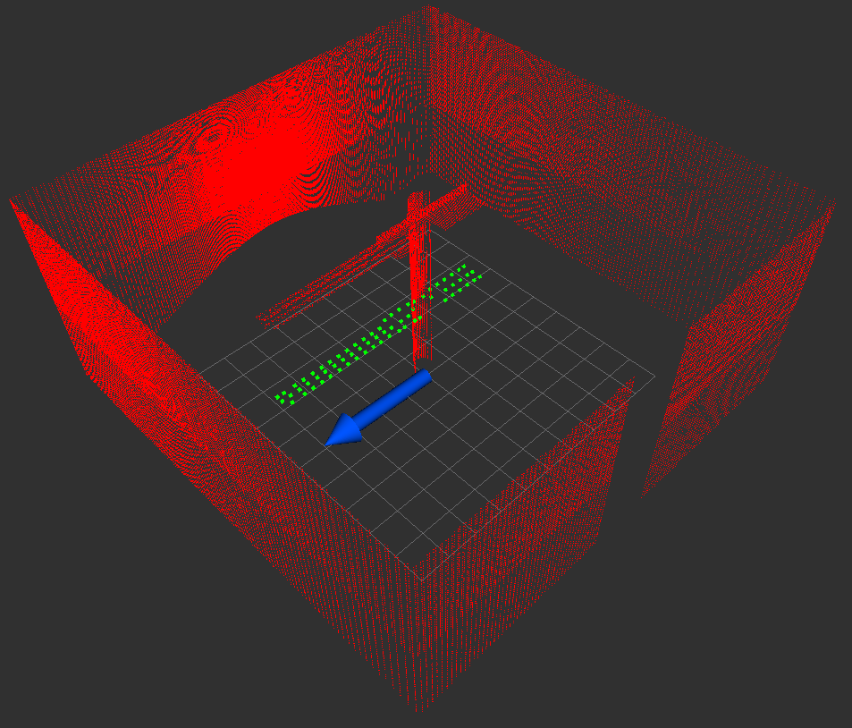
Figure 16. Output of the tracking node visualized alongside an input point cloud.
Large language models have shown effectiveness as digital coaching tools in various domains. Building on this capability, we plan to develop an AI-powered coaching. By learning from the simulation-based planning of precast bridge component installation, the AI system will guide users through the operation tasks step by step. We have created a prototype of the proposed conversational multi-agent AI system. User messages are processed by multiple collaborative agents that leverage a vector database and configurable external documentation. Figure 17 demonstrates the user interface (UI) of our proposed system. The UI simulates a group conversation. It is implemented as a React-based web application designed to facilitate natural interactions between the user and multiple AI agents. To enable knowledge-based discussions, we utilize retrieval augmented generation (RAG) to enhance each agent with distinct domain-specific knowledge. During conversations, the system dynamically retrieves relevant knowledge based on user message and integrates it into the response, while maintaining natural dialogue flow, avoiding explicit references to the knowledge source.


Figure 17. User interface of a conversational multi-agent AI system.
In addition, research from this project has been included into:

(1) the PI’s graduate course CM 581-Technology in Construction Management, more specifically into Lecture 8 (BIM Interoperability and Invariant Signatures, Mar. 4th, 2025) and Lecture 11 (BIM for Infrastructure, Mar. 25th, 2025), Dudley Hall 4117B, Purdue University, West Lafayette, IN.

(2) Zhang, J. “Empowering Seamless and Universal BIM Interoperability with Invariant Signatures of AEC Objects.” Panelist and Speaker at ISPRS - Webinars ICWG II/Ib, Mar. 27th, 2025.



(3) The PI's undergraduate course, CM150 - Construction Management Fundamentals, introduced 90 students to this project on September 22nd at WALC 1087, Purdue University, West Lafayette, IN.
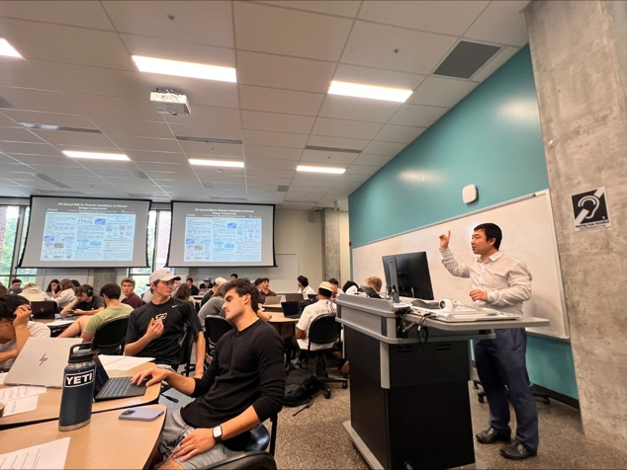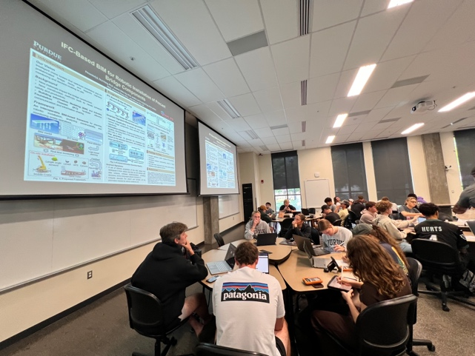
Figure 19. Students engage in group discussions for this project.
Figure 18. PI introduces the project in class.

(4) The PI’s graduate course CM 581-Interoperable BIM and Its Applications, more specifically into Lecture 1 (Introduction to Interoperable BIM & Its Applications, Aug. 29th, 2025) KNOY G007, Purdue University, West Lafayette, IN.

(5) The PI’s Halpin Award Lecture titled “Advancing Construction Engineering and Management, Construction Automation, and Sustainable Infrastructure Using BIM, AI, and Robotics Technologies” at the ASCE International Conference on Computing in Civil Engineering (i3CE 2025), May 13, 2025, InterContinental New Orleans, La Salle Ballroom New Orleans, LA (Figure 4).

(6) The PI’s Keynote Speech at the Joint CSCE Construction Specialty Conference / ASCE Construction Research Congress (CRC) 2025, Jul. 30th, 2025, John Molson School of Business Building 1.210, Concordia University, Montreal, Canada (Figure 5).

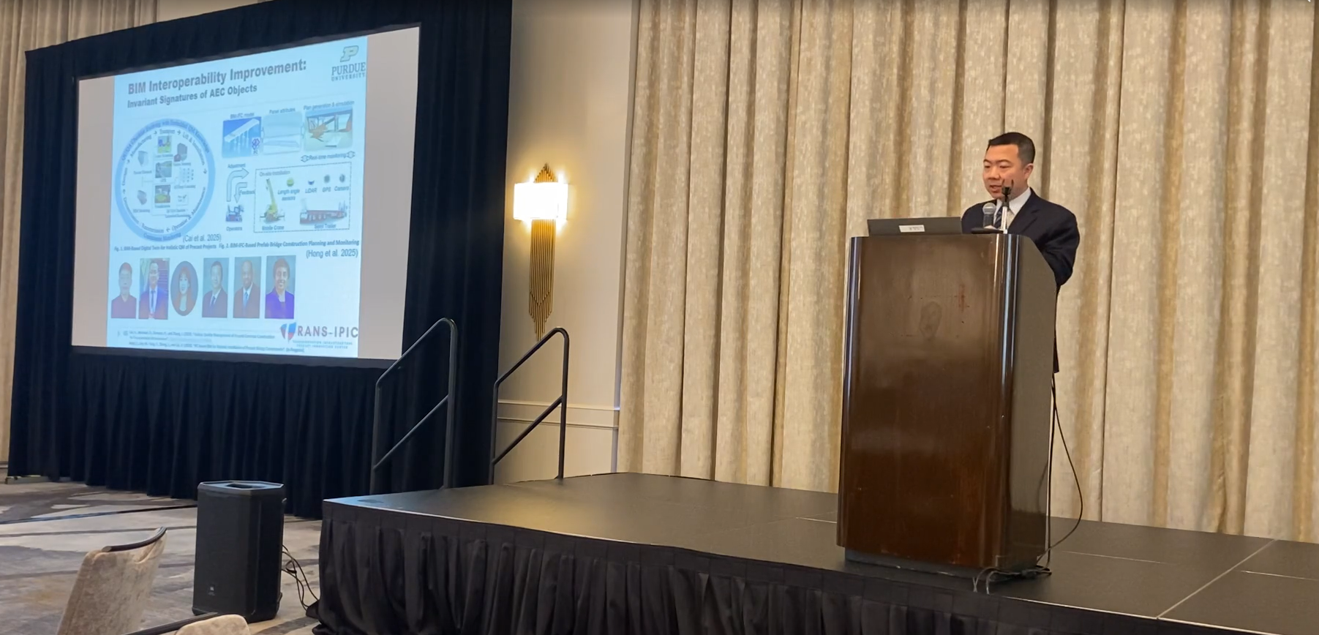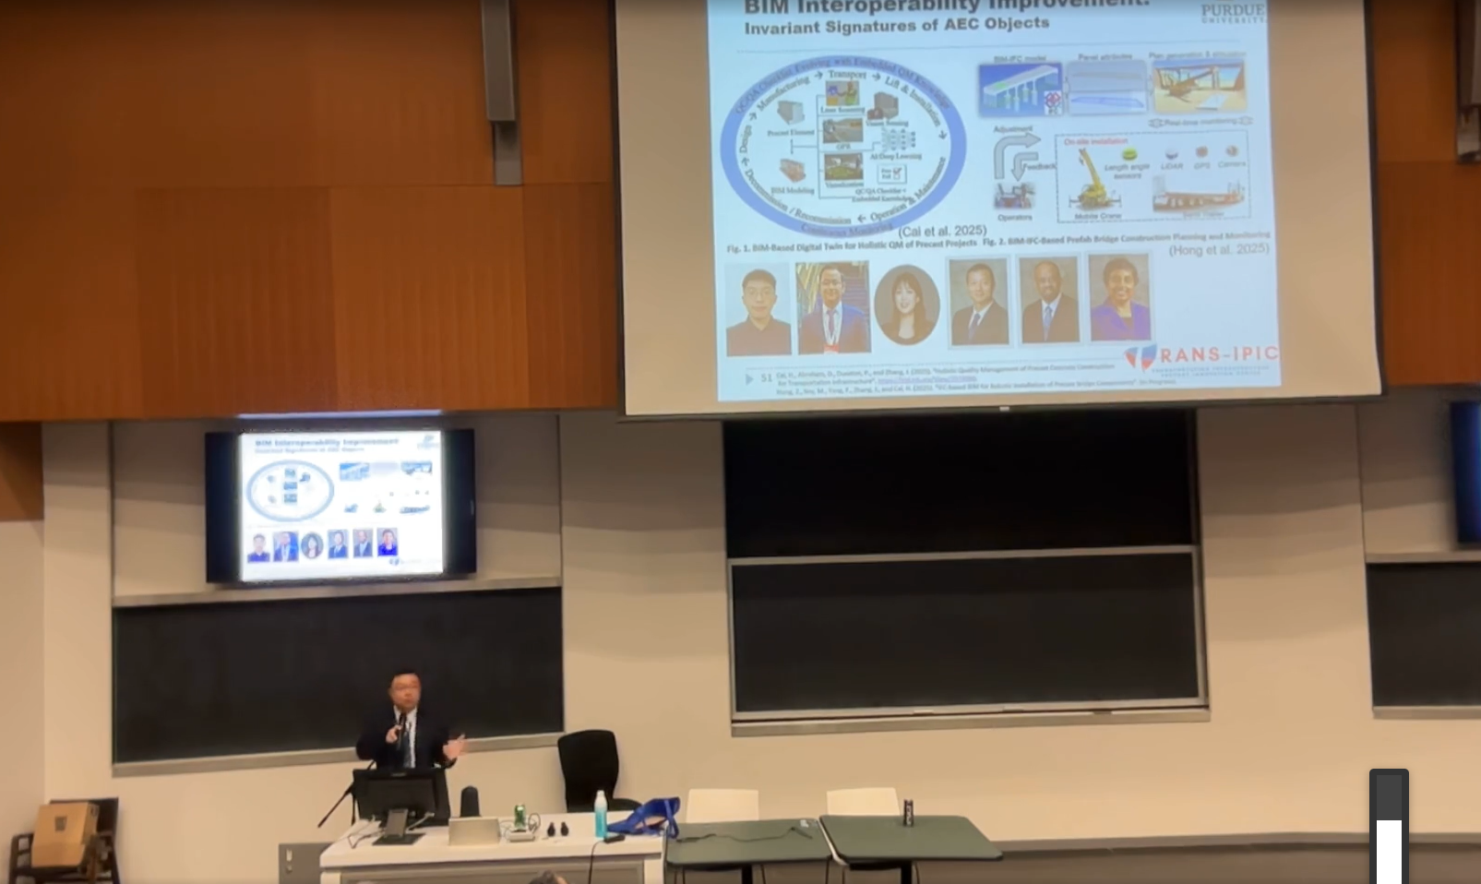
Figure 21. Keynote Speech at Joint CSCE Construction Specialty Conference / ASCE Construction Research Congress (CRC) 2025.
Figure 20. Halpin Award Lecture 2025

(7) Seminar of Lyles School of Civil and Construction Engineering, Talk by PI titled “The Future is Here – Seamless and Universal BIM Interoperability Empowered by Invariant Signatures of AEC Objects and AI Can Accelerate the AEC Industry into Automation and Intelligent Lifecycle Processes”, Sept. 19th, 2025, Hampton Hall, Room 2113, Purdue University, West Lafayette, IN.

(8) Purdue Undergraduate Research Expo Poster Session, Presented by undergraduate researchers Pranav Chitiveli and Ananya Jajoo, titled “Streaming Object Localization Data in Game Simulation for Digital Twinning”, Nov. 18th, 2025, Purdue Memorial Union (PMU) Ballrooms, Purdue University, West Lafayette, IN.

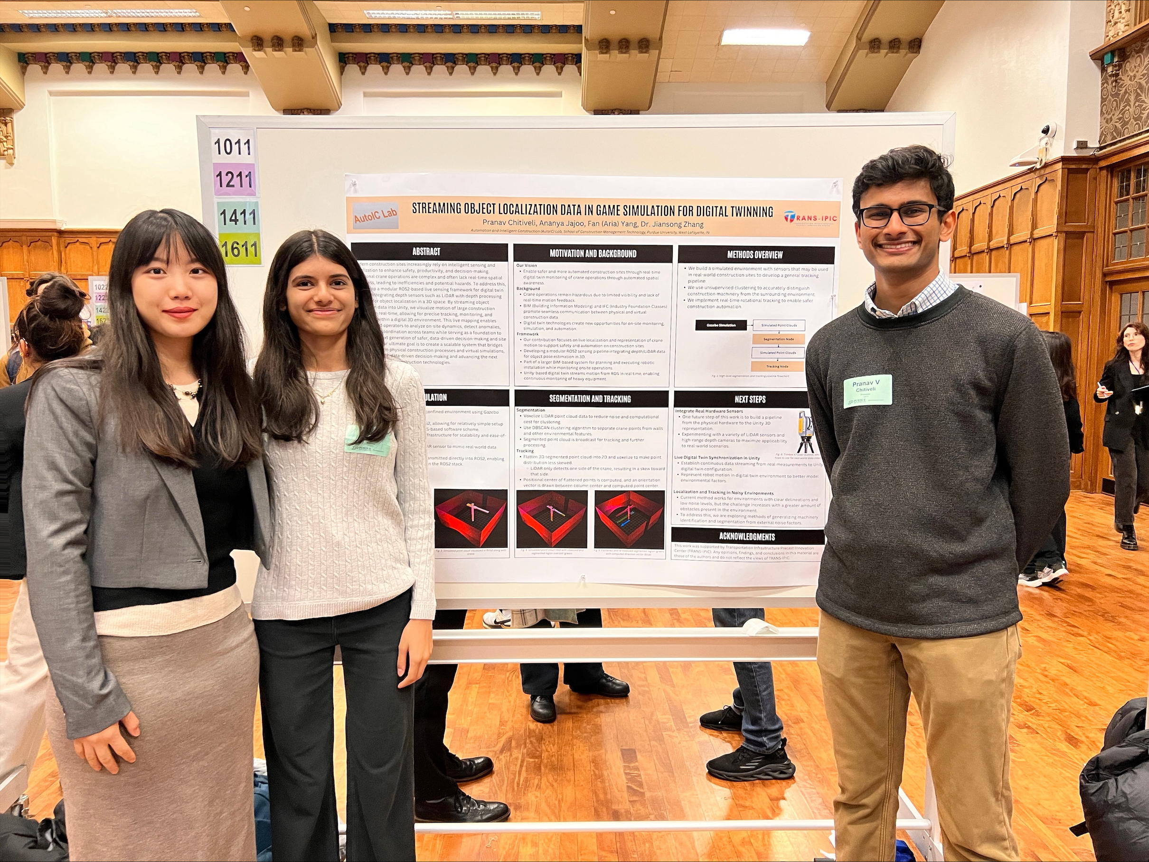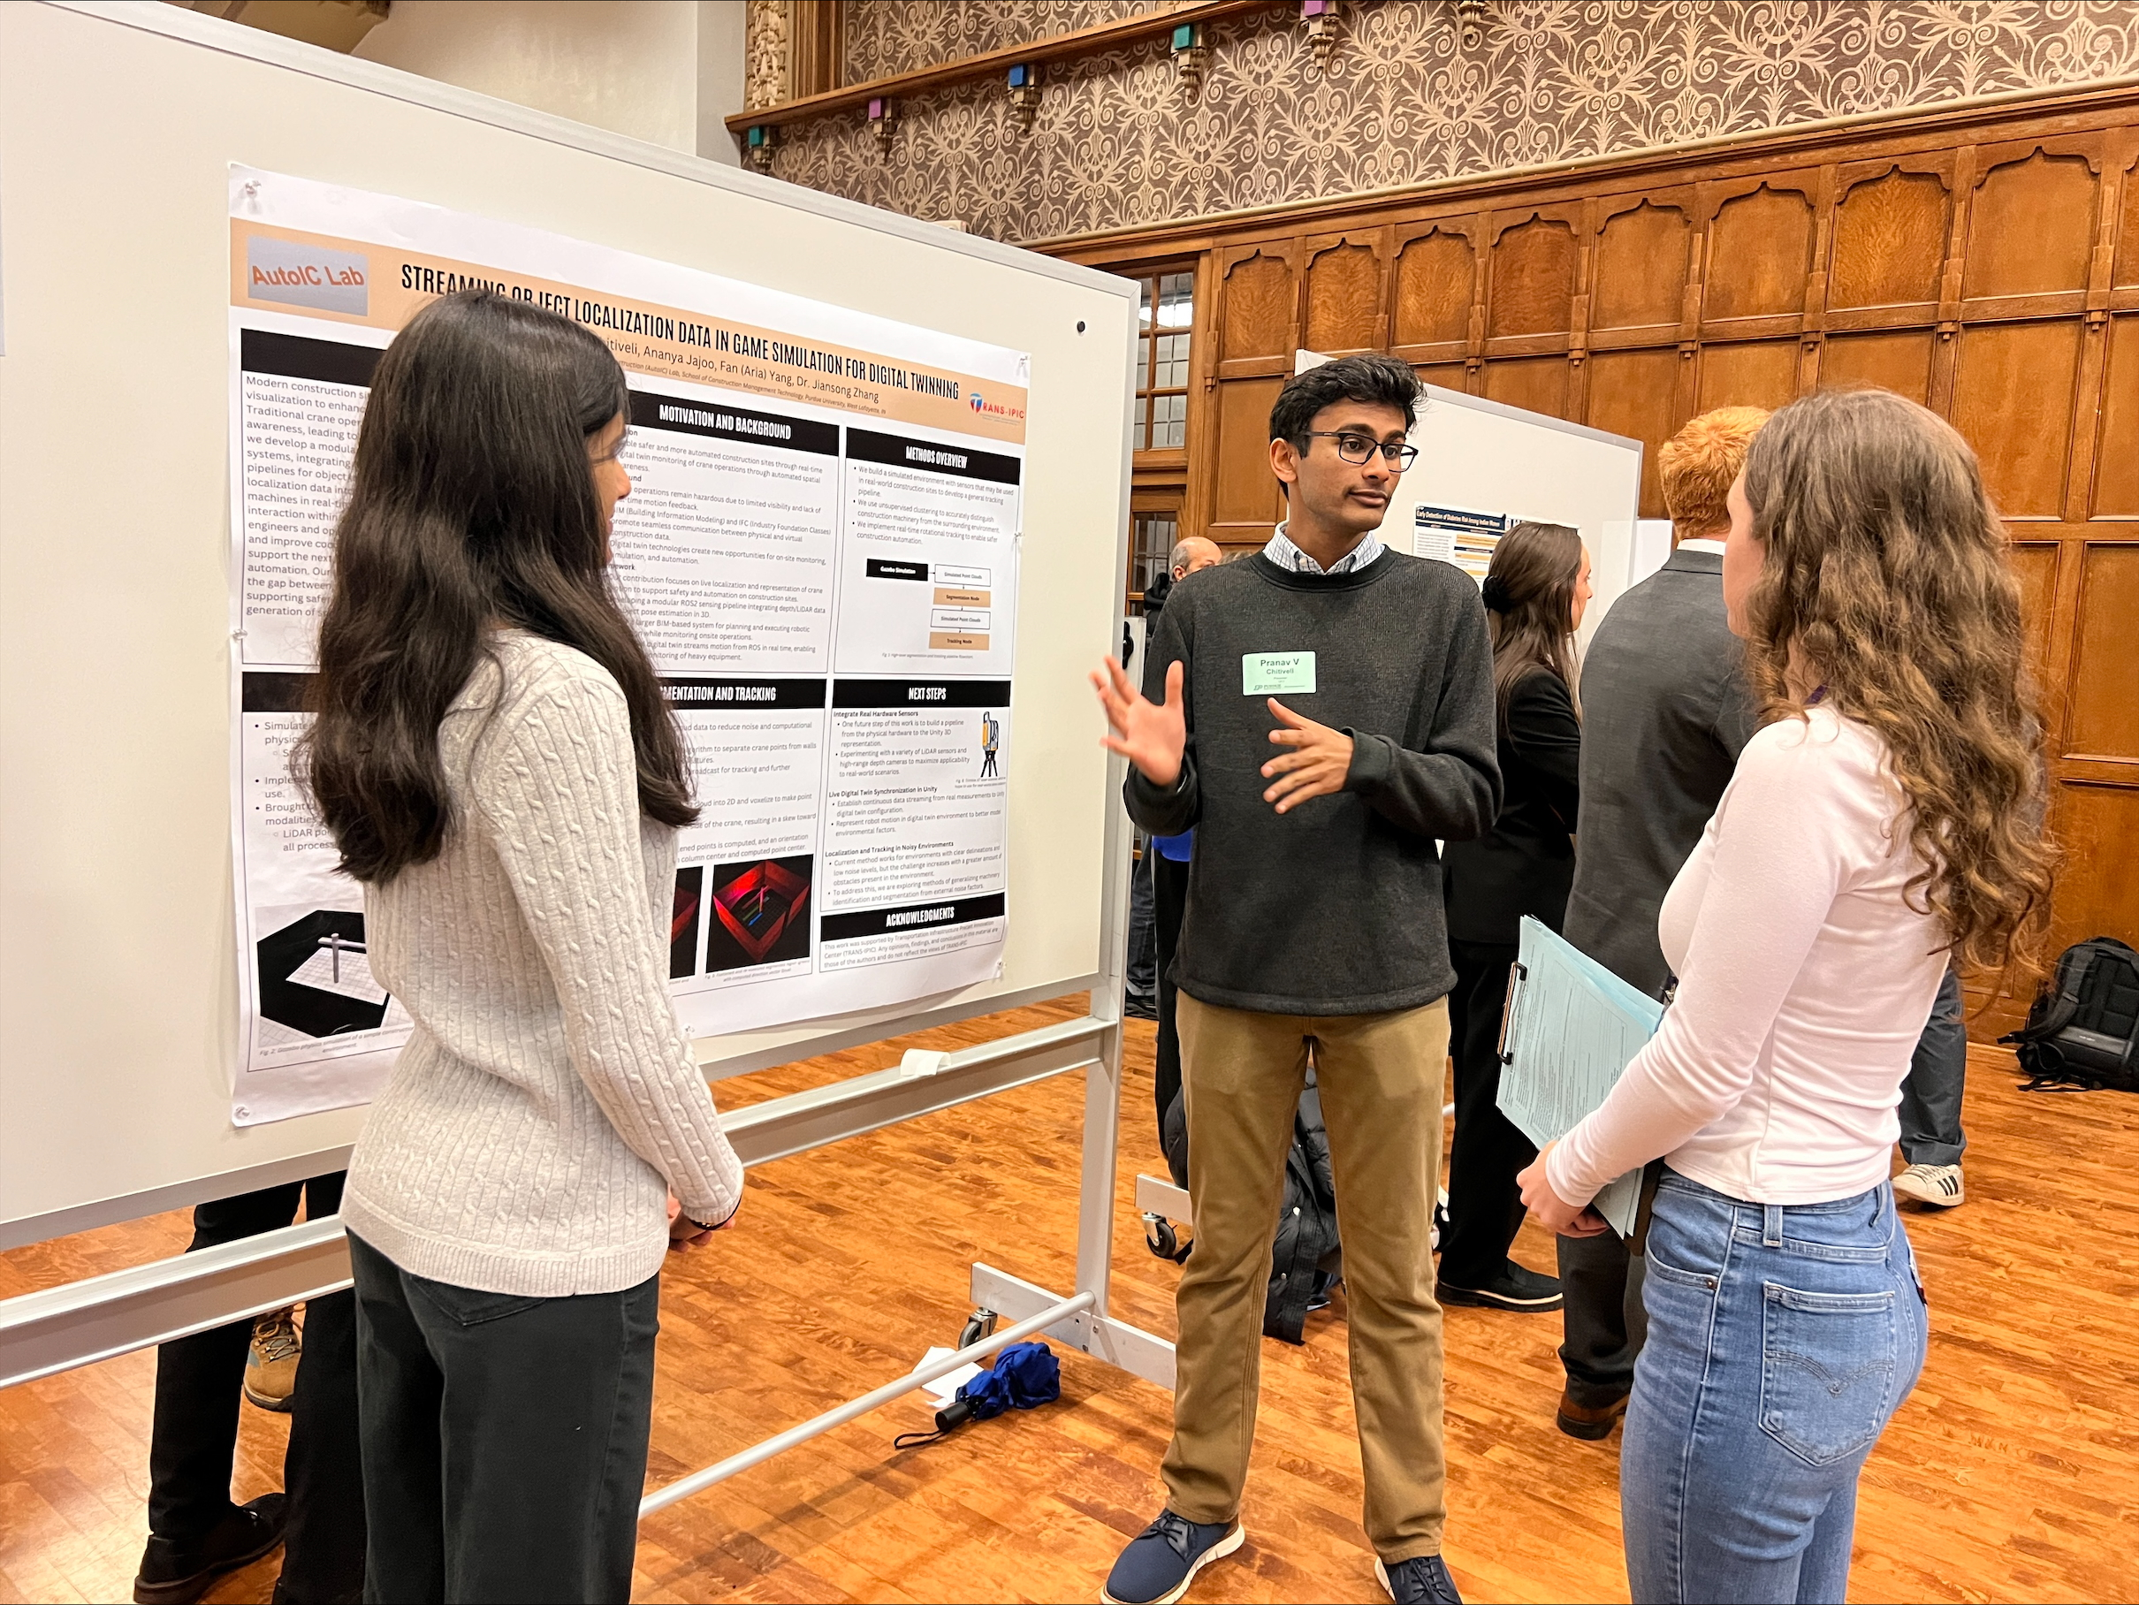
Figure 23. Poster presentation at Purdue Undergraduate Research Expo 2025.
Figure 22. Team members at poster session.

Technology Transfer

One technology disclosure: Hong, Z., Soy, M., Yang, F., Zhang, J., and Cai, H. (2025). “Automation in Crane Planning for Bridge Construction.” Purdue Research Foundation Reference Number: 2025-ZHAN-71285.

Presentations and Posters of TRANS-IPIC funded research:

Hong, Z., Soy, M., Yang, F., Zhang, J., and Cai, H. (2025). “IFC-based BIM for Robotic Installation of Precast Bridget Components.” TRANS-IPIC 2025 Annual Workshop, Chicago, IL., April 22 – 23, 2025.

Chitiveli, P., Jajoo, A., Yang, F., and Zhang, J. (2025). “Streaming Object Localization Data in Game Simulation for Digital Twinning.” Purdue Undergraduate Research Expo Poster Session, West Lafayette, IN., Nov. 18th, 2025.

Soy, M., Hong, Z., Yang, F., Zhang, J., & Cai, H. (2026). IFC-based Installation Simulation of Precast Bridge Panels in Pre-Planning. Paper accepted for presentation at the Transportation Research Board (TRB) 104th Annual Meeting, Washington, D.C.

Conclusions and recommendations:

Our developed algorithm successfully extracted the correct information from six different bridge model files, originating from different software exports into IFC with different versions (IFC4, IFC2X3 and IFC4X3). This testing shows that our invariant signature-based method can successfully complete the bridge components extraction from IFC models correctly. It is a robust and automated approach to IFC information extraction. The interoperability and automation levels in bridge automation construction are expected to be enhanced with this approach.

Experimental results showed that the integration of heuristic and simulation-based planning effectively: 1) assessed the feasibility of lifting operation using selected crane size and crane lifting location, 2) generated feasible plans given the chosen crane size and location with low computational cost, and 3) afforded plan validation via realistic physical simulations for constructability analysis.

One major challenge is implementing our method in the physical world using industry equipment and hardware, as real-world construction operations occur in dynamic environments with a multitude of influencing factors. In view of that, digital twin provides a feasible approach ahead to vividly capture all relevant factors through real-time data. An effective and accurate digital twin is recommended as the next step to help eventually bring our method to real world implementation.

Practical application/impact on transportation infrastructure:

The resulting technology from this project takes different formats of bridge BIM, converts them into IFC-Bridge and then into operation plans and construction process simulations. It can help harness the opportunity that comes with the transformative precast materials and construction methods developed at the TRANS-IPIC center, to help address data efficiency/interoperability problems in the context of precast bridge construction, aligned with TRANS-IPIC’s strategic goal #3 “Advance the field of building information modeling (BIM) using new technologies” and Topic (5): Robotic Production and Installation of Precast Components.

To bring such technology to the field, a necessary bridge between our method and physical world hardware and equipment is an accurate and effective digital twin, for which we recommend future research to work on.

The PI’s AutoIC lab has created a modular remote-control system that integrates a single-board computer, motorized actuators, and a control algorithm with MQTT communication protocol (Figure 24). This plug-and-play design allows smart control modules to be easily attached to existing crane buttons and levers. A customized user interface built with Python enables operators to send commands, which are received by the single-board computer and translated into actuator movements. The system architecture, tested with the tower crane in the D. Dorsey Moss Construction Lab, supports reliable communication, real-time control, and safety functions such as emergency stop. This provides solid foundation for developing the digital twin of a smart crane, which in turn, could facilitate real world testing and implementation of our method.

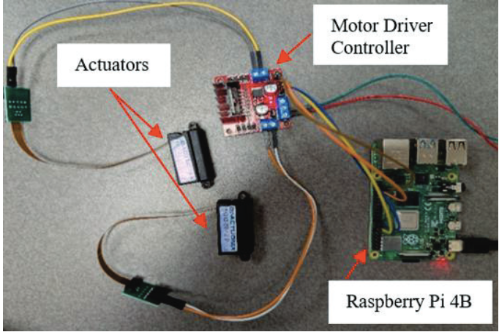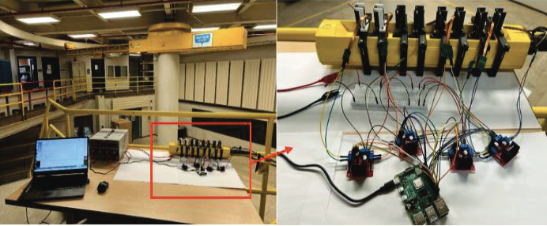
Figure 24. Circuit and setup of the crane remote control system.

References:
[1] National Precast Concrete Association (NPCA). (2013). “Precast Solutions Winter 2013 - Bridges and Transportation.” <https://precast.org/wp-content/uploads/092923_Products_BridgeCaseStudy4.pdf> accessed Nov. 30th, 2025.
[2] Stelsel, B.K. (2019). “Beauty and Durability Shine with Samuel De Champlain Bridge.” <https://precast.org/wp-content/uploads/092923_Products_BridgeCaseStudy1.pdf> accessed Nov. 30th, 2025.
[3] Chea, C.P., Bai, Y., Pan, X., Arashpour, M., and Xie, Y. (2020). “An integrated review of automation and robotic technologies for structural prefabrication and construction.” Transportation Safety and Environment, 2(2020), 81–96.
[4] Wu, J., Sadraddin, H.L., Ren, R., Zhang, J., and Shao, X. (2021). “Invariant signatures of architecture, engineering, and construction objects to support BIM interoperability between architectural design and structural analysis.” J. Constr. Eng. Manage., 147(1), 04020148.
[5] Wu, J., Akanbi, T., and Zhang, J. (2022). “Constructing invariant signatures for AEC objects to support BIM-based analysis automation through object classification.” J. Comput. in Civ. Eng., 36(4), 04022008.
[6] Wu, J., and Zhang, J. (2022). "Model Validation Using Invariant Signatures and Logic-Based Inference for Automated Building Code Compliance Checking.” J. Comput. in Civ. Eng., 36(3), 04022002.
[7] Li, H., and Zhang, J. (2022). "Improving IFC-Based Interoperability between BIM and BEM Using Invariant Signatures of HVAC Objects." J. Comput. in Civ. Eng., 37(2), 04022059.
[8] Li, H., Hegazy, H., Xue, X., Zhang, J., & Chen, Y. (2023). "BIM standards for roads and related transportation assets." (Joint Transportation Research Program Publication No. FHWA/IN/JTRP-2023/16). West Lafayette, IN: Purdue University. https://doi.org/10.5703/1288284317641
[9] Zhang, J., and Yang, F. (2024). "Building a Bridge between Building Information Modeling and Digital Twins: Introducing Invariant Signatures of Architecture, Engineering, and Construction Objects." Chapter 2, Digital Twins in Construction and the Built Environment, ASCE, Reston, VA.
[10] Zhang, Z., Zhang, B., Hu, W., Zhou, R., Cao, D., and Yin, H. (2023). “Dynamic Three-Dimensional Lift Planning for Intelligent Boom Cranes.” IEEE/ASME Transactions on Mechatronics, 28(2023), 2885–2896.
[11] Chen, K., You, B., Zhang, Y., and Chen, Z. (2024). “Automatic lift path planning of prefabricated building components using semantic BIM, improved A* and GA.” Engineering, Construction and Architectural Management, 32(6), 29 March 2024, 4100-4124.
[12] Jang, D.H., Roh, G.T., Jeon, C.H., and Shim, C.S. (2025). “Simulation-Based Optimization of Crane Lifting Position and Capacity Using a Construction Digital Twin for Prefabricated Bridge Deck Assembly.” Buildings, 15(3), 475.
[13] Wu, J. and Zhang, J. (2019). “Introducing geometric signatures of architecture, engineering, and construction objects and a new BIM dataset.” Proc., ASCE International Conference on Computing in Civil Engineering 2019, American Society of Civil Engineers Reston, VA, 264–271.
[14] Liebherr. (2025). “Technical Data - Compact crane LTC 1050-3.1[m/t].” <https://assets-cdn.liebherr.com/assets/api/ba4a69dd-ef28-41a6-ba67-8d8cfe0d90f0/Original/> (accessed June 27, 2025).
[15] Soy, M., Fu, J., Wu, Y., Zhang, J., Gan, D., Wei-Kocsis, J., and Min, B.C. (2025). “Remote Physical Control for Upgrading Heavy Construction Equipment.” Proc., 42nd International Symposium on Automation and Robotics in Construction, IAARC, 258–263.

