[MANUSCRIPT TITLE]

[Name of first author]¹, [Name of second author]², [Name of third Author]³

¹[Affiliation/University of first author, City, State, Country]
²[Affiliation/University of second author, City, State, Country]
³[Affiliation/University of third author, City, State, Country]

*Corresponding Author: [Name & email]

Abstract:
Times New Roman, 11-point font. 1-in margins. 250 words maximum. Justified.

SECTION HEADINGS
Section headings will be Times New Roman, 14-point font. Bold. Written in all caps. Left Aligned.

Sub Section Headings
Sub section headings will be numbered sequentially. Times New Roman, 12-point font. Bold. Left Aligned.

Additional Sub Section headings
Add any additional sub sections as needed. Specific manuscript sections are not required, please organize the manuscript to be fit and describe your topic.

BODY TEXT OF MANUSCRIPT
The body text of each section will be written in Times New Roman 11-point font. 1-in margins. The body text will be justified. The body of the manuscript will not exceed 4-pages. The title page and reference section do not count toward the 4-page limit.

TABLES AND FIGURES
Figures and tables should be numbered serially and centered on the page close to where they are mentioned.

Tables
Use the guidance below if tables are to be included in your manuscript. Table data and fonts will be Times New Roman 11-point. Center aligned. The Table will use horizontal border lines only.

Table 1. A description of the table will be included, centered directly above the table.

Column heading | Column heading | Column heading | Column heading
Data row 1 | 9.0 | 10.0 | 11.0
Data row 2 | 5.0 | 6.0 | 7.0
Data row 3 | 10.0 | 9.0 | 8.0

Table footnote, Times New Roman 11-point font. Center aligned.

Figures
Use the guidance below if Figures are to be included in your manuscript. Times New Roman 11-point font. Center aligned. If the figure has been reused from elsewhere, include a permission statement.

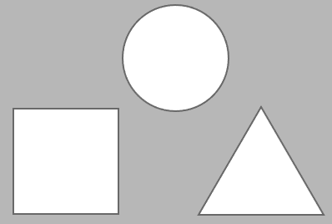

Figure 1. A short description of the figure will be provided directly below the figure itself.

Equations
Use the guidance below if equations are to be included in your manuscript. The equation should be aligned in the center of the page, and a sequential number indicating each equation should be aligned on the right side of the page. Please see the example below.

$J_{i}(v,η)=\operatorname{Pr}{[}U_{1}<F_{i}(v),U_{2}<G(η)]=C_{θ}[u_{1}=F_{i}(v),u_{2}=G(η)]$ (1)

REFERENCES
The reference section does not count toward the 4-page manuscript limit. References should follow the Harvard style, also known as the "author-date" style. A reference within the text is given as, for example, Gibson and Kitase (2005). References should be listed in alphabetical order at the end of the paper. An example is shown below.

Gibson W., Kitase A. (2005). ‘Article Title’, Journal Title, vol. X (no. X), pp. X-X. https://doi.org/10.10101/1.3213456.

