- Report No.  LS-23-RP-03 |  | - Government Accession No  N/A | - Recipient’s Catalog No.  N/A
- Title and Subtitle  Exploring Fungal-Induced Carbonate Precipitation (FICP) for Healing Concrete Cracks |  |  | - Report Date  July, 2026
- Performing Organization Code

N/A
- Author(s)  Nuo Bao, Graduate student, 0009-0006-4837-7968  Hai Lin, Assistant Professor, 0000-0002-1641-4588  Yen-Fang Su, Assistant Professor, 0000-0001-8410-0997 |  |  | - Performing Organization Report No.  69A3552348333
- Performing Organization Name and Address  Louisiana State University  Department of Civil and Environmental Engineering  3255 Patrick F. Taylor Hall,  Baton Rouge, LA, 70803 |  |  | - Work Unit No.  N/A
- Contract or Grant No.

69A3552348333
- Sponsoring Organization Name and Address  Transportation Infrastructure Precast US Department of Transportation  Innovation Center (TRANS-IPIC) Office of Research, Development and University of Illinois Urbana-Champaign. Technology (RD&T)  Civil & Environmental Engineering. 1200 New Jersey Avenue, SE  205 N Mathews Ave, Urbana, IL 61801 Washington, DC 201590 |  |  | - Type of Report and Period Covered  Final Report  January 2024 – June 2025]
14. Sponsoring Agency Code

N/A
15. Supplementary Notes

For additional reports and information visit the TRANS-IPIC website https://trans-ipic.illinois.edu
16. Abstract

Cracking in cement-based materials significantly compromises their durability and long-term structural performance. This study investigates a bio-mediated self-healing strategy by incorporating bacterial and fungal agents into mortar samples. Artificial cracks were induced via split tensile testing, and healing behavior was evaluated through ultrasonic wave velocity measurements and water absorption tests over a 16-day curing period. Wave speed and water absorption measurements indicated signs of partial healing in samples treated with Sporosarcina pasteurii combined with either Aspergillus niger (ATCC 9029) or Neurospora crassa (FGSC 2489), compared to the untreated control group. Compressive strength tests at 28 days revealed that samples treated with Aspergillus niger or Neurospora crassa achieved higher strength than the control group before cracking was introduced. These preliminary findings suggest that microbial-based approaches may offer promising potential for enhancing crack management in cementitious materials.
17. Key Words  self-healing concrete; microbial-induced calcium carbonate precipitation; bacterial treatment; fungal-induced carbonate precipitation; water absorption; crack healing |  |  |  | 18. Distribution Statement  No restrictions.
19. Security Classification (of this report)  Unclassified. | 20. Security Classification (of this page)  Unclassified. |  |  | 21. No. of Pages  29 | 22. Price  N/A
Disclaimer:
The contents of this report reflect the views of the authors, who are responsible for the facts and
the accuracy of the information presented herein. This document is disseminated in the interest of information exchange. The report is funded, partially or entirely, under 69A3552348333 from the U.S. Department of Transportation’s University Transportation Centers Program. The U.S.
Government assumes no liability for the contents or use thereof.



Transportation Infrastructure Precast Innovation Center
(TRANS-IPIC)

University Transportation Center (UTC)

Exploring Fungal-Induced Carbonate Precipitation (FICP) for Healing Concrete Cracks
LS-23-RP-03

FINAL REPORT

Submitted by:
Hai Lin (Principal Investigator), Louisiana State University, hailin1@lsu.edu
Department of Civil and Environmental Engineering
Louisiana State University

Nuo Bao (Graduate student), Louisiana State University, nbao1@lsu.edu
Department of Civil and Environmental Engineering
Louisiana State University

Collaborators / Partners:
Yen-Fang Su, Louisiana State University, ysu@lsu.edu
Department of Civil and Environmental Engineering
Louisiana State University

Submitted to:
TRANS-IPIC UTC
University of Illinois Urbana-Champaign
Urbana, IL

Executive Summary:

Concrete structures are susceptible to cracking during early-stage curing or long-term aging, which can compromise load-bearing capacity and reduce service life. This study investigates fungal-induced mineral precipitation (FIMP) as a potential self-healing mechanism to enhance concrete durability. FIMP is a natural biomineralization process in which fungi promote mineral precipitation (e.g., CaCO₃) via metabolic activity. Fungi offer multiple advantages over bacteria for healing cracks, including: (1) high surface-to-volume ratio, (2) fast mycelial growth across large areas, (3) robust performance in nutrient-poor and alkaline environments, and (4) cost-effective potential to create hydrophobic surfaces and reduce permeability.

Three filamentous fungal strains— Aspergillis niger (ATCC 9029), Neurospora crassa (FGSC 2489), and Trichoderma reesei (ATCC 13631), —were systematically evaluated for their ability to induce mineral precipitation. The research involved: (1) quantifying fungal growth and mineralization in liquid culture; (2) testing fungal viability on cement mortar surfaces; and (3) assessing crack healing performance in bio-treated mortar specimens using visual observation, compressive strength tests, ultrasonic wave propagation (P- and S-wave velocities), and water absorption measurements.

Results demonstrate that Neurospora crassa and Aspergillus niger successfully precipitated calcium-based minerals—calcite and calcium oxalate, respectively—whereas Trichoderma reesei was ineffective. Mortar samples treated with N. crassa and A. niger, especially when combined with hydrophilic cellulose fibers, exhibited substantial improvements in compressive strength (up to 166%), ultrasonic wave velocities, and reductions in water absorption. These findings indicate enhanced matrix densification and effective microcrack closure.

The integration of fungal agents and biodegradable fibers appears to synergistically improve healing efficacy, suggesting a dual function as both self-healing agents and mechanical performance enhancers. This bio-based approach surpasses traditional bacterial MICP in terms of mineral uniformity, metabolic resilience, and cost-effectiveness. Moreover, it introduces a paradigm shift in using fungal cultures as performance-enhancing admixtures in concrete.

This study contributes to the mission of TRANS-IPIC by proposing an ecologically sustainable and technically promising alternative for crack remediation in precast concrete components. Future research should expand the fungal strain library, explore long-term field performance, and optimize conditions for fungal viability and mineralization in real-world applications.

Table of Contents

1. Problem description 6
2. Background 6
3. Research scope and objectives: 7
4. Research description 7
4.1. Task 1. Comparing the performances of three fungal strains on mineral precipitation 7
4.1.1. Cultivation of three fungal strains 7
4.1.2. Adding cementation solution to induce mineral precipitation 7
4.1.3. pH and NH₄⁺ measurements 8
4.1.4. SEM, EDS, and XRD analysis 8
4.2. Task 2. Investigating the growth of three fungal strains on the cement mortar surface 8
4.2.1. Sample preparation 8
4.2.2. Fungal inoculation and cultivation 9
4.3. Task 3. Assessing the self-healing capability of cement mortar cracks using fungal strains 9
4.3.1. Sample Preparation Procedures 9
4.3.2. Crack healing evaluation methods 13
5. Project results: 16
5.1. Task 1. Evaluating the performance of three fungal strains on mineral precipitation 16
5.2. Task 2. Investigating the performance of three fungal strains to induce mineral precipitation on the cement mortar surface. 19
5.3. Task 3. Assessing the self-healing capability of cement mortar cracks using fungal strains 20
6. Conclusions and recommendations: 26
6.1 Summary of Key Findings 26
6.2 Scientific Implications 27
6.3 Recommendations for Future Research 27
6.4 Challenges and Limitations 27
7. Practical application/impact on transportation infrastructure: 27
8. References: 27

Problem description
Concrete structures can develop cracks during early stage curing and/or long-term aging process (Jonkers et al. 2010). These cracks can reduce load-bearing capacity and affect service life by allowing harmful substances (e.g., moisture, chloride, and sulfate ions) to penetrate the concrete and react with the reinforcements, leading to concrete spalling. This compromises durability through reinforcement corrosion and concrete degradation. Yet, due to funding limitations, it is difficult to afford the costly and labor-intensive evaluation, maintenance, and repair needed throughout the service life of structures (Vijay et al. 2017). Recent advancements in self-healing technologies, utilizing encapsulated chemicals, have garnered attention in research (Xue et al. 2020b). Although the released chemicals can fill the cracks, these materials are not usually compatible with concrete compositions. This means that the filler and the crack may have different mechanical properties and thermal expansion coefficients, and, in some cases, this incompatibility causes the existing cracks to propagate further (Xue et al. 2020a). Due to the aforementioned limitations, the biological repair technique based on microbial induced carbonate precipitation (MICP) carried out by the urease-producing bacteria has become a viable alternative (Wiktor and Jonkers 2011). This approach is advantageous over the other self-healing techniques due to its superior microcrack-filling capacity, strong bonding between filler and crack, high compatibility with concrete compositions, favorable thermal expansion, and sustainability (Choi et al. 2017). However, the byproduct of MICP (e.g., ammonium ions) can cause environmental problems. And the adverse environment inside of concrete might inhibit bacteria growth. Furthermore, crack repairing becomes more difficult using bacteria-based self-healing agents with the increase of crack width (larger than 1 mm) (Van Tittelboom et al. 2010).

The goal of this research is to explore the potential of fungal-induced mineral precipitation (FIMP) to heal cracks and improve durability of concrete. FIMP is a naturally occurring biomineralization process that involves metabolic activities of fungi to induce CaCO₃ or other mineral (e.g., calcium oxalate) precipitation (Guggiari et al. 2011). Filamentous fungi are chosen in this study due to several advantages than bacteria-mediated carbonate precipitation, including (1) fungi have enormous surface-to-volume ratio allowing the generation of more uniform carbonate precipitation for crack filling as compared to bacteria-mediated carbonate precipitation, (2) fungi have a significant higher growth rate than bacteria and can cover a large area with the extension of fungal mycelium, which helps quickly heal the wider cracks, (3) fungi have long-term self-healing ability in nutrient-poor and alkaline environments and have low manufacturing cost (i.e., fungal mycelium is self-grown), (4) fungi can turn concrete surface to hydrophobic condition and reduce its permeability (Luo et al. 2018). This research advances fungal-induced mineral precipitation for healing concrete cracks, which is closely aligned with TRANS-IPIC’S research priority area that is improving the durability of the precast concrete (PC) and extending the life of PC transportation infrastructure.

Background
The reported metabolic processes of fungi to induced mineral precipitation include organic acid oxidation, urea mineralization by ureloytic fungal strain, and nitrate assimilation (Fang et al. 2018; Hou et al. 2011). These metabolic processes create an alkaline environment (pH > 7) through bio-chemical reactions. This alkaline environment shifts the chemical equilibrium of carbonate species to carbonate (CO₃²⁻), which leads to CaCO₃ precipitation in the presence of Ca²⁺ or other minerals (Bindschedler et al. 2016). When comparing those metabolic processes regarding practical applicability, ureolytic fungi are fast-growing and can create an alkaline environment within 1 week to induce CaCO₃ precipitation (Li et al. 2014). While denitrifying and organic acid oxidation fungal strains involve pathogenic fungal strains and require a longer time (3 to 4 weeks) to induce CaCO₃ precipitation (Guggiari et al. 2011). Ureolytic fungal strains will be investigated in this project.

Results presented by (Fang et al. 2018; Li et al. 2014) confirm that ureolytic fungal strains (Trichoderma reesei, Neurospora crassa, and Aspergillus niger) can precipitate CaCO₃ via urea hydrolysis as well as promote mycelium growth into a fiber network. These fungal strains secret the urease enzyme to hydrolyze urea into ammonium (NH₄⁺), bicarbonate (HCO₃⁻), and hydroxide ions (OH⁻), creating an alkaline environment (pH = 9 to 10). This alkaline environment shifts the chemical equilibrium of carbon dioxide to supersaturated carbonate. In the presence of calcium (Ca²⁺), CaCO₃ precipitates on mycelium cell walls serving as nucleation sites (Riding 2000). Thus, this research will utilize several of these ureloytic fungal species to heal artificial concrete cracks. There are several studies focusing on fungal-induced concrete self-healing (Luo et al. 2018; Menon et al. 2019). However, all papers studied the effect of concrete environment (i.e., high alkaline condition) on the livability of fungal mycelium. No studies have experimentally investigated the crack healing ability by fungal mycelium, which will be explored in this project.

Research scope and objectives:

Two research objectives are proposed to advance FIMP for healing concrete cracks. Objective I is to investigate the performance of several fungal strains (e.g., their growth behavior and efficiencies of FIMP versus time)(Seifan et al. 2016). The Objective I will help to find the optimal potential fungal strain that heal cracks in concrete in Objective II. Objective II is to assess the healing capability of the optimal fungal strain on the concrete cracks. This objective will evaluate the feasibility of fungi for healing concrete cracks, which will be compared to the capability of bacterial induced self-healing of concrete cracks(Wang et al. 2014).

Research description

4.1. Task 1. Comparing the performances of three fungal strains on mineral precipitation

The research team selected and assessed the performance of three fungal strains, Aspergillis niger (ATCC 9029), Neurospora crassa (FGSC 2489), and Trichoderma reesei (ATCC 13631), on mineral precipitation. This task will be used to find the optimal fungal strain for tests in research tasks No. 2 and 3.

4.1.1. Cultivation of three fungal strains

Three 500 mL Erlenmeyer flasks were prepared by adding 200 mL of grow media (potato dextrose broth, PDB) and a stir bar in each flask. The flask opening was sealed with aluminum foil and then autoclaved in Yamato Autoclave (SK101C) to sterilize the grow media. After sterilization, three fungal trains (obtained from the fungal stocks in the -80ºC freezer) were inoculated into the corresponding flask in a biosafety cabinet (Thermo Scientific 1300 Series A2). These three flasks were then placed on the magnetic stirrer plate with a speed of 60 rpm in an incubator at 28°C for about 19 days to grow fungal strains.

4.1.2. Adding cementation solution to induce mineral precipitation

The cementation solution was prepared by adding 150 mL of 1M Tris Buffer, 20 g of Urea, and 29.4 g of CaCl₂.2H₂O into deionized water to form 1 L solution. The pH of the solution was tuned to 6 using HCL. The cementation solution was then sterilized using the 0.22 um opening filter. After 19 days of fungal growth in the flasks, 200 mL of the cementation solution was then added into each flask to induce mineral precipitation for 7 days. Figure 1 shows the fungal solutions after 7 days of mineral precipitation.

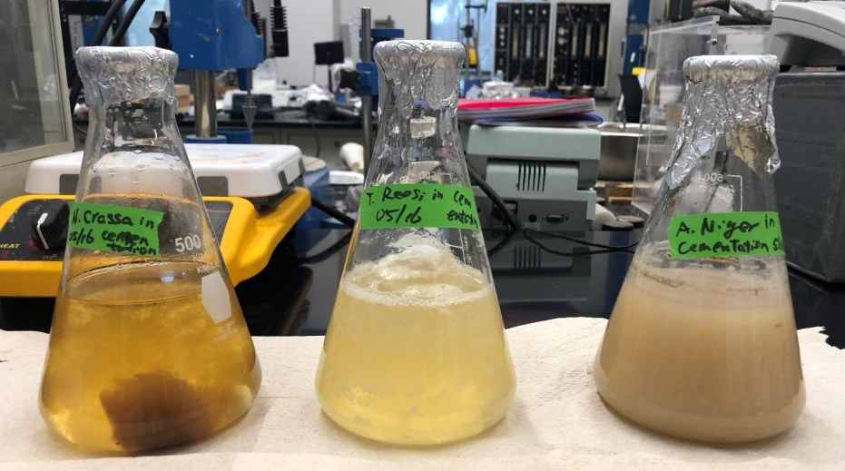
Figure 1. Fungal solutions after 7 days of mineral precipitation.

4.1.3. pH and NH₄⁺ measurements

Starting from the day when the cementation solution was added, 6 mL of the solution in each flask was extracted daily using a sterile syringe for seven consecutive days. The 6 mL extracted solution was then filtered using a 0.22 μm syringe filter to remove suspended fungal mycelium. The filtered solutions were stored in 50 mL centrifuge tubes in a -20°C freezer for pH and NH₄⁺ measurements later.

pH measurement: The stored 50 mL centrifuge tubes corresponding to different sampling date were thawed and subjected to pH measurement using a pH meter (Thermo Scientific ORION 3 STER pH Benchtop). The pH meter was first calibrated using a three-point calibration method with standard buffer solutions (pH 4.0, 7.0, and 10.0) prior to pH measurements.

NH₄⁺ concentration measurement: After pH measurements, the concentration of NH₄⁺ was measured in each collected solution using the Modified Nessler Method. First, a standard curve between true NH₄⁺ concentrations (0.1, 0.3, and 0.5 mM) and measured absorbance at 425 nm using a spectrophotometer (721-VIS spectrophotometer) was developed. Then, the NH₄⁺ concentration in each sample was measured. 2 mL of the solution was mixed with 100$μ$L Nessler reagent for absorbance measurement using the spectrophotometer(Guan et al. 2012).

4.1.4. SEM, EDS, and XRD analysis
After 7 days of mineral precipitation, three fungal solutions were filtered using a 500 mL vacuum filtration unit equipped with a 0.22 μm filter membrane (Fisherbrand 500 mL Bottle Top Filter) to collect fungal mycelia and precipitated mineral material on the filter. During filtration, additional 250 mL of deionized water was added into the filtration funnel three times to rinse the retained material on the filter membrane to remove the residual chemicals on the filter. Then, the retained materials on the filter membrane were carefully collected using a sterile spatula and transferred into sterile storage containers, which was placed in a 60°C drying oven for 48 hours to dry the samples.

The samples were then used for SEM imaging and EDS analysis. Due to the non-conductive nature of the fungal mycelia samples, each fungal sample was needed to undergo an 8-minute coating process prior to SEM analysis. After coating with a thin layer of platinum (EMS550X Sputter Coater), the samples were fixed on the aluminum stubs using conductive carbon tape for SEM imaging. Then, a scanning electron microscope (Thermo Fisher Scientific Quanta 3D FEG, S/N: D8805) was used for sample imaging. The accelerating voltage was set to 5-20 kV, depending on the sample’s conductivity and resolution requirements. The microstructural features of the samples were observed and captured. During SEM imaging, EDS analysis (integrated with the SEM) was also conducted to analyze the elemental compositions in the samples. The EDS spectra were taken from multiple regions of interest on the sample to investigate the distribution and types of elements present in the samples. The mineral compositions of the samples were also characterized using the Panalytical Empyrean X-ray diffractometer (XRD). XRD is based on the principles of emission of X-ray and Bragg's law, which provides information about crystal structures of bulk samples. The XRD scans were recorded with a Cu Kα radiation (λ=1.54 Å, 45 kV, and 40 mA) in the 2θ range from 5° to 80° with a scan rate of 4o/min.

4.2. Task 2. Investigating the growth of three fungal strains on the cement mortar surface

4.2.1. Sample preparation
Based on the results of Task 1, we selected two fungal strains that can precipitate calcium minerals, Aspergillis niger (ATCC 9029) and Neurospora crassa (FGSC 2489), for Task 2. For each fungal strain, three petri dish samples were prepared, including two petri dish samples with cement to evaluate their growth on the cement mortar surface and one petri dish sample without cement to evaluate their growth in the Potato Dextrose Broth (PDB). Another one blank petri dish sample with cement mortar and PDB was prepared to assess potential contaminations. For petri dish samples with cement, a cement paste was prepared using a mass ratio of Ordinary Portland cement (OPC): Sand: Water = 1:1.5:0.4. The paste was poured into the sterilized petri dishes (VWR Sterilized, size: 100 × 15 mm) to reach half the height of the petri dish. The samples were then cured for 28 days at 25°C and 60% relative humidity. After the curing period, the petri dishes were sterilized using an autoclave at 121°C and 0.103MPa for 30 minutes. The petri dishes were then allowed to cool to room temperature before being transferred into a biosafety cabinet for subsequent fungal inoculation.

4.2.2. Fungal inoculation and cultivation
In the biosafety cabinet, 10 mL of sterilized Potato Dextrose Broth (PDB) liquid medium was added to each petri dish. The petri dish was then inoculated with 2 mL of the fungal suspension of each fungus. Aseptic conditions were maintained throughout the inoculation process to prevent contamination. Each petri dish was sealed with parafilm to allow gas exchange while preventing cross-contamination. The sealed petri dishes were incubated in an incubator at 28°C, with monitoring of the sample growth every day. The growth of fungal mycelia in the petri dishes were recorded using a camera.

4.3. Task 3. Assessing the self-healing capability of cement mortar cracks using fungal strains

The research team first investigated the effect of bacteria healing ability on cement mortar cracks. Then, the effect of fungal healing ability on cement mortar cracks was evaluated, which was compared to the healing ability of bacteria. The control samples without bacteria and fungi were also prepared.

Cellulose-based fibers were incorporated into selected mortar samples to enhance crack bridging and provide a microbial-friendly microenvironment. These fibers not only improved the mechanical integrity of the matrix by resisting crack propagation, but also served as scaffolds that facilitated bacterial or fungal attachment and bioactivity. The fibers used in this study were commercially available cellulose fibers with an average length of 2 mm and a diameter of 18 μm, added at a volume fraction of 0.45% to ensure uniform dispersion without compromising workability.

Four types of bacteria mortar samples were prepared, including untreated samples (cement mortar without fiber and bacteria, 20 specimens), fiber samples (cement mortar with fibers but without bacteria, 20 specimens), bacteria samples (cement mortar with bacteria but without fibers, 20 specimens), and fiber bacteria samples (cement mortar with bacteria and fibers, 20 specimens). These sample types will be used to evaluate the effects of fiber and bacteria on the strength and self-healing ability for cement mortar samples.

Cement mortar samples treated by two types of fungi (Neurospora crassa (FGSC 2489) and Aspergillus niger (ATCC 9029)) were also prepared, including fungal samples (cement mortar with fungi but without fibers, 10 specimens of each fungal strain) and fiber fungal samples (cement mortar with fungi and fibers, 10 specimens of each fungal strain).

4.3.1. Sample Preparation Procedures
This section describes the preparation of test specimens used in the study, including bacterial and fungal cultures, cement mortar mixing, and crack formation. All procedures were designed to ensure consistency and reproducibility across test batches.

4.3.1.1. Bacterial cultivation
To cultivate Sporosarcina pasteurii (ATCC 11859) for cement mortar samples, a liquid culture method was employed. The growth medium was prepared by dissolving 10 grams of yeast extract and 5 grams of ammonium sulfate into 500 milliliters of 0.13 M Tris buffer adjusted to pH of 9. The 0.13 M Tris buffer was prepared by diluting 65 milliliters of a 1 M Tris buffer solution (made by dissolving 7.6 grams of Tris hydrochloride and 54.7 grams of Tris base in 500 milliliters of distilled water). The prepared medium was sterilized using a 0.2 µm pore size PES (polyethersulfone) membrane filter (Fisherbrand, FB12566512).

After sterilization, S. pasteurii from the stock in the -80 ºC freezer was aseptically inoculated into 250-milliliter Erlenmeyer flasks containing 100 milliliters of the sterile growth medium. The flasks were incubated at 30°C with shaking at 150 revolutions per minute (rpm) to promote bacterial growth (Figure 2). Once the bacterial solution turned cloudy, it was then transferred into two 2800-milliliter Erlenmeyer flasks containing 1400 milliliters of freshly prepared sterile growth medium (Figure 2) until the optical density at 600 nm (OD₆₀₀) of the solutions reached the target range of 1.2 to 1.4, indicating optimal cell density in the solution(Achal et al. 2011). Then, the 3000 milliliters of bacterial solution were centrifuged (Beckman Coulter Avanti JXN-26) (Figure 3), and the resulting bacterial pellets were stored in a 4ºC fridge for future use. When it was ready for cement mortar mixing, these bacteria pellets were resuspended into sterile growth mediumto obtain 700 milliliters of concentrated bacterial suspension.

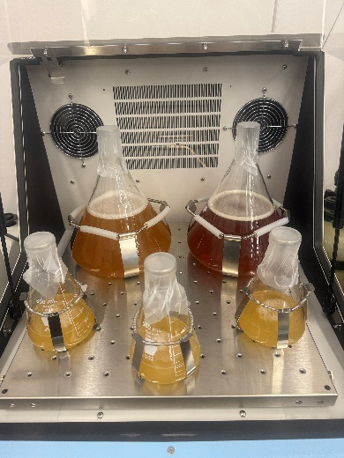
Figure 2. The cultivation of S.pasteurii in the shaking incubator.

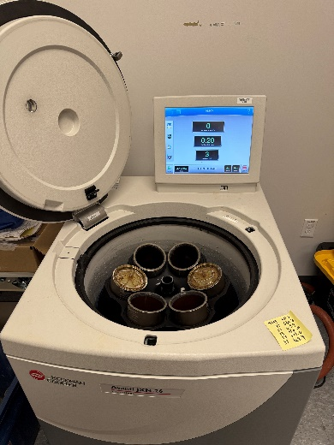
Figure 3. Centrifugation to collect S.pasteurii for cement mortar mixing.

4.3.1.2. Fungal cultivation procedure
Fungal cultivation was conducted using two filamentous fungal strains: Neurospora crassa (FGSC 2489) and Aspergillus niger (ATCC 9029). Both strains were grown in a Potato Dextrose Broth (PDB) medium (HiMedia, GM403-2.5KG), which is widely used for fungal growth. The medium was prepared by dissolving 24.0 grams of granulated PDB powder in 1000 milliliters of distilled water. The solution was mixed thoroughly and sterilized by autoclaving at 121°C and 0.103MPa for 15 minutes. After cooling to room temperature, the sterile PDB medium was then used for fungal inoculation.

Each fungal strain was initially inoculated into 500-milliliter Erlenmeyer flasks, each containing 100 milliliters of sterile PDB medium. These pre-cultures were incubated at 30°C with shaking at 150 rpm for three days to promote initial mycelial growth (Figure 4). Subsequently, the fungal suspensions were transferred into the 2800-milliliter Erlenmeyer flasks containing 1400 milliliters of freshly prepared sterile PDB medium (Figure 5). The cultures were further incubated under the same conditions—30°C and 150 rpm—for an additional seven days to generate sufficient fungal biomass for cement mortar sample preparation. Upon completion of incubation, the fungal cultures were harvested by centrifugation at 19,200 rpm for 4 hours. The harvested fungal suspensions were stored in sterile containers at 4°C fridge before use. To ensure the viability and functionality of the fungi, all samples were used within 10 days after centrifuge.

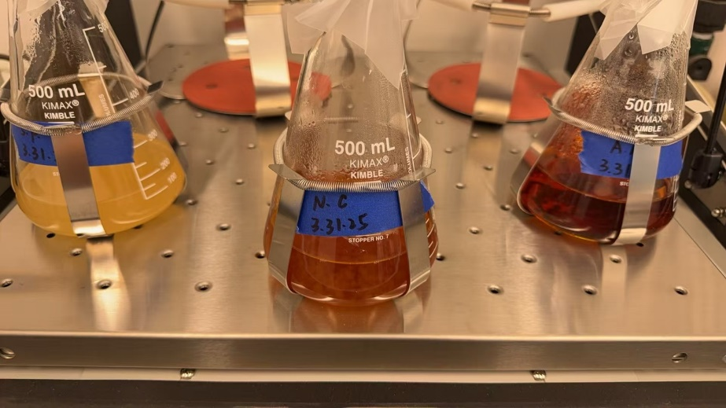
Figure 4. Growth of Fungal Strains in 500 mL Flasks.

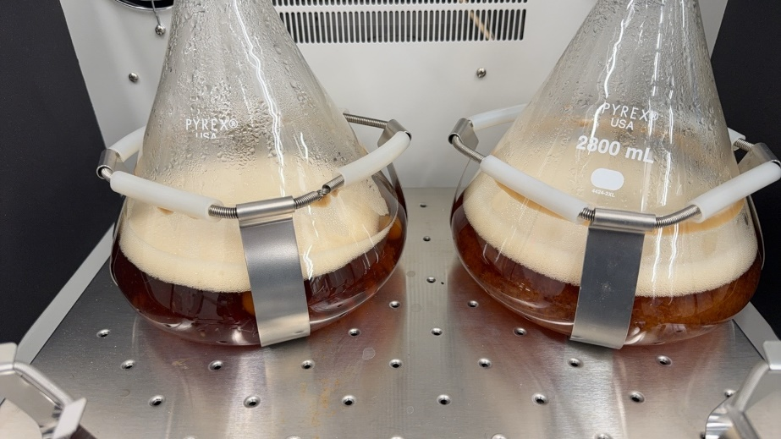
Figure 5. Fungal Culture of Neurospora crassa and Aspergillus niger in 2800-milliliter Erlenmeyer flasks.

4.3.1.3. Cement mortar sample preparation
Cement mortar samples were prepared using a standardized mixing procedure to ensure uniformity and reproducibility across all test batches. A mass ratio of 1:1.5:0.4 for Portland cement, sand, and water, respectively, was adopted. All dry materials were weighed with high precision, maintaining a tolerance within ±0.3 grams to minimize variability. Identical containers and tools were used throughout the process to control for external variation. Mixing was conducted using a mechanical mortar mixer, where the cement and sand were first combined and mixed at low speed for 60 seconds (Figure 6). A spoon was used to manually lift any unmixed material from the bottom of the mixing pot, followed by an additional 30 seconds of low-speed mixing. Water was then added evenly over a 30-second period while mixing at medium speed, and the mixture was further mixed at medium speed for another 30 seconds. Depending on the treatment type, the fiber incorporation process was adjusted to ensure compatibility with microbial agents and proper dispersion. For samples with dry cellulose fibers, the fibers were added directly into the mixer after the cement and sand were combined, followed by 60 seconds of high-speed mixing to ensure uniform distribution. In contrast, for samples containing wet fibers pre-loaded with microbial suspensions (bacterial or fungal), the fibers were first soaked in the respective microbial solution for five minutes prior to mixing. This fiber-liquid mixture was then added during the medium-speed stage and subsequently mixed at high speed for 60 seconds. This distinction was made to accommodate the differing physical properties of the fiber states and the preservation of microbial viability. Final homogenization was achieved by mixing at high speed for 5–6 minutes (Figure 7a). The freshly prepared mortar was poured into cylindrical molds with an inner diameter of 2 inches (50.8 mm) and a height of 4 inches (101.6 mm), which had been cleaned and sterilized prior to casting. After filling, each mold was tapped 15 to 20 times with a metal rod to remove entrapped air and improve compactness, and the surface was leveled using a metal scraper. The samples were then covered with plastic sheets and cured at 25°C and greater than 90% relative humidity for 28 days (Figure 7b and c). After curing, the specimens were demolded and stored under controlled conditions for subsequent testing and treatment (Figure 7d).

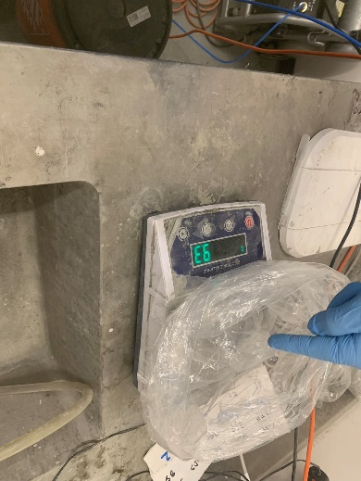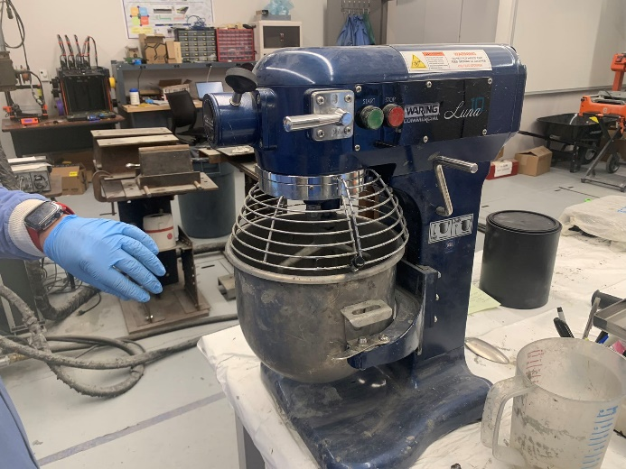
Figure 6. Weighing and mixing of cement mortar samples

Figure 7. (a) Freshly mixed mortar prior to casting, (b) mortar specimens under curing, (c) labeled mortar specimens organized by group, and (d) surface condition of the cured mortar specimens.

4.3.1.4 Artificial crack generation procedure
Artificial cracks were generated in cylindrical mortar specimens (2-inch diameter × 4-inch height) using the split tensile test in accordance with ASTM C496 (Luo et al. 2015). A stress-controlled mode was adopted, and the test was performed using a compression machine (Gilson AC-525MR). The loading ramp rate was set to 2.5 psi/s to maintain control over the crack development process. Preliminary trials demonstrated that applying a break rate of 79% reliably induced visible cracks without causing complete failure. Once the target break rate was reached, the loading process was automatically stopped. The resulting cracks typically propagated vertically along the axis of the cylinder and were generally through-cracks. The measured crack width ranged from 0.04 mm to 0.7 mm, depending on group. Cracked specimens were subsequently subjected to different healing treatments and tested at scheduled time points for mechanical and microstructural evaluation.

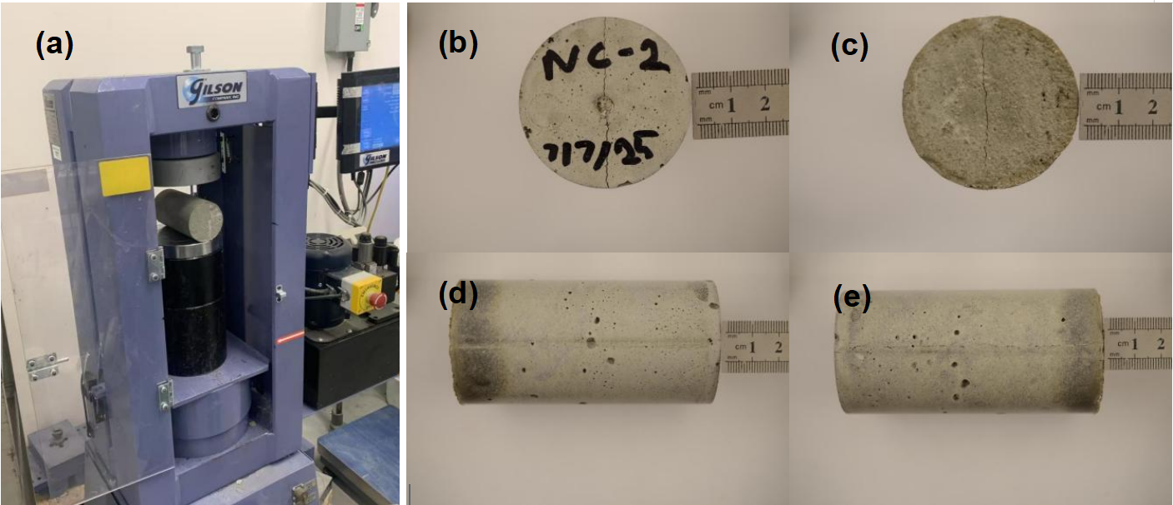
Figure 8. (a) Test setup for crack generation and (b-e) mortar specimen after crack induction.

4.3.2. Crack healing evaluation methods
To assess the effectiveness of fungal- and bacteria-induced crack healing in cement mortar specimens, multiple evaluation techniques were employed. These methods were selected to provide both qualitative and quantitative insights into the healing performance. Visual inspection was used to observe surface crack closure, while mechanical and physical tests—including compressive strength, S-and P-wave velocity measurements, and water absorption—were conducted to quantify the healing progress of the cement mortar smaples.

4.3.2.1. Visual crack closure observation
Visual inspection was conducted to qualitatively evaluate the extent of surface crack healing in the mortar specimens. High-resolution photographs were captured at three critical stages: before the healing treatment, during the healing process, and after the completion of the designated healing period. To ensure consistency, all images were taken under identical lighting conditions, at a fixed camera distance, and using standardized camera settings. A measurement scale was positioned adjacent to the cracks in each photograph to provide dimensional reference. The degree of crack closure was assessed by comparing changes in crack width and continuity across the different stages. Figure 9 shows the preliminary healing results due to bacterial treatment.
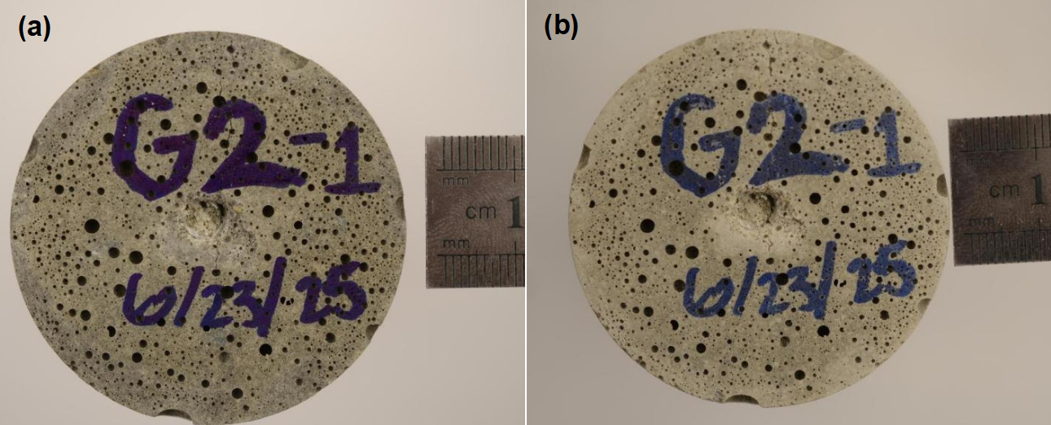
Figure 9. Surface crack measurement with a scale (a) before (b)after healing for 16 days.

4.3.2.2. Compressive strength tests
Compressive strength tests were conducted to evaluate the recovery of the compressive strength of the cement mortar after crack healing. Following ASTM C39, cylindrical specimens with pre-induced cracks were tested alongside uncracked controls and untreated cracked samples, using a universal testing machine (Gilson AC-525MR). Each sample group had at least three replicates. A constant loading rate (0.24MPa/s) was applied until failure, and compressive strength was calculated as the peak load divided by the cross-sectional area. Strength values from the healed groups were then compared to those of the control and untreated cracked groups to assess the strength recovery and healing.
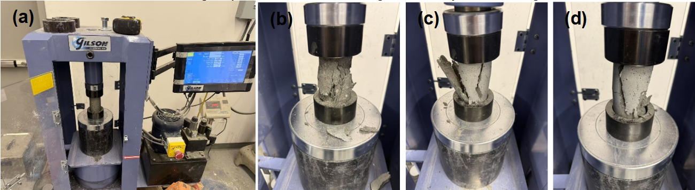

Figure 10. (a) Compression test setup (b–d) fully fractured specimens.

4.3.2.3. S-wave and P-wave velocities tests
The S-wave velocity tests using bender elements and P-wave velocity tests using P-wave sensors were used to assess internal crack healing by measuring S-and P-wave velocities in the cement smortar specimens(Wang et al. 2013; Huang et al. 2017). A pair of piezoelectric bender elements was in touch with the top and bottom of each cylindrical sample, with a square wave signal (typically 100 Hz, 5 V) applied through a function generator. The received signals were captured on a digital oscilloscope with 128-time stacking and filtered using a 100 Hz – 50 kHz band-pass filter to minimize noise (Figure 11). S-wave first arrival time was identified from the waveform which was used to calculate the travel time, and the S-wave velocities were calculated by dividing the spacing between two bender elements by the travel time. Tests were performed before, during, and after healing. An increase in shear wave velocity indicated improved internal continuity and effective crack closure at small strain levels.
The P-wave velocity measurements were conducted in a similar manner to the S-wave tests, except that a pair of compressional wave (P-wave) transducers were positioned at the top and bottom surfaces of each cylindrical specimen. A square wave signal (50 Hz, 5 V) was generated using the same function generator, and the received signals were captured by a digital oscilloscope. The signals were filtered using a 600 Hz–300 kHz band-pass filter to minimize environmental and electrical noise(Figure 11). The first arrival time of the P-wave was identified as the time corresponding to the first stable wave peak in the waveform. P-wave velocities were then calculated by dividing the specimen length by the travel time. Like the S-wave tests, measurements were performed before and after healing, and increases in P-wave velocity were interpreted as indicators of improved material integrity and effective microcrack closure.

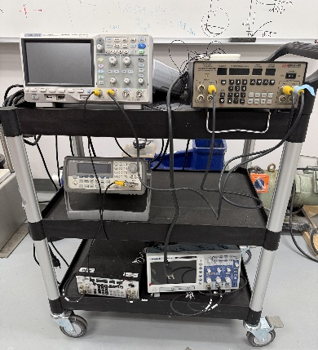
Figure 11. Equipment for S-and P-wave velocity testing.

4.3.2.4. Water absorption tests
Water absorption tests were performed to evaluate the improvement in impermeability resulting from crack healing. The procedure was adapted from ASTM C642, a standard method for assessing the absorption and void content of hardened concrete but was modified to suit the characteristics of bio-treated mortar specimens.

To avoid thermal degradation of fungal or bacterial components during intermediate steps, the samples were air-dried at room temperature for approximately 48 hours instead of being oven-dried. After this period, they were fully immersed in water for 24 hours to allow saturation. This process was carried out both before and after the healing treatment. A reduction in water uptake after healing was considered indicative of improved crack closure and restoration of the internal barrier to water ingress. For consistency and final comparison, oven-drying at 105±5°C was conducted only once—after the healing stage—under standardized conditions.

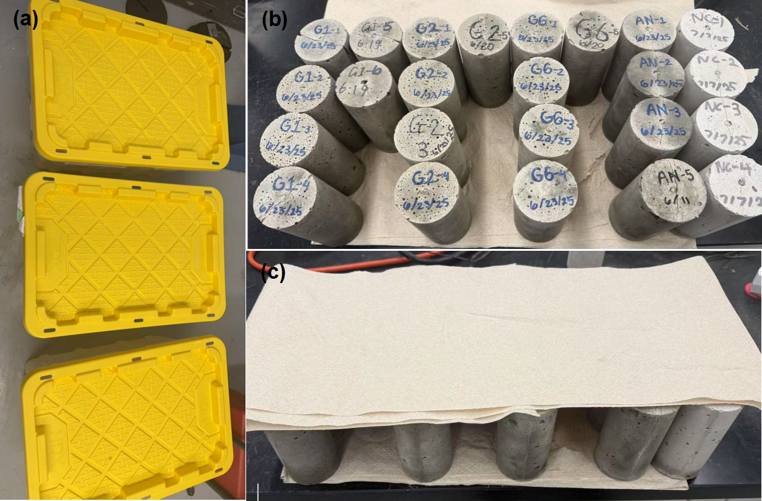
Figure 12. (a) Water absorption test workflow adapted for bio-treated concrete (b-c) saturation and drying stages.

Project results:

5.1. Task 1. Evaluating the performance of three fungal strains on mineral precipitation

The pH results (Figure 12) show a gradual increase in pH over the 8-day testing period following the addition of a urea-based cementation solution. The initial measurement on Day 0 represents fungal cultures that had been pre-incubated for 7 days in PDB medium, after which urea and CaCl₂ were introduced to stimulate urease activity.

Figure 13. pH measurements of three fungal strain solutions.
The pH increase is attributed to the hydrolysis of urea, during which fungal enzymes catalyze the breakdown of urea into ammonia and hydroxide ions, thereby raising the pH. Among the three strains tested, Neurospora crassa (FGSC 2489) demonstrated the most significant increase in pH, reaching approximately 8.4, suggesting the highest enzymatic activity and strongest potential for inducing mineral precipitation. Trichoderma reesei and Aspergillus niger also exhibited upward pH trends, although to a lesser extent.The results support the hypothesis that fungal urease activity contributes to the alkalinization of the medium, laying a foundation for evaluating the strains' effectiveness in fungal-induced mineral precipitation (FIMP) processes.

Figure 14. Variation of NH₄⁺ of three fungal strains with time.

The research team also assessed the performance of three fungal strains, Aspergillis niger (ATCC 9029), Neurospora crassa (FGSC 2489), and Trichoderma reesei (ATCC 13631), on mineral precipitation. Figures 14 to 16 show the SEM images of three fungal mycelial samples. These SEM figures show that the fungal mycelial fibers seemed aggregate together due to drying of the samples, which is difficult to observe mycelial fibers in the images. Figure 17 shows the EDS analysis for Neurospora crassa samples, which shows the presence of calcium minerals in the samples.

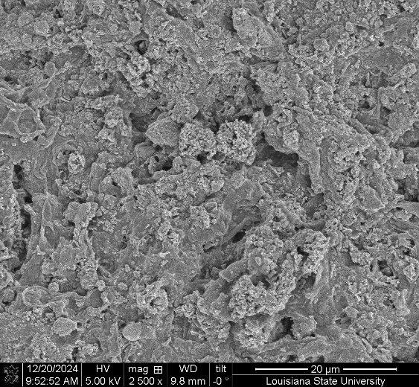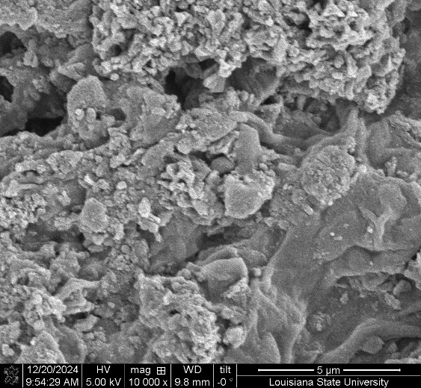
Figure 15. SEM imaging of Trichoderma reesei (ATCC 13631) retained on the filter paper.
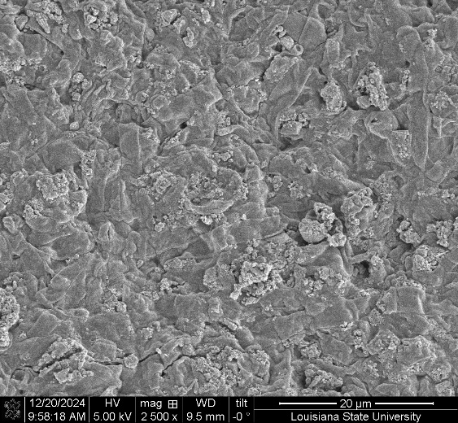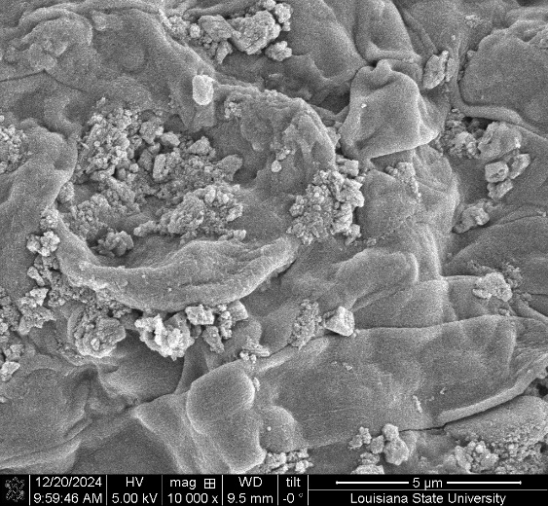
Figure 16. SEM imaging of Aspergillis niger (ATCC 9029)

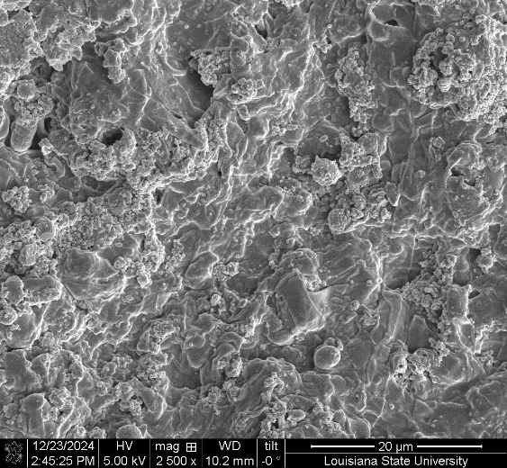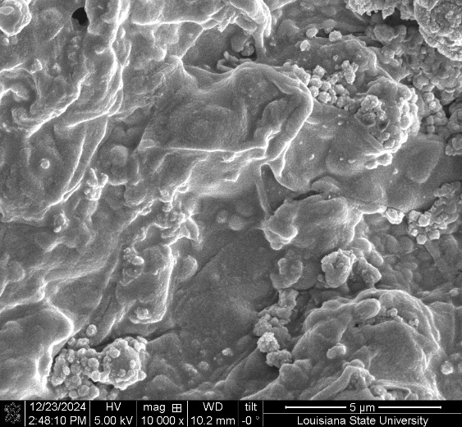
Figure 17. SEM imaging of Neurospora crassa (FGSC 2489).
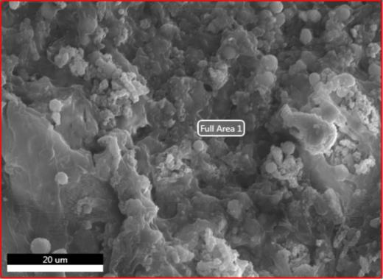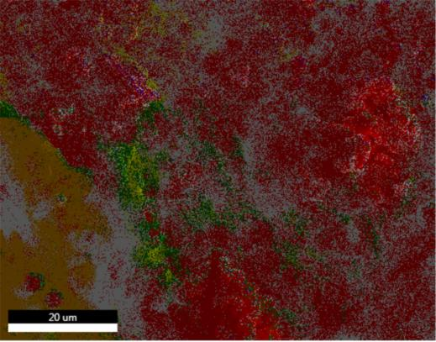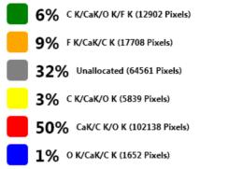
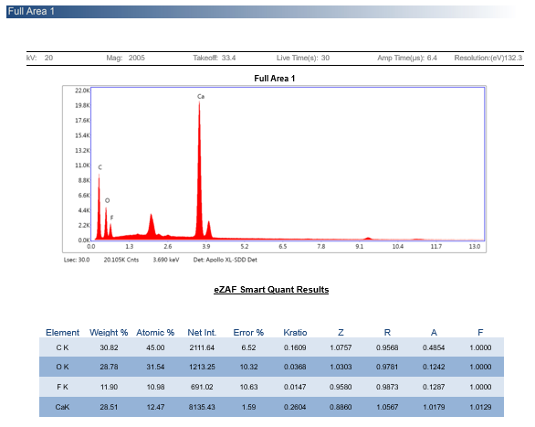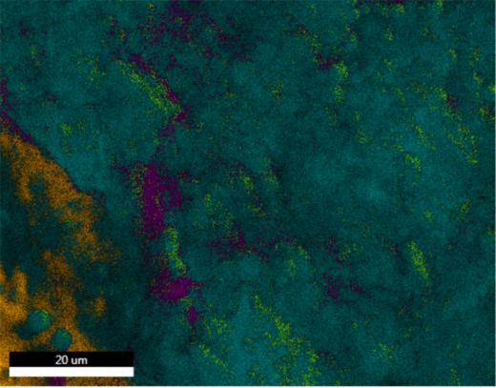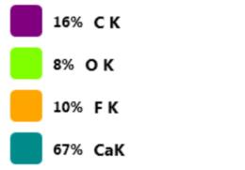
Figure 18. EDS results of Neurospora crassa (FGSC 2489).

The X-ray powder diffraction (XRD) analysis results of three fungal strain samples are shown in Figure 19. It shows that Neurospora crassa can form calcite (CaCO₃). Aspergillis niger can produce calcium oxalate. But Trichoderma reesei cannot precipitate calcium-based minerals. This indicates that both Neurospora crassa and Aspergillis niger can form calcium based mineral precipitation, which can be used for testing self-healing cement mortar later.

Figure 19. XRD results of three fungal strains.

5.2. Task 2. Investigating the performance of three fungal strains to induce mineral precipitation on the cement mortar surface.

Figures 20 shows the fungal growth process in the petri dishes with time. In the top row of each figure, the three petri dishes correspond to Aspergillus niger, while the bottom row corresponds to Neurospora crassa. The petri dish on the right of cement mortar petri dishes in both rows served as a blank control sample without Portland cement. The cement mortar petri dish on the very right is also a control sample with cement and the growth media (PDB, but without fungal strain) to assess the potential contaminations. The samples shown from Figures 20 shows the condition of fungal growth at Days 0, 5, 10.

Figures 20 shows that the two fungal strains were able to grow in the petri dishes with the growth media (PDB) with time. However, these two fungal strains can not grow on the surface of the cement mortar samples. The reasons could be due to the high pH due to cement hydration reaction, water absorbed by cement hydration that reduce the water amount for fungal growth, or cement chemicals that affected the growth of fungal strains(Gadd 2007).

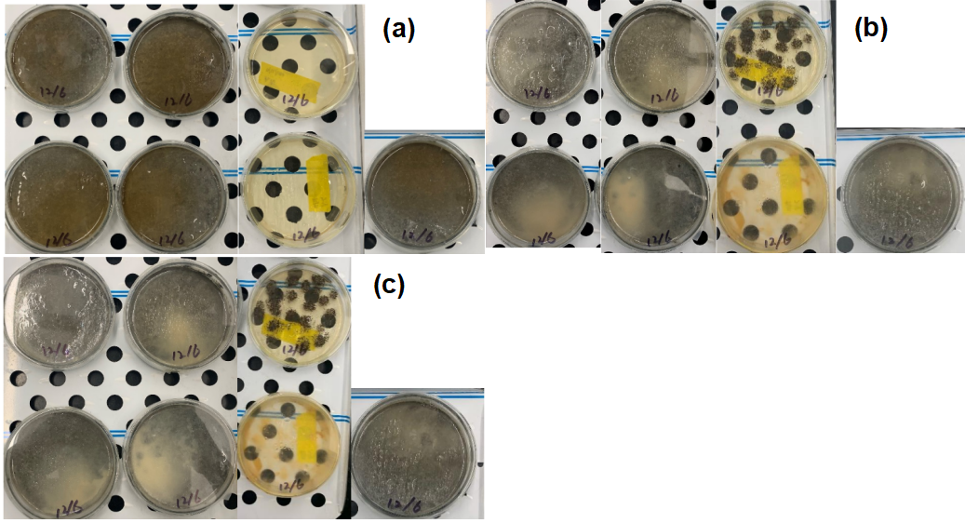Figure 20. (a-c) Days 0, 5, 10 imaging of fungi in petri dish.

5.3. Task 3. Assessing the self-healing capability of cement mortar cracks using fungal strains

Standard compressive strength tests were conducted following ASTM C39/C39M to evaluate the effects of sample shape and fiber addition. Mortar specimens were prepared in cube and cylinder forms, with or without 0.45% cellulose fiber. Tests were performed at 3, 7, and 28 days (n = 3). As shown in Figures 21 and 22, cylindrical samples produced more consistent results than cubes, indicating better data reliability. Although fiber slightly reduced strength, it improved handling and crack induction. Based on these findings, cylindrical samples with 0.45% fiber were selected for the healing experiments.

Figure 21. Compression test result of untreated cement mortar.

Figure 22. Compression test result of cement mortar with cellulose fiber.

Figure 23 presents the 28-day compressive strength results of mortar specimens prior to crack generation. Notably, specimens incorporating pre-wetted cellulose fiber and fungal strains—Aspergillus niger (AN+W-Fiber) and Neurospora crassa (NC+W-Fiber)—demonstrated significant strength enhancement and reduced variability compared to the control group. The AN+W-Fiber group reached 51.46 MPa, an increase of 32.14 MPa (166.4%) over the control (19.32 MPa), while the NC+W-Fiber group achieved 38.89 MPa, an increase of 19.57 MPa (101.3%). In particular, during sample preparation, NC-treated mortar exhibited noticeably faster setting and hardening compared to other groups, suggesting a possible interaction between fungal metabolites and the hydration process.
The improvements were observed under identical mix proportions and curing conditions, indicating that the strength gain was not due to material quantity but likely influenced by early microbial activity. According to recent studies, Neurospora crassa expresses urease and facilitates biomineralization by precipitating calcium carbonate within the matrix, thereby enhancing early structural densification (Zhao et al., 2022). Similarly, Aspergillus niger is known for strong metabolic activity and acid production, which may contribute to microstructural modification and filling effects in cementitious systems (Motaung et al., 2021).

Figure 23. Compression test result of cement mortar 28days.

P-wave velocity tests were conducted along both the height direction (top-to-bottom) and side direction (across the crack plane) of cylindrical mortar specimens to assess internal crack development and consolidation. As shown in Figure 24, the velocity measured along the height direction steadily increased across all groups during the curing period, reflecting continuous matrix densification. The group incorporating Neurospora crassa and fiber (NC+F) exhibited the highest final P-wave velocity (>3100 m/s), followed by the Aspergillus niger and fiber group (AN+F). Both significantly outperformed the control and bacterial (SP) groups, indicating improved internal structure.
In contrast, side-direction velocities—more sensitive to surface-connected discontinuities—showed lower initial values and slower recovery. Among the groups with fiber reinforcement (SP+F, AN+F, NC+F), notable lateral velocity recovery was observed after Day 4, suggesting enhanced crack bridging and healing potential. The NC+F group again demonstrated the best performance, consistent with its superior compressive strength and early hardening behavior.
These results indicate that fungal treatment, especially with Neurospora crassa, combined with pre-wetted fiber reinforcement, contributes to improved structural integrity and micro-crack closure even before formal healing procedures.

Figure 24. P-wave velocity versus time.

S-wave velocity tests were performed in both the vertical (height) and lateral (side) directions of cylindrical mortar specimens to evaluate internal crack healing behavior under small-strain conditions. As shown in Figure 25, the height-direction S-wave velocity exhibited a general upward trend across all groups, reflecting gradual stiffness recovery and matrix consolidation. The fungal-fiber groups—NC+F and AN+F—recorded the highest final velocities, consistent with their improved compressive strength and internal densification.
In the lateral direction, where measurements are more sensitive to crack discontinuities, the unreinforced groups (Control, SP) showed minimal or no recovery. In contrast, fungal groups with fiber reinforcement, particularly NC+F, demonstrated significant increases in S-wave velocity over time, indicating improved structural connectivity and crack closure.
The divergence between vertical and lateral trends reinforces the importance of multi-directional S-wave testing for assessing micro-scale healing performance. These findings confirm that the combined use of fungal strains and hydrophilic fibers enhances mechanical continuity and internal recovery in cracked mortar.

Figure 25. S-wave velocity versus time.
Water absorption tests conducted on Day 0 (right after crack generation in the cement mortar samples) and Day 14 of healing (Figure 26) revealed significant differences in permeability performance among the groups. The SP group exhibited the highest initial absorption (~7%), indicating a relatively porous matrix. In contrast, groups incorporating fungal strains or fiber additives (e.g., AN+F, SP+F, NC+F) showed notably lower absorption at Day 14, suggesting enhanced crack sealing and matrix densification. The NC+F group maintained a low absorption rate throughout (~1%), with almost no change between Day 0 and Day 14.
However, it should be noted that all samples were dried under ambient conditions rather than oven-dried prior to water immersion. This natural drying process may not have fully removed internal moisture, particularly in later testing days (e.g., Day 14 and beyond), potentially leading to an underestimation of the actual water uptake. Therefore, while the relative trends remain meaningful, the absolute absorption values—especially at later stages—may be affected by residual internal moisture.

Figure 26. water absorption tests (day 0 and day 14).

Figure 27 shows the progress of cracking healing on the bottom surface of specimen AN-3. It shows that the crack was healed with time, which confirms that Aspergillus niger can heal cement mortar cracks through an induced mineral precipitation (i.e., precipitation of calcium oxalate as shown in Figure 19).

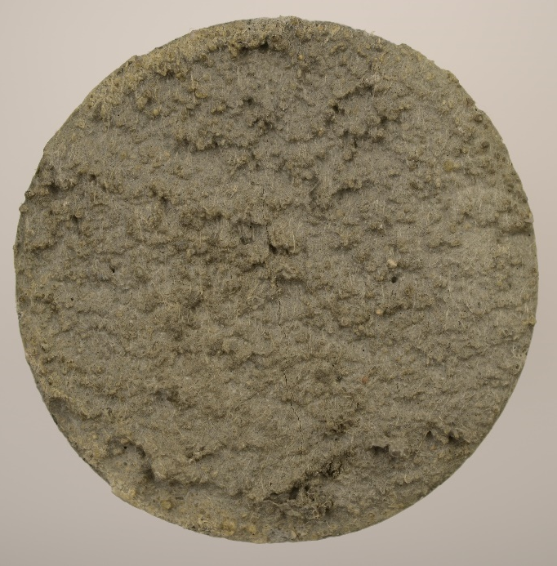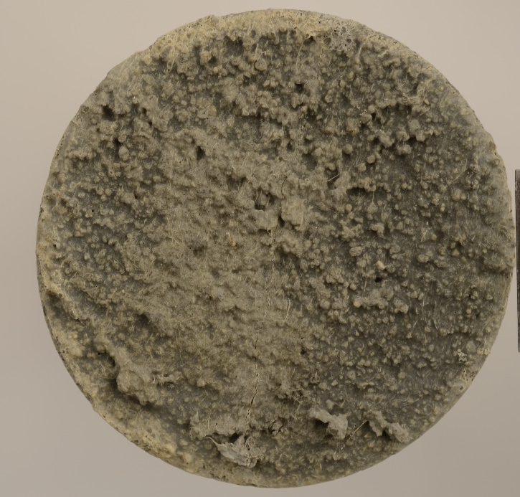
(b)
(c)
(a)
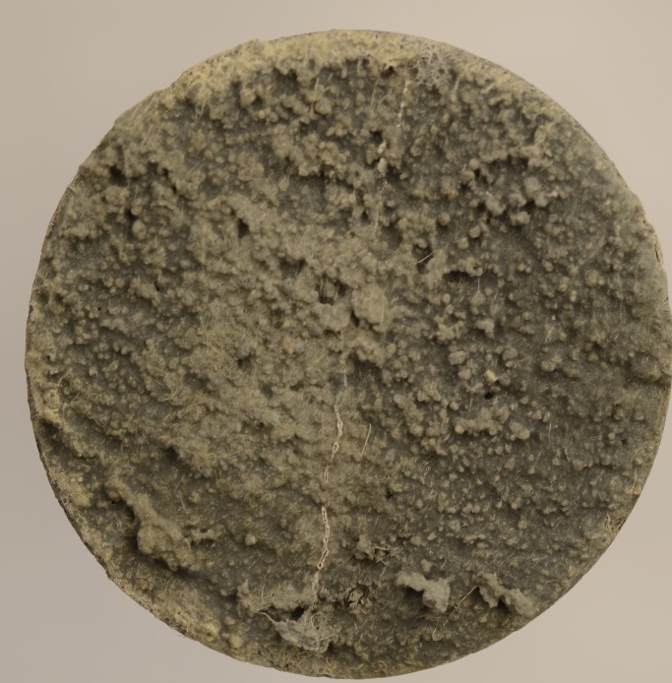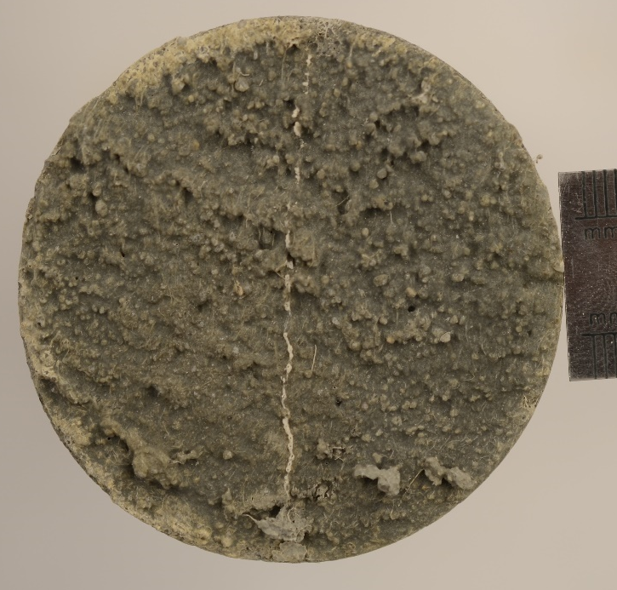
(d)
Figure 27. Time-lapse images of the bottom surface of specimen Aspergillus niger with fiber showing crack healing progression from day 0 to day 16: (a) initial crack at day 0, (b) after 8 days, (c) after 12 days, and (d) after 16 days.

Conclusions and recommendations:

6.1 Summary of Key Findings
This study demonstrated the feasibility of using bio-based methods, specifically fungal strains, to enhance crack healing and durability of cementitious materials. Among the tested strains, Neurospora crassa (NC) exhibited the best performance in promoting early hardening, increasing compressive strength, and reducing water absorption. The incorporation of hydrophilic cellulose fibers facilitated more uniform distribution of biological agents and enhanced water ingress during treatment, which contributed to improved healing outcomes. Mechanical (compressive strength), acoustic (P- and S-wave), and permeability (water absorption) tests collectively confirmed the improvement in internal matrix continuity and healing efficiency post-treatment. One notable and unexpected observation in this study was the increase in compressive strength in mortar specimens treated with fungal cultures, particularly Neurospora crassa and Aspergillus niger, which will be further investigated in the future.

6.2 Scientific Implications
The results suggest that fungal-based mineralization may serve as a viable alternative to traditional bacterial MICP in self-healing concrete applications. The coupling of biological healing agents with fibrous additives represents a promising multi-functional strategy that balances crack closure with matrix integrity. Unlike traditional self-healing approaches that aim merely to restore lost strength, this strength enhancement suggests a new role of fungal cultures as bio-based concrete admixtures that may contribute directly to material densification (Seifan et al. 2019). This finding expands the scope of microbial applications in cementitious materials and offers a potential pathway toward low-carbon, bio-enhanced construction materials.

6.3 Recommendations for Future Research
It is recommended to explore a broader range of fungal species with different enzymatic or metabolic characteristics to optimize healing performance under various environmental conditions. It is necessary to investigate long-term durability and field applicability of fungal-treated concrete, including freeze-thaw resistance, carbonation depth, and real-crack healing.

6.4 Challenges and Limitations
Maintaining microbial viability during sample preparation and curing remains a critical technical bottleneck. Environmental variations (temperature, pH, moisture) significantly influence fungal activity and may limit reproducibility across sites. Current healing evaluations rely on indirect indicators; more refined quantification techniques are required to isolate the biological contribution from physical effects. Future studies are needed to explore the underlying mechanisms of strength gain and identify optimal fungal strains or metabolic pathways for admixture design.

Practical application/impact on transportation infrastructure:
This study highlights the potential of incorporating fungal-induced biomineralization into cement-based materials to improve their self-healing capability and durability. In transportation infrastructure—such as bridges, pavements, tunnel linings, and retaining structures—cracking remains a persistent challenge, often resulting in high maintenance costs and reduced service life. The experimental results demonstrate that mortar specimens treated with fungal cultures, particularly Neurospora crassa, in combination with hydrophilic fibers, exhibited not only enhanced healing performance but also improved mechanical properties. These findings suggest the feasibility of using fungal agents as a biological additive to promote long-term integrity and passive self-repair of concrete structures.

References:
Achal, V., Mukherjee, A., & Reddy, M. S. (2011). Effect of calcifying bacteria on permeation properties of concrete structures. Journal of Industrial Microbiology & Biotechnology, 38(9), 1229–1234. https://doi.org/10.1007/s10295-010-0891-z
ASTM C305-20. (2020). Standard Practice for Mechanical Mixing of Hydraulic Cement Pastes and Mortars of Plastic Consistency. ASTM International. https://doi.org/10.1520/C0305-20
ASTM C39/C39M-23. (2023). Standard Test Method for Compressive Strength of Cylindrical Concrete Specimens. ASTM International. https://doi.org/10.1520/C0039_C0039M-23
ASTM C496/C496M-17. (2017). Standard Test Method for Splitting Tensile Strength of Cylindrical Concrete Specimens. ASTM International. https://doi.org/10.1520/C0496_C0496M-17
ASTM C642-13. (2013). Standard Test Method for Density, Absorption, and Voids in Hardened Concrete. ASTM International. https://doi.org/10.1520/C0642-13
Bindschedler, S., Cailleau, G., & Verrecchia, E. (2016). Role of fungi in the biomineralization of calcite. Minerals, 6(2), 41. https://doi.org/10.3390/min6020041
Choi, S.-G., Wang, K., Wen, Z., & Chu, J. (2017). Mortar crack repair using microbial induced calcite precipitation method. Cement and Concrete Composites, 83, 209–221. https://doi.org/10.1016/j.cemconcomp.2017.07.013
Fang, C., Kumari, D., Zhu, X., & Achal, V. (2018). Role of fungal-mediated mineralization in biocementation of sand and its improved compressive strength. International Biodeterioration & Biodegradation, 133, 216–220. https://doi.org/10.1016/j.ibiod.2018.07.013
Gadd, G. M. (2007). Geomycology: biogeochemical transformations of rocks, minerals, metals and radionuclides by fungi, bioweathering and bioremediation. Mycological Research, 111(1), 3–49. https://doi.org/10.1016/j.mycres.2006.12.001
Guan, Y., Yang, Z., & Liu, S. (2012). An improved Nessler’s reagent method for ammonia determination in wastewater. Journal of Environmental Sciences, 24(9), 1554–1559. https://doi.org/10.1016/S1001-0742(11)60976-4
Guggiari, M., Bloque, R., Aragno, M., Verrecchia, E., Job, D., & Junier, P. (2011). Experimental calcium-oxalate crystal production and dissolution by selected wood-rot fungi. International Biodeterioration & Biodegradation, 65(6), 803–809. https://doi.org/10.1016/j.ibiod.2011.02.012
Hou, W., Lian, B., & Zhang, X. (2011). CO₂ mineralization induced by fungal nitrate assimilation. Bioresource Technology, 102(2), 1562–1566. https://doi.org/10.1016/j.biortech.2010.08.080
Huang, H., Ye, G., & Damidot, D. (2017). Effect of self-healing on the durability of concrete–a review. Construction and Building Materials, 167, 154–162. https://doi.org/10.1016/j.conbuildmat.2018.01.124
Jonkers, H. M., Thijssen, A., Muyzer, G., Copuroglu, O., & Schlangen, E. (2010). Application of bacteria as self-healing agent for the development of sustainable concrete. Ecological Engineering, 36(2), 230–235. https://doi.org/10.1016/j.ecoleng.2008.12.036
Li, M., Qian, C. X., & Yang, Y. (2015). A study on the strength development of microbial mortar using mineral-producing bacteria. Construction and Building Materials, 93, 939–947. https://doi.org/10.1016/j.conbuildmat.2015.05.069
Li, Q., Csetenyi, L., & Gadd, G. M. (2014). Biomineralization of metal carbonates by Neurospora crassa. Environmental Science & Technology, 48(24), 14409–14416. https://doi.org/10.1021/es5042546
Luo, M., Qian, C. X., & Li, R. Y. (2015). Factors affecting crack repairing capacity of bacteria-based self-healing concrete. Construction and Building Materials, 87, 1–7. https://doi.org/10.1016/j.conbuildmat.2015.03.117
Luo, J., Chen, X., Crump, J., Zhou, H., Davies, D. G., Zhou, G., Zhang, N., & Jin, C. (2018). Interactions of fungi with concrete: Significant importance for bio-based self-healing concrete. Construction and Building Materials, 164, 275–285. https://doi.org/10.1016/j.conbuildmat.2017.12.233
Menon, R. R., Luo, J., Chen, X., Zhou, H., Liu, Z., Zhou, G., Zhang, N., & Jin, C. (2019). Screening of fungi for potential application of self-healing concrete. Scientific Reports, 9(1), 2075. https://doi.org/10.1038/s41598-019-39156-8
Motaung, T. E., Ayob, A. H., & Mutamiswa, R. (2021). Biological production of organic acids by Aspergillus species and their applications in the construction industry. Biotechnology Reports, 29, e00594. https://doi.org/10.1016/j.btre.2020.e00594
Riding, R. (2000). Microbial carbonates: the geological record of calcified bacterial–algal mats and biofilms. Sedimentology, 47(S1), 179–214. https://doi.org/10.1046/j.1365-3091.2000.00003.x
Seifan, M., Samani, A. K., & Berenjian, A. (2016). Bioconcrete: next generation of self-healing concrete. Applied Microbiology and Biotechnology, 100(6), 2591–2602. https://doi.org/10.1007/s00253-016-7316-z
Seifan, M., & Berenjian, A. (2019). Biotechnological production of sustainable construction materials: Opportunities and challenges. Biotechnology Advances, 37(8), 107447. https://doi.org/10.1016/j.biotechadv.2019.107447
Van Tittelboom, K., De Belie, N., De Muynck, W., & Verstraete, W. (2010). Use of bacteria to repair cracks in concrete. Cement and Concrete Research, 40(1), 157–166. https://doi.org/10.1016/j.cemconres.2009.08.025
Vijay, K., Murmu, M., & Deo, S. V. (2017). Bacteria based self healing concrete – A review. Construction and Building Materials, 152, 1008–1014. https://doi.org/10.1016/j.conbuildmat.2017.07.040
Wang, J. Y., Soens, H., Verstraete, W., & De Belie, N. (2014). Self-healing concrete by use of microencapsulated bacterial spores. Cement and Concrete Research, 56, 139–152. https://doi.org/10.1016/j.cemconres.2013.11.009
Wang, J., Snoeck, D., Van Vlierberghe, S., & De Belie, N. (2013). Application of P-wave velocity to monitor the self-healing behaviour of cementitious materials containing superabsorbent polymers. Cement and Concrete Composites, 34(9), 1047–1057. https://doi.org/10.1016/j.cemconcomp.2013.06.002
Wiktor, V., & Jonkers, H. M. (2011). Quantification of crack-healing in novel bacteria-based self-healing concrete. Cement and Concrete Composites, 33(7), 763–770. https://doi.org/10.1016/j.cemconcomp.2011.03.012
Xue, C., Li, W., Castel, A., Wang, K., & Sheng, D. (2020a). Effect of incompatibility between healing agent and cement matrix on self-healing performance of intelligent cementitious composite. Smart Materials and Structures, 29(11), 115020. https://doi.org/10.1088/1361-665X/aba9ac
Xue, C., Li, W., F. Qu, Sun, Z., & Shah, S. P. (2020b). Self-healing efficiency and crack closure of smart cementitious composite with crystalline admixture and structural polyurethane. Construction and Building Materials, 260, 119955. https://doi.org/10.1016/j.conbuildmat.2020.119955
Zhao, H., Liu, R., Li, Y., Zhang, X., & Guo, Z. (2022). Urease-producing fungal strains and their effect on calcium carbonate precipitation and compressive strength in mortar. Construction and Building Materials, 326, 126857. https://doi.org/10.1016/j.conbuildmat.2022.126857

