

Transportation Infrastructure Precast Innovation Center
(TRANS-IPIC)

University Transportation Center (UTC)

Physics-Informed Viscoelastic/Viscoplastic Model of Prestressed Concrete Creep
UI-24-RP-05

Quarterly Progress Report
For the performance period ending September 30, 2025

Submitted by:
Ramez Hajj, Assistant Professor, rhajj@illinois.edu
Department of Civil and Environmental Engineering
University of Illinois Urbana-Champaign

Collaborators / Partners:
None

Submitted to:
TRANS-IPIC UTC
University of Illinois Urbana-Champaign
Urbana, IL

TRANS-IPIC Quarterly Progress Report (Section 1 – 7, 5 pages max.):

Project Description:
- Research Plan - Statement of Problem

One of the major goals of TRANS-IPIC is to extend the life of existing transportation infrastructure through the development of novel materials and technologies in precast concrete (PC). Extending the durability of PC requires a thorough understanding of the mechanisms which cause it to fail prematurely. In many cases, creep can cause substantial issues affecting the performance of PC, and concrete in general, which reduces its service life due to substantial cracking. Considering the interest of TRANS-IPIC specifically in prestressed concrete as well, this project is of substantial interest, because creep can result in prestress loss in concrete. Because the creep response in concrete depends on so many factors, this study will explore the response of concrete and PC to creep loading and develop a predictive algorithm based on the latest methods in machine learning, which will allow for newfound insights into creep of PC to better design and formulate concrete which is more durable against this issue.

- Research Plan - Summary of Project Activities (Tasks)

Task 1 – Development of a creep database

In the first research task, the research team will assemble a dataset of existing experimental creep studies on PC. However, it is understood after our initial review that there may be limited data available for precast concrete specifically; therefore, we are expanding the database to study concrete in general and will consider various machine learning algorithms in future tasks to make PC-specific predictions. The research team will also consider simulation studies which are validated by experiments, to maintain the trustworthiness of the input data while also adding data points to the overall matrix. Studies will be considered from previous research reports and peer-reviewed articles. Finally, the research team will work with industry partners of the TRANS-IPIC center to obtain data from experiments and field sites, which provide information which can be added to the datasets from literature. The research team will then clean these datasets and ensure each contains the appropriate inputs, including temperature, concrete composition, reinforcement, and cure time, among others.

Task 2 – Physics Informed Neural Network for creep prediction

The second project phase involves developing a Physics Informed Neural Network (PINN) which can predict creep in PC. The PINN will use the data above for training, testing, and validation, but will also incorporate unseen datasets, which are from different sources than any portion of the data mentioned above, potentially including data from industry partners. While the approach is similar to other Artificial Neural Networks, PINN is a unique method in that the training also involves fitting data to known governing equations. In this case, the primary governing equations for the problem will be known constitutive equations based on models of springs and dashpots or phenomenological models such as the Prony series, as well as viscoplastic models of material behavior such as the Norton-Hoff model for viscoplastic solids. Hyperparameters will be tuned to ensure the best possible model is produced. Once a PINN is developed using a deep neural network approach, the research team will add prediction of uncertainty using a Bayesian neural network. Finally, the developed model will be compared with existing ACI design equations and other developed empirical and mechanistic approaches to predict creep.

Task 3 – Final report submission and posting to TRANS-IPIC website and other reporting

A final report will be submitted to TRANS-IPIC detailing the results of this study for publication on the TRANS-IPIC website after editing. The research team will ensure Section 508 compliance of the report before delivery to TRANS-IPIC. In addition, the research team will present the results of the study at the Transportation Research Board (TRB) annual meeting and at TRANS-IPIC’s workshop. The research team will also pursue at least one peer-reviewed journal publication as a result of the project to disseminate results in the academic community and will present the findings at other workshops and conferences for industry partners. Finally, the research team will also create an interactive online tool to use to predict properties of asphalt concrete and asphalt binders. This tool will be publicly available so that other researchers and practitioners can have an easy-to-use prediction tool for creep in PC.

Project Progress:
- Progress for each research task
[Describe the progress made this quarter for each research task and the % completed]

Task 1 (90% complete)

The research team continued our literature review and data acquisition from the literature. The research team reviewed extensively the previous work by Prof. Bazant’s group at Northwestern University (Bazant & Panula, 1978; Bazant & Li, 2008; Hubler et al., 2015; Wendner et al., 2015). It is worth noting that the recent advances in this database and the associated model were motivated by observations of excessive creep resulting in reduced service life in existing bridges (Bazant et al., 2011). The use of this database to form better predictive creep models therefore may result in enhanced resistance to creep-related damage in precast/prestressed concrete structures.

The research team identified several viscoelastic models for concrete creep from the literature, as well as several uses of machine learning. The research team reviewed all of these and found the work of TU-Delft researchers (Liang et al., 2022) to be insightful and effective. Therefore, we reached out to their team and were able to obtain a clean version of their dataset, which helped tremendously in adopting the NU creep dataset to our needs. Overall, the research team compiled extensive literature and submitted a 5000-word literature review paper to the Transportation Research Board Annual Meeting on the topic of models used for concrete creep prediction and introduction of mechanics of viscoelastic materials as it relates to concrete creep in prestressed concrete structures.

Task 2 (75% complete)

The research team began by replicating the work of Liang et al. (2022). We were able to obtain similar results to their work, indicating the basic efficiency of tree-based ensemble models. The dataset summary is shown in Table 1. A heatmap showing correlations of these parameters is shown in Figure 1, demonstrating that no individual values have a good correlation with creep compliance, and that the inputs are not well-correlated with each other, justifying the choice of all fourteen of these parameters for the machine learning task. Figure 2 shows the replication that we performed of the work of Liang et al., demonstrating the effectiveness of three tree-based models, and the performance of each model is summarized in Table 2.

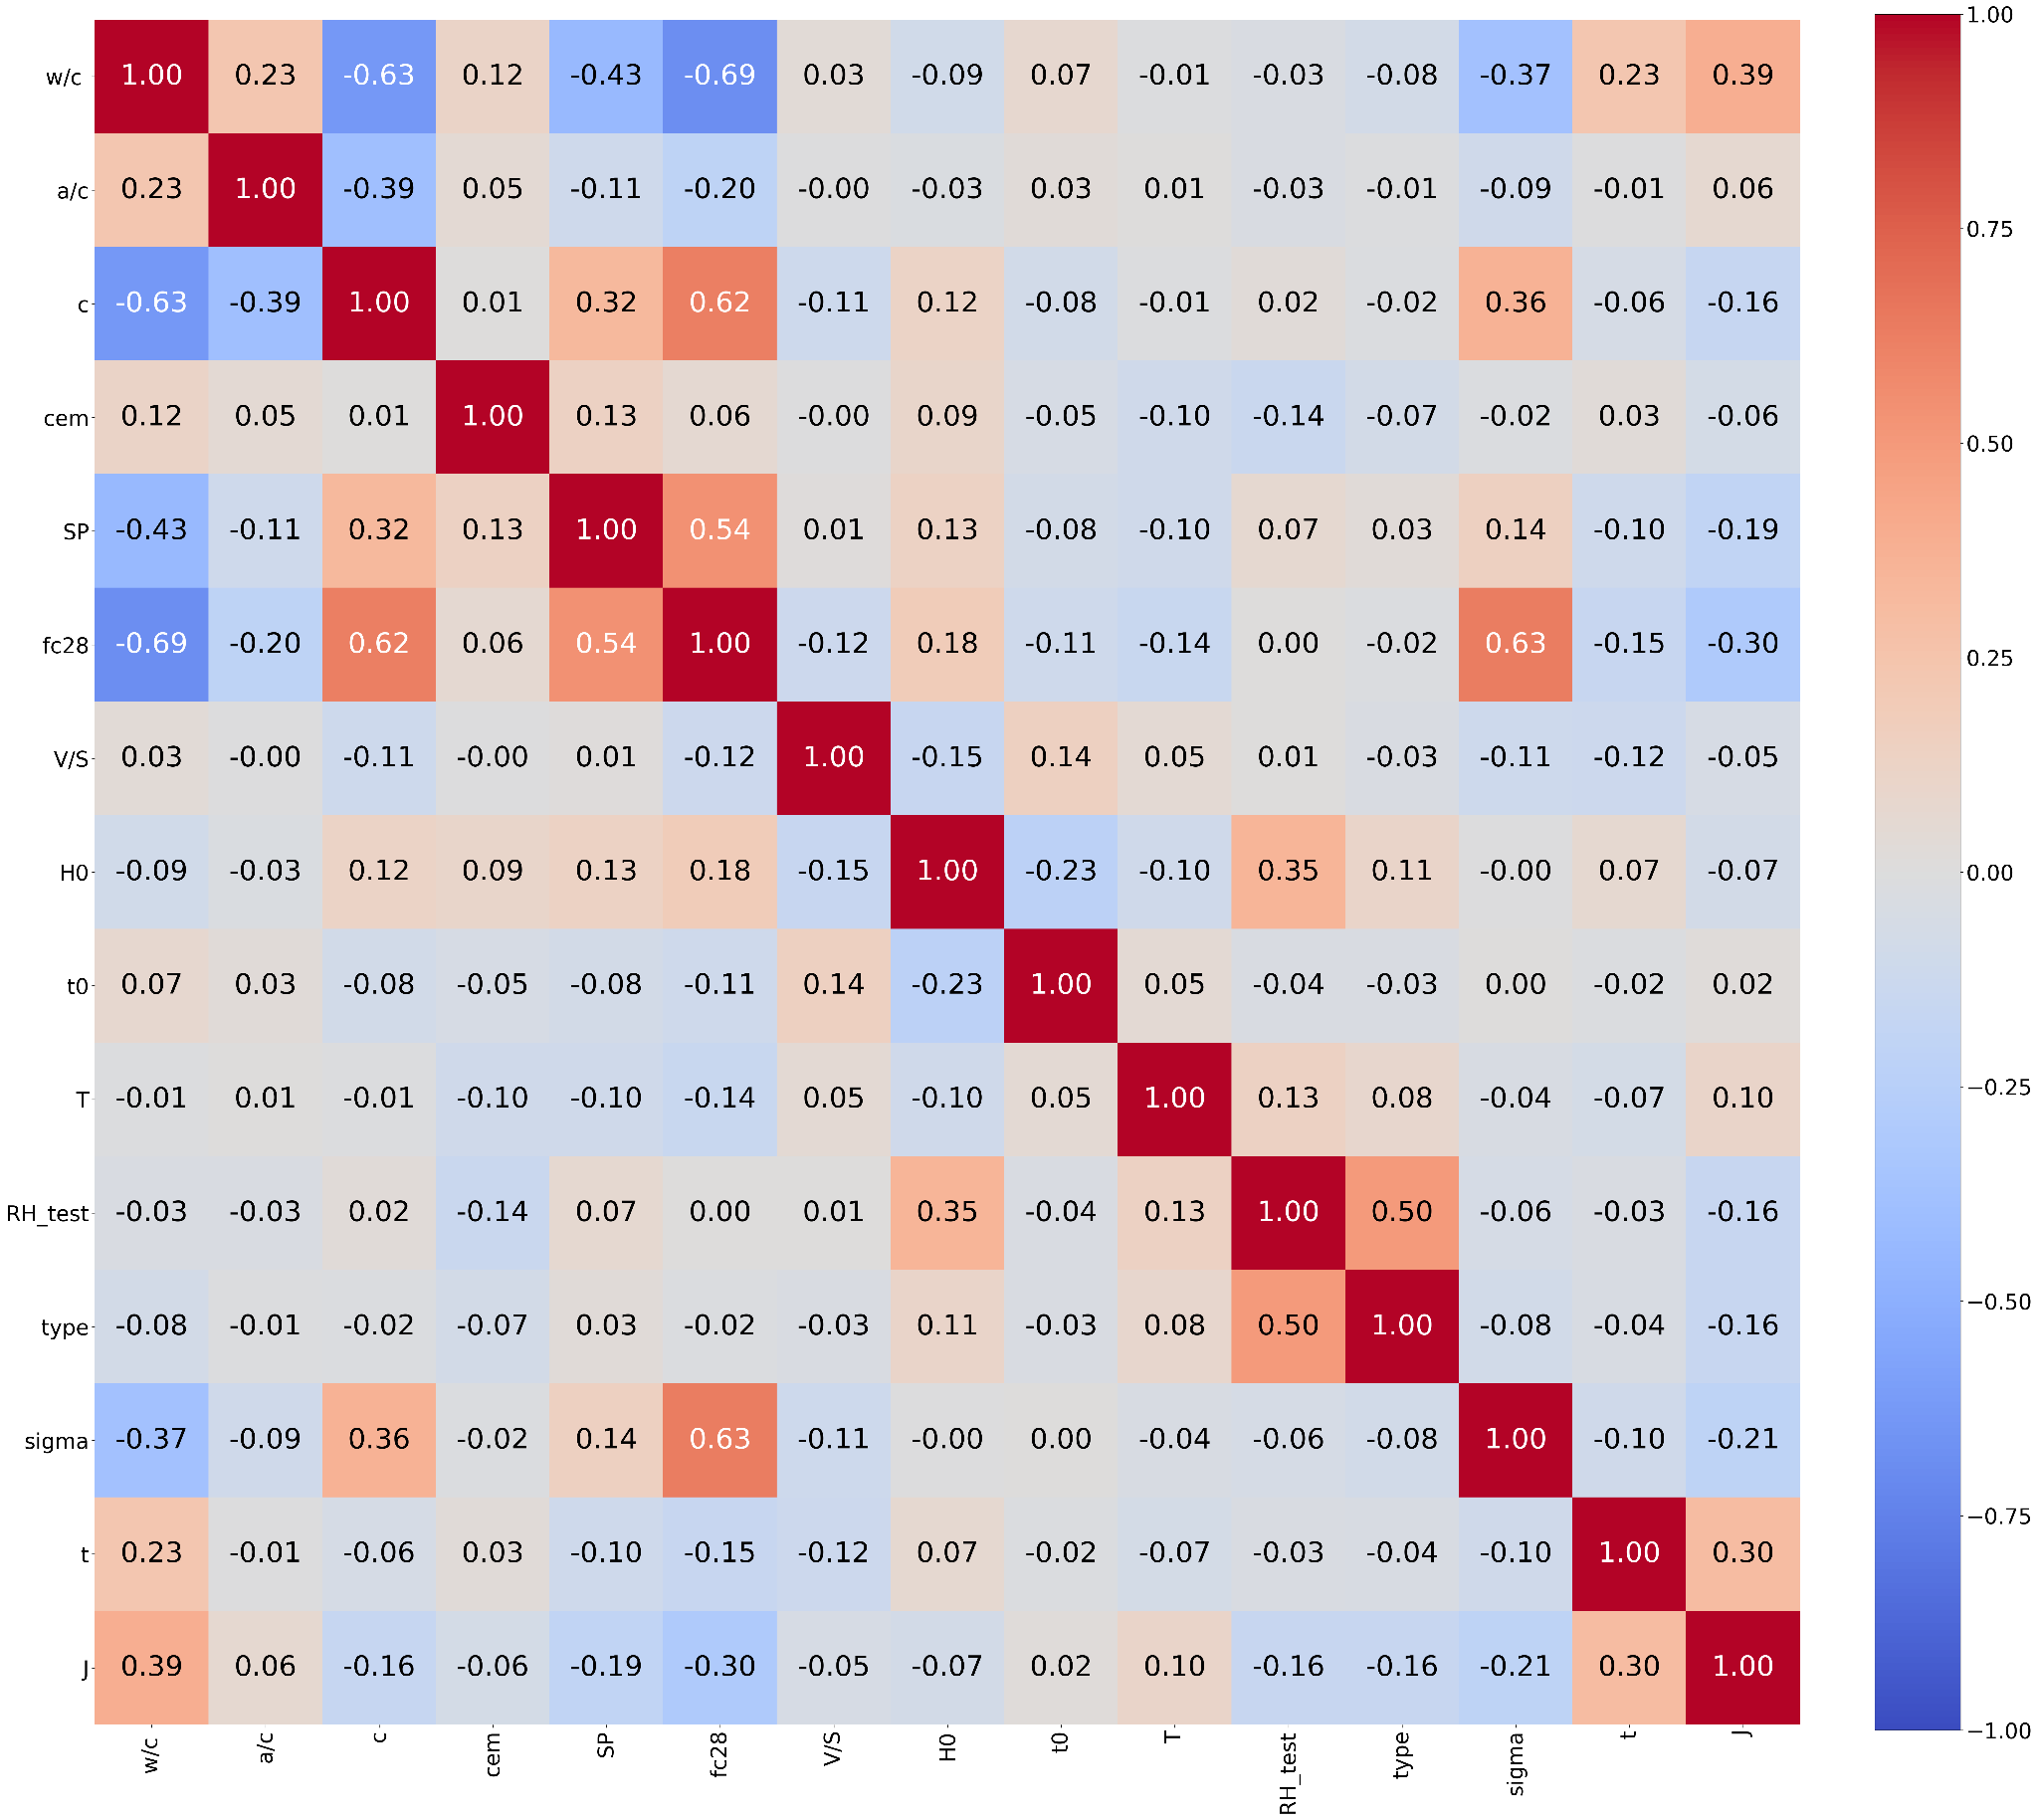
Figure 1. Feature correlation map.

Table 1. Dataset summary.

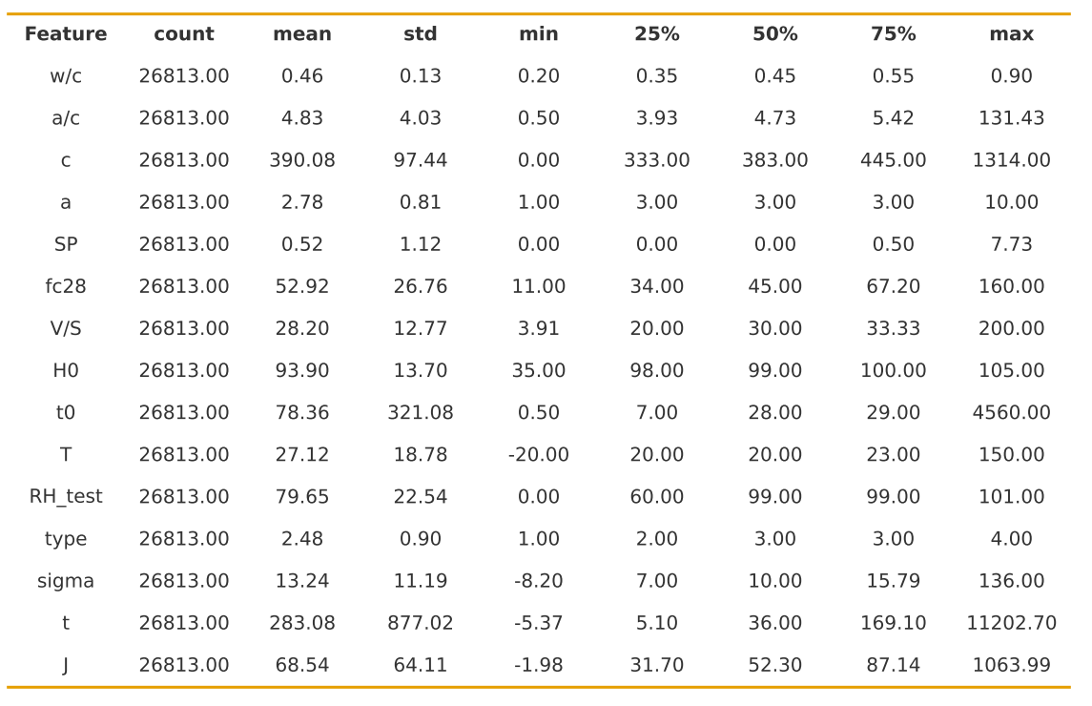

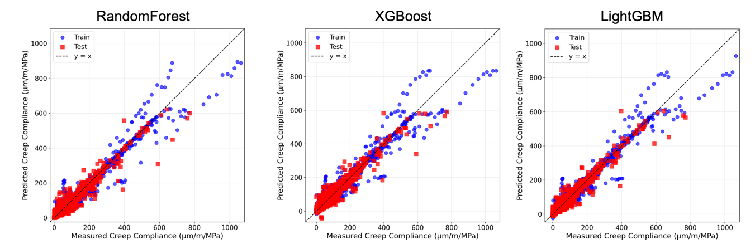
Figure 2. Performance of tree-based models.

Table 2. Summary of performance of tree-based models.

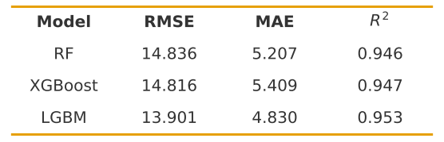
We then developed our own probabilistic neural network model based on Monte Carlo dropout. A detailed description of this method has been written by the team but is not included here for brevity, but will be documented in the final report. The hyperparameters used in this model were as follows:
- Architecture:14–672–336–168–1 (~293 kparameters)
- Loss: MSELoss
- Optimizer: AdamW
Learning rate: 5e-3
Weight decay: 5e-6
- Dropout probability: 0.1
- Batch size: 512
- Patience: 500 epochs (stop if no RMSE improvement)
- Number of stochastic forward passes: 200

Figure 3 shows the performance of the model. Table 3 shows the comparison of this model to the three bagging and boosting models used in the study of Liang et al. and replicated by our team as a benchmark. It is evident that the model performs excellently, but that there is room for improvement in terms of outlier parts, which is where the physics-based modeling part will come into play in the remainder of the project. Finally, Figure 4 shows the probability distribution functions developed for example data points from the dataset. Note that we also did attempt to use the KAN model as mentioned in the last QPR, but the closed-form solutions were too complex to move forward for use in physical modeling, so we are exploring other options to simplify these.

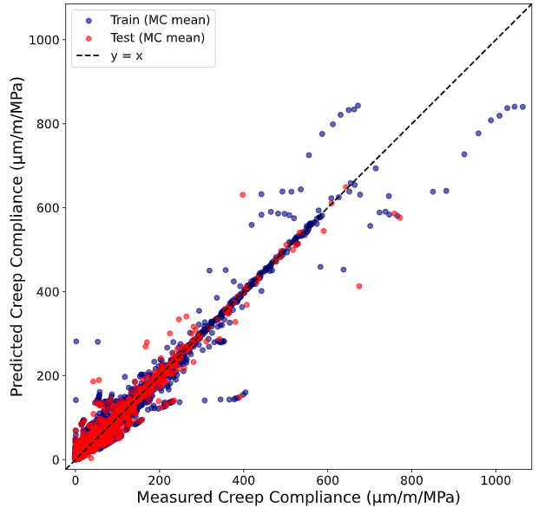
Figure 3. Performance of probabilistic ANN model.

Table 3. Comparison of probabilistic ANN to bagging and boosting models.

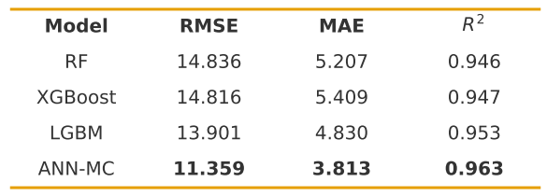

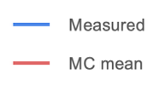
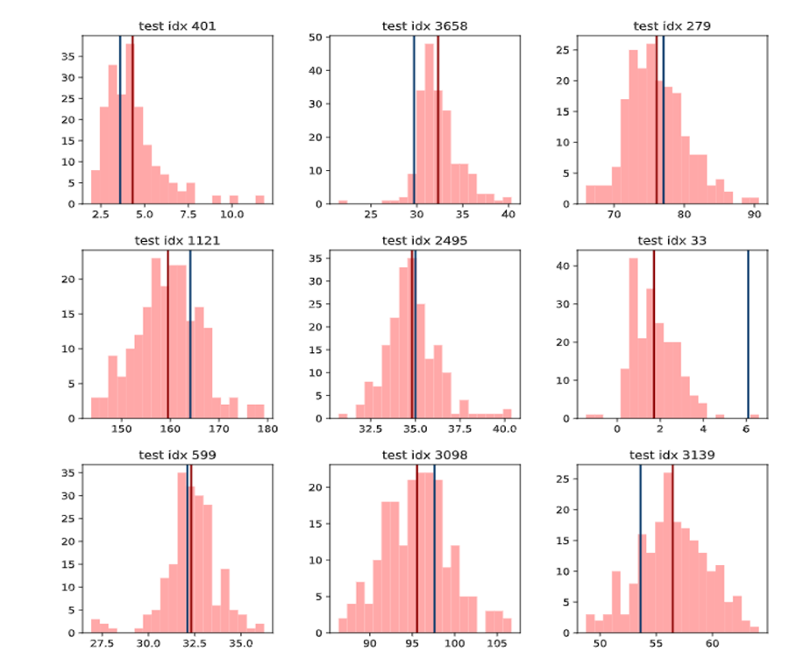
Figure 4. Example probability distribution functions for 9 data points from the creep dataset.

Task 3 (50% complete)

Regarding Task 3, the research team developed a preliminary web application for creep compliance prediction which outputs the probability density function for any data within the bounds of the current dataset. Further refinement is currently underway to make the UI more visually appealing and the features more intuitive. The research team has also begun to compile the final report summarizing all activities thus far.

- Percent of research project completed: 75%
The progress of the project describes above results in 75% of the project completed thus far.

- Expected progress for next quarter
The research team will finalize the physics-part of the model, continue to refine the web interface, and will submit the final report for review.

- Educational outreach and workforce development
PI Hajj presented a TRANS-IPIC research webinar on September 26, 2025 entitled: “Integration of viscoelastic models and machine learning for concrete creep prediction.”

A module which includes discussion of prestressed concrete is under development for use in CEE 310: Introduction to Transportation Engineering at UIUC to be used this fall.

- Technology Transfer
The preliminary predictive tool we developed is available at:
https://creep-compliance-webapp.onrender.com/

Research Contribution:
- Papers that include TRANS-IPIC UTC in the acknowledgments section:
Hajj, R. (2025) Approaches to consider viscoelasticity theory in concrete creep analysis: review and implications on prestressed concrete structures. Submitted for presentation to 105th Transportation Research Board Annual Meeting.

- Presentations and Posters of TRANS-IPIC funded research:
Presented a poster at the TRANS-IPIC Annual Workshop in Rosemont, IL in April 2025:
Asadi, B. & Hajj, R. (2025). Interpretable and Physics-Informed Machine Learning for Modeling and Discovering Concrete Creep. In TRANS-IPIC 2025 Workshop.
For each presentation or poster provide citation]

- Please list any other events or activities that highlights the work of TRANS-IPIC occurring at your university (please include any pictures or figures you may have). Similarly, please list any references to TRANS-IPIC in the news or interviews from your research.

Appendix 1: Research Activities, leadership, and awards (cumulative, since the start of the project)

- Number of presentations at academic and industry conferences and workshops of UTC findings
- No. = 1

- Number of peer-reviewed publications submitted based on outcomes of UTC funded projects
- No. = 1

- Number of peer-reviewed journal articles published by faculty.
- No. = 0

- Number of peer-reviewed conference papers published by faculty.
- No. = 0

- Number of TRANS-IPIC sponsored thesis or dissertations at the MS and PhD levels.
- No. MS thesis = 0
- No. PhD dissertations = 0
- No. citations of each of the above = N/A

- Number of research tools (lab equipment, models, software, test processes, etc.) developed as part of TRANS-IPIC sponsored research
- Research Tool #1 (Name, description, and link to tool) = Web tool for predicting creep compliance of concrete: https://creep-compliance-webapp.onrender.com/

- Number of transportation-related professional and service organization committees that TRANS-IPIC faculty researchers participate in or lead.
- Professional societies
  - No. participated in = 5
  - No. lead = 0
- Advisory committees (No. participated in & No. led)
  - No. participated in = 0
  - No. lead = 0
- Conference Organizing Committees (No. participated in & No. led)
  - No. participated in = 3
  - No. lead = 0
- Editorial board of journals (No. participated in & No. led)
  - No. participated in = 2
  - No. lead = 0
- TRB committees (No. participated in & No. led)
  - No. participated in = 1 (after restructuring)
  - No. lead = 0

- Number of relevant awards received during the grant year
- No. awards received = 0

- Number of transportation related classes developed or modified as a result of TRANS-IPIC funding.
- No. Undergraduate = 1
- No. Graduate = 0

- Number of internships and full-time positions secured in the industry and government during the grant year.
- No. of internships = 1 (Babak Asadi, Graduate Research Assistant)
- No. of full-time positions = 0

References:

Bazant, Z. P., Hubler, M. H., & Yu, Q. (2011). Pervasiveness of excessive segmental bridge deflections: Wake-up call for creep. ACI Structural Journal, 108(6), 766.
Bazant, Z. P. and Li, G.-H. (2008). “Comprehensive database on concrete creep and shrinkage.”, ACI Materials Journal, 106(6, Nov.-Dec.), pp. 635–638.
Bazant, Z. P. and Panula, L. (1978-79). “Practical prediction of time-dependent deformations of concrete.”, Materials and Structures, RILEM, Paris (11) Part I, “Shrinkage”, pp. 307–316. Part II, “Basic creep”, pp. 317–328. Part III, “Drying creep”, pp. 415–424. Part IV, “Temperature effect on basic creep”, pp. 425–434.
Hubler, M.H., Wendner, R., and Bazant, Z.P. “Comprehensive database for concrete and shrinkage: Analysis and recommendations for testing and recording.” ACI Materials Journal 112 (4), 547–558.
Hubler, M.H., Wendner, R., and Bazant, Z.P. (2015). “Statistical justification of model B4 for drying and autogenous shrinkage of concrete and comparisons to other models.” Materials and Structures 48 (4), 797–814.
Liang, M., Chang, Z., Wan, Z., Gan, Y., Schlangen, E., & Šavija, B. (2022). Interpretable Ensemble-Machine-Learning models for predicting creep behavior of concrete. Cement and Concrete Composites, 125, 104295.
Wendner, R., Hubler, M.H., and Baˇzant, Z.P. (2015). “Statistical justification of model B4 for multi-decade concrete creep using laboratory and bridge databases and comparisons to other models”. Materials and Structures 48 (4), 815–833.

