

Transportation Infrastructure Precast Innovation Center
(TRANS-IPIC)

University Transportation Center (UTC)

Precast concrete with self-powering defrosting capability
UB-24-EP-01

Quarterly Progress Report
For the performance period ending Sept. 30, 2025

Submitted by:
Deborah D.L. Chung, ddlchung@buffalo.edu
Department of Mechanical and Aerospace Engineering
University at Buffalo, The State University of New York

Collaborators / Partners:
None

Submitted to:
TRANS-IPIC UTC
University of Illinois Urbana-Champaign
Urbana, IL

TRANS-IPIC Quarterly Progress Report (Section 1 – 7, 5 pages max.):

Project Description:
- Research Plan - Statement of Problem
This project is aimed at developing precast concrete with self-powering defrosting capability. Defrosting capability has long been shown to be effective in cement-based materials by resistance (Joule) heating, provided that conductive admixtures are used to reduce the resistivity (Chung, 2004). Short carbon fiber is the most cost-effective conductive admixture to greatly lower the resistivity (Chen and Chung, 1993), so that resistance heating becomes effective. Short steel microfiber is even more effective than short carbon fiber (Wang, Wen and Chung, 2004), but it is much higher in price.
The main challenge relates to self-powering, which means the provision of electric power without any external energy source (such as solar panels and wind turbines), i.e., the powering capability is built-in to the concrete. The embedment of batteries or battery components in concrete for supplying energy is not desirable, due to the short service life of batteries compared to concrete structures and the difficulty of replacing the embedded batteries. Moreover, the embedment weakens the concrete structure and the battery disposal is of environmental concern. Pyroelectricity may be rendered to concrete for the sake of self-powering under temperature variation by the use of pyroelectric admixtures such as lead zirconotitanate (PZT), which is expensive, needs to be poled, and suffers from depoling tendency. Poling requires the application of a high electric field, which is challenging when the concrete is substantial in size.
The proposed self-powering approach is based on a novel concept that does not involve any of the concepts mentioned above. Rather, it exploits the electrical energy in a capacitor. During discharge, energy is released from the capacitor. During charging, energy is provided to the capacitor. The proposed concept involves the capacitance changing upon a change in temperature, thereby causing discharge or charge of the capacitor.

- Research Plan - Summary of Project Activities (Tasks)
Revised timeline reflecting no-cost extension of the project from 6 months to 12 months
Note: This revision is also due to the exploratory nature of the project, which involves new science. The methodology changes as the research progresses. For example, the design of the capacitor has changed, so that the two conductive layers that sandwich the dielectric layer are steel foils instead of 3D-printed conductive polymer layers. This change is due to the simplicity and low cost of the revised design. The new science relates to the discovery (reported in the second quarterly report) that the concrete embedment of the capacitor (with the capacitor leads protruding from the concrete) increases the capacitance by about 2 orders of magnitude. This unexpected result is confirmed in the third quarter.
Task 1 (Months 1-2). Preparation of the capacitor units by 3D printing, with selection of the polymer and the dimensions of each of the layers in a capacitor unit. Ordering the needed materials and supplies.
Task 2 (Months 2-9). Testing the capacitor units (without embedment in concrete) by capacitance measurement.
Task 3 (Months 3-9). Preparing and testing (in terms of the capacitance) precast concrete specimens with inclusion of fine aggregate and with embedment of selected capacitor units obtained in Task 2. Two thicknesses of the embedding concrete will be used in order to investigate the degree of influence of the concrete dimensions on the capacitance. The capacitor leads are to protrude out of the concrete. The testing is to be performed at various times after concrete casting. Note: Conductive admixtures such as carbon fiber will not be used, in order to broaden the applicability, as conventional concrete does not contain conductive admixtures. Note: Tasks 2 and 3 occur together, as the capacitor making in Task 2 needs to repeated in order to make more concrete-embedded capacitors in Task 3.
Task 4 (Months 5-11) Testing the selected precast concrete specimens obtained in Task 3 by measuring the temperature continuously upon imposed cooling (capacitor charge) and during subsequent automatic heating (capacitor discharge).
Task 5 (Months 10-12) Testing the effectiveness of defrosting using the proposed method. Comparison will be made between concrete with and without an embedded capacitor.
Task 6 (Month12) Devising the research plan after the 12-month project and evaluate the pavement-related technology implementation feasibility. Prepare the final report.

Project Progress:
- Progress for each research task
[Describe the progress made this quarter for each research task and the % completed]

Task 1 100% completed to date
Task 2 100% completed to date
Task 3 100% completed to date
Task 4 75% completed to date
Task 5 0% completed to date
Task 6 0% completed to date

In this third quarter, work was performed in relation to Tasks 2, 3 and 4.

Tasks 2 and 3

A number of capacitors with the abovementioned revised design were made (Task 2). After testing in terms of the capacitance and other electrical quantities (Task 2), each capacitor was embedded in concrete by casting the concrete around the capacitor, such that the two steel capacitor leads protrude from the concrete (Task 3). For each specimen, the capacitor is positioned horizontally in a mold, with concrete cast below, above and around the capacitor. Two heights (27 mm and 17 mm) of the mold are used, so as to investigate the effect of the concrete volume on the electrical behavior.

After setting, subsequent demolding and different curing ages, the concrete-embedded capacitors were tested in terms of the capacitance and other electrical quantities (Task 3). Furthermore, in this quarter, in order to understand the science, the electrical measurement involves measuring not just the capacitance C, but also the resistance R, impedance Z and phase angle θ. As explained in Fig. 1, the real part of Z is the resistance R. The phase angle θ is the angle between Z and R. The imaginary part of Z is the reactance X, which in general can be contributed by the capacitance C and the inductance.

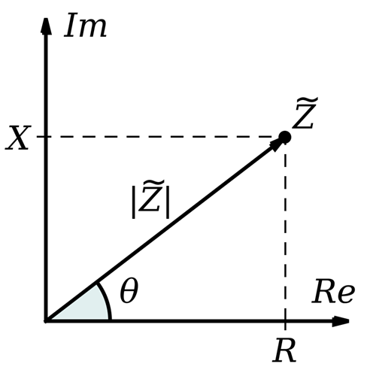

Fig. 1 The complex plane of the impedance Z.

The work in this quarter confirms the unexpected result (reported for the second quarter) concerning the capacitance being higher by about 2 orders of magnitude for the concrete-embedded capacitor compared to the unembedded capacitor. As shown in Table 1, the capacitance is increased from 28.5 pF without concrete embedment to 5.78 µF with concrete embedment.

This unexpected effect is attractive, since the energy of a capacitor is given by ½ CV², where C is the capacitance and V is the voltage. With C being higher by 2 orders of magnitude, the energy is also higher by 2 orders.

With concrete embedment, C is about the same for both specimen sizes. This suggests that the high C in the presence of concrete is not related to the amount of concrete. It is due to the presence of concrete around the capacitor. The concrete decreases greatly the resistance between the two electrodes of the capacitor (Table 1), thereby decreasing the voltage V between the two electrodes. Since C = Q/V, where Q is the charge magnitude on each electrode, the decrease in V causes C to increase. The decrease in Q is small compared to the decrease in V. The presence of concrete around the capacitor also enhances the fringing electrical field, which causes the area of the capacitor to increase effectively, thereby increasing C also.

Table 1 Electrical properties of capacitor before and after concrete embedment for the case of the larger specimen. The frequency is 1 kHz and the voltage is 1 V.

 | Without concrete embedment | With concrete embedment
Capacitance C | 28.5 pF | 5.78 µF
Resistance R | 431 kΩ | 196.52 Ω
Impedance Z | 5.6 MΩ | 199.6 Ω
Reactance X | -5.6 MΩ | -27.64 Ω
Angle θ | -85.5° | -7.96°

Table 1 shows that Z and the magnitude of X are essentially equal for the case without concrete embedment. This is consistent with the fact that θ (-85.5°) approaches -90°. On the other hand, for the case with concrete embedment, Z is much higher than X, as expected from the low magnitude of θ (7.96°). Thus, Z is dominated by X for the case without concrete embedment, but is dominated by R for the case with concrete embedment.

If X is purely capacitive, X is negative and X = - 1/(2πfC), where f = frequency and C = capacitance. For the case without concrete embedment, this equation is indeed satisfied, with the calculated C (28.4 pF) essentially matching the measured C (28.5 pF), so X is purely capacitive, with negligible inductance contribution. For the case with concrete embedment, the calculated C (5.76 µF) essentially matches the measured C (5.78 µF). Thus, X is purely capacitive, whether with or without concrete embedment

The X relates to -1/C. A high C corresponds to a low 1/C and hence a low magnitude of X. With concrete embedment, C is very high, thus causing the capacitive X to be low. On the other hand, R is very small with concrete embedment. Hence, both R and X magnitude are reduced by concrete embedment. However, the reduction in R (a factor of 12,000) is less than the reduction in X magnitude (a factor of 203,000), thus causing the magnitude of θ to decrease greatly, i.e., the presence of the concrete changes from X dominance of Z to R dominance of Z.

With concrete embedment, θ is less negative for the smaller specimen. This is because R is larger for the smaller specimen (Fig. 1).

With concrete embedment, R and Z are both larger for the smaller specimen. This is expected, since concrete is a conductor and more concrete would decrease R and Z (i.e., less concrete would increase R and Z).

Without a change in temperature (i.e., at room temperature), the electrical quantities do not change, being stable as a function of time. In spite of the conductivity of concrete around the capacitor, discharge essentially does not occur without a temperature change. The effect of temperature is addressed below (Task 4). This finding is valuable, as it means that the concrete-embedded capacitor is electrically stable.

The unexpected discovery of very high capacitance of the capacitor in the presence of concrete is supported by science, as discussed above. This science base is important for the overall project.

Task 4

For concrete-embedded capacitor, the capacitance decreases upon cooling (Fig. 2(a)). For the old sample (curing age 23 days), the capacitance decreases from 3.50 µF at 20°C to 1.73 µF at -20°C, i.e., a fractional change in capacitance of -51%. For the new sample (curing age 8 days), the capacitance decreases from 3.17 µF at 20°C to 1.23 µF at -20°C, i.e., a fractional change in capacitance of -61%.

This trend is attributed to the decrease of the relative permittivity κ of the 3D-printed polymer layer with decreasing temperature, as expected from the entropy-driven decrease in mobility of the polymer molecules as the temperature decreases. This trend cannot be due to the thermal contraction of the dielectric layer, as the thermal contraction would have caused the capacitance to increase (not decrease) upon cooling. This means that the capacitor discharges (with the capacitance decreasing) upon cooling, thereby providing energy for anti-frosting (i.e., preventing frosting) and/or defrosting. During heating, the capacitance increases, due to the increase in the relative permittivity κ, so that the capacitor charges. The charging occurs automatically. This constitutes self-charge, which is very different from batteries, which self-discharges and required energy input for charging.

The capacitance decrease upon cooling is accompanied by a resistance increase (Fig. 2(b)). For the old sample (curing age 23 days), the resistance increases from 625 Ω at 20°C to 3325 Ω at -20°C, i.e., a fractional change in resistance of 432%). For the new sample (curing age 8 days), the resistance increases from 900 Ω at 15°C to 3400 Ω at -20°C, i.e., a fractional change in resistance of 278%).

The fractional change in resistance upon cooling is greater than the magnitude of the fractional change in capacitance upon cooling. The resistance change is attributed to the fact that the capacitance and resistance are not independent electrical quantities. According to physics (the Kramers Kronig relationship), the permittivity and resistivity are not independent of one another. A decrease in permittivity tends to be correlated with a decrease in resistivity, because a low resistance limits the electric field, thereby hampering the polarization (i.e., the separation of the positive and negative change centers) in the dielectric material.

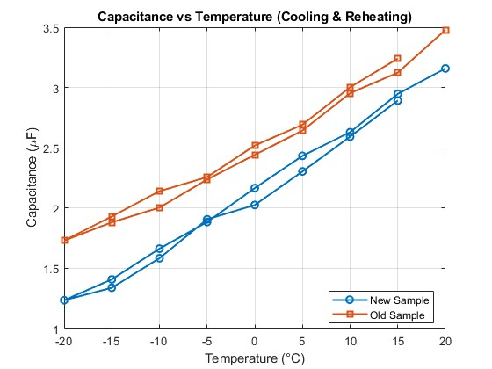

(a)

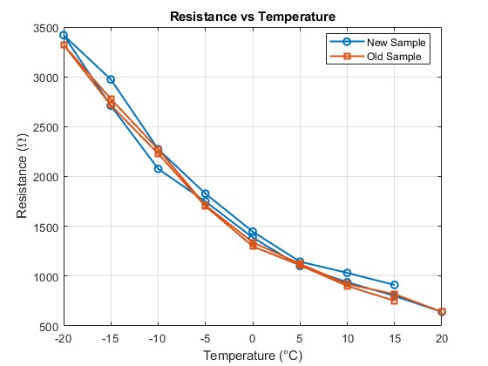

(b)

Fig. 2 Effect of cooling and subsequent heating on concrete-embedded capacitor.
(a) Capacitance. (b) Resistance.

Curing decreases the capacitance and increases the resistance. For example, for the concrete with embedded capacitor, increasing the curing age from 6 days to 13 days and then to 17 days decreases the capacitance from 2.01 µF to 1.95 µF and then to 1.57 µF, and increases the resistance from 744 Ω to 785 Ω and to 1020 Ω.

It is well-known for concrete itself (without an embedded capacitor) that the capacitance decreases and the resistance increases upon curing, due to the decrease in the amount of free water as the water enters the cement, which becomes a hydrate. With the capacitor embedment, the trends for the capacitor and resistance changes are the same, as mentioned above. This suggests that the concrete plays a role even in the presence of the embedded capacitor.

- Percent of research project completed
[Describe the progress made this quarter for each research task and the % completed]

In this third quarter, progress was made in relation to Tasks 2-4.
Task 2 100% completed to date
Task 3 100% completed to date
Task 4 75% completed to date

- Expected progress for next quarter
[Describe the expected progress to be made next quarter]
Task 4 100% completed to date
Task 5 100% completed to date
Task 6 100% completed to date

- Educational outreach and workforce development
[List any educational activities your research has been included in or plans to pursue, such as camps, new courses, research or professional workshops, seminars, or webinars etc.]
- An invited keynote lecture was given by Professor Chung on her 50-year journey in science in the St. Mark’s School Alumni Association (Ontario) Gala held in Markham, Ontario, Canada, on July 31, 2025. The school is a top-ranked secondary school located in Hong Kong, with about 1,000 students (https://www.stmarks.edu.hk/web/).

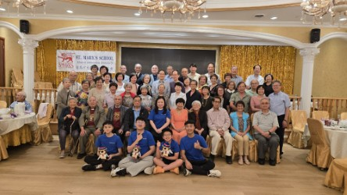

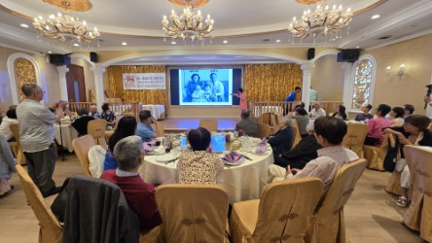

- An invited keynote lecture was given by Professor Chung on her 50-year journey in science in Buffalo Chinese Christian Church on August 29, 2025.
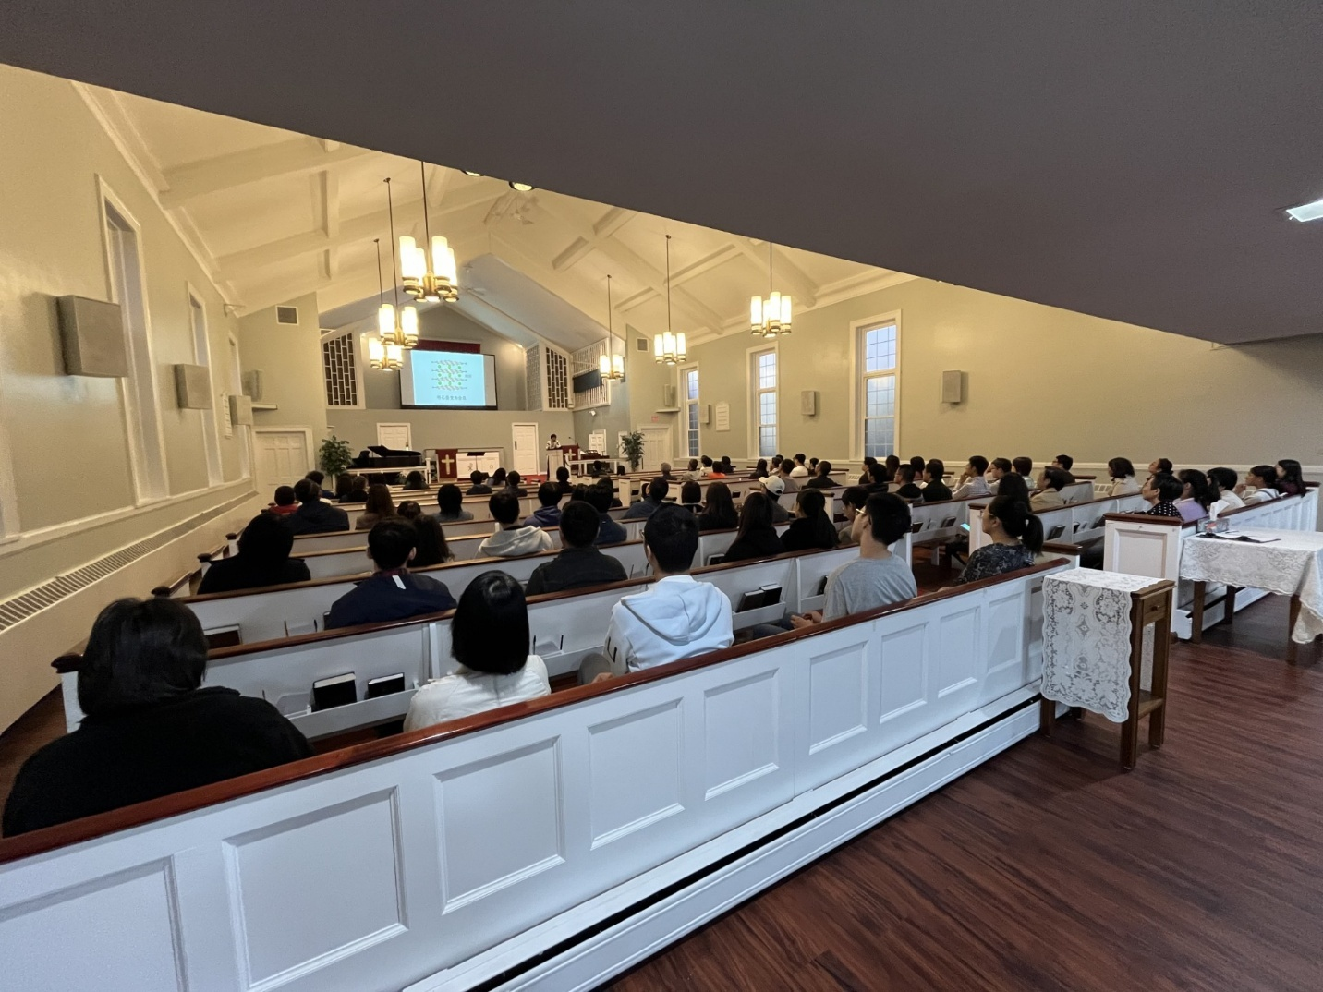

- Technology Transfer
[Describe any patents, new technologies or techniques, new specifications, or guidelines for transportation systems, etc. resulting from this project]
None

Research Contribution:
- Papers that include TRANS-IPIC UTC in the acknowledgments section:
[List any journal and conference papers/publications resulting during this quarter from this project. List only papers including TRANS-IPIC UTC in the acknowledgments section

Provide citation for any published work]
None

- Presentations and Posters of TRANS-IPIC funded research:
[List any presentations or posters presenting TRANS-IPIC research
For each presentation or poster provide citation]
None

- Please list any other events or activities that highlights the work of TRANS-IPIC occurring at your university (please include any pictures or figures you may have). Similarly, please list any references to TRANS-IPIC in the news or interviews from your research.
None

Appendix 1: Research Activities, leadership, and awards (cumulative, since the start of the project)

- Number of presentations at academic and industry conferences and workshops of UTC findings
- No. = 0

- Number of peer-reviewed publications submitted based on outcomes of UTC funded projects
- No. = 0

- Number of peer-reviewed journal articles published by faculty.
- No. = 636

- Number of peer-reviewed conference papers published by faculty.
- No. = ?

- Number of TRANS-IPIC sponsored thesis or dissertations at the MS and PhD levels.
- No. MS thesis = 0
- No. PhD dissertations = 0
- No. citations of each of the above = 0

- Number of research tools (lab equipment, models, software, test processes, etc.) developed as part of TRANS-IPIC sponsored research
- Research Tool #1 (Name, description, and link to tool) = 0
- Research Tool #2 (Name, description, and link to tool) = 0
- Research Tool #3 (Name, description, and link to tool) = 0

- Number of transportation-related professional and service organization committees that TRANS-IPIC faculty researchers participate in or lead.
- Professional societies
  - No. participated in = 0
  - No. lead = 0
- Advisory committees (No. participated in & No. led)
  - No. participated in = 0
  - No. lead = 0
- Conference Organizing Committees (No. participated in & No. led)
  - No. participated in = 0
  - No. lead = 0
- Editorial board of journals (No. participated in & No. led)
  - No. participated in = 0
  - No. lead = 0
- TRB committees (No. participated in & No. led)
  - No. participated in = 0
  - No. lead = 0

- Number of relevant awards received during the grant year
- No. awards received = 1 (Caltech’s 2025 Distinguished Alumni Award)
- https://engineering.buffalo.edu/home/news/seas.host.html/content/shared/engineering/home/articles/news-articles/2025/chung-named-recipient-caltech-distinguished-alumni-award.detail.html

- Number of transportation related classes developed or modified as a result of TRANS-IPIC funding.
- No. Undergraduate = 0
- No. Graduate = 0

- Number of internships and full-time positions secured in the industry and government during the grant year.
- No. of internships = 0
- No. of full-time positions = 0

References:
[List all the references associated with this research project]
[1] D.D.L. Chung, “Electrically Conductive Cement-Based Materials”, Adv. Cem. Res. 16(4), 167-176 (2004).
[2] Pu-Woei Chen and D.D.L. Chung, "Carbon Fiber Reinforced Concrete as a Smart Material Capable of Non-Destructive Flaw Detection", Smart Mater. Struct.2(1), 22-30 (1993).
[3] Shoukai Wang, Sihai Wen and D.D.L. Chung, “Resistance Heating Using Electrically Conductive Cements”, Adv. Cem. Res. 16(4), 161-166 (2004).

