

Transportation Infrastructure Precast Innovation Center
(TRANS-IPIC)

University Transportation Center (UTC)

Evaluating Prestressed Concrete Beams with Cracks using Machine Learning – Phase II
UB-23-RP-01

Quarterly Progress Report
For the performance period ending September 30

Submitted by:
Pinar Okumus, Associate Professor, pinaroku@buffalo.edu
Department of Civil, Structural and Environmental Engineering
University at Buffalo, the State University of New York

Collaborators / Partners:
None

Submitted to:
TRANS-IPIC UTC
University of Illinois Urbana-Champaign
Urbana, IL

TRANS-IPIC Quarterly Progress Report (Section 1 – 7, 5 pages max.):

Project Description:
- Research Plan - Statement of Problem
Bridge owners face difficult decisions on whether a bridge should be posted, repaired or replaced when prestressed concrete members have shear cracks due to overloading. The decisions are currently made based on engineering judgment, costly load testing or time consuming modeling. Guidance is needed to interpret cracks to avoid overly conservative load ratings and to keep bridges operational, without compromising safety and economy. Year 1 of this project developed a tool through machine learning (ML) that relates cracking to the load history of bridge members. This web-based tool can be used by bridge owners, asset managers and inspectors to guide repair decisions. Year 2 of this project will generate the test data required to validate the data-driven tool and to improve its predictions by adding higher-quality data to the existing limited datasets. Integrating higher-quality data into the existing datasets will improve the reliability of the tool’s predictions for real-world applications. Additionally, the tool will be expanded to predict changes in the stiffness of a beam due to cracking, which is another indicator for beam health.

- Research Plan - Summary of Project Activities (Tasks)
Task 1. Stiffness History Prediction: In this task, existing data in the literature on load history and stiffness history are collected, filtered and used to train a Gaussian Process Regression (GPR) algorithm. This newly developed algorithm is integrated with the algorithm for predicting crack width vs load history. The outcome is predictions of stiffness given crack widths.

Task 2. Pre-test Prediction: Algorithms for crack width vs load history and load history vs stiffness history are used to predict the load history and stiffness corresponding to a set of crack widths for a beam to be tested in Task 3.

Task 3. High Quality Data Generation: A prestressed concrete beam is designed, fabricated, and tested to collect the data needed to refine and validate the evaluation tools.

Task 4. Refine Predictions: The data collected in Task 3 is used to re-train and refine the predictions of shear strength, load history and stiffness history of the ML algorithms. The improvement in predictions due to higher quality data is documented.

Task 5. Post-test Prediction: The web-based evaluation tool is updated. Shear strength, load history, and stiffness history of the tested prestressed beam are predicted to demonstrate the use of the tool, build confidence in the tool, and set expectations for prediction error.

Project Progress:
- Progress for each research task
Task 1. Stiffness History Prediction [70% completed to date]: Stiffness history has already been predicted using the direct relationship between stiffness and crack width measurements in the last quarters. However, because the available dataset size is small (37 beams and 254 data points), the results had a relatively large scatter (ten-fold error of 18%). In this quarter, a larger dataset that indirectly links stiffness to crack widths by linking stiffness to load and load to crack width is compiled. This larger dataset (130 beams, 1300 data points) is expected to provide improved predictions.

Task 2. Pre-test Prediction [80% completed to date]: The AASHTO Type I beam designed in the last quarter had to be changed to a Pennsylvania PA 18/30 beam because no precasters carried the forms for AASHTO Type I beam or building of the AASHTO Type I beams were cost prohibitive. Similar to the AASHTO Type I beam, the new beam was designed to fail under shear. Pre-test predictions of the shear strength were updated for this beam as shown in Table 1 and were obtained from finite element analysis, machine learning, the 10th Edition of the AASHTO LRFD Bridge Design Specifications, ACI 318-19, and ACI 318-25. The variations between predictions are consistent with the uncertainties associated with shear behavior of concrete structures.
Table 1. Strength predictions of various methods for the test specimen
Prediction Method | Predicted Shear Strength
FEA | 196 kips
Machine learning | 280 kips
AASHTO LRFD Bridge Design Specifications | 133 kips
ACI 318-25 Detailed method | 170 kips
ACI 318-19 Simplified method | 105 kips

Machine learning was also used to predict the shear corresponding to a set of crack widths for the newly designed test specimen. Shear history (V_{applied}) is normalized with respect to the shear capacity (V_{max}) and the predictions of shear history are shown with respect to crack width (W_{cr}) in Fig. 2. Fig. 2 shows that machine learning predicts the first crack to occur when the applied shear reaches at approximately 74% of the shear capacity. This is consistent with the finite element analysis prediction.

Fig. 2. Pre-test GPR predictions of shear history corresponding to crack widths for the test beam

Task 3. High Quality Data Generation [30% completed to date]: The research team had designed an AASHTO Type I beam in the last quarter to be the test specimen. However, precast concrete manufacturers informed the research team that either the forms for AASHTO Type I beams did not exist or manufacturing these beams would be cost-prohibitive. Therefore, the beam design was changed to a Pennsylvania PA 18/30 beam that is similar in shape to an AASHTO Type I beam. The beam was redesigned to ensure that the failure mode remains shear and that the capabilities of our Structural Engineering and Earthquake Simulation Laboratory regarding loading and space are not exceeded. The updated specimen design is shown in Fig. 3. A purchase order was initiated for this beam, and the beam is scheduled to be cast early November 2025.

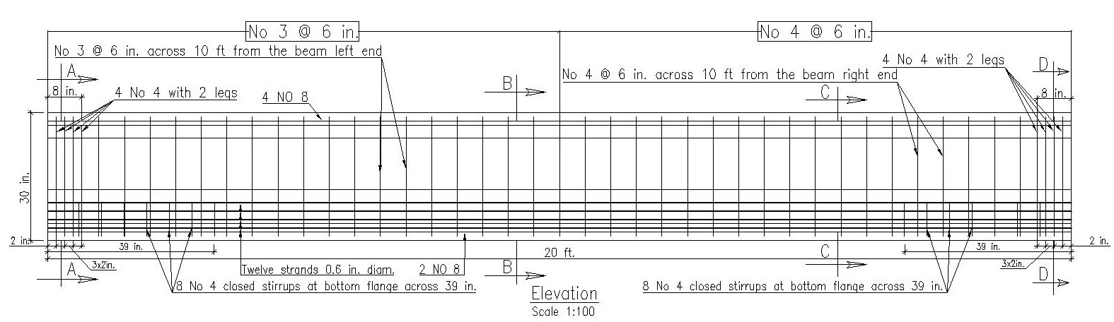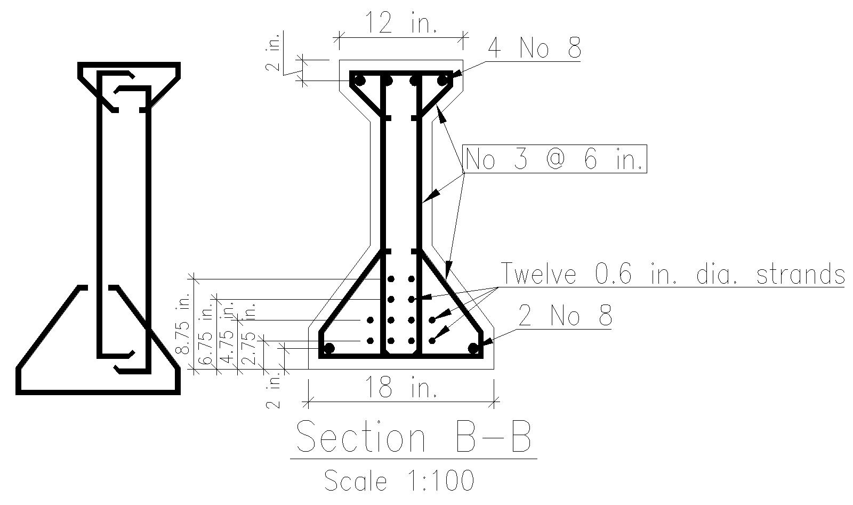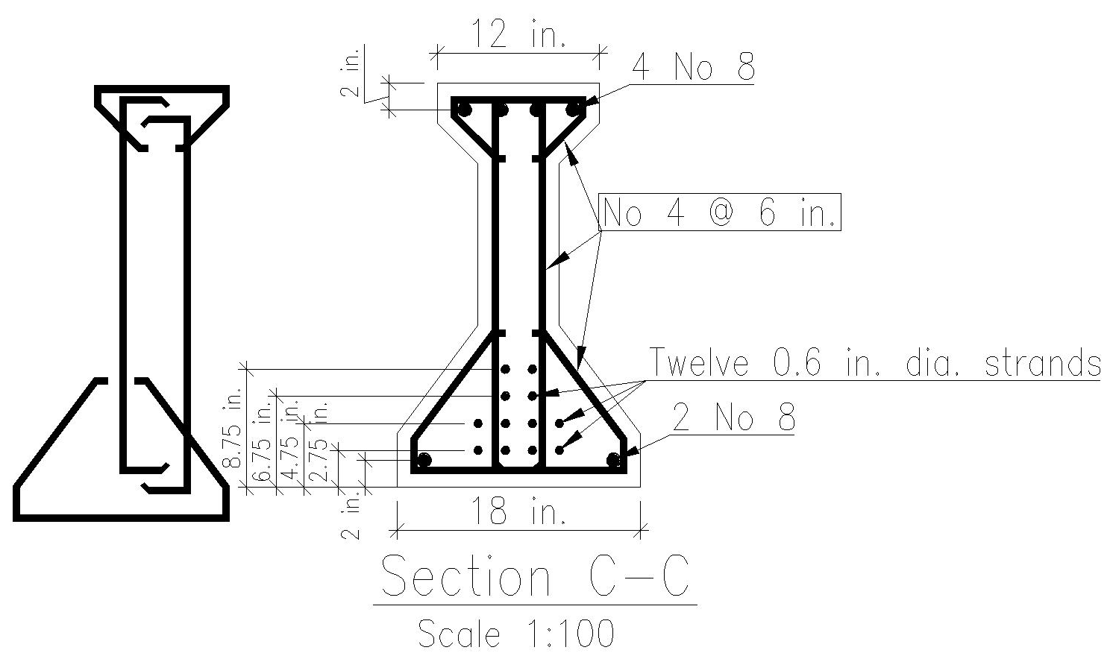

Fig. 3. New beam specimen design

A loading protocol and an instrumentation plan were developed in the last quarter. A test setup is developed in this quarter and is shown in Fig. 4. The beam will be tested in a load frame using an actuator with a 600 kip capacity under compression (push) and 440 kip capacity in tension (pull). The beam will be loaded in compression load cycles, and cracking will be documented.

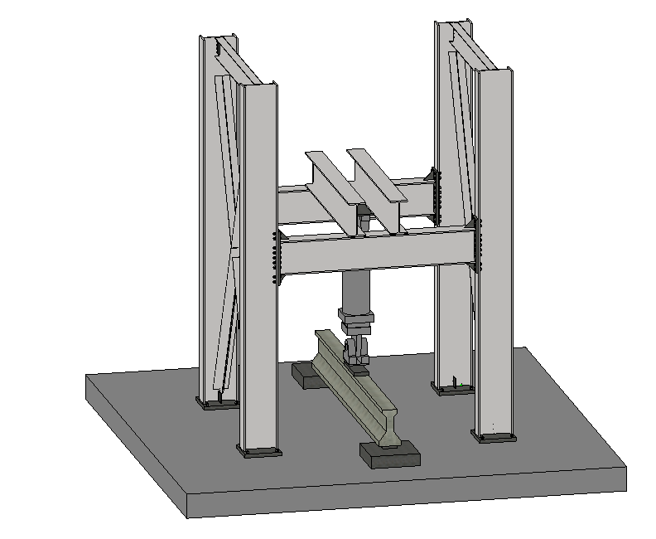
440 kip / 600 kip capacity actuator
20 ft long PA18/30 specimen
Loading frame
Fig. 4. Planned test setup

Task 4. Refined Predictions [10% completed to date]: Test data from Task 3 is needed to complete this task. Algorithms on strength, crack width vs load history, and crack width vs stiffness are being refined by further filtering the data and post-processing the results as described in Task 1, and will be used for refined predictions when Task 3 is completed.

Task 5. Post-test Prediction [60% completed to date]: The web-based evaluation tool already predicted shear history for given beam properties and crack width. In this quarter, the tool was updated to predict stiffness as an additional indicator for beam health. The user interface of the updated tool is shown in Fig. 5. The tool will be updated again when the test results become available from Task 3, and when the stiffness predictions are improved in Task 1.
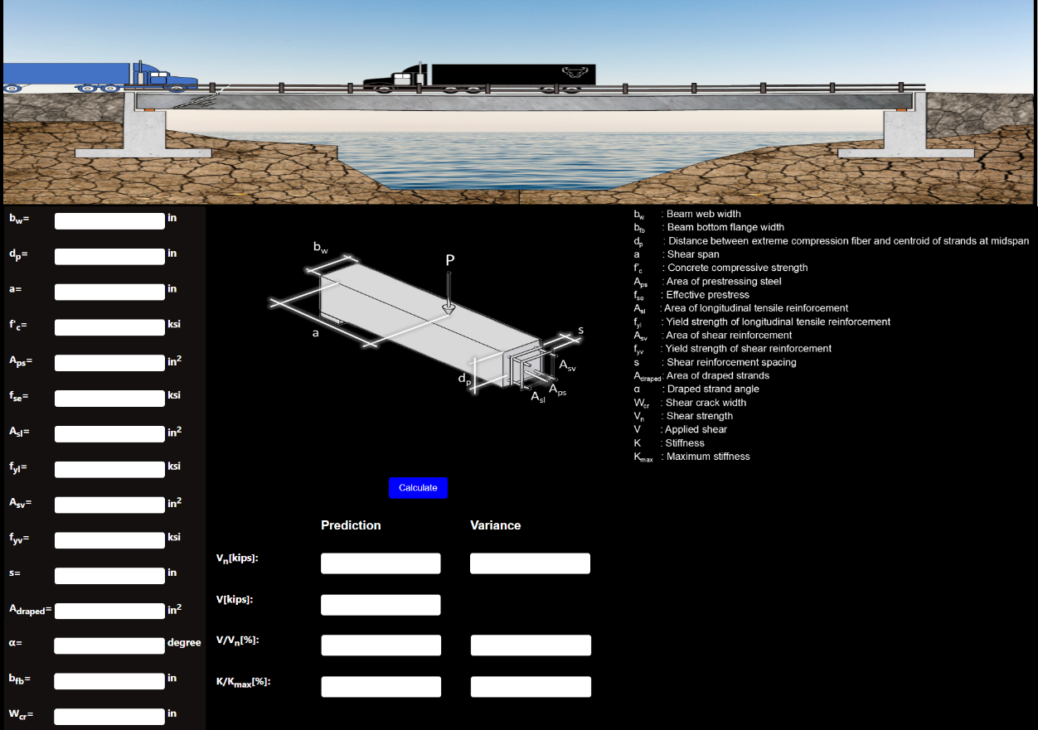
Fig. 5. Web-based evaluation tool
- Percent of research project completed
Progress made in this quarter for each research task is described and task completion rates are provided in Section 3. Overall, the project is 70% completed.

- Expected progress for next quarter
In the next quarter, the beam will be tested and the machine learning predictions will be updated. The research team will ask for a no-cost-extension because the beam is expected to be delivered to the laboratory in November or December 2025.

- Educational outreach and workforce development
The PhD student supported by this project delivered a presentation on the evaluation of cracked bridges using machine learning on August 7, 2025, to high school students as part of the National Summer Transportation Institute that took place at the University at Buffalo campus in Buffalo, NY. The Institute aims to encourage K-12 students to consider transportation related careers. A photograph from the event is shown in Fig. 6.
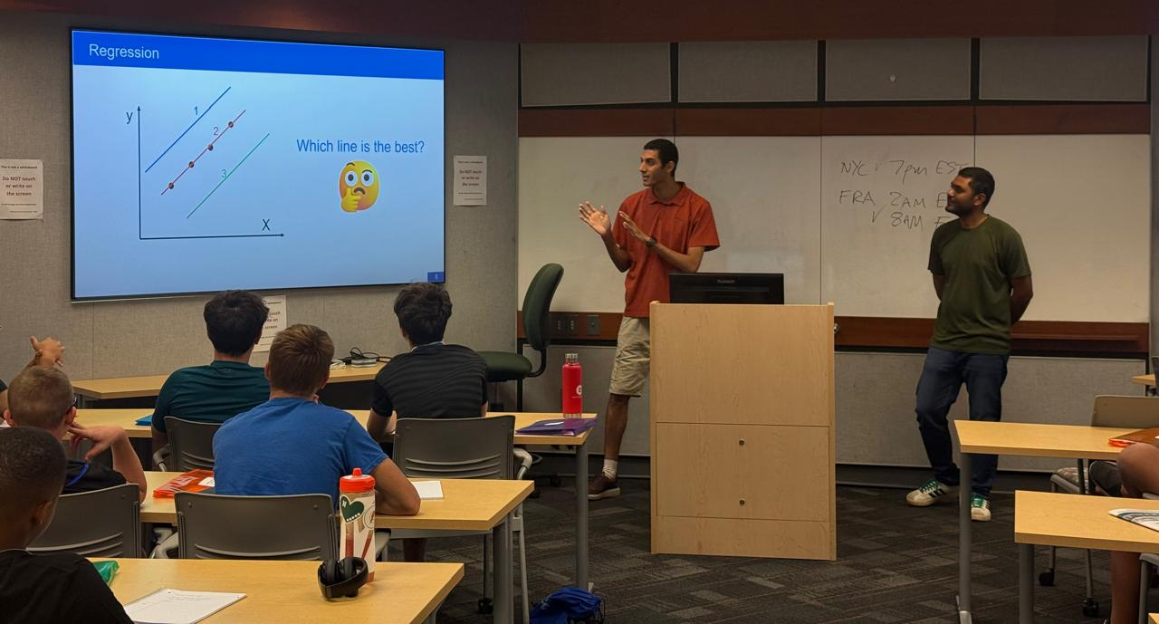
Fig. 6. Presentation on evaluation of cracked concrete bridges at the National Summer Transportation Institute

- Technology Transfer
None.

Research Contribution:
- Papers that include TRANS-IPIC UTC in the acknowledgments section:
The following are the papers published or submitted during the entire project length:
- Hassan Lasheen, M., Okumus, P., Elhami-Khorasani, N., Chandola, V. “Predicting Shear Strength of Prestressed Concrete Beams using Machine Learning.” Submitted to the ACI Structural Journal.
- Hassan Lasheen, M., Okumus, P., Elhami-Khorasani, N. (2025). “Evaluation of Structural Cracking in Reinforced and Prestressed Concrete Bridges: A review and a machine learning-based framework.” Transportation Research Board (TRB) Annual Meeting, January 5-9, Washington, DC.

- Presentations and Posters of TRANS-IPIC funded research:
The following are the presentations or posters presented during the entire project length:
- Okumus, P., Elhami Khorasani, N., Hassan Lasheen, M. (2025) “Evaluating Concrete Bridges for Shear using Machine Learning.”, presentation, TRANS-IPIC Research Highlights Webinar, July 25.
- Hassan Lasheen, M., Okumus, P., Elhami-Khorasani, N. (2025). “An Enhanced and Implementable Machine Learning-Based Evaluation Tool for Prestressed Concrete Bridges.” presentation, PCI Northeast Technical Bridge Committee Meeting, April 24, Sturbridge, MA and online.
- Hassan Lasheen, M., Okumus, P., Elhami-Khorasani, N. (2025). “An Enhanced and Implementable Machine Learning-Based Evaluation Tool for Prestressed Concrete Bridges.” presentation, TRANS-IPIC Workshop, April 22-23, Rosemont, IL.
- Hassan Lasheen, M., Okumus, P., Elhami-Khorasani, N. (2025). “Evaluation of Structural Cracking in Reinforced and Prestressed Concrete Bridges: A Review and a Machine Learning-based Framework.”, presentation, Transportation Research Board (TRB) Annual Meeting, January 5-9, Washington, DC.
- Hassan Lasheen, M., Okumus, P., Elhami-Khorasani, N. (2025). “Evaluating Prestressed Concrete Beams with Shear Cracks Using Machine Learning.”, poster presentation, Department of Civil, Structural and Environmental Engineering Graduate Student Poster Competition, University at Buffalo, January 31, Buffalo, NY.
- Hassan Lasheen, M., Okumus, P., Elhami-Khorasani, N. (2025). “Evaluating Prestressed Concrete Beams with Shear Cracks Using Machine Learning.”, poster presentation, Transportation Research Board (TRB) Annual Meeting, Institute of Bridge Engineering Reception, January 5-9, Washington, DC.
- Hassan Lasheen, M., Okumus, P., Elhami Khorasani, N. (2024) “Evaluating prestressed concrete beams with cracks using machine learning.”, presentation, TRANS-IPIC Research Highlights Webinar, August 22.
- Hassan Lasheen, M., Okumus, P., Elhami Khorasani, N. (2024). “Machine Learning for Evaluating In-Service Concrete Bridges.”, presentation, Northeastern Peer Exchange for Resilient and Sustainable Bridges, August 7, Buffalo, NY.
- Okumus, P., Elhami Khorasani, N. (2024), “Bridge engineering research at University at Buffalo.”, presentation, New York City DOT and University at Buffalo Meeting, New York City, NY, June 12.
- Okumus, P., Elhami Khorasani, N., Hassan Lasheen, M. (2024) “Evaluating prestressed concrete beams with cracks using machine learning.”, presentation, External Advisory Board Meeting of Institute of Bridge Engineering, University at Buffalo, the State University of New York, virtual, April 30.
- Hassan Lasheen, M., Okumus, P., Elhami Khorasani, N. (2024). “Evaluating Prestressed Concrete Beams with Cracks using Machine Learning.” Presentation, TRANS-IPIC Workshop, April 22, Rosemont, IL.
- Hassan Lasheen, M., Okumus, P., Elhami Khorasani, N. (2024). “Predicting shear strength of prestressed concrete beams using machine learning”, poster presentation, TRB Annual Meeting, Institute of Bridge Engineering Reception, University at Buffalo, January 8.
- Please list any other events or activities that highlights the work of TRANS-IPIC occurring at your university (please include any pictures or figures you may have). Similarly, please list any references to TRANS-IPIC in the news or interviews from your research.
None.

Appendix 1: Research Activities, leadership, and awards (cumulative, since the start of the project)

- Number of presentations at academic and industry conferences and workshops of UTC findings
- No. = 12

- Number of peer-reviewed publications submitted based on outcomes of UTC funded projects
- No. = 2

- Number of peer-reviewed journal articles published by faculty.
- No. = 22

- Number of peer-reviewed conference papers published by faculty.
- No. = 19

- Number of TRANS-IPIC sponsored thesis or dissertations at the MS and PhD levels.
- No. MS thesis = 0
- No. PhD dissertations = 0
- No. citations of each of the above = 0

- Number of research tools (lab equipment, models, software, test processes, etc.) developed as part of TRANS-IPIC sponsored research
- Research Tool #1 (Name, description, and link to tool) = A web-based prestressed concrete girder evaluation tool was developed in year 1. This tool is being expanded in year 2. The tool can be found at https://hassan-lasheen.onrender.com

- Number of transportation-related professional and service organization committees that TRANS-IPIC faculty researchers participate in or lead.
- Professional societies
  - No. participated in = 5
  - No. lead = 0
- Advisory committees (No. participated in & No. led)
  - No. participated in = 1
  - No. lead = 0
- Conference Organizing Committees (No. participated in & No. led)
  - No. participated in = 1 + 1
  - No. lead = 0
- Editorial board of journals (No. participated in & No. led)
  - No. participated in = 3
  - No. lead = 1
- TRB committees (No. participated in & No. led)
  - No. participated in = 0 + 1
  - No. lead = 0

- Number of relevant awards received during the grant year
- No. awards received = 0

- Number of transportation related classes developed or modified as a result of TRANS-IPIC funding.
- No. Undergraduate = 0
- No. Graduate = 2

- Number of internships and full-time positions secured in the industry and government during the grant year.
- No. of internships = 0
- No. of full-time positions = 1

References:
None

