

Transportation Infrastructure Precast Innovation Center
(TRANS-IPIC)

University Transportation Center (UTC)

IFC-based BIM for Robotic Installation of Precast Bridge Components
[PU-24-EP-01]

Quarterly Progress Report
For the performance period ending September 30, 2025

Submitted by:
Jiansong Zhang, zhan3062@purdue.edu
School of Construction Management Technology
Purdue University

Hubo Cai, hubocai@purdue.edu
Lyles School of Civil and Construction Engineering
Purdue University

Collaborators / Partners:
Atlas Excavating; Milestone Contractors; Force Construction; Kelley Construction; Walsh Group; Aldridge Electric; Superior Construction; FH Paschen; Indiana Constructors

Submitted to:
TRANS-IPIC UTC
University of Illinois Urbana-Champaign
Urbana, IL

TRANS-IPIC Quarterly/Final Progress Report:

Project Description:
- Research Plan - Statement of Problem
Precast bridge projects have been widely adopted by US DOT agencies to accelerate construction, minimize traffic disruptions, and enhance structural quality and durability [1,2]. However, onsite assembly of precast components remains a time-consuming, repetitive, and hazardous task in precast projects [3]. Robotic installation of precast bridge components presents a promising solution to improve both efficiency and safety in precast bridge construction.

Building information modeling (BIM) plays an important role in gathering design and construction information for the planning and execution of robotic installation. AASHTO has adopted the Industry Foundation Classes (IFC) standard for BIM-based bridge modeling in 2019. Although the IFC bridge standard is well developed to facilitate the communication and coordination of building information modeling (BIM)-based bridge construction, there is a lack of interoperable BIM to support robotic installation and its constructability analysis. This limitation restricts the achievement of BIM benefits throughout the lifecycle of a bridge project, which involves a large number of precast products such as beams, girders, and deck panels. In addition, to automate crane operational analysis, recent studies developed computational algorithms for lifting trajectory planning by focusing on 1) optimizing multiple performance objectives (e.g., minimum energy and time consumption, shortest path, smooth trajectories), and 2) improving computational efficiency of the algorithms [4,5]. However, there is a gap in including crane dynamics in assessing the lifting plans [6].

This project aims at developing technologies that enhance IFC-based BIM interoperability and facilitate robotic installation of large and complex precast bridge components such as deck panels. Specifically, our project develops an invariant signature-based approach for automated extraction of critical bridge component information from IFC data. Furthermore, heuristic and simulation-based planning are integrated to generate crane operational plans and provide a systematic assessment of the plans’ constructability. The proposed approaches are investigated in applications that support BIM interoperability among precast bridge design, robotic installation, and constructability analysis through the following four tasks.

- Research Plan - Summary of Project Activities (Tasks)
Task 1 – Model bridge in different BIM software. This task selects representative large and complex pre-cast bridge deck components and models them using OpenBridge and Autodesk Revit, with the aim to generate non-proprietary bridge deck data for supporting later algorithm development.

Task 2 – Export IFC from BIM models. This task exports the components from different BIM software (OpenBridge and Revit) into IFC, directly and/or indirectly (thru third-party or open-source paths), with a focus on IFC4 and contingency use of IFC2X3 and IFC4X3.

Task 3 – Develop planning algorithms and associated simulation. This task develops invariant signature-based algorithms that take IFC-based precast bridge designs and automatically produce operational plans for robotic installation and corresponding construction simulations for constructability analysis and process optimization.

Task 4 – Roundtable. A roundtable with industry professionals will be held at Purdue Construction Advisory Council Meetings to gauge industry needs/interest and broadly disseminate the research findings.

Project Progress:
- Progress for each research task

Task 1 – Model bridge in different BIM software [100% completed and reported in Q2]
Task 2 – Export IFC from BIM [100% completed and reported in Q2]
Task 3 – Develop planning algorithms and associated simulation [100% completed and reported in Q2]
Task 4 – Roundtable [100% completed and reported in Q2]
In addition, we plan to give a presentation of this project at TRB 2026 to disseminate our research findings, the presentation is already accepted.

- Percent of research project completed
The project is 100% completed in this quarter ending on September 30, 2025, as per details in Section 3 above.

- Expected progress for next quarter

We have achieved bridge construction simulations in a virtual environment for planning assistance. To further evaluate this approach in the physical world, we plan to focus on the following directions for the next phase:

5.1 Development of a digital twin

We plan to establish a digital twin for the D. Dorsey Moss Construction Lab at Purdue University. Figure 1 below shows some preliminary virtual scenes for safety protocol training, crane operation, and steel structure assembly, respectively.

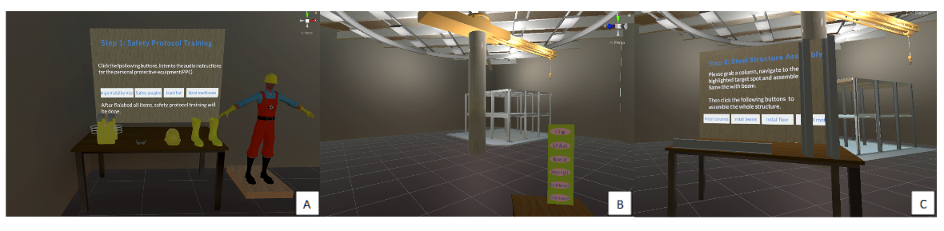
Figure 1. The scenes of preliminary virtual simulation: (a) Safety protocol training; (b) Crane operation;(c) Steel structure assembly.

A two-way data synchronization framework will be implemented to ensure real-time communication between the physical and virtual worlds. A sensing system will be deployed using inertial measurement units (IMU), depth cameras, and LiDAR to capture environmental and operational data, which will be streamed to the digital simulation platform. Conversely, data generated in the digital simulation will be used to remotely control crane operations [7]. our AutoIC lab has created a modular remote-control system that integrates a single-board computer, motorized actuators, and a control algorithm with MQTT communication protocol (Figures 2 & 3). This plug-and-play design allows smart control modules to be easily attached to existing crane buttons and levers. A customized user interface built with Python enables operators to send commands via MQTT, which are received by the single-board computer and translated into actuator movements. The system architecture, tested with the tower crane in our construction lab, supports reliable communication, real-time control, and safety functions such as emergency stop.

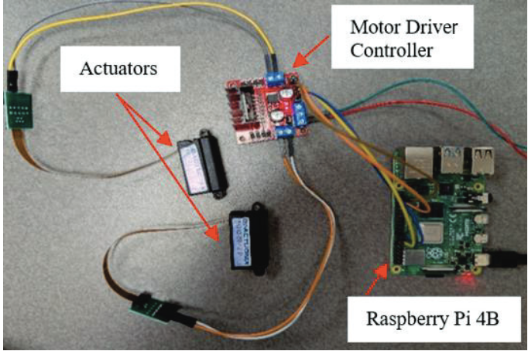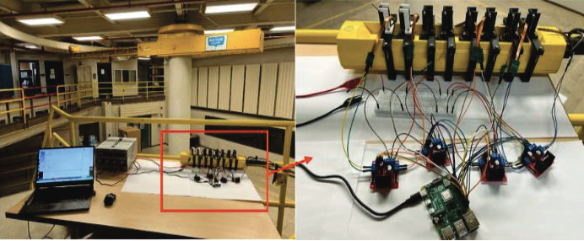
Figure 2. Circuit and setup of the crane remote control system.

5.2 AI-Powered user training and operational support

Large language models have shown effectiveness as digital coaching tools in various domains. Building on this capability, we plan to develop an AI-powered coaching. By learning from the simulation-based planning of precast bridge component installation, the AI system will guide users through the operation tasks step by step.
(1) Digital Coach Components: The AI agent will act as a “digital coach” supporting the entire installation cycle, including capacity filtering, geometric constraint filtering, execution of the installation sequence, diagnosis of errors, correction, and re-execution.
(2) Knowledge Integration: Knowledge Integration: The AI system will be equipped with retrieval-augmented generation (RAG) capabilities. A structured knowledge base will be developed that contains project-specific resources, including pseudocode, mathematical formulas, the installation action sequence and the crane’s load chart. By combining retrieval from this knowledge base with generative reasoning, the AI agent can provide evidence-grounded explanations, guide users through constraint checking, and recommend corrective actions in an interpretable manner.
(3) Interface Design: The coaching system will be integrated into the simulation environment to provide an interactive and immersive training experience.

- Educational outreach and workforce development

Research from this project has been included into:

- The PI's undergraduate course, CM150 - Construction Management Fundamentals, introduced 90 students to this project on September 22nd at WALC 1087, Purdue University, West Lafayette, IN.
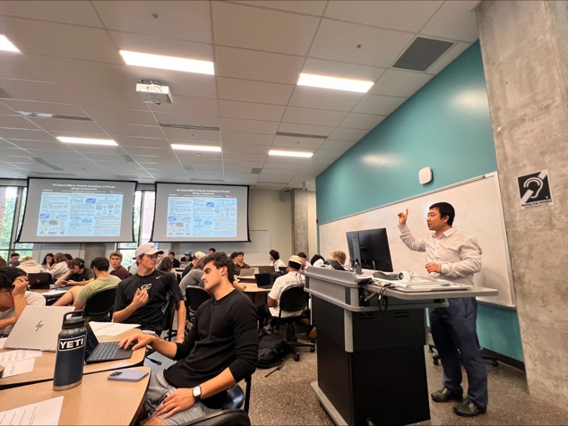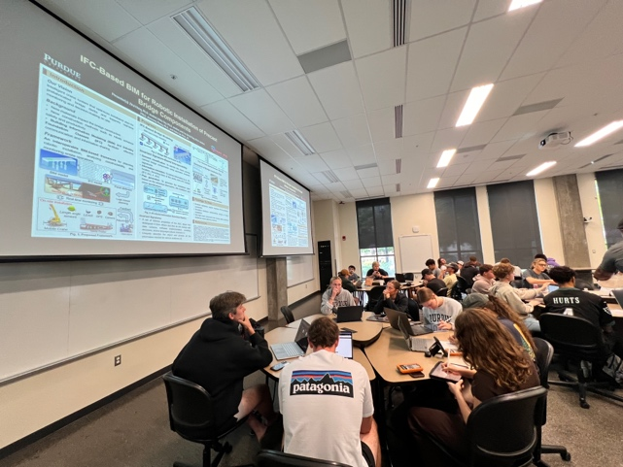
Figure 4. Students engage in group discussions for this project.
Figure 3. PI introduces the project in class.

(2) the PI’s graduate course CM 581-Interoperable BIM and Its Applications, more specifically into Lecture 1 (Introduction to Interoperable BIM & Its Applications, Aug. 29th, 2025) KNOY G007, Purdue University, West Lafayette, IN.

(3) the PI’s Halpin Award Lecture titled “Advancing Construction Engineering and Management, Construction Automation, and Sustainable Infrastructure Using BIM, AI, and Robotics Technologies” at the ASCE International Conference on Computing in Civil Engineering (i3CE 2025), May 13, 2025, InterContinental New Orleans, La Salle Ballroom New Orleans, LA (Figure 4).

(4) the PI’s Keynote Speech at the Joint CSCE Construction Specialty Conference / ASCE Construction Research Congress (CRC) 2025, Jul. 30th, 2025, John Molson School of Business Building 1.210, Concordia University, Montreal, Canada (Figure 5).

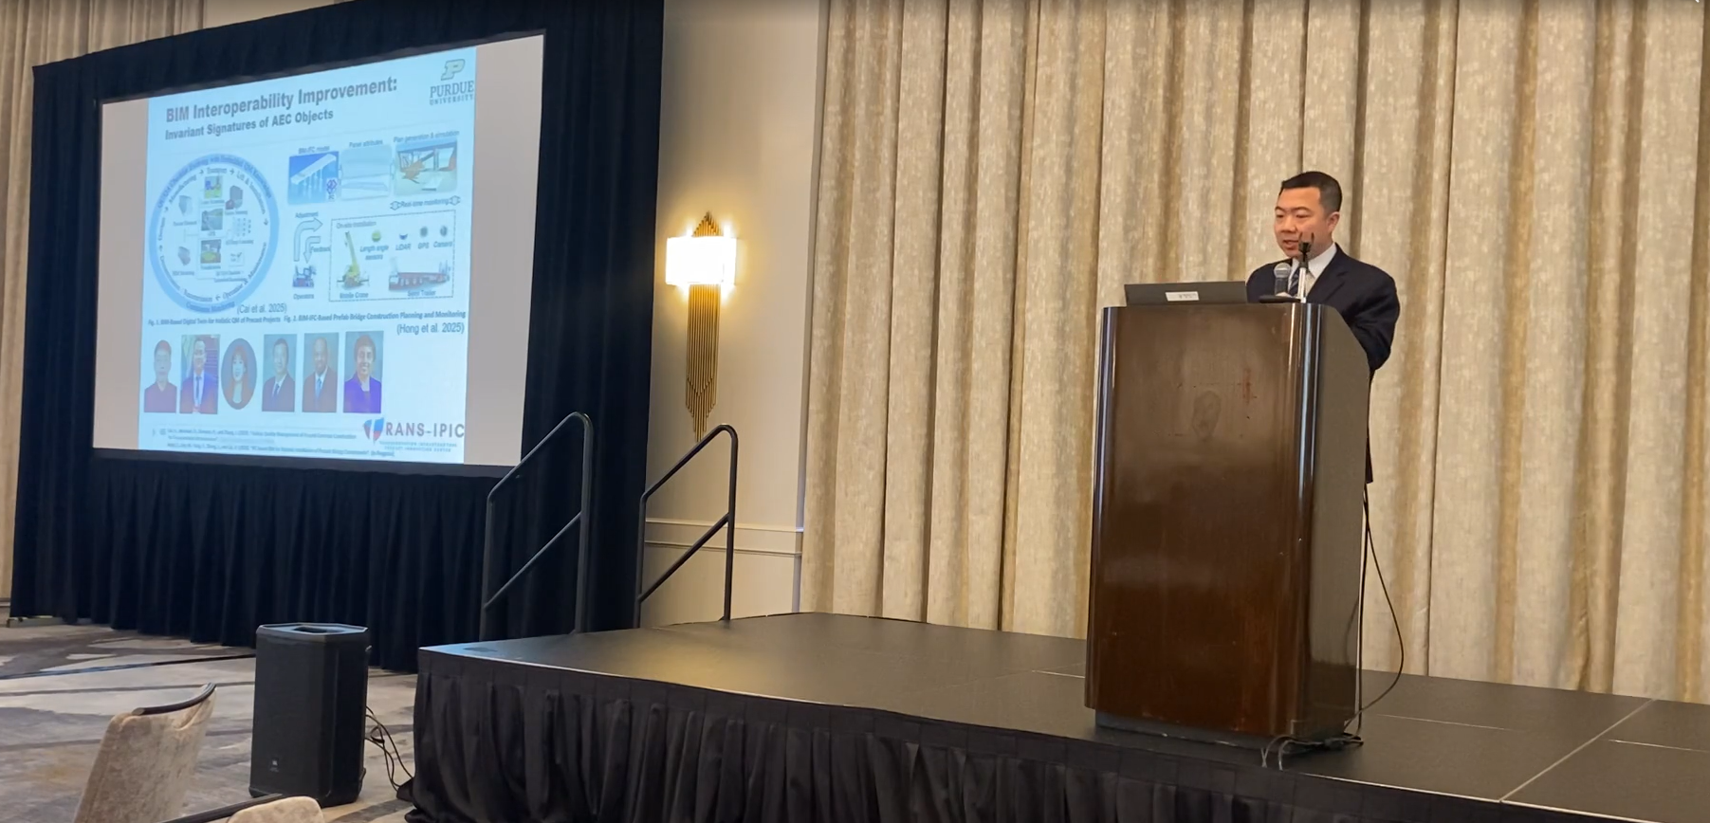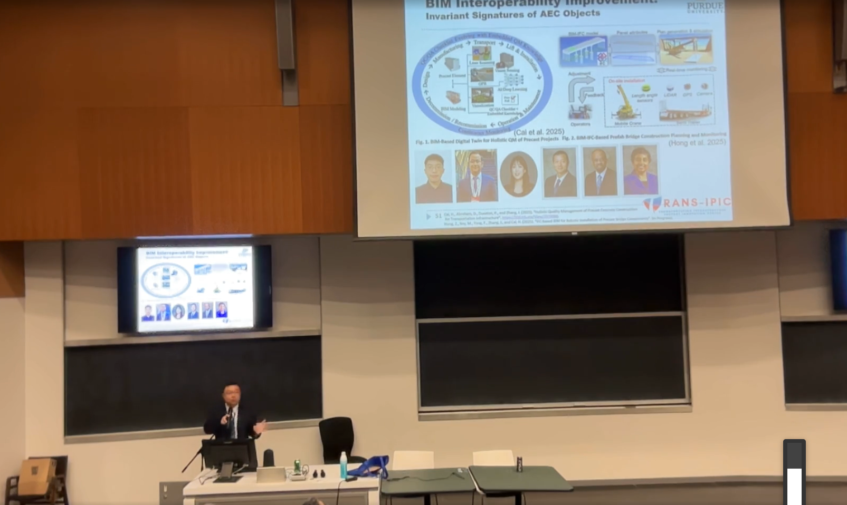
Figure 5. Keynote Speech at Joint CSCE Construction Specialty Conference / ASCE Construction Research Congress (CRC) 2025.
Figure 4. Halpin Award Lecture 2025

(5) Seminar of Lyles School of Civil and Construction Engineering, Talk by PI titled “The Future is Here – Seamless and Universal BIM Interoperability Empowered by Invariant Signatures of AEC Objects and AI Can Accelerate the AEC Industry into Automation and Intelligent Lifecycle Processes”, Sept. 19th, 2025, Hampton Hall, Room 2113, Purdue University, West Lafayette, IN.

- Technology Transfer
One technology disclosure: Hong, Z., Soy, M., Yang, F., Zhang, J., and Cai, H. (2025). “Automation in Crane Planning for Bridge Construction.” Purdue Research Foundation Reference Number: 2025-ZHAN-71285.

Research Contribution:
- Papers that include TRANS-IPIC UTC in the acknowledgments section:
N/A

- Presentations and Posters of TRANS-IPIC funded research:
Hong, Z., Soy, M., Yang, F., Zhang, J., and Cai, H. (2025). “IFC-based BIM for Robotic Installation of Precast Bridget Components.” TRANS-IPIC 2025 Annual Workshop, Chicago, IL, April 22 – 23, 2025.

Soy, M., Hong, Z., Yang, F., Zhang, J., & Cai, H. (2025). IFC-based installation simulation of precast bridge panels in pre-planning. Paper accepted for presentation at the Transportation Research Board (TRB) 104th Annual Meeting, Washington, D.C.

- Please list any other events or activities that highlights the work of TRANS-IPIC occurring at your university (please include any pictures or figures you may have). Similarly, please list any references to TRANS-IPIC in the news or interviews from your research.
N/A

Appendix 1: Research Activities, leadership, and awards (cumulative, since the start of the project)

- Number of presentations at academic and industry conferences and workshops of UTC findings
- No. = 8

- Number of peer-reviewed publications submitted based on outcomes of UTC funded projects
- No. = 1

- Number of peer-reviewed journal articles published by faculty.
- No. =

- Number of peer-reviewed conference papers published by faculty.
- No. =

- Number of TRANS-IPIC sponsored thesis or dissertations at the MS and PhD levels.
- No. MS thesis =
- No. PhD dissertations = 1
- No. citations of each of the above =

- Number of research tools (lab equipment, models, software, test processes, etc.) developed as part of TRANS-IPIC sponsored research
- Research Tool #1 (Name, description, and link to tool) =
- Research Tool #2 (Name, description, and link to tool) =
- Research Tool #3 (Name, description, and link to tool) =

- Number of transportation-related professional and service organization committees that TRANS-IPIC faculty researchers participate in or lead.
- Professional societies
  - No. participated in = 1
  - No. lead =
- Advisory committees (No. participated in & No. led)
  - No. participated in = 1
  - No. lead =
- Conference Organizing Committees (No. participated in & No. led)
  - No. participated in = 3
  - No. lead = 1
- Editorial board of journals (No. participated in & No. led)
  - No. participated in = 14
  - No. lead =
- TRB committees (No. participated in & No. led)
  - No. participated in = 1
  - No. lead =

- Number of relevant awards received during the grant year
- No. awards received = 1

- Number of transportation related classes developed or modified as a result of TRANS-IPIC funding.
- No. Undergraduate = 90
- No. Graduate = 28

- Number of internships and full-time positions secured in the industry and government during the grant year.
- No. of internships =
- No. of full-time positions =

References:
[1] National Precast Concrete Association (NPCA), Precast Solutions Winter 2013 - Bridges and Transportation, 2013.
[2] B. Kirk Stelsel, Beauty and Durability Shine with Samuel De Champlain Bridge, 2019.
[3] C.P. Chea, Y. Bai, X. Pan, M. Arashpour, Y. Xie, An integrated review of automation and robotic technologies for structural prefabrication and construction, Transportation Safety and Environment 2 (2020) 81–96. https://doi.org/10.1093/tse/tdaa007.
[4] Z. Zhang, B. Zhang, W. Hu, R. Zhou, D. Cao, H. Yin, Dynamic Three-Dimensional Lift Planning for Intelligent Boom Cranes, IEEE/ASME Transactions on Mechatronics 28 (2023) 2885–2896.
[5] K. Chen, B. You, Y. Zhang, Z. Chen, Automatic lift path planning of prefabricated building components using semantic BIM, improved A* and GA, Engineering, Construction and Architectural Management (2024).
[6] D.H. Jang, G.T. Roh, C.H. Jeon, C.S. Shim, Simulation-Based Optimization of Crane Lifting Position and Capacity Using a Construction Digital Twin for Prefabricated Bridge Deck Assembly, Buildings 15 (2025). https://doi.org/10.3390/buildings15030475.
[7] M. Soy, J. Fu, Y. Wu, J. Zhang, D. Gan, J. Wei-Kocsis, B.C. Min, Remote Physical Control for Upgrading Heavy Construction Equipment, in: ISARC 2025, Proceedings of the International Symposium on Automation and Robotics in Construction, vol. 42, IAARC Publications, 2025: pp. 258–263.≠

