

Transportation Infrastructure Precast Innovation Center
(TRANS-IPIC)

University Transportation Center (UTC)

Data-driven smart composite reinforcement for precast concrete - Phase II
PU-23-RP-05

Quarterly Progress Report
For the performance period ending September 30, 2025

Submitted by:
Chengcheng Tao (PI), tao133@purdue.edu
Shanyue Guan (Co-PI), guansy@purdue.edu
School of Construction Management Technology
Purdue University

Collaborators / Partners:
Heidelberg Materials, North Dakota State University

Submitted to:
TRANS-IPIC UTC
University of Illinois Urbana-Champaign
Urbana, IL

TRANS-IPIC Quarterly Progress Report:
Project Description:
- Research Plan - Statement of Problem
It is critical to design high-performance, sustainable, and cost-effective reinforced precast concrete (PC) to extend the life of PC transportation infrastructure. Physical testing with trial-and-error approaches on reinforced PC components requires substantial time, labor, and material resources to achieve the optimal design for superior material properties, ecological and economic sustainability. There is a lack of an efficient and precise way to design reinforced precast by fully considering potential configurations and material options with optimal performance. To address these challenges, the project innovatively integrates sensing technology, physical testing, multivariate numerical modeling, and multi-objective optimization to achieve optimal performance of the reinforced precast concrete materials. The expected output will guide the design and manufacturing of reinforced PC components with improved durability, environmental impact, and economic value.

- Research Plan - Summary of Project Activities (Tasks)
Task 1. Experimental investigation of mechanical properties of various reinforced precast concrete components. Built upon the testbed from our TRANS-IPIC Year 1 project, we will investigate the mechanical performance of various reinforced precast concrete components with different reinforcement configurations, geometries, and material types of rebar and concrete.
Task 2. Multivariate numerical modeling of reinforced precast concrete components and physics-informed database establishment. In this task, we will perform computer-guided design via three-dimensional (3D) numerical analysis and parametric study to analyze the sensitivity of various influencing factors on the mechanical properties of the reinforced concrete components.
Task 3. Development of multi-objective metaheuristic optimization framework with Pareto front analysis to achieve optimal mechanical properties, sustainability, and economic values. In this task, we will develop a multi-objective optimization framework to efficiently provide optimal solutions for high-performance, sustainable, and low-cost reinforced precast concrete components.
Task 4: Reporting. Research outcomes will be summarized in the quarterly and final reports submitted to TRANS-IPIC and publications in high-impact journals and TRB conference.

Project Progress:
- Progress for each research task
Task 1. Experimental investigation of mechanical properties of various reinforced precast concrete components [100% completed]
Concrete is a brittle material, which often experiences a sudden and catastrophic loss of load bearing capacity after rupture ^{[1]}. To investigate the flexural behavior of reinforced concrete, beam specimens with dimensions of 6” × 6” × 20” and 6” × 6” × 36”, and span lengths of 18” and 30”, are selected for flexural testing. The dimensions offered a manageable scale for laboratory work while preserving the critical behavior observed in pavement and structural applications. By applying a center-point load, the experiment replicates the concentrated stress caused by wheel loads, generating bending stresses and crack patterns similar to those found in service conditions. The experiment investigated the influence of several key factors on the load bearing capacity of reinforced concrete beams, including PVA fiber (13 mm) inclusion, water content, span length, and the type of reinforcement including steel rebar and glass fiber-reinforced plastic (GFRP). Distributed fiber-optical sensors (DFOS) were installed on the rebar and used to measure the strain during flexural test.
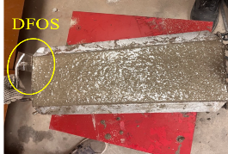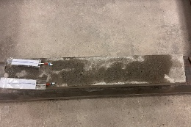
(a) (b)
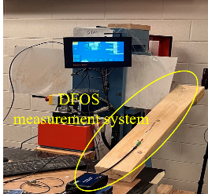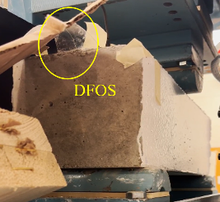
(c) (d)
Figure 1. (a) Freshly casted beam; (b) Demolded beam; (c) & (d) Flexural test set up
To evaluate the effects of fiber content, rebar type, beam span length, and curing time on flexural performance, six beam specimens are prepared with fiber optic sensors installed. The beam preparation process and the flexural test setup are illustrated in Figure 1. Five beams are cured for around one month in the lab. The flexural test is performed using a Forney 400 machine, with the ramp rate 0.05 MPa/s. Center-point flexural tests are performed and the modulus of rupture can be calculated using R=3PL/2bd^{2 [2]} as per ASTM C293. The span length is 18” for the 20” length beam, and 30” for the 36” beam. In this report, the concrete with 0.6% PVA fiber by volume is mixed with 3.2 L of water per 60 lbs bag of dry concrete, whereas the mix without fibers required only 2.6 L of water.
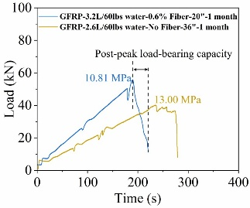
(a) (b) (c) (d)
Figure 2. Center-point flexural test results: (a) Effect of inclusion of PVA fiber on beam with steel rebar; (b) Effect of inclusion of PVA fiber and curing age on beam with GFRP rebar; (c) Effect of GFRP and steel rebar on beam (d) Effect of span length and fiber inclusion on beam

Figure 2 shows the flexural test results considering various effect. As shown in Figure 2(a), PVA fibers significantly reduces the modulus of rupture. For example, in the case of beams reinforced with steel rebar, the modulus of rupture decreases from 16.82 MPa (no fiber) to 13.93 MPa (0.6% fiber). All beams containing fibers exhibit improved post-peak load-bearing capacity. This post-peak bearing phenomenon has also been reported in the literature for fiber reinforced concrete ^{[3]}. This behavior enhances the damage tolerance of the beam, thereby improving the overall structural safety ^{[4]}. In contrast, the load versus time curve for beams without fibers drops abruptly after reaching the peak load. The effect of fiber on strength is more obvious in beams reinforced with GFRP. The one-month GFRP reinforced beam with fibers exhibits an even lower modulus of rupture than the 66-hour beam without fibers. In addition, the beam with steel rebar (13.93 MPa) has a higher modulus of rupture than one with GFRP (10.81 MPa). This may be attributed to the weak bonding between GFRP bars and the surrounding concrete ^{[5]}. Furthermore, we observe that beams tested with a longer span length (30″) exhibit more fluctuations (“bumps”) in the load versus time curve during ramp up, indicating that more cracks are initiated prior to rupture. According to the experimental results, adding 0.6% PVA fibers significantly enhances the ductility of reinforced concrete beams. Steel rebars still outperformed GFRP in concrete beam under bending.

Task 2. Multivariate numerical modeling of reinforced precast concrete components and physics-informed database establishment [100% completed]
2.1. Finite Element Analysis and Validation
To cross-check between numerical modeling and laboratory testing, the finite element analysis (FEA) is configured to replicate the same geometries, boundary conditions and loading protocols used in the experiments, as shown in Figure 3. The load is applied at midspan through a load-controlled ramping procedure. The strain results from FEA are validated by DFOS data from flexural tests. The strain data along the 18” span of the rebar is first extracted from the DFOS. To reduce local fluctuations caused by sensor noise and bonding imperfections, the experimental strain profile is processed using a Savitzky–Golay filter (window length = 51, polynomial order = 3). This smoothing technique preserves the overall strain trend while eliminating high-frequency noise ^{[6]}. For comparison, the FEA strain distribution is obtained from half-span results and reconstructed into a full-span curve by enforcing structural symmetry. The FEA strain values are further converted into micro-strain units for consistency. Since data from the DFOS only records the time without considering the loading condition, and the data from FEA simulates the real loading condition while compromising the real time, we use the time-loading curve from the bending machine to bridge and calibrate the DFOS and FEA results.
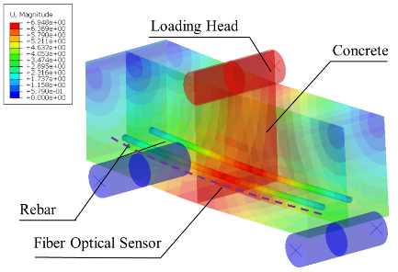
Figure 3. FEA results of reinforced concrete beam under center-point flexural loading
Figure 4 shows the comparison among the original DFOS measurements, the smoothed experimental curve, and the FEA prediction at 40.18 kN load. All three curves exhibit the typical strain distribution of a centrally loaded simply supported beam, with a distinct peak at the midspan (≈ 9”) and decreasing strains toward the supports. This agreement confirms both the effectiveness of the DFOS technique in capturing continuous strain fields and the validity of the finite element model in reproducing the global structural response. Some discrepancies are observed. The experimental peak strain reached 6500-7000 με, while FEA predicted 5500-6000 με. The higher experimental values may result from nonlinearities, local cracking not captured in FEA, or localized strain detected by DFOS. After smoothing, DFOS data aligned well with the FEA results.
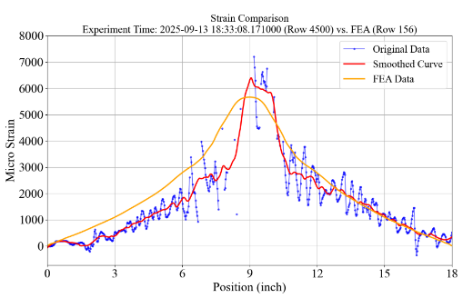
Figure 4. Strain comparison results at 40.18 kN load
2.2. Establishment of FEA Database of Reinforced Concrete Beam
This section describes the generation of the validated database from FEA simulations. Building on the previous cases, the database is expanded to 432 cases, with all parameters evenly distributed. Each simulation replicates the experimental setup, modeling 6” × 6” × 20”. The reinforced concrete beam is scaled to one-fourth of the full geometry to reduce computational cost. Longitudinal rebars are placed 2” apart. Stirrups, when present, use grade 60 steel #3 bars. Beams with stirrups contain four longitudinal bars, while those without contain two, which suits practical layouts. Python scripts are employed to define geometry, assign materials, generate meshes, apply loading, and extract results. All models are subjected to displacement-controlled loading conditions to capture the maximum load capacity and the corresponding flexural displacement. Key variables are systematically varied, including rebar type [aramid FRP (AFRP), basalt FRP (BFRP), carbon FRP (CFRP), glass FRP (GFRP)], and steel grades [G40, G60, G80, G100, and G120], rebar size [#2, #3, #4, and #5], concrete strength [20.7, 34.5, and 48.3 MPa], presence of stirrups and PVA fiber in concrete [0% and 0.66%].

Task 3. Development of multi-objective metaheuristic optimization framework [75% completed]
The structural optimization of reinforced concrete beams is a critical problem in civil engineering, as designers must balance cost efficiency, load-bearing capacity, and durability. Beam designs are simulated in Abaqus under central point bending, with parameters systematically varied (consistent with those mentioned in Section 2.2): nine rebar types, four bar sizes, three concrete strengths, stirrup inclusion (0/1), and fiber content. This produced 432 FEA cases for optimization. Each design is evaluated against four objectives: beam cost (minimize), ultimate load capacity (maximize), mid-span deflection at ultimate load (minimize), and surface tensile damage ratio (minimize). Multiple objectives involves maximizing strength and ductility while minimizing cost and damage. To search the design space efficiently, a surrogate-assisted framework combining Random Forest regressors with a Genetic Algorithm (GA) is used. Independent Random Forest models, each with 100 trees, captured nonlinear interactions and provided accurate predictions for the optimization process. The optimization problem is formulated as a single aggregated fitness function, balancing the four normalized objectives with weights.
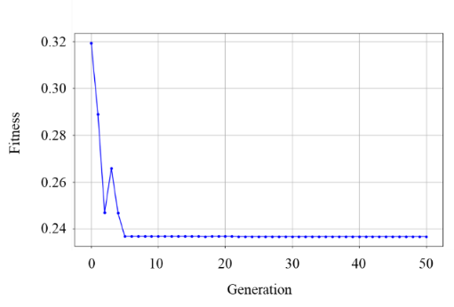
Figure 5. Convergence history of the GA
$$Fitness=w_{1}×Price+w_{2}×(1-Load)+w_{3}×\left|Deflection\right|+w_{4}×DAMAGET$$ | (1)
where $w_{1}+w_{2}+w_{3}+w_{4}=1$. The normalization ensures comparability between different scales: minimization objectives (unit cost, deflection, damage ratio) are scaled directly; maximization objective (ultimate load capacity) is inverted before normalization; and the absolute value of deflection is considered to enforce serviceability limits. The GA is implemented using Distributed Evolutionary Algorithms in Python (DEAP) framework, considering its ability to handle nonlinear, mixed-variable, multi-modal search space. Each candidate design is represented by six decision variables. Surrogate models predict objective values, aggregated into a scalar fitness score. As shown in Figure 5, fitness drops sharply in the first 5 generations before stabilizing, indicating rapid convergence. No major improvement occurs after 10 generations, suggesting a stable optimum is achieved. The GA thus effectively explores the design space and identifies optimal beam parameters under equal weighting. The GA refined the population toward optimal trade-offs among cost, strength, serviceability, and damage resistance. To analyze these trade-offs, 3D Pareto fronts are generated by excluding one objective and optimizing the remaining three. Random forest surrogate models provided predictions, and Ridge regression surfaces are fitted post hoc to Pareto-optimal points for smooth visualization. This strategy clarifies interactions among objectives and shows how trade-offs shift when one metric is removed. Figure 6 displays the Pareto fronts of four optimization cases, with blue markers as optimal solutions, gray dots as raw data, and smoothed surfaces highlighting trade-off structures. Figure 6(a) highlights the dominant compromise between economy and serviceability when durability is not explicitly constrained. Figure 6(b) shows both deflection and damage improve until a threshold, after which further deflection reduction yields little damage benefit. The front on Figure 6(c) forms a smooth ridge, indicating that without budget constraints, performance improves across all metrics. Figure 6(d) shows a knee at cost 6-12 per unit, load 65-75 kN, and damage 0.007-0.013. Below this, cost cuts add little; above 75 kN, strength gains raise cost and damage. This balance preserves strength and durability at moderate cost.
(a) (b)
(c) (d)
Figure 6. Pareto front of different multi-objective optimization cases: (a) min cost – max load capacity – min deflection; (b) min cost – min deflection – min damage ratio; (c) max load capacity – min deflection – min damage ratio; (d) min cost – max load capacity – min damage ratio
Transportation-related Applications
To demonstrate the potential implications of the developed AI-driven digital twin framework, we demonstrated the smart reinforced concrete system applied in pavement and bridge infrastructure.
1. Digital twin model of smart reinforced concrete pavement
In practical transportation applications, the experimental beam can serve as a representative prism of a pavement, allowing the structural response of the full system to be inferred from prism-level analysis ^{[7]}. This section provides an example of the developed digital twin model applied in pavement. Figure 7(a) is adapted from FHWA’s analytical modeling approach for concrete pavement, where a representative reinforced concrete prism with centrally embedded reinforcement. Built upon this concept, the prism methodology from the experimental beam tests and the corresponding simulation database is extended to the context of concrete pavements ^{[8]}. In concrete pavement design, a prism segment is analyzed under a 4000 lb axle load to represent local wheel effects ^{[9]}. The center-point loading replicates concentrated tire forces, inducing bending stresses and tensile cracks. This approach captures realistic pavement response to traffic while avoiding the need to model the entire panel. By varying design parameters, a range of design scenarios can be explored to achieve an optimal balance between structural performance and cost efficiency for overall pavement design. A digital twin model of precast concrete pavement has potential to be developed by incorporating smart composite reinforcement, enabling both corrosion resistance and structural health monitoring for pavement structures. A finite element model of a two-lane PCP is developed. Figure 7(c)-(e) presents visual presentations of the mechanical behaviors of smart reinforced concrete pavement. The model captures pavement behavior including maximum deflection occurs under the vehicle, longitudinal stress coincides with tire locations, and reinforcement strains align with deformation zones. The real-time strain information provided by the developed digital twin model allows rapid identification and localization of any structural damage, facilitating structural health monitoring for pavement structures.
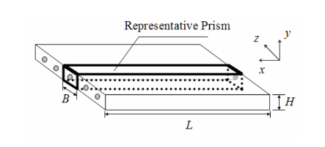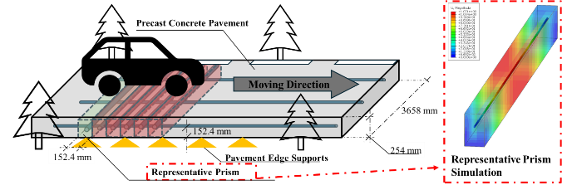
- (b)
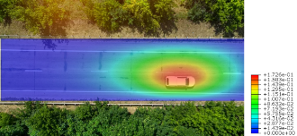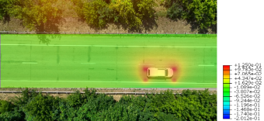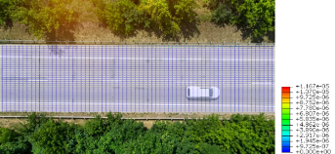
(c) (d) (e)
Figure 7. Schematic of a representative reinforced concrete prism for road pavement analysis. (a) Prism of a pavement ^{[6]} (b) Concrete pavements under center-point loading; Digital twin model of smart reinforced concrete pavement under traffic load: (c) deflection, (d) longitudinal stress, (e) reinforcement strain
2. Digital twin model of smart reinforced concrete bridge
By incorporating the high-fidelity finite element model into smart reinforced transportation infrastructure, their conditions have potential to be real-time monitored and visualized through digital twin technology.
Bridge structures use large amounts of concrete and reinforcement to withstand heavy traffic but are difficult to inspect due to their scale and complexity ^{[10]}. Therefore, a digital twin model of a simply supported, composite-reinforced concrete girder bridge is developed in this study to monitor its structural behavior under traffic load. The bridge model comprises five main components: guard, deck, girder, pier cap, and pier ^{[11]}, as shown in Figure 8(a). It is simplified as a single-span bridge with a 30 m span and 10.5 m width. Five T-girders form deck flanges and resist shear through their webs, a typical long-span design. All components except the guardrail use composite reinforcement. The concrete is modeled using solid elements and a damage plasticity model, while composite reinforcements are simplified with truss elements and modeled as linear elastic ^{[12]}. Traffic loads follow AASHTO HL-93 ^{[13]}, defined by a design truck with three axles: one 35 kN front axle and two 145 kN rear axles, spaced 4.3 m apart, with 1.8 m tire spacing. As shown in Figure 8, maximum deformation occurs at the deck bottom, with high stresses in girder webs near the sides (Figure 8(b)-(c)). Tensile stress concentrates at girder bottoms, compressive zones at girder pier cap connections. Figure 8(d) illustrates the strain distribution within the composite reinforcement, with high-stress concentrations closely aligning with regions of high deformation.
The digital twin models provide visual representation of the structural conditions of bridges and pavements under traffic load, enabling real-time structural health monitoring and improving situational awareness for timely maintenance and rehabilitation of transportation infrastructure. Moreover, the proposed approach is promising to a broad range of transportation infrastructure, including tunnels, runways, and harbors, offering a scalable solution for resilient infrastructure management.
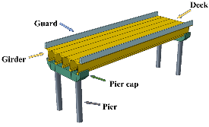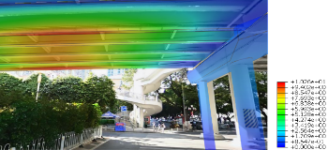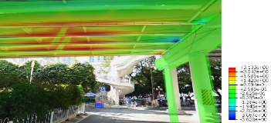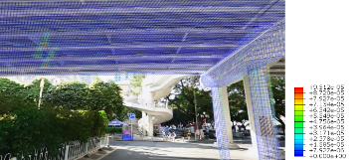
(a) (b) (c) (d)
Figure 8. (a) Simply supported composite reinforced concrete bridge model; Digital twin model of smart reinforced concrete bridge under traffic load: (b) deflection; (c) longitudinal stress; (d) reinforcement strain

Task 4: Reporting [75% completed]
Three quarterly reports have been completed and submitted.

- Percent of research project completed: 75%
- Expected progress for next quarter
We will expand the database with image data and keep working on the multi-objective optimization on transportation-related applications.
- Educational outreach and workforce development
The PIs mentored Ph.D. students through weekly individual meetings, and bi-weekly group meetings.
- Technology Transfer: None.
Research Contribution:
- Papers that include TRANS-IPIC UTC in the acknowledgments section:

Journal publications:
- Duan, J., Yan, H., Tao, C.*, Wang, X., Guan, S., & Zhang, Y. (2025). Integration of Finite Element Analysis and Machine Learning for Assessing Spatial-Temporal Conditions of Reinforced Concrete. Buildings, 15(3), 435.
- Xiong, X., & Tao, C.* (2025). Utilization of Dredged Sediments from Southern Lake Michigan in Cement Mortar Production. Construction and Building Materials, 494, 143444.
Journal papers under review:
- Wang, S., Lin, Y., Duan, J., Yan, H., Wang, X., Xiong, X., Huang, Y., Guan, S., & Tao, C.* (submitted in June, 2025). Intelligent Prediction Framework for Mechanical Response of FRP-Concrete Beam Reinforcement using KAN-based Convolutional Neural Network, Computer-Aided Civil and Infrastructure Engineering.
- Duan, J., Yan, H., Lin, Y., Guan, S., Tao, C. * (submitted in September, 2025). Advanced Structural Health Monitoring and Situational Awareness of Reinforced Concrete Beam using Smart, Self-sensing Composite Reinforcement through Digital Twin Model. Journal of Civil Structural Health Monitoring.
- Wang, S., Wang, X., Duan, J., Yan, H., Huang, Y., & Tao, C.*. (submitted in August, 2025). UNet-based Buckling Deformation Reconstruction from Strain Distributions and Knowledge Distillation. Engineering Applications of Artificial Intelligence.
- Duan, J., Wang, X., Yan, H., Wang, S., Huang, Y., & Tao, C.*(submitted in August, 2025). A Damage-informed Digital Twin Framework for Self-sensing Cured-in-place Underground Pipelines. Engineering Structures.
- Presentations and Posters of TRANS-IPIC funded research:

Presentations:
- Tao, C., Duan, J., Lin, Y., & Yan, H., Wang, S., Xiong, X., & Guan, S., Data-Driven Smart Composite Reinforcement for Precast Concrete, U.S. Department of Transportation (USDOT) - University Transportation Center (UTC), Transportation Infrastructure Precast Innovation Center (TRANS-IPIC) Workshop, April 22-23, 2025.
- Tao, C., Data-Driven Smart Composite Reinforcement for Precast Concrete, Transportation Infrastructure Precast Innovation Center (TRANS-IPIC) Monthly Research Webinar, March 28, 2025.
- Tao, C., Guan, S., & Duan, J., Data-Driven Smart Composite Reinforcement for Precast Concrete, Transportation Infrastructure Precast Innovation Center (TRANS-IPIC) Monthly Research Webinar, September 23, 2024.
- Tao, C., Guan, S, Duan, J., Lin, Y., & Yan, H. (2024). Data-Driven Smart Composite Reinforcement for Precast Concrete, U.S. Department of Transportation (USDOT) - University Transportation Center (UTC), Transportation Infrastructure Precast Innovation Center (TRANS-IPIC) Workshop, Chicago, IL, April 22, 2024.
Conference paper and presentation:
- Lin, Y., Yan, H., Duan, J., Li, Y., Xiong, X., Guan, S., & Tao, C.*(accepted). Multi-objective Metaheuristic Optimization of Reinforced Concrete Beam for Improved Flexural Performance. the 105th Transportation Research Board (TRB) Annual Meeting, Washington, D.C., January 11-15, 2026.
- Tao, C., Guan, S., Duan, J., Lin, Y., Yan, H., Li, Y., Xiong, X. (accepted). Smart Composite Reinforced Concrete System with Digital Twin-Based Monitoring and AI-Driven Condition Assessment. American Concrete Institute Concrete Convention, Chicago, IL, March 29–April 1, 2026.
- Please list any other events or activities that highlights the work of TRANS-IPIC occurring at your university (please include any pictures or figures you may have). Similarly, please list any references to TRANS-IPIC in the news or interviews from your research.
None.

Appendix 1: Research Activities, leadership, and awards (cumulative, since the start of the project)

- Number of presentations at academic and industry conferences and workshops of UTC findings
- No. = 4

- Number of peer-reviewed publications submitted based on outcomes of UTC funded projects
- No. = 4

- Number of peer-reviewed journal articles published by faculty.
- No. = 2

- Number of peer-reviewed conference papers published by faculty.
- No. = 1

- Number of TRANS-IPIC sponsored thesis or dissertations at the MS and PhD levels.
- No. MS thesis = 0
- No. PhD dissertations = 2
- No. citations of each of the above = 0

- Number of research tools (lab equipment, models, software, test processes, etc.) developed as part of TRANS-IPIC sponsored research
- Research Tool #1 (Name, description, and link to tool) = 0
- Research Tool #2 (Name, description, and link to tool) = 0
- Research Tool #3 (Name, description, and link to tool) = 0

- Number of transportation-related professional and service organization committees that TRANS-IPIC faculty researchers participate in or lead.
- Professional societies
  - No. participated in = 1
  - No. lead = 0
- Advisory committees (No. participated in & No. led)
  - No. participated in = 1
  - No. lead = 0
- Conference Organizing Committees (No. participated in & No. led)
  - No. participated in = 0
  - No. lead = 0
- Editorial board of journals (No. participated in & No. led)
  - No. participated in = 1
  - No. lead = 0
- TRB committees (No. participated in & No. led)
  - No. participated in = 0
  - No. lead = 0

- Number of relevant awards received during the grant year
- No. awards received = 0

- Number of transportation related classes developed or modified as a result of TRANS-IPIC funding.
- No. Undergraduate = 0
- No. Graduate = 1

- Number of internships and full-time positions secured in the industry and government during the grant year.
- No. of internships = 0
- No. of full-time positions = 0

References:
[1] Colombo, L., Sbarufatti, C., & Giglio, M. (2019). Definition of a load adaptive baseline by inverse finite element method for structural damage identification. Mechanical Systems and Signal Processing
[2] Krassowska, J. (2025). Experimental and analytical study on concrete mechanical properties of recycled carbon fibers from wind turbine blades. Materials. Multidisciplinary Digital Publishing Institute
[3] Sun, W., Gao, T., Zhao, J., & Cheng, H. (2023). Research on fracture behavior and reinforcement mechanism of fiber-reinforced locally layered backfill: Experiments and models. Construction and Building Materials
[4] Ren, X., Xie, Y., Ding, F., Sun, D., & Liu, H. (2024). Steel Fiber Reinforced Concrete: A Systematic Review of Usage in Shield Tunnel Segment. Sustainability. Multidisciplinary Digital Publishing Institute
[5] Zhou, L., Yu, Y., Zheng, Y., Ye, Y., Wang, Y., & Lao, J. (2025). Investigation on bond behavior of GFRP bar embedded in ultra-high performance polyoxymethylene fiber reinforced concrete. Engineering Structures
[6] Schafer, R. W. (2011). What is a savitzky-golay filter? [Lecture notes]. IEEE Signal Processing Magazine
[7] Choi, J.-H., & Chen, R. H. L. (2005). Design of continuously reinforced concrete pavements using glass fiber reinforced polymer rebars
[8] Tayabji, S. D. (2019). Precast concrete pavement technology implementation
[9] Raifman, M., Atkins, J., Johnson, C., & PI, J. G. (2024). Vehicle Weight Safety Study Academic Report
[10] Li, Y., Thielemans, W., Yuan, Q., & Li, J. (2022). PVA fiber reinforced cement composites with calcined cutter soil mixing residue as a partial cement replacement. Construction and Building Materials
[11] Ma, L. L., Wu, H., & Fang, Q. (2021). Damage mode and dynamic response of RC girder bridge under explosions. Engineering Structures
[12] Lee, S.-H., Abolmaali, A., Shin, K.-J., & Lee, H.-D. (2020). ABAQUS modeling for post-tensioned reinforced concrete beams. Journal of Building Engineering
[13] AASHTO LRFD bridge design specifications (9th edition).pdf

