

Transportation Infrastructure Precast Innovation Center
(TRANS-IPIC)

University Transportation Center (UTC)

IFC-based BIM for Robotic Installation of Precast Bridge Components
[PU-24-EP-01]

Quarterly/Final Progress Report
For the performance period ending June 30, 2025

Submitted by:
Jiansong Zhang, zhan3062@purdue.edu
School of Construction Management Technology
Purdue University

Hubo Cai, hubocai@purdue.edu
Lyles School of Civil and Construction Engineering
Purdue University

Collaborators / Partners:
Atlas Excavating; Milestone Contractors; Force Construction; Kelley Construction; Walsh Group; Aldridge Electric; Superior Construction; FH Paschen; Indiana Constructors

Submitted to:
TRANS-IPIC UTC
University of Illinois Urbana-Champaign
Urbana, IL

TRANS-IPIC Quarterly/Final Progress Report:

Project Description:
- Research Plan - Statement of Problem
Precast bridge projects have been widely adopted by US DOT agencies to accelerate construction, minimize traffic disruptions, and enhance structural quality and durability [1,2]. However, onsite assembly of precast components remains a time-consuming, repetitive, and hazardous task in precast projects [3]. Robotic installation of precast bridge components presents a promising solution to improve both efficiency and safety in precast bridge construction.

Building information modeling (BIM) plays an important role in gathering design and construction information for the planning and execution of robotic installation. AASHTO has adopted the Industry Foundation Classes (IFC) standard for BIM-based bridge modeling in 2019. Although the IFC bridge standard is well developed to facilitate the communication and coordination of building information modeling (BIM)-based bridge construction, there is a lack of interoperable BIM to support robotic installation and its constructability analysis. This limitation restricts the achievement of BIM benefits throughout the lifecycle of a bridge project, which involves a large number of precast products such as beams, girders, and deck panels. In addition, to automate crane operational analysis, recent studies developed computational algorithms for lifting trajectory planning by focusing on 1) optimizing multiple performance objectives (e.g., minimum energy and time consumption, shortest path, smooth trajectories), and 2) improving computational efficiency of the algorithms [4,5]. However, there is a gap in including crane dynamics in assessing the lifting plans [6].

This project aims at developing technologies that enhance IFC-based BIM interoperability and facilitate robotic installation of large and complex precast bridge components such as deck panels. Specifically, our project develops an invariant signature-based approach for automated extraction of critical bridge component information from IFC data. Furthermore, heuristic and simulation-based planning are integrated to generate crane operational plans and provide a systematic assessment of the plans’ constructability. The proposed approaches are investigated in applications that support BIM interoperability among precast bridge design, robotic installation, and constructability analysis through the following four tasks.

- Research Plan - Summary of Project Activities (Tasks)
Task 1 – Model bridge in different BIM software. This task selects representative large and complex pre-cast bridge deck components and models them using OpenBridge and Autodesk Revit, with the aim to generate non-proprietary bridge deck data for supporting later algorithm development.

Task 2 – Export IFC from BIM models. This task exports the components from different BIM software (OpenBridge and Revit) into IFC, directly and/or indirectly (thru third-party or open-source paths), with a focus on IFC4 and contingency use of IFC2X3 and IFC4X3.

Task 3 – Develop planning algorithms and associated simulation. This task develops invariant signature-based algorithms that take IFC-based precast bridge designs and automatically produce operational plans for robotic installation and corresponding construction simulations for constructability analysis and process optimization.

Task 4 – Roundtable. A roundtable with industry professionals will be held at Purdue Construction Advisory Council Meetings and/or Purdue Road School to gauge industry needs/interest and broadly disseminate the research findings.

Project Progress:
- Progress for each research task

Task 1 – Model bridge in different BIM software [100% completed]
With the purpose of running a simulation of the installation process in the Unity3D environment, IFC model of the bridge with pre-cast panel for the deck is required as input. Two different software programs (OpenBridge Designer and Autodesk Revit) were utilized in these model development process. Each software was used to create models of a sample bridge with precast decks based on assumed initial dimensions and primary information about the bridge. The models developed using OpenBridge Designer and Autodesk Revit are shown in Figure 1.

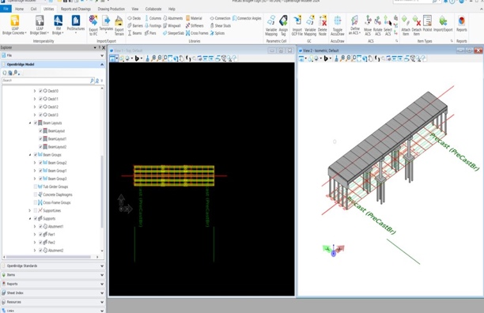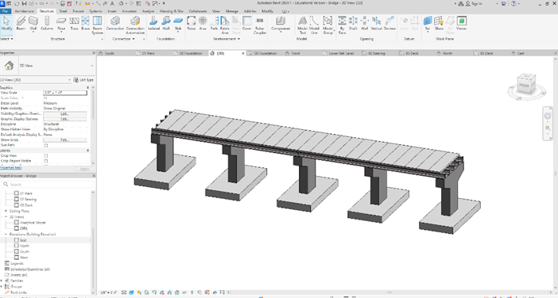
Figure 1. Bridge modelling with Openbridge Designer (left) and with Autodesk Revit (right).

Task 2 – Export IFC from BIM [100% completed]
Task 2 involves converting the models from Task 1 (modeled using the two mentioned software) to IFC format. The sample bridge models from Task 1 were converted to IFC as shown in Figure 2.

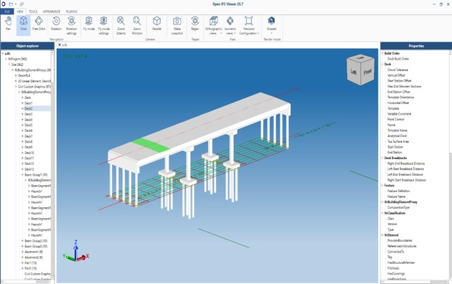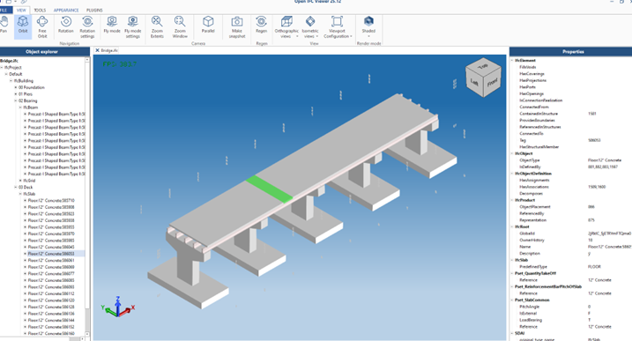
Figure 2. IFC file of the bridge modeled from OpenBridge Designer (left) and modeled from Autodesk Revit (right).

Task 3 – Develop planning algorithms and associated simulation [100% completed]
This project culminates at Task 3, which involves two sub tasks that are detailed as follows. Task 3.1 presents an invariant signature-based approach for automatically extracting bridge component information from IFC. Task 3.2 introduces an automated method for bridge installation planning and associated constructability analysis by integrating heuristic and simulation-based planning.

Task 3.1 – IFC information extraction based on invariant signatures for bridge installation planning [100% completed]
The first step in establishing interoperable BIM for robotic bridge installation is the automated extraction of critical information from IFC models to serve as inputs to installation planning. Figure 3 illustrates our pipeline for the automated information extraction. Key information includes the size, location, and mass of bridge panels, as well as obstacle information such as the geometry of the bridge body. One major challenge of the extraction is the absence of explicit component-type attributes in the exported IFC data. For example, in early IFC versions, bridge components exported from OpenBridge were often labeled generically as IfcBuildingElementProxy rather than as specific IFC entities such as IfcSlab and IfcBeam. Additionally, the geometry of these components was typically represented as undifferentiated meshes, which makes it difficult for the computer to distinguish between critical components such as slabs, piers, and girders.

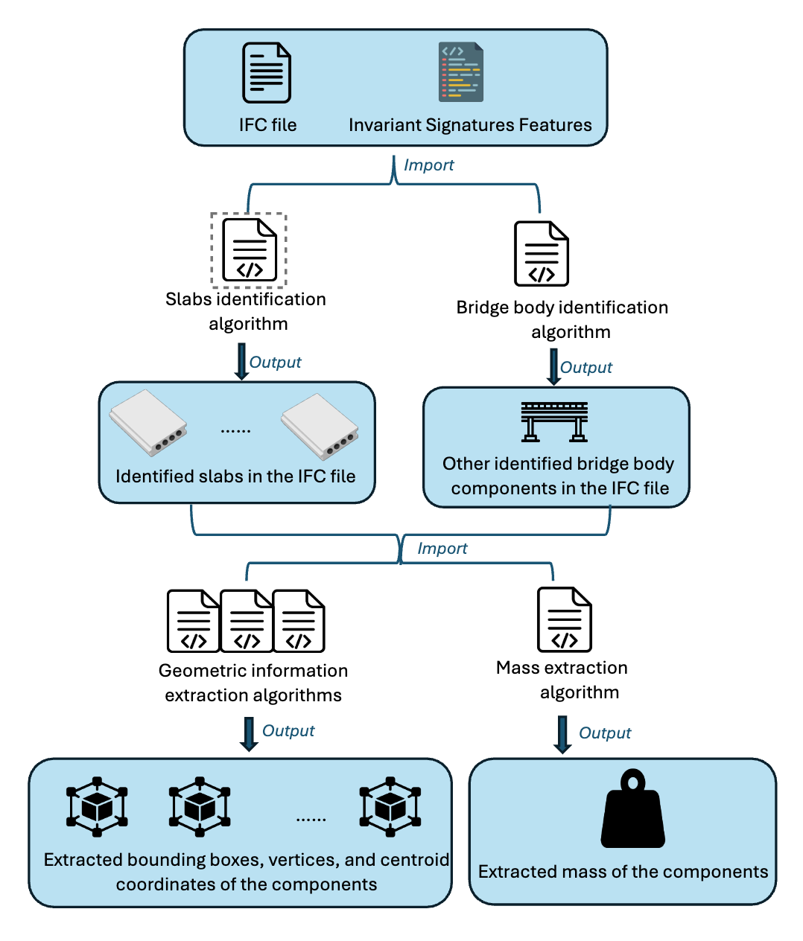
Figure 3. IFC-based information extraction pipeline.
To address these challenges, we utilized invariant signatures to identify the target components. As demonstrated in previous research [7] and also illustrated in Figure 4, different types of components have distinct ranges of geometric invariant signature values. Focusing on installation of deck panels (slabs), we developed a classification algorithm that can automatically differentiate the decks from other bridge components using geometric invariant signatures (see Figure 5). Similarly, we applied the same approach to identify bridge body components (primarily Beams), to provide contextual information to assist downstream planning tasks.
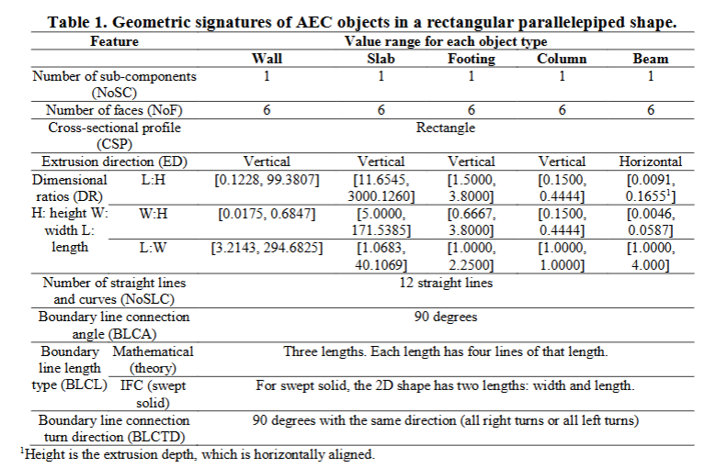
Figure 4. Invariant geometric signatures adapted [8].
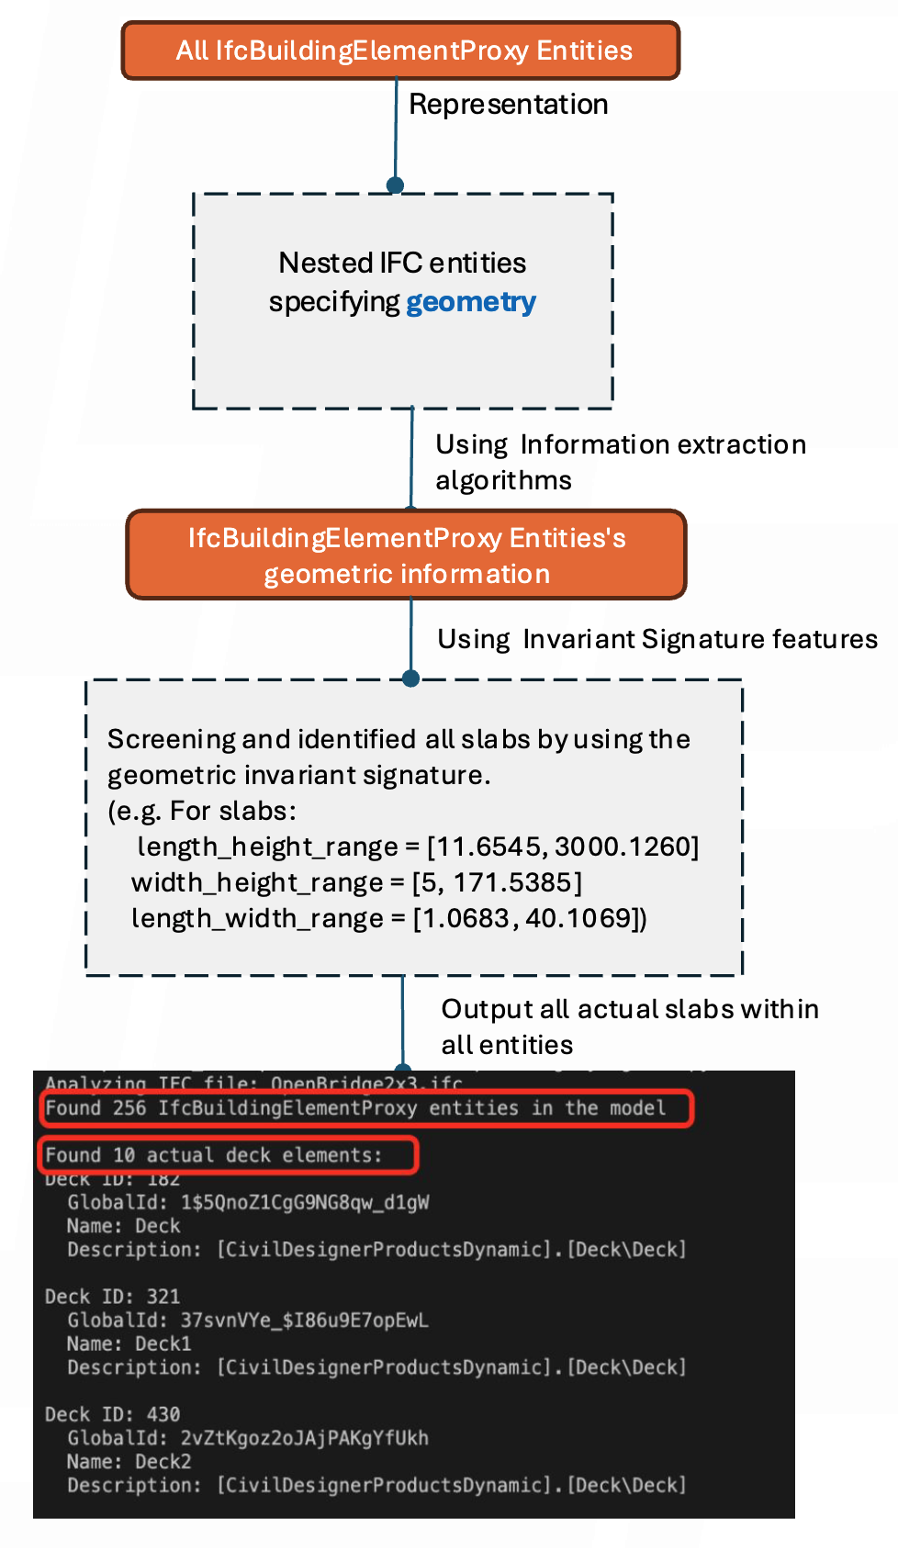
Figure 5. An example of applying invariant signatures to extract target components.
The second step involves extracting relevant information from identified components. Essential information includes ID, location, bounding box, mass of the slabs and other bridge body components. An extracted information sample is shown in Figure 6, where ten slabs in an IFC model were identified, and the coordinates of their bounding boxes vertex and center points were extracted. The developed algorithms can adapt to different software platforms (e.g., OpenBridge and Revit) and IFC versions (IFC4, IFC4X3, IFC2X3).

Our developed algorithm successfully extracted the correct information from six different bridge model files, originating from two software (Revit and Openbridge) and their exports into three IFC versions (IFC4, IFC2X3 and IFC4X3). This testing shows that the pipeline can successfully complete all the above extraction correctly. The invariant signature-based pipeline is a robust and automated approach to IFC information extraction. The interoperability and automation levels in bridge automation construction are expected to be enhanced with this approach.

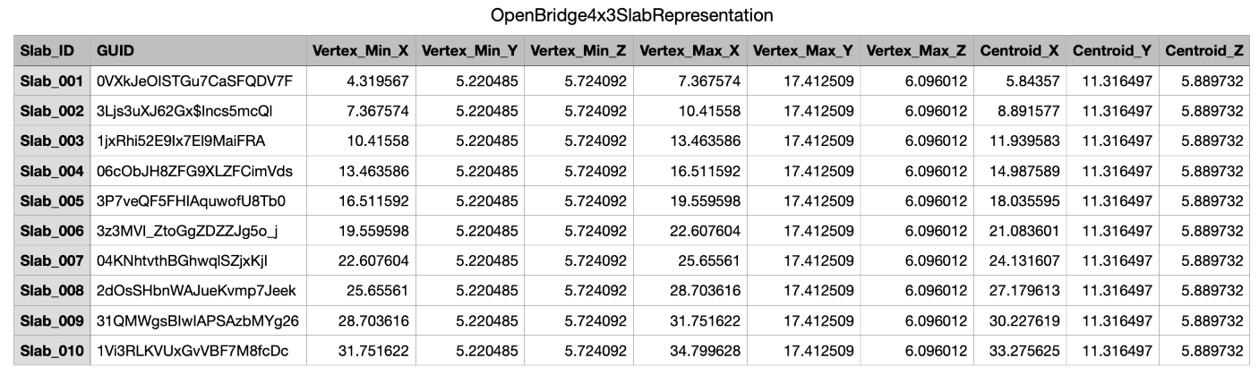Figure 6. Extracted IFC information sample of the algorithms.
Task 3.2 – Develop heuristic planning algorithm and simulation for bridge panel installation [100% completed]

In this sub task, we developed a heuristic planning algorithm that automatically generates control parameters for crane operations. In addition, a behavior tree-based control architecture was developed for executing the generated plans and was simulated in Unity3D for constructability analysis. The results showed that the integration of heuristic and simulation-based planning effectively: 1) assessed the feasibility of lifting operation using selected crane size and crane lifting location, 2) generated feasible plans given the chosen crane size and location with low computational cost, and 3) afforded plan validation via realistic physical simulations for constructability analysis.

3.2.1. Heuristic planning algorithm

The presented algorithm is for analyzing the crane lifting conditions in a precast bridge construction project. The algorithm is based on the heuristic planning approach which evaluates crane operation feasibility, calculates optional boom configuration, ensures safe lifting operation by avoiding physical collision.

The heuristic planning approach is designed for locating the feasible crane location for lifting precast panels based on the crane lifting capacity configuration (in reference to the load chart). Engineering heuristics are applied to determine and identify the boom length and working radius based on preferred crane location by users. With the feasible pairs of crane locations and boom length, under the physical movement constraint of the crane, the output of the heuristic planning algorithm serves as input to crane simulation detailed in section 3.2.2.

We adopted a multi-stage planning strategy that mimics crane operators’ engineering decisions under real-world crane operational constraints and three operation assumptions: (1) one action of the crane at a time. For example, while rotating, boom length cannot be extended or retracted. (2) the location of the crane and panel pick-up location can be provided by user and adjusted in the simulation environment (detailed in section 3.2.2). (3) the distance from the pick-up location to the crane is closer than the distance from the crane to the placement location.

The heuristic planning algorithm (see pseudo code in Table 1) contains two main filtering stages:
- Stage 1: Capacity-based filtering: based on the load chart of a crane (see Figure 7 for example), pairs of feasible radius and boom length, the pairs valid for operation are obtained. For example, assuming the load is heavier than 10 tons, all the possible capacity in the box is satisfied, and the system will obtain corresponding pairs (radius and boom length).

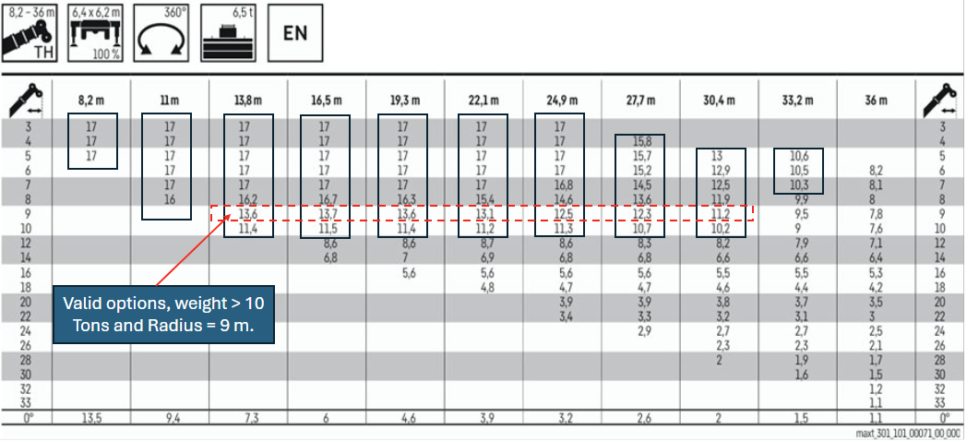
Figure 7. Load chart and example for valid pairs for load heavier than 10 tons [9].

The pairs are further filtered with the provided coordination of the crane which was obtained from the simulation environment (see section 3.2.2). By using the coordination of the placement location and crane location, distance is calculated in horizontal plane (XZ), based on which the number of valid pairs are further reduced. For example, assuming that the crane was parked at a distance 9 m from the placement location, the valid capacity reduces to those in the dashed line box shown in Figure 7.

- Stage 2: Geometric constraint filtering:

Three geometric constraints are used for further filtering. Details based on the planning layout and lifting action diagram are as follows (Figure 8).
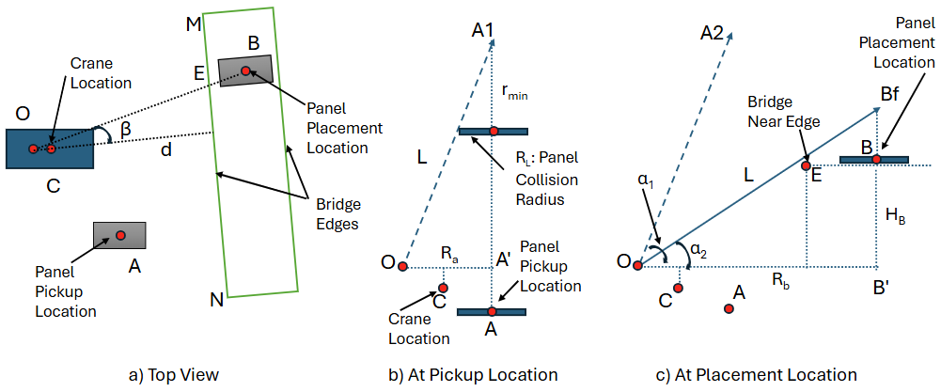
Figure 8. Crane, panel, and bridge layout and diagrams.

Constraint 1: Boom-Load Collision Prevention at Pickup location (see Figure 8b)
With the selected pairs, the length of the Boom (L) is known. Considering the radius of the panel, R_{L}, (assuming the panel can be rotated around its center) and the height of bridge (H_{B}), the constraint 1 is obtained using Equations (1) to (3) below:

$$\frac{r_{min}}{R_{L}}=\frac{\sqrt{L^{2}-R_{a}^{2}}}{R_{a}}$$
(Equation 1)
$$\sqrt{L^{2}-R_{b}^{2}}-r_{min}>H_{B}$$
(Equation 2)
$\sqrt{L^{2}-R_{b}^{2}}-\frac{\sqrt{L^{2}-R_{a}^{2}}}{R_{a}} R_{L}>H_{B}$ (Equation 3)

Constraint 2: Load-Bridge Collision Prevention/Rope length constraints
By taking into account the length of the rope during the operation, from both pickup location and placement location, we got the constraints of Equation (4) and Equation (5):

$\frac{\sqrt{L^{2}-R_{a}^{2}}}{R_{a}} R_{L}<r<\sqrt{L^{2}-R_{b}^{2}}-H_{B}$ (Equation 4)
$\frac{\sqrt{L^{2}-R_{a}^{2}}}{R_{a}} R_{L}<\sqrt{L^{2}-R_{b}^{2}}-H_{B}$ (Equation 5)

Also, the sling height (H_{s}) is user provided and a part of the lifting cable length, presenting the constraints of Equations (6) to (8).
$r_{min}>H_{s}$ (Equation 6)
$r_{min}=\frac{\sqrt{L^{2}-R_{a}^{2}}}{R_{a}}R_{L}$ (Equation 7)
$\frac{\sqrt{L^{2}-R_{a}^{2}}}{R_{a}}R_{L}>H_{s}$ (Equation 8)

Constraint 3: Boom-bridge collisions
While rotating the boom from pickup location to the placement plane, the angle of pickup boom must be larger than the angle formed between the horizontal plane and the closest edge of the bridge boundary to the crane. Therefore, it ensures that there is no collision while rotating. This is reflected in Equation (9), where d is the shortest distance from point O to the bridge’s edge.

$\frac{\sqrt{L^{2}-R_{a}^{2}}}{R_{a}} >\frac{H_{B}}{d}$ (Equation 9)

During the placement of the panel onto the bridge, considering the placement plane in Figure 8c, the final angle of the boom (∠α₂) during placement must be larger than the angle between the edge of the bridge in the place and the horizontal plane (∠B’OE). This ensures that when placed, the boom does not collide with the edge of the bridge. It is important to note that the bridge edge is governed by two points (i.e., point M and point N in Figure 8).

$\frac{\sqrt{L^{2}-R_{b}^{2}}}{R_{b}} >\frac{H_{B}}{d/{\cos{β}}}$ (Equation 10)

After applying the constraints [Equations (1)-(10)], only final feasible pairs of boom length remain and are used in setting up the simulation (detailed in section 3.2.2)

Table 1. Pseudo code of heuristic planning algorithm (based on illustration of Figure 8).
Algorithm 1 Heuristic planning
- Input: $loadChart,$ $panelInfo$, and parameters from simulator
- Output:1) IDs of installable panels $slabIDList$ given current site layout, and 2) control parameters for installing these panels $paramList$ (including ${boomAngle}_{pickUp}$,$boomAngle_{placement}$, $boomLength$, ${cableLength}_{_pickUp}$, ${cableLength}_{_liftUp}$, ${cableLength}_{_placement}$)
- Get coordinates of point $A$ and $C$ from simulator
- Get coordinates of point $B$, $N$ and $M, loadRadius, loadWeight$ from $panelInfo$
- Define parameters such as $slingHeight, outriggerHeight, installHeight$, and $safetyFactor$
- Main()
- {
- pairList1 = CapacityBasedFiltering($loadWeight$, $safetyFactor$, $loadChart$)
- foreach panel in $panelInfo$ do
- pairList2 = GeometricConstraintFiltering($C,A,B,N,M, pairList1$, $loadRadius$, $slingHeight$, $outriggerHeight$)
- if pairList2 != null then
- controlParam = GetControlParameters($C,A,B, pairList2$, $loadRadius$, $slingHeight$, $outriggerHeight$, $installHeight$)
- $slabIDList$.Add(panel.ID)
- $paramList$.Add(controlParam)
- end
- end for
- }
- CapacityBasedFiltering($loadWeight$, $safetyFactor$, $loadChart$)
- {
- for i = 1, 2, …, $loadChart.rowLength$ do
- for j = 1, 2, …, $loadChart.colLength$ do
- if $loadChart\left[i,j\right]> loadWeight/safetyFactor$ then
- pairList1.Add([i, j])
- end
- end for
- end for
- Convert pairLst1 from indices to associated values of boom length and working radius
- return converted pairList1
- }
- GeometricConstraintFiltering($C$, $A$, $B$, $N$, $M$,$pairList1$, $loadRadius$, $slingHeight$, $outriggerHeight$)
- {
- Derive point $O_{pickUp} and O_{placement}$ based on $C$, $A$, and $B$
- Derive $d$ and $β$ based on $C$, $N$, and $M$
- if |$O_{placement}B^{'}|$ is within radius range from pairList1 then
- foreach pair=1,2, … in $pairList1$ do
- if Constaint#1, Constaint#2, and Constaint#3 are satisfied then
- pairList2.Add(pair)
- end
- end for
- end
- return pairList2
- }
- GetControlParameters($C, A, B, pairList2$, $loadRadius$, $slingHeight$, $outriggerHeight$, $installHeight$)
- {
- Randomly select one feasible pair from $pairList2$
- Calculate the control parameters based on relative spatial layout among bridge, load, and crane given the selected pair.
- return control parameters
- }
3.2.2. Unity3D-based Simulation for Constructability Analysis

A simulation application was developed using Unity3D to support constructability analysis and plan refinement for robotic bridge panel installation. The development process comprises three primary components: virtual environment configuration, algorithm development, and simulation-based constructability analysis.

Virtual environment configuration aims at preparing 3D models (bridge and crane) and virtual scenes (terrain and layout of models) for simulation. To ensure model compatibility with Unity3D, IFC bridge models were preprocessed and converted into OBJ models using Blender. The preprocessing included merging components (e.g., columns, foundations, piles, and beams) into a single bridge body model while retaining individual deck panels as separate components. To facilitate accurate physical simulation, the pivot point of bridge component, which defines the component’s local coordinate system and controls its transformations (i.e., location, rotation, and scale), needs to be properly set up. In our case, the pivot of bridge body was set to the global origin, while deck panel pivots remained at their respective centroids. These models, along with a programmable crane, were then imported into Unity3D and augmented with colliders to enable realistic physical interactions. Figure 9 illustrates the workflow of model preprocessing and importing.

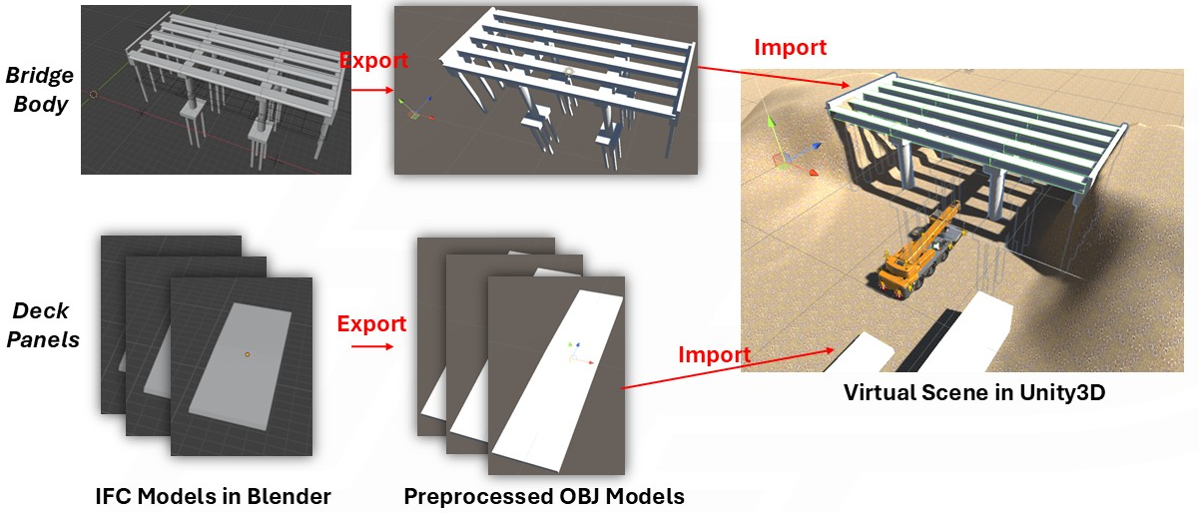
Figure 9. Preprocessing and importing IFC bridge models into Unity3D.

Algorithm development involves developing algorithms for heuristic planning and crane control. The heuristic planning algorithm was developed by following the pseudo code in Table1, which calculates necessary parameters for crane installation actions. The crane control algorithm was developed based on behavior tree (BT) - a tree-like control architecture that sequences crane actions (Figure 10). The BT decomposes a high-level installation goal into a set of primitive actions. Each action is responsible for a specific subtask/subgoal (see Table 2) and consumes the generated parameters to execute the installation. As illustrated in Figure 10, the BT features a sequence node at the bottom for single-panel installation actions, and a repeater node at the top to loop the process until all panels are installed. Figure 11 presents a screenshot of the BT execution interface, which enables intuitive monitoring of the whole installation process and status of individual nodes.

Table 2. Primitive actions of bridge panel installation
Action ID | Action Name | Function
A1 | SetUpSupport | Deploy crane outriggers to stabilize lifting operations
A2 | SetUpCrane | Prepare crane components (cabin, hook, boom) at a ready pose for lifting operations
A3 | SetUpLoop | Set up loop number for the installation process
A4 | GeneratePlan | Read and share action parameters with subsequent actions
A5 | RotateToDirection | Rotate crane body towards target panel location
A6 | LuffToAngle | Adjust boom to desired elevation angle
A7 | BoomReaching | Extend/retract boom to specified length
A8 | HookDown&Up | Lower/lift hook to manipulate panel
A9 | Loading | Attach panel to hook
A10 | Unloading&Installation | Detach and install panel at the specified location

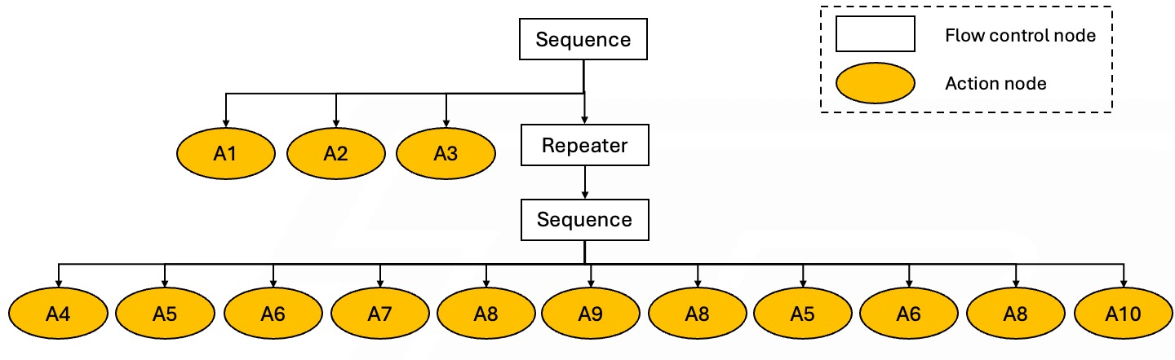
Figure 10. Behavior tree that describes and controls the panel installation.

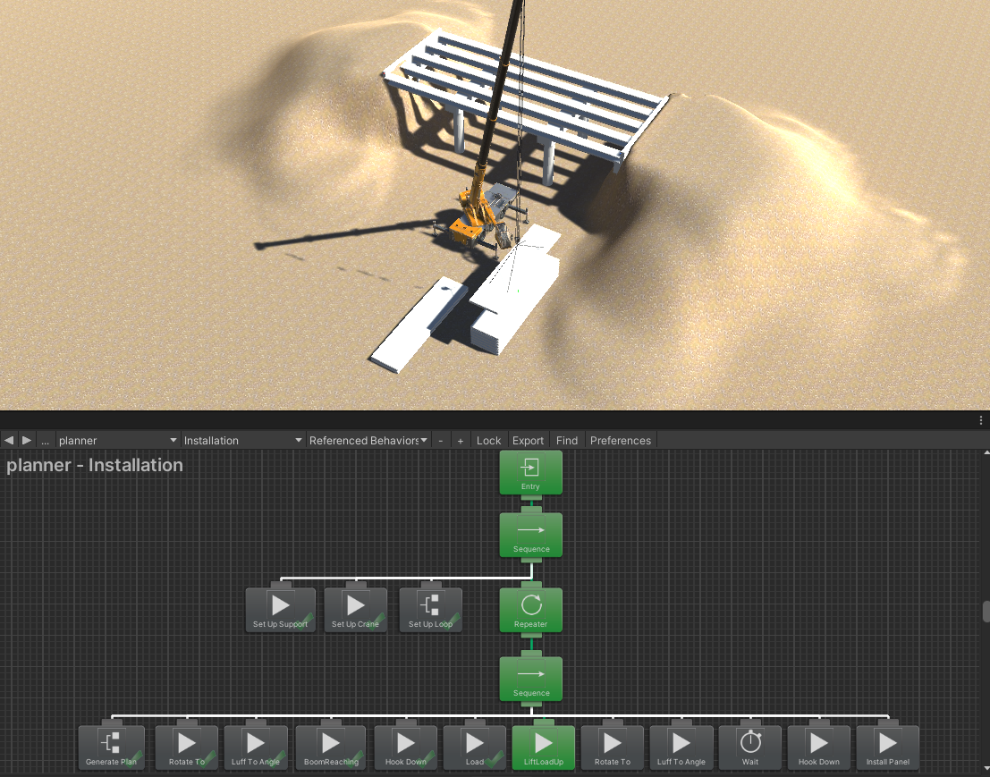
Figure 11. A screenshot of the execution of developed behavior tree.
Simulation-based constructability analysis evaluates and refines generated plans through iterative simulation. As illustrated in Figure 12, the process begins with crane selection and site layout setup, followed by heuristic planning. If the generated plan is valid, it is executed via physical simulation and visually evaluated by the human user. When planning or execution issues are identified, the user can adjust the layout or reselect a capable crane and repeat the process until a satisfactory plan is found. This iterative process enables 1) feasibility assessment of the chosen crane size and site layout at the pre-execution planning phase, and 2) detailed validation of the generated plan by examining dynamics of the execution using Unity3D’s physical engine.

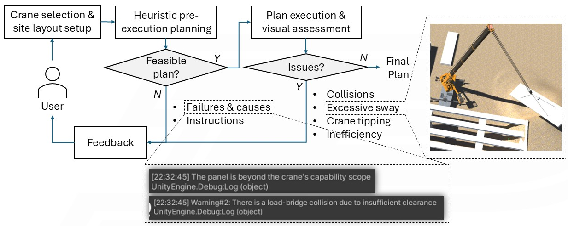
Figure 12. Workflow of simulation-based constructability analysis and feedback illustrations.

Task 4 – Roundtable [100% completed]
We organized a roundtable discussion during school of construction management technology’s construction advisory council meeting to solicit industry inputs in challenges and pain points in bridge construction in general, and in precast bridge construction in particular. Main points of challenging construction operations received include: ground improvements, deep foundation, drilled shafts, cement stabilization, crane sizing, and jobsite layout. These were taken into consideration in our crane planning algorithms. We also plan to give a presentation of this project at Purdue Road School 2026 or TRB 2026 to disseminate our research findings.

- Percent of research project completed
The project is 100% completed in this quarter ending on June 30, 2025, as per details in Section 3 above.

- Educational outreach and workforce development

Research from this project has been included into:

(1) the PI’s graduate course CM 581-Technology in Construction Management, more specifically into Lecture 8 (BIM Interoperability and Invariant Signatures, Mar. 4th, 2025) and Lecture 11 (BIM for Infrastructure, Mar. 25th, 2025), Dudley Hall 4117B, Purdue University, West Lafayette, IN.

(2) Zhang, J. “Empowering Seamless and Universal BIM Interoperability with Invariant Signatures of AEC Objects.” Panelist and Speaker at ISPRS - Webinars ICWG II/Ib, Mar. 27th, 2025.



(3) Zhang, J. “Advancing Construction Engineering and Management, Construction Automation, and Sustainable Infrastructure Using Building Information Modeling (BIM), Artificial Intelligence (AI), and Robotics Technologies.” Halpin Award Lecture, ASCE International Conference on Computing in Civil Engineering (i3CE 2025), New Orleans, LA, May 13, 2025.

- Technology Transfer
One technology disclosure: Hong, Z., Soy, M., Yang, F., Zhang, J., and Cai, H. (2025). “Automation in Crane Planning for Bridge Construction.” Purdue Research Foundation Reference Number: 2025-ZHAN-71285.

Research Contribution:
- Papers that include TRANS-IPIC UTC in the acknowledgments section:
N/A

- Presentations and Posters of TRANS-IPIC funded research:
Hong, Z., Soy, M., Yang, F., Zhang, J., and Cai, H. (2025). “IFC-based BIM for Robotic Installation of Precast Bridget Components.” TRANS-IPIC 2025 Annual Workshop, Chicago, IL, April 22 – 23, 2025.

- Please list any other events or activities that highlights the work of TRANS-IPIC occurring at your university (please include any pictures or figures you may have). Similarly, please list any references to TRANS-IPIC in the news or interviews from your research.
N/A

Appendix 1: Research Activities, leadership, and awards (cumulative, since the start of the project)

- Number of presentations at academic and industry conferences and workshops of UTC findings
- No. = 3

- Number of peer-reviewed publications submitted based on outcomes of UTC funded projects
- No. =

- Number of peer-reviewed journal articles published by faculty.
- No. =

- Number of peer-reviewed conference papers published by faculty.
- No. =

- Number of TRANS-IPIC sponsored thesis or dissertations at the MS and PhD levels.
- No. MS thesis =
- No. PhD dissertations = 1
- No. citations of each of the above =

- Number of research tools (lab equipment, models, software, test processes, etc.) developed as part of TRANS-IPIC sponsored research
- Research Tool #1 (Name, description, and link to tool) =
- Research Tool #2 (Name, description, and link to tool) =
- Research Tool #3 (Name, description, and link to tool) =

- Number of transportation-related professional and service organization committees that TRANS-IPIC faculty researchers participate in or lead.
- Professional societies
  - No. participated in = 1
  - No. lead =
- Advisory committees (No. participated in & No. led)
  - No. participated in = 1
  - No. lead =
- Conference Organizing Committees (No. participated in & No. led)
  - No. participated in = 3
  - No. lead = 1
- Editorial board of journals (No. participated in & No. led)
  - No. participated in = 14
  - No. lead =
- TRB committees (No. participated in & No. led)
  - No. participated in = 1
  - No. lead =

- Number of relevant awards received during the grant year
- No. awards received = 1

- Number of transportation related classes developed or modified as a result of TRANS-IPIC funding.
- No. Undergraduate =
- No. Graduate = 19

- Number of internships and full-time positions secured in the industry and government during the grant year.
- No. of internships =
- No. of full-time positions =

References:
[1] National Precast Concrete Association (NPCA), Precast Solutions Winter 2013 - Bridges and Transportation, 2013.
[2] B. Kirk Stelsel, Beauty and Durability Shine with Samuel De Champlain Bridge, 2019.
[3] C.P. Chea, Y. Bai, X. Pan, M. Arashpour, Y. Xie, An integrated review of automation and robotic technologies for structural prefabrication and construction, Transportation Safety and Environment 2 (2020) 81–96. https://doi.org/10.1093/tse/tdaa007.
[4] Z. Zhang, B. Zhang, W. Hu, R. Zhou, D. Cao, H. Yin, Dynamic Three-Dimensional Lift Planning for Intelligent Boom Cranes, IEEE/ASME Transactions on Mechatronics 28 (2023) 2885–2896.
[5] K. Chen, B. You, Y. Zhang, Z. Chen, Automatic lift path planning of prefabricated building components using semantic BIM, improved A* and GA, Engineering, Construction and Architectural Management (2024).
[6] D.H. Jang, G.T. Roh, C.H. Jeon, C.S. Shim, Simulation-Based Optimization of Crane Lifting Position and Capacity Using a Construction Digital Twin for Prefabricated Bridge Deck Assembly, Buildings 15 (2025). https://doi.org/10.3390/buildings15030475.
[7] J. Zhang, F. Yang, Building a Bridge between Building Information Modeling and Digital Twins: Introducing Invariant Signatures of Architecture, Engineering, and Construction Objects, (2024).
[8] J. Wu, J. Zhang, Introducing geometric signatures of architecture, engineering, and construction objects and a new BIM dataset, in: ASCE International Conference on Computing in Civil Engineering 2019, American Society of Civil Engineers Reston, VA, 2019: pp. 264–271.
[9] Liebherr, Technical Data - Compact crane LTC 1050-3.1[m/t], (n.d.) 20–20. https://assets-cdn.liebherr.com/assets/api/ba4a69dd-ef28-41a6-ba67-8d8cfe0d90f0/Original/ (accessed June 27, 2025).

