

Transportation Infrastructure Precast Innovation Center
(TRANS-IPIC)

University Transportation Center (UTC)

Exploring Fungal-Induced Carbonate Precipitation (FICP) for Healing Concrete Cracks
LS-23-RP-03

Quarterly Progress Report
For the performance period ending 3/30/2025

Submitted by:
Hai Lin, Louisiana State University, hailin1@lsu.edu
Department of Civil and Environmental Engineering
Louisiana State University

Collaborators / Partners:
Yen-Fang Su, Louisiana State University, ysu@lsu.edu
Department of Civil and Environmental Engineering
Louisiana State University

Submitted to:
TRANS-IPIC UTC
University of Illinois Urbana-Champaign
Urbana, IL

TRANS-IPIC Quarterly Progress Report:

Project Description:
- Research Plan - Statement of Problem
This research aims to explore fungal-induced carbonate precipitation (FICP) to heal cracks and improve the durability of concrete. FICP is a natural biomineralization process involving calcifying fungi's metabolic activities to induce CaCO₃ precipitation.

- Research Plan - Summary of Project Activities (Tasks)
Task 3. Healing artificial concrete cracks using the optimized fungal strain.

The research team first investigated the effect of bacteria healing ability on cement mortar samples. Then, the research team prepared cement mortar samples for fungal healing, which will be used to compare to the bacterial healing ability of cement mortar samples.

We prepared four sample types to evaluate self-healing capability of bacteria, including untreated samples (without fiber and bacteria, 20 specimens), fiber samples (without bacteria, 20 specimens), samples with bacteria (without fibers, 20 specimens), and fiber samples with bacteria (20 specimens). These sample types are being used to evaluate the effects of fiber and bacteria on the strength and self-healing ability for cement mortar samples.

We are also preparing cement mortar samples treated by two types of fungi (Neurospora crassa (FGSC 2489) and Aspergillus niger (ATCC 9029)), including samples with fungi (without fibers, 10 specimens of each fungal strain), and fiber samples with fungi (10 specimens of each fungal strain).

1. Sample Preparation Procedures
This section describes the preparation of test specimens used in the study, including bacterial and fungal cultures, concrete mixing, and crack formation. All procedures were designed to ensure sterility, consistency, and reproducibility across test batches.

1.1. Bacterial Culture Procedure
To cultivate Sporosarcina pasteurii (ATCC 11859) for the preparation of bacteria cement mortar samples, a liquid culture method was employed. The growth medium was prepared by dissolving 10 grams of yeast extract and 5 grams of ammonium sulfate into 500 milliliters of 0.13 M Tris buffer adjusted to pH 9. The 0.13 M Tris buffer was prepared by diluting 65 milliliters of a 1 M Tris buffer solution (made by dissolving 7.6 grams of Tris hydrochloride and 54.7 grams of Tris base in 500 milliliters of distilled water). The prepared medium was sterilized using a 0.2 µm pore size a PES (polyethersulfone) membrane filter (Fisherbrand, FB12566512).

After sterilization, S. pasteurii from the stock in the -80 ºC freezer was aseptically inoculated into 250-milliliter Erlenmeyer flasks containing 100 milliliters of the sterile growth medium. The flasks were incubated at 30°C with shaking at 150 revolutions per minute (rpm) to promote bacterial growth (Figure 1). Once the optical density at 600 nm (OD600) of the culture reached the target range of 1.0 to 1.2, indicating optimal cell density, the pre-cultured bacterial solution was transferred into 2800-milliliter Erlenmeyer flasks containing 1400 milliliters of freshly prepared sterile growth medium (Figure 1). Approximately 3000 milliliters of bacterial solution were centrifuged (Beckman Coulter Avanti JXN-26) (Figure 2), and the resulting bacterial pellet was resuspended to obtain 700 milliliters of concentrated bacterial suspension.

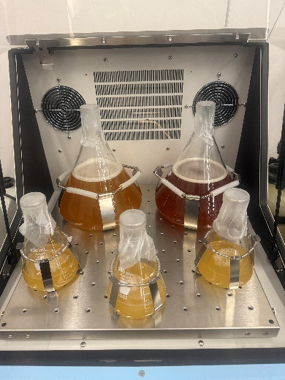
Figure 1. The growth of S.pasteurii in the shaking incubator.

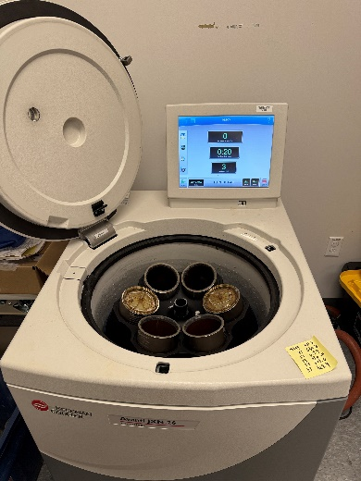
Figure 2. Centrifugation to collect S.pasteurii for cement mortar mixing.

1.2. Fungal Culture Procedure
Fungal cultivation was conducted using two filamentous fungal strains: Neurospora crassa (FGSC 2489) and Aspergillus niger (ATCC 9029). Both strains were grown in a Potato Dextrose Broth (PDB) medium (HiMedia, GM403-2.5KG), which is widely used for fungal growth. The medium was prepared by dissolving 24.0 grams of granulated PDB powder in 1000 milliliters of distilled water. The solution was mixed thoroughly and sterilized by autoclaving at 121°C and 15 psi for 15 minutes. After cooling to room temperature, the sterile PDB medium was used for fungal inoculation.

Each fungal strain was initially inoculated into 500-milliliter Erlenmeyer flasks, each containing 100 milliliters of sterile PDB medium. These pre-cultures were incubated at 30°C with shaking at 150 rpm for three days to promote initial mycelial growth (Figure 3). Subsequently, the fungal suspensions were transferred into 2800-milliliter Erlenmeyer flasks containing 1400 milliliters of freshly prepared sterile PDB medium (Figure 4). The cultures were further incubated under the same conditions—30°C and 150 rpm—for an additional seven days to generate sufficient fungal biomass for cement mortar sample preparation. Upon completion of incubation, the fungal cultures were harvested by centrifuge. The resulting fungal suspensions were stored in sterile containers at 4°C. To ensure the viability and functionality of the fungi, all samples were used within 10 days after centrifuge.

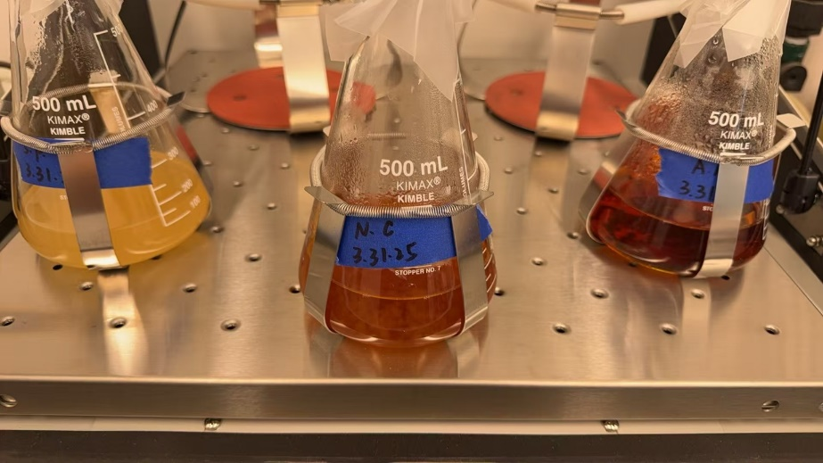

Figure 3. Growth of Fungal Strains in 500 mL Flasks.

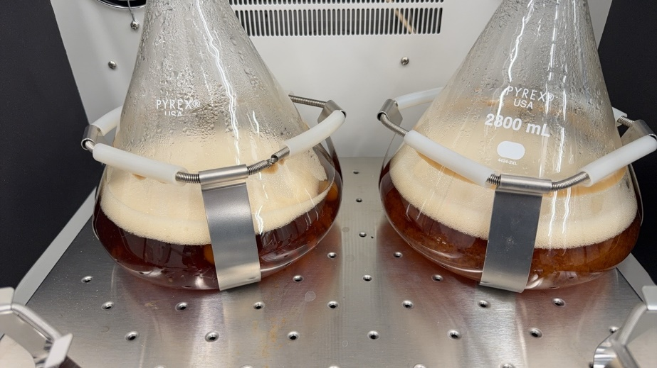

Figure 4. Fungal Culture of Neurospora crassa and Aspergillus niger in 2800-milliliter Erlenmeyer flasks.

1.3. Mortar Sample Preparation
Cement mortar samples were prepared using a standardized mixing procedure to ensure uniformity and reproducibility across all test batches. A mass ratio of 1:1.5:0.4 for cement, sand, and water, respectively, was adopted. All dry materials were weighed with high precision, maintaining a tolerance within ±0.3 grams to minimize variability. Identical containers and tools were used throughout the process to control for external variation. Mixing was conducted using a mechanical mortar mixer, where the cement and sand were first combined and mixed at low speed for 60 seconds. A spoon was used to manually lift any unmixed material from the bottom of the mixing pot, followed by an additional 30 seconds of low-speed mixing. Water was then added evenly over a 30-second period while mixing at medium speed, and the mixture was further stirred at medium speed for another 30 seconds. If fibers, bacteria, or fungal cultures were included in the mix, these were introduced at this stage and mixed at high speed for 60 seconds. Final homogenization was achieved by mixing at high speed for 5–6 minutes (Figure 5a). The freshly prepared mortar was poured into cylindrical molds with an inner diameter of 2 inches (50.8 mm) and a height of 4 inches (101.6 mm), which had been cleaned and sterilized prior to casting. After filling, each mold was tapped 15–20 times with a metal rod to remove entrapped air and improve compactness, and the surface was leveled using a metal scraper. The samples were then covered with plastic sheets and cured at 25°C and greater than 90% relative humidity for 28 days (Figure 5b and c). After curing, the specimens were demolded and stored under controlled conditions for subsequent testing and treatment (Figure 5d).

Figure 5. (a) Freshly mixed mortar prior to casting, (b) mortar specimens under curing, (c) labeled mortar specimens organized by group, and (d) surface condition of the cured mortar specimens.

1.4. Artificial Crack Generation
Artificial cracks were generated in cylindrical mortar specimens (2-inch diameter × 4-inch height) using controlled uniaxial compression (Figure 6a). Based on the method described by Luo et al. (2015), each specimen was first subjected to a preload corresponding to 75% of its average compressive strength. After reaching the preload, axial compressive loading was continued at a slow and stable rate, maintaining the load increment between approximately 0.5 and 1.5 psi per second. The loading process was carefully monitored, and as soon as visible surface cracks began to develop, loading was immediately stopped to avoid failure. This procedure enabled the formation of reproducible microcracks with widths ranging between 0.05 mm and 0.1 mm (Figure 6b). The cracked specimens were then used for subsequent self-healing treatment and evaluation. This cracking approach was designed to simulate realistic structural cracking conditions while minimizing unintended damage beyond the desired crack region.
Figure 6. (a) Test setup for crack generation and (b) mortar specimen after crack induction

2. Crack Healing Evaluation Methods (ongoing tasks)
To assess the effectiveness of fungal- and bacteria-induced crack healing in mortar specimens, multiple evaluation techniques were employed. These methods were selected to provide both qualitative and quantitative insights into the healing performance. Visual inspection was used to observe surface crack closure, while mechanical and physical tests—including compressive strength, ultrasonic pulse velocity, and water absorption—were conducted to quantify the restoration of structural integrity and durability.

2.1. Visual Crack Closure Observation
Visual inspection was conducted to qualitatively evaluate the extent of surface crack healing in the mortar specimens. High-resolution photographs were captured at three critical stages: before the healing treatment, during the healing process, and after the completion of the designated healing period. To ensure consistency, all images were taken under identical lighting conditions, at a fixed camera distance, and using standardized camera settings. A measurement scale was positioned adjacent to the cracks in each photograph to provide dimensional reference. The degree of crack closure was assessed by comparing changes in crack width and continuity across the different stages. Figure 7 shows the preliminary healing results due to bacterial treatment. The team is currently performing additional self-healing tests on 120 cement mortar samples

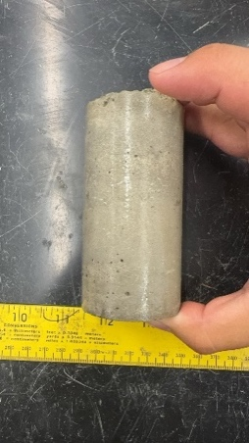
Figure 7. Surface crack measurement with scale

2.2. Compressive Strength Test
Compressive strength tests were conducted to evaluate the recovery of mechanical integrity after crack healing. Following ASTM C39, cylindrical specimens with pre-induced cracks were tested alongside uncracked controls and untreated damaged samples, using a universal testing machine. Each group included at least three replicates. A constant loading rate was applied until failure, and compressive strength was calculated as the peak load divided by the cross-sectional area. Strength values from the healed group were compared to those of the control and untreated groups to assess recovery, with improved strength indicating effective healing.

2.3. Bender Element Shear Wave Test
The Bender Element (BE) test was used to assess internal crack healing by measuring shear wave velocity in mortar specimens. A pair of piezoelectric bender elements was embedded at the top and bottom of each cylindrical sample, with a square wave signal (typically 20 Hz, 5 V) applied through a function generator. The received signals were captured on a digital oscilloscope with 128-time stacking and filtered using a 100 Hz – 50 kHz band-pass filter to minimize noise (Figure 8). Shear wave arrival time was identified from the waveform, and wave velocity was calculated by dividing the element spacing by the travel time. Tests were performed before and after healing. An increase in shear wave velocity indicated improved internal continuity and effective crack closure at small strain levels.

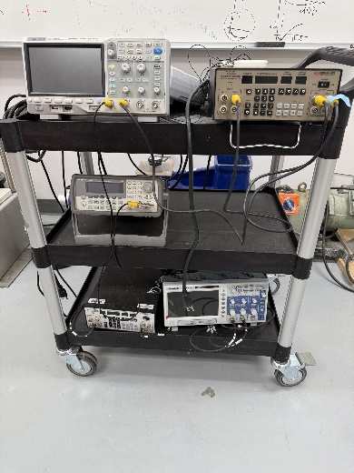
Figure 8. Equipment for Bender Element testing.

2.4. Water Absorption Test
Water absorption tests were conducted to evaluate the improvement in impermeability resulting from the crack healing process. The method was adapted from the water permeability test described by Luo et al. (2015) but modified to suit the cylindrical mortar specimens (2-inch diameter × 4-inch height) used in this study. Each specimen was fully immersed in water for 24 hours before testing to ensure saturation. After surface drying, specimens were placed vertically in a sealed PVC mold, and the mold was connected to a vertical water column. The initial water level (h₀) in the column was recorded, and the time taken for the water level to drop to a lower point (h₁) was measured. Water absorption rate was calculated based on the change in water height over time. Tests were performed on specimens both before and after the healing treatment. A decrease in water absorption rate after healing was considered indicative of effective crack closure and restoration of impermeability.

Project Progress:
- Progress for each research task
Task 1 progress [100% completed].
Task 2 progress [100% completed]
Task 3 progress [70% completed]

- Percent of research project completed
80% of total project completed through the end of this quarter

- Expected progress for next quarter
Finish 100% of the tasks. In the next quarter, the research team will continue to investigate the healing capability of fungi and bacteria on cement mortar cracks. Compression tests, S-wave velocity measurements, and crack size measurements will be performed to evaluate the healing performance.

- Educational outreach and workforce development
LSU ENGAGE (research demonstrations for middle school students)
LSU college of engineering
March 2025(Figure 9)
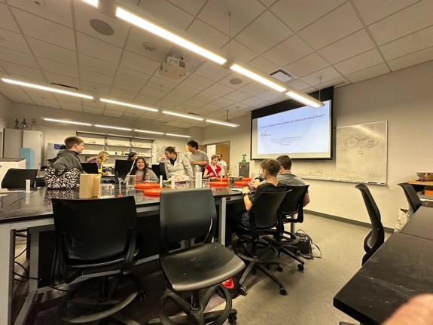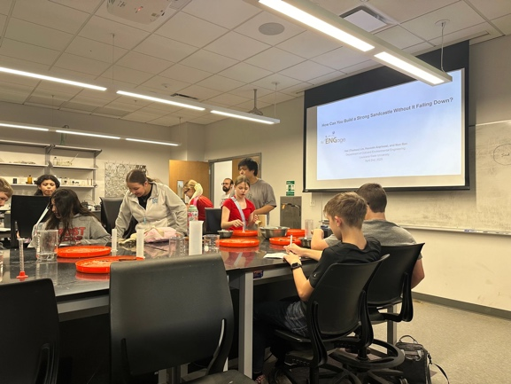
Figure 9. Photos of LSU ENGAGE for middle school students.

- Technology Transfer
None

Research Contribution:
- Papers that include TRANS-IPIC UTC in the acknowledgments section:
Lin, H. (2025). “Harnessing Fungal Mycelia for Sustainable Soil Improvement: Opportunities and Challenges.” Biogeotechnics, Under preparation.
Park, J.S., and Lin, H. (2025). “Role of Trichoderma Virens Mycelium in Enhancing Erosion Resistance of Low Plasticity Silt.” Biogeotechnics, In Press.

- Presentations and Posters of TRANS-IPIC funded research:
TRANS-IPIC September Monthly Research Webinar, title: Exploring Fungal-Mediated Carbonate Precipitation for Healing Concrete Cracks, Presented by Dr. Hai Lin

- Please list any other events or activities that highlights the work of TRANS-IPIC occurring at your university (please include any pictures or figures you may have). Similarly, please list any references to TRANS-IPIC in the news or interviews from your research.
None

Appendix 1: Research Activities, leadership, and awards (cumulative, since the start of the project)

- Number of presentations at academic and industry conferences and workshops of UTC findings
- No. = 2

- Number of peer-reviewed publications submitted based on outcomes of UTC funded projects
- No. = 1

- Number of peer-reviewed journal articles published by faculty.
- No. = 1

- Number of peer-reviewed conference papers published by faculty.
- No. = 0

- Number of TRANS-IPIC sponsored thesis or dissertations at the MS and PhD levels.
- No. MS thesis = 0
- No. PhD dissertations = 0
- No. citations of each of the above = 0

- Number of research tools (lab equipment, models, software, test processes, etc.) developed as part of TRANS-IPIC sponsored research
- Research Tool #1 (Name, description, and link to tool) = N/A
- Research Tool #2 (Name, description, and link to tool) = N/A
- Research Tool #3 (Name, description, and link to tool) = N/A

- Number of transportation-related professional and service organization committees that TRANS-IPIC faculty researchers participate in or lead.
- Professional societies
  - No. participated in = 2
  - No. lead = 0
- Advisory committees (No. participated in & No. led)
  - No. participated in = 0
  - No. lead = 0
- Conference Organizing Committees (No. participated in & No. led)
  - No. participated in = 2
  - No. lead = 0
- Editorial board of journals (No. participated in & No. led)
  - No. participated in = 0
  - No. lead = 0
- TRB committees (No. participated in & No. led)
  - No. participated in = 0
  - No. lead = 0

- Number of relevant awards received during the grant year
- No. awards received = 0

- Number of transportation related classes developed or modified as a result of TRANS-IPIC funding.
- No. Undergraduate = 1
- No. Graduate = 0

- Number of internships and full-time positions secured in the industry and government during the grant year.
- No. of internships = 0
- No. of full-time positions = 1

References:
Luo, M., Qian, C.X. and Li, R.Y., 2015. Factors affecting crack repairing capacity of bacteria-based self-healing concrete. Construction and building materials, 87, pp.1-7.

