UNIVERSITY OF ILLINOIS AT URBANA-CHAMPAIGN
THE GRAINGER COLLEGE OF ENGINEERING
306 Engineering Hall MC 266
1308 West Green Street
Urbana, Illinois 61801

Philippe H. Geubelle (217) 244-7648
Bliss Professor of Aerospace Engineering geubelle@illinois.edu
Executive Associate Dean http://ae.illinois.edu/directory/profile/geubelle

October 10, 2024
Andre Schleife (schleife@illinois.edu, MatSE) - Chair
Nick Colaneri (nfc@illinois.edu, GCOE office of Research)
Mark Hart (mshart@illinois.edu, Engineering IT – Ex Officio)
Mark Neubauer (msn@illinois.edu, Physics)
Jianqi Xi (jianqixi@illinois.edu, NPRE)
Jinhui Yan (yjh@illinois.edu, CEE)

Dear Colleagues:

Thank you for agreeing to serve on the Grainger College of Engineering IT Governance Research Working Group for the academic year 2024-2025. This working group is critical to helping ensure that IT support of the research needs of faculty, researchers, and graduate students in the College is of the highest quality and reliability.

Your recommendations and comments are advisory to the Executive Associate Dean, with primary responsibilities for:
- Reviewing policies concerning the sustainability and provision of any needed research IT that enhances the College research mission, both at the Engineering College level and at the campus level.
- Considering IT support for new research pursuits in our College, anticipating new opportunities and responding to interests and initiatives from our units.
- Monitor, assist with prioritizing, and provide feedback on the implementation of any proposals concerning research IT.
- Assist with monitoring, providing feedback, and reporting on the progress of work to align Engineering IT services with campus-level IT services, in particular with respect to research.
- Coordinating and communicating with the other IT working groups with overlapping interests.

In particular, over this academic year, I would like to ask you to
- Develop recommendations on DataCenter investment within GCOE
- Explore the pros and cons of a dedicated college-level office to handle software procurement.
- Consider the current ecosystem that supports the use of AI tools for research and make recommendations for policies and investments to enhance these capabilities.
- Review and evaluate efforts related to increasing awareness of technology resources for research.
- Review the need to renew previously recurring investments in research computing GCOE has made on behalf of our researchers.
- Review any proposed investments in research computing originating from campus and provide input on how they may be best directed and utilized by GCOE faculty

You will also be asked to provide an assessment at the end of the academic year (no later than June 1, 2025) on the current state of IT support for research activities. Dr. Schleife has graciously agreed to chair this working group. He will be in contact with you soon to arrange for your first meeting.

I am thankful to all of you for your willingness to contribute to this important work for our College.

Sincerely,
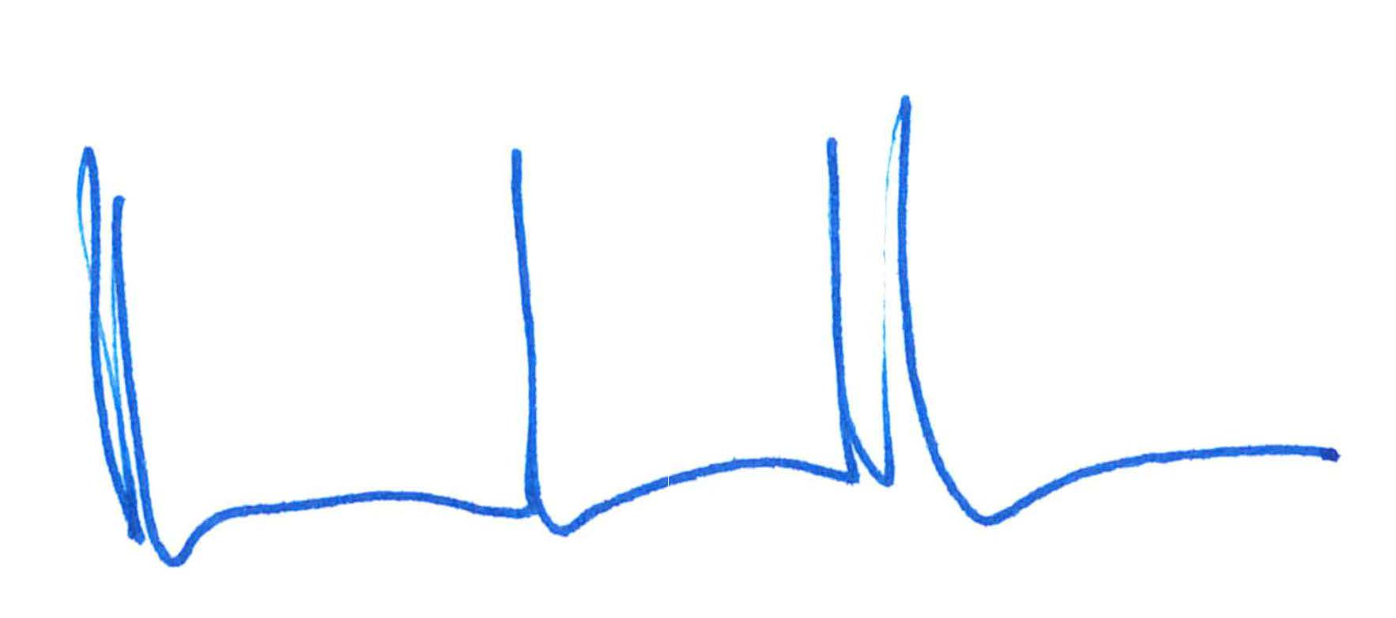
Philippe H. Geubelle

