

Transportation Infrastructure Precast Innovation Center
(TRANS-IPIC)

University Transportation Center (UTC)

Gaze-directed UAV-UGV Coordination Framework for Onsite Quality Inspection of Precast Bridge Construction
UT-23-RP-02

Quarterly Progress Report
For the performance period ending June 30, 2024.

Submitted by:
PI: Dr. Jiannan Cai, School of Civil & Environmental Engineering, and Construction Management (CECM), The University of Texas at San Antonio (UTSA); jiannan.cai@utsa.edu
Co-PI: Dr. Ao Du, CECM, UTSA, ao.du@utsa.edu
Co-PI: Dr. Ibukun Awolusi, CECM, UTSA, ibukun.awolusi@utsa.edu

Collaborators / Partners:
N/A

Submitted to:
TRANS-IPIC UTC
University of Illinois Urbana-Champaign
Urbana, IL

TRANS-IPIC Quarterly Progress Report:

Project Description:
- Research Plan - Statement of Problem
This project will develop a novel gaze-directed UAV-UGV coordination framework for on-site quality inspection of precast bridge construction. UAV will provide global coverage for inspectors to quickly identify the components and construction activities for inspection while UGV will navigate to specific locations for close inspection following human guidance. A new gaze-directed human-machine interface will be developed, where inspectors can express their guidance via natural gaze movements, to reduce worker mental load. The proposed framework is expected to transform the practice of onsite quality inspection for precast infrastructure construction by establishing intuitive multi-robot-human teaming for efficient inspection. Such a system can be extended to provide guidance during bridge installation, thus improving construction quality and durability with reduced rework. The proposed framework can also be extended for lifecycle inspection, including offsite component inspection and condition monitoring of existing infrastructure, and eventually improve the durability and extend the life of precast transportation infrastructure.

- Research Plan - Summary of Project Activities (Tasks)
Task 1. UAV-UGV coordinated localization and navigation.
This task aims to develop a hierarchical framework that will enable UGV to automatically locate and navigate to the inspection area as indicated by the UAV, leveraging sensing data from onboard GPS and camera of both robots.

Task 2. Gaze-directed and AI-powered human-robot interface.
This task aims to develop a gaze-directed and AI-powered human-robot interface (HRI) such that the robot could navigate to a specific location based on the guidance from human natural gaze movement.

Task 3. Prototype development and experimental demonstration.
This task aims to develop and test a prototype of the proposed framework. In our preliminary study, we have developed a mobile robot teleoperation interface that can be used for inspection on jobsites.

Project Progress:
- Progress for each research task

Task 1 progress [70% completed]
Task 2 progress [100% completed]
Task 3 progress [25% completed]

Note: The research planned for Task 1 and Task 2 is relatively independent. Therefore, based on our current research schedule and resources, we started Task 2 first and have completed the technical development of Task 2, i.e., a gaze-directed and AI-powered interface for ground robot inspection. Task 3 will combine both methods for testing real world scenarios.

Our developed methods and results for this quarter are detailed below.

Task 1. UAV-UGV coordinated localization and navigation.

- Using the Gazebo physics simulator, we developed a construction environment site to test our mapping and navigation algorithms. We configure the simulator to run a digital twin of the Clearpath Husky ground robot (Fig 1) used in our research lab and of a generic quadrotor UAV model (Fig 2). Both robots can be controlled autonomously through Robot Operating System (ROS) packages and teleoperated from a keyboard. The robots are equipped with cameras and laser depth sensors for mapping the simulated environment. A demo of the simulated environment can be found here: Video Link Here

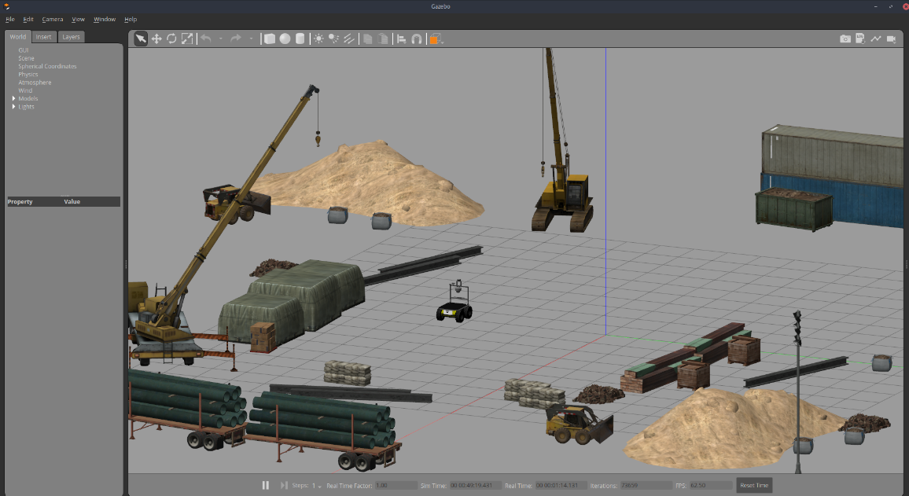
Fig. 1 Simulation for ground robot

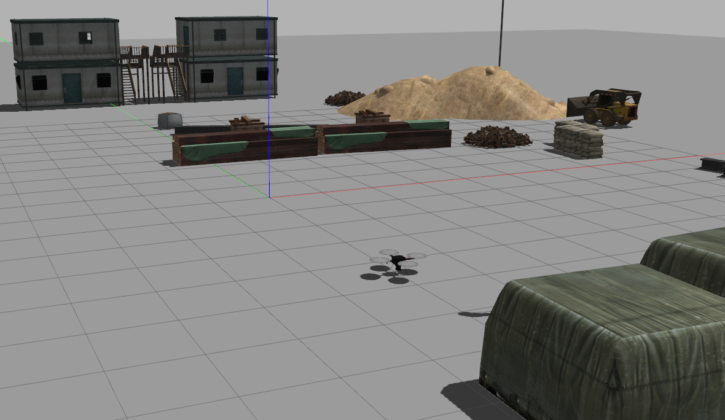
Fig. 2 Simulation for UAV

- We developed a GPS multi-waypoint navigation method for coordination between drone and ground robot (Fig. 3). Our method proposes a drone gathers Waypoint message data and streams all to a base station, Waypoint data is sorted by distance from UGV initial location and is then sent to the UGV as an InspectionPlan message with multiple Waypoint messages. The UGV then drives to the GPS target and attempts to match the scene by scanning and moving within an circular area of likelihood based on the accuracy of the GPS sensor. When a certain confidence threshold is reached, the UGV request remote operator assistance for further inspection. If the robot has scanned the area of likelihood but could not match to the confidence threshold, user assistance is requested.
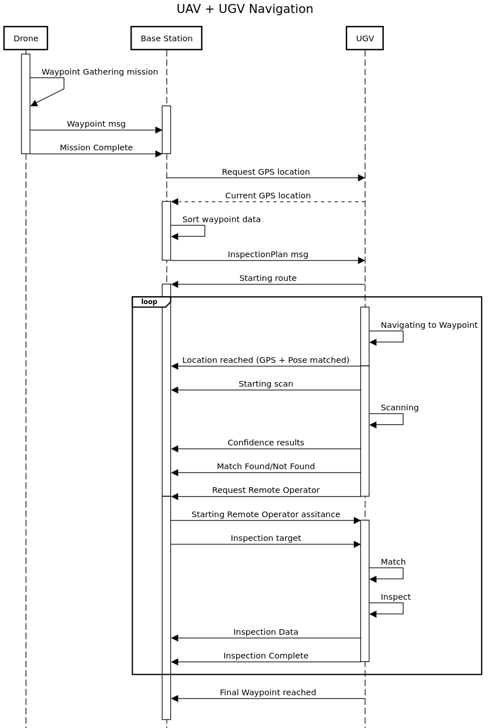
Fig. 3 GPS multi-waypoint -based coordination between drone and ground robot

- We tested up the waypoint navigation method within the simulation environment. In this testing the aforementioned sequence is followed, where a drone captures data and GPS coordinates of a target and then a ground robot (Clearpath Husky) proceeds to navigate to those coordinates (Fig. 4).
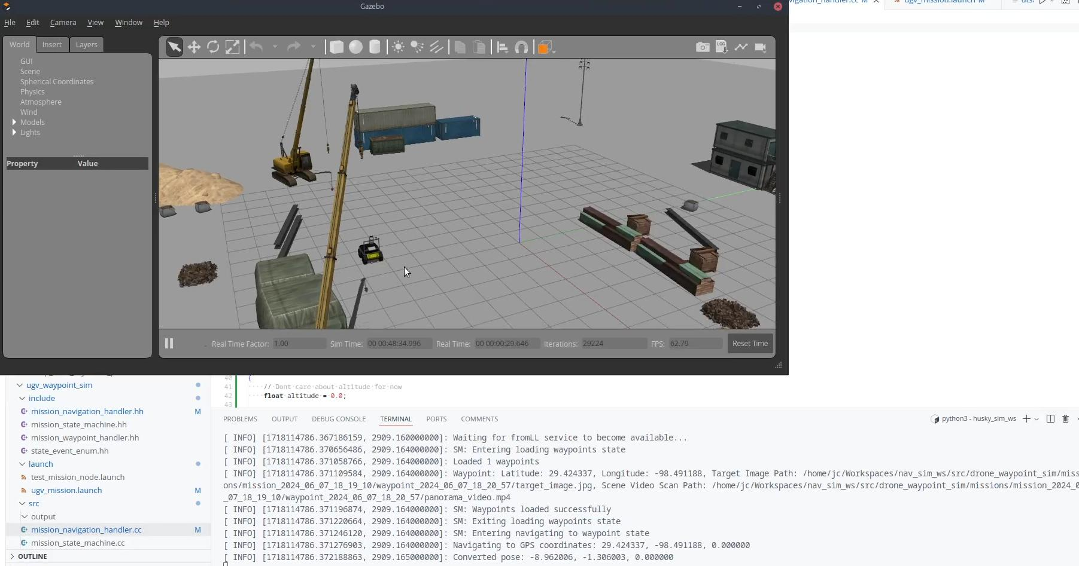
Fig. 4 GPS-based navigation for ground robot in simulation

- To complete our proposed method, we are developing a refined localization method where the ground robot references provided images and video from the drone to find the target within its scene. This method enables a UGV to localize a target even if its GPS receiver only offers meter accuracy, thus allowing less expensive and accurate sensors to be used for robotic automation of remote precast concrete structure inspection.

Task 3. Prototype development and experimental demonstration.

- We tested the GPS waypoint method outdoors on a real ground robot. For this demonstration we gave the Clearpath Husky robot a target latitude and longitude near our lab space and then allowed it to navigate to that position. A demo video can be found here: Video Link Here

- We gathered outdoor drone data to test visual scene matching methods and multi-waypoint GPS navigation on ground robot in outdoor environments. For this, multiple concrete based objects were situated within a netted drone cage (Fig. 5). We then piloted a M30 DJI drone to capture video footage with annotated GPS coordinates on each frame. After the drone inspects each object of interest, we captured video footage at the expected level the ground robot would be at. As the ground robot’s software is still being developed, we did not plan to drive it out in the drone cage at this time. The captured video will be used to test our visual matching software for the ground robot target localization. Video Link Here

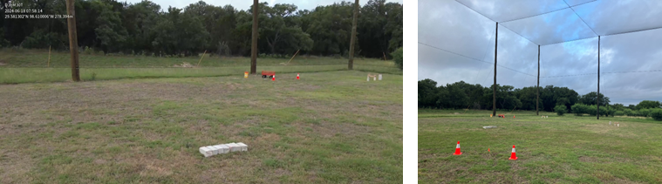
Fig. 5 Sample set up for outdoor data collection

- Percent of research project completed
Estimate 65% of total project completed by the end of this quarter.

- Expected progress for next quarter
- Complete Task 1 scene matching methods.
  - Using the simulated environment and real-world data gathered from the drones, we plan on developing a value mapping method for creating a local 2D exploration map for the UGV. Value will be assigned to different regions of the map based on correspondence and similarity to the target image. Then the robot will identify and locate the required target autonomously and then request a remote user to perform further inspection of the target based on our work in Task 2.
  - Once verified, we will begin integrating the framework together and test within our simulated environment.
- Complete initial testing for Task 3.
  - For testing in Task 3, we will take both the drone and the robot to our outdoor netted environment and set up concrete-based structures for inspecting with the developed framework. For these tests, the drone will capture GPS coordinates and image data so that the UGV can localize the target at a later time. We will experiment to see how changing background clutter and lighting affects the developed localization methods.

- Educational outreach and workforce development
- Supported and trained one Ph.D. student, Xiaoyun Liang (female student) and, one master student, Juan Cruz Rivera (Hispanic student), on robotic research with applications in transportation infrastructure.

- Technology Transfer
N/A

Research Contribution:
- Number of papers
two conference papers accepted
- Juan Cruz Rivera, Xiaoyun Liang, Ibukun Awolusi, Ao Du, and Jiannan Cai. (2024). A Gaze-Controlled Robotic Framework for Remote Site Inspection. ASCE International Conference on Computing in Civil Engineering 2024. (accepted)
- Liang, X., Cruz Rivera, J., Cai, J., & Li, S. (2024). Gaze-enhanced and LLM-enabled System for Intuitive Human-Robot Collaboration. In Computing in Civil Engineering 2024 (accepted)

- Number presentations (when, where)
N/A

References:
N/A

