- Go to the ICT website (www.ict.illinois.edu) (unless you used the link from the email)
- Click Research then QPR Login (shown in the image below)
- 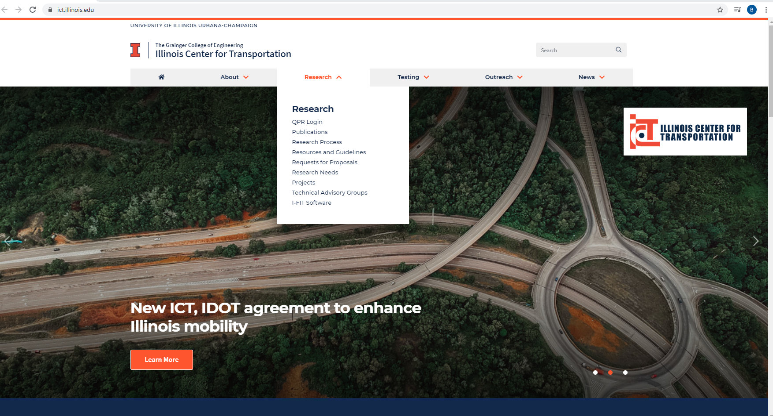

- Enter username/password. (Follow instructions on website if you do not know your password)
- If you are the PI of a project, ICT - has entered your username as the PI for that project. Once your username is entered into a project’s Personnel list, that project will appear after you have logged in. Projects that require your attention for the current quarter will have a blue Submit/Update QPR button under the “Action Needed” column on the right side of the screen.
- Find the project for which you wish to update the QPR, click Submit/Update QPR on right hand side (shown in the image below).
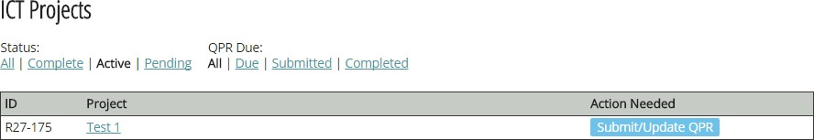

- Once you have clicked the Submit/Update QPR button, you will see several sections. Some fields are greyed out, some appear in white, while others appear in white with a red asterisk. A white field with a red asterisk denotes a required field. If you see an error in a greyed out section, please leave a comment in the project discussion board at the bottom of the QPR or email the ICT staff at ICTProjectManagement@illinois.edu with the error you have noticed.
Please review and update the following areas:

  - Personnel (shown in the image below) – as PI of the project, you may add:
    - Co-investigators
    - Students working on the project

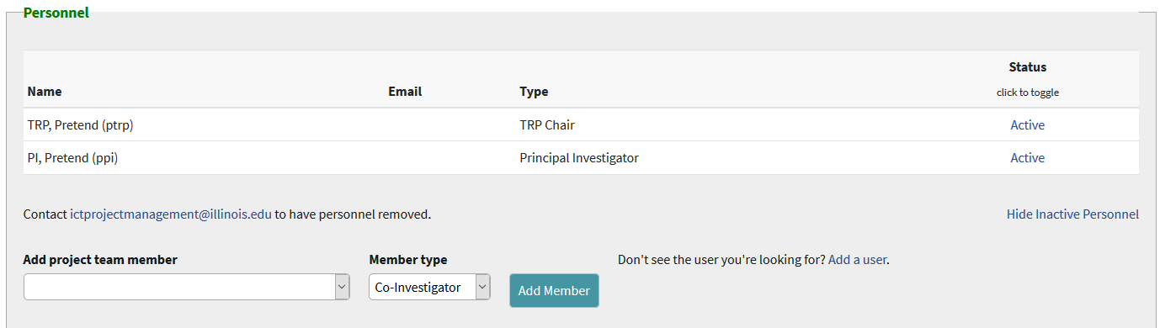

  - Project Details (shown in the image below)
    - Keywords – please enter or update keywords that may be associated with the project
    - Tasks – For each task, complete the following.
      - Task Status (Required) – Please select one of the options for the status of the task. These include: On Schedule, Ahead of Schedule, Potential Problem, Behind Schedule, and Completed.
      - Total % Complete (Required): Please enter the percentage that correlates to how complete the task is (please note that each task can have a value from 0-100).
      - Total Project Completion (Required): Please enter the percentage that states how complete the entire project is (please note that this should not be a summation of each individual tasks’ percentage. This field can have a value from 0-100).

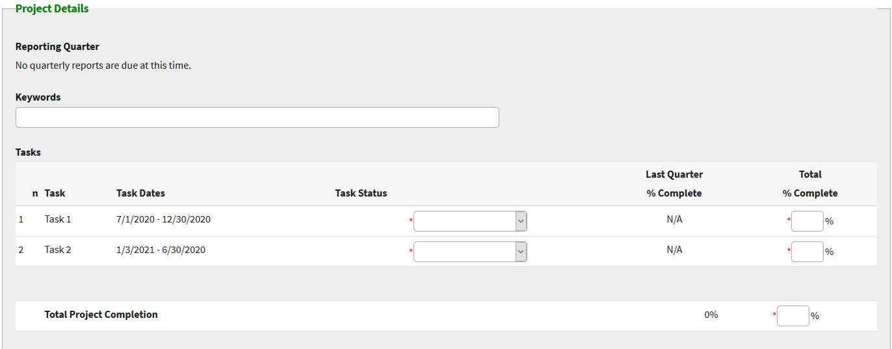

    - Project Description (shown in the image below) – please enter or update the description of the project. This section has a 100 word limit.


    - Progress and Significant Results this Quarter (Required) (shown in the image below) – Please only enter information for the present quarter. Entries from previous quarters will be archived in the database. Please click Show history to view any available archive.

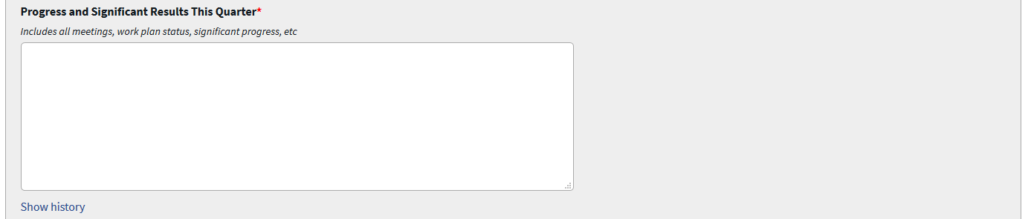

    - Anticipated Work Next Quarter (Required) (shown in the image below) – Please only enter information for the next quarter. For example, if you are completing the QPR for the quarter of January 1 – March 31, then you would enter the anticipated results for the April 1 - June 30 quarter. Entries from previous quarters will be archived in the database. Please click Show history to view any available archive.



    - Project Schedule Status (Required) (shown in the image below) – Use to indicate to the TRP Chair any potential schedule problems with the project. This will color code the project on the view project page, so that the TRP Chair will know there is a warning or that the project is behind schedule.
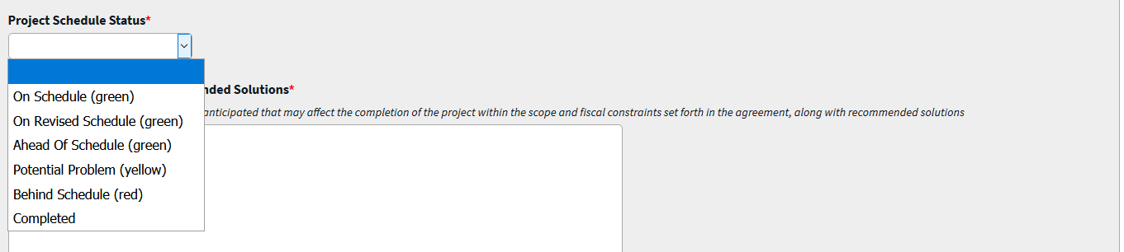

    - Project Impediments and Recommended Solutions (Required) (shown in the image below) – If the project is behind schedule, indicate the specifics of the problem here and recommend solutions to the TRP chair, as appropriate. Please click Show history to view any available archive.
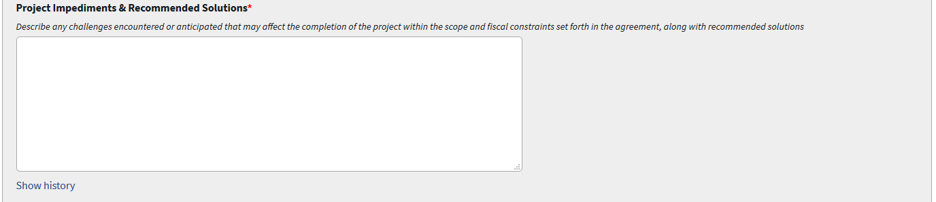

  - Project Discussion Board (shown in the image below)
    - Please use this section to send comments to the TRP Chair of the project and to ICT staff. Discussion can include, but are not limited to:
      - An explanation of why you entered certain information into the quarterly report.
      - Any errors or typos you may notice on the report.
    - Please note that both the Save QPR and Save and Submit QPR buttons will submit any comments.
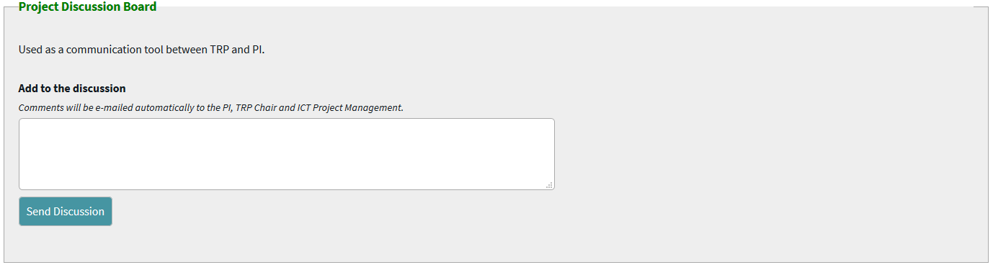

- To save your progress without submitting to the TRP chair, click Save QPR at the bottom of the page (shown in the image below).

- Once all fields have been reviewed and updated and you are ready to submit the report to the TRP Chair, please click the Save and Submit QPR button at the bottom of the page (shown in the image below).
  - Please note the TRP Chair will have the option to send the QPR back to you to make changes and/or address comments he/she makes before final approval. Such action will require you to click Save and Submit QPR again.

- If you submitted the QPR, but did not complete all required fields (denoted with a red asterisk), you will receive a message similar to the below. You will have to complete the required fields and click Save and Submit QPR again.
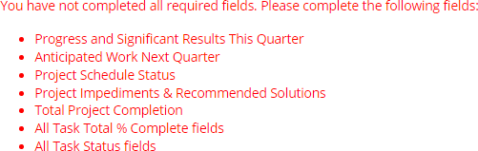

- When you have completed the QPR (and completed all required fields) you will receive the following message thanking you for submitting your QPR (shown in the image below):
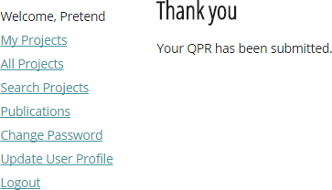

- Once the TRP Chair approves the QPR, you are finished with the report for this quarter, and all archived sections are stored for future reference. You will receive an email stating that the TRP Chair for your project has approved your QPR (shown in image below).

