

Final Report

NG 9-1-1 Interoperability Testing Program
June 2021

Critical Infrastructure Resilience Institute

Texas A&M University

University of Washington

Acknowledgement: This material is based upon work supported by the U.S. Department of Homeland Security under Grant Award Number 15STCIR00001.

Disclaimer: The views and conclusions contained in this document are those of the authors and should not be interpreted as necessarily representing the official policies, either expressed or implied, or the U.S. Department of Homeland Security.

Table of Contents
Executive Summary 4
Research Approach 4
Key Findings 5
Recommended Path Forward 6
INTRODUCTION 9
Background 10
Objectives 11
RESEARCH APPROACH 12
First Responder Engagement 12
Understanding Technical Requirements 14
The Process of Developing a Sustainable Business Model 16
FINDINGS 22
Key Definitions – Types of Testing 22
Scope of Testing Effort 24
Review of Existing Testing Methods and Programs 28
Establishing Accredited Test Facilities 34
Options for Deploying a Testing Facility 36
Business Model Recommendations 39
Revenue Model 40
Stakeholder and Vendor Participation and Feedback 41
Establishing a Standards-Based Testing Program 42
Federal Sponsor Engagement and Priorities 43
Proposed Path Forward 45
Appendix 50

Executive Summary

  - Final Report: NG 911 Interoperability Testing Program

The Critical Infrastructure Resilience Institute (CIRI) a Department of Homeland Security (DHS) Center of Excellence housed at the University of Illinois was tasked with researching, analyzing, and producing a series of deliverables that define a detailed process through which one or more sustainable organizations could be created that meet the demand for achieving interoperability across NG 9-1-1 systems through industry-supported interoperability testing programs. To achieve this objective, CIRI partnered with Texas A&M University Internet 2 Technology Evaluation Center (ITEC) for public safety communications and testing expertise, and University of Washington for first responder engagement.

Together with a robust collection of industry stakeholders, the project team set forth to research and establish a plan to achieve the project objective, thereby providing a sound path forward toward ensuring that the nation’s first responders can execute their collective public safety mission through use of reliable and secure systems with seamless communication and data exchanges. This Executive Summary prevents a brief review of the approach, outcomes and go forward strategy defined through this effort. For a complete report of the analysis and other efforts that brought us to the conclusion summarized here, please reference “Final Report: NG 911 Interoperability Testing Program.”

Research Approach
In order the gain the insights needed to define a successful testing program, the project team require input from industry stakeholders across the vendor community, first responders, industry associations, standards bodies, testing organizations, and government. The effort required deep understanding of both practical, operational concerns of PSAP operators and front-line responders, and detailed technical insights into standards, testing best practices and processes. Finally, to design a sustainable business model, the team needed to understand the nature of the NG 9-1-1 market and the potential for industry engagement in a testing program.

To gain the insights required, the project team established two primary avenues of information gathering:

- stakeholder group engagement – through establishing a stakeholder committee comprised of technical, business, and first responder sub-committees, meetings, discussions, online portal, and gathering of input regarding test cases and prioritization

- industry research – through literature searches and interviews with key industry organizations engaged in testing and related activities

Regular meetings of the stakeholder committees provided a venue for rich discussion of key definitions, technical considerations, factors that will impact financial sustainability of any given business model, and first responder perspectives. Sub-committees met separately for focused discussions and listening sessions and as combined groups so that each had the opportunity to hear other perspectives.

Stakeholders represented industry organizations, including iCert, APCO, and NENA as well as first responder organizations such as NASNA, International Association of Chiefs of Police, International Association of Fire Chiefs, National Sherriff’s Association, among others. A full list of first responder outreach and rosters of business model, membership is included in the full report.

Industry research conducted through both literature searches and interviews with organizations actively engaged in testing provided insight into technical issues and helped the team understand key considerations for a sustainable business model. Finally, and importantly, interviews with state and federal representatives provided the insights needed and the basis for the ultimate model recommended for the path forward. In research models for certified conformance testing program, much was gained by studying the existing P25 Compliance Assessment Program (CAP). Ultimately, and based on the success of P25 CAP and the existing infrastructure and lessons learned through the development of the program, the research team modeled the path forward for NG 911 Interoperability Testing Program after the P25 CAP program.

Key Findings
Key findings of the research effort relate to both the technical definitions and approach and the program business model. Foundational to both is the definition of key terms upon which to build a testing program for NG 911. This is essential given that stakeholders and industry groups in the NG 911 space have been using the same terms to define different types of testing efforts and have had different understandings regarding the scope of a testing effort.

After a great deal of discussion and in consideration of the objective to establish a testing program that will affirm that a given product reliably operates in accordance with a given set of test parameters, the research team settled on the following definitions of the types of testing relevant to the scope of the NG 911 Interoperability Testing Program.

- Conformance Testing - the testing of a vendor system, subsystem, component, or element against a promulgated/published standard. This type of testing requires a known working standard implementation as the “reference implementation,” and formalized test plans specific to a system, subsystem, component, or element. This testing is typically done in a lab environment by an independent third party. Vendors can perform testing without coordinating with other vendors.

- Compatibility Testing (formerly Interoperability Testing) - The testing of the functional interaction of two or more systems, subsystems, components or elements at the point/method of interconnection. This type of testing is typically done on a cooperative basis by vendors supplying systems, subsystems, components, or elements that must interact with each other seamlessly. This effort is usually done in the lab of one of the vendors and sometimes done over a site-to-site VPN. In some cases, this can also be done in a lab by an independent third party, but this option generally costs more than conformance testing. Many times, this testing is done because the participating vendors are business partners and routinely collaborate preparing proposals in response to RFPs. Sometimes the testing is done at the request of a customer or customers. This testing deals with the interconnection of Core Functional Elements within a single domain or jurisdiction.

- Interoperability Testing (formerly End-to-End Testing) - Testing of all systems, subsystems, components, or elements comprising a complete system or solution. This testing is almost always done in the customer environment and typically at the time of turn-up of the heterogeneous system. Some large customers have lab environments established to support this type of testing. Most customers, however, depend on the vendors to set up the test environment. This testing in terms of this study is being described as testing across and between domains or jurisdictional boundaries.

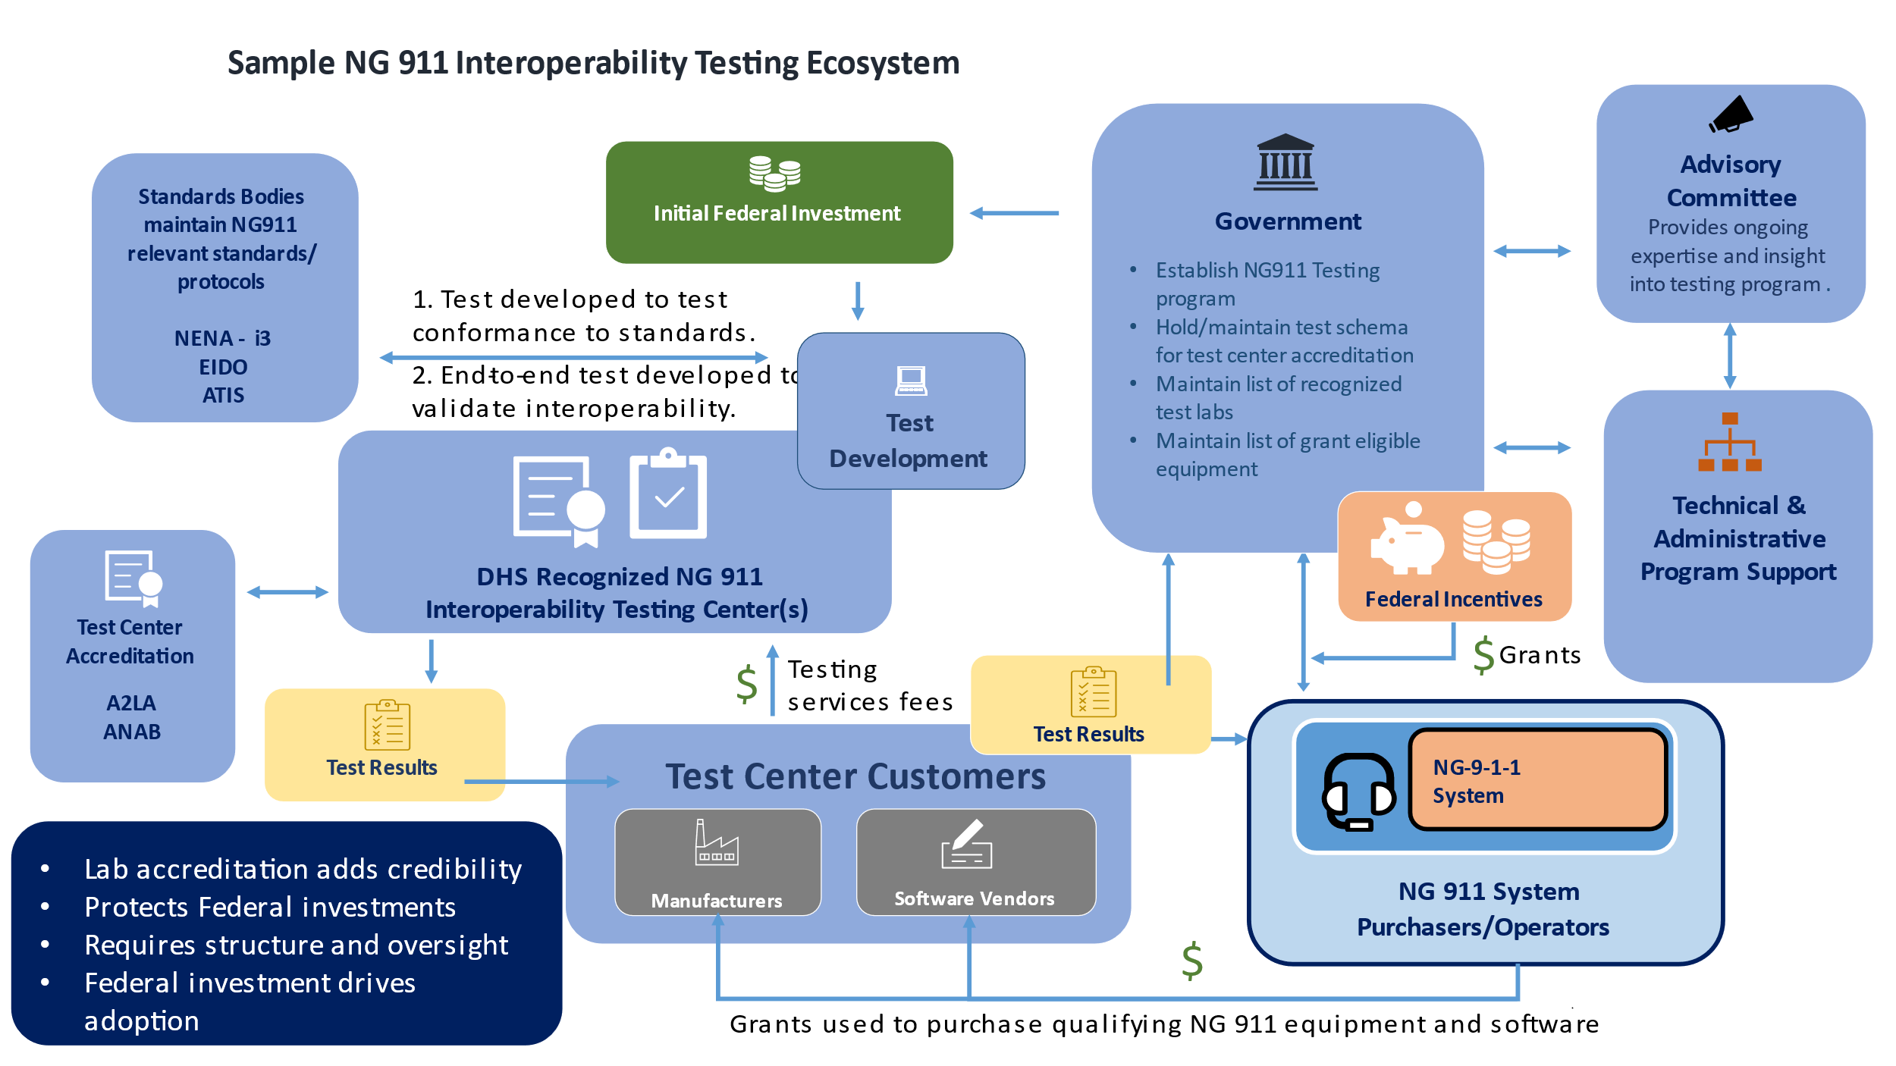
With definitions established for the types of testing to be undertaken, the research team focused on defining the players and roles required to establish a sustainable testing business model. A key outcome of discussions with stakeholders that influences the model is the requirement for authorized testing labs – facilities that achieve an industry standard certification to assure that testing will be conducted in a reliable and repeatable fashion. This requirement dictates that an entity must be established to own testing protocols against which authorized labs are evaluated. Furthermore, there must be a mechanism for establishing the testing protocols, adapting them over time as technology evolves, and continue to engage stakeholders from industry and the first responder community. To capture the ecosystem required to support the NG 911 Interoperability Testing Program, the research team developed the summary graphic below. This ecosystem is modeled largely after the P25 CAP program and assumes that infrastructure established for that program can be leveraged in support of the NG 911 Interoperability Testing program.
Figure 1: NG 911 Interoperability Testing Ecosystem

Recommended Path Forward

Following is a summary of the research team’s recommended approach to move forward with development of the NG 911 Interoperability Test Suite.

- Government establish an NG 9-1-1 Compliance Assessment Program modeled after and leveraging the resources of the DHS P2 CAP program.
- Establish a Program Office responsible for technical and administrative support of the NG 9-1-1 Testing Program.
- Establish an NG 9-1-1 CAP Advisory Committee which would be the forum for stakeholder representation and engagement.
- Designate DHS authorized NG 9-1-1 Interoperability Testing Centers.
- Require Test Center Accreditation – Any test center performing NG 9-1-1 interoperability under the DHS CAP program would be required to obtain ISO 17025 testing certification.
- Engage Relevant Standards Bodies – The project team recommends recognition of any standards body that is an ANSI recognized Standards Development Organization (SDO) and is relevant to NG 9-1-1. The standards bodies initially recognized would be the National Emergency Number Association (NENA) with their i3 Standard for Next Generation 9-1-1 and the Alliance for Telecommunications Industry Solutions (ATIS) with their ATIS-0500032 ATIS Standard for implementation of and IMS-Based NG9-1-1 Service Architecture.
- Fund Test Development – The research team recommends funding the development of the test cases for the NENA i3 specifications. The NENA i3 is currently a draft document awaiting ratification which is likely to occur before the NG 9-1-1 Testing project begins. The research team did consider other standards such as the ATIS IMS specifications and the NENA EIDO specifications. We did not recommend development of the ATIS standard test cases since only one manufacturer is currently developing or marketing any core IMS NG 9-1-1 functional elements and we were not able to identify any service provider in the United States planning such a network.

The development effort would be a 24-month effort managed by the TAMU ITEC with Dr. Walt Magnussen serving as the Principle Investigator and it would include at least three subcontracts, one would be for the documentation of the test cases, another to do the actual writing of the code for the test cases (these two could be conducted by the same firm), one to provide any additional support services required to create the full test system and at least one to fund Subject Matter Experts to ensure conformance to the standards. These SMEs would likely come from the committees that helped to develop the standards which would ensure an understanding of the original intent of the standard. Once these test cases are developed the IP would belong to the funding entity to be managed by the CIRI NG 9-1-1 CAP Program Office.

The research team have met with firms capable of supporting such a subcontract and recommend Grid Gears of Austria to support this part of the project. The entire interoperability suite would include somewhere between 150 and 250 test cases and could take up to 24 months with the final 12 months reserved for bug fixes, test suite enhancements and possible additional test cases. These test cases would include about 33% conformance tests, 33% compatibility tests and 34% interoperability tests. Grid Gears is recommended due to their experience in TTCN-3 as well as their deep understanding of NG 9-1-1. This was a combination of skills that came highly recommended by the ETSI team that funded the initial NG 112 conformance test suite in 2019.

Finally, while the research team initially anticipated a Phase II proof of concept and eventually a Phase III full production development effort, anticipation of significant Federal NG 911 funding prompted the team to recommend fast tracking the effort. The continuity and exigency of the momentum created by this project will very likely impact the proper allocation of between nine and fifteen billion dollars of federal NG 9-1-1 network deployment funds, if appropriated by Congress. As such, the team recommends proceeding with the above outlined path forward to enable continued momentum and progress toward realization of an NG 911 Interoperability Test Suite.

INTRODUCTION

The Critical Infrastructure Resilience Institute (CIRI) a Department of Homeland Security (DHS) Center of Excellence housed at the University of Illinois at Urbana-Champaign, was tasked with researching, analyzing and producing a series of deliverables that define a detailed process through which one or more sustainable organizations could be created that meet the demand for achieving interoperability across NG 9-1-1 systems through industry-supported interoperability testing programs. To achieve this objective, CIRI partnered with Texas A&M University Internet 2 Technology Evaluation Center (ITEC) for public safety communications and testing expertise, and University of Washington for first responder engagement.

Together with a robust collection of industry stakeholders, the project team set forth to research and establish a plan to achieve the project objective, thereby providing a sound path forward toward ensuring that the nation’s first responders are able to execute their collective public safety mission through use of reliable and secure systems with seamless communication and data exchanges.

One of the central project deliverables is the definition of a business model that outlines a comprehensive, sustainable, market-based approach to ensure the sustainability of this project’s solution. Intrinsically linked to the business model is the other major project deliverable, a detailed plan and proposal to develop the testing suite. Implementation of the proposed testing methodology and business model for executing that solution will result in the envisioned functional interoperability testing program.

At the project outset, central components of success were identified to include achievement of stakeholder consensus on requirements for interoperability, identification of appropriate technical means for conducting interoperability testing, and articulation of a self-sustaining business model to implement interoperability testing. The following key considerations were central to the approach taken, the research and evaluation process, and the resulting recommendations:

- It is critical to secure widespread stakeholder adoption for the testing program
- Interoperability must be tested and validated through both conformance testing and end-to-end testing
- Business model must be self-sustaining - without perpetual government subsidy
- The program must address access to, interpretation of, and availability of test results
- Vendors must have early and continuous visibility, input and access to testing methodologies
- A visible and effective governance structure must underpin the operation of the program
- To better define the parameters of their role, the first responder and 911 professional communities must play an active role in the evolving testing strategies to ensure outcome alignment, and provide feedback on the impact of interoperability testing
- Testing processes must be designed to permit both monitored and self-administered tests
- The entire structure of the testing program must be malleable to allow for innovation, evolving requirements and ultimately achievement of the underlying purpose for the testing

This report conveys the results of the collective efforts of teams from CIRI, the University of Illinois Urbana-Champaign, Texas A&M University, University of Washington and various collaborators who have been actively engaging in its creation. During that process broad stakeholder participation was invited and achieved. A wide range of technical considerations were assessed and discussed and the blueprint for a sustainable business model was influenced by those critical inputs. The business design process was significantly informed by technical considerations and consistent input from the created member ecosystem that included the lead Universities, Public Safety Answering Points, or PSAPs (including state, local, tribal, and territorial (SLTT), DHS, the Department of Transportation, the vendor community, representative associations and organizations (including first responder groups) and the critical presence of public safety representatives from across the country.

Background

In 2004 the National Emergency Number Association (NENA) began the process of transitioning to Next Generation 911 (NG 9-1-1). Supporting requirements include use of Internet Protocol, support of multi-media to include not only voice but video, text, external data and any other media that may come in the future, and that it would be built on open standards. The NENA i3 architecture document was created as the basis for a proposed standard that is currently in draft and expected to be adopted in the coming months.

While the effort to establish NG 9-1-1 functional and interface standards marks major forward progress toward achieving interoperability, a critical need to understand operational and technical requirements for testing interoperability remains. Existing 911 systems were designed to meet jurisdictional needs and thus each is likely to be unique. As these systems are migrated or upgraded, there is no single approach or methodology for implementation of NG 9-1-1 systems and thus each implementation may not be fully interoperable or compatible and therefore able to share information across systems. A cohesive and broadly supported plan is required for empirically testing NG 9-1-1 interoperability.

The ultimate objective is not to identify, select and drive compliance to only a single industry standard. Rather, this stakeholder community is supportive of the creation of an agreed upon standards-based approach to creating a comprehensive testing program, implemented through one or more entities in combination with a management oversight entity to ensure program implementation. The program will be voluntary and vendors will have to opt-in. The existence and use of the testing program will drive progressive industry behavior toward actions that reduce unacceptable risk to public safety by significantly increasing the availability of demonstrably interoperable systems.

Furthermore, compliance with a standard does not in and of itself guarantee interoperability. What is feasible is gaining stakeholder agreement to participate in a testing process demonstrating the potential for an increasingly interoperable system architecture. This program will achieve its objectives through the oversight and direction of both federal program sponsors and an independent third-party program management entity, facilitation of a testing program that includes some combination of required conformance testing, available end-to-end testing and overall interoperability testing.
The marketplace will dictate some behaviors, while other behaviors may require certain incentives to be actualized. Federal program sponsors are driven to support and encourage marketplace behavior that results in the demonstration of actual interoperability through initial program investments and long-term outcome-driven support for procurements that result in the installation and use of fully interoperable public sector NG 9-1-1 systems.

Since 2009, a series of Industry Collaboration Events (ICE-1 to ICE-9) have been held (initially by Texas A&M University) that continue today. These events, while useful in assembling engineers for the purpose of collaboration and bilateral testing, were not designed to evaluate interoperability against a set of interoperability requirements. Further ICE testing is directed solely by participating vendors and their specific needs and the results of tests not publicly disclosable by design. While the ICE annual program provides a platform for innovation and equipment testing, it does not address the purposes intended hereunder.

Objectives

The Department of Homeland Security has demonstrated the ability to drive other successful testing programs, and this program has the same potential for marketplace impact. Ultimately, for entities managing NG 9-1-1 systems and agencies funding these systems, the most important aspect of testing is that the process reveals outcomes that are consistently predictable of how these systems and their components will function when installed in complex and diverse environments. As a result, there remains an ongoing need to balance the direction and relevance of evaluation requirements against the practicality of marketplace adoption and execution so that compliance with those requirements translates into predicable and consistent interoperable systems in practice. Toward these ends, this project has the following defined objectives:

- Engage stakeholder representatives from the first responder community and industry and build consensus around a testing program approach
- Analyze existing testing efforts elsewhere in the industry to understand lessons learned and identify best practices
- Document requirements to be tested
- Analyze technical issues for interoperability testing
- Research and analyze test development models that could support interoperability testing in the NG 9-1-1 industry
- Analyze potential business models for sustainability

This effort has included significant stakeholder engagement and confirmed both the existence of uniform interest in achieving system interoperability, and also thatwhile participants may disagree on exactly how that outcome is achieved, stakeholders are committed to participating in this process and providing ongoing feedback and input. As a result, solicitation of input and feedback from active stakeholders must continue throughout the testing design, implementation and assessment processes going forward.

Finally, while interoperability is the primary focus of this project, the team recognizes the necessity to always be cognizant of the existence of cyber threats as an overlay consideration when engaging in the design and execution of standard architecture, design elements and system testing requirement. As attack surfaces are created, identified and exploited, awareness of those risks should always be a primary consideration. Even though specifically addressing cybersecurity is not an identified part of the deliverables of this project, its existence is topical and always relevant. Independent of this project, CIRI is fully engaged in multiple other work efforts focused on cyber threat mitigation specific to 911 systems. Communication channels are open and to the extent information or best practices are identified as necessary for integration with interoperability testing programs, those recommendations will be made, and steps taken to ensure substantive project integration occurs where appropriate.

RESEARCH APPROACH

In order the gain the insights needed to define a successful testing program, the project team requires input from industry stakeholders across the vendor community, first responders, industry associations, standards bodies, testing organizations, and government. The effort requires deep understanding of both practical, operational concerns of PSAP operators and front line responders, and detailed technical insights into standards and testing best practices and processes. Finally, in order to design a sustainable business model, the team needed to understand the nature of the NG 9-1-1 market and the potential for industry engagement in a testing program.

To gain the insights required, the project team established two primary avenues of information gathering:

- Stakeholder group engagement – through establishing a stakeholder committee comprised of technical, business, and first responder sub-committees, meetings, and discussions; develop an online portal, and gather input regarding test cases and prioritization

- Industry research – through literature searches and interviews with key industry organizations engaged in testing and related activities

Following is a summary of the research activities undertaken to ensure thorough understanding of first responder, technical, and business considerations for an effective and sustainable NG 9-1-1 testing program.

First Responder Engagement

For the purposes of this project, first responders, including municipal police, tribal police, sheriffs, fire chiefs, volunteer fire agency leadership, and emergency medical services (EMS), were identified. Collectively, sheriff’s offices, police departments, and fire department organizations operate and manage over 6,000 primary and secondary PSAPs in the United States. The first responder participant group does not represent the totality of PSAPs in the U.S. when considering Department of Defense (DoD) and other federal agencies that have 911/emergency communications capability.

It has been important to incorporate first responders into the technology and business process structure of this project because of their dual role—as PSAP operators and as the frontline response to a 911 emergency call. Their engagement contributes the “hands on” application of NG 9-1-1 interoperability on the technical and hardware/software side of the initial call for help. It is their (PSAP) telecommunicators taking in and pushing out to enroute and/or on-scene line personnel who may then have to uniformly and seamlessly intake, interpret, respond to, and manage the addition of text, video, GPS/location, and other data types, including citizens, victims, witnesses, or others in crisis, to coordinate life-safety decisions in minutes or even seconds.

On the other end of interoperability, first responders contribute the perspective of field-based information sharing, reaction, and response among various disciplines (fire, emergency medical services (EMS), Offices of Emergency Management (OEM), transportation, etc.), and the drivers of complex transfers of information emerging as NG 9-1-1 technology and implementation evolves on the front line. This is the technological interoperability necessitated via the real-time transfer of information from the community operationalizing a scenario, now potentially from many players and perspectives (e.g., phone video and audio) and initiating a call for help across any of NG 9-1-1’s emerging options. This all occurs with the transfer of the intake call (911 call routing) to telecommunicators and out to the field from inside the PSAP.

Interoperability evaluation and testing discussions in this project, whether technological or response-based, have been enhanced and served where the relevant factors of human behavior have been considered and applied as critical first responder contributions, perspectives, and input. In the end, true interoperability relies on the partnership and relationship between technology/industry and first responders/PSAPs as the inseparable and seamless link to saving lives and property.

Key First Responder Inclusion

Initial outreach to first responder groups was directed to individual national organizations, primarily focusing on firefighters, law enforcement agencies, and emergency medical response. Additional efforts were made to contact state 911 administrators (National Association of State 9-1-1 Administrators, or NASNA) and key tribal law enforcement leadership and national tribal organizational representatives.

Outreach included:

  - National Sheriffs’ Association*
  - Major County Sheriffs of America*
  - International Association of Chiefs of Police*
  - Major Cities Chiefs Association*
  - International Association of Firefighters
  - International Association of Fire Chiefs*
  - National Volunteer Fire Council
  - Public Safety Next Generation 9-1-1 Coalition
  - National Association of State EMS Officials
  - Association of Public Safety Communications Officials (APCO International)
  - Metropolitan Fire Chiefs Association
  - Washington State Military Department/State E911 Coordinator (NASNA Secretary)
  - Quinault Indian Nation
  - National Congress of American Indians
  - National Native American Law Enforcement Association (NNALEA)

Many of the organizations are members of the Public Safety NG 9-1-1 Coalition. To be most effective with the CIRI project, the Coalition members actively managed their participation and shared their collective “voice” in this project through their Coalition Chair and other volunteer coalition members from different disciplines who attended CIRI project committee and stakeholder meetings.

Consistent with the initial plan, first responders actively engaged and contributed on the three primary levels of the project as:

1. Core Stakeholder Group members
2. Technical Committee participants
3. Business Process Committee participants

Given the overall time constraints of the project, the operational responsibilities of the two primary committees, and the universal challenges and impediments created by COVID-19, the CIRI management team recognized that the first responder community needed, and the project would benefit from, an additional platform to discuss their perspectives relative to the Phase I design and recommendations for an interoperability testing program. While not in the original plan, several group and core leadership meetings were held to accelerate the first responder engagement and contributions to the project via a First Responder Committee.

Next Steps

At a strategic level, the perspective of end users, citizens and first responders has been introduced into this interoperability testing design process. This inclusion should initiate next steps that will further capture and integrate the field-level first responder needs into the evolution and implementation of NG 9-1-1 across the continuum from practitioners to hardware and software engineer/developers, systems designers, and major delivery providers.

Merging interoperability at the systems level with real-time, front-line response coordination is complex, but is a critical component that is topical for key ongoing conversations that should be facilitated by this project by involving our nation’s first responders. This project has initiated what should be a continuous process of advancing a deeper understating of mutual circumstances and operational requirements.

A core objective of first responder inclusion and alignment requires that truly interoperable NG 9-1-1 systems will emerge as part of a jointly developed strategic vision. This vision embraces a foundational and fully secure, interoperable public safety emergency response network that measurably contributes to protecting the lives and property of citizens and the first responders called upon to serve them.

As this initiative moves forward, it will be important to keep first responders directly involved and engaged in the next phases of interoperability testing design and implementation. Our recommended model fully facilitates such ongoing engagement with first responders.

Understanding Technical Requirements

In order to establish technical requirements for a test suite that would support NG 9-1-1 interoperability, the team researched industry best practices and engaged a committee of technical stakeholders representing industry and the first responder community. The Technical Committee was comprised of more than 30 stakeholders from all levels of government throughout the U.S. and Canada, as well as industry association representatives. The Technical Committee met regularly from October 2020 through January 2021 with some meetings being held in conjunction with the Business Model Committee. There was considerable overlap between the two committees, providing for insightful and engaged discussion relevant to all aspects of the project.

To kick off discussion and begin to establish a common understanding of testing terminology and approaches, an internationally recognized subject matter expert was invited to address a joint meeting of both technical and business model stakeholders at the project kick-off. Harald Ludwig, chairman of The Critical Communications Association (TCCA)Technical Forum, (TCCA is an international membership organization committed to the global development of standardized critical communications solutions) made a presentation in which he provided definitions of various types of testing, as follows:

- Conformance Testing: to ensure the implementation under test conforms to the standard or reference
- Interoperability Testing: to ensure that two or more implementations under test interoperate (work together)
- Performance Testing: to ensure that implementations under test meet key performance indicators

Mr. Ludwig also provided a series of graphics representing the various types of tests. His full presentation is provided in the Appendix to this document.

Following the kickoff meeting, the Technical Committee met every other week to discuss various aspects of the technical requirements and challenges associated with the envisioned testing effort and spent considerable time debating the definitions of key types of testing, discussing the scope of testing efforts, and what types of testing would be required to support the aim of validating demonstrable interoperability of NG 9-1-1 systems. In order to provide a venue for feedback in addition to the regular meetings and capture input from the group, the team established a portal and invited stakeholders to offer definitions and comments regarding scope. While only four of the 30+ members of the committee contributed to the online portal, the input is nonetheless valuable and guided both dialogue and ultimate direction of this effort. A full transcript of the definitions and comments offered is provided in the Appendix of this document.

Finally, and in an effort to identify and prioritize test cases to be including in conformance testing, the team reviewed both the NENA i3 and ATIS standards documents to identify test cases relevant to NG 9-1-1 interoperability. A thorough review of the relevant documents yielded 115 interface specifications in the NENA i3 Version 3 and 51 interface specifications in the ATIS IMS NG 9-1-1 document. Operational requirements were not included as they could not be tested in the sort of testing that a NG 9-1-1 interoperability test suite would require.
Figure 1: Participation by group in Test Case Prioritization Process

The test cases were then presented with descriptive information and the members of the stakeholder committee (first responders, technical and business model) were asked to review all the test cases and provide input regarding prioritization of test cases. The intent of this study was to scope the test development effort and establish a sense of priority among test cases, should funding availability limit the number of tests that can be developed. In addition, stakeholders provided input into any elements that were not included in the list of test cases that needed to be included in the overall scope of an NG 9-1-1 interoperability testing effort.

Because of the technical nature of standards documentation, the review of test cases proved challenging for many of the less-technical members of the stakeholder committee. The research team made every effort to respond to questions, and for the first responder group in particular, set up meetings to discuss the test cases in more detail.

The test case identification and prioritization effort proved fruitful, providing not only for a sense of scope and prioritization for test development, but it also gave the stakeholder group another venue for providing feedback. Specifically, as a result of the study and analysis of test cases, the stakeholder committee was able to help the team identify key test cases that had been overlooked and to clarify key testing considerations. Overall, the list of identified test cases and the input provided will provide a basis upon which to begin building the actual test requirements. Given that 12 of the 44 stakeholder committee members provided input (27%), including five vendors, two first responders, 1 government representative, and four in the other category, we are confident that the responses provide a good representation of the stakeholder group and will well serve the purpose of the effort.

However, it is important to emphasize that the reader of this report should not review the stakeholder inputs and take away any assumptions that were not intended. The sole purpose of this study was to set priorities for test cases should funding for all 166 not be made available. For this reason we did not calculate any average or mean values of the input results.

A copy of the full list of test cases provided to all 44 stakeholders for review, and a compilation of the inputs received can be found in the Appendix.

Ultimately, the group came to a consensus that conformance testing to an agreed upon set of reference test cases will be a necessary step toward interoperability testing. Further, the group agreed that, in addition to and following demonstrated conformance, compatibility, and finally interoperability (end-to-end) testing would need to be performed in order to assure interoperability of systems under test. The terms conformance, compatibility and interoperability are not used in a traditional manner in this study so these three terms are defined in both the Executive Summary and in the Types of Testing section later in this document. It was also determined that a rule of three should be applied as a reasonable means to demonstrate interoperability, requiring a vendor to test its system in an end-to-end configuration against at least two other vendors’ products (plus the system under test making it three) within the confines of any specific test. A full discussion of research findings and technical considerations for development of a sustainable interoperability testing program are provided in the Findings section of this document, including key definitions, scope of testing, a review of existing testing programs, analysis of test center certification process, and options for deploying a testing facility.

The Process of Developing a Sustainable Business Model

Many stakeholders, as identified in the Introduction, participated in the process of researching, discussing and informing a business model to support the design and implementation of one or more interoperability testing entities capable of carrying out specific mandates from its sponsors DHS and DOT. The stakeholders’ contributions were significant and much appreciated. While not all of the opinions and expectations of those contributing were in exact alignment, there was significant common ground upon which to work and move forward in support of this effort. The results were possible because of broad stakeholder collaboration and central agreement that some form of testing is necessary to support seamless cross-jurisdiction communications and data exchange when first responders are actively working to protect the public. The results reflect consensus that at a high level, in order to achieve the desired outcomes, the business model must include elements that address:

- Governance, oversight and ongoing stakeholder input
- A functional operating model for standardized testing
- Measurable outcomes that result in improved operational effectiveness resulting from interoperability testing
- Financially sustainable business model that diminishes need for government investment over time

The Most Significant Technical Issue and Impacts on Business Strategy
There are many specific technical considerations related to designing and implementing a testing program that include compliance, participation and testing output evaluations. The most significant of those issues is determining the type of testing to be facilitated: conformance testing, compatibility or end-to-end testing or some combination of the two. This issue has dominated many of the conversations of the technical working group, and crossed over into many of the business group discussions. Though clearly a technical issue, it does impact business planning and organizational design and thereby becomes a business challenge.

Conformance testing is a form of testing used in engineering to ensure that a product, process, computer program or system meets or functions consistent with a defined set of standards. These standards are commonly defined by large, independent entities. This type of testing would be performed to confirm adherence to a set of standards or specific technical and operational expectations. While conformance testing alone does not assure interoperability of disparate systems, it is a necessary step toward achieving interoperability. There is a certain cost and testing methodology required to facilitate this type of testing. There is general agreement among stakeholder groups and subject matter experts that that there is value in conformance testing and that it is possible to establish any number of formal testing processes that, when implemented properly, accomplish the fundamental purpose of conducting conformance testing.

The results of those structured tests are informative and capable of predicting whether the tested elements - when deployed - will be interoperable with other such tested systems, software and components when they work in conjunction with one another in the field.

Disagreement begins with the premise that conformance testing does not go far enough in ensuring that tested equipment, software and components will actually interoperate when placed into a 911 system’s unique operational footprint. This premise is supported by the fact that there is significant variability in how tested components are deployed. The expected implementation and interactions with extremely diverse sets of topologies and vendor designs as well as ancillary interfaces cannot be accurately predicted through a conformance test. A conformance test will reveal performance against a standard set of requirements, but will not guarantee that interoperability will result in any configuration where variables exist. As a result, there is a parallel demand for some form of end-to-end testing to be available through the resulting testing process.

End-to-End Testing is a technique that tests the entire flow of an expected outcome through a fully configured set of equipment and software from beginning to end. This form of testing seeks to confirm predicted outcomes in a test that mirrors what would be expected in a fully deployed environment with multiple vendor components. While it is believed that conformance testing is both valuable and can likely be done through a cost-effective approach as further articulated in the proposed business model, conducting end-to-end testing is more complicated and will add cost to the testing program. It is also understood that there are so many combinations and permutations of deployable configurations and vendor developed software and solutions that it would not be possible (as well as being cost prohibitive) to pre-test every such configuration. While there is agreement that this challenge is formidable, there is consensus for creating an available testing process that permits vendors and end users to conduct specific types of testing that, when completed, further demonstrates how variable components, software and solutions would actually operate when connected together with other vendor’s solutions in a test environment that seeks to emulate an actual deployment.

A more detailed explanation of types of testing is provided within the Findings section of this document. The recommendation for addressing this specific technical issue within the business planning process includes a business structure that is capable of supporting the three recommended types of testing toto be undertaken, specifically: conformance, compatibility and end-to-end testing. The requirements for each must be clearly articulated by the stakeholders and included in the specific descriptions and requirement for each form of testing offered by the resulting entity. The proposed testing center(s) will also likely require a hybrid implementation of virtual and physical capabilities for different testing applications. This possibility is discussed further in the Findings section of this document.

Execution Challenges
Notwithstanding the foregoing, most of the components necessary to execute the business plan are straight-forward and lend themselves to be implemented in a fluid manner within an expected period of time and will very likely match outcome with expectations. However, when pursuing a complex solution with many stakeholders (who have both competing and aligning interests and expectations - as well as associated individual behavior drivers), challenges to success will exist. In this case there are specific challenges that must be overcome in order for any resulting entities to emerge fully capable of directing and overseeing the desired testing processes in a manner that ensures that it is able to achieve its mission. As further discussed below, our model will facilitate addressing such challenges.

When implementing the recommended business plan, the challenges and potential impacts listed below must be considered to avoid the creation of delay and/or negative impact to identified implementation timelines, organizational structure, effective operation and achievement of its mission. It is possible that each challenge can be addressed in ways that overcome friction and align with successful execution of the proposed business plan.

Awareness of these challenges and the need to proactively navigate them will continue to be a key component of successful implementation of the strategy for the testing program.
Below are examples of expected challenges.

- Ensure continuous long term first responder participation and support
- Keep special interests from driving myopic testing outcomes
- Maintain alignment with marketplace reality, needs, expectations and business drivers
- Navigate a balance between testing process cost recovery and the burden on NG 9-1-1 system operator budgetary constraints
- Ensure financial sustainability and longevity of testing centers and continuity of processes
- Insist on governance, testing process certification, and the availability of test results
- Test result data should meaningfully correlate with increased interoperability of NG 9-1-1 systems and a decrease in proprietary solutions that do not support seamless multi-system communications by first responders
- Create and foster a competitive landscape where vendors are encouraged to innovate for competitive advantage while maintaining consistent interoperability
Below are examples of negative consequences of failure to address the above challenges.

- Absent first responder support - outcomes will drift from mission
- Testing Center Credibility will be in question
- Testing process could become dislocated from sound financial decisions
- Without testing longevity, the long-term impact will become fragmented
- Effectiveness of the entire testing process will be questioned
- Loss of benefits derived from testing process by stakeholders
- Innovation will be stifled, and solutions could become less impactful

Articulation of a Clear Mission and Ensuring Outcome Alignment
The proposed NG 9-1-1 testing program and supporting organizations should align their missions and activities toward achievement of those outcomes they were designed to facilitate. In order to be successful, attention must be paid to requirements of the user community. Maintaining awareness of and alignment with end user requirements will position the new organization to be continuously effective in accomplishing its mandate. In order to accurately reflect those requirements, attention should be paid to what the public safety and 911 professionals communicate, as ultimately the outcomes of any testing program will impact the effective and efficient operation of the 911 systems for which they are responsible. The testing process should then be designed to drive outcomes that match those expectations while increasing actual system interoperability. Understanding what their expectations are for interoperability and its impact clearly informs the process of determining which tests are appropriate, how those tests are conducted and how the result of the tests can best be utilized by both the vendor and public safety communities. Throughout the process stakeholders must be engaged and feedback sought in ways that balance integrating the practical needs of stakeholders with the practicality of managing testing and compliance operations.

Following is an example of some of those expressed expectations taken from the Public Safety Next Generation 9-1-1 Coalition webpage (a diverse group of stakeholders representing public safety including fire service, emergency medical service, law enforcement, and 911 professionals). This group as well as other members of public safety and 911 professionals were actively engaged in many stakeholder discussions. While all of these expectations may not be specifically relevant to this project, they provide guidance to those creating a testing program and those supporting its existence, inform priorities, and suggest how to best align a variety of disparate interests with impactful and consistent outcomes.

First Principles of the Public Safety NG 9-1-1 Coalition:

- NG 9-1-1 should be technologically and competitively neutral and use commonly accepted standards that do not lead to proprietary solutions that hamper interoperability, make mutual aid between agencies less effective, limit choices, or increase costs.
- Development of program requirements, grant guidance, application criteria, and rules regarding NG 9-1-1 grants should be guided by an advisory board of public safety practitioners, and both public and private sector 911 professionals.
- Sufficient funding is available to ensure NG 9-1-1 is deployed throughout the country in an effective, innovative, and secure manner and to ensure NG 9-1-1 network implementation and training nationwide.
- The process for allocating funds to localities should be efficient, federal overhead costs should be minimized, and grant conditions should not be onerous or extraneous and should be targeted to achieve important objectives including interoperability and sustainability.
- Cybersecurity of NG 9-1-1 systems should be a primary consideration.
- Incentives for increased efficiency of NG 9-1-1 functions, including through shared technology and regional collaboration, should be included.

Research and Sources of Information
This research effort included input from a wide range of representative groups. There were multiple Business Model stakeholder discussion sessions during which feedback was presented and discussed. Stakeholders also worked independently and provided written comments and feedback through a shared repository and through presentations. Below are some samples of stakeholder and consultant participation and input:

- CIRI engaged Illinois Business Consulting - the nation’s largest fee-based, student-run consulting firm which is comprised of 250 Students per year from 9 colleges across the University of Illinois campus. A team of 10 students was given 12 weeks to research and present their findings on a wide range of considerations for designing and implementing a functional business model. The students did exceptional research work, conducting interviews with existing testing organizations, and presented their findings to the CIRI research team and DHS sponsors in late 2020. Many of their findings supported and confirmed existing expectations, while some were novel and added a different perspective and informed the overall research results conveyed herein. The report is provided in Appendix.

- Example of Input from NENA 9-1-1 Coalition - Recommendation regarding the approach to test software: “test software or scripts should be open-source and freely available to developers in the public safety community, so that developers can test their code throughout the development cycle. This leads to fewer errors later in the process, and errors are easier to fix, because they can be identified earlier in development. Additionally, an open-source model provides its own benefits at no substantial cost to the program because developers can identify problems with test tools and submit corrections, or can submit additions or improvements to the test methodology, at no cost to the conformance test program itself. Like any open-source initiative this model must include governance and oversight of some sort and some authority that controls changes, even if that authority is simply majority opinion of all active participants (which is common in the open source community).”

- iCERT supports testing of NG 9-1-1 solutions. In its October 2019 white paper “The Critical Role of Testing to Achieve and Maintain NG 9-1-1 Standards,” iCERT shares its thoughts on the “Benefits of Interoperability of NG 9-1-1 Networks - Interoperability is a key building block of NG 9-1-1, providing the following end-state benefits:

- Ability to dynamically share network resources and reroute calls with call-taker notes and data, across NG 9-1-1 jurisdictions;
- Support for an environment of nationally shared data;
- Capability for overall system monitoring across a region or state;
- Ability to share call answering loads across jurisdictions in the case of a major incident; and
- Ability to benefit from shared mapping or technology to locate and respond to citizens in need.”

FINDINGS

Key Definitions – Types of Testing

This project began with a search for a definition of Interoperability Testing. At the first joint meeting of the stakeholders, Mr. Chris Hogg and Mr. Harald Ludwig gave a presentation where they shared the joint view of the Global Certification Forum (GCF) and the TCCA of Interoperability Testing. The following chart from their presentation summarizes their view.
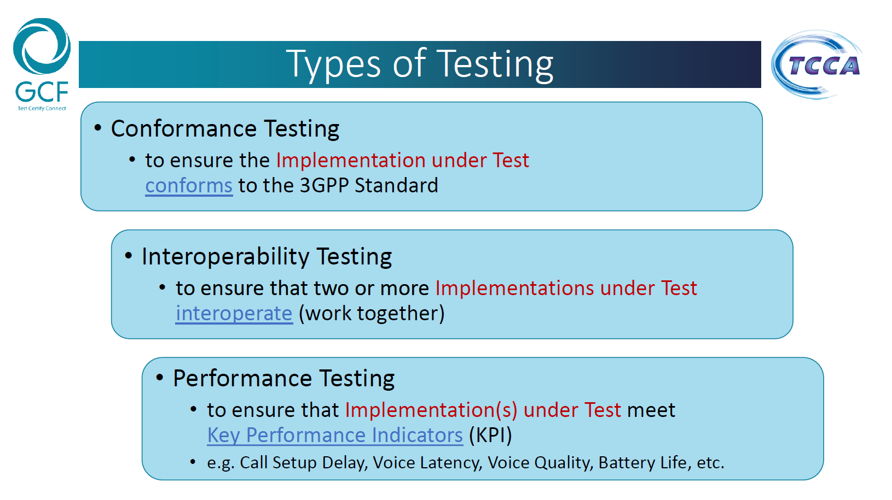
Figure 2: Types of Testing by Global Certification Forum
Next, iCERT, the industry association for emergency communications, gave a presentation where they shared their White Paper entitled “The Critical Role of Testing to Achieve and Maintain NG 9-1-1 Standards Conformance and Interoperability.” In this white paper, they described their view which included conformance, interoperability, end-to-end, performance and life cycle testing. After much deliberation with the steering committee, first responders, research team and federal sponsors it was decided that using these definitions as they stood led to much confusion. This confusion stemmed from the use of the term “Interoperability Testing” as an element of Interoperability Testing. For this reason, the following modifications to the definitions were adopted:

- Conformance Testing - the testing of a vendor system, subsystem, component, or element against a promulgated/published standard. This type of testing requires a known working standard implementation as the “reference implementation,” and formalized test plans specific to a system, subsystem, component, or element. This testing is typically done in a lab environment by an independent third party. Vendors can perform testing without coordinating with other vendors.

- Compatibility Testing (formerly Interoperability Testing) - the testing of the functional interaction of two or more systems, subsystems, components or elements within a single Next Generation Core Services (NGCS) managed by a single jurisdiction. This type of testing is typically done on a cooperative basis by vendors supplying systems, subsystems, components or elements that must interact with each other seamlessly. This effort is usually done in the lab of one of the vendors and sometimes done over a site-to-site Virtual Private Network (VPN). In some cases, this can also be done in a lab by an independent third party, but this option generally costs more than conformance testing. Many times, this testing is done because the participating vendors are business partners and routinely collaborate preparing proposals in response to RFPs. Sometimes the testing is done at the request of a customer or customers. This testing deals with the interconnection of Core Functional Elements within a single domain or jurisdiction.

- Interoperability Testing (formerly End-to-End Testing) - testing of all systems, subsystems, components or elements between two NGCS networks. Some large customers have lab environments established to support this type of testing. Most customers, however, depend on the vendors to set up the test environment. This testing in terms of this study is being described as testing across and between domains or jurisdictional boundaries.

- Performance Testing - testing of systems, subsystems, components or elements to determine responsiveness and stability under an actual or simulated load to validate other attributes such as resource utilization, availability or resiliency. This testing is typically done in a testing lab by the vendor of the system, subsystem, component or element. Since a real-world deployment is impossible to duplicate in a lab, this type of testing has some risk. Very large 911 systems supporting the largest metropolitan areas in the country are particularly interested in testing the performance of a system.

- Life-Cycle Testing - Interoperability testing performed prior to the market release of any system changes since the last successful interoperability testing scenario. This testing is the same as interoperability testing but done proactively prior to allowing any changes being made to a customer’s environment.
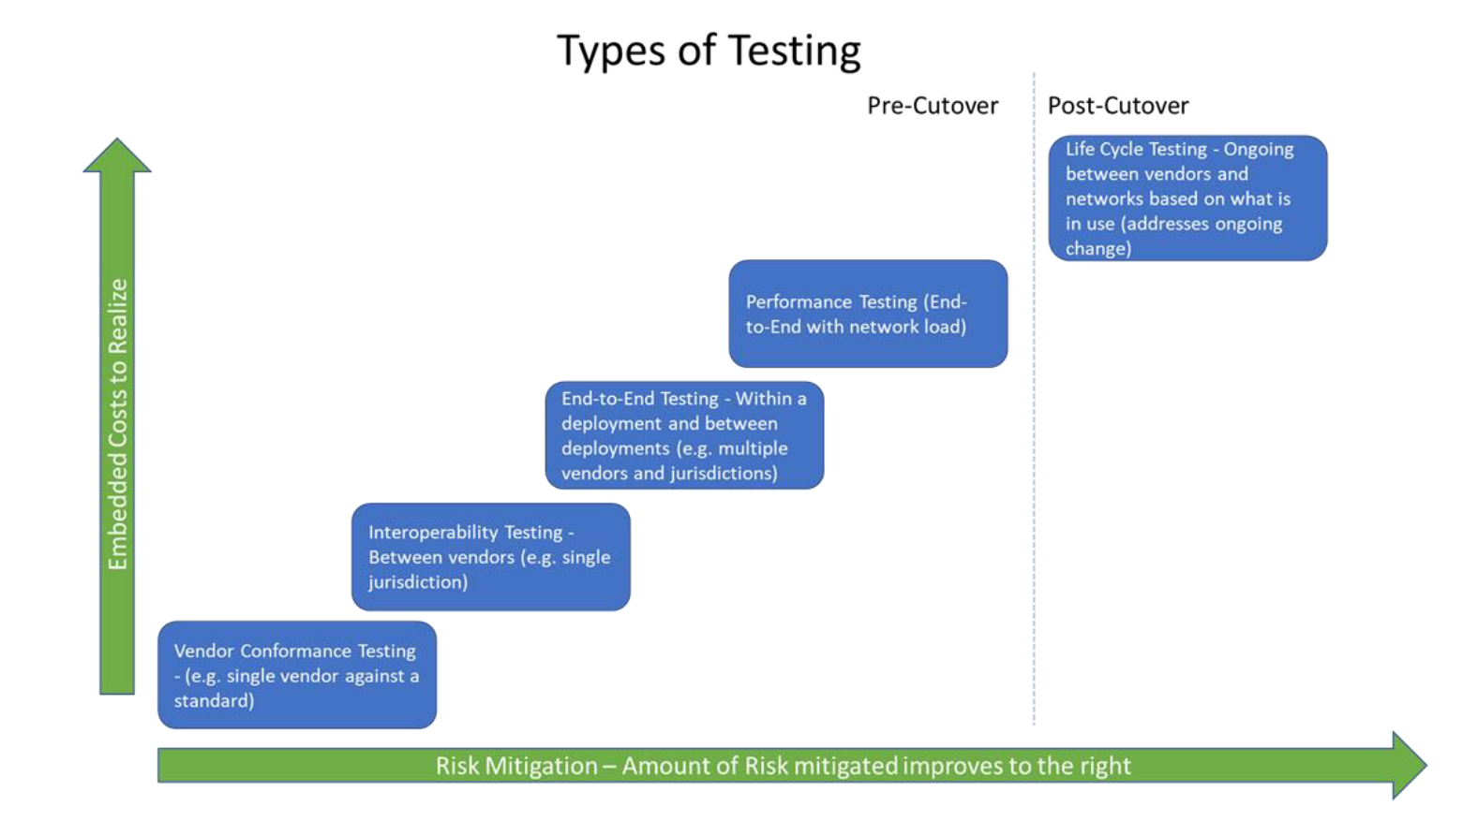
Figure 3: Types of Testing as defined by iCERT

Note that on the above diagram the Y—Axis shows the cost (complexity) increase going up the scale and the X-Axis denotes the amount of risk avoided proceeding further to the right.
The month that followed the two presentations offered up significant debate within the stakeholders’ groups. The discussion centered around what would be the required amount of testing. Consensus was reached that the optimal level of testing should include conformance, interoperability and end-to-end. The group felt that performance depended too much upon variables that were not under the control of a test center. These variables included things like ESInet medium (dark fiber, MPLS), ESInet architecture (mesh, ring, hub and spoke), server configurations (memory, processor speed) and network devices (router packet per second). Life Cycle was also deemed to be inappropriate as it was post implementation.

Scope of Testing Effort

Universe of NG9-1-1 System Functional Elements
The National Emergency Number Association (NENA) defines requirements and standards for NG9-1-1 systems. Their document, “NENA Next Generation 9-1-1 Public Safety Answering Point Requirements”, NENA-REQ-001.1.2-2018, identifies the following functional elements of a NG9-1-1 system:
For each functional element in the diagram below, there are a few too many vendor options, resulting in an enormous number of possible combinations. Clearly, testing every combination would be cost prohibitive. The test results for a given combination of vendors would only be useful to the one or very few customers that have chosen that particular set of vendors. Providing standardized testing for a critical subset of these functional elements could provide a cost-effective and more meaningful result to a broader set of customers.
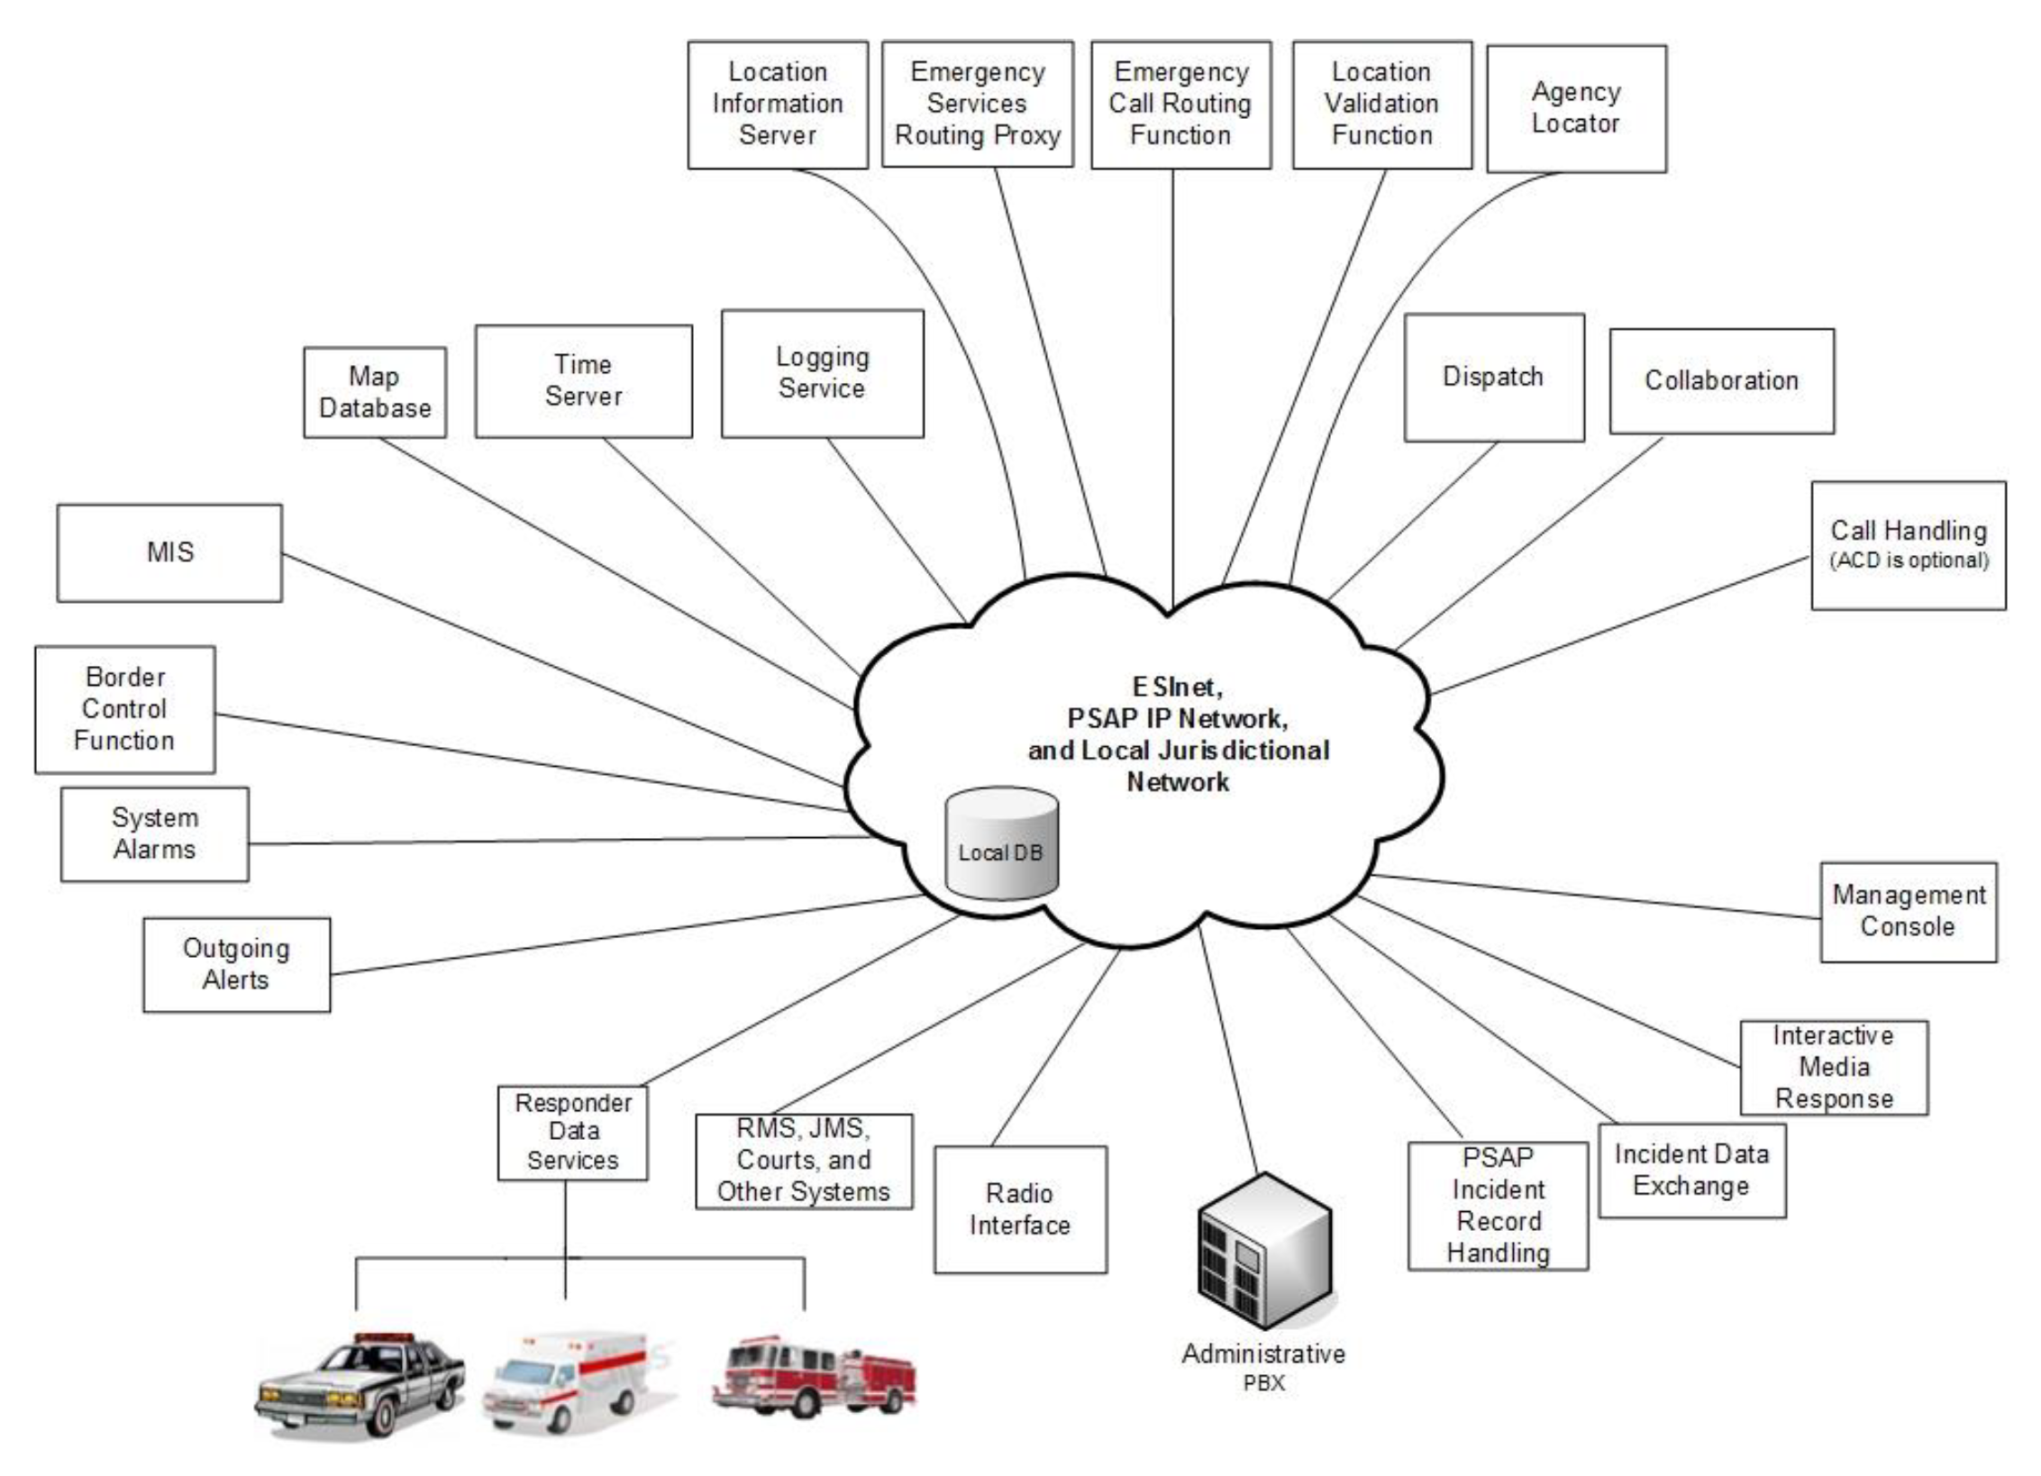
Figure 4: NG9-1-1 Functional Elements (Source: NENA-REQ-001.1.2-2018)

Next Generation Core Services
The NENA Master Glossary of 9-1-1 Terminology (NENA-ADM-000.23-2020) defines the Next Generation Core Services (NGCS) as “the base set of services needed to process a 9-1-1 call on an ESInet” (Emergency Services IP network). The ESInet is designed as an IP-based inter-network (network of networks) that can be shared by all public safety agencies that may be involved in an emergency and a set of core services (NGCS) that process 9-1-1 calls on that network. These core services are:

- ESRP Emergency Services Routing Proxy
- ECRF Emergency Call Routing Function
- LVF Location Validation Function
- BCF Border Control Function
- Bridge (for bridging calls together)
- Policy Store
- Logging Services
- and typical IP services such as DNS and DHCP

NGCS includes the services, but not the network on which they operate. The NENA Emergency Services IP Network Design Information Document, NENA-INF-016.2-2018 describes how to build a private Emergency Services IP network (ESInet) to provide NG 9-1-1 services to their constituents. The document covers a variety of network design aspects, including OSI layers 1, 2 and 3; Availability and Reliability; network security; network management and monitoring; and network architecture.

Figure 5 below, was extracted to as a visual representation describing how state and regional-level ESInets can be connected to provide high-reliability service, from an access network on the right side to the Public Safety Answering Points (PSAPs; the locations where 911 calls are handled) on the left side. The diagram helps with understanding where each of the NG 9-1-1 Core Services reside.
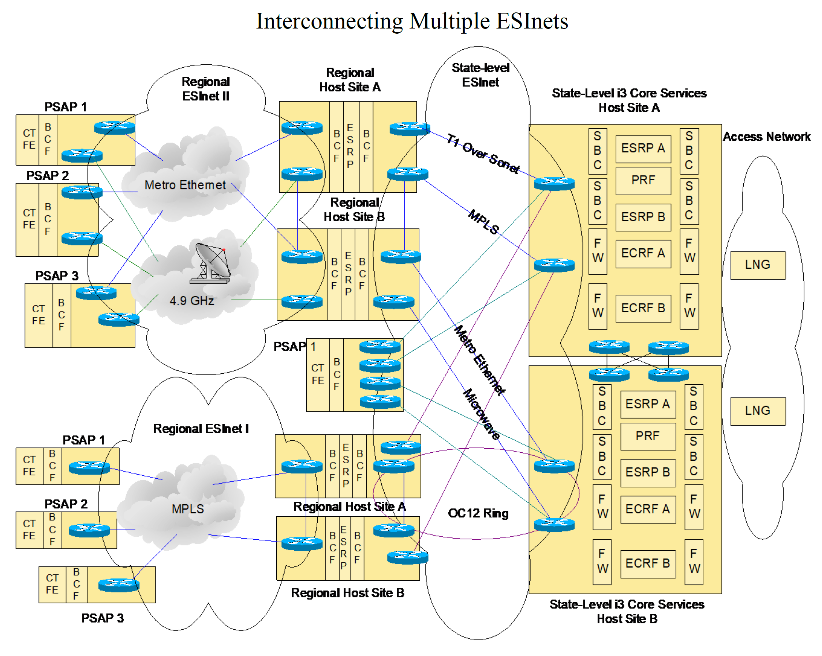
Figure 5: Interconnecting Multiple ESInets (Source: NENA-INF-016.2-2018)
Here are the following functional elements in the ESInet host sites, typically deployed in a redundant configuration:

- SBC Session Border Controller (part of the BCF core service)
- FW Firewall (part of the BCF core service)
- BCF Border Control Function (the combination of SBC and FW functions)
- ESRP Emergency Services Routing Proxy
- ECRF Emergency Call Routing Function
- PRF Policy Routing Function (closely coupled with the ESRP core service)

And the following functional elements exist at the PSAP:

- BCF Border Control Function (a combination of SBC and FW functions)
- CTFE Call Taking Functional Element

The Call Taking function is commonly referred to as the PSAP function, even though the PSAP itself also includes dispatch, logging, radio systems, and other functions involved in handling NG 9-1-1 calls (as shown in Figure 5 above). PSAP is also being redefined by the industry to be referred to as the Emergency Communications Center (ECC). The ECC is considered to be more inclusive and could include a Fusion Center.

Note that the LVF (Location Validation Function) core service does not appear in the above drawing. This function is closely coupled to the ECRF function and may not appear in all diagrams in order to reduce clutter.

Also note that the above diagram includes the LNG (Legacy Network Gateway) functional element in the access network. The LNG provides an interface between a non-IP originating network and a Next Generation Core Services (NGCS) enabled network. The project stakeholders agreed that the project should focus only on the NGCS part of the network. Therefore, the LNG is not considered in scope for the project.

Standard Functions and Interfaces
The NENA i3 Standard for Next Generation 9-1-1 (NENA-010.3, current in draft) clearly defines the behavior of NGCS functional elements, including how they interface with other NG 9-1-1 functional elements. These definitions allow for consistent and repeatable tests to be created to verify conformance to the standard.

Resulting Project Scope
Early in the project, the technical stakeholder subcommittee discussed and decided to focus the project efforts on testing of a subset of key functional elements. Each of the functional elements have well-defined interface requirements in the NENA i3 Standard for Next Generation 9-1-1.

Next Generation Core Services that are in scope for this project are:

- BCF Border Control Function
- ESRP Emergency Services Routing Proxy
- ECRF Emergency Call Routing Function
- LVF Location Validation Function
- Bridge (for bridging calls together)
- Policy Store
- Logging Services

Additional functional elements that are in scope:

- CTFE Call Taking Functional Element

Although not one of the Next Generation Core Services, the ability to deliver an NG 9-1-1 call to the Call Taking function in the PSAP is critical to the success of the NG 9-1-1 system. Therefore, testing of call flows up to the Call Taking function is within scope.

Next Generation Core Services that are not in scope:

- Typical IP services such as DNS and DHCP

These services are used extensively in NG 9-1-1 but are not specific to NG 9-1-1; they are ubiquitous in modern IP networks. Therefore, testing of these services will happen as part of the general IP network testing and does not need to be defined by this group.

Review of Existing Testing Methods and Programs

Texas A&M Internet 2 Technology Evaluation Center (ITEC) conducted a series of interviews with organizations operating in the public safety broadband arena both domestically and abroad in an effort to understand the state of conformance testing in the industry. The ITEC team engaged in multiple interviews with each of the following organizations and from those conversations gained insights into organizational perspectives on and interest in supporting NG 9-1-1 conformance testing, as well as technical issues associated with such an effort. ITEC interviewed the Cellular Telecommunications and Internet Association (CTIA), Valid8, ETSI Specialist Task Force on “NG112 Conformance Test Specifications,” and the National Emergency Number Association. Following is a summary of current efforts.

Cellular Telecommunications and Internet Association

The Cellular Telecommunications and Internet Association (CTIA) is a trade association representing the wireless communications industry and companies throughout the mobile communications ecosystem in the United States. The association was established in 1984 and is headquartered in Washington, D.C. It is a 501(c)(6) nonprofit membership organization, and represents wireless carriers and suppliers, and manufacturers and providers of wireless products and services. CTIA operates certification programs for the wireless industry and publishes wireless industry surveys. It has also sponsored various public service initiatives related to wireless.

CTIA and its members operate CTIA Authorized Testing Laboratories (CATL) and CTIA works with members to develop test plans and certification processes for mobile devices, coordinates with members and other industry leaders to ensure the security of mobile networks and devices, and leads industry initiatives to enhance accessibility, improve 911 location accuracy, and deter phone theft. Policies and Procedures for CATLs are provided on the organization's website at:
https://api.ctia.org/docs/default-source/certification/policies-and-procedures-for-ctia-authorized-testing-laboratories.pdf

In discussions with the CTIA the team learned that, because its membership is comprised primarily of wireless service providers, the association’s current conformance testing deals primarily with 4G and 5G LTE testing of devices in the United States. The CTIA supports six certification programs which include:

- Battery Compliance
- Battery Life
- Device Hardware Reliability
- Internet of Things (IoT) Cybersecurity
- Over the Air (OTA) Performance
- PTCRB Certification
The PTCRB Certification is the only CTIA certification process similar to what we are attempting to do with NG 9-1-1, and isdefined as follows:

“The PTCRB certification program ensures device interoperability on global wireless networks. The program supports smartphones, feature phones, tablets, IoT devices, notebook computers and wireless modules with 4G or 5G capability”

The PTCRB stated during phone interviews that they would likely not be able to support an NG 9-1-1 testing program. They are a member association and their membership - which is mostly the large telephone companies (service providers) and telephone equipment manufacturers - do not provide NG 9-1-1 core services today. They did not feel that they would be able to obtain Board of Directors’ support for such a proposal.

Valid8


Valid8 is a private company providing physical, virtual and cloud-based test solutions to markets in need of affordable and comprehensive performance and security verification. The company focuses specifically on niche markets needing flexible and affordable testing and delivers using a software platform developed to provide testing that is both replicable and customizable to client needs. Valid8 proved its commitment to the industry over more than 10 years of development and industry engagement for P25 testing. Despite early unwillingness from industry to engage, Valid8 remained committed to providing cost effective testing earlier in the manufacturing process, helping to foster innovation and the entrant of new players into the marketplace.

The team had three separate interviews with Valid8 leadership regarding the NG 9-1-1 conformance suite and they have an interest in working on a project should it come to fruition. Valid8 had their beginnings in TTCN-3 but were not happy with some of the shortcomings of the test language. As a result, they developed their own Valid8 Test Description Language or VTDL. Valid8 will sell a perpetual license and they do have a number of prepackaged modules on which to build. These modules include 3GPP 4G, 3GPP 5G, VoIP and legacy protocols.

Valid8 has two business models. Valid8 develops test scripts for a specific device and sell the tests along with the hardware and software to run the tests. Valid8 also licenses the VTDL code, allowing a company to develop its own test suite. One service that Valid8 does not provide is the testing itself. They will assist in the development of a testing suite, but they will not do any of the testing.
Having shared the challenges of providing the public safety community with a cost-effective NG 9-1-1 conformance test suite supported by a financially sustainable business model, Valid8 expressed a potential interest in engaging in the effort depending on the scope and assuming there is an established sequence of priority interfaces to consider. While the company has implemented both P25 and mission-critical push-to-talk (McPTT), Valid8 did acknowledge that they do not have any experience with the NG 9-1-1 architecture and protocols.

ETSI Specialist Task Force on “NG112 Conformance Test Specifications”

In April 2018, ESTI, a European standards body, established a special task force (STF) intended to create a reference model to define requirements related to the conformance testing of NG112. Both NG112 and NG 9-1-1 are built upon the NENA i3 specification. The duration of this task force was from April 2018 until June 2019 and included the following tasks.

Task T1: Project Management (ETSI/CTI)
- Attending Technical Body and working group meetings
- Coordination, communication, reporting and leading of activities
- The STF Leader will prepare the Final Report.
Task T2: PICS and TSS&TP development
Extraction of testable requirements. Production of the PICS and TSS&TP document. PICS and TSS&TP will be delivered in a single document. This task can be executed remotely, however at least a kick-off meeting at ETSI HQ is preferred.

Task T3: Test Suite Development
Development of the test suite in TTCN-3. The test scripts shall be able to be compiled with Elvior, Titan and Spirent tools. This task shall review the deliverables of Task T2. This task shall be executed in work sessions at ETSI HQ.

Task T4: Codec and TA plugin development
The Codec and TA software shall be delivered as source code including all source code modules needed for the compilation into an executable version of the software. All software shall be accessible from https://forge.etsi.org. This task shall be executed in work sessions at ETSI HQ.

Task T5: Test Suite Validation
The following SUTs shall be validated: LIS, ECRF, ESRP and PSAP. In case a NG 112 Plugtests™ event is held during the present STF is active then part of the Test Suite Validation shall be performed at the event. The Plugtests™ event is planned to be held at ETSI HQ.

Task T6: Provide Support to the SC EMTEL Approval Process

T6.1 – Review of Stable Drafts
Before reaching the status of stable draft, the STF will submit the draft deliverables to editHelp for clean-up. The STF will then present the stable drafts to SC EMTEL for comments and to the ETSI Secretariat for pre-processing.

T6.2 - Inclusion of Comments from Stable Draft review
The STF will include the comments received from the stable draft review (technical as well as editHelp! clean-up) and produce the final drafts of the deliverables for SC EMTEL approval.

The task force was funded by ETSI at the 57,000 Euro level. The Objectives of the project were described as follows:

- The following interfaces shall be covered:
  - LIS interface via HELD or SIP
  - ECRF interface via LOST
  - PSAP interface via SIP
  - ESRP interface via SIP
  - Systems Under Test (SUTs)
  - LIS
  - ECRF
  - ESRP
  - PSAP
- Collect Test requirements and define the Protocol Implementation Conformance Statement (PICS)
- Define Test Suite Structure and Test Purposes (TSS&TP)
- Develop Abstract Test Suite (ATS) and Protocol Implementation eXtra Information for Testing (PIXIT) and to compile on Titan, Elvior and Spirent test tools
- Develop a NG112 plugin for the ETSI Codec and Adapter Test Framework
- Validate the test suite before and during the next NG112 PlugtestsTM event
By January of 2019, Tasks 1-4 had been completed and validation of effort to date was completed at the NG 112 PlugtestTM number 3 held at the ETSI headquarters at Sophia Antipolis, France. Dr. Magnussen from the TAMU ITEC was invited as a U.S. observer and he was able to verify that the results rendered by the test suite and the results rendered by the Plugtest were identical.
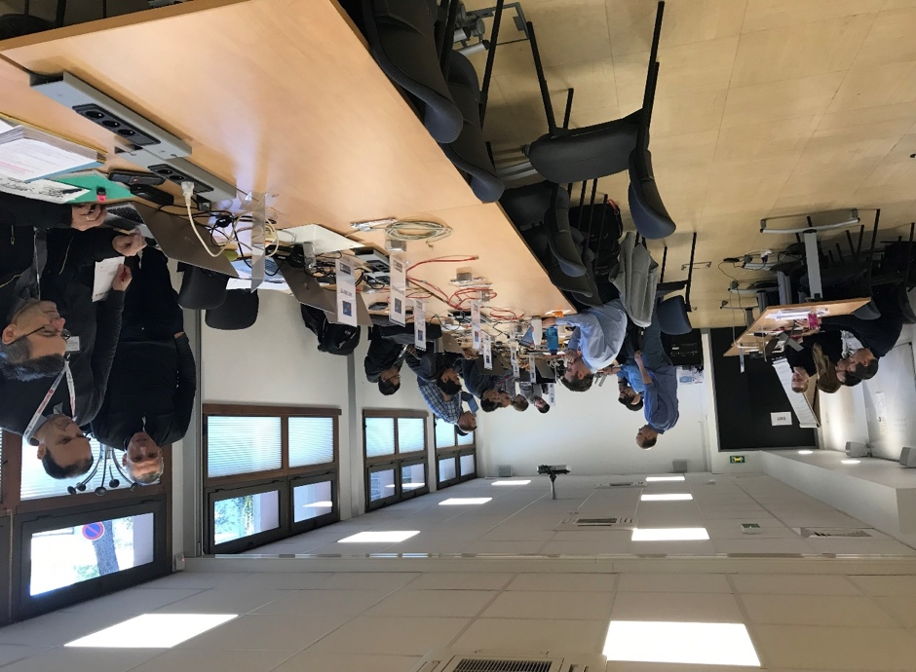
The ETSI team noted in their final report that the skillsets required to complete a successful conformance development effort such as this included:
- expert knowledge of all base standards mentioned above in clause 6.1; especially HELD, LoST, SIP Emergency Calls
- expert knowledge of TTCN-3 (ES 201 873);
- expert knowledge in conformance testing;
- expert knowledge in codec and adaptation layer development in C++/Java.
With this project reaching its conclusion we were informed that there was no interest or support for taking this project from its initial proof of concept to a fully funded ongoing effort. Furthermore the ETSI also indicated that it did not want to own the NG 9-1-1 testing. The code and test model from this project were used to validate the NG 9-1-1 conformance model that came from this DHS funding. It was also used to create the testing video that came out of our project.

NENA Industry Collaboration Event (ICE)
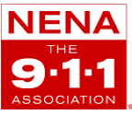
By 2009, NENA had completed Version 1 on the i3 NG 9-1-1 architecture document and had collaborated with the US Department of Transportation NG9-1-1 office in their Proof of Concept project. The next step taken by NENA intended to accelerate the nation-wide deployment of the next generation was to establish an interoperability framework. This framework came in the form of an industry plugtest at came to be known as the Industry Collaboration Event or ICE.

Working with a planning committee and Texas A&M University, the first ICE event was held at Texas A&M University in November 2009 with an emphasis on basic interconnection of i3 functional elements. The event was a one-week face-to-face event with about 25 firms participating in the tests. Each firm brought their systems to plugfest. From the first event, all participants were subject to a strict code of conduct which prohibited sharing of individual test results outside of the ICE community. This confidentiality, it was felt, was required for companies to agree to participate.

In the past twelve years since the first ICE event there have been 9 such events with the most recent one being held in February and March of 2021. The previous 8 events were all held in person but ICE 9 was held in a virtual environment due to the Covid-19 pandemic. It is uncertain if future events will be revert to the in-person format.

At the same time span of ICE the European Emergency Number Association (EENA) began to hold their NG 112 Plugtests. For the first time the ICE event and the NG 112 Plugfest will be held concurrently with U.S. tests being held early in the U.S. day, and international tests held in the afternoon and Europe centric tests held later in the day. This will support testing across time zones.

Both the NENA and the EENA events involve two types of testing, bilateral between two vendors and complex which could be considered an end-to-end test. The testing combinations for both bilateral and end-to-end can be large when there are up to 30 plus vendors, many of which support multiple functional elements. Below is a diagram of what this testing could look like.
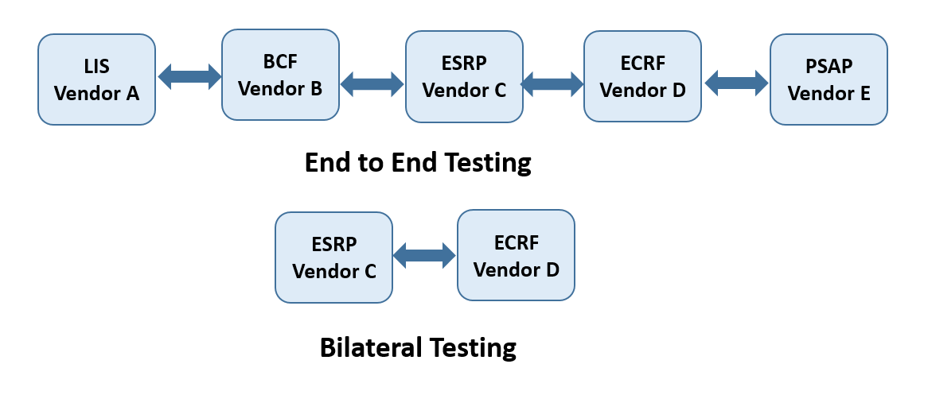
Figure 6: Bilateral and Complex Testing

DHS Project 25 (P25) Compliance Assessment Program (CAP)
According to the DHS Science and Technology website, the P25 CAP “was formed in 1990 in accordance with an agreement between the Association of Public-Safety Communications Officials (APCO), the National Association of State Technology Directors (NASTD), and agencies of the U.S. federal government, Project 25 (P25) is a unique user-driven process that works with equipment manufacturers to establish current and emerging wireless land mobile radio (LMR) communications standards that meet the requirements of the public safety community. Project 25 is the only known user-driven emergency communications standards process in the U.S. The Department of Homeland Security Science and Technology Directorate leads the congressionally legislated P25 Compliance Assessment Program and supports SAFECOM recommendations related to emergency communication standards development.” As a well-known program within the public safety community that was frequently referenced by stakeholders during various meetings, the research team sought to understand the CAP operational model and how best practices might be applied to NG 9-1-1 testing efforts.

More complete descriptions of the various aspects of the P25 program can be found on the program website, but a few key elements of the program that were noted in the team’s interviews are:

- DHS funded the Institute for Telecommunications Sciences in Boulder, Colorado to help stand up the P25 program.
- DHS engaged APCO for project support, including development of the P25 tests
- DHS and other Federal agencies formed an advisory panel restricted to users who own and operate P25 systems; the group is very knowledgeable and briefs DHS quarterly
- APCO owns the P25 standard
- DHS issues bulletins as needed to update P25 testing requirements; these bullets become the basis for certification of test labs (the schema)
- DHS entered into relationships with accreditation bodies (A2LA, ANSI) to authorize them to certify P25 test labs in accordance with the P25 schema which includes a requirement for ISO 17025 accreditation.
- DHS provides test report templates, statement of compliance templates

The information gained in the interview helped the research team understand how many of the elements of the CAP might be applied to the NG 9-1-1 testing program in order to establish a credible testing program that the federal government can utilize to drive conformance to a defined set of NG 9-1-1 test cases. Finally, and importantly, when discussing the proposed approach with first responder stakeholder representatives and referencing the potential for modeling the NG 9-1-1 testing program after the P25 CAP, the first responder group indicated confidence in following this proven approach. These insights are reflected in the proposed NG 9-1-1 ecosystem and go forward plan.

Texas Engineering Extension Service (TEEX) & Testing Innovation Center (TIC)
A member of the Texas A&M University System, TEEX serves more than 200,000 people annually, representing every U.S. state and territory and 105 countries, through on-site and online resources for specialties from homeland security to economic development and workforce training.

Home to some of the world’s top training facilities, the emergency preparedness campus in Bryan/College Station includes the Brayton Fire Training Field, Disaster City® and the Emergency Operations Training Center. Customized TEEX training programs develop practical solutions for each client’s need through hands-on instructional facilities for public utilities, law enforcement and unexploded ordinance training at the home campus or at customer-specified locations worldwide.
Texas A&M Task Force 1 and Texas Task Force 2, the state’s elite urban search and rescue teams, are sponsored by TEEX. Throughout its existence, TX-TF1 has served the state of Texas and the nation by participating in over 100 deployments, completing search and rescue missions with highly trained and qualified personnel.

As part of the National Domestic Preparedness Consortium and home to the National Emergency Response and Recovery Training Center, TEEX has been leading homeland security training since 1998.
The major TEEX programs include fire and rescue, infrastructure and safety, law enforcement, economic and workforce development, and homeland security. As a member of The Texas A&M University System, TEEX is unique in its ability to access a broad range of emerging research and technical expertise to provide training and technical assistance.

Building on the strength of its subject matter expertise and unique facilities, TEEX established its TEEX Tested program in order to serve and support innovators seeking to bring new products to market. The TEEX Technology Innovation Center (TIC) tests and evaluates first responder technologies working directly with the private sector as well as federal sponsors. From 2016-2019, TEEX TIC executed the Defense to Response Technology Transition Program (D2R) awarded by the Domestic Preparedness Support Initiative (DPSI) in the Office of the Secretary of Defense. Every year, Texas A&M ITEC partners with TEEX to for the annual Winter Institute (now Interoperability Institute) workshop and full-scale exercise of public safety communications technologies with a focus on advancing interoperability.

As public safety technologies increasing rely on advanced communications, TAMU ITEC and TEEX work closely together for technology testing and evaluation. The research team met with the TEEX TIC leadership to assess their interest in and capacity to support a testing program, lending both insights into the public safety community and long-standing strong reputation to a potential program as well as potential leveraging investments in infrastructure and marketing to help manage costs. Understanding the TAMU ITEC maintains the communications and networking expertise, the TEEX Director indicated an interest in supporting an NG 9-1-1 testing program if funded.

Establishing Accredited Test Facilities

Based on research into best practices and the expressed requirement by the sponsor for NG 9-1-1 interoperability test lab accreditation, we researched the requirements for certification of the testing labs in accordance with ISO/IEC 17065 Conformity Assessment: Requirements for Bodies Certifying Products, Processes and Services and, subsequently, ISO/IEC 17025 General Requirements for the Competence of Testing and Calibration Laboratories. While the infrastructure, systems, and effort required to achieve accreditation of one or more testing facilities is considerable, the assurances of credibility, objectivity, and test validity are worthwhile for the long-term sustainability of the NG 9-1-1 Interoperability Testing program. Following is a summary of the requisite infrastructure, processes and costs involved in establishing an accredited test facility.

Accreditation Infrastructure
The table below summarizes the entities and roles that make up the ISO 17025 accredited test lab infrastructure. The certifying body is the entity that holds testing schema and recognizes accreditation bodies authorized to perform assessments and accredit testing labs in accordance with the testing schema. The certification body will maintain lists of recognized accreditation bodies, accredited testing labs, and a list of products that met all testing requirements for certification at an accredited testing lab.

Players and their roles in accrediting NG 9-1-1 interoperability testing labs
Entity | Role in Accredited Test Lab Program
Governing/Certifying Body | Develops and maintains NG 9-1-1 conformance test certification scheme based on relevant standard(s); authorizes test lab accreditation bodies; May be ISO 17065 accredited.
Accreditation body (ANAB, A2LA, etc.) | Independent third party that assesses and accredits testing labs in accordance with the NG 9-1-1 interoperability testing schema and ISO 17025; is recognized by Certifying Body to accredit testing labs and named as such in test certification scheme.
Testing facility | Performs test in accordance with established testing scheme; ISO 17025 accredited by recognized accreditation body.

Testing vs. Certification
ISO/IEC 17065 is concerned with certification of products or processes. If an independent body were established to certify products as conformant with referenced standards and/or interoperable, that certification would be granted based on defined testing outcomes. The certifying body holds and maintains the testing schema, which in addition to specifying test cases and processes, also specifies authorized testing facilities. If desired or deemed appropriate, the independent certifying body could seek ISO/IEC 17065 accreditation.

ISO/IEC 17025 is concerned with accreditation of testing facilities in order to assure that testing is performed in a consistent manner that is compliant with a certifying body’s defined schema. The testing facility can operate independently from the certifying body and as such testing facilities seeking an authorized status as part of the overall NG 9-1-1 testing schema need only secure ISO/IEC 17025 accreditation.

Test Lab Accreditation Process, Timeline and Cost
ANSI National Accreditation Board (ANAB) provides accreditation for organizations for both ISO/IEC 17065 and ISO/IEC 17025. Similarly, the American Association for Laboratory Accreditation (A2LA) is an alternative accreditation service to ANAB. The team requested interviews with both ANAB and A2LA but only A2LA provided additional insights into their accreditation process. Based on the interview with A2LA and additional interviews with organizations that completed the accreditation process for the DHS P25 Conformance Assessment Program (CAP), it is expected that, once the testing scheme is established, testing labs could complete the application and assessment process and secure ISO/IEC 17025 accreditation for NG 9-1-1 Interoperability Testing within approximate 150 days of initial application.

The overall process can be split into three phases: application, assessment, and corrective action.
During the application phase, the accreditation body collects materials from the applicant regarding test lab operations and management systems. Once those materials are submitted, the accreditation body identifies an assessor and ensures there are no conflicts of interest that could impede the assessment. After an assessor is assigned, they are expected to complete the assignment within 60 days. Any findings from the assessment would then need to be resolved in the corrective action phase. New applicants are given up to 120 days to resolve findings requiring correction. Finally, the assessment materials are reviewed by the accrediting entity’s Accreditation Council for final vote on accreditation.

Based on the P25 CAP accreditation process, A2LA estimated out of pocket expense of $10,000 in application and annual fees as well as assessor time for preparation, assessment time, and reporting. It also assumes NG 9-1-1 CAP is comparable to P25 in terms of complexity and requirements. In addition to out-of-pocket expenses, there is considerable time commitment required for candidate laboratories to establish management systems and protocols specific to ISO/IEC 17025 accreditation requirements, including ISO 9001 or comparable management system documentation, operation and maintenance. Based on conversations with organizations accredited under P25 CAP, an organization pursuing and maintaining accreditation under a similar NG 9-1-1 Interoperability testing program should expect tens of thousands of dollars in staffing expenses associated with securing the accreditation as well as ongoing personnel and annual re-accreditation expenses to maintain the accreditation over time.

Options for Deploying a Testing Facility

Following extensive discussion and research into test program models, the Department of Homeland Security Compliance Assessment Program (CAP) for APCO’s P25 standard provides a sound model upon which to form conceptual plans for an NG 9-1-1 interoperability testing program. Under the DHS CAP model, the DHS becomes the Certifying body with test labs operating under an approved testing plan that is owned by the DHS. Under such a model, there can be as many test labs as the market/industry can support. In fact, any firm can purchase the test suite and self-test as long as they meet all of the CAP requirements. These requirements are:

- The tests performed are the DHS approved tests.
- The test lab performing the test has ISO 17025 certification. This ensures that testing results will be conducted in a consistent manner and properly documented.
- The end-to-end testing will be conducted integrating at least three other vendors.

Types of Testing Systems
Any test lab that chooses to become an approved DHS CAP test lab would utilize a test engine that would be developed with funding from the proposed project. Depending upon how the test engine is configured it would support conformance, interoperability and/or end-to-end testing. The three types of tests are described in more detail below.

Conformance Tests
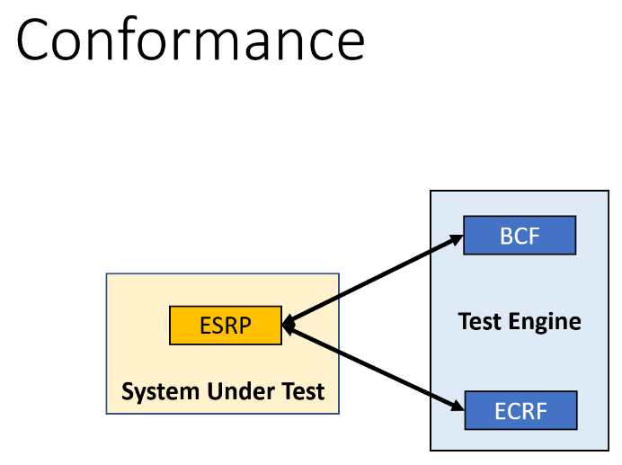
The simplest of all tests considered, conformance tests involve the System Under Test (SUT) and the Test System. The Test System is configured to perform the testing of messaging from both the upstream system and the downstream system for the SUT. The SUT could be any i3 compliant NG 9-1-1 Next Generation Core System (NGCS) manufactured by any firm. The following diagram depicts the test were the ESRP to be the SUT.

Compatibility Tests
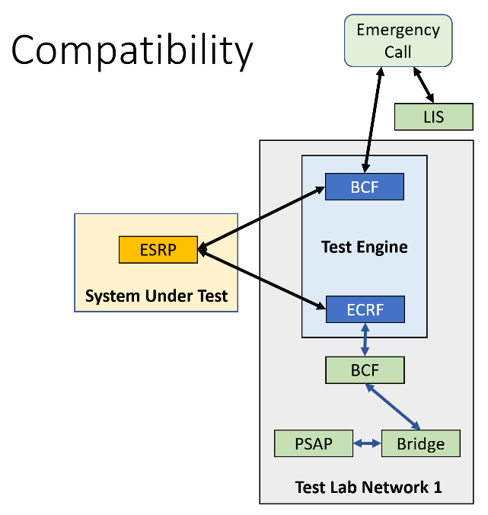
These tests are the next, more complex sets of tests of tests. These tests begin with an NG 9-1-1 call being placed with the calling device initating sequence, as follows:
- Calling device requesting location via a HELD query to the Location Information Server
- Calling device sending SIP invite with location to Border Control Function
- Border Control Function sends invite to Emergency Services Routing Proxy
- Emergency Services Routing Proxy sends LoST query to Emergency Communications Routing Function
- Emergency Services Routing Function returns PSAP URI to caller
- Calling device sends SIP invite to PSAP
- PSAP accepts call
This process tests an end-to-end emergency call all the way from the calling party to the PSAP that are all contained within one jurisdiction’s network. The System Under Test could be any functional element within the NGCS. The test system serves as the upstream and downstream functional elements of the SUT. In this case it is important for the test lab to have functional elements from several vendors in order to be able to meet the three different vendors rule. The SUT would always be one of the three vendors. This configuration is shown in the diagram above.

Interoperability Tests
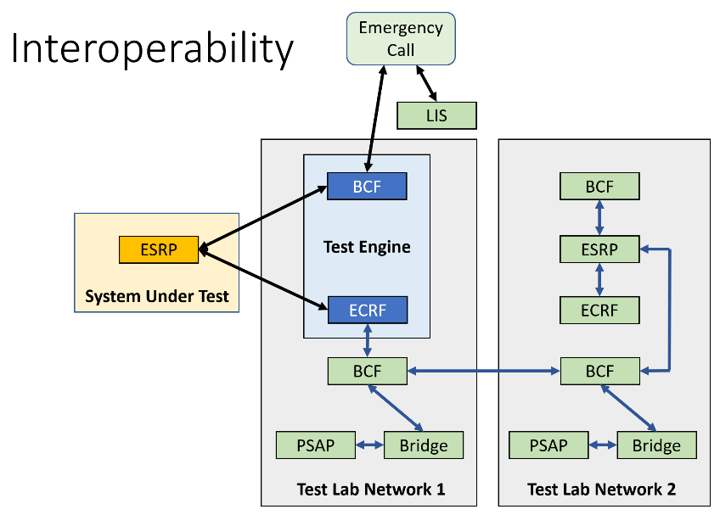
The most complex of tests is the interoperability test. This configuration uses the same call flows as in the compatibility test but in this case, we are testing a call transfer initiated in one ESInet that is then transferred to another ESInet being answered by a call center connected to the second ESInet. This call flow is shown in Figure 9.

In each of the tests described, the virtual upstream element in the Test Engine will send signaling packets to the System Under Test and will look for the appropriate response. The System Under Test will then send the appropriate data packets to the downstream element and will look for the appropriate response.

In the figures, the orange device is the system under test. The blue devices are virtual devices that are a part of the test engine. The test engine will contain all of the i3 specified functional elements. The functional elements that are the appropriate upstream and downstream functional elements will be selected from all of the functional elements depending upon which functional elements is selected to be the System Under Test.

An individual test may contain several test cases, each determined by a specific I3 Standard requirement. Test cases will include both a properly formed query and an improperly formed query. This represents both a positive and a negative test case. For each test case the Test Engine will record a “Pass” or “Fail”. These test results are then compiled into a report that follows the DHS CAP required format. An example of a test report is contained in the Appendix. This report is filed with the NG 9-1-1 CAP Program office which allows the device to be given “CAP approved status”

Business Model Recommendations

After extensive dialogue between sponsors, stakeholders, experts, program managers and academic researchers, an interoperability ecosystem has emerged that is the basis of a business model that is recommended to achieve the program objectives. This blueprint can be used to create a functional process through which certified, repeatable interoperability testing may ensue and drive increased system interoperability across a broad-reaching network of individual systems working in concert with each other to deliver consistent, expected performance in support of the mission of first responders.

This graphic illustrates an ecosystem design and matrix of interrelated elements necessary to ensure all aspects operate effectively and efficiently with the backdrop of promoting continuous communication, feedback and, where necessary, adjustments to process and outcomes.
Figure 10: NG 9-1-1 Interoperability Testing Ecosystem

While a more detailed discussion of the ecosystem elements is provided in the Proposed Path Forward section of this document, there are three primary components of the business model to be considered at a higher level.

First, multiparty engagement will include active engagement in the testing program by vendors, organizations, associations, academia, government sponsors and the first responder community.

Second, active participation and management is needed by a designated entity responsible for executing the mission of the sponsors while balancing multiple inputs, agendas, and moving parts. This entity will be positioned to ensure the existence of a functional testing process, input from stakeholders is considered and acted upon as appropriate, outcomes are continuously assessed, and the mission of the program is ultimately achieved. This role will include multiple aspects and will work closely with the testing design and execution entities to continuously drive desired outcomes and an overall increase in the interoperability of operational 911 systems.

Third, a lead entity responsible for driving the creation and stability of the desired interoperability testing process as well as for actively participating in testing needs to be designated. This entity will be expected to both oversee the standards-based testing approach and conduct ongoing testing to be available as both a resource and a check to the process to ensure desired outcomes are achieved and timely adjustments are made as needed. While it is expected that over time there may be multiple certified testing entities, this entity will act as the control and be expected to demonstrate how the testing process should work most effectively and consistently. This role will be critical to model and perform standardized testing procedures that produce accurate and informative test results. This function also ensures the actual testing program remains in alignment with the original intent and reflects the needs of the stakeholder ecosystem in a consistent manner. This lead testing entity will function as a design center and execution model for achieving desired testing protocols, outcomes and meaningful test results in support of the overall mission of this program while working in close concert with the management organization to ensure all aspects of this complex intersection of moving parts operates both effectively and efficiently with the backdrop of promoting continuous communication, feedback and where necessary adjustments to process and outcomes.

The recommended business model contemplates utilization of an organizational structure that prioritizes the value of a non-profit, independent, goal oriented and result-driven framework. There are several advantages to this approach that include typically lower human capital cost structures and access to a flourishing talent pool of full time and part time employees. Engaging students in this way will also provide valuable “hands-on” exposure and experience with emergency communications technologies (in particular NG 9-1-1 systems) resulting in an increase in the pipeline of knowledge workers into this critical ecosystem. Additionally, a university centered program management approach provides the interoperability testing program with the benefit of an unbiased third party to balance the multiple interests that are actively engaged in this process. Further, a university center-led approach has proven successful elsewhere in aligning interests and working closely with federal sponsors to focus on cost containment, uniformity of goals and purpose and the alignment of marketplace dynamics together with research results and stakeholder involvement without the concern for competition or profit motive.

Revenue Model
In order to implement the sustainable business model a multi-step funding approach will be required. Initially the sponsors will need to fund the initial startup phase of the business model. It is expected that the first 18-30 months will require seed funding that will be used to quickly get the testing program up and running and establish the oversight management structure. Once the program is up and running and the testing process has been initiated and the revenue sources begin to contribute, the seed funding will decrease over time and within the first three years the program will transform into a fully supported business model that utilizes some combination of membership, pay-by-test and/or project-based methodology. The seed funding is critical for jump-starting the program, but the long-term revenue model anticipates that the entities actively participating in the testing process will fund the entire operation of the program through a cost recovery funding model.

A transition plan will be developed within the first six months of the program that articulates a path to self-sustainability and a long-term financial plan funded by the stakeholder community. The longevity of this program will require a flexible and reasonable revenue model that does not require long term federal assistance. The business model will need to support some combination of membership fee, project-based and per-test pricing models.

Finally, the business model should anticipate a certain amount of funding needed to conduct R&D of modern testing procedures. The funding provided through a combination of sources will enable the management and lead testing center entities to operate on a cost recovery basis and overtime become self-sustaining while delivering expected returns on investment.

Stakeholder and Vendor Participation and Feedback
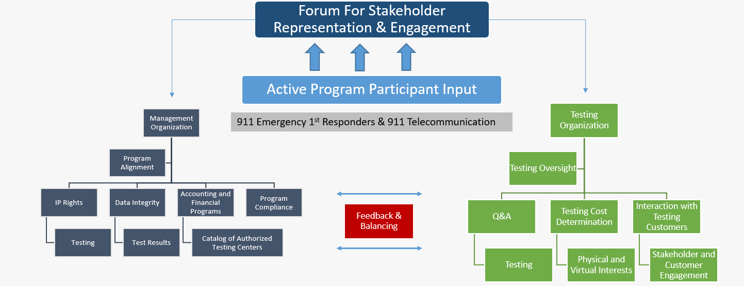
One of the most important aspects of this business model is the active participation by stakeholders in the testing design and execution process. While it is not possible to run any program by committee - and this business model does not contemplate that - major operational decisions will be reviewed and deliberated by a representative advisory panel. The value of stakeholder input and feedback will be strongly considered by both the management organization, the testing design and execution entity and by the federal program sponsors. In order to actively engage with vendors of various sizes, representatives from industry associations and organizations and the 9-1-1 agencies and organizations, emergency responders, local government and the managers and operators of telecommunications systems, this business model contemplates the creation of an oversight entity. This advisory panel will be responsible for providing regular feedback, sharing level(s) of satisfaction, raising and addressing technical program challenges and participating in active bi-directional communications to address current and future decisions that impact the overall program. As articulated in the diagram active participation from a broadly representative forum of stakeholders and participating vendors will underpin the success of this program.
Figure 11: Stakeholder Representation and Engagement

The forum for stakeholder engagement should encourage first responders, 911 systems operators, vendors and stakeholder associations to stay engaged on a regular basis to gain marketplace feedback on the effectiveness of the testing process and its outcomes. The management organization will work closely with federal sponsors and the lead testing organization to consider the feedback provided, advice and challenges from the forum for stakeholder engagement, as well as provide a check and balance between program management and testing efficiency and performance-based outcomes that increase the overall interoperability of end user communications systems while controlling costs of the overall program.

Establishing a Standards-Based Testing Program
The entity responsible for testing standards and execution of testing will play a critical role in the development of standards-based interoperability testing programs while also stepping into the role of testing entity to provide immediate access to a functional testing process, work out initial testing program issues and continue to perform required testing while coordinating with and consulting to future testing centers that may be established over time to meet the demand of those entities that drive testing volume for assessing interoperability. This entity will navigate the need to be centrally involved with testing design while also injecting checks and balances into the process, so no single entity is developing the tests, performing the tests and reporting on the test results.

This entity will be required to invest in the necessary equipment to perform standardized testing, oversee the test design process and interact with the stakeholder community to demonstrate testing capabilities and expected outcomes while ensuring tests are consistently performed against an established testing scheme.

Certification, Testing and Oversight
Process Certification: To assure confidence among stakeholders, customers and federal sponsors a formal multilevel certification process should be considered. There will not be certification of equipment and software, but rather certification of the testing process, repeatable results and availability of data. The resulting entity will pursue ISO certification of the testing program itself and will follow guidelines for the testing process and results certification in accordance with ISO standards.

Implementation Methodology: It is crucial to the success of the program that there is a clear expression of the testing process. The process should be articulated in a step-by-step manner including the requirement for certification of the process itself, those conducting the testing, and the results of the process as it is completed. The certification process should follow an ISO-approved format that navigates the testing process and those conducting testing through an analysis of the outcome data and the repeatable nature of the testing. The formality of the certification process seeks to eliminate random unsubstantiated testing approaches as well as test outcomes that are not repeatable through a formal process.

Testing Procedures: The details of the testing procedure will be outlined in greater detail later in this document. The testing procedure will explain how any participating vendor would test their product for interoperability. It is anticipated that there will be both virtual and physical testing available through the center.

Results and Process Transparency: The entire testing process must adhere to a set of guidelines that furthers the mission of the implementing entity. For example, in order to balance the need for end-to-end testing against the many variables associated with such testing, a rule-of-three approach would be applied. In the rule-of-three approach a vendor testing its system in an end-to-end configuration must successfully test against at least two other vendors’ products within that configuration.

Test Results Reporting Process: As the tests are completed, results need to be analyzed and data made available to vendors and end users, and for audit and compliance purposes.

Vendor Engagement and Input: It is critical to the success of the resulting entity to fully engage the vendor community. The testing center must communicate with vendors early and often. Vendors must understand requirements, testing options and operations, how results will be made available and distributed, and interpretation of results. Vendors will need to participate in each stage of the development and implementation of testing methodologies.

Federal Sponsor Engagement and Priorities
During the stakeholder engagement process, DHS presented its perspective on many technical and execution elements of the anticipated testing program. The below slide captures several of the critical steps in the process that DHS anticipates will be included in a successful program implementation.
Figure 12: NG 9-1-1 Compliance Assessment Program

DHS and DOT ultimately own the contractual deliverables and momentum that drives the NG 9-1-1 interoperability testing program. They will remain an active facilitator to shape and drive the behavior of the marketplace to meet identified policy objectives. This business model is designed to support and work closely within the above framework.

Recommendation to Move Forward with Business Model
CIRI recommends to DHS and DOT that it proceed with the above-described business model while considering the advantage of selecting the existing team of The University of Illinois – Critical Infrastructure Resilience Institute (CIRI), an established DHS Center of Excellence, in cooperation with its partners the University of Washington and Texas A&M University, to manage and initiate the interoperability program contemplated herein. CIRI would assume the lead role as the program management organization with the University of Washington supporting CIRI as needed, including ongoing interoperability and cybersecurity research, stakeholder outreach and communication while Texas A&M University would take the lead on facilitating the technical testing standards design, actively engage in performing initial and long-term testing requirements and assume an advisory role to other approved testing entities or centers. In this business model CIRI would be responsible for a wide range of management objectives and deliverables, that when combined would drive the program to be successful and thereby ensure it meets program objectives. In this role, CIRI would provide governance and oversight of all parts of the interoperability testing program, as regularly informed by input from the stakeholders, while working closely with Texas A&M University to facilitate an effective testing program that delivers expected outcomes.

CIRI believes this combination best positions DHS and DOT to quickly leverage the momentum achieved through the recent stakeholder engagement process, puts this program into immediate operation, and supports DHS and DOT in ensuring that the program is moving in the right direction and focuses on the most important goals and objectives – minimizing the additional time and cost of restarting the program while introducing new entities into the fabric. Given that there is currently debate in Congress that could result in the nationwide funding of NG 9-1-1 systems, the streamlined implementation recommended by this project ensures that interoperability testing would be available to support spending of funds should Congress choose to allocate. Any other approach would result in contractual delays pushing test implementation beyond the time when it could impact how those significant federal funds are spent.

In order to maximize efficiency and ensure the testing programs are put in place as quickly as possible, CIRI recommends that DHS and DOT provide seed funding for the first 2-3 years of the program during which the team lead by CIRI would operationalize the business model design and foster a self-funded cost recovery revenue model. To the extent that DHS agrees to implement this program as recommended, CIRI will provide DHS with a blueprint for the necessary seed funding that includes the cost for the University of Illinois operations, those of its partners (including the University of Washington) and those anticipated by Texas A&M University, and how those funds will be leveraged to initiate and continue the program until such time as it can cover its own operating costs.
Proposed Path Forward

The research undertaken over the past year made it clear that there is a strong need for interoperability testing. Input from both the Department of Homeland Security and from the National 911 Program of the Department of Transportation indicated a desire to ensure that any federal investment in NG 9-1-1 have the maximum impact possible. Among industry stakeholders the primary concern seemed to be that all firms be held to the same high standards. Agency administrators expressed that the complexity of the NG 9-1-1 architecture made it difficult to make informed decisions. Lastly, first responders simply were concerned that a lack of interoperability testing could lead to a lack of end-to-end interoperability and significant cost increases when interoperability issues require abatement. In summary, there is overwhelming concurrence that an interoperability testing program is needed.

While stakeholders agree on the merit of the project goals, questions remained on how to achieve those goals. Questions raised included:

- At the end of the day who would bear the cost?
- What would be the governance structure?
- What sorts of tests would ensure interoperability?
- Who would do the testing?
- Would the test results be public or private?
- Could tests be self-administered on an at-will basis?

Answering these questions and others were the focus of our inquiry. This inquiry involved meetings with three separate stakeholder groups, discussions with testing bodies, meetings with testing conformance groups, meetings with firms that design and build test systems and regular feedback from the project sponsors. From this investigation we found that the testing ecosystem would require all the functions of Figure 10 (above).

This diagram was presented to the DHS sponsors first then and to all three of the stakeholder groups on April 30, 2021. Hearing no negative feedback either at the meeting or afterwards during the feedback period this became our path forward document. Based upon our research, the team of Principal Investigators (PIs) agreed upon the following proposed path forward.

- Government to establish an NG 9-1-1 Testing program. Both logically and fiscally, it makes sense that, since there is not an existing structure for NG 9-1-1 testing, an existing and proven program structure should be applied here. The Department of Homeland Security P25 Compliance Assessment Program (CAP) “establishes standards and compliance test protocols for ensuring the interoperability of the digital communications equipment emergency responders use.” As per the CAP structure for P25 testing, the NG 9-1-1 CAP program would hold the test schema, authorize and maintain a list of recognized test labs, and maintain a list of grant-eligible equipment in accordance with published NG 9-1-1 CAP program bulletins. Like the P25 CAP, the ultimate owner of the NG 9-1-1 CAP would be the Department of Homeland Security Science and Technology Directorate (S&T) working in collaboration with the Department of Transportation’s National NG 9-1-1 Office.

- Establish a Program Office responsible for technical and administrative support of the NG 9-1-1 Testing Program. The Program Office would be responsible for a subcontract to develop the testing systems, for ensuring systems vendors and test labs compliance to CAP requirements, administratively supporting the Governance Committee, be the liaison to the approved test labs, verify ISO certification by the test labs, maintaining summary test results, maintaining list of approved equipment and serving as liaison with DHS and DoT program owners. Because of their understanding of the requirements and their existing contract as a DHS Center of Excellence, it is the team’s recommendation that CIRI be appointed as the NG 9-1-1 CAP Program Office. Funding for this office would come from DHS for the first three years. A long-term sustainability recommendation would be provided by CIRI 18 months into the project once actual costs are better understood.

- Establish an NG 9-1-1 CAP Advisory Committee which would be the forum for stakeholder representation and engagement. This committee would consist of 18 members that are allowed to hold up to two six-year terms and would be nominated by a related association, vetted by CIRI and approved by the sponsors. The first board members would receive a two year, a four year or a six-year appointment to allow for staggering membership. This committee would be made up of six governmental 911 officials, six industry representatives, and six first responders. The committee would make recommendations for future test cases, provide feedback for the Program Office, testing process and test labs, and represent their constituents’ needs in the program. The Advisory Committee would be administratively supported by the NG 9-1-1 CAP Program Office.

- Designate DHS authorized NG 9-1-1 Interoperability Testing Centers. Under the DHS CAP program, a test facility can either be a commercial or university/government testing lab providing the testing as a service, or an equipment manufacturer can utilize their own testing labs. In all cases, authorized laboratories would meet the requirements to become ISO 17025 certified for testing, demonstrating that they utilize the approved testing procedures and that they consistently provide test results in compliance with established protocols to the NG 9-1-1 CAP Program Office. Ideally, there would be at least 10 such authorized testing facilities, but the reality of the NG 9-1-1 industry is that the small size will likely make this a much smaller number. The P25 CAP program currently lists six such testing facilities, one serving as a testing as a service lab and the other five are manufacturer owned and operated self-testing labs. The difference between the P25 market and the NG 9-1-1 industry however is that the NG 9-1-1 market is much smaller and more fragmented. The calculated land mobile radio market, including P25, Tetra and others, is $7.38 billion annually with an anticipated 9% annual growth. In just the P25 portion of the market there are like many tens if not hundreds of millions of units in existence today. Comparing that to the NG 9-1-1 industry, it is not certain that there are over 30,000 units to be sold industry wide even when considering the fact that the FCC reports over 6,000 PSAPs nationwide. Given the small market size and based on our interviews with industry organizations, there is little market motivation to establish testing as a service laboratory. Thus, for the testing program to be viable, it is important that there be at least one testing as a service test lab established. Toward this end, we recommend that DHS fund the TAMU ITEC for a three-year startup period to be the first test lab. One of the requirements would be that the ITEC meet all the requirements of any other test lab and that they also support other such testing facilities seeking to offer the services. To add additional value and credibility, the TAMU ITEC would enter into an MOU with TAMUS Texas Engineering Extension Service (TEEX) Testing and Innovation Center (TIC) to undergo the certification of the testing facility. As described in the Review of Existing Programs, TEEX currently is involved in several other testing initiatives in the public safety market under their TEEX Tested banner, bringing both testing experience and market credibility to the effort. And, as testing of additional IP-based public safety technologies are served through the Center, the cost of testing could decrease. Finally, because public universities operate in a not-for-profit manner, increasing the amount of testing accomplished has the effect of increasing the denominator in the costing model.

- Require Test Center Accreditation – Any test center performing NG 9-1-1 interoperability under the DHS CAP program would be required to obtain ISO 17025 testing certification. This process can be time consuming and costly, but it is the best way to ensure that tests will always produce the same results under the same conditions regardless of the product being tested. The recommendation is that some funding for the TAMU ITEC be provided under the project funding, which would ensure that there is at least one certified test center and provide a venue for testing the tests under a pilot program model. Given the high cost of securing ISO accreditation, Federal investment in an initial testing center is required due to the small size of the industry and the high risk for any firm seeking to enter the NG 9-1-1 testing market.

- Engage Relevant Standards Bodies - The project team recommends recognition of any standards body that is an ANSI-recognized Standards Development Organization (SDO) and is relevant to NG 9-1-1. The standards bodies initially recognized would be the National Emergency Number Association (NENA) with their i3 Standard for Next Generation 9-1-1, and the Alliance for Telecommunications Industry Solutions (ATIS) with their ATIS-0500032 ATIS Standard for implementation of and IMS-Based NG9-1-1 Service Architecture. Going forward it is recommended that members of any recognized standards body that is relevant to the NG 9-1-1 industry also be considered as potential members of the NG 9-1-1 CAP Advisory Committee. The test developers and the NG 9-1-1 CAP Program Office should establish a formal relationship with these two associations which would allow this program to feed back to the standards committees any issues or potential improvements that could be uncovered during the testing process. Likewise, the relationship will help secure insights from standards experts in the event that there is a standards dispute over testing processes and procedures.

- Funding Test Development – The test development options and recommendations were covered in more detail in the previous sections of this document. In summary it is recommended that the project fund the development of the test cases for the NENA i3 specifications. The NENA i3 is currently a draft document awaiting ratification which is likely to occur before the NG 9-1-1 Testing project begins. The research team did consider other standards such as the ATIS IMS specifications and the NENA EIDO specifications. The team did not recommend development of the ATIS standard test cases since only one manufacturer is developing or marketing any core IMS NG 9-1-1 functional elements at this time, and the team was not able to identify any service provider in the United States planning such a network. It is anticipated that there could very well be an international market for this architecture, but the team could find no real justification for the United States government to fund development of tests to this standard at this time. Should this turn out to be an eventual requirement, the team may choose to seek international funding for the effort from EENA or ETSI. It is clear that the EIDO specification does have a significant support base but as it is more of a data dictionary than a standard to be tested against, it is unclear what the benefit of this would be. There are several EIDO requirements in the most recent i3 specification and they would be included in development of those NENA i3 test cases.

The test development would be funded by DHS, and it is anticipated that the full conformance test suite would take about 24 months to develop. The development effort would be managed by the TAMU ITEC with Dr. Walt Magnussen serving as the Principal Investigator, and it would include several subcontracts: one would be for the documentation of the test cases, another to do the actual writing of the code for the test cases (these two could be conducted by the same firm), one to provide any additional support services required to create the full test system and at least one to fund Subject Matter Experts to ensure conformance to the standards. These SMEs would likely come from the committees that helped to develop the standards which would ensure an understanding of the original intent of the standard. Once these test cases are developed, the IP would belong to DHS to be managed by the CIRI NG 9-1-1 CAP Program Office. The team has met with firms capable of supporting such a subcontract and recommend Grid Gears of Austria to support this part of the project. The entire interoperability suite would include somewhere between 150 and 250 test cases and could take up to 24 months, with the final 12 months reserved for bug fixes, test suite enhancements and possible additional test cases. These test cases would include approximately 33% conformance tests, 33% compatibility tests and 34% interoperability tests. Grid Gears is recommended due to their experience in TTCN-3 as well as their deep understanding of NG 9-1-1. This was a combination of skills that came highly recommended by the ETSI team that funded the initial NG 112 conformance test suite in 2019.

- The team also met with Valid8 three times and evaluated their conformance suite. They are a very skilled, and proven team and the team has no concern about their ability to complete this task on time and on budget. The recommendation to contract with Grid Gears is based upon the difference between the use of TTCN-3 (which is a widely supported open-source test language) and the use of Valid8 Test Development Language (VTDL). Since the project could be investing up to $1.2 million in the development of the test cases, it is critical to ensure that the underlying platform will be open and sustainable. The use of any proprietary solution represents an unacceptable risk.

- Test System Customers - In discussions with both the business and technical subcommittees it was determined that the direct customers or the entities that would be potential customers would include at least the manufacturers such as GeoComm, Indigital, Solacom, etc. and system integrators that design and install the system such as General Dynamics Information Technology (GDIT), Motorola Solutions, Inc. (MSI), etc. Indirect customers could include governmental agencies responsible for the operations of NG 9-1-1 systems and public safety consultants.

- Initial Federal Investment – While this item is mentioned last, in the above-described ecosystem it is by no means the least important. In fact, without Federal investment, this program cannot proceed. As mentioned previously, this sort of function is typically self-funded by the industry but in this size industry with as few participants and as few systems being sold, the economic justification is just not there to support testing. Were some sort of external funding not made available, the interoperability testing would likely not occur. If this did happen, public safety would suffer as there would be a reduction in interoperability resulting in higher costs due to much needed work arounds and there would be a significant reduction in first responder functionality.

This report articulates the findings and summaries the output of Phase 1 of the NG 9-1-1 interoperability testing project. Initially the team thought that there would be a Phase II proof of concept and eventually a Phase III full production development effort but in light of the pendency of a potential NG 9-1-1 funding vehicle, it is important that this project be fast tracked. The continuity and exigency of the momentum created by this project will very likely impact the proper allocation of between $9 and $15 billion dollars of federal NG 9-1-1 network deployment funds, if appropriated by Congress.

Regardless of the direction taken by DHS going forward, this report was created to be an informative summary and transitional asset the reflects the collaborative efforts of the federal government, the 9-1-1 community and the 9-1-1 industry to actively address this pressing challenge. The team is very thankful for the insightful guidance received from sponsors along the way, for the hundreds and hundreds of cumulative hours that were provided by the three stakeholder groups and by the able staff from the University of Illinois, Texas A&M University and the University of Washington. The team is also grateful for the opportunity to be part of this immensely important effort, the outcome of which has the potential to positively or negatively impact everyone on a daily basis in support of and interactions with with the first responder community.

Appendix

The following documents are provided as separate attachments to this report.

- Study Participants
- Harold Ludwig Slide Presentation
- Definitions and Comments on Scope
- List of ATIS Test Cases
- List of NENA i3 Test Cases
- Compilation of Stakeholder Inputs Regarding Test Case Priorities
- Illinois Business Consulting Presentation Slides
- Example Test Report
- Subcommittee Meeting Tracker
- Report to Stakeholder Committees 22 April 2021
- NG 9-1-1 Compliance Assessment Program Presentation 22 April 2021
- NENA Letter to Walt Magnussen 16 December 2020
- NENA Conformance Test Program Business Model Feedback Briefing

All * organizations are members of the Public Safety NG 9-1-1 Coalition. They were first contacted independently.
CIRI has been and is currently funded by DHS to examine the cybersecurity and resilience of legacy, hybrid, and NG 9-1-1 systems and to recommend NIST-based cybersecurity standards and best practices for owners and operators of PSAPs. CIRI is best positioned to leverage these DHS investments to achieve the objective of secure interoperability for NG 9-1-1 systems.
https://ctiacertification.org/device-certification-programs/
https://www.911.gov/project_dotNG 9-1-1initiativehistoricalresources.html
https://eena.org/
https://www.prnewswire.com/news-releases/land-mobile-radio-market-to-garner-usd-7-38-billion-with-over-9-cagr-during-2021-2025-technavio-301255145.html

