# Siebel 3102

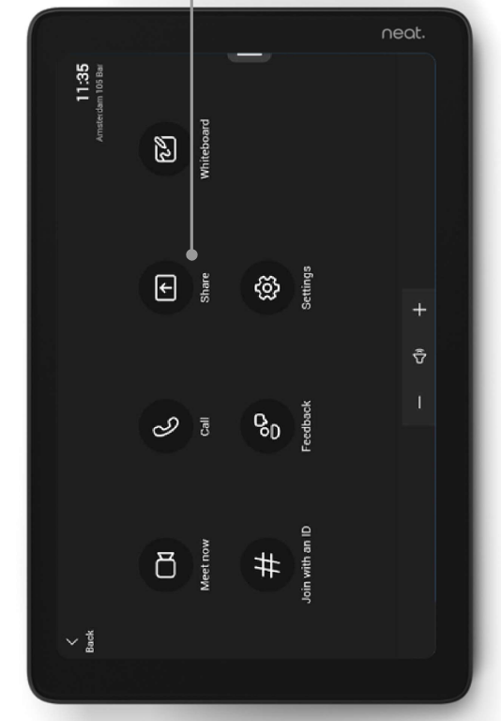

## Using the SC 3102 Conferencing System

The SC 3102 conferencing system is built into the room to operate on the **Laptop** and **Neat Pad (Teams)**. If using the conferencing system with your **laptop**, please ensure that the **USB-C** cord on the podium is plugged into your device along with the **HDMI**.

## Using the conference system with Zoom

* Open Zoom on your laptop and sign in using SSO (Illinois.zoom.us)
* Select **Share** on the NEAT Pad to share the HDMI content from your laptop.
* Verify the audio and video settings:
  1. Click on your user icon in the upper right corner of Zoom, then select **Settings**.
  2. In the Settings window, select **Video** from the left menu.
  3. Select the appropriate primary video device for the room – see the device table below.
  4. Ensure that the other video settings match your preferences.
  5. In the Settings window, select **Audio** from the left menu.
  6. Select the appropriate **Speaker** and **Microphone** for the room – see the device table below.
  7. Ensure that the other audio settings match your preferences.
* Place your call or join your meeting.

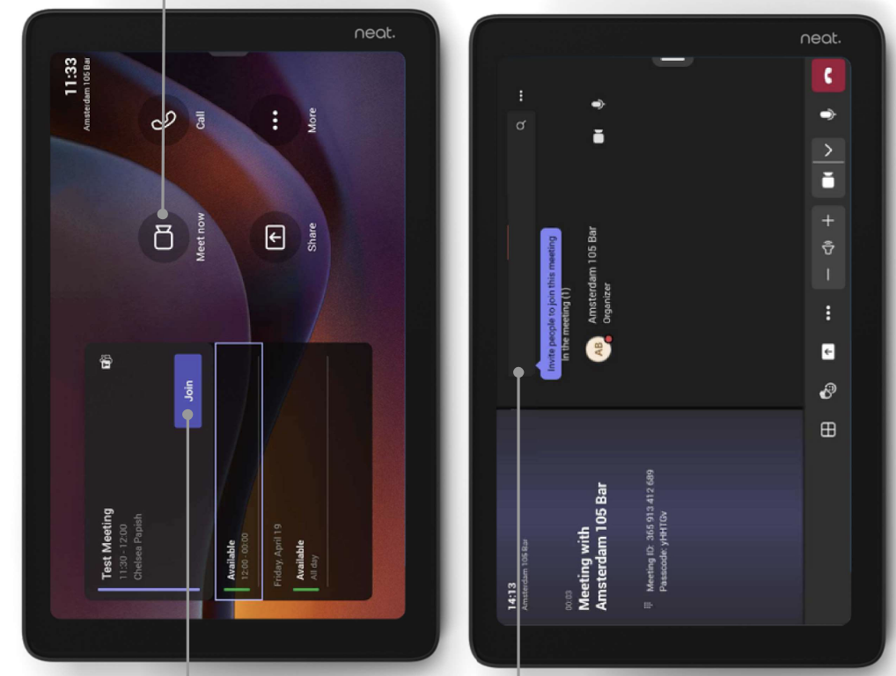

## Using the conference system with Teams

* You can add the room to your **Teams** meeting, this shall give you/room the advanced features for using Teams.
* Once the room has accepted the meeting, you can click “join” the meeting on the room’s **Neat Pad.**