ECEB 2017
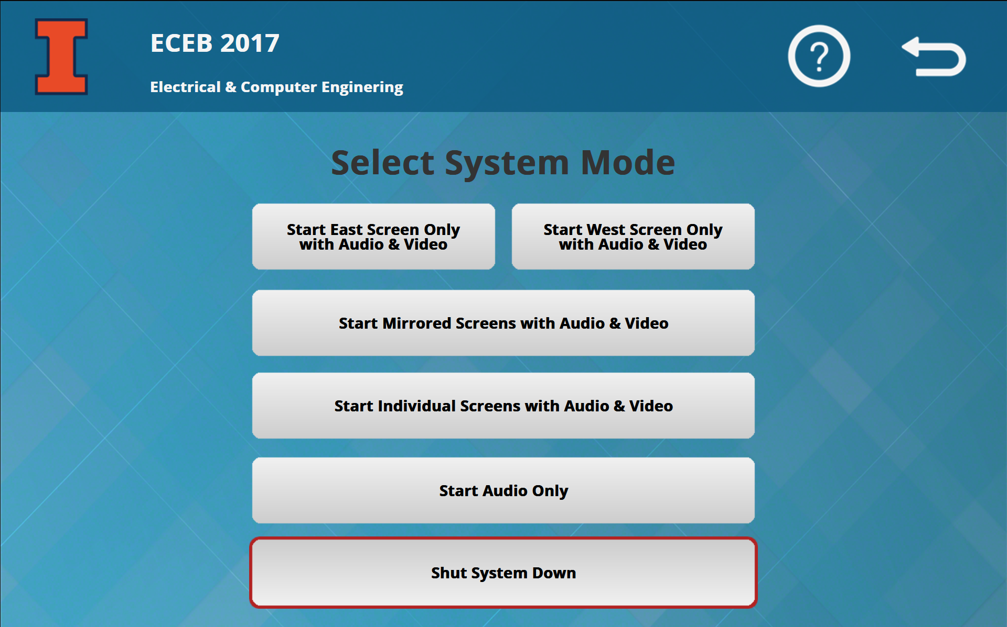

Turning the System On
- Press the control panel screen anywhere once to begin.
- Select the desired system mode: Audio & Video or Audio Only.
- Wait for the system to warm up.
Note: The system must be turned on before sources can be selected.
Control Panel

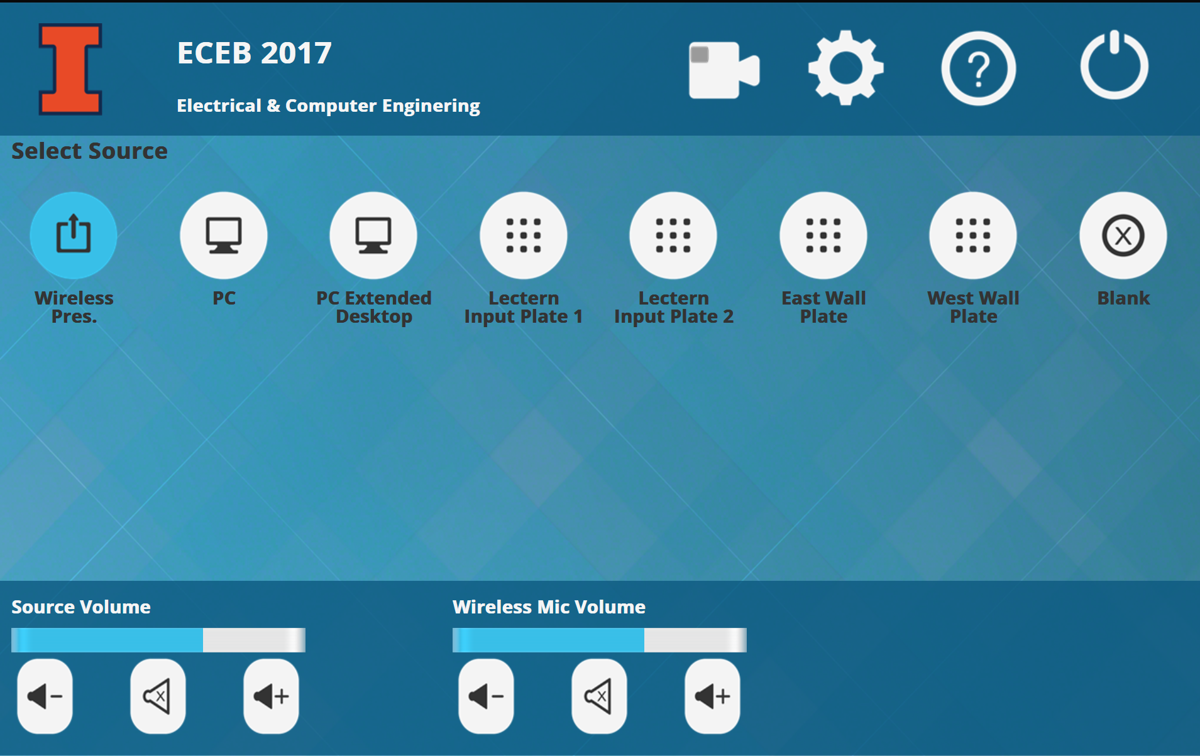
Using the Wireless Presenter
- If the Wireless Presenter is not already selected, press the [Wireless Pres.] button on the control panel.
- To connect your device to the Wireless Presenter, connect to IllinoisNet and follow the on-screen instructions.
- Once you attempt to connect, a 4 digital passcode will be displayed. Enter this on your device when prompted.

Using the Room PC
- If the Room PC is not already selected, press the [Room PC] button on the control panel.
- Ensure that the PC is powered on and not in sleep mode.
Note: The PC automatically logs in. If you find it at a lock screen, press Ctrl+Alt+Del to unlock

Using a Laptop
- Connect your laptop to one end of the HDMI or VGA cable and ensure the other end is plugged into the input panel.
- Select the [HDMI] or [VGA] button on the control panel corresponding to the cable used to connect the laptop.
Note: Depending on your laptop model, you may need an adapter. Adapters can be borrowed on short term loan (4hrs.) from an Engineering IT Help Desk.

Turning the System Off
- Press the power icon in the upper right corner of the control panel.
- Select [Shut System Down] and then confirm that you want to power off the system.
- Wait for the system to cool down.

Using Audio/Video Room Conferencing
Audio/Video Room conferencing is available in this room.
To use conferencing on the Room PC follow these instructions:
- Select [Room PC] on the control panel.
- Start and log into your conferencing software of choice.
- Select Black Magic Web Presenter (Presenter Camera) or QuickConnect-USB (Audience Camera).
- Select Extron HDMI Scaler D as your speakers and Black Magic Web Presenter as your microphone.
- Start or join your conference call.
To use conferencing on your PC follow these instructions:
- Select [Wireless Pres.], [HDMI], or [VGA] on the control panel depending on how you are connected.
- Make sure your PC is connected to a WiFi network (IllinoisNet, IllinoisNet_Guest, or EduRoam)
- Plug the Conferencing USB from the input panel into your PC.
- Allow your operating system to install any necessary drivers for the conferencing hardware. This should happen automatically.
- Start and log into your conferencing software of choice.
- Select Black Magic Web Presenter (Presenter Camera) or QuickConnect-USB (Audience Camera).
- Select Extron HDMI Scaler D or as your speakers and Black Magic Web Presenter as your microphone.
- Start or join your conference call.

