**NPRE 470 – Fuel Cells and Hydrogen Sources**

**Instructor: Dr. Kyu-Jung Kim (** [**kyujung@illinois.edu**](mailto:kyujung@illinois.edu) **)**

Hydrogen is proposed as the basis for a worldwide energy economy that can resolve current supply issues and meet environmental requirements for a greener future. However, to achieve this vision, many obstacles must be overcome, starting with a greenhouse gas-free production method and the development of a distribution infrastructure. This course will address key issues, including hydrogen production, transport, storage, and uses, especially fuel cells.

Lectures will cover hydrogen production from both nuclear and non-nuclear power sources, hydrogen handling and safety, and transportation and storage methods, ranging from high-pressure or cryogenic tanks to metal or chemical hydrides. The basic science and technology of fuel cells will be presented, including electrochemical processes, fuel cell thermodynamics, and various types of low- and high-temperature fuel cells designed for applications such as portable electronics, automotive, and space power. The final exam will include a term paper and group presentation. Course work will involve five homework assignments, two midterm exams, and an in-class team presentation as the final project. Enrollment is open to juniors, seniors, graduates, or by instructor permission.

2025 Spring; <https://courses.engr.illinois.edu/npre470/sp2025/web/NPRE-470.htm>

1. Course introduction
2. Introduction to Hydrogen Economy and Fuel Cell
3. Hydrogen Property and Production
4. Hydrogen Transportation
5. Hydrogen Conversion Technology : (I) Combustion
6. Hydrogen Conversion Technology : (II) Metal Hydrides and applications
7. Fuel Cell Introduction : Chapter 1. of Fuel cell fundamentals
8. Fuel Cell Thermodynamics : Chapter 2 of Fuel Cell Fundamentals
9. Fuel Cell Reaction Kinetics : Chapter 3 of Fuel Cell Fundamentals
10. Fuel Cell Charge Transport : Chapter 4 of Fuel Cell Fundamentals
11. Fuel Cell Types : Chapter 8 of Fuel Cell Fundamentals
12. Overview of Fuel Cell System : Chapter 10 of Fuel Cell Fundamentals
13. Fuel Cell Application - Stationary Applications, Mobile Device Applications, Wearable Power Pack, Transportation Applications

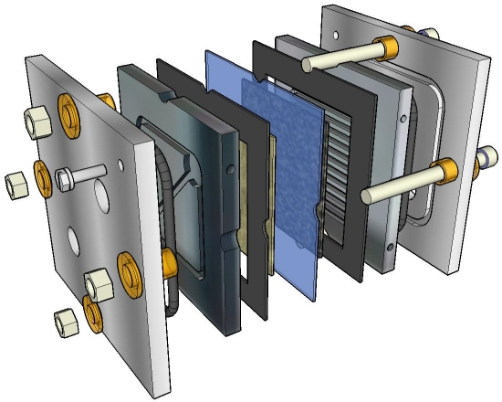

Membrane

Anode electrode

Cathode electrode

Rubber sealing

Graphite end-plate

(Fuel/Oxidizer flow channel)

Stainless steel end-plate

(Coolant circulating)

Coolant in and out

Fuel in and out

Oxidizer in and out

5x5 cm2 of active MEA area

Controlled temperature operation

Designed for MEA and Flow channel optimization study

