MSE 529: Hard Materials Seminar, Spring 2025

Instructors:
Jian-Min (Jim) Zuo, jianzuo@illinois.edu, 1006 MRL
Yingjie Zhang, yjz@illinois.edu, 256 MRL

Schedule:
Thursdays 4:00 pm–4:50 pm, 100 MSEB

Course Websites:

https://canvas.illinois.edu/courses/55890

Objectives:
The course provides opportunities for students to present their own scientific research work to their peers, to learn about contemporary materials science from students’ and invited guests’ research presentations, and to actively participate in scientific discussions by asking and answering questions.
Course Grade:
The course grade will be given based on attendance only. If you have more than 3 unexcused absences for the semester, you will receive an unsatisfactory grade. For those students that are scheduled to give a presentation, if you miss your presentation without notifying the instructors, you will also receive an unsatisfactory grade.
Excused absences are for medical or professional reasons only, such as attending and traveling to professional conferences, or performing off-campus research at National labs. For more details about reporting absences see below.
Attendance:
Attendance is taken through iclicker and occasional classroom attendance check. Please download the iclicker app to your phone, and join the iclicker course “MSE 529 - Hard Materials Seminar”. Many of you should have already been enrolled through Canvas roster import. However, please double check. If you have not enrolled in the iclicker course yet, join through the following link or by scanning the QR code below:
https://join.iclicker.com/VEEL
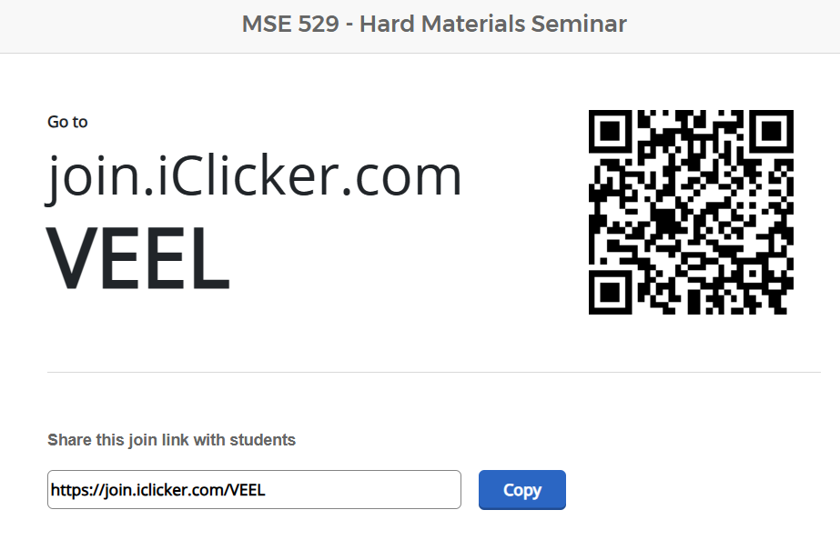
To get attendance through iclicker, your device must be connected to the internet and be inside the classroom. Ensure that the location permission of the iclicker app is active.
You are expected to ensure that your iclicker runs properly before the start of each seminar. However, if you occasionally run into technical problem with iclicker, please inform the instructor in the classroom right before the seminar starts, so that your attendance may be manually recorded.
Please also check your iclicker attendance record regularly to ensure that you attendances are correctly recorded.
Occasional classroom attendance checks may be carried out. Any discrepancy between iclicker and in classroom attendance will result in fail grade without exception.
Presentations:
We will have student or invited guest presentations. During the dates with student presentations, selected graduate students enrolled in the PhD program will present a 15-minute research seminar. The schedule of the presentations is available on the course Canvas site. If you have been selected to present on a given day and you have a schedule conflict, it is your responsibility to inform the instructor well in advance so that your presentation can be rescheduled. All presentations will be delivered in person.
The invited guest presentation will be 40 to 45 minutes, followed by discussions.

Expectations:
To succeed in this class, you will need to:
- Attend class regularly and participate through thoughtful questions;
- Prepare and practice your presentation;
- Seek out help when you have trouble.

Absences:
Excused Absence Request Form:
https://forms.illinois.edu/sec/1841242658
- Excuses from assessments will only be given in the following circumstances: a. Illness b. Personal crisis (e.g., car accident, required court appearance, death of close relative) c. Required attendance at a professional activity or official UIUC activity (e.g., professional conference, job interview, off-campus research activities, etc.)
- In all cases you must complete the online Excused Absence Request Form and upload a scan of the official written documentation explaining your absence.
- In cases (a) or (b) please provide some form of documentation via the online form within 2 weeks of the due date of the missed assessment, but no later than reading day. In case of extended or unusual illness, late submission of excuse documentation will be considered. See Student Assistance Center.
- On case (c) an official letter from the designated university official must be submitted via the online form at least one week prior to the due date of the missed assessment.
- If you will not be able to present on your assigned date, you are required to notify the instructor as soon as possible so alternative arrangements can be made.
- Notwithstanding the above, at the discretion of the instructors, you may be required to make up any excused work.

Special accommodations:
To obtain disability-related academic adjustments and/or auxiliary aids, students with disabilities must contact their lecturer and the Disability Resources and Educational Services (DRES, disability.illinois.edu) as soon as possible, and no later than Jan. 31, 2025.
Academic Integrity, Harassment, and Discrimination:
You are bound by the University Honor Code in this course. Any violation of the Honor Code will result in disciplinary action. In addition, harassment or discrimination of any kind will not be tolerated. Please report any concerns immediately to your professor.

Changes to the syllabus:
Changes may occur as deemed necessary by the instructors; they will be announced.

