TE 462: Leading Sustainable Change
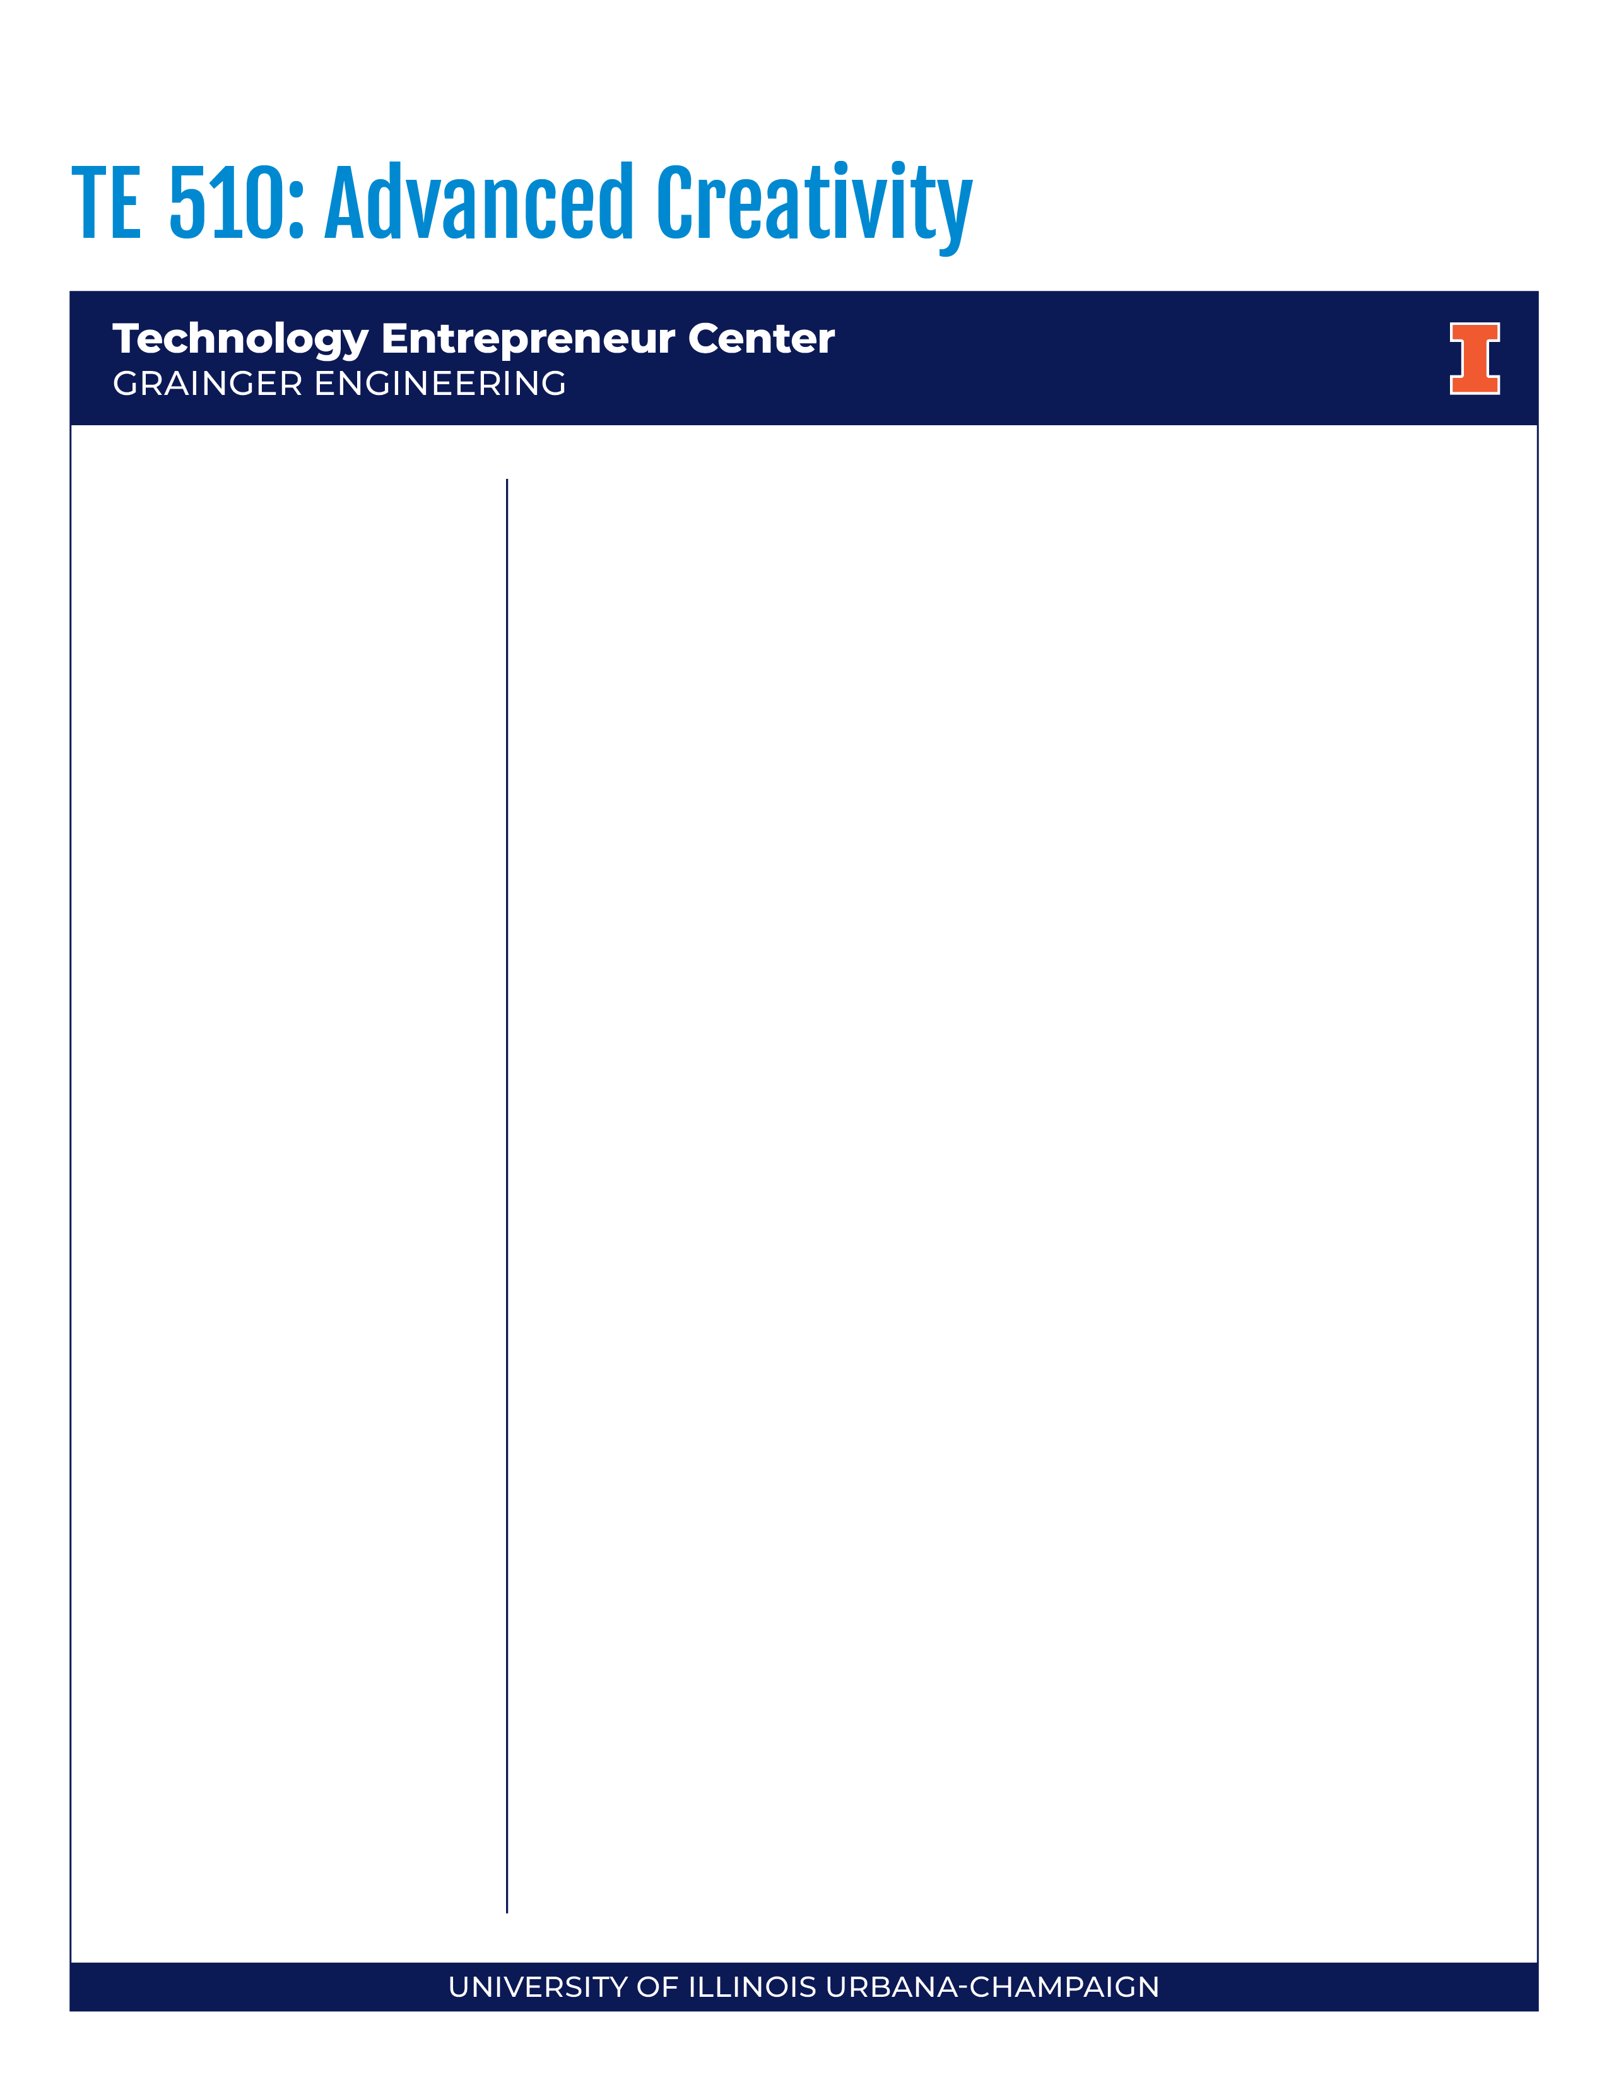
Course Purpose
This course covers various models and frameworks for change management in organizations. Students will learn systems thinking concerning change consequences; building coalitions and communities to support change; and understand resistance to change. Processes to plan, implement, manage, and sustain change within an organization through alignment of change strategies with organizational and individual concerns.
Learning Objectives
Upon completion of this course, you will be able to:
- Identify individual reactions to change and transition.
- Compare and contrast different change management theories/approaches including Kotter’s Change Model, Social Change Model, Bridges Transition Model, Heath and Heath’s Elephant/Rider Metaphor.
- Describe the components of systems thinking (e.g., balancing/reinforcing loops, delays) and apply these concepts to a current individual and organizational challenges.
- Analyze organizations through four organizational frames (structural, human resources, political, and symbolic) and assess how a potential change will impact each frame in an organization.
- Recognize complexity in decision making and conduct a decision-making simulation.
- Analyze case studies of organizational change initiatives and change leaders. Apply various change theories and develop recommendation plans for leading and managing organizational change.

Required Texts
- Bridges, W. (2016). Managing transitions. Cambridge, MA: Perseus.
*The 2014 edition is available at the UIUC library or via I-share including eBook and digital audio copies.
- Heath, C. & Heath, D. (2010). Switch: How to change things when change is hard. New York, NY: Random House
*Numerous copies of the 2010 edition are available at the UIUC library or via I-share including eBook and digital audio copies. Copies also available at ILC library.
- Bolman & Deal (2008). Reframing organizations. San Francisco, CA: Jossey Bass. [Chapters 3, 8, 9,12]
*We encourage you not to purchase this book. It is available on UIUC eBooks: Find it here (all of the pages required can be downloaded and printed)

Spring 2025
- 3 credit hours
- Mon./Weds.
- 4-5:15pm
- 2078 Natural
History Building

Instructors
Dr. Gayle Spencer
gspencer@illinois.edu
Dr. Beth Hoag
bhoag2@illinois.edu



Additional Readings or Educational Resources
TE 462: Leading Sustainable Change | Technology Entrepreneur Center
- Conner, D. R. (1992). Managing at the speed of change. New York, NY: Random House [Chapter 8]
- Kea, H. (2003). Leadership in time of crisis: NASA and the Columbia Tragedy. Selected Proceedings from International Leadership Association, Guadalajara, Jalisco, Mexico.
- Kotter, J. P. (2012 or 1996). Leading change. Cambridge, MA: Harvard Business School Press. [Chap. 1-2]
- Senge, P. M. (1990). The fifth discipline: The art and practice of the learning organization. New York, NY: Doubleday. [Chapter 5]
- Skendall, K. C. (2017). An overview of the social change model of leadership development. In S. R. Komives, S. R. & W. Wagner W. (Eds.). Leadership for a better world: Understanding the Social Change Model for Leadership Development. (pp. 17-42). San Francisco, CA: Jossey Bass.
- Sweeney, B. (2016). Lean Six Sigma: QuickStart Guide. [Chapter 1 and Chapter 3]
- Vedantam, S. The power and problem of grit. Hidden Brain. Retrieved from https://www.npr.org/2016/04/04/472162167/the-power-and-problem-of-grit [PODCAST]
- Wagner, W. (2017). Change. In S. R. Komives, S. R. & W. Wagner W. (Eds.). Leadership for a better world: Understanding the Social Change Model for Leadership Development. (pp. 201-232). San Francisco, CA: Jossey Bass.
- Podcast – Life Kit: How to start a new habit: Think small, BJ. Fogg https://www.npr.org/2020/02/25/809256398/tiny-habits-are-the-key-to-behavioral-change

Grading Overview
The assignments in this course are designed to help you enhance your creativity in a variety of ways. Being a student is rigorous, so each assignment has been developed to benefit your development.
Assignment Points Deadline
Reflection #1: Transition 100 2/5
Chapter Infographic and Presentation 2/24 or 2/26
Infographic 100
Presentation 25
Reactions to Change – In class assignment 25 3/3
Sustainability and Change – In class assignment 25 3/12
Systems Thinking Module (Virtual) 50 TBA
Reflection #2: Four Frames 100 4/7
Engineering/Technology Change Agent 4/15,4/17,4/22
Pecha Kucha Presentation 150
Summary 150
Reflection #3: Synthesis of Theories 100 5/14
Reading Quizzes
(4 quizzes at 25pts each, we will drop lowest quiz grade) 75
Class Engagement and Discussion 100 All Semester
__________________________________________________________________________________
Total Points Possible 1000

Grading Scale
A 94-100% B+ 86-89% C+ 75-78% D+ 63-66%
A- 90-93% B 82-85% C 70-74% D 60-62%
B- 79-81% C- 67-69% F <60%

Course Assignment Descriptions
In this section you will find a description of each course project. We will also discuss each project in class, and you can find grading rubrics on Canvas.

Reflections
300 points total (3 reflections, 100 points each)
There will be three short reflection/application papers (2-4 pages double spaced, 12 pt. font, 1-inch margins) throughout the semester. For each of these papers we ask that you apply your personal experiences to theories/concepts learned in class and through readings.
- #1 Describe a significant change/transition in your life. Describe each stage of the transition you experienced. What was your reactions to the change (e.g. positive, negative) and how did you manage them? Apply what you have learned in the class thus far to analyze the change/transition in your own life. Make sure to reference at least two sources from class (e.g. Bridges, Wagner, Connor)
- #2: Examine an organization you are a part of (academic college, student organization, work/internship site). Briefly analyze the organization through each of the four frames. Make sure to apply at least two key concepts from each frame to your organization. What new insights did you learn about the organization by using this framework?
- #3: Reflect on the various theories/frameworks we have explored about this semester (Social Change Model, Heath and Heath, Kotter, Bridges, Systems Thinking, etc.) Identify two that has informed your thinking and influenced how you perceive change in your own life. Provide examples to demonstrate your learning.
Reflections will be graded on the following criteria: (a) Analysis and synthesis of readings and class materials (multiple sources), (b) Paper Components, (c) Connection between personal experiences and readings, (d) Quality of Writing (Grammar, Spelling, Organization). See Reflection Rubric on Canvas for more detail.

Chapter Presentation and Infographic Summary
125 points total (100 infographics, 25 presentation)
Each student will be assigned a chapter to read and create a 1-page infographic of the chapter. They will present the infographic to class and summarize the key findings from the chapter.
- Chapter Infographic– The summary should address main points of the chapter and be visually appealing. We recommend programs such as Piktochart or Canva to create your design. For more information about how to create an infographic watch: https://www.youtube.com/watch?v=nLxQAa5Sras
- Chapter Summary Presentation–Students will present their chapter to the class. The presentation should be approximately 10-15 minutes with at least 5 minutes reserved for questions.
- Review the “Infographic Rubric” on Canvas for specific grading criteria.

Reactions to Change In-Class Assignment
25 points
This assignment will be done in class. Students will read a chapter about reactions to changes, watch an episode of Parks and Rec, and complete a worksheet related to the concepts.

Sustainability and Change In-Class Assignment
25 points
This assignment will be done in class. Students will apply concepts from the UN Sustainability goals.

Systems Thinking Module
50 points
[THIS MODULE MAY BE MOVED IF WE HAVE TO MOVE A CLASS TO ONLINE DUE TO INCLEMENT WEATHER] You can find the Systems Thinking Module in Canvas which contains details of the assignment. In this module students will read a chapter by Peter Senge on Systems Thinking, complete the LinkedIn Learning course Systems Thinking by Dr. Derek Cabera and submit a quiz and reflection. This module is available and can be completed any time before deadline.

Engineering/Technology Change Agent Project
Total Points: 300 (Pecha Kucha: 150 points, Summary: 150 points)
Choose a current or historical engineering or technological change agent. Explore their efforts to make change within their organization, business, or society. Develop a PechaKucha presentation to be given to the class. PechaKucha is a presentation format where you show 20 slide images for 20 seconds each. The slides will advance automatically, and the presenter talks alongside the images. To view examples of PechaKucha please visit www.pechakucha.org.

Presentations should address biographical information, outline the technological change initiative, and make applications to theory. Students will also be graded on their presentation skills, organization/timing, and use of media/images. See Engineering/Technology Change Agent Pecha Kucha Grading Rubric in Canvas.

In addition to the presentation, you are required to submit a summary regarding the change agent to support your presentation. This will be turned in the same day you present. Address the following in 3-4 pages double spaced, 12 pt. font, 1-inch margins:
- Identify the engineering/technology change agent you chose and describe why you chose them. (1/2 page – 1 page)
- Provide a short biography of the change agent and describe the engineering/technology change initiatives they led. (1 page)
- Analyze at least 2 change theories/concepts you have learned in class and apply them to the experience of the change agent. (1 – 2 pages)
- What did you learn from this change agent? (1/2page -1 page)
- Provide a reference page using APA formatting that cites at least 3 non-course resources you used to research the change agent. For more information about APA reference visit: https://owl.purdue.edu/owl/research_and_citation/apa_style/apa_formatting_and_style_guide/general_format.html (If you would prefer to use another formatting style, please contact the instructors prior to submission.)
- Review the Engineering/Technology Change Agent Summary Rubric, in the Change Agent tab on CANVAS for specific grading criteria.

Reading Quizzes
75 points (25 points each)
Throughout the semester, we will have 4 quizzes based on the readings equaling 25 points each. At the end of the semester, we will drop the lowest quiz score.

Class Engagement and Attendance
100 points
Class engagement is a significant part of the learning experience. You will be required to participate in class discussions and activities. “Engagement,” however, looks different for different people. Therefore, you will NOT be graded on the number of times you speak in class, nor the length of your verbal responses. You WILL be graded on how physically and psychologically present you are in class, and how authentically you share your thoughts and reactions while in class. Our class is small in nature, and we should view ourselves as a working team. Your engagement in class is essential and shows respect for the learning environment and for your colleagues since we will all be co-learning with one another. “Showing up” means not only being physically present on time, but also discussing the assigned readings, paying attention, having honest dialogue, and interacting respectfully. All students will be allowed one free absence, point deductions will occur for additional absences.

Schedule and Assignment Due Dates
*Schedules and due dates subject to change, see Canvas for the most updated information
Session | Date | Day | Instructor | Topic | Reading | Due
1 | 1/22 | W | B & G | Introduction to Class | Syllabus
2 | 1/27 | M | B | Change Management and Mental Models | Wagner (2017) in Komives, Wager, et al. Chapter 10
3 | 1/29 | W | G | Change v. Transition  In Class-Software Company Case Study | Bridges (2016) – Chapter 1, p. 3-10
4 | 2/3 | M | B & G | Transition Timelines
5 | 2/5 | W | B | Transition Theory: Letting Go/Neutral Zone | BRING BRIDGES BOOK TO CLASS FOR IN CLASS READING of Chapter 3 and 4 | Reflection #1 Due
6 | 2/10 | M | G | The Elephant, the Rider, & the Path | Heath (2010)– Chapter 1: Three Surprises about Change  Bridges, Chapter 5: New Beginnings | Quiz 1
7 | 2/12 | W | B | Social Change Model | Skendall (2017) Chapter 2 - p. 17-42
8 | 2/17 | M | B | Social Change Model
9 | 2/19 | W | G | Kirton Adaption/Innovation Inventory | Complete KAI Prior to class
10 | 2/24 | M | B&G | Direct the Elephant: Chapters 2, 3, 4; Motivate Elephant: 5, 6 | Read assigned chapter | Infographic Presentation – Print Infographic for Class
11 | 2/26 | W | B&G | Motivate the Elephant: Chapters 7 Shape the Path: Chapters 8,9, 10 | Read assigned chapter  Heath and Heath: Chapter 11 “Keep the Switch Going
12 | 3/3 | M | B | Reactions and resistance to change | Read Conner (1992) - Resistance to Change p. 125-145 | In-class assignment
13 | 3/5 | W | B | NO IN-PERSON CLASS: Complete Systems Thinking Assignment | Senge (1990), Chapter 5 | NO IN-PERSON CLASS: Complete Systems Thinking Assignment
14 | 3/10 | M | G | Sustainability and Change |  | In-class assignment
15 | 3/12 | W | G | Sustainability and Change |  | Quiz 2
Spring Break March 15-23 (no classes)
16 | 3/24 | M | B | Structural Frame | Bolman and Deal (2010) –  Chapter 3: Getting Organized, p. 45-69
17 | 3/26 | W | G | Human Resource Frame | Bolman and Deal (2010) – Chapter 8: Interpersonal and Group Dynamics, p. 165 – 187
18 | 3/31 | M | B | Political Frame | Bolman and Deal (2010) – Chapter 9: Power, Conflict, and Coalitions, p. 191-210
19 | 4/2 | W | G | Symbolic Frame | Bolman and Deal (2010) – Chapter 12: Organizational Culture and Symbols, p. 251-278
20 | 4/7 | M | G | Kotter’s Model of Leading Change | Kotter (1996) Chapters 1 and 2 (CANVAS) | Quiz 3  Reflection #2
21 | 4/9 | W | B | Introduction to Lean and Six Sigma | Sweeney (2016) Chapter 1 and 3
22 | 4/14 | M | B | Grit/Growth Mindset | Listen to podcast “The Power and Problem of Grit”
23 | 4/16 | W | B | Presentation Prep/Work Time
24 | 4/21 | M | B & G | Engineering/Technology Change Agent Pecha Kucha |  | Pecha Kucha & Summary
25 | 4/23 | W | B & G | Engineering/Technology Change Agent Pecha Kucha |  | Pecha Kucha & Summary
26 | 4/28 | M | B & G | Engineering/Technology Change Agent Pecha Kucha |  | Pecha Kucha & Summary
27 | 4/30 | W | G | Chaos and Non-Stop Change | Bridges (2003): Chapter 7: How to Deal with Nonstop Change, p. 99-120 (NOT ON CANVAS)
28 | 5/5 | M | B | Tiny Habits | Listen to Life Kit: How to start a new habit: think small
29 | 5/7 | W | B & G | Course Wrap up and Summary |  | Quiz 4
 | 5/14 |  |  | No class |  | Reflection #3

Class Policies

Absence and Sick Policy
As discussed in the class engagement and attendance section, students are allowed one free absence, point deductions will occur for additional absences. Students who feel ill should not come to class, please notify both instructors prior to class and alternative assignments will be discussed.

Late Assignments
Assignments are expected to be completed by due date at 11:59pm. If you are unable to complete the assignment by the due date you must email the instructors by the deadline and you will be given up to one additional week to complete the assignment. Point deductions will occur if the assignment is not submitted after the additional week.

Sex-Based Misconduct Policy and Reporting
The University of Illinois is committed to combating sex-based misconduct. As such, you should know that faculty and staff members are required to report any instances of sex-based misconduct—which can include discrimination, harassment, sexual assault, sexual exploitation, dating violence, domestic violence, and stalking—to the University’s Title IX Office. What this means is that as your instructors we are required to report any incidents of sex-based misconduct that are directly reported to us, or of which we are somehow made aware. When a report is received, an individual with the Title IX Office reaches out to provide information about rights and options, including accommodations, support services, the campus disciplinary process, and law enforcement options.
There is an exception to this reporting requirement about which you should be aware. A list of the designated University employees who, as counselors, confidential advisors, and medical professionals, do not have this reporting responsibility and can maintain confidentiality, can be found here: wecare.illinois.edu/resources/students/#confidential. We specifically recommend the confidential advising resources available at the Women’s Resources Center (serving all gender identities).
Other information about resources and reporting is available here: wecare.illinois.edu.

Academic Integrity and Generative AI
You are expected uphold the highest ethical standards, to be honest, and to practice academic integrity. This includes doing original work and citing sources, including the work of other students. Please give special care to prepare high-quality submissions with proper grammar and spelling. The University of Illinois at Urbana-Champaign Student Code should also be considered as a part of this syllabus. Students should pay particular attention to Article 1, Part 4: Academic Integrity. Read the Code at the following URL: http://studentcode.illinois.edu/. Academic dishonesty may result in a failing grade.
Every student is expected to review and abide by the Academic Integrity Policy:
https://studentcode.illinois.edu/article1/part4/1-401/. Ignorance is not an excuse for any academic dishonesty. It is your responsibility to read this policy to avoid any misunderstanding. Do not hesitate
to ask the instructor if you are ever in doubt about what constitutes plagiarism, cheating, or any other breach of academic integrity.
The use of generative AI tools is permitted in this course for the following activities:

- Brainstorming and refining your ideas;
- Fine tuning your research questions;
- Finding information on your topic;
- Assisting you in the graphic design of your infographic;
- Drafting an outline to organize your thoughts; and
- Checking grammar and style.

The use of generative AI tools is not permitted in this course for the following activities:

- Impersonating you in classroom contexts, such as using generative AI for personal reflections.
- Completing group work that your group has assigned to you, unless it is mutually agreed upon that you may utilize the tool.
- Writing a draft of a writing assignment.
- Writing entire sentences, paragraphs or papers to complete class assignments.

You are responsible for the information you submit based on an AI query (for instance, that it does not violate intellectual property laws, or contain misinformation or unethical content). Your use of AI tools must be properly documented and cited in order to stay within university policies on academic honesty. Any use outside of this permission will be considered academic dishonesty and a violation of the Student Code.

Religious Observances
Illinois law requires the University to reasonably accommodate its students' religious beliefs, observances,
and practices in regard to admissions, class attendance, and the scheduling of examinations and work requirements. You should examine this syllabus at the beginning of the semester for potential conflicts between course deadlines and any of your religious observances. If a conflict exists, you should notify your instructor of the conflict and follow the procedure at https://odos.illinois.edu/community-of-care/resources/students/religious-observances/ to request appropriate accommodations. This should
be done in the first two weeks of classes.

Disability Related Accommodations
To obtain disability-related academic adjustments and/or auxiliary aids, students with disabilities must contact the course instructor and the Disability Resources and Educational Services (DRES) as soon
as possible. To contact DRES, you may visit 1207 S. Oak St., Champaign, call 333-4603, email disability@illinois.edu or go to https://www.disability.illinois.edu. If you are concerned you have a disability-related condition that is impacting your academic progress, there are academic screening appointments available that can help diagnosis a previously undiagnosed disability. You may access these by visiting the DRES website and selecting “Request an Academic Screening” at the bottom of
the page.

FERPA
Any student who has suppressed their directory information pursuant to Family Educational Rights and Privacy Act (FERPA) should self-identify to the instructor to ensure protection of the privacy of their attendance in this course. See https://registrar.illinois.edu/academic-records/ferpa/ for more information on FERPA.

Anti-Racism and Inclusivity Statement
The Grainger College of Engineering is committed to the creation of an anti-racist, inclusive community that welcomes diversity along a number of dimensions, including, but not limited to, race, ethnicity and national origins, gender and gender identity, sexuality, disability status, class, age, or religious beliefs. The College recognizes that we are learning together in the midst of the Black Lives Matter movement, that Black, Hispanic, and Indigenous voices and contributions have largely either been excluded from, or not recognized in, science and engineering, and that both overt racism and micro-aggressions threaten the well-being of our students and our university community.

The effectiveness of this course is dependent upon each of us to create a safe and encouraging learning environment that allows for the open exchange of ideas while also ensuring equitable opportunities and respect for all of us. Everyone is expected to help establish and maintain an environment where students, staff, and faculty can contribute without fear of personal ridicule, or intolerant or offensive language. If you witness or experience racism, discrimination, micro-aggressions, or other offensive behavior, you are encouraged to bring this to the attention of the course director if you feel comfortable. You can also report these behaviors to Campus Belonging Resources (https://diversity.illinois.edu/diversity-campus-culture/belonging-resources/). Based on your report, Members of the Office of the Vice Chancellor for Diversity, Equity & Inclusion staff will follow up and reach out to students to make sure they have the support they need to be healthy and safe. If the reported behavior also violates university policy, staff in the Office for Student Conflict Resolution may respond as well and will take appropriate action.

Emergency Response Recommendations
Emergency response recommendations can be found at the following website: http://police.illinois.edu/emergency-preparedness/. I encourage you to review this website for the Natural History Building floor plan https://police.illinois.edu/wp-content/uploads/floor-plans/u0032.pdf

