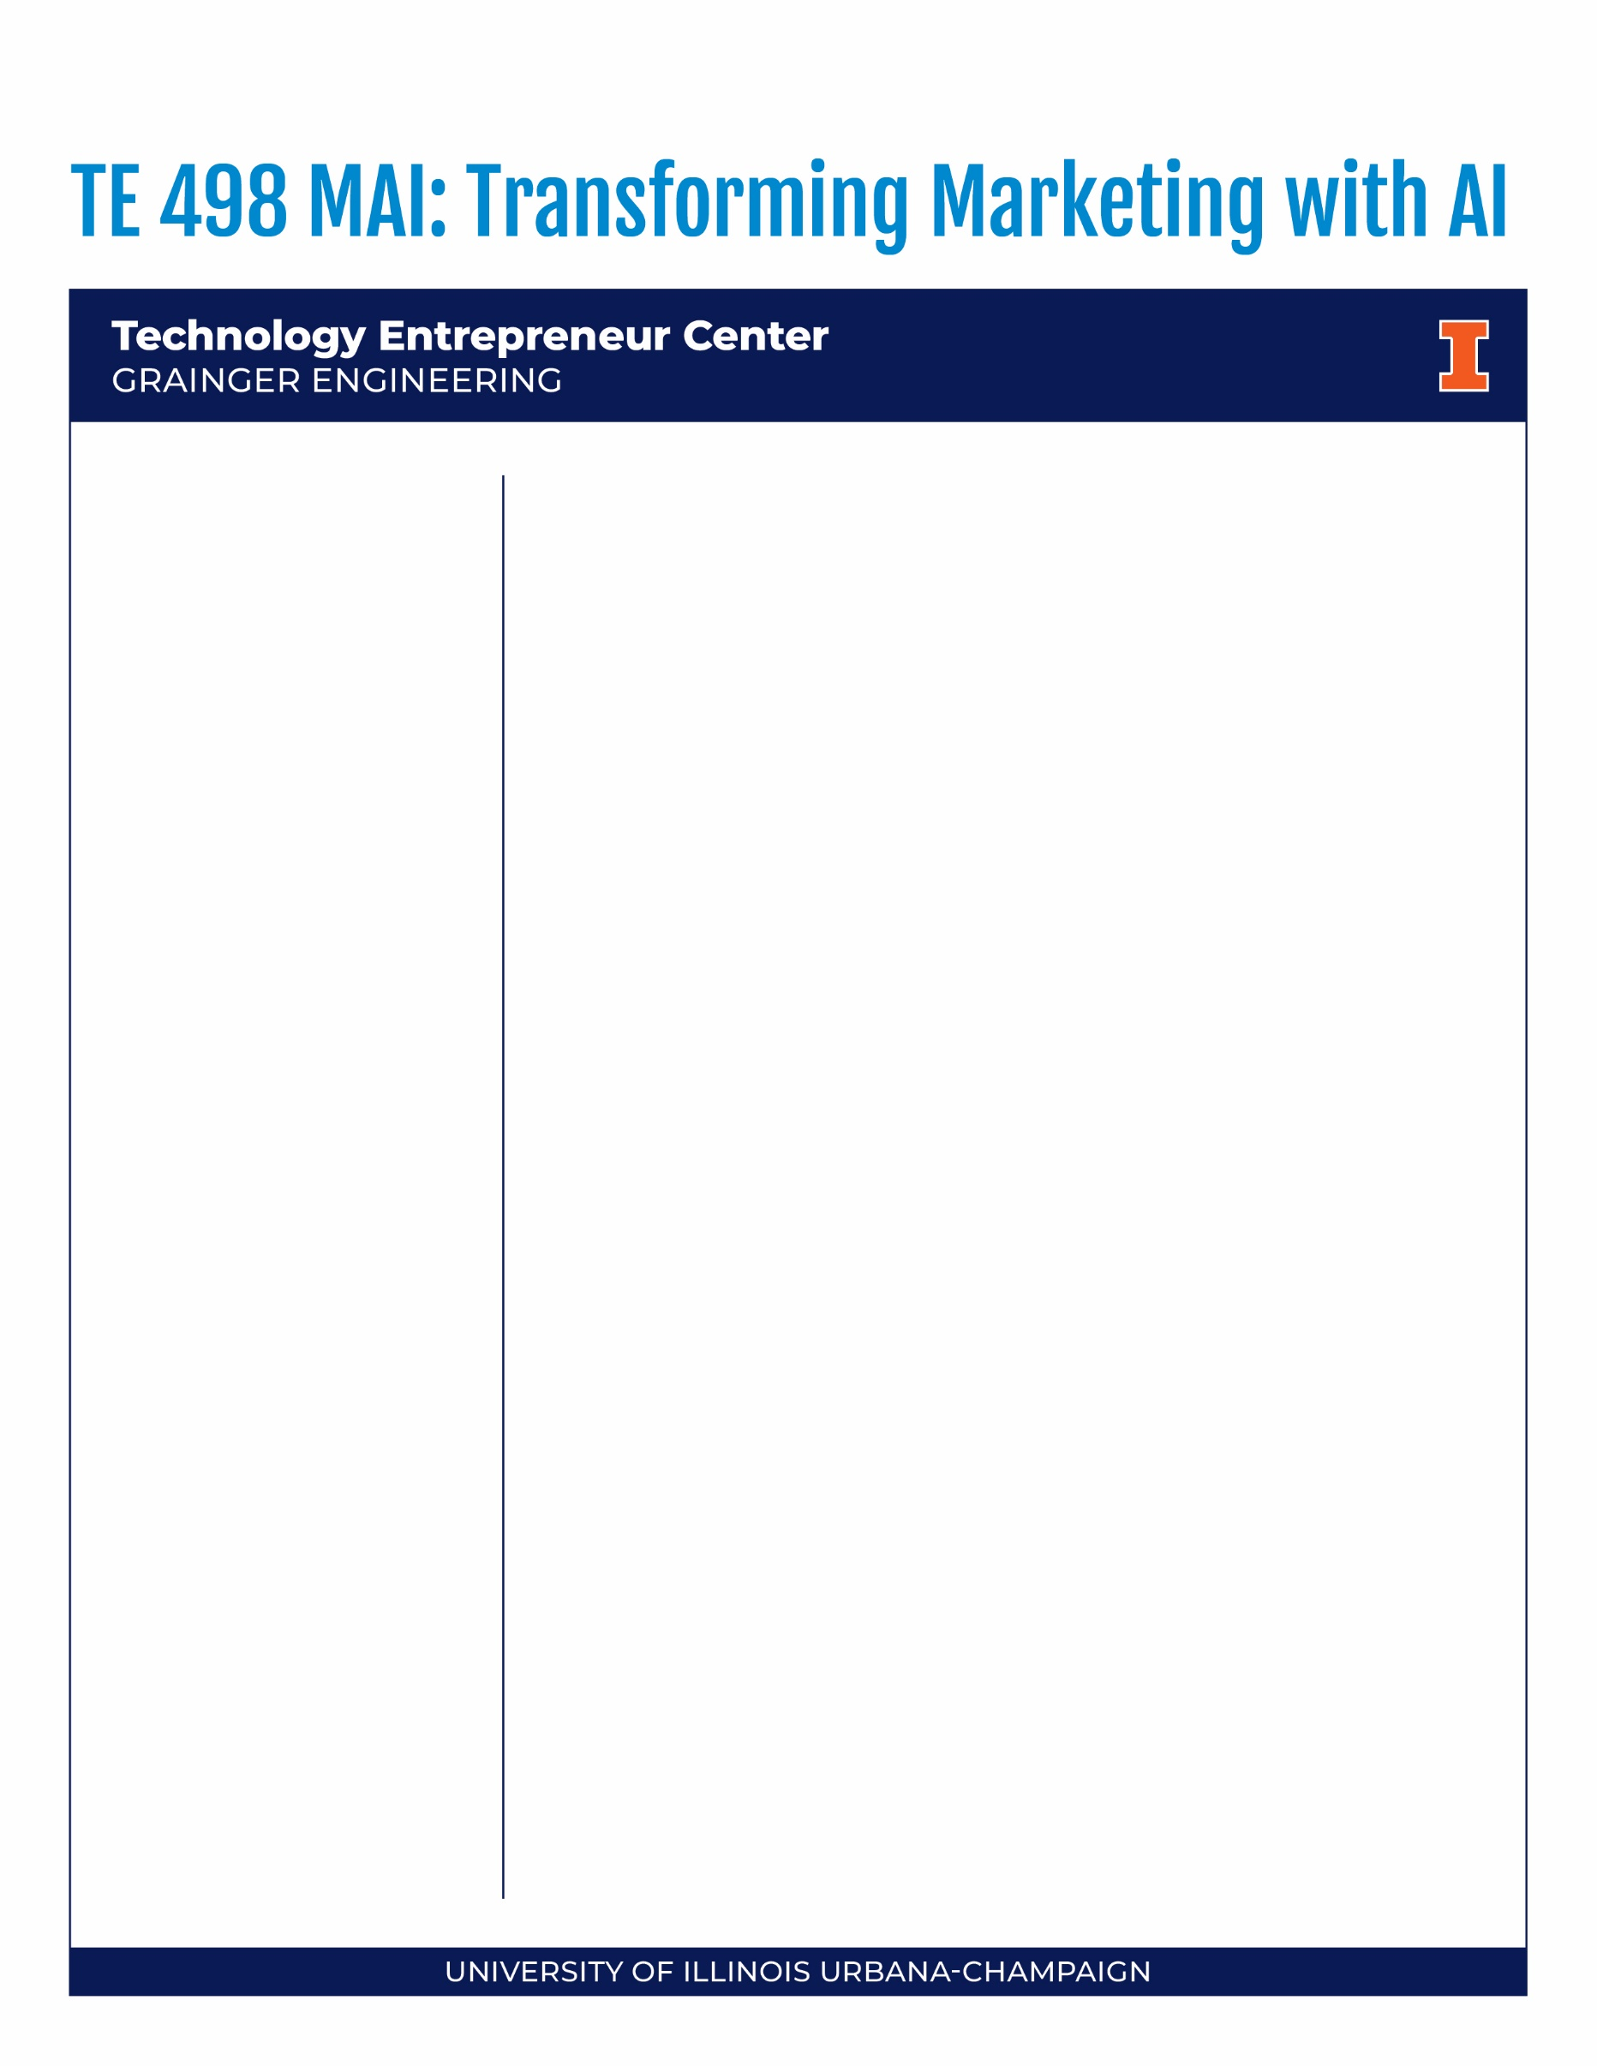

TE 468: Transforming Marking with AI
Course Purpose
This course will explore the cutting-edge use of artificial intelligence (AI) in marketing for technology ventures. We’ll delve into how AI can revolutionize entrepreneurial marketing in various ways, including targeting, personalization, content creation, analytics, optimization, customer service, sales, research, and ethics. Each week we will examine real-world case studies of how leading companies harness AI's power to supercharge their marketing efforts. By the end of the course, you will have a strong framework to recognize better how AI can be used to create more effective and efficient marketing campaigns in engineering entrepreneurship. Weekly class sessions are synchronous, online via Zoom. Attendance is required. Course materials are available in Canvas.
Learning Objectives
Upon completion of this course, you will be able to:
- Understand the basics of artificial intelligence.
- Identify the different ways that AI can be used in marketing.
- Analyze case studies of how AI is being used by leading companies.
- Develop a plan for using AI to improve your own marketing campaigns.
Learning Outcomes
- Grasping AI's Role in Marketing: Students will acquire a foundational understanding of artificial intelligence concepts, particularly focusing on their applications and significance in modern marketing strategies.
- Case Study Analysis: Through examination of real-world instances, students will gain insights into how industry leaders leverage AI for enhancing their marketing initiatives and will be able to draw key lessons from these applications.
- Strategic AI Deployment: By exploring AI's evolving multifaceted applications in marketing, from targeting to content creation, students will cultivate the skills needed to design and execute preliminary AI-driven marketing strategies tailored to specific needs.
- Navigating AI Ethics in Marketing: Addressing the nuanced ethical landscape, students will comprehend the potential challenges and considerations when implementing AI solutions, ensuring that marketing practices remain responsible and consumer centric.
- Anticipating AI's Evolution in Marketing: By surveying emerging technologies and methods, students will develop an understanding of the potential trajectory of AI in marketing, positioning themselves at the forefront of innovation.
- Applied AI Marketing Campaign: Synthesizing course content, students will conceptualize and outline an AI-integrated marketing campaign, demonstrating their ability to pragmatically harness AI's capabilities for tangible marketing outcomes.
- Students will identify, discuss, formulate, and solve critical problems, and
- Recognize the need for, and an ability to engage in, life-long learning.
Required Texts | Software
- Required: Harvard Business School Cases:
Instructions will be posted on Canvas in each module. Cost is per individual case on HBS & other Websites.
- Required: Blotato.com to support your crowed funding project. 70% TE 498 discount forever, on any plan: HERO70
- Required: Business Model Generation by Osterwalder & Pigneur
Student Responsibilities
- For TE468, a typical week begins on Monday and ends Sundays at midnight. YOU HAVE WORK DUE FOR THE FIRST MONDAY WE MEET, CHECK CANVAS!
- All assignments are due on Sunday at 11:59 p.m. (CST) to be precise, prior to the Monday class discussion. You are expected to be prepared for the class discussion the first class.
- The weekly agenda will highlight the student responsibilities for the week.
- Each week will have assigned reading(s) from the case text, as well as related articles/podcast(s). Students should review each item carefully and come to class prepared to discuss. Your grade is heavily weighted on class discussion and participation.
- There will be a group assignment during the class weeks where small teams will use AI tools to stand up a creative marketing campaign that drives backers on a Crowdfunding Platform. Please actively monitor the weekly module on Canvas for details (note, modules are updated often).
- Keep abreast of what is happening in the course. Attend class & participate. Challenge the professor, guests & each other with questions. Do not feel intimidated. Ask for help, if (and when) you need it.
Grading
Component Points %
1. Post Module Case Write-up 450 45% (due before each class)
2. Peer Collaboration Review 50 5%
3. Class Participation
w/ Final Project Presentation: 250+ 25% w/ article/podcast conversations woven in as BONUS Pts.
4. Project | Drill Performance 250 25% w/ drill workshop session participation | contributions

IMPORTANT NOTE: As a baseline, you can’t get points for participation if you don’t show up for class with your camera on.
Final grades will be assigned strictly based on the following point scale. No final grade will be rounded.
Grading Scale
A 930-1000 A-900-929
B+ 875-899 B 825-874 B- 800-824
C+ 775-799 C 725-774 C- 700-724
D+ 675-699 D 625-674 D- 600-624 F < 600

Fall 2026
- 2 credit hours
- Monday
- 2:00-3:50pm CST
- Online via Zoom
- Attendance at the weekly synchronous sessions is required.
- Video MUST always be on.

Instructor
Marc Bivona
bivona@illinois.edu
Marc Bivona is the former Executive Vice President, Marketing of a multi-faceted international real estate company providing B2B & B2C investments, development, education, coaching, and SAS services. He earned an MBA from the University of Virginia’s Darden School of Business, where he served as President of their NYC alumni association. Marc earned dual-Bachelor of Science degrees in Computer Applications and Information Systems, as well as Accounting from New York University’s Stern School of Business.



Grades will be accessible by password only on Canvas. For your security, grades will not be provided by phone or email. Grades are not negotiable. Students with extenuating circumstances which require them to receive a certain grade or maintain a particular GPA (e.g., graduation, loss of a scholarship, University probation or suspension, loss of a job offer, revocation of student Visa, etc.) need to realize that they are responsible for working hard to achieve the needed class grade. Please ask for help if you see that you are falling short of the grade that you expect or need. We want students to succeed but you must know that we cannot make exceptions for individual students. Grades can be changed only if I have made an input or calculation error. It is important that you check your class grades and immediately notify me of any discrepancies.
Grading Components
- Post-Class Write-ups
Throughout the semester weeks, a summary write-up from each weekly case material from a particular module will be required. You should submit a write up on time to have the full points count. Without extenuating circumstances, you will be penalized by 50% for the available points if you miss those deadlines. Each write-up will cover your summary of the case material from a summary analysis as well as your 3+ key take-aways. IMPORTANT: Adhere to the case template and ensure that you answer all case questions posted to the module in that write-up. You will lose points if you do not. The purpose of these write-ups is to ensure that you have read and considered the cases. I will note how you weave these topics into the weekly conversations for your class participation.
- Peer Collaboration Review
- Each student is required to complete a spreadsheet point rubric for each classmate, as well as themselves, and upload it to canvas by the end of the Class Week 13, Sunday 11:59PM. AN HONEST ASSESMENT IS REQUIRED FOR FULL POINTS IN THE ENTIRE COURSE. Late submissions will not be counted, and you will be marked as 0% of your total personal points.

- Project|Crowdfunding Assignment
The class will be broken up into teams and the goals are simple:
- Decide on one product. Using AI Tools via BLOTATO.COM, each team will brand, develop a marketing campaign and stand-up automated AI augmented content marketing strategies (earned and paid media) that drives: Awareness, engagement, and support in their respective Kickstarter|Gofundme|etc. campaigns.

For this assignment, we will decide as a class on one product (item, application, etc.) to market. Everyone will then use various AI tools to generate and automate campaign images, videos, social media posts and their efforts to drive traffic to a unique URL for individual team Kickstarter campaigns.
Grade Breakdown: Crowdfunding Launch: 25pts | Campaigns (x-platform, focus, message, experimentation): 25pts | KPI’s (traffic, likes, views, interest: email addresses, funding, followers & the story it tells as explained by you): 25pts | Use of AI to make it easy: image, video, scripts, voice-overs & creative execution: 25pts | Campaign(s) & automation (you got a prospect’s email address, what next? AI-driven engagement etc.: 25pts || Total 250pts

Note: Funding goals are to be set high so as not to get funded. The objective is to generate backer interest. KPIs will include traffic to the campaign page and registrations, any other measure of interest that tells the story of your journey in the market. Your team is responsible for branding, content, pricing, and the overall campaign-efforts. You will need to grant me access to your key metrics on platforms – e.g.: Kickstarter, Google or others leveraged to receive your points – plan access and passwords accordingly.

Student Roster
Each student is required to complete Student Roster or Class Roster. You are required to add a wiki page to this roster with a little information about yourself. Instructions for how to do this assignment can be found in the weekly module for the week one.
A Note about Emergencies and Exam Dates
To be as fair as possible to everyone in the class, deadlines will be strictly enforced, regardless of personal emergencies, technical problems, etc. You will have plenty of time to complete exams, chapter quizzes, online component quizzes, or cases so please DO NOT wait until the last minute. If you wait until the deadline, issues such as illness or problems with the University server might make it impossible for you
to complete the assignments.
Statute of Limitations
Exam grades, quiz grades, extra credit and final grades are non-negotiable and final. Grades will only be changed if the grade results from a mathematical or record-keeping error. It is important that each student frequently checks their class grades and immediately notifies the instructor of any discrepancies that have been discovered. After the posting of grades, you will have one week to notify the instructor about any grading issues or errors. After this period, no corrections or recalculations will be made.
Class Policies
Policy on academic misconduct: Illinois is committed to a policy of honesty in academics. Conduct compromising this policy will result in academic and/or disciplinary action. Cheating and plagiarism are violations of student academic behavior standards. Any student who violates or knowingly helps another student violate academic behavioral standards will be pursued through the Office of the Dean of the College of Business Administration and through the Dean of Students at UI. (Source: The Student Handbook). All work you submit in this class must be your own, original work or that of your team. The standard penalty for any instance of academic dishonesty is an ‘F’ for the course. Your submission will be checked/tested through an anti-plagiarism software. Late Assignment Submission Policy: Any late submission will lose 50% points and maximum 7 days late submission will be accepted. Submissions exceeding 7 days will not be graded.
Special Needs
The University of Illinois is committed to providing reasonable accommodations for students with disabilities to allow for equal learning opportunities. If you need such accommodations, please contact Disability Resources and Educational Services at (217) 333-1970. Also, if you are likely to have religious obligations that will conflict with the due dates for particular assignments, please contact the instructor immediately.
Final Note
The detailed schedule is provided on Canvas. Changes to the syllabus may be made to reflect the needs of the class. Any changes will be announced in class and/or on the course web site modules (Canvas). It is the students’ responsibility to stay aware of any changes made. If you have questions, JUST ASK via an email, a post or in class.

COVID
Following University policy, all students are required to engage in appropriate behavior to protect the health and safety of the community. Students are also required to follow the campus COVID-19 protocols.
Students who feel ill must not come to class. In addition, students who test positive for COVID 19 or have had an exposure that requires testing and/or quarantine must not attend class. The University will provide information to the instructor, in a manner that complies with privacy laws, about students in these latter categories. These students are judged to have excused absences for the class period and should contact the instructor via email about making up the work.
Students who fail to abide by these rules will first be asked to comply; if they refuse, they will be required to leave the classroom immediately. If a student is asked to leave the classroom, the non- compliant student will be judged to have an unexcused absence and reported to the Office for Student Conflict Resolution for disciplinary action. Accumulation of non-compliance complaints against a student may result in dismissal from the University.
Emergency Response Recommendations
Emergency response recommendations can be found at the following website: http://police.illinois.edu/emergency-preparedness/. I encourage you to review this website and the campus building floor plans website within the first 10 days of class. http://police.illinois.edu/emergency-preparedness/building-emergency-action-plans/.
Sexual Misconduct Reporting Obligation
The University of Illinois is committed to combating sexual misconduct. Faculty and staff members are required to report any instances of sexual misconduct to the University’s Title IX Office. In turn, an individual with the Title IX Office will provide information about rights and options, including accommodations, support services, the campus disciplinary process, and law enforcement options.
A list of the designated University employees who, as counselors, confidential advisors, and medical professionals, do not have this reporting responsibility and can maintain confidentiality, can be found here: wecare.illinois.edu/resources/students/#confidential. Other information about resources and reporting is available here: wecare.illinois.edu.
Academic Integrity
You are expected uphold the highest ethical standards, to be honest, and to practice academic integrity. This includes doing original work and citing sources, including the work of other students. Please give special care to prepare high-quality submissions with proper grammar and spelling.
The University of Illinois Urbana-Champaign Student Code should also be considered as a part of this syllabus. Students should pay particular attention to Article 1, Part 4: Academic Integrity. Read the Code at the following URL: http://studentcode.illinois.edu/. Academic dishonesty may result in a failing grade. Every student is expected to review and abide by the Academic Integrity Policy: https://studentcode.illinois.edu/article1/part4/1-401/. Ignorance is not an excuse for any academic dishonesty. It is your responsibility to read this policy to avoid any misunderstanding. Do not hesitate to ask the instructor if you are ever in doubt about what constitutes plagiarism, cheating, or any other breach of academic integrity.
Religious Observances
Illinois law requires the University to reasonably accommodate its students' religious beliefs, observances, and practices in regard to admissions, class attendance, and the scheduling of examinations and work requirements. You should examine this syllabus at the beginning of the semester for potential conflicts between course deadlines and any of your religious observances. If a conflict exists, you should notify your instructor of the conflict and follow the procedure at https://odos.illinois.edu/community-of-care/resources/students/religious-observances/ to request appropriate accommodations. This should be done in the first two weeks of classes.
Disability-Related Accommodations
To obtain disability-related academic adjustments and/or auxiliary aids, students with disabilities must contact the course instructor and the Disability Resources and Educational Services (DRES) as soon as possible. To contact DRES, you may visit 1207 S. Oak St., Champaign, call 333-4603, email disability@illinois.edu or go to https://www.disability.illinois.edu. If you are concerned you have a disability-related condition that is impacting your academic progress, there are academic screening appointments available that can help diagnosis a previously undiagnosed disability. You may access these by visiting the DRES website and selecting “Request an Academic Screening” at the bottom of the page.
Family Educational Rights and Privacy Act (FERPA)
Any student who has suppressed their directory information pursuant to Family Educational Rights and Privacy Act (FERPA) should self-identify to the instructor to ensure protection of the privacy of their attendance in this course. See https://registrar.illinois.edu/academic-records/ferpa/ for more information on FERPA.
Anti-Racism and Inclusivity Statement
The Grainger College of Engineering is committed to the creation of an anti-racist, inclusive community that welcomes diversity along a number of dimensions, including, but not limited to, race, ethnicity and national origins, gender and gender identity, sexuality, disability status, class, age, or religious beliefs.
The College recognizes that we are learning together in the midst of the Black Lives Matter movement, that Black, Hispanic, and Indigenous voices and contributions have largely either been excluded from, or not recognized in, science and engineering, and that both overt racism and micro-aggressions threaten the well-being of our students and our university community.
The effectiveness of this course is dependent upon each of us to create a safe and encouraging learning environment that allows for the open exchange of ideas while also ensuring equitable opportunities and respect for
all of us. Everyone is expected to help establish and maintain an environment where students, staff, and faculty can contribute without fear of personal ridicule, or intolerant or offensive language. If you witness or experience racism, discrimination, micro-aggressions, or other offensive behavior, you are encouraged to bring this to the attention of
the course director if you feel comfortable. You can also report these behaviors to the Bias Assessment and Response Team (BART) (https://bart.illinois.edu/). Based on your report, BART members will follow up and reach
out to students to make sure they have the support they need to be healthy and safe. If the reported behavior also violates university policy, staff in the Office for Student Conflict Resolution may respond as well and will take appropriate action

