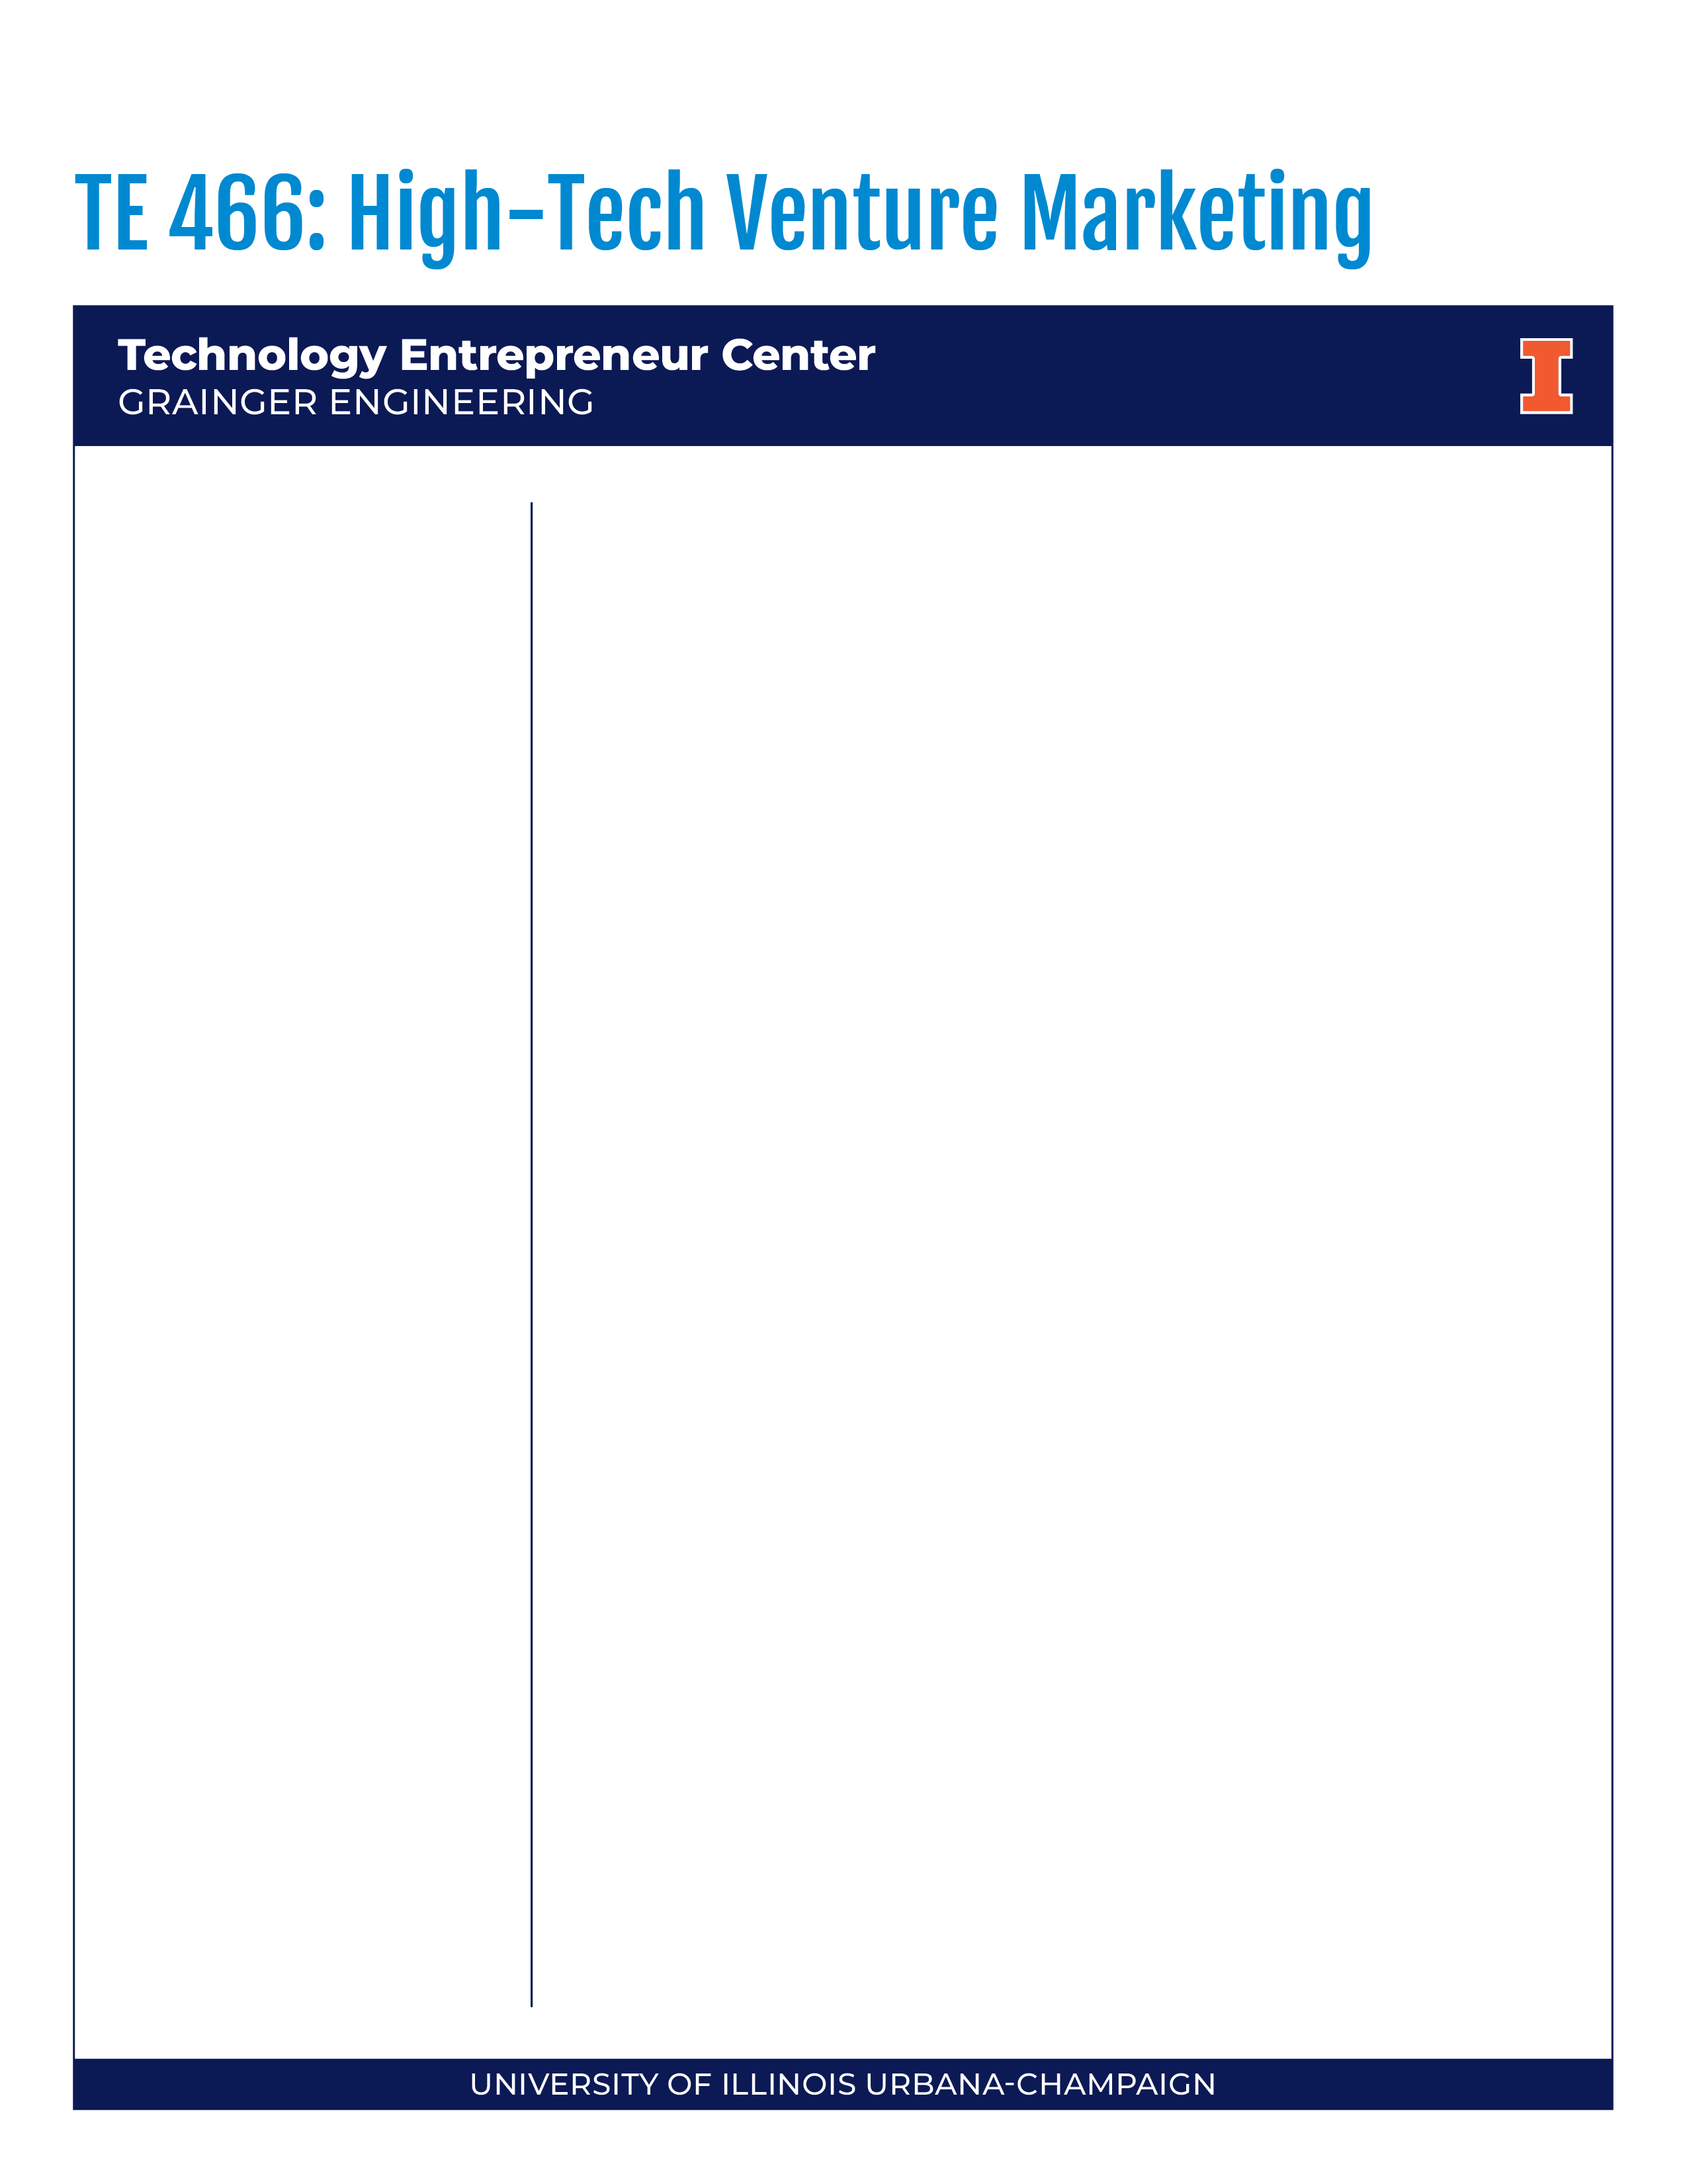

Fall 2026
- 2 credit hours
- Friday
- 2:00-3:50pm CST
- Online via Zoom
- Attendance at the weekly synchronous sessions is required.
- Video MUST always be on.

Instructor
Marc Bivona
bivona@illinois.edu
Marc Bivona is the former Executive Vice President, Marketing of a multi-faceted international real estate company providing B2B & B2C investments, development, education, coaching, and SAS services. He earned an MBA from the University of Virginia’s Darden School of Business, where he served as President of their NYC alumni association. Marc earned dual-Bachelor of Science degrees in Computer Applications and Information Systems, as well as Accounting from New York University’s Stern School of Business.
Course Purpose
Explore cornerstone marketing concepts for innovators and engineers and integrate the impact of strategic marketing decisions and opportunities for considering artificial intelligence (AI) augmentation in scaling performance of the enterprise. Engage in analysis of products and technologies from a marketing perspective including engineering product development and adoption life cycle, objectives and strategies, marketing management, communication skills, sales process and tactics, and special considerations for new high-tech engineering products and innovations. Relevant industry professionals will share their experiences. Synchronous attendance at the weekly sessions is required.
Learning Objectives
Upon completion of this course, you will be able to:

Understand entrepreneurial marketing,

Apply entrepreneurial marketing principles to high-tech industry,

Explore opportunities to leverage AI support in scaling ideas & efforts,

Develop a working vocabulary regarding these subjects and to become familiar with theories and concepts regarding them, and lean-into emerging opportunities to integrate AI,

Understand and discuss the application of course concepts to real world high-tech marketing.
Learning Outcomes
You will:
- Possess knowledge of high-tech marketing, the foundations of marketing strategy & the elements of an AI enhanced marketing plan,
- Make marketing decisions based on professional and ethical knowledge and responsibility,
- Be able to solve marketing related problems and manage the whole marketing process,
- Be able to integrate marketing frameworks with financial results and business models,
- Demonstrate awareness of contemporary issues and future trends in high-tech marketing practice,
- Demonstrate critical thinking skills by analyzing marketing problems and applying proper logic,
- Demonstrate an ability to design a process to meet desired needs within realistic economic, environmental, social, political, ethical, health and safety, manufacturability, and sustainability constraints,
- Be able to function on multidisciplinary teams,
- Be able to identify, formulate, and solve critical problems, and
- Recognize the need for, and an ability to engage in, life-long learning.
Required and Optional Texts
- Required: Marketing of High-Technology Products and Innovations
(3rd Edition). ISBN: 1269770136. Publisher: Pearson. Authors: Jakki J. Mohr, Sanjit Sengupta, Stanley Slater (find it online)
- Required: Harvard Business School Pricing Simulation: Universal Rental Car V2.
Instructions will be posted on Canvas. Cost is $16.25.
- Required: Business Model Generation by Osterwalder & Pigneur [Link Provided]
Student Responsibilities
- For TE 466, a typical week begins on Monday and ends Sundays at midnight.
- All assignments are due on Thursday at 11:59 p.m. (CST) PRIOR TO CLASS to be precise.
- The weekly agenda will highlight the student responsibilities for the week.
- Each week will have assigned reading(s) from the text. Students should read each chapter carefully. Weekly PowerPoints summarizing class conversations will be made available in Canvas after each discussion.
- There may be other assignments such as Business Article Analysis Assignments, Brand Yourself assignment, Harvard Pricing Simulation and Marketing Plan assignment during certain weeks. Please actively monitor the weekly module on Canvas for details (note, modules are updated often).
- Keep abreast of what is happening in the course. Attend class & participate. Challenge the professor, guests & each other with questions. Do not feel intimidated. Ask for help, if (and when) you need it. Speaking = Participation
Grading
Component Points %
1. Post Chapter Quizzes 200 20%
2. Self-branding Assignment 50 5%
3. Harvard Pricing Simulation 50 5%
4. Midterm Exam 250 25%
5. Final exam 250 25%
6. Class Participation 200+ 20% w/ article/podcast assignment conversations woven in
as BONUS consideration
IMPORTANT NOTE: As a baseline, you can’t get points for participation if you don’t show up for class with your camera on.
Final grades will be assigned strictly based on the following point scale. No final grade will be rounded.

Grading Scale
A 930-1000 A- 900-929
B+ 875-899 B 825-874 B- 800-824
C+ 775-799 C 725-774 C- 700-724
D+ 675-699 D 625-674 D- 600-624 F < 600



Grades will be accessible by password only on Canvas. For your security, grades will not be provided by phone or email. Grades are not negotiable. Students with extenuating circumstances which require them to receive a certain grade or maintain a particular GPA (e.g., graduation, loss of a scholarship, University probation or suspension, loss of a job offer, revocation of student Visa, etc.) need to realize that they are responsible for working hard to achieve the needed class grade. Please ask for help if you see that you are falling short of the grade that you expect or need. We want students to succeed but you must know that we cannot make exceptions for individual students. Grades can be changed only if I have made an input or calculation error. It is important that you check your class grades and immediately notify me of any discrepancies.
Grading Components
- Post-Chapter Quizzes
Throughout the semester, 13 online quizzes covering textbook material from a particular chapter will be required. You MUST take all 13 quizzes for 10 to count. You will be penalized if you miss quizzes. We will drop three lowest score post quiz and count your best 10 post quiz scores. Each quiz will cover material from specific chapters of the book. The pedagogical purpose of these quizzes is to ensure that you have read and understood the textbook chapters. I will note how you weave in these topics into the weekly conversations for your class participation.
- Business Podcast|Article Analysis
We have several business articles, case studies or podcasts during the semester. Business assignments provide a great opportunity to not only understand newest business, marketing trends and hotspots, but also develop strategic and critical thinking as well as work on your “presentation layer” during class discussion. It will be noted how you weave in these topics each week into the conversations for your class participation. Most class conversations will be anchored on the supplemental assignment, so it is imperative that you come prepared to discuss these each week.
- Self-Branding Assignment
In 1997, Tom Peters, the famous consultant wrote the following in Fast Company: “Big companies understand the importance of brands. Today, in the Age of the Individual, you have to be your own brand. Regardless of age, regardless of position, regardless of the business we happen to be in, all of us need to understand the importance of branding. We are CEOs of our own companies: Me Inc. To be in business today, our most important job is to be head marketer for the brand called You.”
This assignment is about creating your own personal/professional brand strategy. After your stint at Illinois, if you want to be an entrepreneur and start your own company, you need to be differentiated and stand out. A well-done assignment can help you understand what makes you tick and help you communicate that message effectively. The output of this exercise is for you to have a clear understanding of what makes you competent to be an excellent entrepreneur. You must find out and deliver your strength to prospective partners, employees, and investors.
Your assignment must include the elements below, and will be delivered as a video, audio, in a narrated presentation. Details about the delivery included at the end.
Step 1. Self-analysis: Do a strengths / weaknesses analysis of yourself. What are the attributes / characteristics that make you distinctive from your colleagues or competitors? What is your strong suit? What needs improvement? This will help you understand what you must focus on in the future.
Step 2. External analysis: Talk to your family and friends. What do they say about you? What do they say is your greatest and clearest strength? Your best personal trait? Your weaknesses?
Step 3. Is there congruence between your self-analysis and the external analysis? If so, you’re lucky. If not, why not? What direction is the incongruence? How would you reposition yourself? Remember it does not matter what you think of yourself. Other people’s perception of you is the reality. While what your friends and family say may not be completely true, that perception is how the world sees you.
Step 4. Based on the analyses above, what is the “feature-benefit” model that you offer. Every feature a product offers yields an identifiable and distinguishable benefit for their customer or client. Car companies don’t sell 60” back seat; they sell that the car can seat four people comfortably. A dominant feature of Nordstrom is the personalized service, but the customer benefit is a feeling of being accorded individualized attention.

Self-branding delivery options:
It is important that you show your creativity in this assignment. Here you will see some guidelines but feel free to innovate.
You must create a 5–10-minute video that you can post to YouTube. I must be able to see it with no password, so make it public. It is a good idea to create a script to follow as you record this video, or else, you may go overtime or miss some of the points you want to make.
- Harvard Pricing Simulation: Universal Rental Car V2
All students will participate in the Pricing Simulation: Universal Rental Car V2, published through Harvard Business School publishing. The simulation plays like a game, and we have found it very engaging. We hope that students find that simulation not only interesting, but a powerful learning experience where you see the results of effective and ineffective application of course concepts. You will benefit from running the simulation multiple times (3 attempts) with increasing complexity (scenarios A & C). This single-player simulation includes two pre-set scenarios (A and C) to meet specific learning objectives.
Description:
At a Florida rental car agency, you assume the role of a district manager responsible for setting prices for rental cars across three Florida cities: Miami, Orlando, and Tampa. Over 12 simulated months, you will analyze price sensitivity between leisure and business travelers and consider strategies that maximize rentals across weekdays and weekends in each city. Demand for rental cars can vary depending on the month and whether the location is more popular with business or leisure travelers. Unrented cars have associated holding costs while running out of cars is lost opportunity for profit. You can make periodic inventory adjustments among the locations to match anticipated demand. The market for rental cars in Florida is intensely competitive and you must also consider the likely competitive response to their pricing decisions. Ultimately, you will analyze the economic, seasonal, and competitive forces of the rental car market and develop a pricing strategy to maximize the cumulative profit for the firm.

Learning Objectives:
- Understand the nature and dynamics of consumer response to price (price elasticity).
- Account for demand differences across customer segments and regions.
- Understand and plan for seasonal variations in demand.
- Explore the impact of pricing decisions on firm profitability.
- Use pricing strategies to optimize inventory.
- Anticipate and understand competitive reactions to pricing decisions.
- Understand how price and general economic conditions affect overall market demand.
Grading:
This assignment is worth 50 points and 5% of your grade. To be graded, you will need to complete 2 scenarios (for a total of 6 tries, you must do all to get full credit) and the Strategy Discussion part of this assignment in the forum below. You will receive 25 points for your performance in both scenarios and 25 points for your simulation strategy response. To get performance points: you are required to target earning $10 million profit in each Scenario while maintaining “good” market share.
- Exams
There will be two exams that account for the bulk of your grade in the course. These will be timed exams. There will be one midterm exam and a final exam. The exams may consist of multiple-choice, open-ended, essay and true/false questions from the text and other course activities. The details of the exams will be posted on the Canvas website prior to the start.
Student Roster
Each student is required to complete Student Roster or Class Roster. You are required to add a wiki page to this roster with a little information about yourself. Instructions for how to do this assignment can be found in the weekly module for the week one.
A Note about Emergencies and Exam Dates
To be as fair as possible to everyone in the class, deadlines will be strictly enforced, regardless of personal emergencies, technical problems, etc. You will have plenty of time to complete exams, chapter quizzes, online component quizzes, so please DO NOT wait until the last minute. If you wait until the deadline, issues such as illness or problems with the University server might make it impossible for you to complete the assignments.
Statute of Limitations
Exam grades, quiz grades, extra credit and final grades are non-negotiable and final. Grades will only be changed if the grade results from a mathematical or record-keeping error. It is important that each student frequently checks their class grades and immediately notifies the instructor of any discrepancies that have been discovered. After the posting of grades, you will have one week to notify the instructor about any grading issues or errors. After this period, no corrections or recalculations will be made.
Class Policies
Policy on academic misconduct: Illinois is committed to a policy of honesty in academics. Conduct compromising this policy will result in academic and/or disciplinary action. Cheating and plagiarism are violations of student academic behavior standards. Any student who violates or knowingly helps another student violate academic behavioral standards will be pursued through the Office of the Dean of the College of Business Administration and through the Dean of Students at UI. (Source: The Student Handbook). All work you submit in this class must be your own, original work or that of your team. The standard penalty for any instance of academic dishonesty is an ‘F’ for the course. Your submission will be checked/tested through an anti-plagiarism software. Late Assignment Submission Policy: Any late submission will lose 50% points and maximum 7 days late submission will be accepted. Submissions exceeding 7 days will not be graded.
Special Needs
The University of Illinois is committed to providing reasonable accommodations for students with disabilities to allow for equal learning opportunities. If you need such accommodations, please contact Disability Resources and Educational Services at (217) 333-1970. Also, if you are likely to have religious obligations that will conflict with the due dates for particular assignments, please contact the instructor immediately.
Final Note
The detailed schedule is provided on Canvas. Changes to the syllabus may be made to reflect the needs of the class. Any changes will be announced in class and/or on the course web site modules (Canvas). It is the students’ responsibility to stay aware of any changes made. If you have questions, JUST ASK via an email, a post or in class.
COVID
Following University policy, all students are required to engage in appropriate behavior to protect the health and safety of the community. Students are also required to follow the campus COVID-19 protocols.
Students who feel ill must not come to class. In addition, students who test positive for COVID 19 or have had an exposure that requires testing and/or quarantine must not attend class. The University will provide information to the instructor, in a manner that complies with privacy laws, about students in these latter categories. These students are judged to have excused absences for the class period and should contact the instructor via email about making up the work.
Students who fail to abide by these rules will first be asked to comply; if they refuse, they will be required to leave the classroom immediately. If a student is asked to leave the classroom, the non- compliant student will be judged to have an unexcused absence and reported to the Office for Student Conflict Resolution for disciplinary action. Accumulation of non-compliance complaints against a student may result in dismissal from the University.
Emergency Response Recommendations
Emergency response recommendations can be found at the following website: http://police.illinois.edu/emergency-preparedness/. I encourage you to review this website and the campus building floor plans website within the first 10 days of class. http://police.illinois.edu/emergency-preparedness/building-emergency-action-plans/.
Sexual Misconduct Reporting Obligation
The University of Illinois is committed to combating sexual misconduct. Faculty and staff members are required to report any instances of sexual misconduct to the University’s Title IX Office. In turn, an individual with the Title IX Office will provide information about rights and options, including accommodations, support services, the campus disciplinary process, and law enforcement options.
A list of the designated University employees who, as counselors, confidential advisors, and medical professionals, do not have this reporting responsibility and can maintain confidentiality, can be found here: wecare.illinois.edu/resources/students/#confidential. Other information about resources and reporting is available here: wecare.illinois.edu.

Academic Integrity
You are expected uphold the highest ethical standards, to be honest, and to practice academic integrity. This includes doing original work and citing sources, including the work of other students. Please give special care to prepare high-quality submissions with proper grammar and spelling.
The University of Illinois Urbana-Champaign Student Code should also be considered as a part of this syllabus. Students should pay particular attention to Article 1, Part 4: Academic Integrity. Read the Code at the following URL: http://studentcode.illinois.edu/. Academic dishonesty may result in a failing grade. Every student is expected to review and abide by the Academic Integrity Policy: https://studentcode.illinois.edu/article1/part4/1-401/. Ignorance is not an excuse for any academic dishonesty. It is your responsibility to read this policy to avoid any misunderstanding. Do not hesitate to ask the instructor if you are ever in doubt about what constitutes plagiarism, cheating, or any other breach of academic integrity.
Religious Observances
Illinois law requires the University to reasonably accommodate its students' religious beliefs, observances, and practices in regard to admissions, class attendance, and the scheduling of examinations and work requirements. You should examine this syllabus at the beginning of the semester for potential conflicts between course deadlines and any of your religious observances. If a conflict exists, you should notify your instructor of the conflict and follow the procedure at https://odos.illinois.edu/community-of-care/resources/students/religious-observances/ to request appropriate accommodations. This should be done in the first two weeks of classes.
Disability-Related Accommodations
To obtain disability-related academic adjustments and/or auxiliary aids, students with disabilities must contact the course instructor and the Disability Resources and Educational Services (DRES) as soon as possible. To contact DRES, you may visit 1207 S. Oak St., Champaign, call 333-4603, email disability@illinois.edu or go to https://www.disability.illinois.edu. If you are concerned you have a disability-related condition that is impacting your academic progress, there are academic screening appointments available that can help diagnosis a previously undiagnosed disability. You may access these by visiting the DRES website and selecting “Request an Academic Screening” at the bottom of the page.
Family Educational Rights and Privacy Act (FERPA)
Any student who has suppressed their directory information pursuant to Family Educational Rights and Privacy Act (FERPA) should self-identify to the instructor to ensure protection of the privacy of their attendance in this course. See https://registrar.illinois.edu/academic-records/ferpa/ for more information on FERPA.
Anti-Racism and Inclusivity Statement
The Grainger College of Engineering is committed to the creation of an anti-racist, inclusive community that welcomes diversity along a number of dimensions, including, but not limited to, race, ethnicity and national origins, gender and gender identity, sexuality, disability status, class, age, or religious beliefs.
The College recognizes that we are learning together in the midst of the Black Lives Matter movement, that Black, Hispanic, and Indigenous voices and contributions have largely either been excluded from, or not recognized in, science and engineering, and that both overt racism and micro-aggressions threaten the well-being of our students and our university community.
The effectiveness of this course is dependent upon each of us to create a safe and encouraging learning environment that allows for the open exchange of ideas while also ensuring equitable opportunities and respect for
all of us. Everyone is expected to help establish and maintain an environment where students, staff, and faculty can contribute without fear of personal ridicule, or intolerant or offensive language. If you witness or experience racism, discrimination, micro-aggressions, or other offensive behavior, you are encouraged to bring this to the attention of
the course director if you feel comfortable. You can also report these behaviors to the Bias Assessment and Response Team (BART) (https://bart.illinois.edu/). Based on your report, BART members will follow up and reach
out to students to make sure they have the support they need to be healthy and safe. If the reported behavior also violates university policy, staff in the Office for Student Conflict Resolution may respond as well and will take appropriate action.

