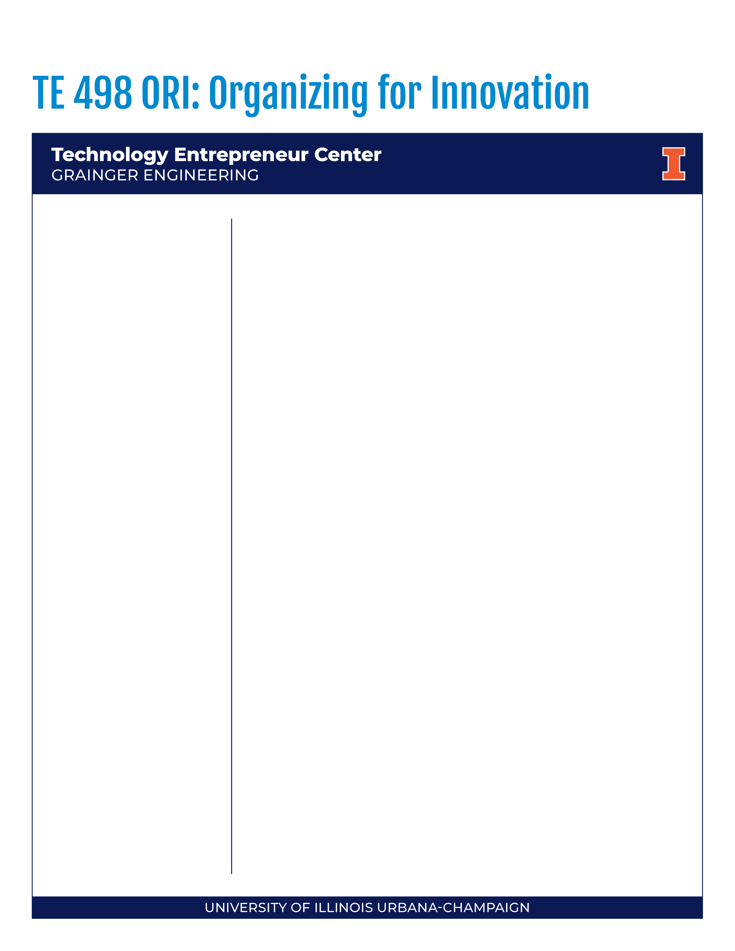

TE 198 Introduction to Innovation and Entrepreneurship
Spr 2026
- 1 credit hour
- Asynchronous
- 8 Week Section
Instructor
Prof. Mark Karasek
mkarasek@illinois.edu
Office Hours
Sign up available at:
See Canvas Page

Professor Karasek has decades of experience leading innovation in the enterprise and years of experience coaching startups. The course content is based on real life experiences in developing and leading organizations that are the primary drivers of innovative growth in the enterprise.
Innovation is the foundation of growth in existing enterprises and in startups.
Companies must grow to survive over the long term. Innovation is the lifeblood of growth in corporations and startups. But innovation is arguably the most difficult thing an organization can try to do. And the challenge of innovative growth is getting more complicated. Product companies are adding software services. Service companies are adding products. Value in the marketplace is moving from products or services to ecosystems platforms. As ecosystems define value in a marketplace, the profit pool can redistribute creating new winners and losers.
Markets are evolving – employees must evolve with them
Intro to Innovation and Entrepreneurship is an ideal course for undergraduate students across the university who want to begin to build a foundation of understanding of what drives innovation in existing enterprises and startups.
Innovation Toolsets
How does the emergence of ecosystems change how we innovate in enterprises and companies? What are the toolsets of innovation that a modern ecosystem participant needs to master? How do you find problems to solve that matter enough to customers that they will pay for a solution?
Learning Objectives
Upon completion of this course, you will be able to:
- Recognize the differences among innovation, creativity, and invention,
- Explain how innovation is used in corporations to create value, and how innovation is different in a start-up versus an established enterprise,
- Explain why innovation and entrepreneurship are important to the economic health of the country,
- Explain how to identify and evaluate customer problems worth solving,
- Explain the key steps and tools of customer discovery.

Contact Time
The Canvas site includes a list of links for reading materials and videos for each week of the class. Since the students are expected to complete 2 modules per week, they should expect to spend about 2 hrs per week reading assigned articles and blogs and watching assigned prior to completing the weekly assignments. All students should also plan to watch the video review of the first half of the semester which will be available the week before the midterm. They should also plan to watch the video review of the entire course which will be available prior to the final.

Optional Synchronous Sessions

Optional synchronous Zoom sessions will be offered in Week 2 and Week 6. The instructor will provide a brief review of course concepts and allow time for student questions.
Grading
50% - Weekly individual assignments
20% - Midterm exam on Canvas
30% - Final exam on Canvas

Assignment Requirements
Weekly homework assignments are listed on Canvas. Assignments must be submitted in Canvas prior to the listed deadline each week for full credit. Late assignments may be submitted but penalized 50% on points awarded. The individual midterm exam will be completed on Canvas during Week 4 and the Final Exam will be completed on Canvas during Week 8.
Grading Scale:
- A+ 97 – 100
- A 93 – 96.9
- A- 90 – 92.9
- B+ 87 – 89.9
- B 83 – 86.9
- B- 80 – 82.9
- C+ 77 – 79.9
- C 73 – 76.9
- C- 70 – 72.9
- D+ 67 – 69.9
- D 63 – 66.9
- D- 60 – 62.9
- F <60



Tentative Schedule & Assignment Dates
Session | Week | Lecture/Discussion | Assignments Due as Noted
1A | 1 | - Invention versus Innovation | - Crazy Patent Assignment
1B | 1 | - Types of Innovation | - Types of Innovation Assignments (2)
2A | 2 | - Products, Services and Ecosystems | - McDonalds and Food Delivery Assignment
2B | 2 | - Innovation in Large and Small Companies including Startups | - Uber/Lyft Disruption of Taxi Industry Assignment
3A | 3 | - Problem Identification versus Solution Focus | - Customer Problems Assignment
3B | 3 | - Creating an Effective Team for Problem Identification | - Good and Bad Team Experiences  - Team Ground Rules Assignment
4A | 4 | - Defining a Business Model | - GarageVana Business Model Canvas Assignment
4B | 4 | - Midterm Exam | - Midterm Exam
5A | 5 | - Understanding the Customer Problem | - GarageVana Problem Statement Canvas Assignment
5B | 5 | - Identifying Customer Needs | - GarageVana Value Proposition Canvas Assignment
6A | 6 | - Stakeholder Ecosystem Identification and Mapping | - GarageVana Stakeholder Identification Assignment
6B | 6 | - Planning and Documenting Stakeholder Interviews | - GarageVana Customer Interview Plan Assignment
7A | 7 | - Identifying the Competition | - Shake Box Petal Diagram Assignment
7B | 7 | - Fall break | - None
8A | 8 | - Market Segment Sizing | - GarageVana Market Segment Sizing Assignment
8B | 8 | - Course Wrap-up and Review | - Final Exam

COVID
Following University policy, all students are required to engage in appropriate behavior to protect the health and safety of the community. Students are also required to follow the campus COVID-19 protocols.
Students who feel ill must not come to class. In addition, students who test positive for COVID 19 or have had an exposure that requires testing and/or quarantine must not attend class. The University will provide information to the instructor, in a manner that complies with privacy laws, about students in these latter categories. These students are judged to have excused absences for the class period and should contact the instructor via email about making up the work.
Students who fail to abide by these rules will first be asked to comply; if they refuse, they will be required to leave the classroom immediately. If a student is asked to leave the classroom, the non-compliant student will be judged to have an unexcused absence and reported to the Office for Student Conflict Resolution for disciplinary action. Accumulation of non-compliance complaints against a student may result in dismissal from the University.
Emergency Response Recommendations
Emergency response recommendations can be found at the following website: http://police.illinois.edu/emergency-preparedness/. I encourage you to review this website and the campus building floor plans website within the first 10 days of class.
http://police.illinois.edu/emergency-preparedness/building-emergency-action-plans/.
Sexual Misconduct Reporting Obligation
The University of Illinois is committed to combating sexual misconduct. Faculty and staff members
are required to report any instances of sexual misconduct to the University’s Title IX Office. In turn,
an individual with the Title IX Office will provide information about rights and options, including accommodations, support services, the campus disciplinary process, and law enforcement options.
A list of the designated University employees who, as counselors, confidential advisors, and medical professionals, do not have this reporting responsibility and can maintain confidentiality, can be found here: wecare.illinois.edu/resources/students/#confidential. Other information about resources and reporting is available here: wecare.illinois.edu.
Academic Integrity
You are expected uphold the highest ethical standards, to be honest, and to practice academic integrity. This includes doing original work and citing sources, including the work of other students. Please give special care to prepare high-quality submissions with proper grammar and spelling.
The University of Illinois at Urbana-Champaign Student Code should also be considered as a part of this syllabus. Students should pay particular attention to Article 1, Part 4: Academic Integrity. Read the Code at the following URL: http://studentcode.illinois.edu/. Academic dishonesty may result in a failing grade. Every student is expected to review and abide by the Academic Integrity Policy:
https://studentcode.illinois.edu/article1/part4/1-401/. Ignorance is not an excuse for any academic dishonesty. It is your responsibility to read this policy to avoid any misunderstanding. Do not hesitate to ask the instructor if you are ever in doubt about what constitutes plagiarism, cheating, or any other breach of academic integrity.
Religious Observances
Illinois law requires the University to reasonably accommodate its students' religious beliefs, observances, and practices in regard to admissions, class attendance, and the scheduling of examinations and work requirements. You should examine this syllabus at the beginning of the semester for potential conflicts between course deadlines and any of your religious observances. If a conflict exists, you should notify your instructor of the conflict and follow the procedure at https://odos.illinois.edu/community-of-care/resources/students/religious-observances/ to request appropriate accommodations. This should be done in the first two weeks of classes.
Disability-Related Accommodations
To obtain disability-related academic adjustments and/or auxiliary aids, students with disabilities must contact the course instructor and the Disability Resources and Educational Services (DRES) as soon as possible. To contact DRES, you may visit 1207 S. Oak St., Champaign, call 333-4603, email disability@illinois.edu or go to https://www.disability.illinois.edu. If you are concerned you have a disability-related condition that is impacting your academic progress, there are academic screening appointments available that can help diagnosis a previously undiagnosed disability. You may access these by visiting the DRES website and selecting “Request an Academic Screening” at the bottom of
the page.
Family Educational Rights and Privacy Act (FERPA)
Any student who has suppressed their directory information pursuant to Family Educational Rights and Privacy Act (FERPA) should self-identify to the instructor to ensure protection of the privacy of their attendance in this course. See https://registrar.illinois.edu/academic-records/ferpa/ for more information
on FERPA.
Anti-Racism and Inclusivity Statement
The Grainger College of Engineering is committed to the creation of an anti-racist, inclusive community that welcomes diversity along a number of dimensions, including, but not limited to, race, ethnicity and national origins, gender and gender identity, sexuality, disability status, class, age, or religious beliefs.
The College recognizes that we are learning together in the midst of the Black Lives Matter movement, that Black, Hispanic, and Indigenous voices and contributions have largely either been excluded from,
or not recognized in, science and engineering, and that both overt racism and micro-aggressions threaten the well-being of our students and our university community.
The effectiveness of this course is dependent upon each of us to create a safe and encouraging learning environment that allows for the open exchange of ideas while also ensuring equitable opportunities and respect for all of us. Everyone is expected to help establish and maintain an environment where students, staff, and faculty can contribute without fear of personal ridicule, or intolerant or offensive language. If you witness or experience racism, discrimination, micro-aggressions, or other offensive behavior, you are encouraged to bring this to the attention of the course director if you feel comfortable. You can also report these behaviors to the Bias Assessment and Response Team (BART) (https://bart.illinois.edu/). Based on your report, BART members will follow up and reach out to students to make sure they have the support they need to be healthy and safe. If the reported behavior also violates university policy, staff in the Office for Student Conflict Resolution may respond as well and will take appropriate action.

