SE/IE 590 Spring 2021 Syllabus

Welcome to the SE/IE 590 seminar course. All ISE graduate students are required to register for SE 590 (Systems and Entrepreneurial Engineering) or IE 590 (Industrial Engineering) every fall and spring semester they are students in the program.
Students must attend 6 seminars to earn a satisfactory grade. An unsatisfactory grade in IE 590 or SE 590 must be finalized by the 16 week semester following, or you will need to complete all 6 seminars in order to receive a satisfactory grade for that term. For example, if you only need 1 additional seminar from Spring 2020, but do not complete this 1 seminar by the end of the Fall 2020 semester, you will need to complete all 6 seminars in order to receive a satisfactory grade for Spring 2020. Once all seminars are made-up per the previous policy, the final grade will be updated.
- Spring unsatisfactory grades must be complete by the end of the following fall semester
- Fall unsatisfactory grades must be complete by the end of the following spring semester

Students may submit a seminar substitution form to make up any missed seminars or to count a seminar offered by another department toward the required seminars for this course. This form requires a signature of the staff member in charge (not the speaker). Students may attend 2 non-technical seminars per semester (examples include the resume workshop or SE 290 Engineer in Residence presentation) and count these as part of their total requirements.
For the Spring 2021 semester, all seminars will be handled through Zoom. Emails will be sent one week before the seminar and the morning of the seminar. See the announcements for confirmation of day and time. Seminars will be recorded (assuming speakers' consent) and will be available for you to watch after the conclusion of the seminar. However, watching online seminars will not be counted toward the total requirements except for valid reasons (i.e., your time zone).

ATTENDANCE THROUGH ZOOM
When logging into the Zoom session each week, it is imperative you use your full name (no nicknames). The only way you will receive credit for attending is by using your full name and remaining in the seminar for the entire duration.

To change your name after entering a Zoom meeting, click on the "Participants" button at the top of the Zoom window. Please note that if you are logging in through your phone, these screenshots may look a little different, but the steps are the same.
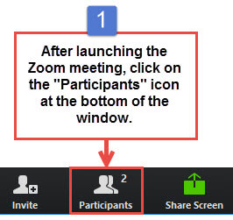
Next, hover your mouse over your name in the "Participants" list on the right sode of the Zoom window. Click on "Rename".
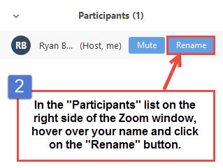
Enter your FULL NAME and click on "OK".
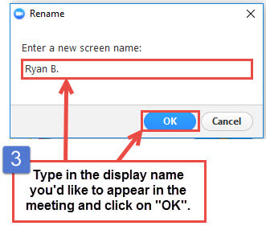
REQUIRED MATERIALS
No materials are required. Just come as you are, sign-in, listen and interact with our speakers.

